Homework3

Dalia Habiby

9/18/2020

library(reshape2)  
library(ggplot2)  
View(tips)  
  
#1  
?tips

## starting httpd help server ... done

# The variable size in the dataset represents the size of the party eating at the restaurant.  
  
#2  
ggplot(data = tips) +  
 geom_bar(mapping = aes(x = size, fill = "red")) +  
 ggtitle("Bargraph showing counts for tip size")

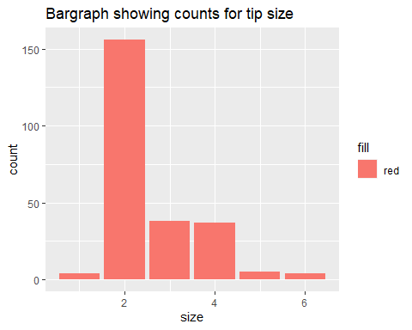

#3  
sb<- ggplot(data = tips, aes(x="", y = size, fill=day))+  
 geom_bar(width = .5, stat = "identity")  
sb

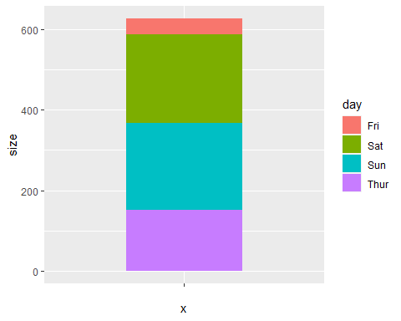

#4  
pie <- sb + coord_polar("y", start=0)  
pie

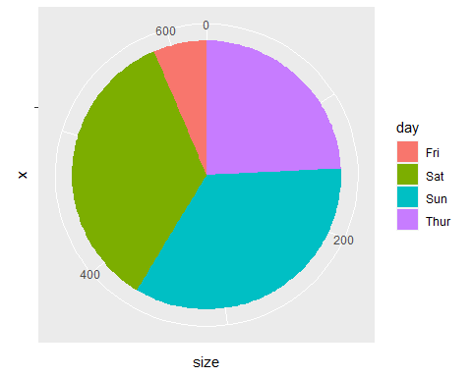

#5  
ggplot(data=tips) +  
 geom_point(mapping = aes(x = total_bill, y=tip/total_bill))

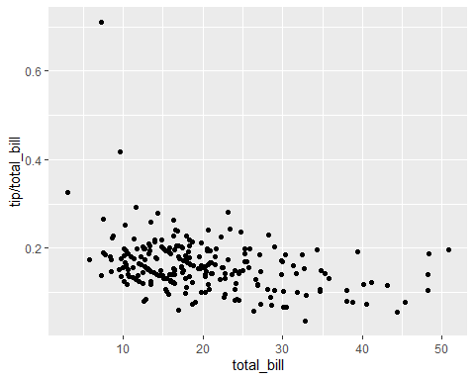

#6  
ggplot(data=tips, mapping=(aes(x=total_bill, y=tip/total_bill))) +  
 geom_point() +  
 facet_wrap(~day)

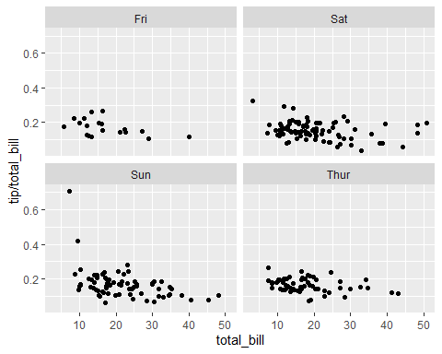

#The day with the most extreme outlier is Sunday  
  
#7  
ggplot(data=tips) +  
 geom_point(mapping=(aes(x=total_bill, y=tip/total_bill))) +  
 facet_grid(time~size)

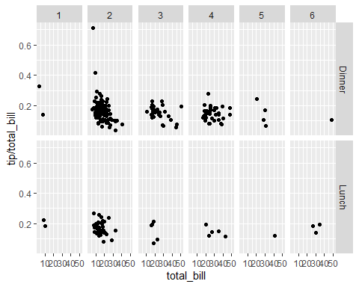

#The most populated at dinner time with a size of 2.