DS 413/613 FINAL EXAM Summer 2021 (Generate and submit an Rmarkdown file and a Word file that shows all required code and output for problems 1-4. Problem 5 can be submitted independent of the others.

**Problem 1**

Using the following link, <https://forecast.weather.gov/MapClick.php?CityName=Washington&state=DC&site=LWX&textField1=38.895&textField2=-77.0373&e=1#.YLPCyflKiUk> . Show and use R code and the Web Scraping methods illustrated in class to collect data on weather for Denver Colorado. The entire table is given below (There may be differences in your table, but structurally, you should get a table very similar to the one shown below.. Do not forget to use Chrome and Selector Gadget.

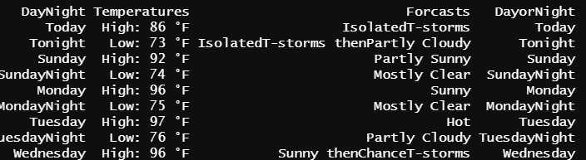

**Problem 2**

a) Use data.table coding to read in the nyc14 data as was done in class. Assign the data table to the variable **flights3**

b) Use data.table coding to modify flights3 so that only the column variables **origin**, **dest**, and **carrier** appear.

c) Now use data.table coding that reflects an origin of JFK, a destination of SEA and a carrier of only Delta Airlines DL.

d) Use data.table coding to remove the variable **air_time** from the original flights3 data table.

e) Use and show data.table coding to output the maximum and the minimum values for the variable **distance.**

f) Use two or three sentences to explain the summary provided below and then use and show data.table coding to produce the table.

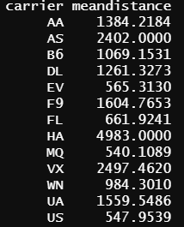

**Problem 3**

Provided below is the famous poem **“ Stopping by the Wood On a Snowy Evening” by Robert Frost.**

Use the text mining sequence of steps and the R code modeled in class to create a tibble, find line location of words, produce a word frequency table, and a bar graph data visualization plot that will also display word frequency trends.

Hint( do not forget to process a single spaced body of text ; be careful about commas and double quotation marks.)

Whose woods these are I think I know.

His house is in the village though;

He will not see me stopping here

To watch his woods fill up with snow.

My little horse must think it queer

To stop without a farmhouse near

Between the woods and frozen lake

The darkest evening of the year.

He gives his harness bells a shake

To ask if there is some mistake.

The only other sound’s the sweep

Of easy wind and downy flake.

The woods are lovely, dark and deep,

But I have promises to keep,

And miles to go before I sleep,

And miles to go before I sleep.

**Problem 4**

Use and show an R coding structure (found in your notes) that will produce the following matrix

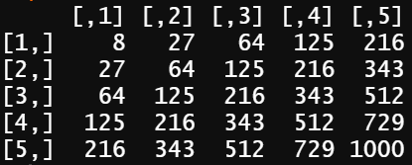

**Problem 5**

Produce the R code(In an R script file) that will produce the interactive shiny app shown below. The histogram and the boxplot are Reactive and controlled by the select input box Iris variables.

In Github, create a new repository whose name is **Final Exam Problem 5.** Use the sequence of steps outlined in you notes and demonstrated in class to push your R script file, containing the shiny app code, from the Git bash terminal to your new Github repository. Email me the url of the repository that will contain the R script file with the shiny app code. The ui section of the shiny app (and required libraries are provided for you on the following page. You must produce additional coding that will generate the app as it appears.

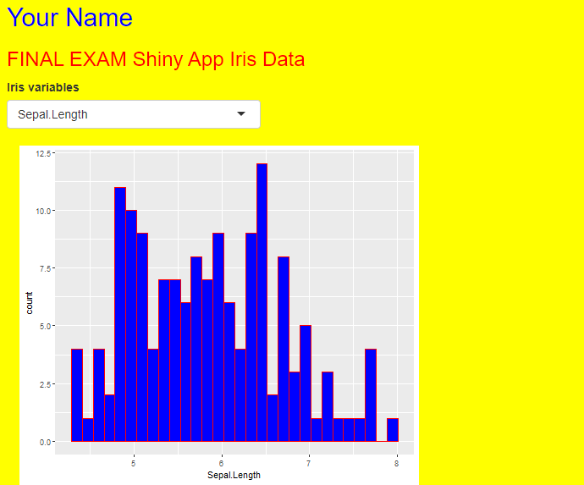

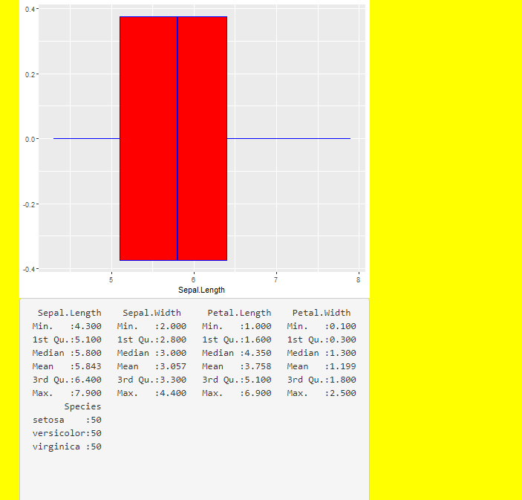

**library(shiny)**

**library(tidyverse)**

**library(shinyWidgets)**

**ui <- fluidPage(**

**tags$h2("Your Name", style = "color:blue"),**

**h3("FINAL EXAM Shiny App Iris Data",**

**style = "color:red"),**

**setBackgroundColor("yellow"),**

**selectInput("vars", "Iris variables", choices = names(iris)),**

**mainPanel(**

**plotOutput(outputId = "Histogramplotvar1"),**

**plotOutput(outputId = "Boxplotvar1"),**

**verbatimTextOutput("summary")**

**)**

**)**

**)**