DS 413/613 Classwork/Lab Shiny Apps

Instructions: Email an R file only. **Do not send an Rmarkdown file or a Word file**

1) Use and show R code that will create a shiny app that produces a scatter plot for any two variables for the **iris** data set. Provided below is the layout for your shiny app.

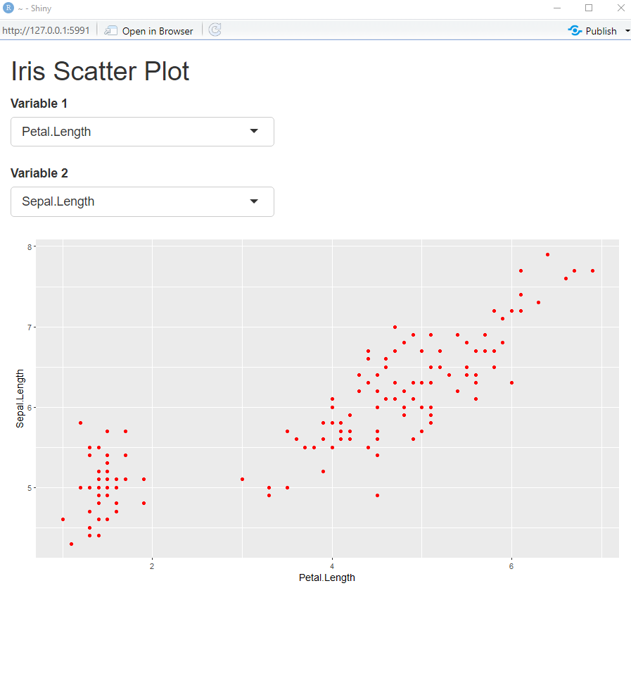

2) Use and show R code that will create a shiny app that produces a boxplot for any variable of the **iris** data set. The layout is provided below.

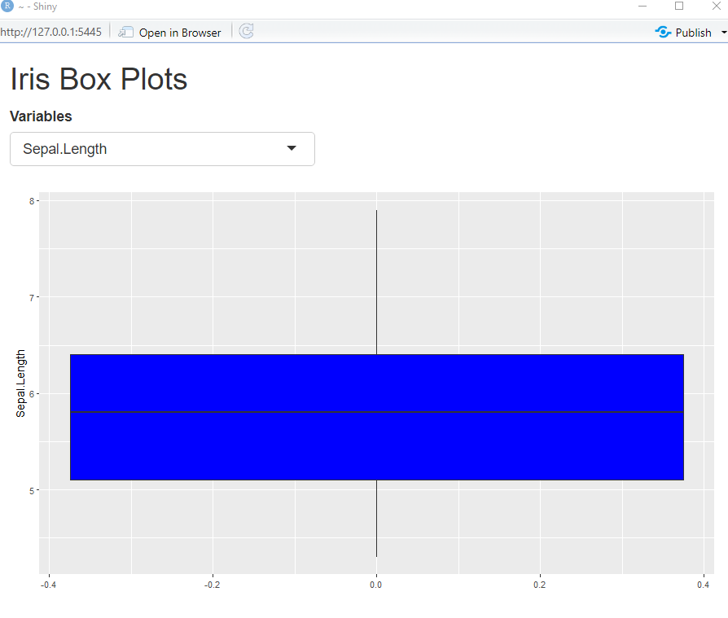

3) Use and show R code that will create a shiny app that produces multiple choice options for choosing favorite sports. The shiny layout is provided below.

