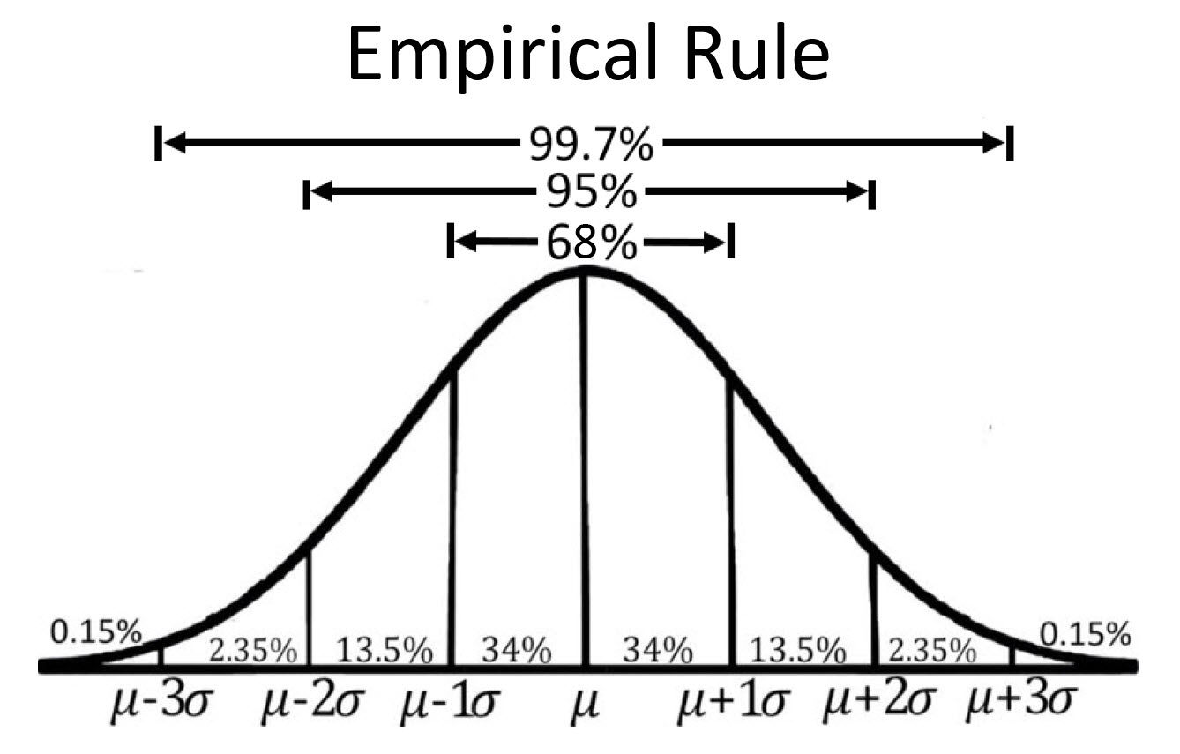

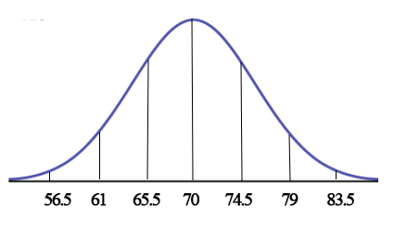

What is the mean ?

What is the standard deviation ?



.15 2.35 13.5 34 34 13.5 2.35 .15

1) What percent of the data is between 65.5 and 74.5?

2) What percent of the data is between 61 and 74.5?

3) What percent of the data is less than 61?

4) What percent of the data is greater than 74.5?

5) What percent of the data greater than 79 and less than 56.5?

6) What percent of the data is greater than 82?

7) What percent of the data is between 68 and 73.5?

9) Find Q1

10) What value is at the 65th percentile?

IQR and Outliers

IQR (Interquartile Range) Q3 – Q1 Should be used for skewed data.

Using the IQR in order to determine if a data set has outliers. **(1.5 IQR rule)**

**Example 1 Use the IQR rule to determine if the data set below has outliers.**

**S = {12,16,22,5,18.5,31}**

**Q1** = 13 **Q3 =** 21.12 **IQR =** 21.12 – 13 = 8.12

**Lower Bound = Q1 – 1.5(IQR) = 13 – 1.5(8.12) = .82**

**Upper Bound = Q3 + 1.5(IQR) = 21.12 + 1.5(8.12) = 33.3**

**Is there a data value lower than .82? no !!**

**Is there a data value higher than 33.3? no !!**

**Data set S does not have outliers**

**Example 2 Use the IQR rule to determine if the data set below has outliers.**

**K = { 4,13,15,17,20,22,25,31,38, 64}**

**Q1** = 15.5 **Q3 =** 29.5 **IQR =** 29.5 – 15.5 = 14

**Lower Bound = Q1 – 1.5(IQR) = 15.5 – 1.5(14) = -5.5**

**Upper Bound = Q3 + 1.5(IQR) = 29.5 + 1.5(14) = 50.5**

**Is there a data value lower than -5.5? no !!**

**Is there a data value higher than 50.5? yes !!**

**Since 64 > 50.5, 64 is an outlier**

Z score (How many standard deviations is a data set value from the mean?)

Example 3 A data set has an observation value of 46, a mean of 43, and a standard deviation of 4. How many standard deviations is the value 46 from the mean of 43 ?

Z = (observation – mean)/standard deviation

Z = (46 – 43)/4 = .75

46 is .75 standard deviations above the mean.

Assuming a normal distribution, a Z score can also be used to determine if the observation value is an outlier.

If the Z score is greater than +3 or less than -3, then the associated observation value is an outlier.

Since .75 is not greater than +3 or less than -3, 46 is not an outlier for the data set.

Example 4

The Biology test scores from Mr. Arnold’s class and Mrs Adam’s class are approximately normal.

Mr. Arnold’s test data: mean = 72, sd = 3.5 Mrs Adam’s test data: mean = 74.5, sd = 4

John is in Mr. Arnold’s class, his test score was 76; Ann is in Mrs Adam’s class, her test score was 78. Which student performed better ?

Calculate the z score for John: (76 -72) / 3.5 = **1.145**

Calculate the z score for Ann: (78 - 74.5) / 4 **= .875**

**Conclusion:**

The two students are in different classes and taught by different teachers. Since John has a higher z score, he performed better than Ann with respect to mean and standard deviation given for both testing environments.

TRUE or FALSE

1) The empirical rule only applies to data that is normal (bell shaped) not skewed data

2) If a data distribution is skewed right, the mean is less than the median

3) A z score cannot be 0.

4) The median and Q2 are the same.

5) The minimum value of a data set is always an outlier.

6) The range of a data set is found by subtracting Q1 from Q3

7) The mode of a data set is the value with the greatest frequency

8) Q2 is the same as the 50th percentile

9) The standard deviation of a data set is always a positive value

10) Possible z scores for a data set is a **discrete** set.

CIRCLE THE CORRECT ANSWER

11) If a data set has outliers the *mean*  *median* should be used to summarize the data.

12) The statistical summary that **does not** belong to the standard five number summary for a data set is *maximum minimum Q1 Q3 Median Mode*

13) The observation that falls in the middle of an ordered data set is the *Mean Mode Median*

14) A **standard normal distribution** has a mean *of 0 1 -1* and a standard deviation of *0 1 -1*

15) The summary statistic that averages the squared deviations about the mean is the

*standard deviation IQR mode range variance*