**ANOVA approach to hypothesis testing**

**The F Test**

* In this section, we will talk about a different strategy to testing *H*0:*β*1=0

In simple linear regression, this results in the *exact same-value* as the test that uses the t-statistic.

However, this strategy is more applicable to general linear hypotheses that we’ll discuss in multiple linear regression.

• Testing *H*0:*β*1=0

is really a comparison between the two models:

*H*0: *Yi*=*β*0+*ϵi*

*HA*: *Yi*=*β*0+*β*1*Xi*+*ϵi*

• We will call the first model the **reduced** model and the second model the **full** model. This is because the reduced model is a subset of the full model (you get the reduced from the full by setting *β*1=0).

• Our strategy will be to compare the residuals under *H*0 and *HA*. If *HA* were true, we would expect those residuals to be much smaller than the residuals under *H*0 (because the line fits a lot better).

If *H*0 were true, then we would expect the residuals under *HA* to only be a little bit smaller than those under *H*0

• We fit *HA* by the method of least squares, obtaining the OLS estimates and the corresponding residuals.

• We fit *H*0 also by least squares. It turns out that under *H*0, the OLS estimate is just *Y*¯ We measure how small the residuals are by the sum of squared residuals.

PICTORIAL and PLOT representation SSTO, SSE, and SSR

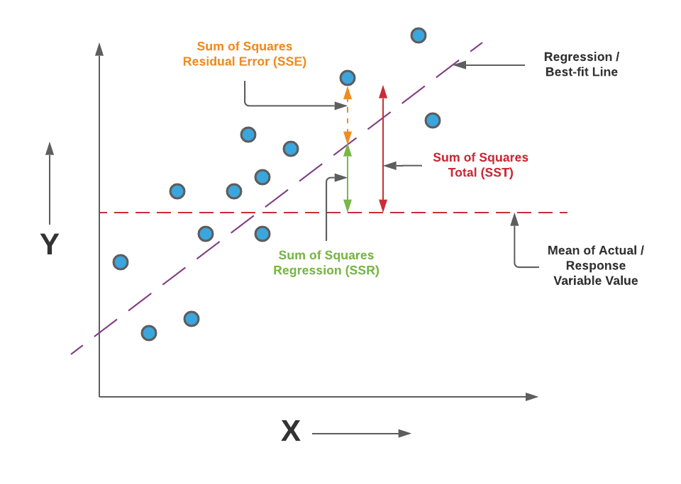

Example:

SSTO : Sum of Squares Total SSR : Sum of Squares due to Regression SSE : Sum of Squares due to Errors Note: Using the R generated ANOVA table, SSE is referred to as the Sum of Squares Residuals

|  |  |  |  |  |  |  |
| --- | --- | --- | --- | --- | --- | --- |
| X | Y | Yi(hat)  Predicted  Value | YI - Yi(hat)  Residuals | (YI - Y(bar))2 | (YI - Y(hat))2 | (Yi(hat) - Y(bar))2 |
| 34 | 5 | 4.1505 | .8496 | 25 | .72165 | 34.21665 |
| 108 | 17 | 14.9693 | 2.0307 | 49 | 4.12374 | 24.69394 |
| 64 | 11 | 8.5365 | 2.4635 | 1 | 6.06883 | 2.14183 |
| 88 | 8 | 12.0453 | -4.0453 | 4 | 16.3644 | 4.18325 |
| 99 | 14 | 13.6535 | .3465 | 16 | .12006 | 13.34906 |
| 51 | 5 | 6.6359 | -1.6359 | 25 | 2.6762 | 11.31717 |
| TOTALS |  |  |  | 120 | 30.07488 | 89.9019 |

Y(bar) = 10

The following Regression Model for the data is found by using R coding: lm(y ~ x)

Y(hat) = -0.8203 + 0.1462X

The following ANOVA table is generated by using R coding: anova(lm(y ~ x)

Analysis of Variance Table

Response: y

Df Sum Sq Mean Sq F value Pr(>F)

x 1 89.925 89.925 11.96 0.02586 *

Residuas 4 30.075 7.519

---

Signif. codes:

0 ‘***’ 0.001 ‘**’ 0.01 ‘*’ 0.05 ‘.’ 0.1 ‘ ’ 1

Now let us conduct the F test to determine if *H*o: *Yi*=*β*o+*ϵi* should be rejected.

If the Fvalue, is greater than the Fcritical, we reject *H*o and conclude *H*a

If the Fvalue, is less than or equal to Fcritical, we fail to reject *H*a

The Fvalue, is found in the ANOVA table.

The Fcritical value if found in the F distribution table, using the construction

F(1 – alpha; 1, n -2) or by using

For our case, Fvalue, is 11.96 (found in the ANOVA output table).

The Fcritical value can be found as follows;

Let alpha = .05, and our designated degrees of freedom are 1 and 4.

We therefore require F(.95,1, 4), now going to the F table in the back of the textbook ;we get 7.71

We can also use R code as follows to get the Fcritical value.

qf(p=.05, df1=1, df2=4, lower.tail=FALSE)

7.708647

Since Fvalue,(11.96) is greater than Fcritical, ,(7.71), we will reject the null

Hypothesis that B1= 0 and conclude that B1 does not = 0. Moreover, a linear

relationship does exist between Y and X.

Graphical Interpretation: F Distribution Curve

If Fvalue is greater than (to the right of Fcritical you are to reject Ho

If Fvalue is less than (to the left)of Fcritical or equal to Fcritical , you fail to reject Ho

