STAT 614 Homework 7 KEY (114 points)

#1)  
  
 #a. Ho: π = 501; Ha: π < 501 4 points  
  
 #b. df = 99; t = -1.379  
  
 # df=n-1; df=100-1; df=99  
  
 # t= (y(bar)-π)/se #se=s/srqt(n)  
 # = (y(bar)-π)/(s/srqt(n))  
 # = (485-501)/(116/sqrt(100)) 8 points (must show all work)  
 # = (-16)/(11.6)  
 # t = -1.379  
  
  
 #c. p value = .0855 4 points  
  
 #d. We fail to reject the null hypothesis becuase the p-value is greater than .05 4 points  
  
#2)   
  
 #2a. 1/4 mile time 4 points

#2b.   
 qqnorm(mtcars$qsec) 4 points

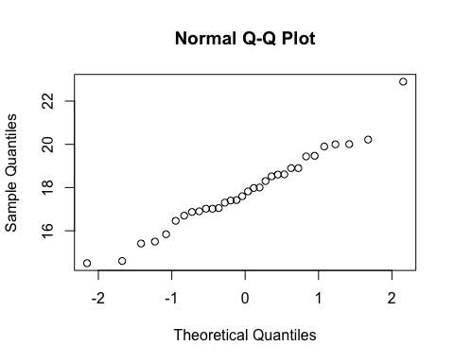

#2c.   
 hist(mtcars$qsec) 4 points

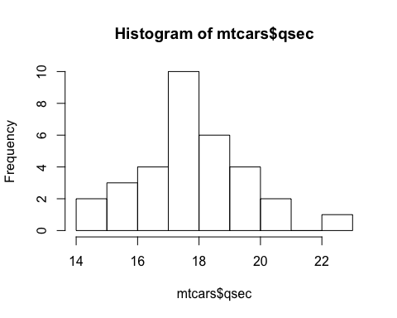

#2d. Both the QQ plot and histogram suggest normality as the qq plot has a fairly stright line and the histogram does not appear skewed left or right.

4 points

#2e.  
 # Ho: π = 16  
 # Ha: π > 16 4 points   
 t.test(mtcars$qsec, mu=16, alternative = "greater", conf.level = .95)

4 points

##   
## One Sample t-test  
##   
## data: mtcars$qsec  
## t = 5.8525, df = 31, p-value = 9.34e-07  
## alternative hypothesis: true mean is greater than 16  
## 95 percent confidence interval:  
## 17.31315 Inf  
## sample estimates:  
## mean of x   
## 17.84875

#t statistic: t = 5.8525, 2 points  
 #p-value: 9.34e-07 2 points  
 #95% confidence interval: LB:17.31315, UB: Infinity 4 points

#We reject the null hypothesis becuase the p value is less than .05. In this case, this means we are more than 95% confident that mean is greater than the null hypothesis. 4 points  
 #We reject the null hypothesis becuasethe it is not within our 95% confidence interval. We can say with 95% confidence that our mean is greater than 17.31315. The null hypothesis is 16, thus we reject it. 4 points

#3.) For a test of Ho : π = 0.45, n = 150, x = 75  
#Use R code for the following.  
  
#3a) Find the p value for Ha : π > 0.45  
prop.test (x = 75, n= 150, p = .45, alternative ="greater", conf.level = .95, correct = FALSE)

##   
## 1-sample proportions test without continuity correction  
##   
## data: 75 out of 150, null probability 0.45  
## X-squared = 1.5152, df = 1, p-value = 0.1092  
## alternative hypothesis: true p is greater than 0.45  
## 95 percent confidence interval:  
## 0.4334467 1.0000000  
## sample estimates:  
## p   
## 0.5

#p-value = 0.1092 4 points  
  
#3b) Find the p value for Ha : π < 0.45  
prop.test (x = 75, n= 150, p = .45, alternative ="less", conf.level = .95, correct = FALSE)

##   
## 1-sample proportions test without continuity correction  
##   
## data: 75 out of 150, null probability 0.45  
## X-squared = 1.5152, df = 1, p-value = 0.8908  
## alternative hypothesis: true p is less than 0.45  
## 95 percent confidence interval:  
## 0.0000000 0.5665533  
## sample estimates:  
## p   
## 0.5

#p-value = 0.8908 4 points  
  
#3c) Find the p value for Ha : π ≠ 0.45  
prop.test (x = 75, n= 150, p = .45, alternative ="two.sided", conf.level = .95, correct = FALSE)

##   
## 1-sample proportions test without continuity correction  
##   
## data: 75 out of 150, null probability 0.45  
## X-squared = 1.5152, df = 1, p-value = 0.2184  
## alternative hypothesis: true p is not equal to 0.45  
## 95 percent confidence interval:  
## 0.4209901 0.5790099  
## sample estimates:  
## p   
## 0.5

#p-value = 0.2184 4 points  
  
#3d) Do any of the p values in a, b, or c give strong evidence against the null hypothesis Ho?  
#Non of these give us strong evidence against the null hypothesis. In each cases we fail to reject the null hypothesis becuase the p-value is greater than .05.   
#Case 'a' has the lowest p-vaue, and would be the strongest case against the null hypothesis out of the three.  
   
  
  
#4.)   
  
# 4) State the appropriate null and alternative hypotheses  
#Hnull = percentage = .65  
#Halternative = percentage > .65 4 points

#• Use R code to execute the proportion test  
prop.test (x = 297, n= 480, p = .65, alternative ="greater", conf.level = .95, correct = FALSE) 4 points  
  
## 1-sample proportions test without continuity correction  
##   
## data: 297 out of 480, null probability 0.65  
## X-squared = 2.0604, df = 1, p-value = 0.9244  
## alternative hypothesis: true p is greater than 0.65  
## 95 percent confidence interval:  
## 0.5817162 1.0000000  
## sample estimates:  
## p   
## 0.61875  
#• Identify the p value, the 95% confidence interval, and the z statistic.  
 p=0.92, 2 points conf interval=(0.58,1.0), 2 points z= sqrt(2.0604) 2 points  
#• Should your null hypothesis be rejected? Why or Why not.

#It should not be rejected because the p value is greater than 0.05 and because the null falls within the confidence interval. 4 points

#5.)  
  
#a.) Test whether the mean income of graduate employees differs from $2000 per month.   
#Include assumptions hypotheses, test statistic, and the p value. Interpret the result.  
  
 #Ho: π = 2000; Ha: π ≠ 2000 4 points  
  
 # t = (y(bar)-π)/(s/sqrt(n)) = (1500-2000)/(100/sqrt(10)) = (-500)/(31.6227766)= -15.8113883 8 points (must show all work)  
  
 #t statistic = -15.8113883  
 #p value = 0.00000007 4 points  
  
 # The p-value is very small and thus we will reject the null hypothesis. There is a very low probability that we will get the sample mean of $1500, or a value close to it from a population whose true mean is $2000. 4 points  
  
  
#b.) Report the p value for Ha: µ < 2000. Interpret  
  
 #p value = 0.00000003  
 #We again reject the null hypothesis, beacuse p-value is very small. 4 points  
  
  
#c.) Report and interpret the p value for Ha: µ > 2000  
 #p value = 0.99999997  
 #We fail to reject the null hypothesis becasue the p-value is very large, meaning the probability is high and we do not have enough evidence to reject the null hypothesis. 4 points