**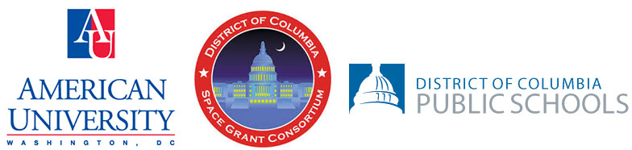  
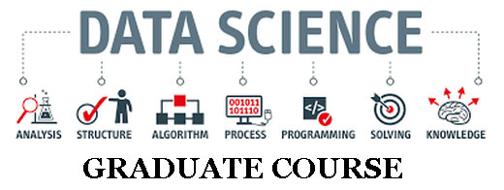**

**DEADLINE TO APPLY: August 16, 2021**

The NASA DC Space Grant Consortium and American University (Washington DC) in partnership with the District of Columbia Public Schools is very pleased to announce an online graduate course in the field of Data Science at no charge for graduate credit in the upcoming Fall 2021 semester.  The primary goal of this initiative is to equip teachers with skills and experiences needed to provide impactful learning opportunities for students of the DCPS system. Data Science is a growing field that merges elements of Statistics, Mathematics, and Computer Science. It is an academic discipline that is growing substantially in higher education and the world of work.  
  
In particular, the graduate course of interest is STAT 612 STATISTICAL PROGRAMMING IN R.  This particular Data Science graduate course features training in the programming language R. You will be taught how to use this programming language to process, manipulate, and graphically display quantitative and categorical data.  Specific learning objectives of the course are given below. **Learning Objectives;  
•** Reproducible research using R  
•    Use R as a powerful calculator  
•    Import data from external sources  
•    Perform analyses including hypothesis testing and regression  
•    Write basic R programs using control and data structures  
•    Install and use packages for specific applications  
•    Use graphical tools to visualize and understand dataPrior training in computer programming is beneficial, but not a requirement. Most of our graduate students succeed at a high level in the course with no previous exposure to the R programming language.  Many of the Data science classes (specifically STAT 612) are offered conveniently in the evening,  so that teachers can matriculate after the typical school day has ended.  
  
This is a special opportunity to take a graduate course for personal growth and for the purpose of ultimately delivering a Data Science foundation for DCPS students.  Additionally, there is the possibility to take follow up courses and supplemental training (at no cost) in Data Science for selected teachers. **Important Calendar Dates**•    Friday 8/27/2021  Last Day to register for Fall semester (without a late fee)  
•    Monday 8/30/2021  Classes begin  
•    Monday 8/30/2021  Late registration begins  
•    Friday 9/3/2021  Late registration ends  
  
 **IMPORTANT COURSE SCHEDULING INFORMATION**The time slots for the three STAT 612 R Programming courses (dates: 8/30/2021 – 12/18/2021):  
•         Monday - 5:30pm - 8:00pm         section 3    Dickens  
•         Tuesday - 5:30pm - 8:00pm         section 4    Mehta  
•         Wednesday - 5:30pm - 8:00pm    section 5   Ressle  
•         Thursday – 5:30pm – 8:00pm      section 6   Dickens  
•         Asynchronous Online Only          section 7   Barratt **KEY CONTACTS   
  
Dr. Nathan Harshman Director, NASA DC Space Grant Consortium**[**harshman@american.edu**](mailto:harshman@american.edu)

**Eric Day  Program Manager, NASA DC Space Grant Consortium**[**eday@american.edu**](mailto:eday@american.edu) **Dr. Jeff Gill  American University**[**jgill@american.edu**](mailto:jgill@american.edu)

**Dr. Betty Malloy  American University**[**malloy@american.edu**](mailto:malloy@american.edu)

**Dr. James Dickens   American University**[**jdickens@american.edu**](mailto:jdickens@american.edu)**Gabriel Cartagena  Director, Secondary Mathematics DC Public Schools**[**gabriel.cartagena@k12.dc.gov**](mailto:gabriel.cartagena@k12.dc.gov) **ONLINE APPLICATION - Deadline to Apply is: August 16, 2021**[**https://www.formdesk.com/DCSpaceGrant/datascience**](https://www.formdesk.com/DCSpaceGrant/datascience)