BASH

B.

1. From which ip were the most requests?
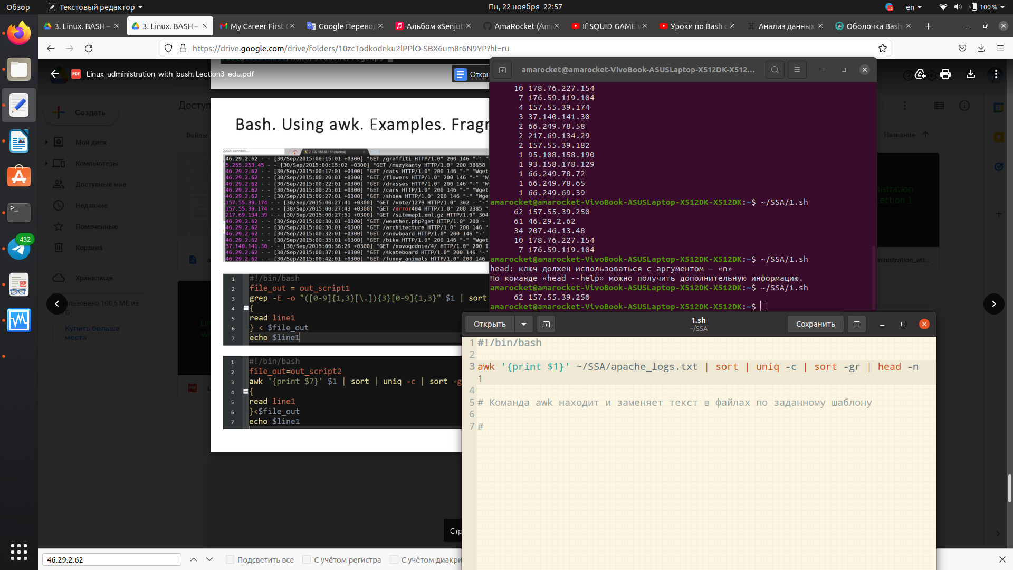

2. What is the most requested page?

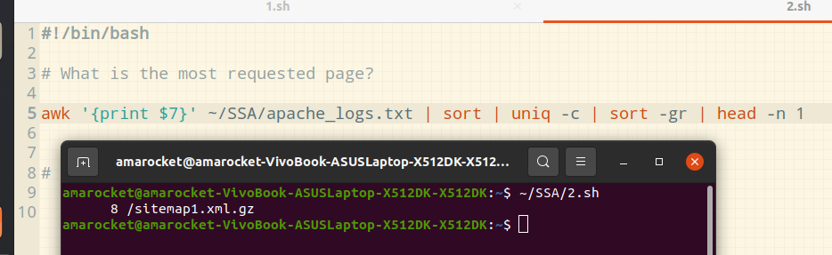

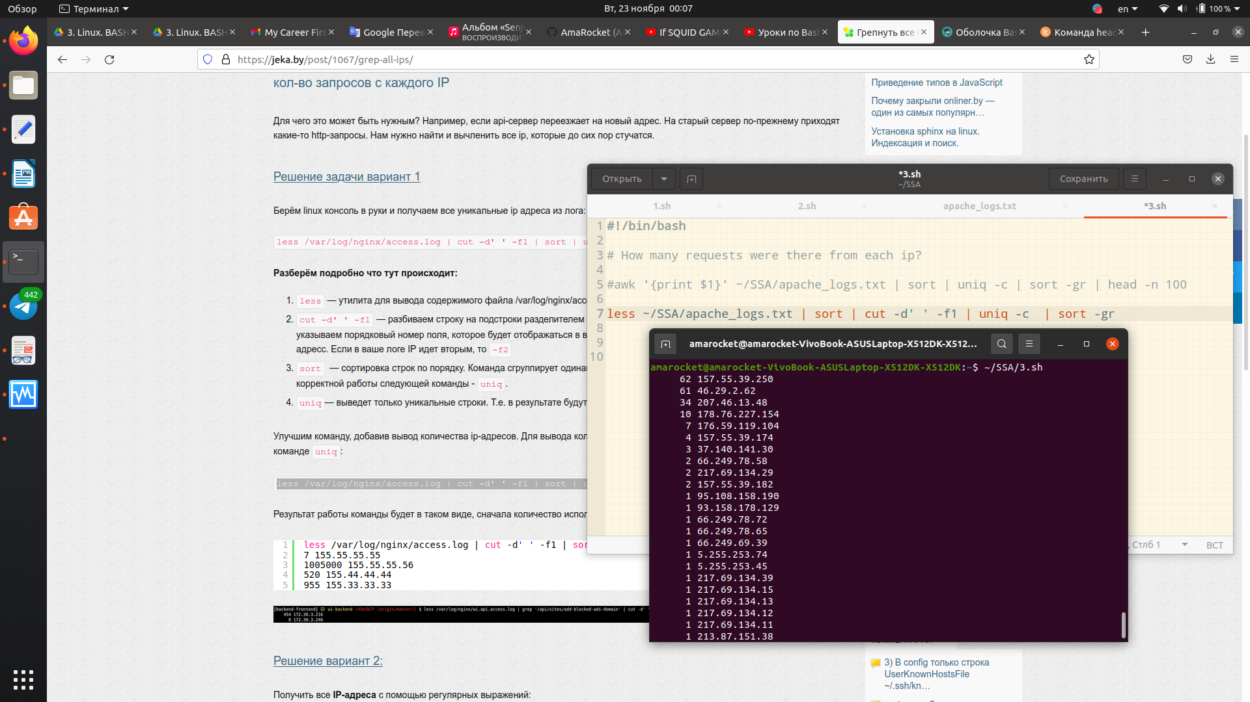
3. How many requests were there from each ip?

4. What non-existent pages were clients referred to?
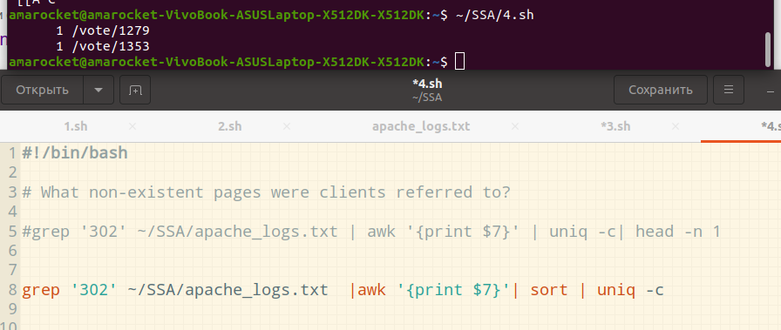
5. What time did site get the most requests?
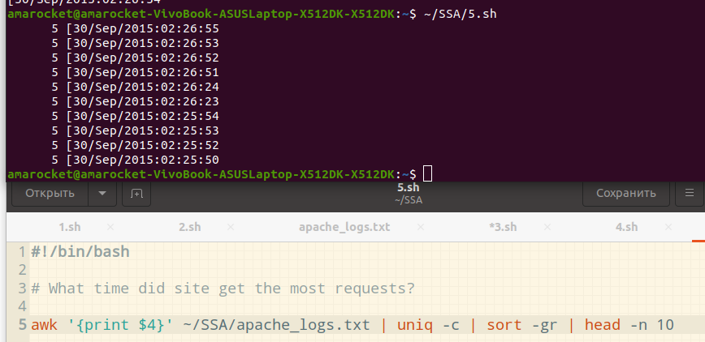
TOP 10 — time when site get most requests

6. What search bots have accessed the site? (UA + IP)
