Task1.Part1

1) Log in to the system as root

$ sudo - i

Check: $ whoami
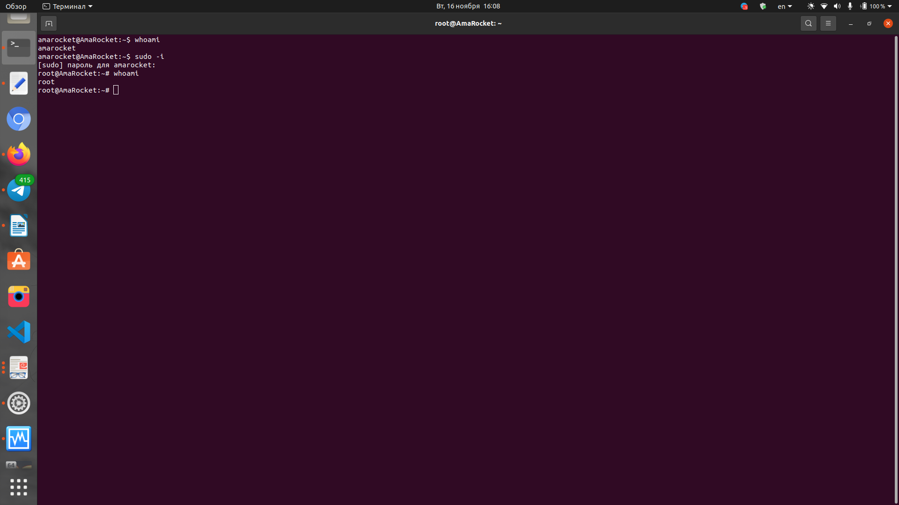

2) Use the passwd command to change the password. Examine the basic
parameters of the command. What system file does it change *?

$ passwd

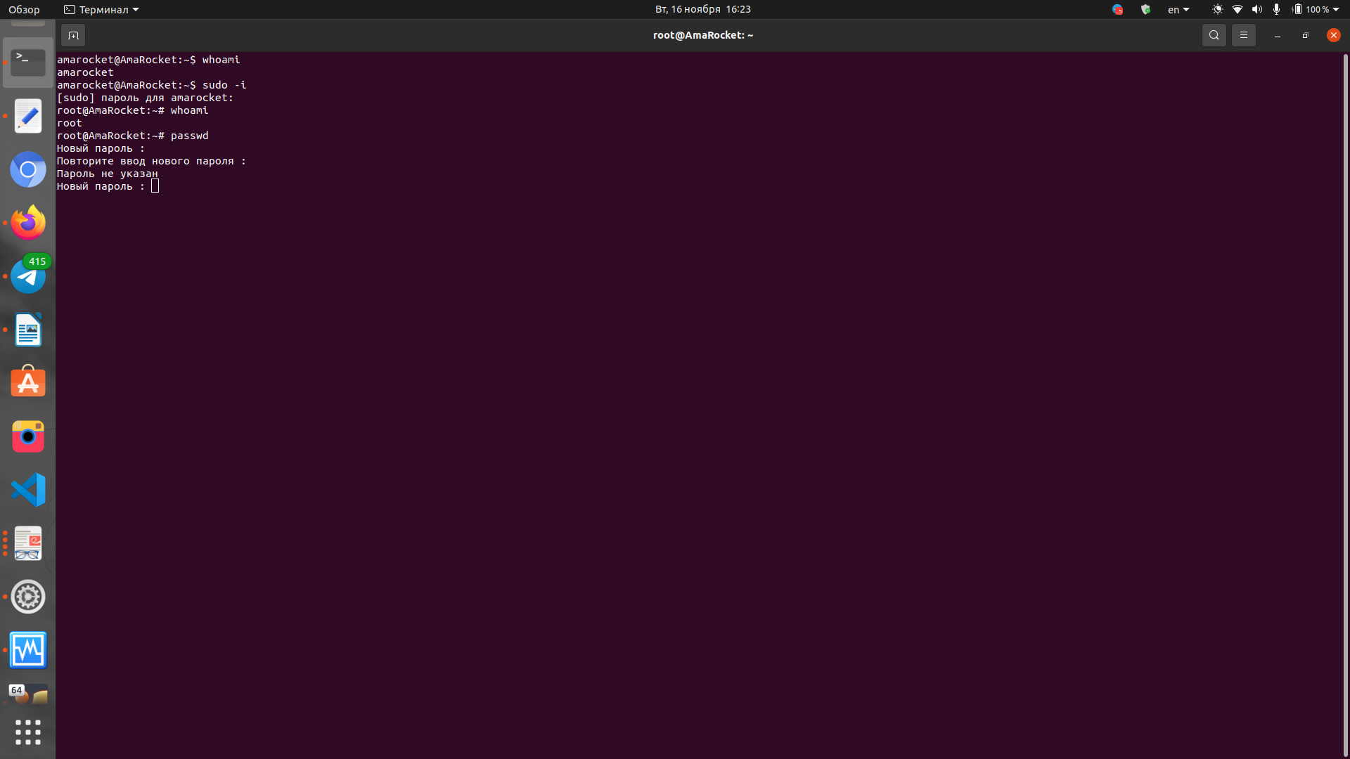

passwd [-k] [-l] [-u [-f]] [-d] [-S] [username]
The meaning of the command options :
-k - Used to update only those passwords that have expired.
-l - blocks the specified user (available only to the administrator). Blocking is performed by adding the !
Prefix to the password.
stdin - accept new password from standard input.
-u - unblock user and remove prefix! (available only to the administrator).
-d - cancel the password for the user (available only to the administrator). Allows the user to log in without
a password and change it themselves.
-n - sets the minimum period in days before changing the password (available only to the administrator).
-x - sets the maximum period in days before changing the password (available only to the administrator).
-w - sets the period in days when the user starts receiving messages about the need to change the
password (available only to the administrator).
-i - sets the period in days until the old password is no longer active and the registration record is blocked
(available only to the administrator).
-S - displays short information about the state of the password (about its validity period). Available only to
the administrator.

Change sys files as:

/etc/passwd - info about users

/etc/shadow - contain protected info about users

/etc/pam.d/passwd - PAM configuration foe passwd

3) Determine the users registered in the system, as well as what commands they
execute. What additional information can be gleaned from the command
execution?

$ cat/etc/passwd
or
$sed's/:.*//'/etc/passwd

and active users in system :
$ w
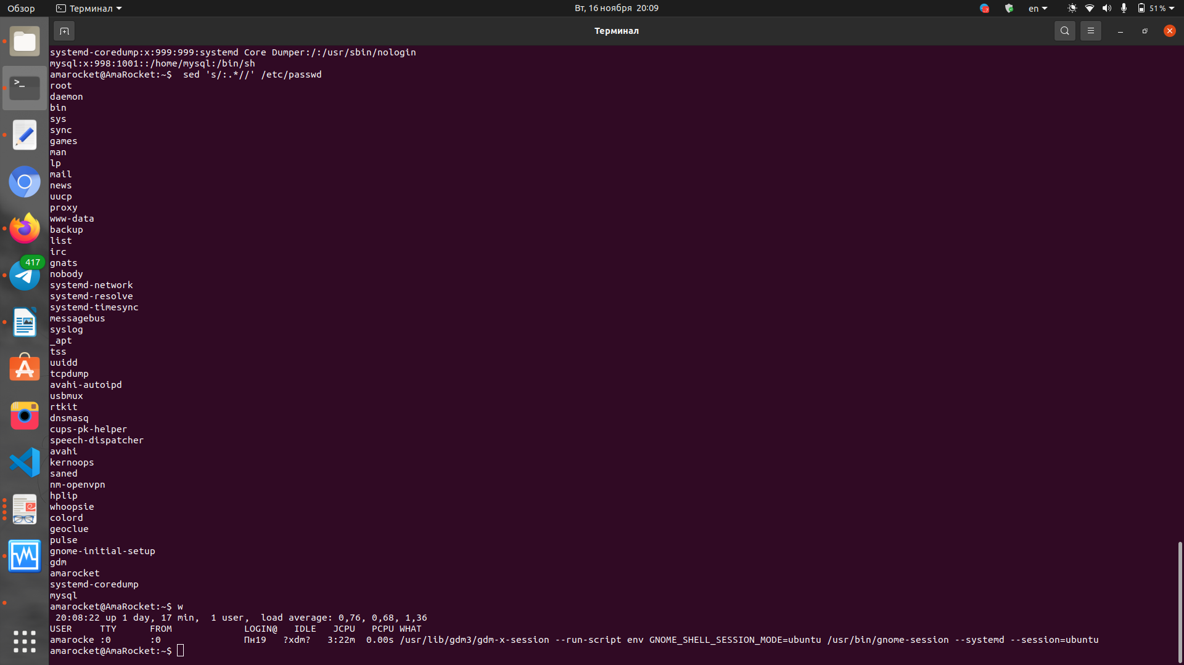
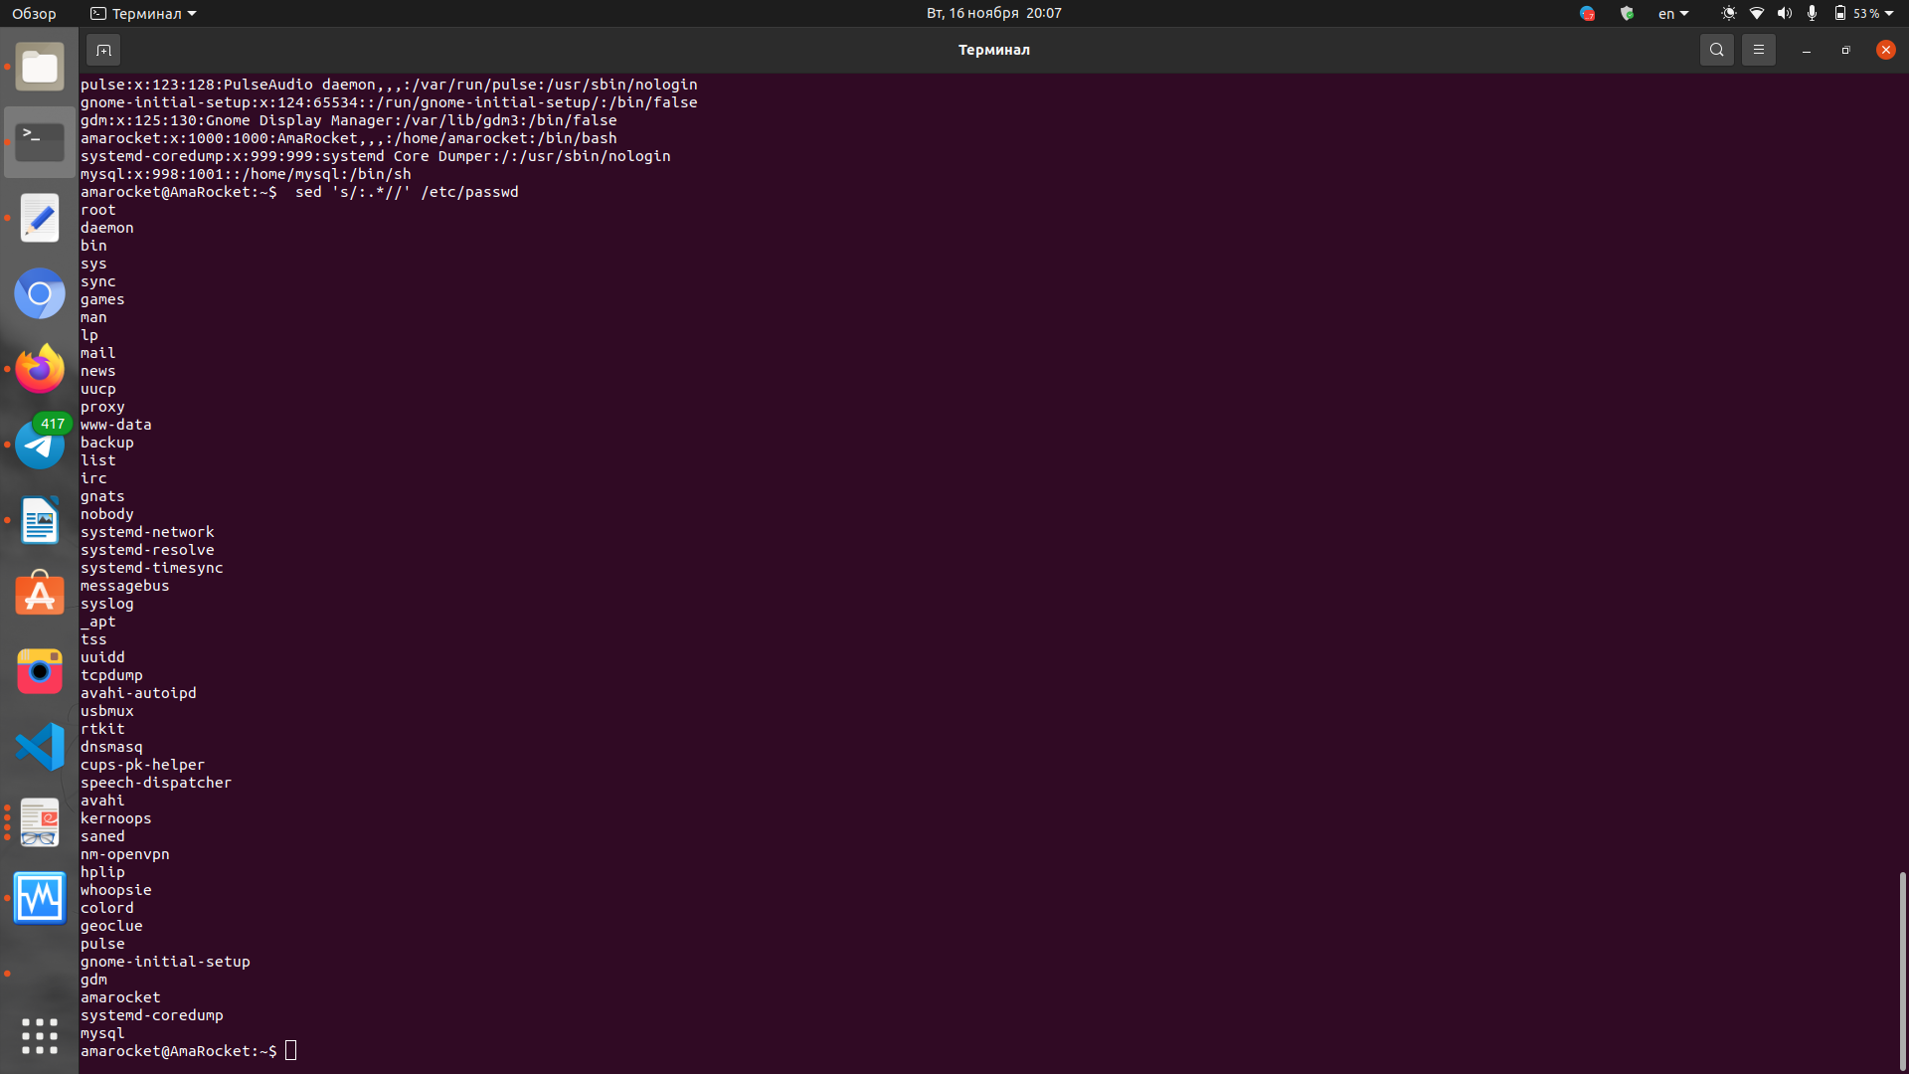
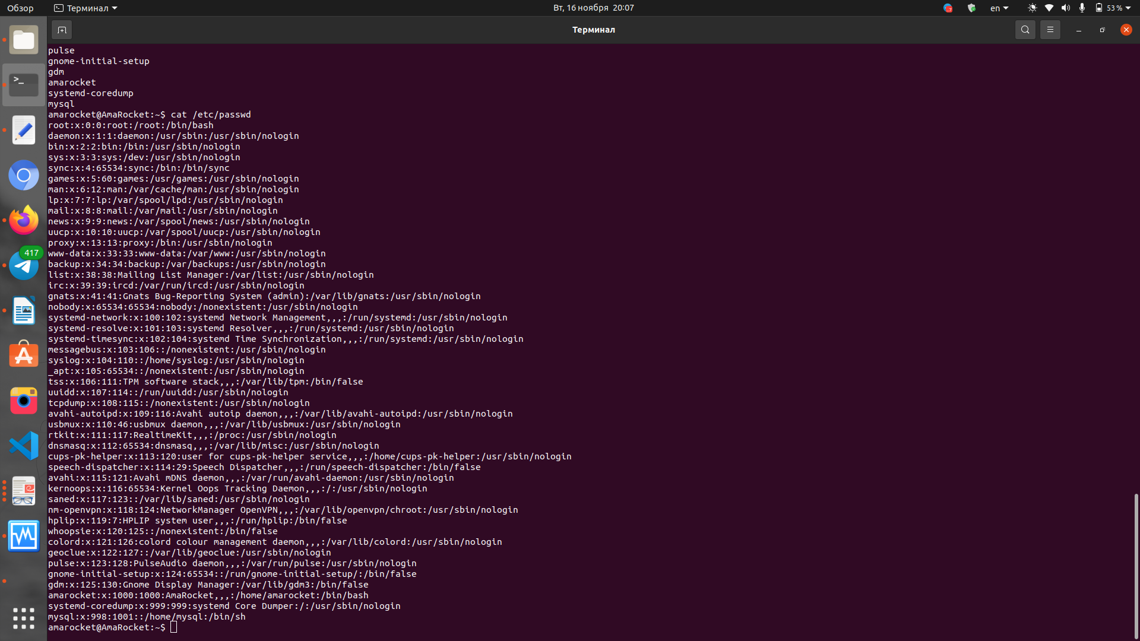

4) Change personal information about yourself.

$ chfn <USERNAME>
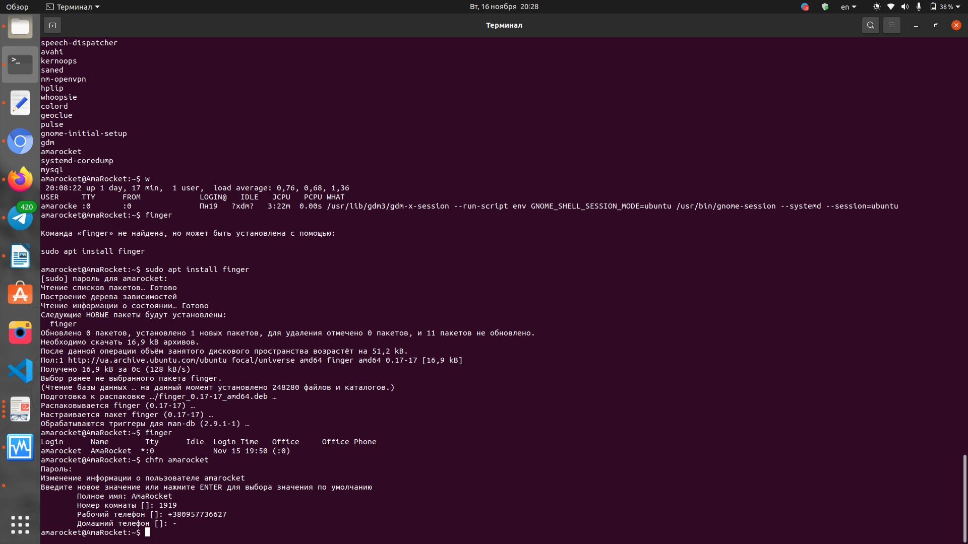

5) Become familiar with the Linux help system and the man and info commands.
Get help on the previously discussed commands, define and describe any two
keys for these commands. Give examples.

Use command $ man <command> and $ info <command>

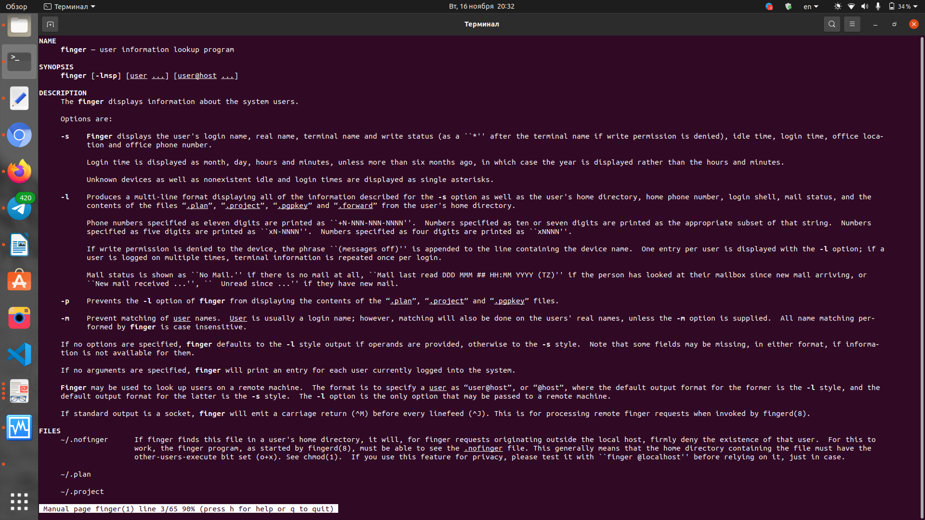

6) Explore the more and less commands using the help system. View the contents
of files .bash* using commands.

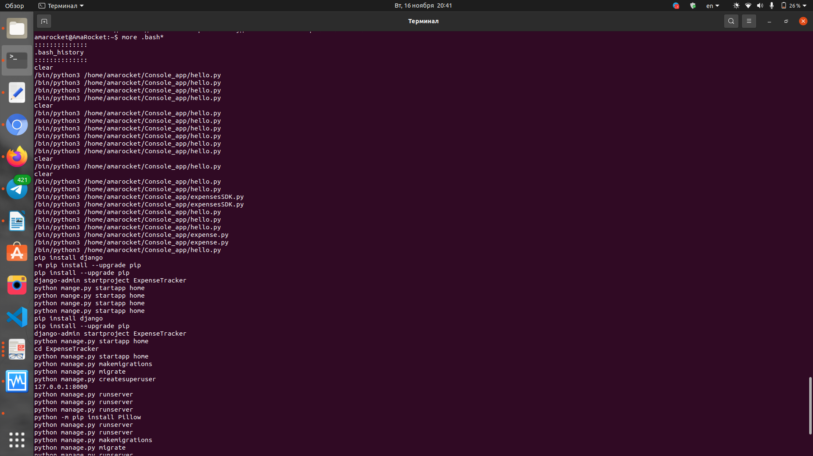

7) * Describe in plans that you are working on laboratory work 1. Tip: You should
read the documentation for the finger command.

$ touch .plan
$ echo „I work on Lab 1“ > .plan
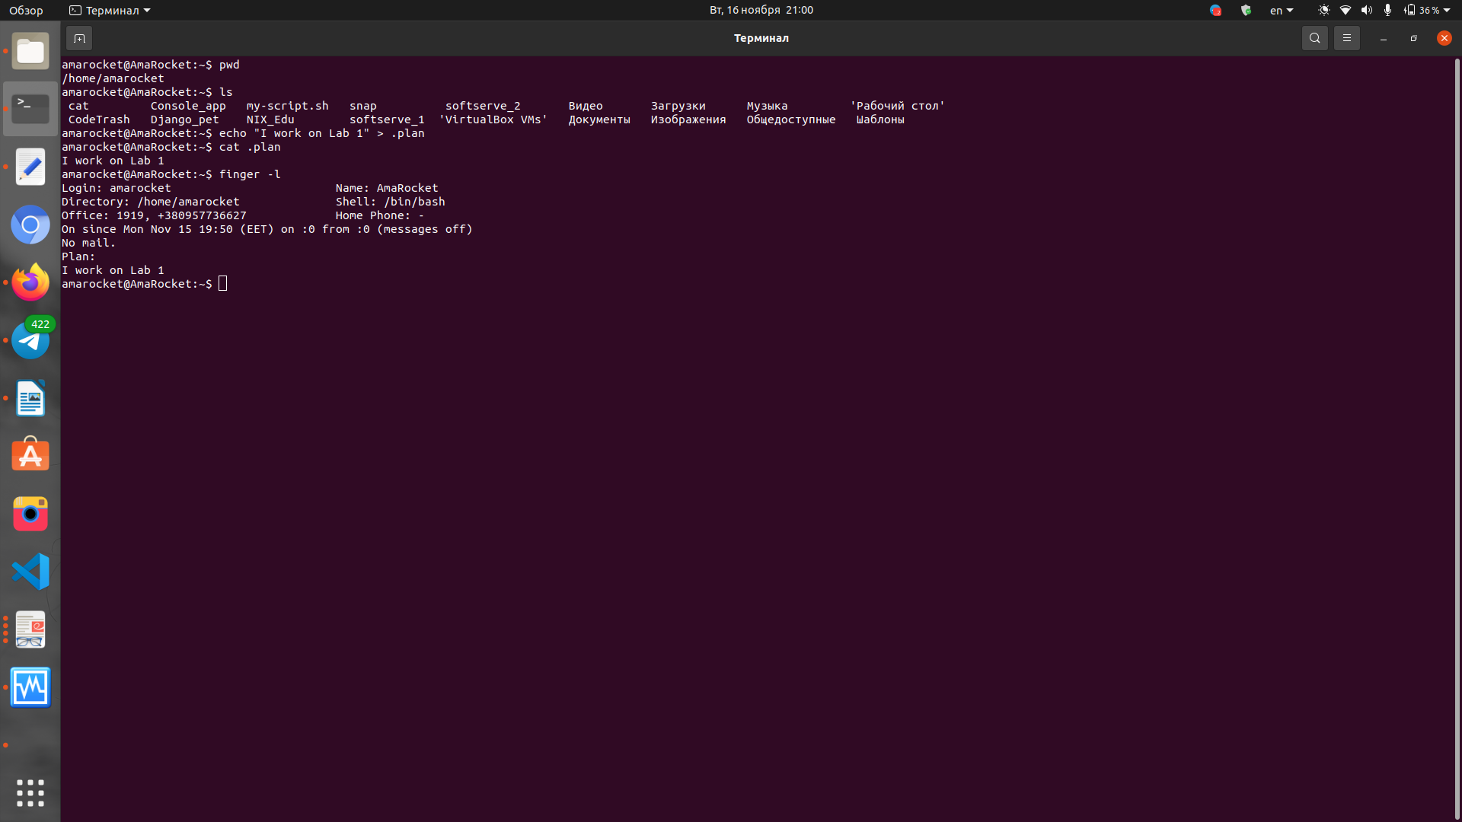
$ finger -l # check

8) * List the contents of the home directory using the ls command, define its files
and directories. Hint: Use the help system to familiarize yourself with the ls
command.

$ pwd
$ ls -la
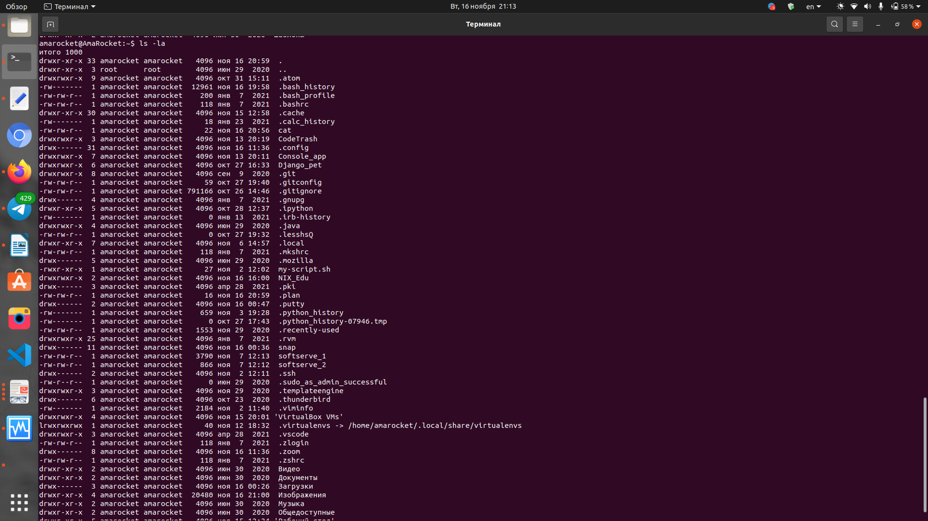

Task1.Part2

1) Examine the tree command. Master the technique of applying a template, for
example, display all files that contain a character c, or files that contain a
specific sequence of characters. List subdirectories of the root directory up to
and including the second nesting level.

$ tree -L 2
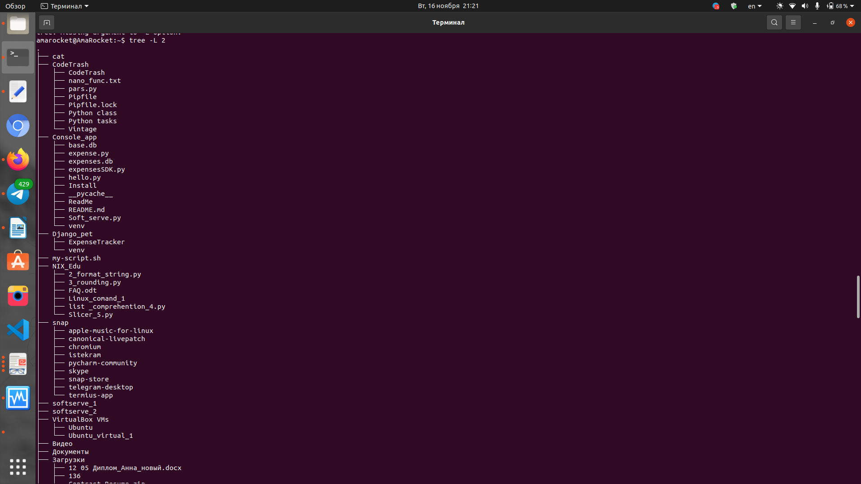

2) What command can be used to determine the type of file (for example, text or
binary)? Give an example.

$ file <name-file>
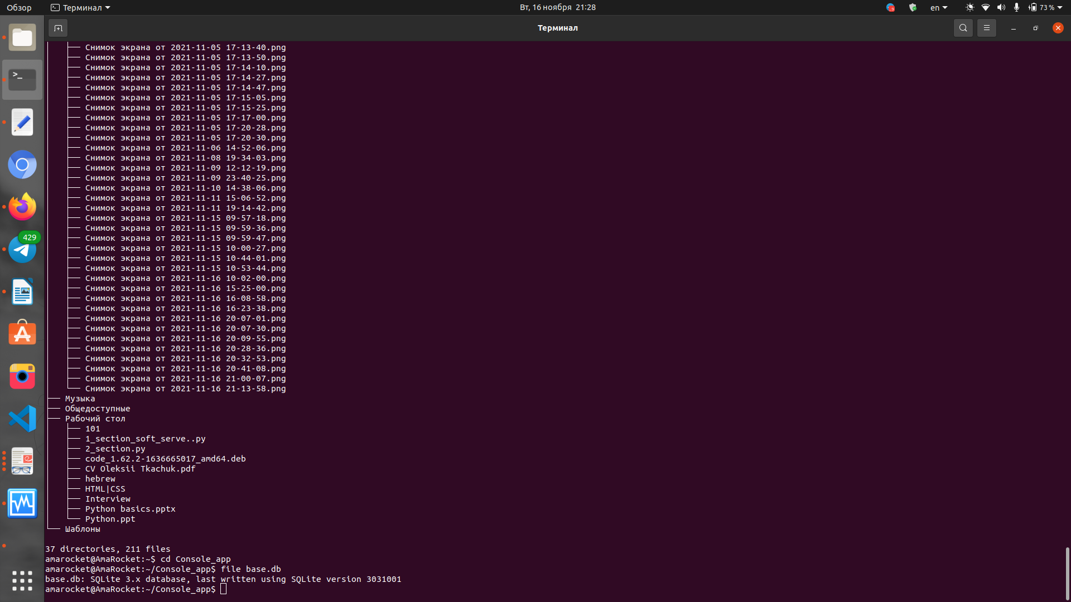

3) Master the skills of navigating the file system using relative and absolute paths.
How can you go back to your home directory from anywhere in the filesystem?

$ cd <way/to/directory>
$ ~/ <name_of_file>
$ cd

4) Become familiar with the various options for the ls command. Give examples
of listing directories using different keys. Explain the information displayed on
the terminal using the -l and -a switches.

$ ls - show files in directory
$ ls -a - show all files (with hiden) in directory
$ ls -l - show detailing list (user, group, date, size, funcs (rwr) etc)

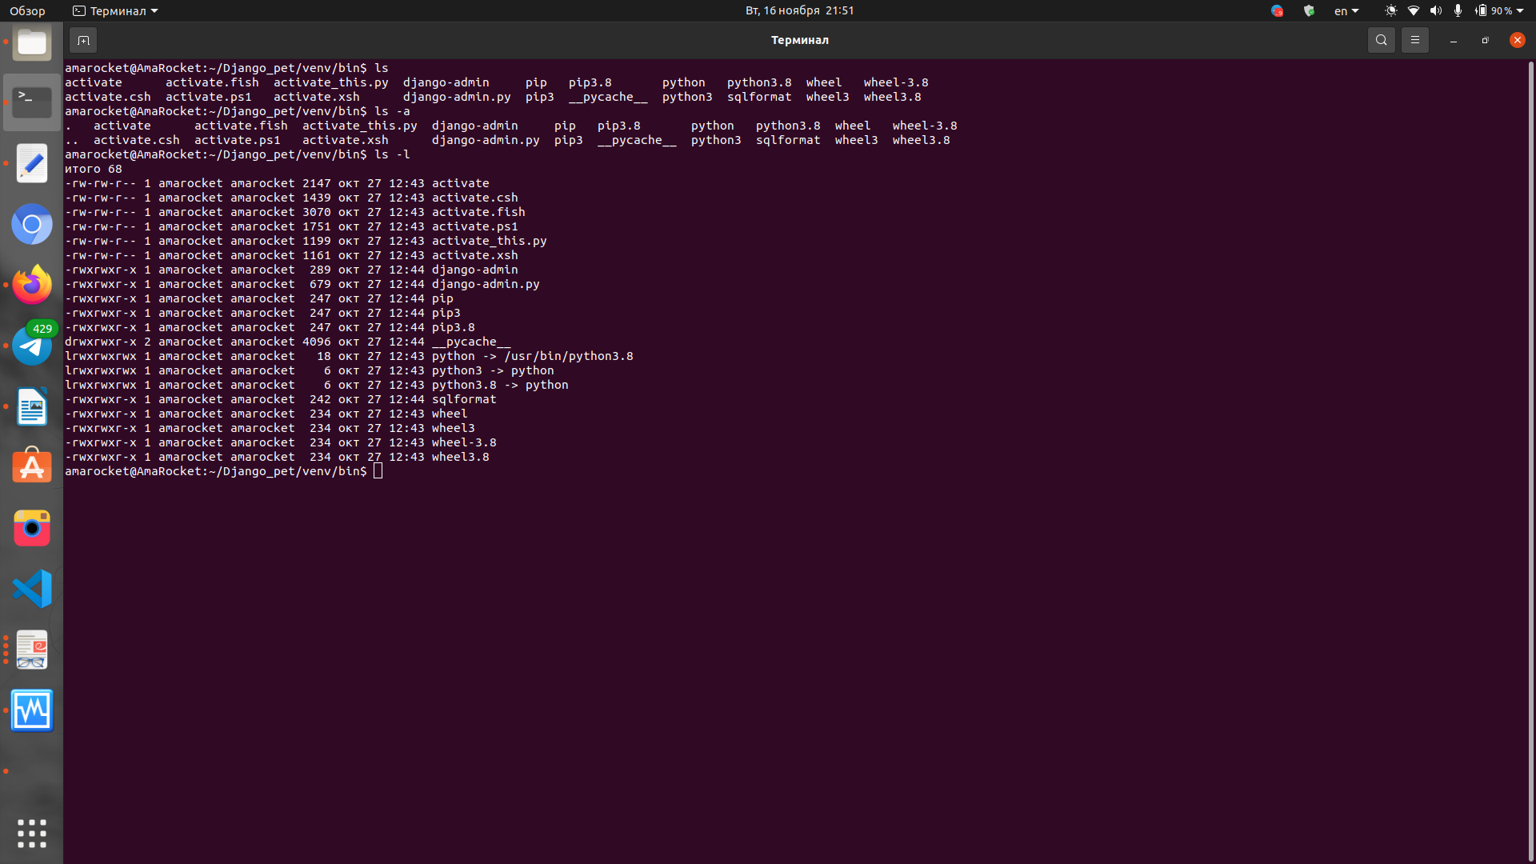

5) Perform the following sequence of operations:
- create a subdirectory in the home directory;
- in this subdirectory create a file containing information about directories
located in the root directory (using I/O redirection operations);
- view the created file;
- copy the created file to your home directory using relative and absolute
addressing.
- delete the previously created subdirectory with the file requesting removal;
- delete the file copied to the home directory.

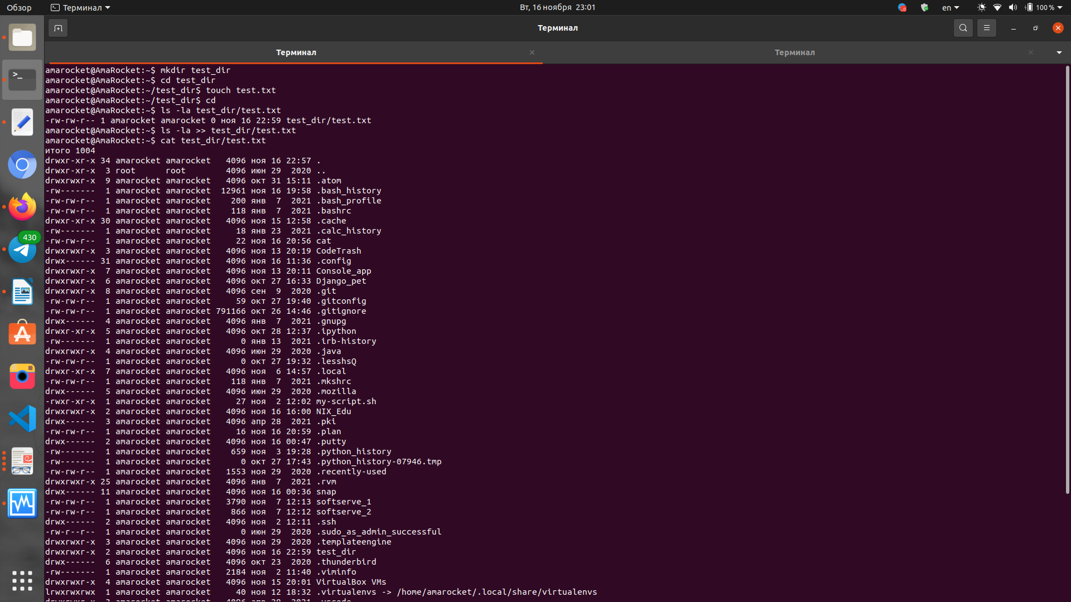
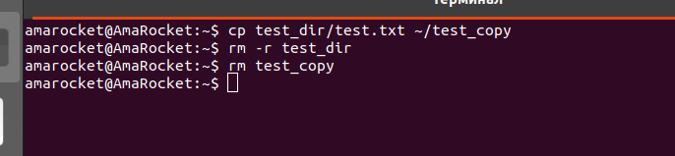

6) Perform the following sequence of operations:
- create a subdirectory test in the home directory;- copy the .bash_history file to this directory while changing its name to
labwork2;
- create a hard and soft link to the labwork2 file in the test subdirectory;
- how to define soft and hard link, what do these
concepts;
- change the data by opening a symbolic link. What changes will happen and
why
- rename the hard link file to hard_lnk_labwork2;
- rename the soft link file to symb_lnk_labwork2 file;
- then delete the labwork2. What changes have occurred and why?
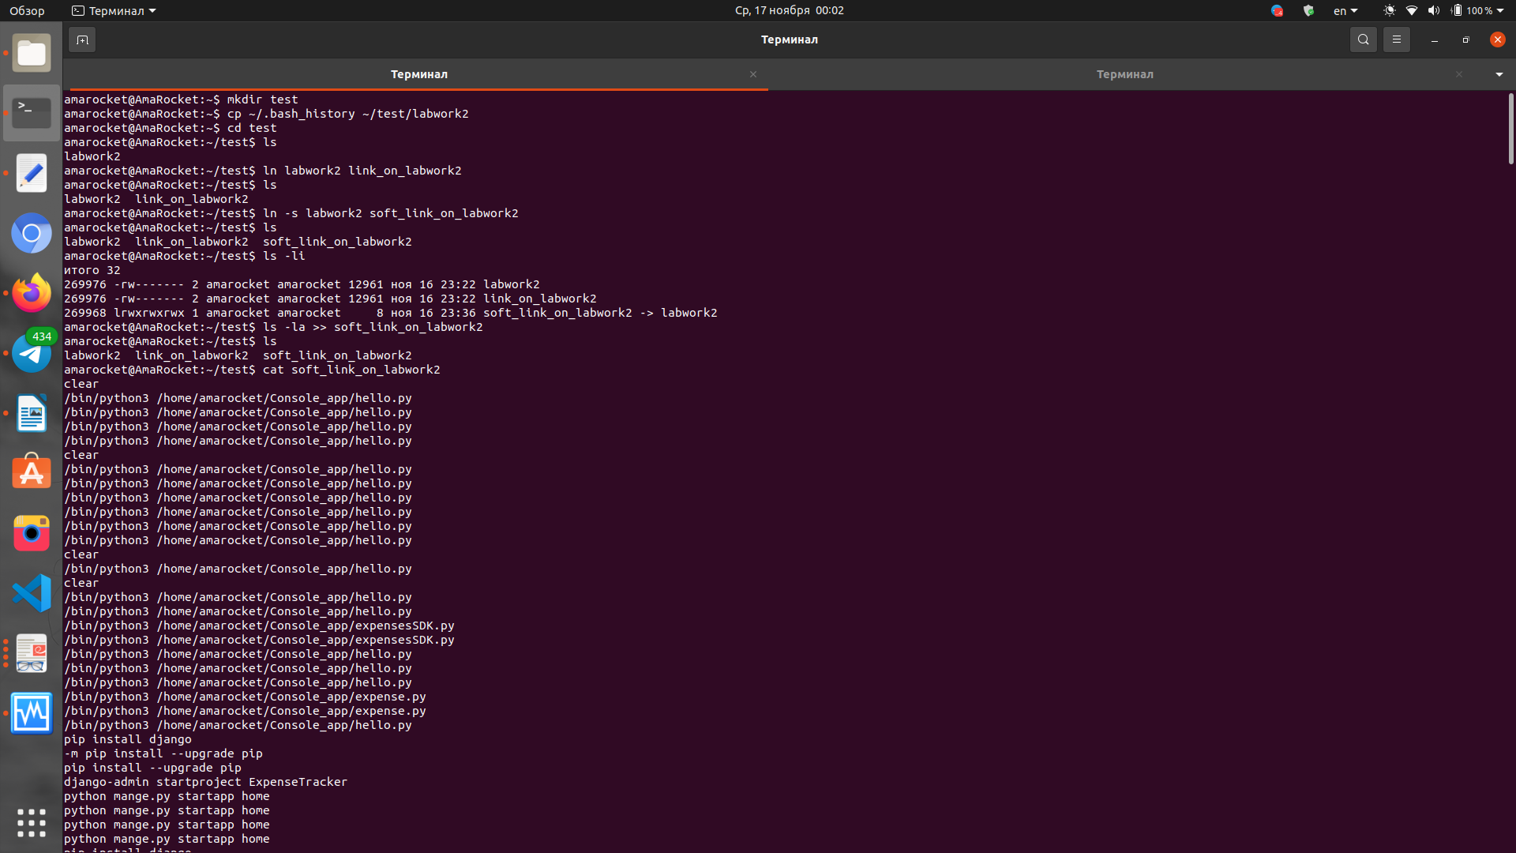
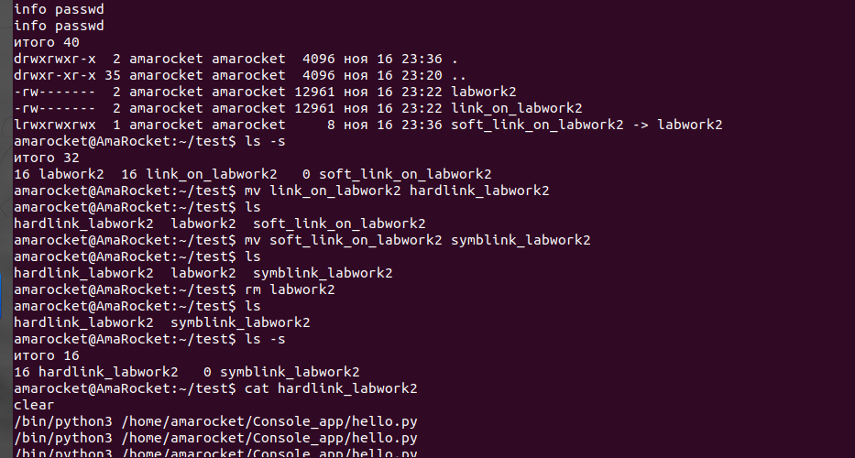
7) Using the locate utility, find all files that contain the squid and traceroute
sequence.
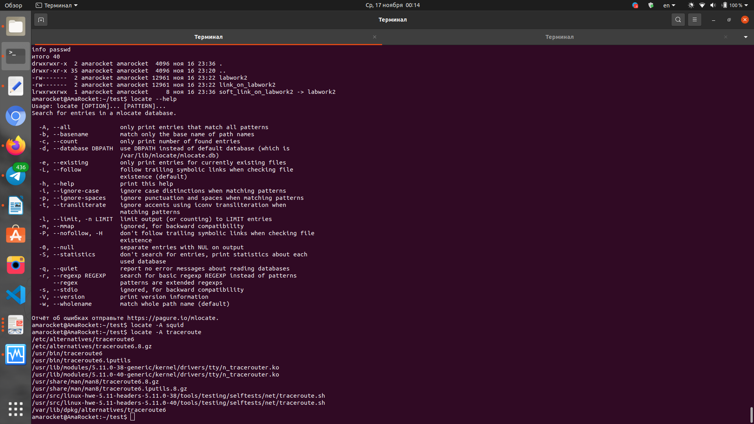

Or:
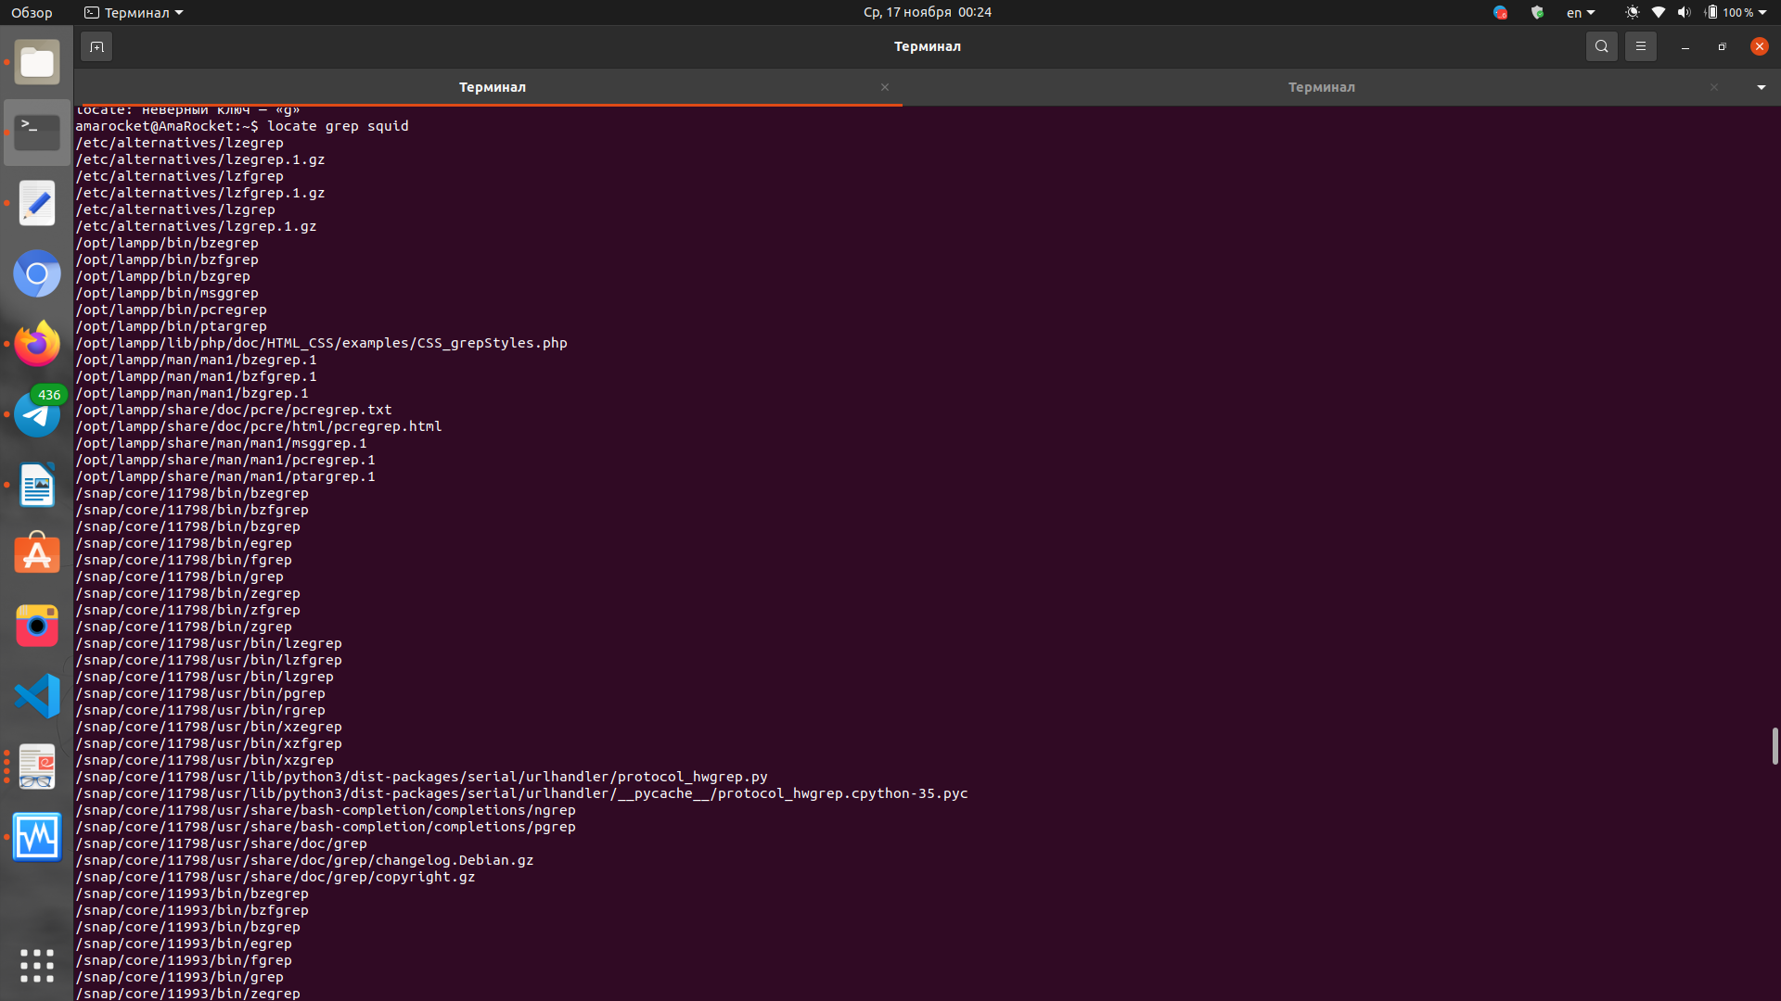

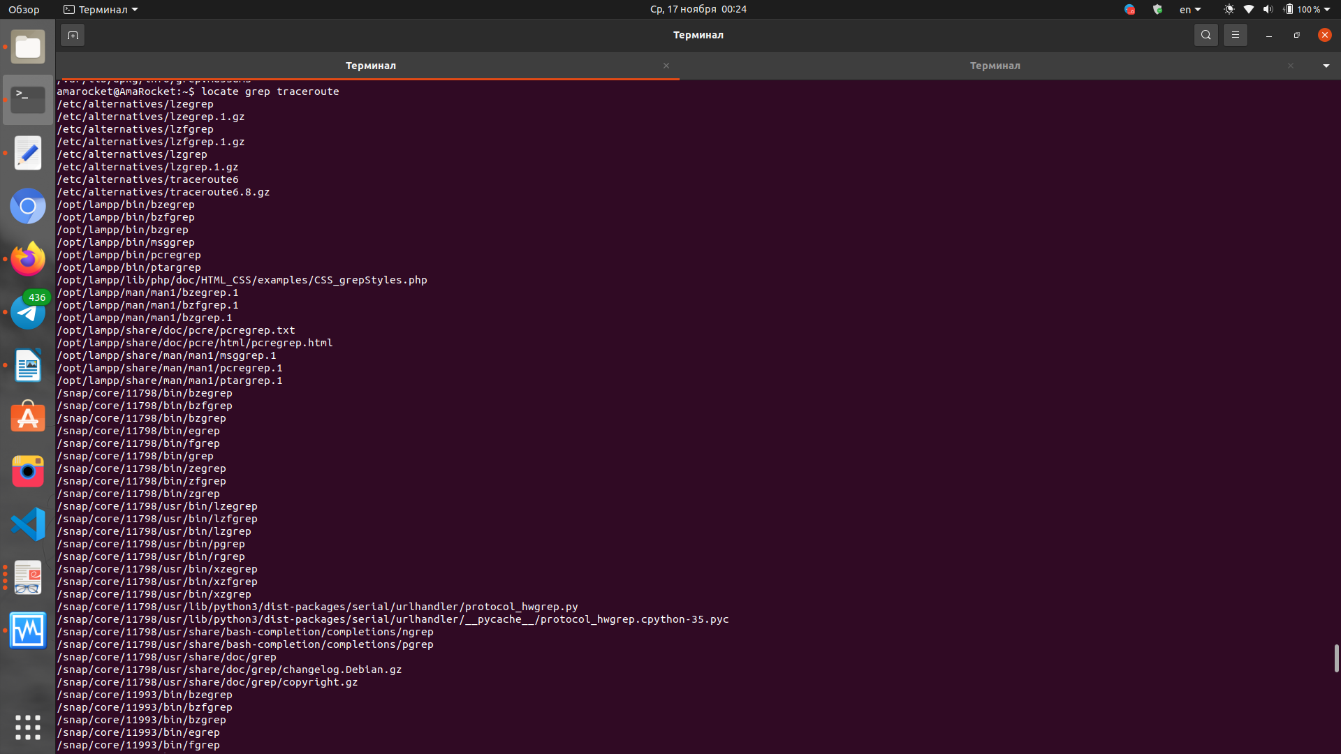

8) Determine which partitions are mounted in the system, as well as the types of
these partitions.

# mount -a

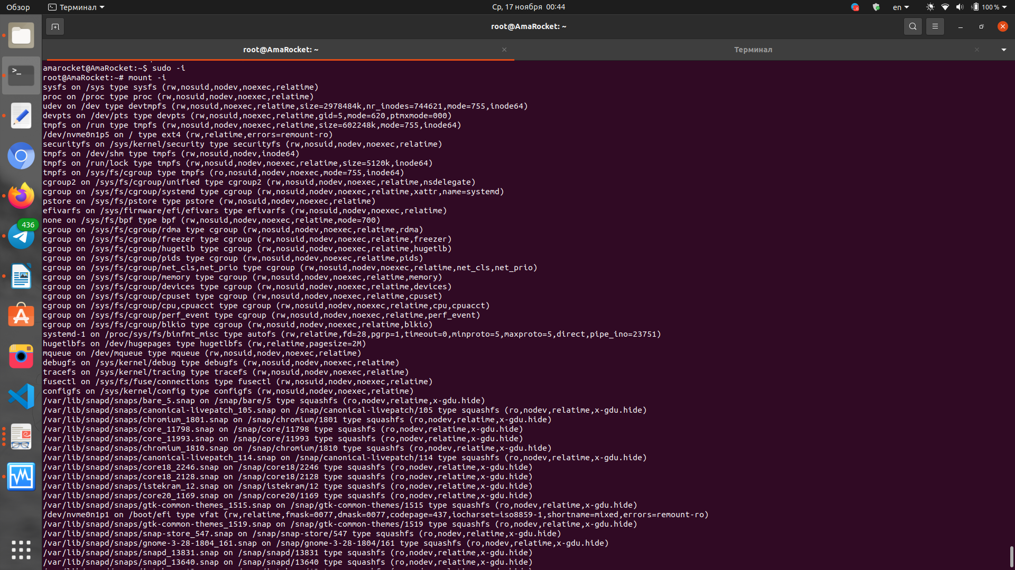

9) Count the number of lines containing a given sequence of characters in a given file.

$ grep <pattern> <way/to/file> -c

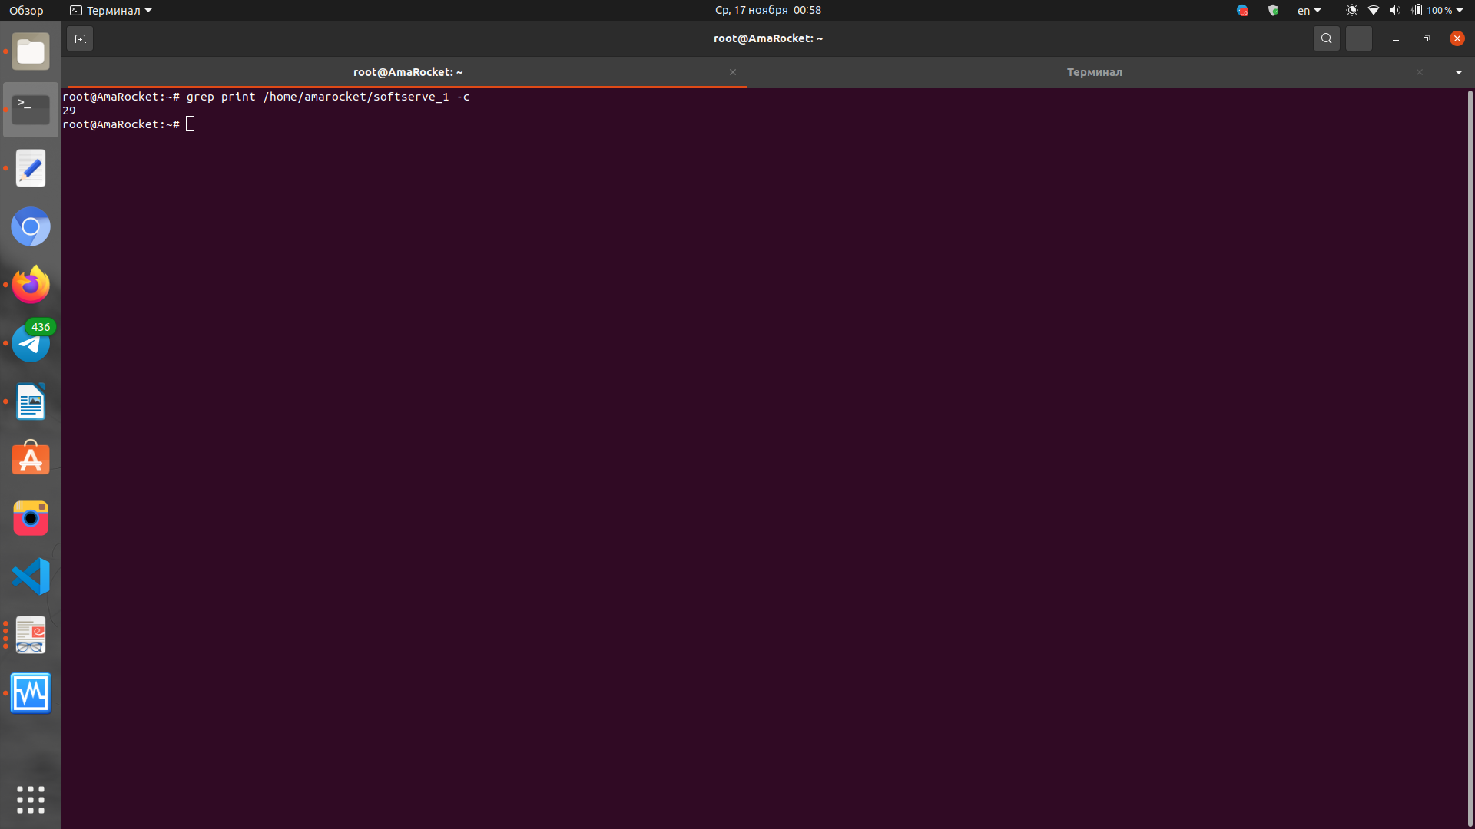

10) Using the find command, find all files in the /etc directory containing the
host character sequence.

$ find /etc -name „*host“

11) List all objects in /etc that contain the ss character sequence. How can I
duplicate a similar command using a bunch of grep?

$ find /etc -name „*ss“ or grep -w «seach» /way/to/file

12) Organize a screen-by-screen print of the contents of the /etc directory. Hint:
You must use stream redirection operations.

dir /etc > test

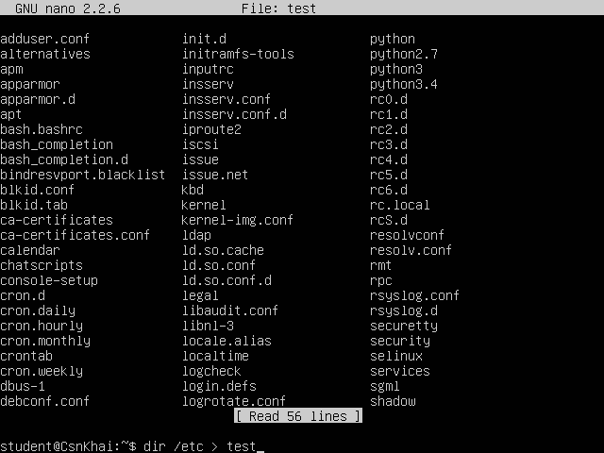

13) What are the types of devices and how to determine the type of device? Give
examples.

В системе UNIX, а следовательно и Linux, существует два типа устройств: блочные устройства с прямым доступом (такие как диски) и символьные устройства (такие как ленточные накопители и последовательные порты), некоторые из них могут быть последовательными, а некоторые - с прямым доступом. Каждое поддерживаемое устройство представляется в файловой системе файлом устройства. При выполнении операций чтения или записи с подобным файлом, происходит обмен данными между устройством, на которое указывает этот файл. Такой способ доступа к устройствам позволяет не использовать специальные программы (а также специальные методы програмирования, такие как работа с прерываниями).
Однако, для распечатки файлов используется специальная программа (обычно lpr(1)), которая контролирует поток поступающих файлов во избежание возникновения конфликтных ситуаций, например, при попытке распечатать на одном принтере одновpеменно несколько разных файлов. По мере распечатки, новые файлы поступают автоматически. По подобной схеме работает большинство устройств. Однако с файлами устройств проблемы возникают очень редко.
Так как устройства отображаются как файлы в файловой системе (в каталоге /dev), несложно обнаружить с помощью команды ls(1) какие существуют файлы устройств. После выполнения команды ls -l на экран выводится список файлов, причем в первой колонке содержится тип файла и права доступа к нему.

14) How to determine the type of file in the system, what types of files are there?

$ ls la

15) * List the first 5 directory files that were recently accessed in the /etc
directory.
$ find /etc -ctime +1 | head -n 5

