**Page – 01**

<!DOCTYPE html>

<html lang="en">

<head>

    <meta charset="UTF-8">

    <meta name="viewport" content="width=device-width, initial-scale=1.0">

    <title>Amali Thathsarani - Portfolio</title>

    <style>

        body {

            font-family: Arial, sans-serif;

            margin: 0;

            padding: 0;

        }

        header, section, footer {

            padding: 20px;

            text-align: center;

        }

        header {

            background-color: #f4f4f4;

        }

        h1, h2 {

            color: #333;

        }

        p {

            color: #555;

        }

        .profile-picture {

            width: 250px;

            height: 250px;

            border-radius: 50%;

            margin-top: 15px;

            object-fit: cover;

            border: 3px solid #333;

            transition: transform 0.3s ease, opacity 0.3s ease;

            cursor:pointer;

        }

        .profile-picture:hover{

            transform: scale(1.05);

            opacity: 0.9;

        }

        .next{

            float:right;

        }

        table{

          width:300px;

      }

      .contact img{

            transition: transform 0.3s ease, opacity 0.3s ease;

            cursor:pointer;

        }

.contact img:hover{

    transform: scale(1.05);

    opacity: 0.9;

}

.container {

            max-width: 800px;

            margin: 20px auto;

            padding: 20px;

            background-color: #fff;

            border-radius: 8px;

            box-shadow: 0 4px 8px rgba(0, 0, 0, 0.1);

        }

       h1, h2{

            color: #0056b3

        }

    </style>

</head>

<body>

    <div class="container">

    <header>

        <h1>W.K Amali Thathsarani</h1>

        <img src="f1.jpg" alt="Profile Picture" class="profile-picture">

        <p>I am a dedicated final-year computer science undergraduate passionate about developing innovative solutions through full-stack development and machine learning. With hands-on experience in React, MongoDB, and Spring Boot, I enjoy creating dynamic web applications that enhance user experiences. In addition to my technical skills, I’m enthusiastic about AI and exploring its applications in content creation. Outside of academics, I love photography, traveling, and engaging in sports like cricket and badminton.</p>

    </header>

    <section>

        <h2>Skills </h2>

        <ul style="list-style-type: none;">

            <li>Full-Stack Development</li>

            <li>Machine Learning</li>

            <li>Git & version Control</li>

            <li>Java, Python</li>

            <li>Responsive Web Design</li>

        </ul>

<hr>

        <h2>Strengths </h2>

        <ul style="list-style-type: none;">

            <li>Problem-Solving</li>

            <li>Attention to Detail</li>

            <li>Adaptability</li>

            <li>Collaboration</li>

            <li>Creativity</li>

        </ul>

    </section>

    <footer>

    <center>

        <div class="contact">

    <table>

        <tr> <b><u>Contact Me On:</u></b></tr>

        <tr>

            <th><a href="Ahttps://www.linkedin.com/in/amali-thathsarani-623bb2334?utm_source=share&utm_campaign=share_via&utm_content=profile&utm_medium=android_app""><img src="lin.JPEG" align="left" height="40px" width="40px"></th>

            <th><a href="Ama Thathsarani"><img src="Gmail.JPEG" align="left" height="40px" width="40px"></th>

            <th><a href="Ama Thathsarani"><img src="pho.JPEG" align="left" height="40px" width="40px"></th>

            <th><a href="Ama Thathsarani"> <img src="fab.JPEG" align="left" height="40px" width="40px"></th>

        </tr>

    </table>

</div>

</center>

<div class="next">

<a href ="SecondPage.html" ><img src="nex.JPEG" height="70px" width="200px"> </a>

</div>

    </footer>

    </div>

</body>

</html>

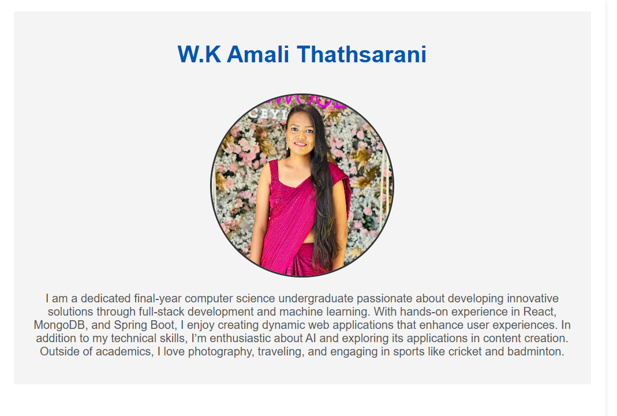

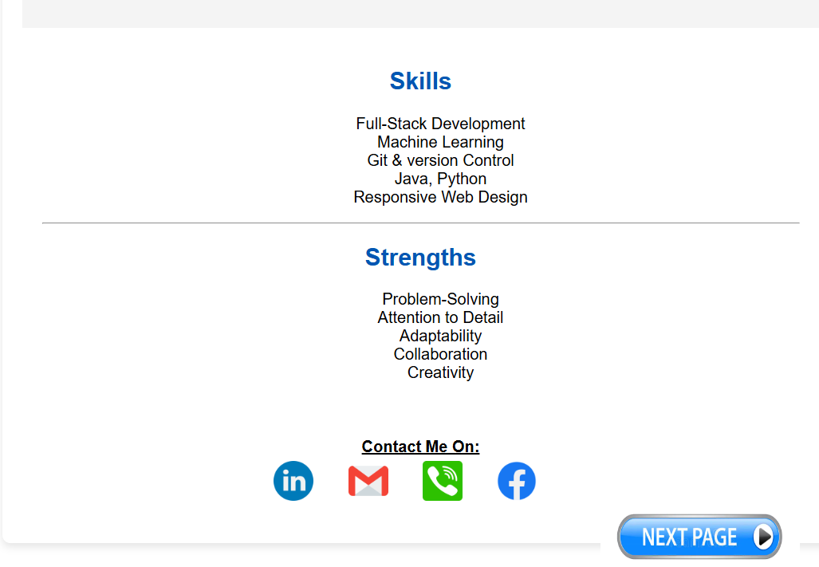

**Page – 02**

<!DOCTYPE html>

<html lang="en">

<head>

    <meta charset="UTF-8">

    <meta name="viewport" content="width=device-width, initial-scale=1.0">

    <title>Amali Thathsarani - Projects & Achievements</title>

    <style>

        body {

            font-family: Arial, sans-serif;

            margin: 0;

            padding: 0;

        }

        header, section, footer {

            padding: 20px;

            text-align: center;

        }

        header {

            background-color: #f4f4f4;

        }

        h1, h2, h3 {

            color: #333;

        }

        p {

            color: #555;

        }

        .project, .skills,.achievements {

            margin-bottom: 20px;

            border: 1px solid #ddd;

            padding: 15px;

            border-radius: 5px;

            background-color: #f9f9f9;

        }

        .project img {

            width:600px;

            height: 300px;

            border-radius: 5px;

            margin-top: 10px;

            transition: transform 0.3s ease, opacity 0.3s ease;

            cursor:pointer;

        }

        .project img:hover{

            transform: scale(1.05); /* Slightly enlarge the image */

            opacity: 0.9;

        }

        .next{

            float:right;

        }

        table{

            width:300px;

        }

        .contact img{

            transition: transform 0.3s ease, opacity 0.3s ease;

            cursor:pointer;

        }

.contact img:hover{

    transform: scale(1.05);

    opacity: 0.9;

}

.achievements img{

    transition: transform 0.3s ease, opacity 0.3s ease;

            cursor:pointer;

}

.achievements img:hover{

    transform: scale(1.05);

    opacity: 0.9;

}

.container {

            max-width: 800px;

            margin: 20px auto;

            padding: 20px;

            background-color: #fff;

            border-radius: 8px;

            box-shadow: 0 4px 8px rgba(0, 0, 0, 0.1);

        }

        h1,h2{

            color: #0056b3

        }

    </style>

</head>

<body>

    <div class="container">

    <header>

        <h1>W.K Amali Thathsarani</h1>

        <p>Projects & Achievements</p>

    </header>

    <section>

        <h2>Projects</h2>

        <div class="project">

            <h3>Project 1: Real Time Badminton Scoring System</h3>

            <p>How to Score badminton match using AI and machine Learning techniques. we created it to scoring real time badminton match using machine learning algorithms</p>

            <img src="badminton.jpg" alt="Project 1 Screenshot">

        </div>

        <div class="project">

            <h3>Project 2: Fitness Lab</h3>

            <p>we are created a website for fitness lab using html, css, javascript and php</p>

            <img src="fit.jpg" alt="Project 2 Screenshot">

        </div>

    </section>

    <section>

        <h2>Technologies and Skills Used</h2>

        <div class="skills">

            <ul style="list-style-type: none">

                <li>Machine Learning</li>

                <li>HTML</li>

                <li>Javascript</li>

                <li>PHP</li>

                <li>React.js</li>

                <li>Node.js</li>

            </ul>

    </section>

    <section>

        <h2>Achievements</h2>

        <div class="achievements">

            <p> I have particated for the MATLAB competition organized by InspiHexS</p>

<img src="A1.jpg" width="400px" height="300px">

        </div>

    </section>

    <footer>

        <center>

            <div class="contact">

        <table>

            <tr> <b><u>Contact Me On:</u></b></tr>

            <tr>

                <th><a href="Ahttps://www.linkedin.com/in/amali-thathsarani-623bb2334?utm_source=share&utm_campaign=share_via&utm_content=profile&utm_medium=android_app""><img src="lin.JPEG" align="left" height="40px" width="40px"></th>

                <th><a href="Ama Thathsarani"><img src="Gmail.JPEG" align="left" height="40px" width="40px"></th>

                <th><a href="Ama Thathsarani"><img src="pho.JPEG" align="left" height="40px" width="40px"></th>

                <th><a href="Ama Thathsarani"> <img src="fab.JPEG" align="left" height="40px" width="40px"></th>

            </tr>

        </table>

    </div>

    </center>

    <div class="next">

    <a href ="firstPge.html" ><img src="prev.JPEG" height="60px" width="150px"> </a>

    </div>

        </footer>

        </div>

</body>

</html>

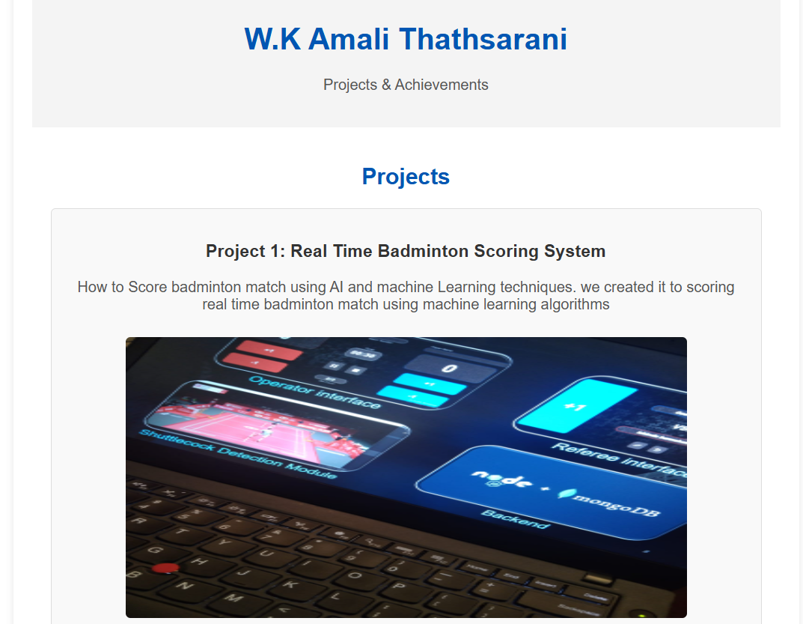

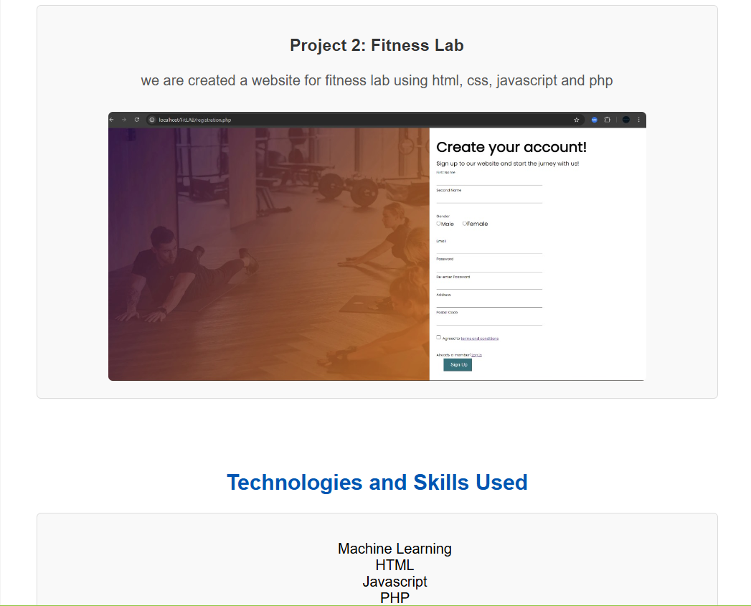

4.

5.

