**How to run Framework:**

* Clone repo
* Open project in intellij
* R click on test and run test

**Environment :**

* Chrome browser version 93
* OS : Windows 10

**Framework used is :**

* Page Object Model
* Data driven.

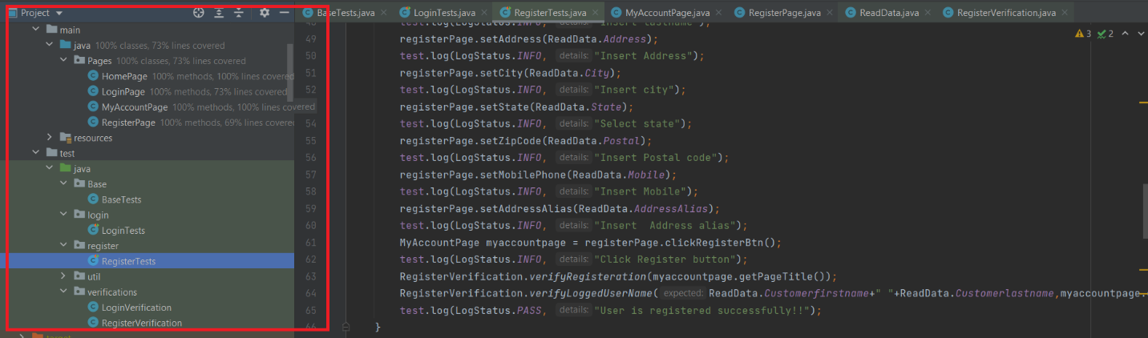

* **Under main Folder there are the following classes:**
  + HomePage
  + RegisterPage
  + LoginPage
  + MyAccountPage

Each class represents a page in the application and each contains methods that interacts with the application

* Under test Folder:
  + BaseTests: Class that contains the Web driver set up , teardown and screenshot capture.
  + LoginTests: Class inherits Contains tests for Login and
  + RegisterTests: Class contains test scenarios for user registration
  + Util(package that contains test data and helpers)
    - Constants: contains constant fields such as URL
    - Excel read: Class is used to read data from excel
    - ReadData: Class used to assign the data read from Excel read class to statis variables that will be used in the test classes
    - Helpers: to generate random data
* Each test classes has Extent Reports set up.