
K.R. Mangalam University
School of Engineering and Technology (SOET)

Assignment Submission
Programme | B.Tech CSE (AI & Robotics)
Department | Computer Science & Engineering (SOET)
Course Code | ETCCPP102
Course Name | Programming for Problem Solving Using Python
Assignment No. | 0
Assignment Title | Library Management System
Student Name | Amaan Ahmed
Roll No. | 2501730305
Faculty | Mr. Sameer Farooq

Introduction
The purpose of this assignment is to design and implement a Library Inventory Management System using Object-Oriented Programming (OOP) in Python.
This system allows a librarian or user to:
- Add books
- Issue books
- Return books
- Search for books
- View all books available
The system uses a menu-based Command Line Interface (CLI) and stores all book information in a JSON file, ensuring data persists even after the program is closed.
This assignment demonstrates understanding of OOP concepts, JSON file handling, exception handling, logging, modular programming, and CLI application development.
_________________________________

Objectives
- To understand and implement Python classes and objects.
- To design a modular program using multiple files.
- To implement real-world functionality using OOP principles.
- To perform file operations for persistent data storage using JSON.
- To build a menu-driven CLI application.
- To apply exception handling and logging in Python.
- To develop a small but functional library management system.
_________________________________

Problem Statement
A library needs a simple digital system to store and manage book records.
The system must:
- Store book details (Title, Author, ISBN, Status)
- Prevent duplicate books
- Allow issuing and returning of books
- Maintain data permanently using a JSON file
- Provide a clean menu for user interaction
- Allow searching by title or ISBN
The goal is to create an OOP-based Python program that fulfills these requirements
____________________________________________ System Overview (Working of the Application)
The application has three main components:

1️.Book Class (book.py)
- Represents a single book
- Stores title, author, ISBN, and status (available/issued)
- Provides methods to issue and return a book
- Converts object to dictionary for JSON storage

2️.LibraryInventory Class (inventory.py)
- Stores all books in a list
- Loads and saves data to books.json
- Adds new books
- Searches books
- Issues and returns books
- Handles errors and logging

3️.CLI Program (main.py)
- Provides a menu-based system for user operations
- Calls LibraryInventory functions
- Handles all user inputs and displays output
_________________________________

Project Structure
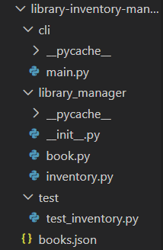
____________________________________________

Code Explanation

Book Class
- Represents a single book entry
- Contains methods:
  - issue() – marks as issued
  - return_book() – marks as available
  - to_dict() – converts book object to JSON-compatible dictionary

LibraryInventory Class
- Manages entire book collection
- Functions include:
  - load() – loads books from JSON
  - save() – saves books to JSON
  - add_book() – prevents duplicate ISBNs
  - search_by_title()
  - search_by_isbn()
  - issue_book() / return_book()

CLI Program
- Displays menu
- Takes user input
- Calls methods from LibraryInventory
- Handles input errors using try/except
_______________________________

OUTPUT 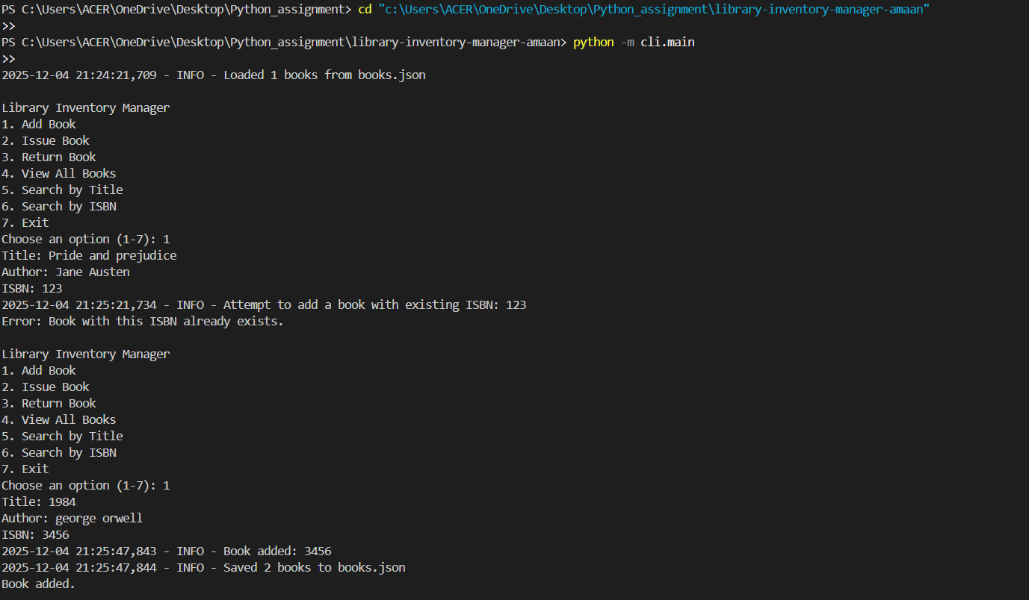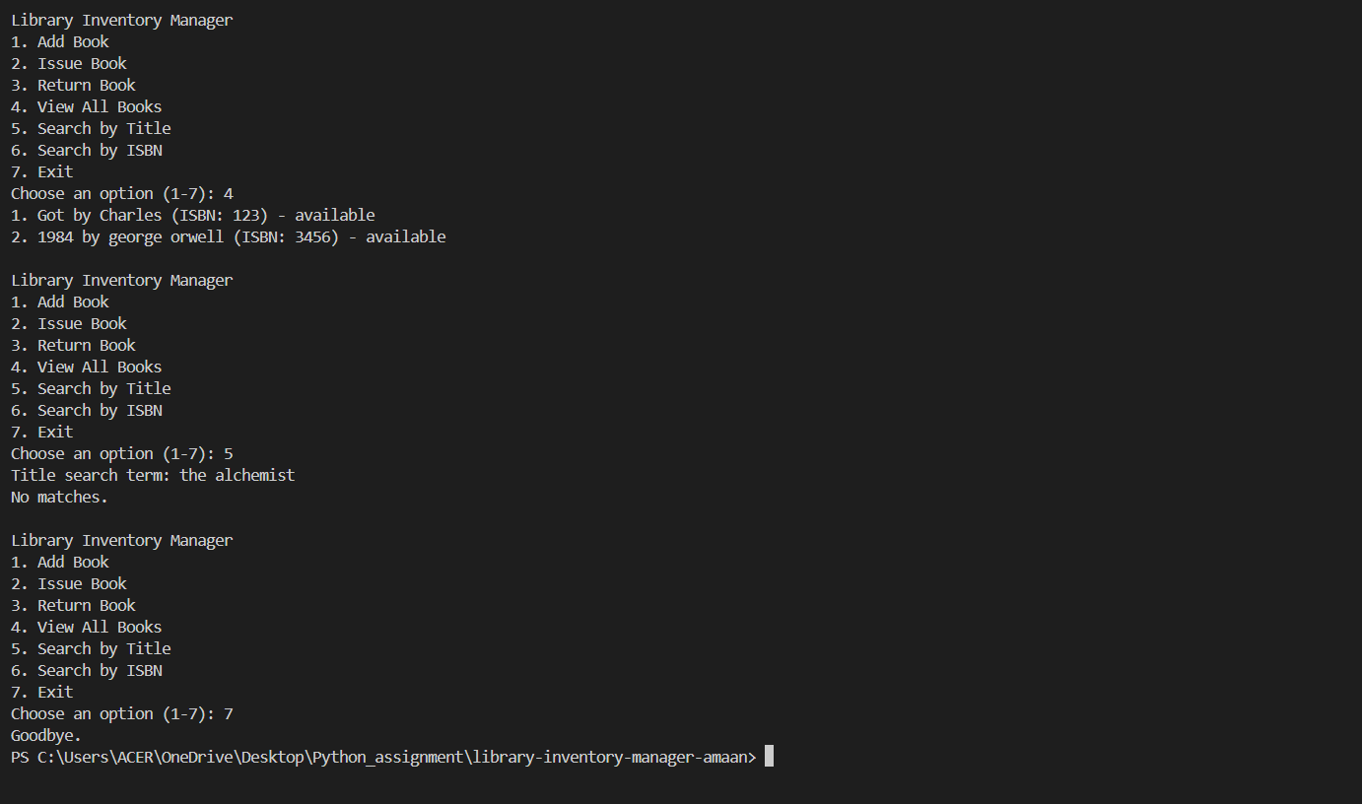

CONCLUSION
This project successfully implements a functional Library Inventory System using Python’s OOP capabilities.
Through this assignment, I learned:
- Designing real-world systems using classes and objects
- Managing data using JSON
- Creating interactive CLI applications
- Handling user input and exceptions
- Writing modular and clean Python code
The assignment objective has been fully achieved.
_____________________________
THANK YOU

