
K.R. Mangalam University
School of Engineering and Technology (SOET)

Assignment Submission
Programme | B.Tech CSE (AI & Robotics)
Department | Computer Science & Engineering (SOET)
Course Code | ETCCPP102
Course Name | Programming for Problem Solving Using Python
Assignment No. | 02
Assignment Title | Gradebook Analyzer
Student Name | Amaan Ahmed
Roll No. | 2501730305
Faculty | Mr. Sameer Farooq

Introduction
Managing and analyzing student marks is an essential part of the academic process, but doing it manually can be slow, repetitive, and prone to errors. Teachers often need to calculate averages, determine grade distribution, and identify students who are performing well or who may need additional support. As the number of students increases, these tasks become even more challenging.
To simplify this process, this project introduces GradeBook Analyzer, a Python-based program designed to automate student grade analysis. The system allows users to enter student marks manually or load them from a CSV file, making it flexible and easy to use. After collecting the data, the program calculates important statistics such as the average, median, highest, and lowest marks.
The application also assigns letter grades (A–F) using predefined score ranges and categorizes students into pass and fail groups through list comprehensions. All results are displayed in a neat, formatted table, and users have the option to export the final report to a CSV file for record-keeping.
Overall, this project demonstrates how Python can be used to automate everyday academic tasks. It highlights concepts such as functions, file handling, data processing, and control structures, while providing a practical and efficient solution for grade management.
____________________________________________

Problem Statement
In academic settings, teachers often need to manage and analyze student marks to determine their performance, grade distribution, and overall class statistics. Manually performing this process for multiple classes or large datasets is inefficient and prone to errors.
The goal of this assignment is to design and implement a Python-based CLI (Command Line Interface) application that can automatically handle all essential grade processing tasks, including:
- Collecting student names and marks
- Reading data from a CSV file
- Calculating important statistics (mean, median, minimum, maximum)
- Assigning letter grades (A–F) based on predefined criteria
- Displaying grade distribution
- Identifying pass/fail students using list comprehensions
- Presenting results in a formatted table
- Optionally exporting the final output to a CSV file
This program helps automate academic data processing and demonstrates the use of functions, file handling, loops, conditionals, dictionaries, list comprehensions, and modular programming in Python.
____________________________________________

Objectives
The main objectives of this project are:
- Develop a flexible grade analysis system using Python.
- Implement manual and CSV-based data entry.
- Perform statistical operations using in-built libraries.
- Generate letter grades and categorize students.
- Display results in a clear, readable table format.
- Allow exporting of analyzed data to external files.
- Demonstrate programming concepts like modular design, loops, functions, list comprehensions, and error handling.
_________________________________

Tools & Technologies Used
- Programming Language: Python 3
- Libraries:
  - csv (for file handling)
  - statistics (for mean & median)
  - pandas (optional for robust CSV handling)
- Environment: Any Python interpreter / VS Code / Terminal

Methodology / Program Flow
The system works through the following major steps:
- The program starts and displays a main menu.
- The user chooses between:
  - Manual student entry
  - CSV file import
- The program collects all student data.
- Statistical analysis is performed:
  - Mean
  - Median
  - Maximum and Minimum
- Grades are assigned using predefined thresholds.
- Pass/fail lists are created using list comprehensions.
- A formatted table is displayed.
- User optionally exports results to a new CSV file.
- The program loops back to allow repeated use.

_________________________________

Code Implementation
#!/usr/bin/env python3
"""
GradeBook Analyzer - gradebook.py
Name: Amaan Ahmed
Assignment: Mini Project - GradeBook Analyzer
"""

import csv
import sys
from statistics import median as stat_median

# -----------------------
# Helper / Core Functions
# -----------------------
def read_csv_to_dict(filename):
"""Reads a CSV with two columns: name,marks (marks numeric). Returns dict."""
marks = {}
try:
with open(filename, newline='', encoding='utf-8') as f:
reader = csv.reader(f)
for row in reader:
if not row:
continue
# allow rows with name,marks or name, marks, ...
name = row[0].strip()
# attempt to find numeric in subsequent columns
mark = None
for cell in row[1:]:
cell = cell.strip()
if cell == '':
continue
try:
mark = float(cell)
break
except ValueError:
continue
if name and mark is not None:
marks[name] = float(mark)
except FileNotFoundError:
print(f"File not found: {filename}")
except Exception as e:
print("Error reading CSV:", e)
return marks

def manual_input_marks():
"""Prompt user to manually enter names and marks, returns dict"""
marks = {}
print("Manual entry mode. Enter student data. Leave name blank to finish.")
while True:
name = input("Student name (blank to stop): ").strip()
if name == "":
break
mark_raw = input(f"Mark for {name}: ").strip()
try:
mark = float(mark_raw)
except ValueError:
print("Invalid mark. Please enter a numeric value.")
continue
marks[name] = mark
return marks

def calculate_average(marks_dict):
if not marks_dict:
return 0.0
return sum(marks_dict.values()) / len(marks_dict)

def calculate_median(marks_dict):
if not marks_dict:
return 0.0
return stat_median(list(marks_dict.values()))

def find_max_score(marks_dict):
if not marks_dict:
return None, None
name = max(marks_dict, key=lambda k: marks_dict[k])
return name, marks_dict[name]

def find_min_score(marks_dict):
if not marks_dict:
return None, None
name = min(marks_dict, key=lambda k: marks_dict[k])
return name, marks_dict[name]

def assign_grades(marks_dict):
grades = {}
distribution = {"A":0,"B":0,"C":0,"D":0,"F":0}
for name, score in marks_dict.items():
if score >= 90:
g = "A"
elif score >= 80:
g = "B"
elif score >= 70:
g = "C"
elif score >= 60:
g = "D"
else:
g = "F"
grades[name] = g
distribution[g] += 1
return grades, distribution

def pass_fail_lists(marks_dict, pass_threshold=40):
passed = [n for n,s in marks_dict.items() if s >= pass_threshold]
failed = [n for n,s in marks_dict.items() if s < pass_threshold]
return passed, failed

def print_results_table(marks_dict, grades_dict):
# Determine column widths
name_w = max([len(name) for name in marks_dict.keys()] + [4])
marks_w = 6
grade_w = 5
header = f"{'Name':<{name_w}} {'Marks':>{marks_w}} {'Grade':^{grade_w}}"
print("\n" + header)
print("-" * (name_w + marks_w + grade_w + 4))
for name, mark in marks_dict.items():
grade = grades_dict.get(name, "")
print(f"{name:<{name_w}} {mark:>{marks_w}.2f} {grade:^{grade_w}}")
print()

def export_to_csv(filename, marks_dict, grades_dict):
try:
with open(filename, 'w', newline='', encoding='utf-8') as f:
writer = csv.writer(f)
writer.writerow(["Name", "Marks", "Grade"])
for name, mark in marks_dict.items():
writer.writerow([name, f"{mark:.2f}", grades_dict.get(name, "")])
print(f"Exported results to {filename}")
except Exception as e:
print("Failed to export CSV:", e)

# -----------------------
# CLI / Main Program
# -----------------------
def run_analysis(marks):
if not marks:
print("No marks to analyze.")
return

avg = calculate_average(marks)
med = calculate_median(marks)
max_name, max_score = find_max_score(marks)
min_name, min_score = find_min_score(marks)
grades, distribution = assign_grades(marks)
passed, failed = pass_fail_lists(marks)

# Print summary stats
print("\n=== Analysis Summary ===")
print(f"Students analyzed: {len(marks)}")
print(f"Average score: {avg:.2f}")
print(f"Median score: {med:.2f}")
print(f"Highest: {max_name} ({max_score:.2f})")
print(f"Lowest: {min_name} ({min_score:.2f})")
print("\nGrade distribution:")
for g in ["A","B","C","D","F"]:
print(f" {g}: {distribution[g]}")

print("\nPass/Fail (pass if >= 40):")
print(f" Passed ({len(passed)}): {', '.join(passed) if passed else 'None'}")
print(f" Failed ({len(failed)}): {', '.join(failed) if failed else 'None'}")

# Table
print_results_table(marks, grades)

# Ask to export
while True:
choice = input("Export results to CSV? (y/n): ").strip().lower()
if choice == 'y':
outname = input("Enter output filename (e.g., results.csv): ").strip()
if outname == "":
outname = "results.csv"
export_to_csv(outname, marks, grades)
break
elif choice == 'n' or choice == "":
break
else:
print("Type 'y' or 'n'.")

def main_menu():
print("Welcome to GradeBook Analyzer")
while True:
print("\nMenu:")
print(" 1) Manual entry")
print(" 2) Load CSV file")
print(" 3) Exit")
choice = input("Choose option (1/2/3): ").strip()
if choice == '1':
marks = manual_input_marks()
run_analysis(marks)
elif choice == '2':
fname = input("Enter CSV filename (e.g., sample_marks.csv): ").strip()
if fname == "":
print("No filename entered.")
continue
marks = read_csv_to_dict(fname)
if not marks:
print("No valid data loaded from CSV.")
else:
run_analysis(marks)
elif choice == '3':
print("Exiting. Goodbye.")
sys.exit(0)
else:
print("Invalid option. Choose 1, 2 or 3.")

if __name__ == "__main__":
main_menu()

_________________________________

OUTPUT
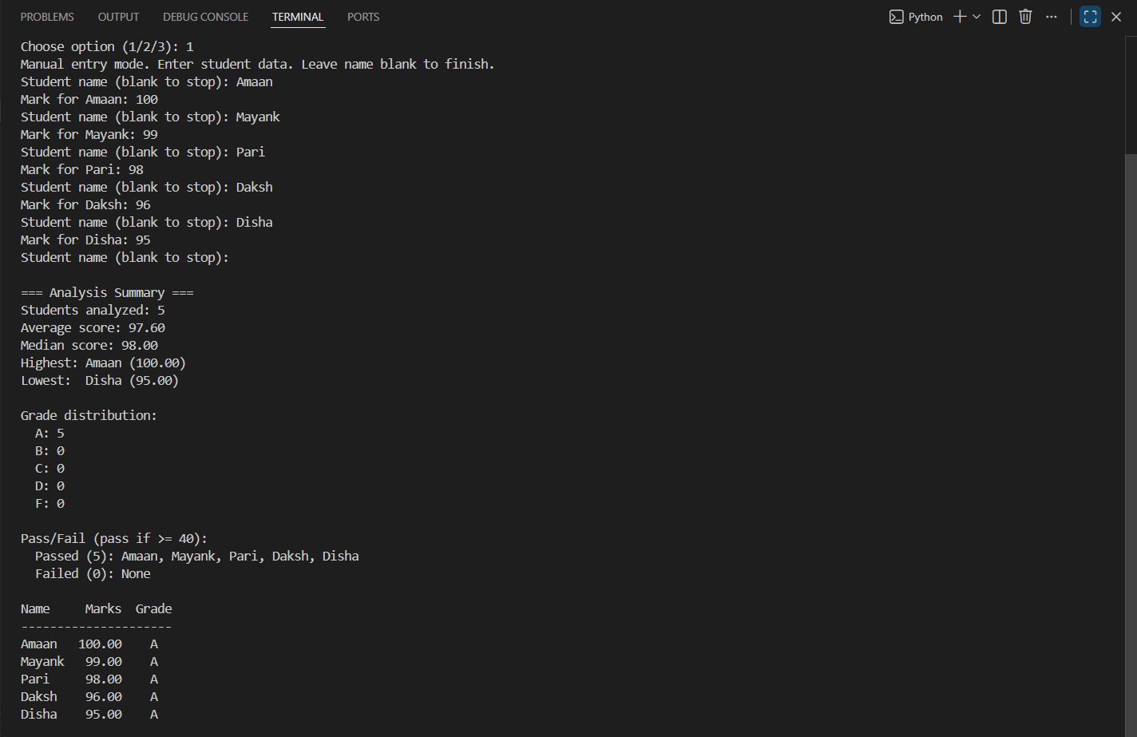
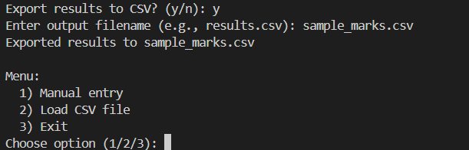
____________________________________________

Conclusion
This assignment enhanced practical Python skills by integrating core programming concepts into a real-world application. The GradeBook Analyzer efficiently processes student data, generates meaningful insights, and automates academic tasks that would otherwise be time-consuming.
The project successfully meets all requirements and provides a solid foundation for further improvements.

____________________________________________
THANK YOU

