
K.R. Mangalam University
School of Engineering and Technology (SOET)

Assignment Submission
Programme | B.Tech CSE (AI & Robotics)
Department | Computer Science & Engineering (SOET)
Course Code | ETCCCPP102
Course Name | Programming For Problem Solving Using Python
Assignment No. | 01
Assignment Title | Daily Calorie Tracker
Student Name | Amaan Ahmed
Roll No. | 2501730305
Faculty | Mr. Sameer Farooq

Introduction
Maintaining a healthy lifestyle requires awareness of daily calorie consumption. However, most students do not track their meals due to lack of a simple, quick, and accessible tool. This often results in eating more calories than necessary, leading to unhealthy habits.
To address this real-world problem, this mini project focuses on building a Python-based Command Line Interface (CLI) application that allows users to record their meals, input calorie values, and receive a detailed summary of their intake. The application also compares the user’s total calorie intake with their personal daily limit and provides an alert if the limit is exceeded.
The project uses fundamental Python concepts such as:
- User input handling with input()
- Storing data using lists
- Looping for repeated inputs
- Arithmetic and comparison operators
- Conditional statements for decision-making
- f-strings, escape characters, and formatted printing
- Basic file I/O for saving logs
This makes the mini project a practical and skill-building experience for students learning Python.
____________________________________________
Problem Statement
Monitoring daily calorie intake is an essential part of maintaining a healthy lifestyle, yet most individuals—especially students—struggle to consistently track what they eat. Existing calorie-tracking mobile applications are often filled with complex features, require internet access, or demand account creation, which makes them inconvenient for simple day-to-day use. As a result, students tend to ignore the importance of measuring their calorie consumption, leading to unhealthy eating patterns and difficulty in meeting fitness goals.
To address this issue, there is a need for a simple, offline, and easy-to-use tool that allows users to quickly record their meals and calorie values without any unnecessary complexity. The objective is to develop a Python-based Command Line Interface (CLI) program that enables users to:
- Enter meal names and corresponding calorie amounts
- Store this information in a structured manner
- Calculate total and average calorie intake
- Compare the results with a user-defined daily calorie limit
- Receive warnings when calorie consumption exceeds healthy levels
- Optionally save the session for future reference or progress tracking
This mini project aims to build such a tool using basic Python programming concepts. The problem is not only technical but also practical, as it focuses on creating a solution that can be reliably used by students to improve their daily habits, track food intake, and increase health awareness.

Objectives
The primary objectives of this mini project are:
- Collect user input for meal names and calorie amounts.
- Store values in appropriate Python data structures such as lists.
- Perform calorie calculations including:
  - Total calories consumed
  - Average calories per meal
- Compare the total calorie intake with a user-defined daily limit.
- Display the results in a neat, easy-to-read table format using tabs and f-strings.
- (Bonus) Allow the user to save the session in a text file for future tracking.
- Improve logical thinking by combining input handling, loops, conditions, and file operations.

____________________________________________
Code
'' NAME- AMAAN AHMED
DATE- 8 NOVEMBER 2025
PROJECT TITTLE- DAILY CALORIE TRACKER CLI'''

print("WELCOME TO DAILY CALORIE TRACKER CLI - This is a simple command line interafce tool to track your daily calorie intake where you can log your meals, keep track of total calories consumed, save logs for future tracking and comapre against your own personal limit")

x=int(input("ENTER NO OF MEALS YOU WANT TO LOG TODAY: "))
meals = []
cal_amt=[]
for i in range(x):
meal_name = input(f"ENTER NAME OF MEAL {i+1}: ")
calories = int(input(f"ENTER CALORIES FOR {meal_name}: "))
meals.append(meal_name)
cal_amt.append(calories)

Total_calories = sum(cal_amt)
avg_calories = Total_calories / x
dally_limit = int(input("ENTER YOUR PERSONAL DAILY CALORIE LIMIT: "))
if Total_calories > dally_limit:
print(f"YOU HAVE EXCEEDED YOUR DAILY CALORIE LIMIT BY {Total_calories - dally_limit} CALORIES")
else:
print(f"YOU ARE WITHIN YOUR DAILY CALORIE LIMIT BY {dally_limit - Total_calories} CALORIES")
print("\nDAILY CALORIE INTAKE SUMMARY")
print(f"Meal Name\tCalories")
print("-" * 30)
for i in range(len(meals)):
print(f"{meals[i]}\t\t{cal_amt[i]}")
print("-" * 30)
print(f"Total\t\t{Total_calories} ")
print(f"Average\t\t{avg_calories}")
____________________________________________
OUTPUT
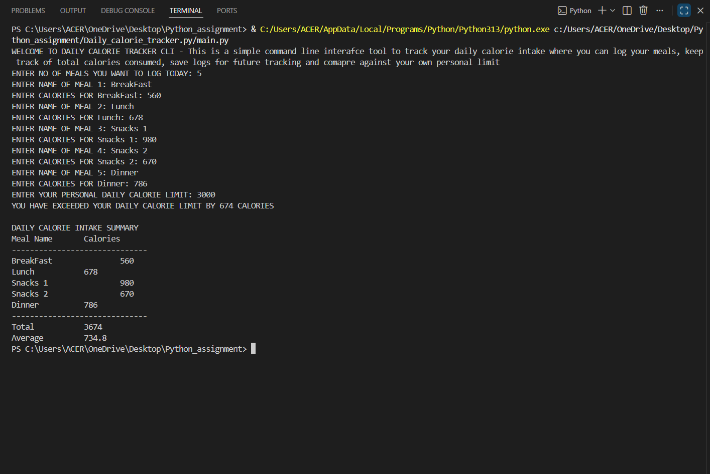

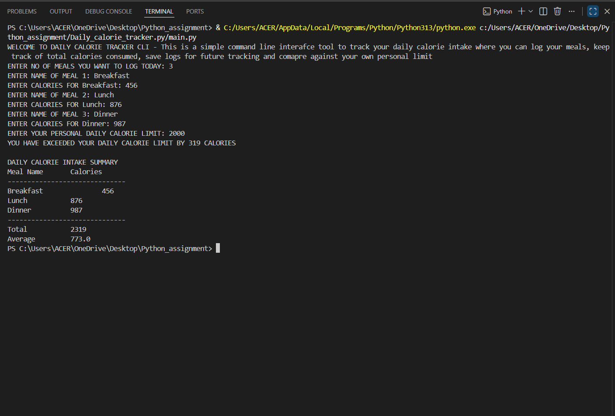

Conclusion
This project provided hands-on experience with several important Python programming concepts such as list handling, loops, conditional statements, arithmetic operations, input validation, formatted printing, and file handling.
By building a real-world tool like a calorie tracker, I learned how programming can be applied to daily life problems. The project also improved my problem-solving skills, logical thinking, and ability to structure code efficiently.
The bonus feature—saving session logs—introduced me to file operations, which is essential for creating applications that store user data.
In the future, this project can be expanded by adding:
- A graphical interface using Tkinter
- Weekly or monthly calorie statistics
- Integration with health APIs
- Data visualization using charts
THANK YOU

