Q.1)Demonstration of Conditional Statement using logical AND Operator
(if- else if - else) with limits?
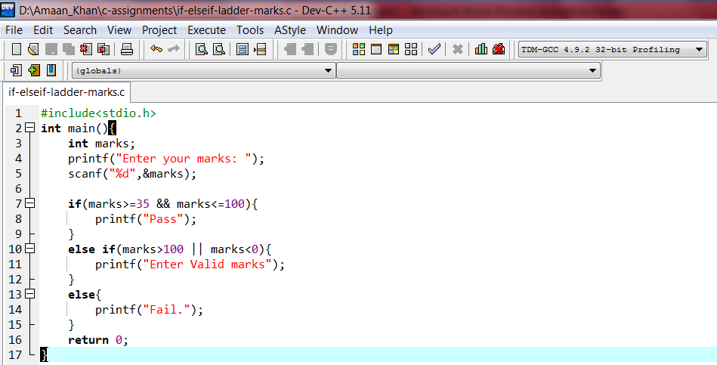

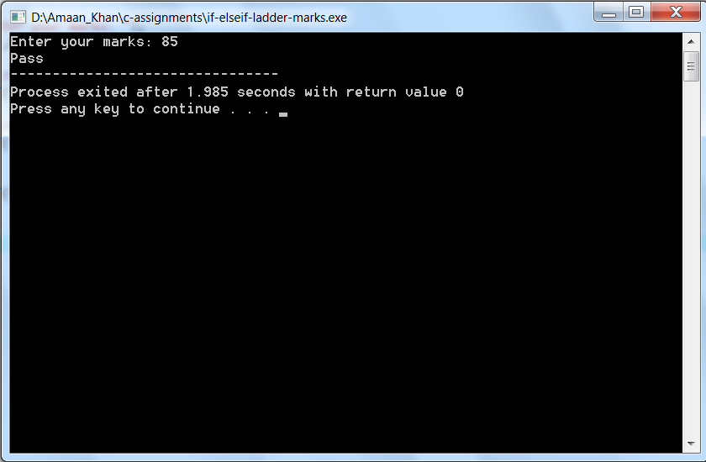

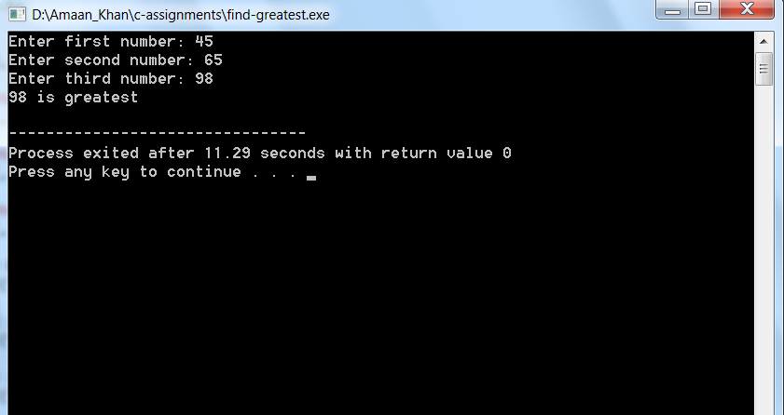
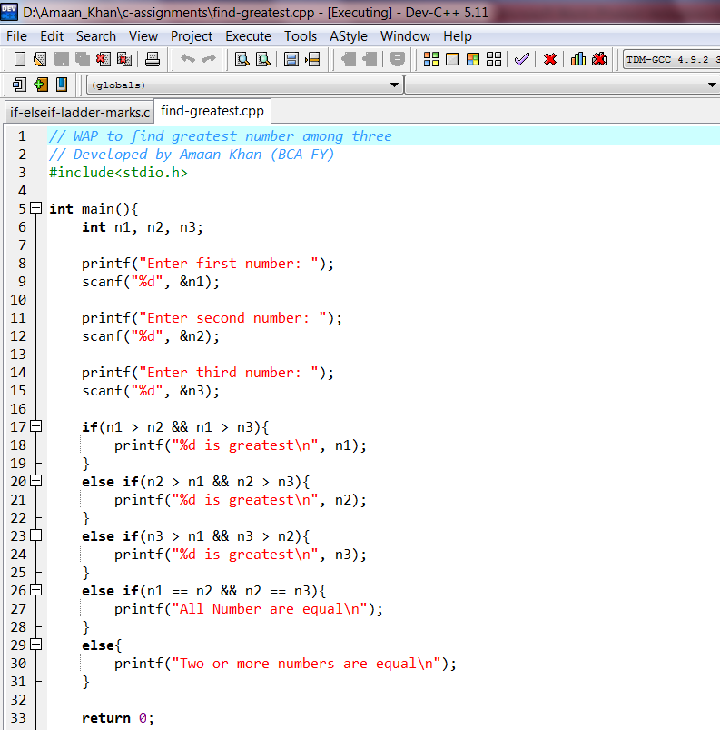
Q.2) Write a program to find out Greatest number among three number?

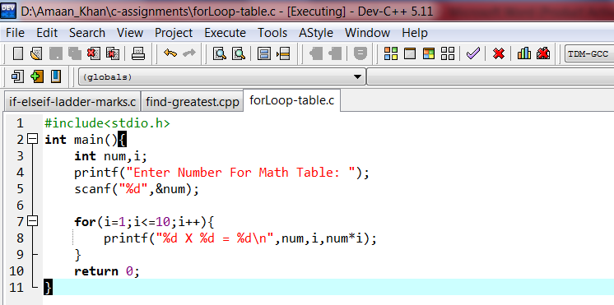
Q.3) WAP for Looping statements math Table in this format ( 2x1=2)?
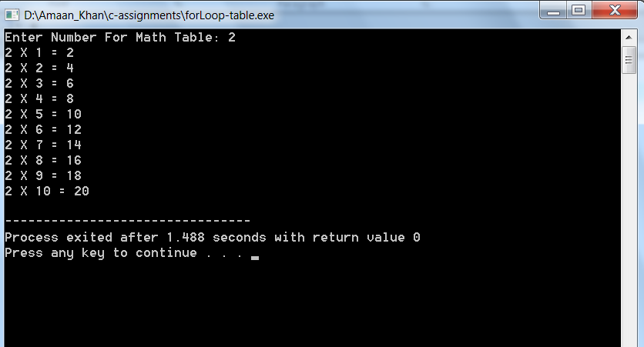

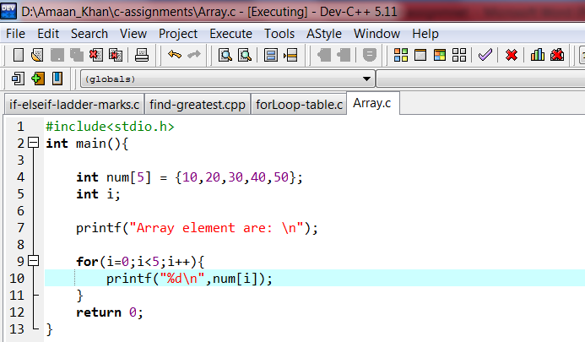
Q.4) Write a C Program to read 5 elements of an array and display them using a Loop?
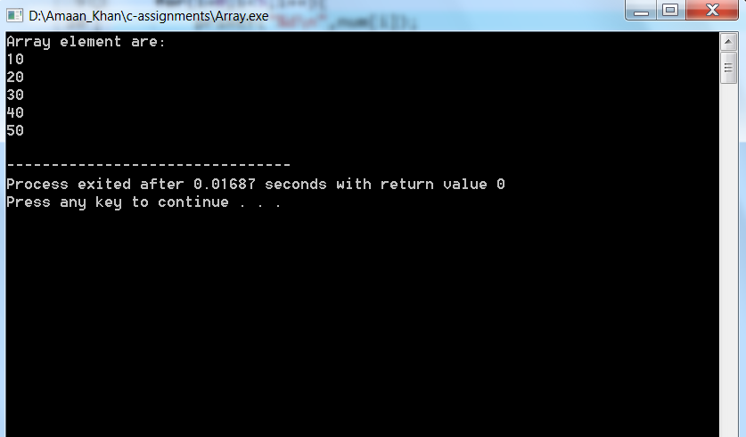

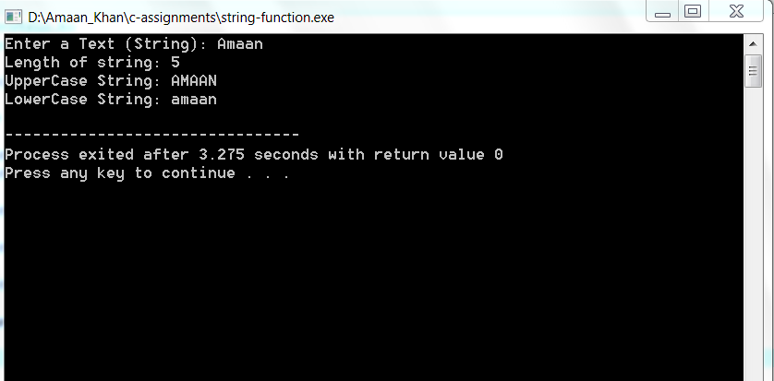
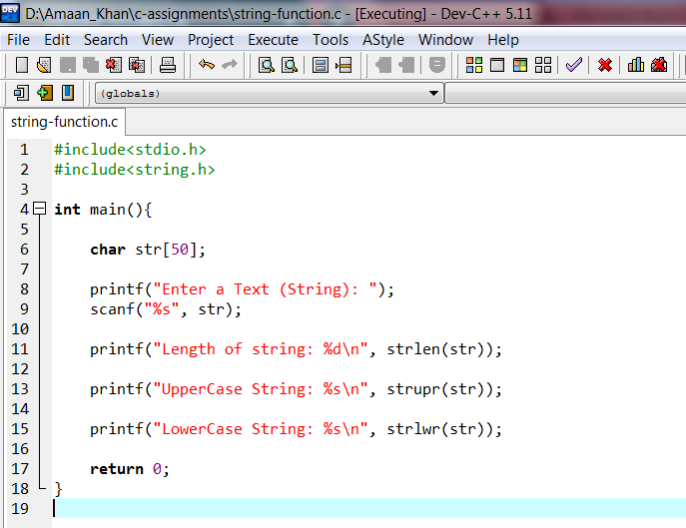
Q.5) Write a C Program to demonstrate Any Three String Function?

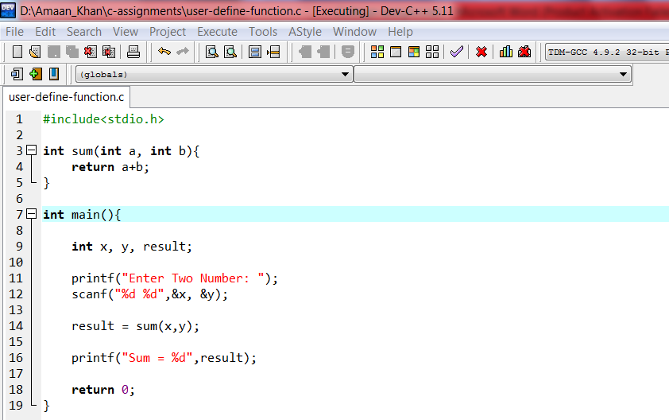
Q.6) Write a C Program using user-defined function to find the sum of two number?

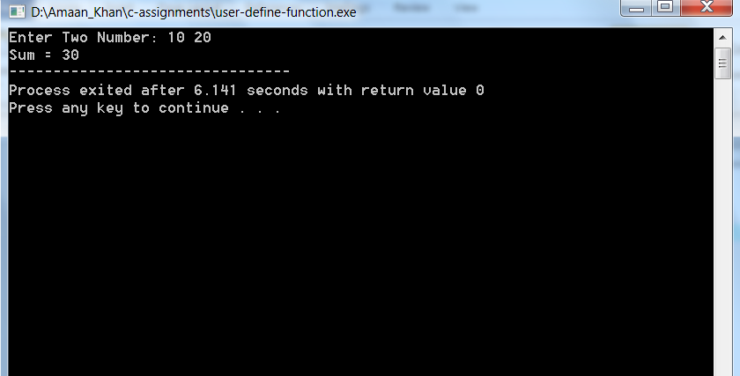

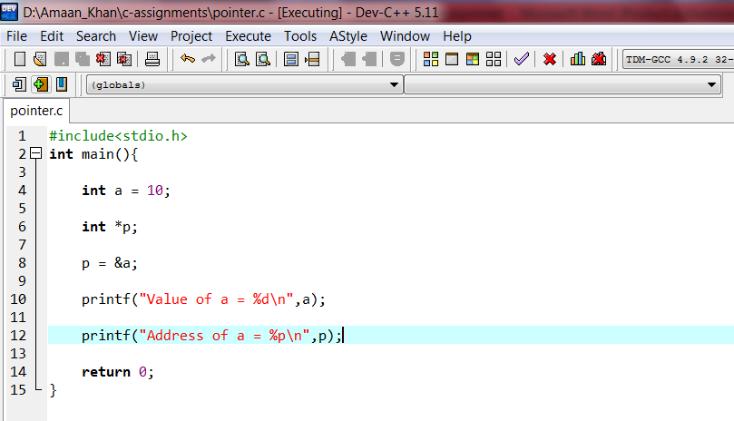
Q.7) write a C Program to display address of a variable using a POINTER?

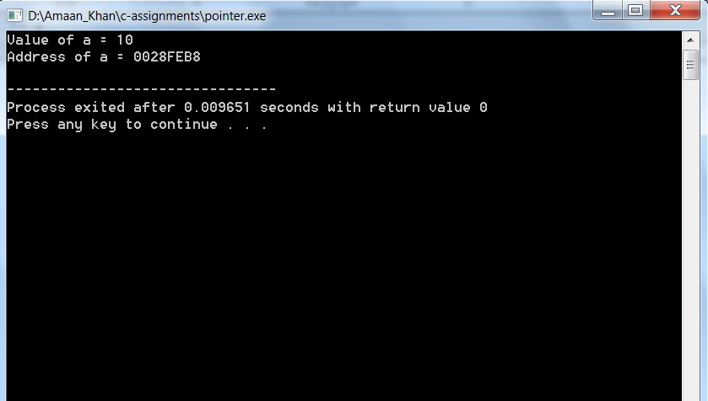

Q.8) write a C Program to print pattern using Nested Loop by taking number of rows
And Columns from the user?

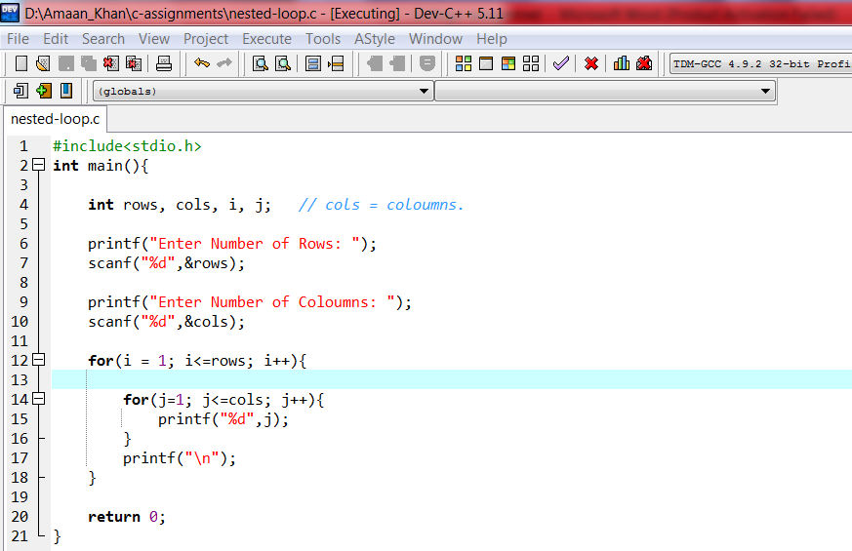

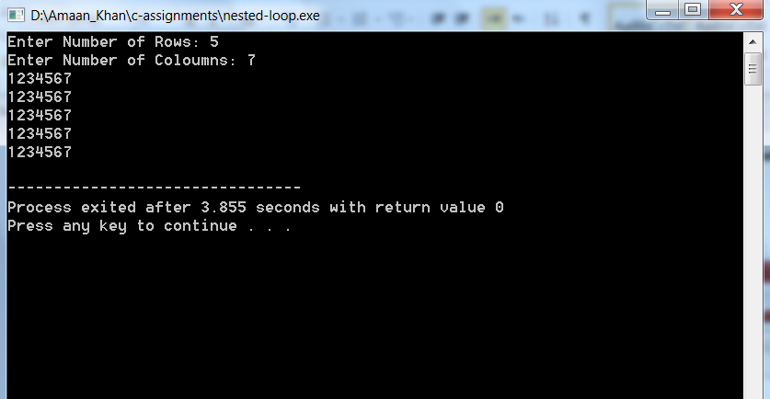

Q.9) write a C Program to store and display element of 2-D Array?

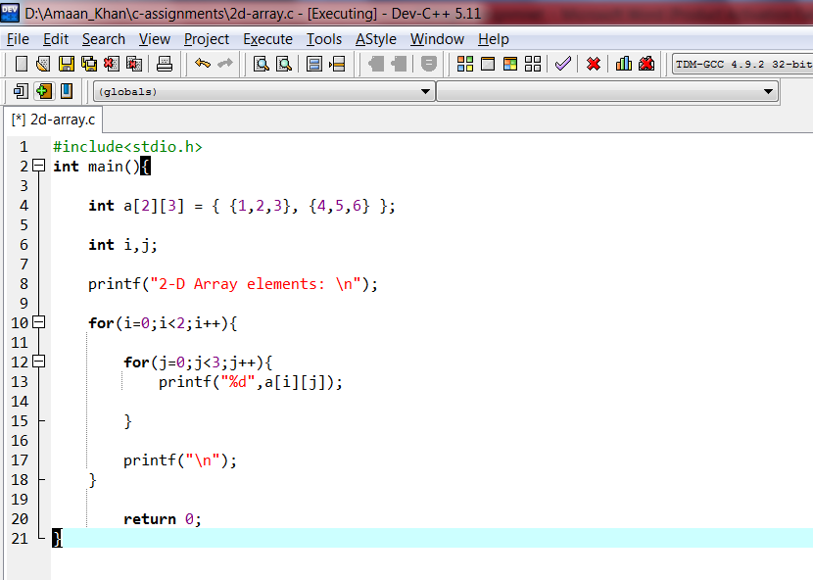

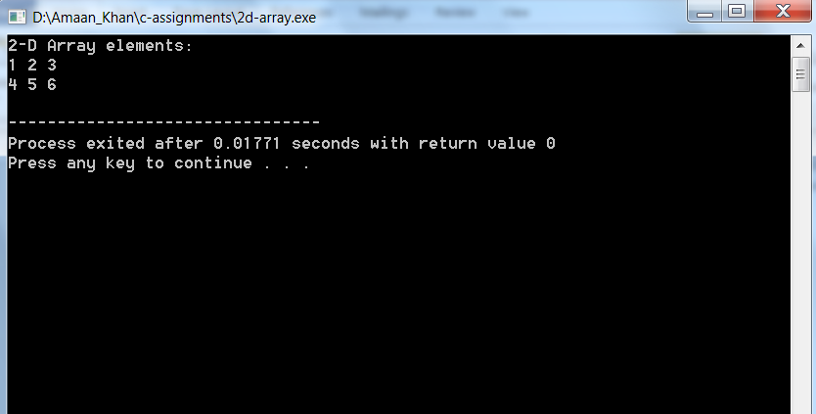

Q.10) write a C Program to Perform basic arithmetic aperation using switch case.
(Basic Calculator)?

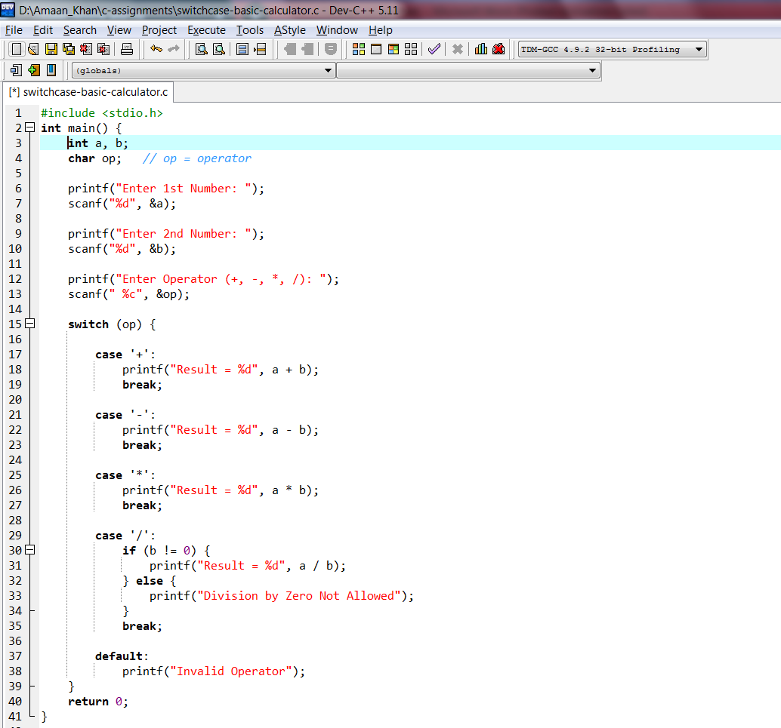
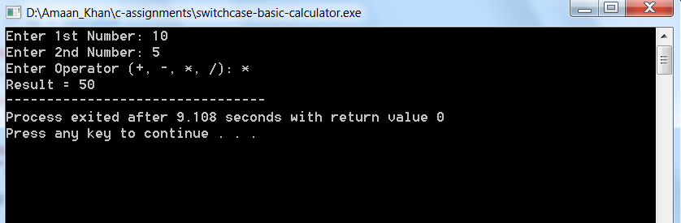

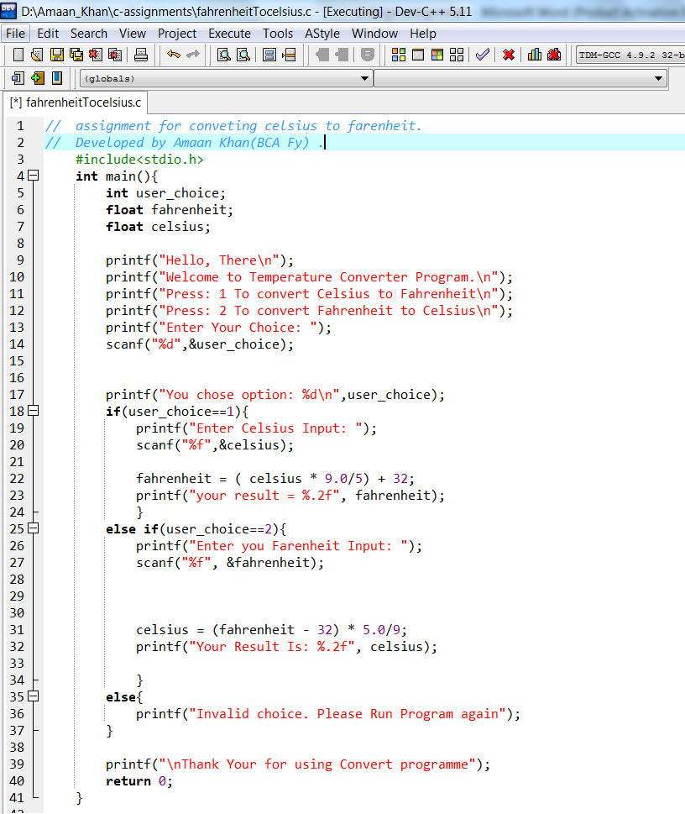
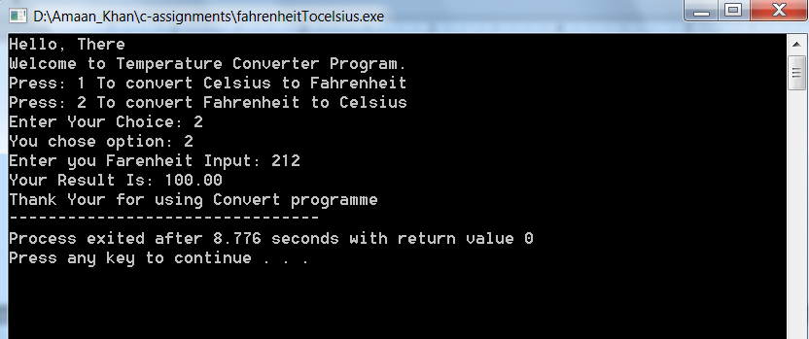
Q.11) 1. Converting degrees Celsius to Fahrenheit and vice versa?
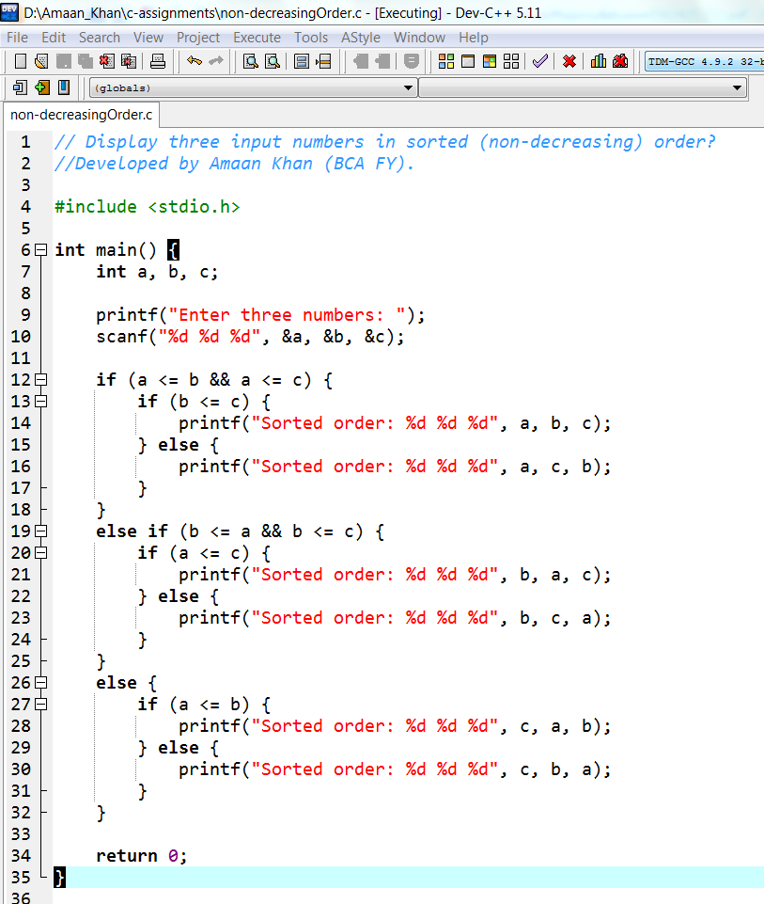
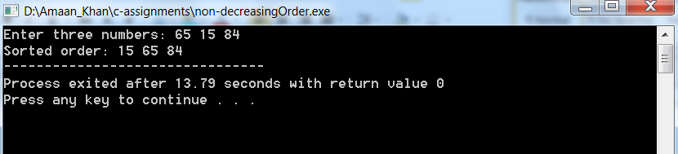
Q.12) 2.Display three input numbers in sorted (non-decreasing) order?
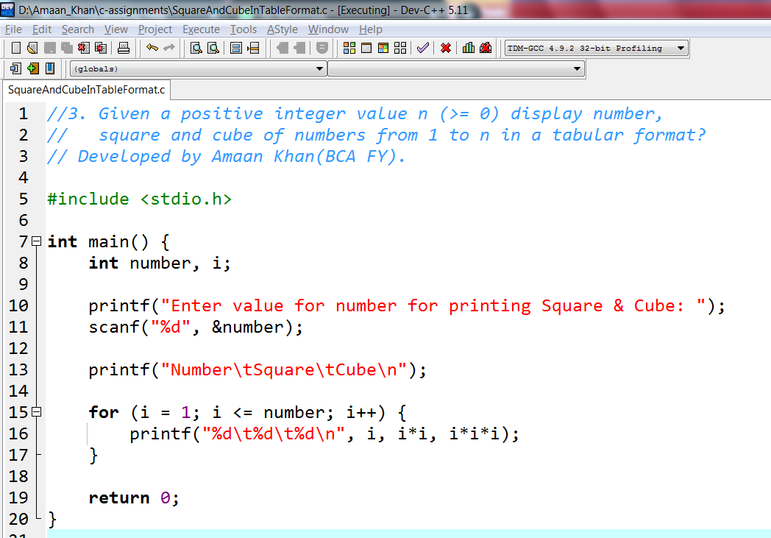
Q.13) 3. Given a positive integer value n (>= 0) display number, square and cube of numbers from 1 to n in a tabular format?
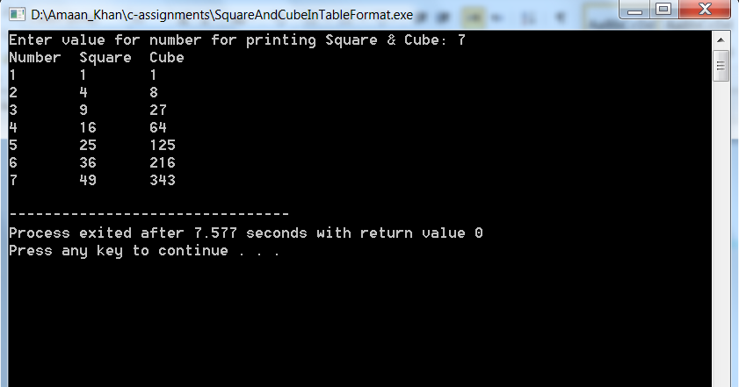

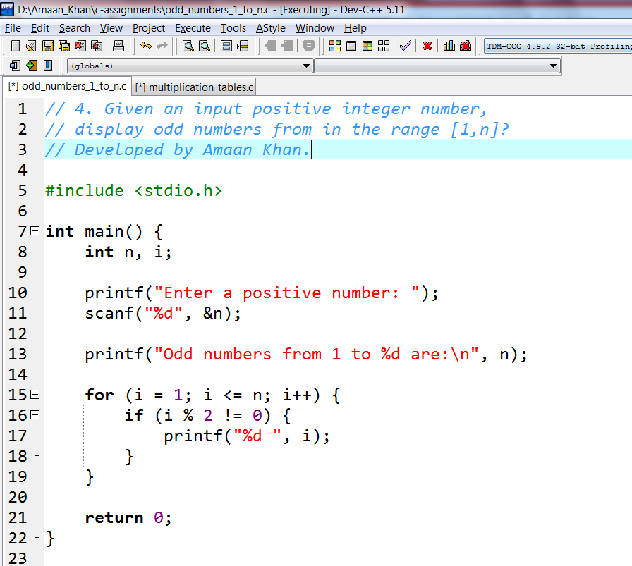
Q.14) 4.Given an input positive integer number, display odd numbers from in the range [1,n]?

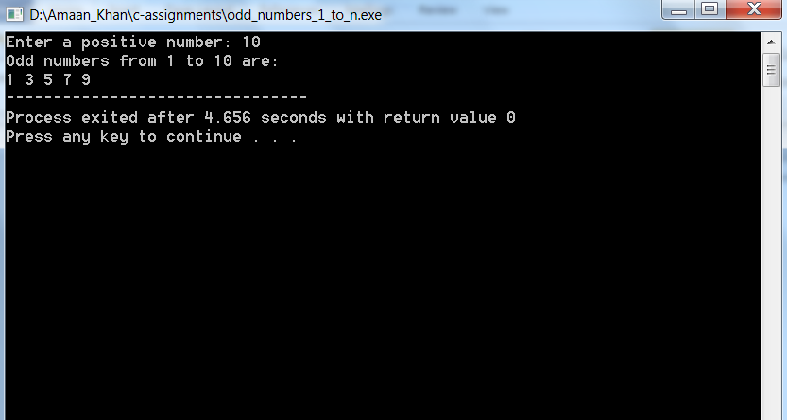
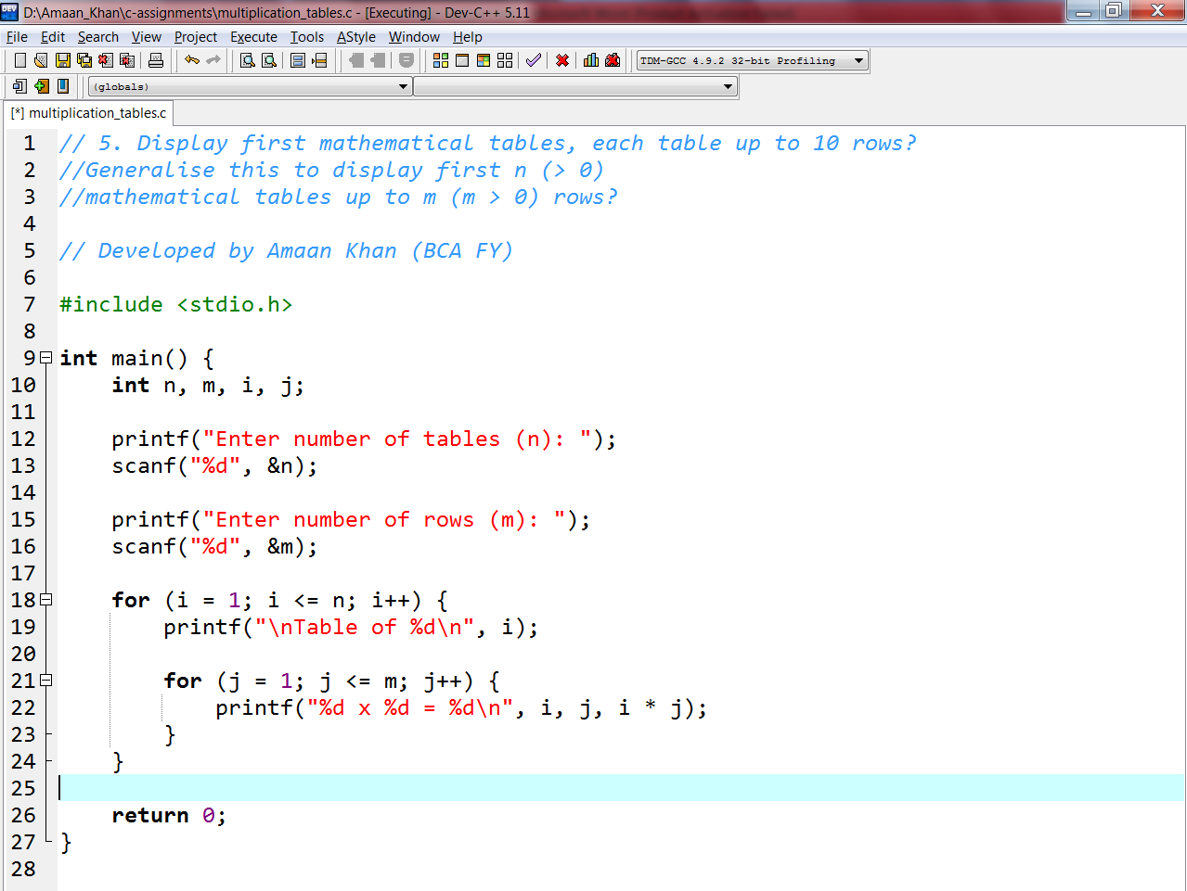
Q15) 5. Display first mathematical tables, each table up to 10 rows? Generalize this to display first n (> 0) mathematical tables up to m (m > 0) rows?
Pattern writes a separate algorithm/program?

