Project 01

Deploying a Node.js App Using Minikube Kubernetes

Set Up Git Version Control
Initialize a Git Repository

Create a new directory for your project:
mkdir nodejs-k8s-project
cd nodejs-k8s-project
Initialize a Git repository:
git init
Create a Node.js Application
Initialize a Node.js project:
npm init -y

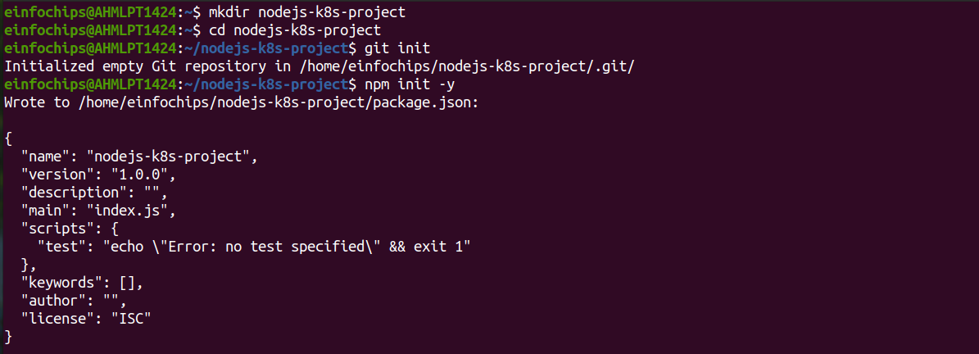
Install Express.js:
npm install express
Create an index.js file with the following content:
Create a .gitignore file to ignore node_modules:
node_modules

Commit the Initial Code
Add files to Git:
git add .
Commit the changes:
git commit -m "Initial commit with Node.js app"
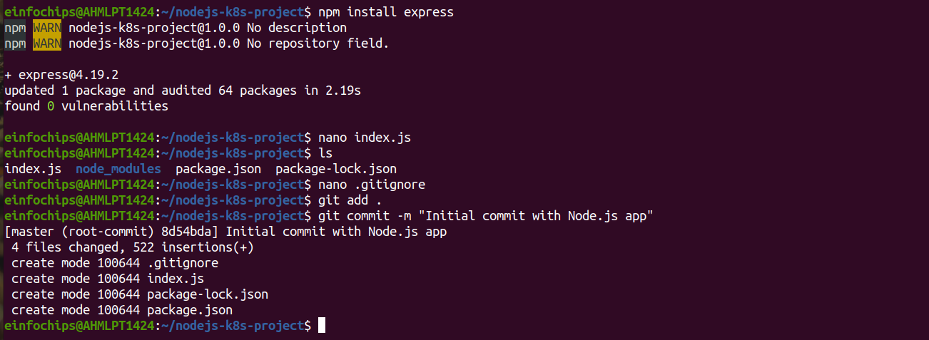
Branching and Fast-Forward Merge
Create a New Branch
Create and switch to a new branch feature/add-route:
git checkout -b feature/add-route

Implement a New Route
Modify index.js to add a new route:
Commit the changes:
git add .
git commit -m "Add new route"
Merge the Branch Using Fast-Forward
Switch back to the main branch:
git checkout main

Merge the feature/add-route branch using fast-forward
git merge --ff-only feature/add-route
Delete the feature branch:
git branch -d feature/add-route
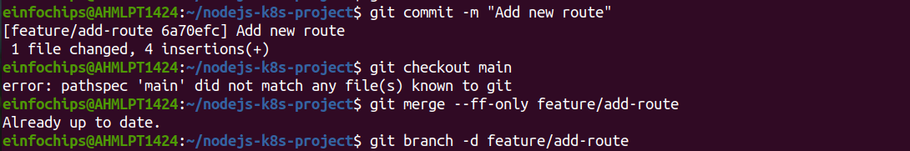
Containerize the Node.js Application
Create a Dockerfile

Create a Dockerfile with the following content:
Build and Test the Docker Image
Build the Docker image:
docker build -t nodejs-k8s-app .
Run the Docker container to test:
docker run -p 3000:3000 nodejs-k8s-app
Access http://localhost:3000 to see the app running.
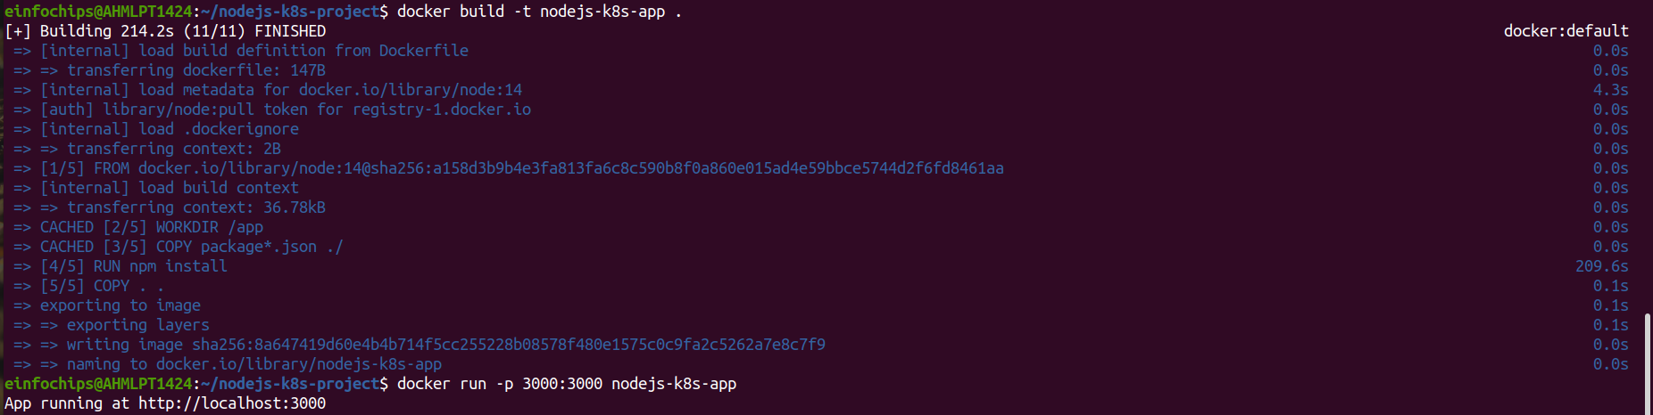
Deploying to Minikube Kubernetes
Start Minikube
Start Minikube:
minikube start

Create Kubernetes Deployment and Service Manifests
Create a deployment.yaml file:
Create a service.yaml file for ClusterIP:
Create a service-nodeport.yaml file for NodePort:
Apply Manifests to Minikube
Apply the deployment:
kubectl apply -f deployment.yaml
Apply the ClusterIP service:
kubectl apply -f service.yaml
Apply the NodePort service:
kubectl apply -f service-nodeport.yaml
Access the Application
Get the Minikube IP:
minikube ip
Access the application using the NodePort:
curl http://<minikube-ip>:30001

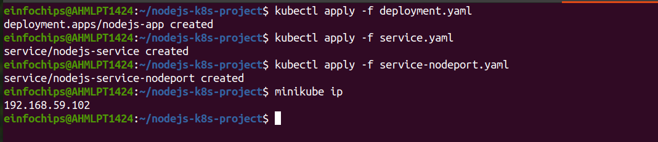
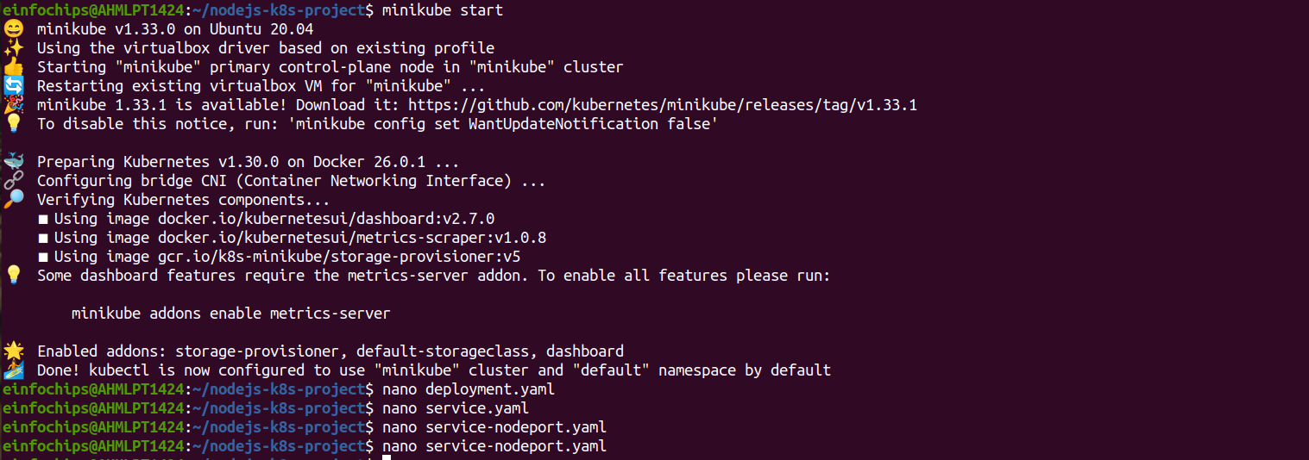

Making Changes to the Node.js Application
Create a New Branch for Changes
Create and switch to a new branch feature/update-message:
git checkout -b feature/update-message

Update the Application
Modify index.js to change the message:

Commit the Changes
Add and commit the changes:
git add .
git commit -m "Update main route message"

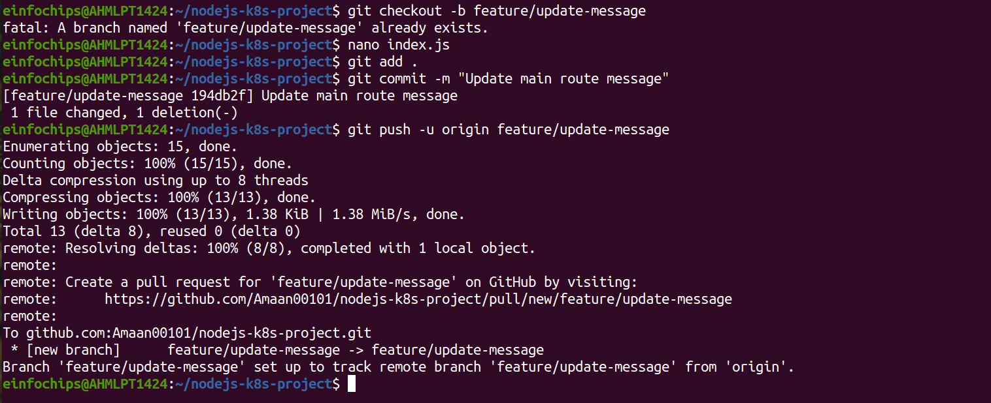

Merge the Changes and Rebuild the Docker Image
Merge the Feature Branch
Switch back to the main branch:
git checkout main
Merge the feature/update-message branch:
git merge --ff-only feature/update-message
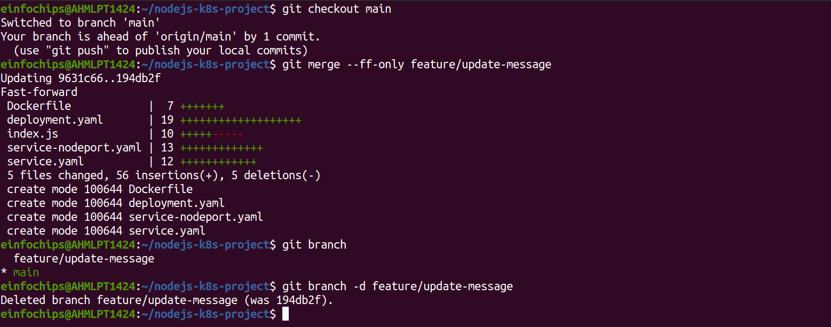
Delete the feature branch:
git branch -d feature/update-message
Rebuild the Docker Image
Rebuild the Docker image with a new tag:
docker build -t nodejs-k8s-app:v2 .

Update Kubernetes Deployment
Update the Deployment Manifest
Modify deployment.yaml to use the new image version:
image: nodejs-k8s-app:v2
Apply the updated deployment:
kubectl apply -f deployment.yaml

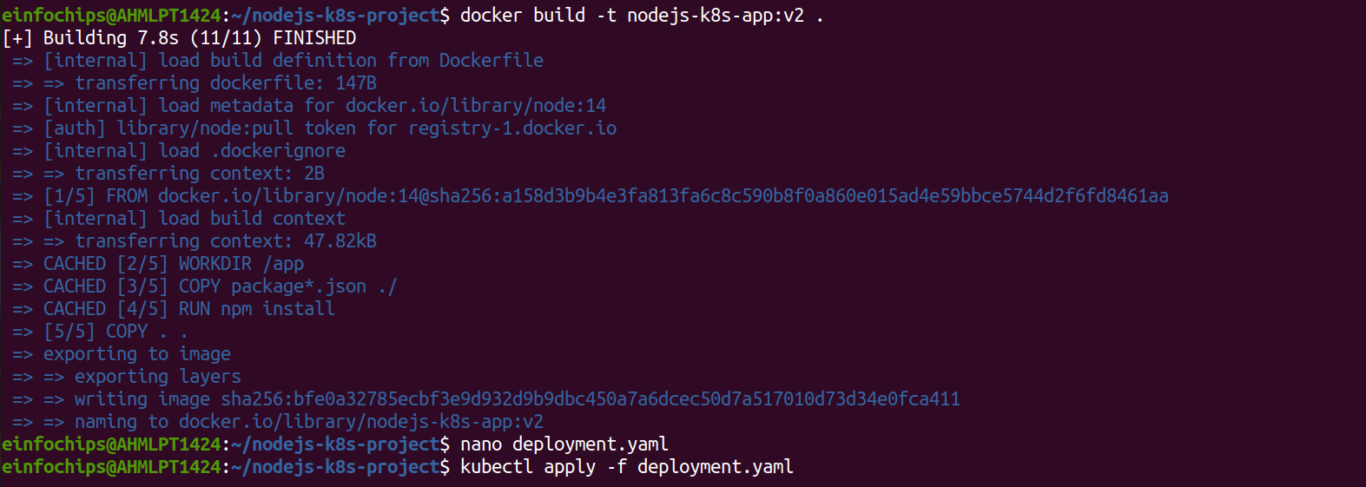
Verify the Update
Check the status of the deployment:
kubectl rollout status deployment/nodejs-app

Access the Updated Application
Access Through ClusterIP Service

Forward the port to access the ClusterIP service:
kubectl port-forward service/nodejs-service 7000:80
Open your browser and navigate to http://localhost:7000 to see the updated message.
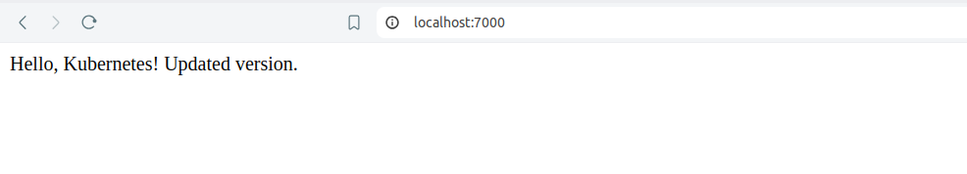
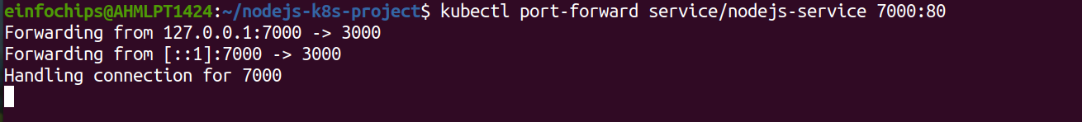
Access Through NodePort Service
Access the application using the NodePort:
curl http://<minikube-ip>:30001
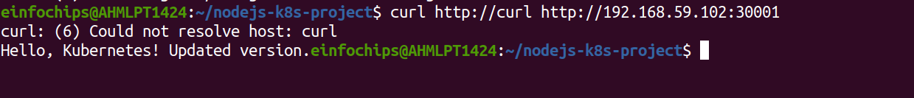

Project 02

Deploying a Python Flask App Using Minikube Kubernetes

Set Up Git Version Control
Initialize a Git Repository
Create a new directory for your project:
mkdir flask-k8s-project
cd flask-k8s-project
Initialize a Git repository:
sh
Copy code
git init
Create a Python Flask Application
Create a virtual environment:
python -m venv venv
source venv/bin/activate
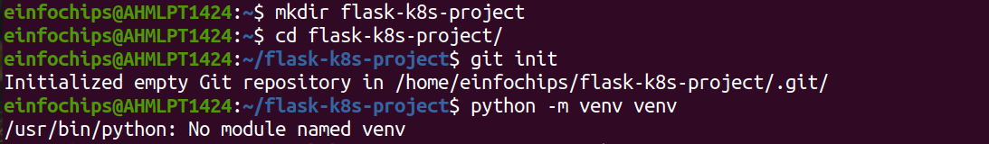
Install Flask:
sh
Copy code
pip install Flask

Create an app.py file with the following content: python
Create a requirements.txt file to list the dependencies:
Copy code
Flask

Create a .gitignore file to ignore venv:
Copy code
venv
Commit the Initial Code
Add files to Git:
git add .
Commit the changes:
git commit -m "Initial commit with Flask app"

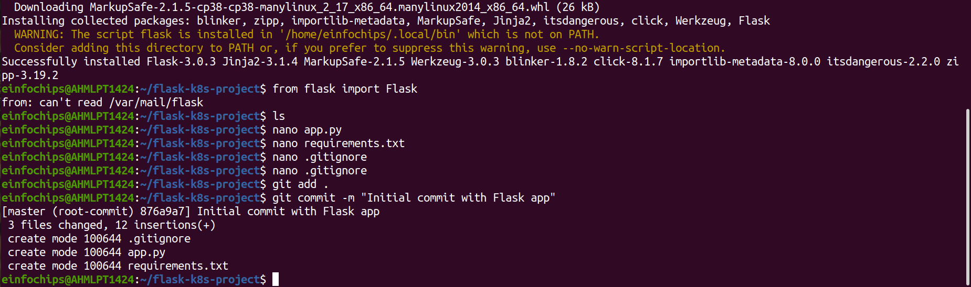
Branching and Fast-Forward Merge
Create a New Branch
Create and switch to a new branch feature/add-route:
git checkout -b feature/add-route
Implement a New Route
Modify app.py to add a new route:
@app.route('/newroute')
def new_route():
return 'This is a new route!'
Commit the changes:
git add .
git commit -m "Add new route"

Merge the Branch Using Fast-Forward
Switch back to the main branch:
git checkout main
Merge the feature/add-route branch using fast-forward:
git merge --ff-only feature/add-route
Delete the feature branch:
git branch -d feature/add-route
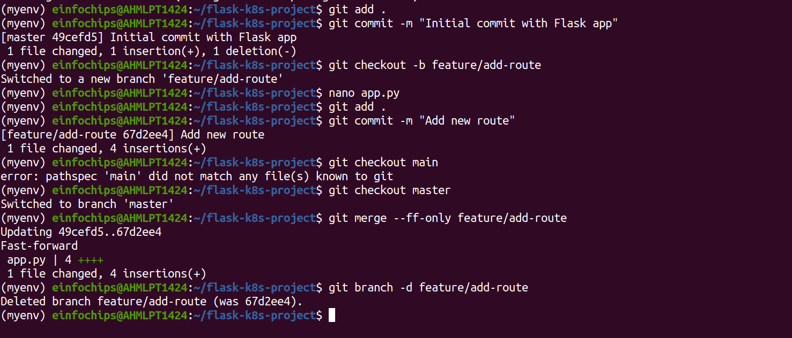
Containerize the Flask Application
Create a Dockerfile
Create a Dockerfile with the following content:
Build and Test the Docker Image
Build the Docker image:
docker build -t flask-k8s-app .

Run the Docker container to test:
docker run -p 5000:5000 flask-k8s-app
Access http://localhost:5000 to see the app running.

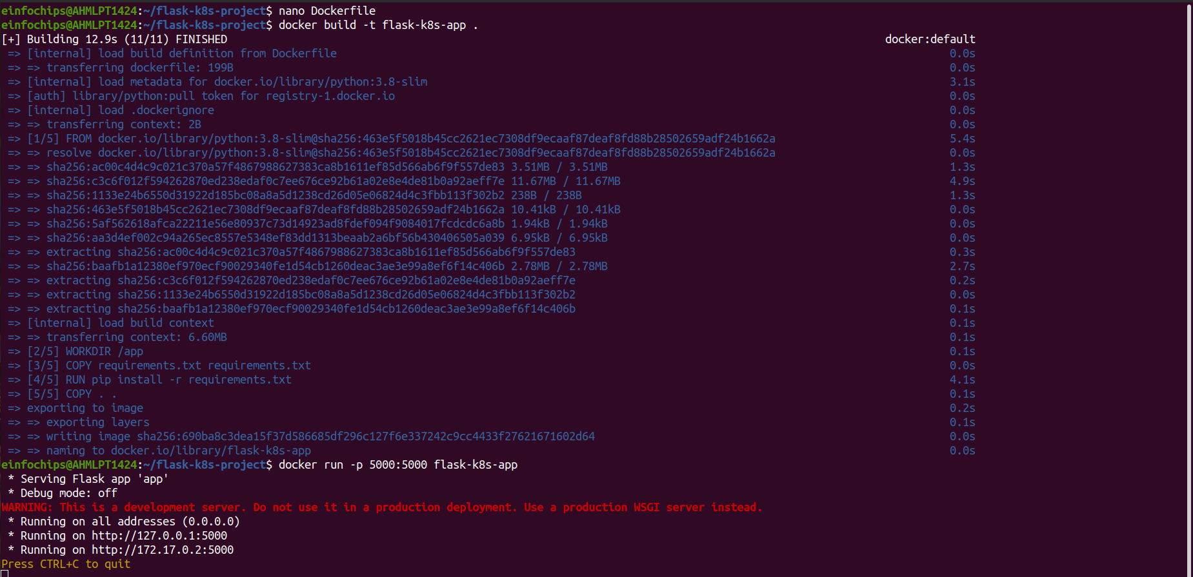

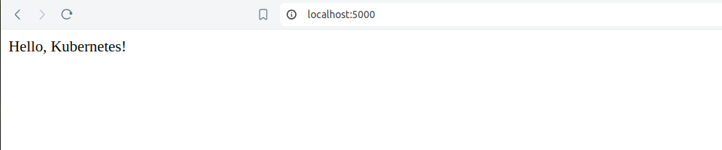

Deploying to Minikube Kubernetes
Start Minikube
minikube start
Create Kubernetes Deployment and Service Manifests
Create a deployment.yaml file:
Create a service.yaml file for ClusterIP:
Create a service-nodeport.yaml file for NodePort:

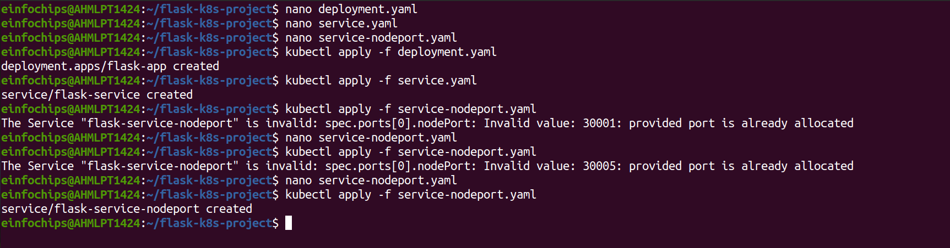
Apply the deployment:
kubectl apply -f deployment.yaml
Apply the ClusterIP service:
kubectl apply -f service.yaml
Apply the NodePort service:
kubectl apply -f service-nodeport.yaml
Access the Application
Get the Minikube IP:
minikube ip
Access the application using the NodePort:
curl http://<minikube-ip>:30001
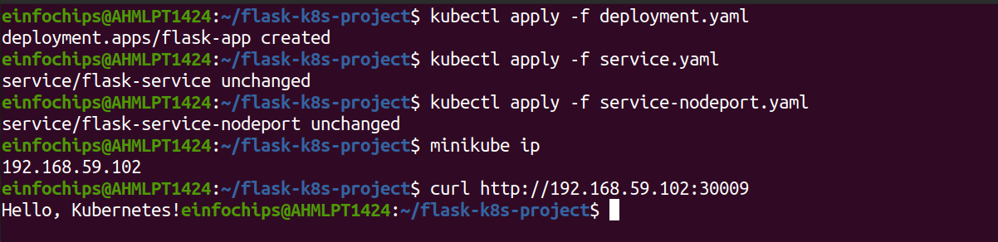

Making Changes to the Flask Application
Create a New Branch for Changes
Create and switch to a new branch feature/update-message:
git checkout -b feature/update-message
Update the Application
Modify app.py to change the message:
Commit the Changes
Add and commit the changes:
git add .
git commit -m "Update main route message"

Merge the Changes and Rebuild the Docker Image
Merge the Feature Branch
Switch back to the main branch:
git checkout main
Merge the feature/update-message branch:
git merge --ff-only feature/update-message

Delete the feature branch:
git branch -d feature/update-message

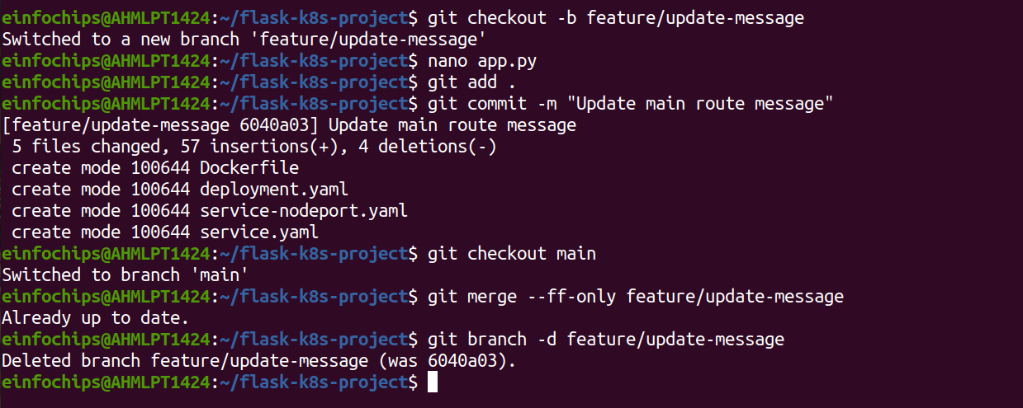
Rebuild the Docker Image
Rebuild the Docker image with a new tag:
docker build -t flask-k8s-app:v2 .

Update Kubernetes Deployment

Update the Deployment Manifest
Modify deployment.yaml to use the new image version:
Apply the Updated Manifest
kubectl apply -f deployment.yaml
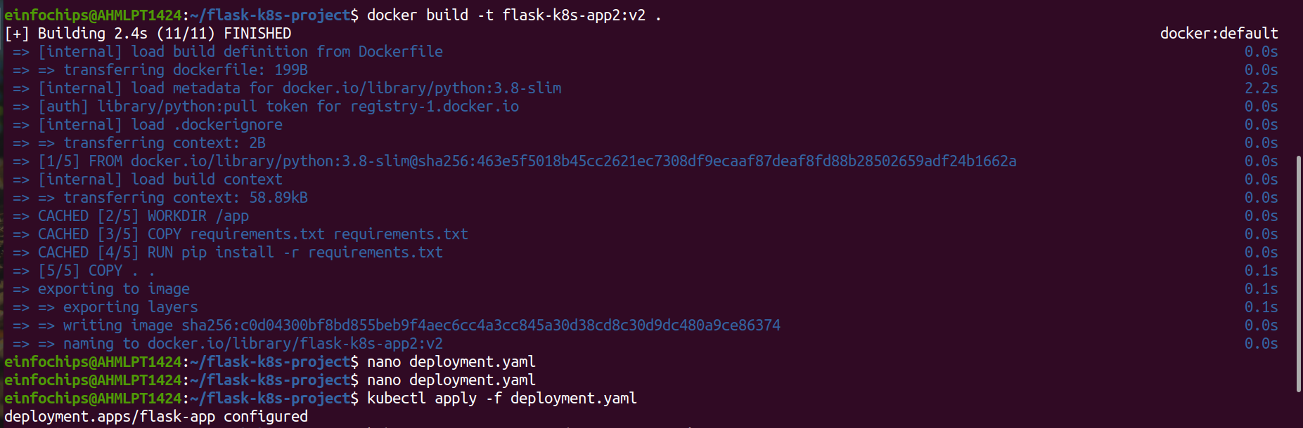

Verify the Update
Check the status of the deployment:
kubectl rollout status deployment/flask-app

Access the Updated Application
Access Through ClusterIP Service
Forward the port to access the ClusterIP service:
kubectl port-forward service/flask-service 8080:80
Open your browser and navigate to http://localhost:8080 to see the updated message.
Access Through NodePort Service
Access the application using the NodePort:
curl http://<minikube-ip>:30001

