Day-1 Comprehensive Linux Operations

Part 1: Creating and Editing Text Files

Create a file server_config.txt using Nano:

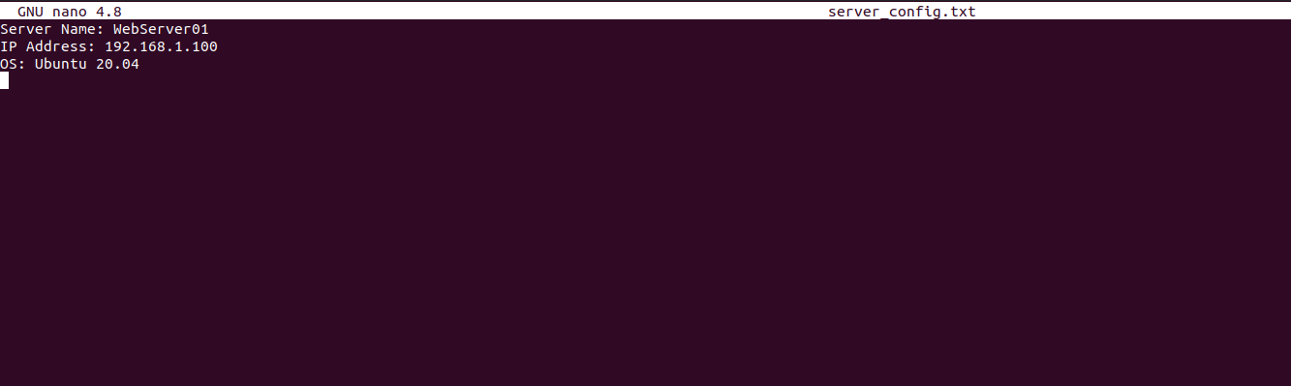
Part 2: User & Group Management
Adding/Removing Users

Create a group devteam:

Add the user developer to the devteam group:

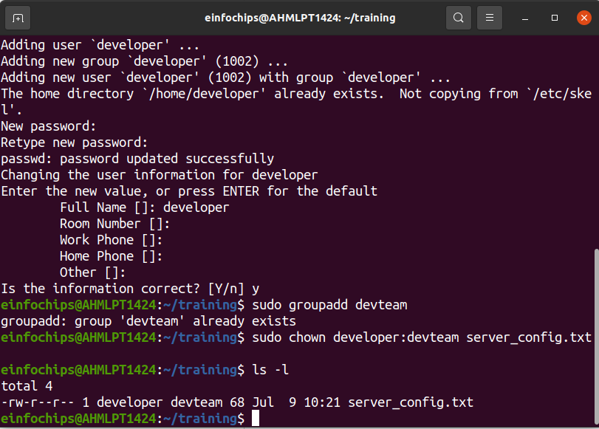
Part 3: File Permissions Management

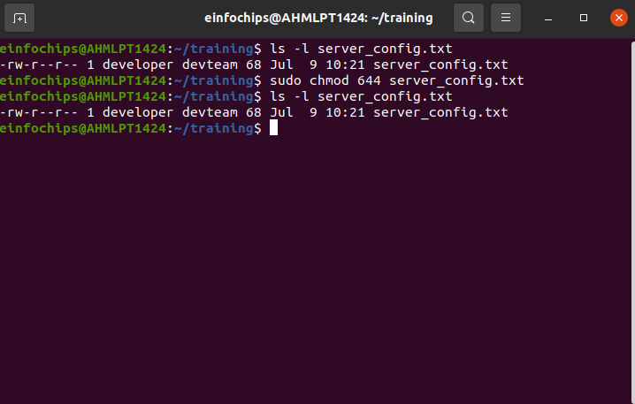
Part 4: Creating and Deploying a Static Website with Apache2

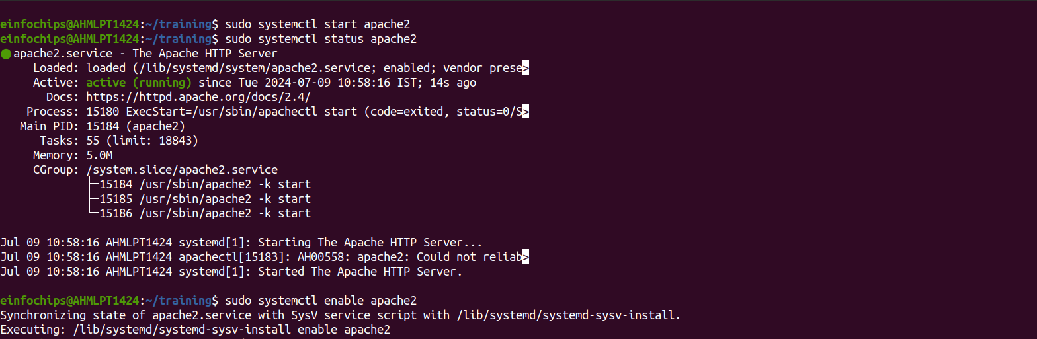
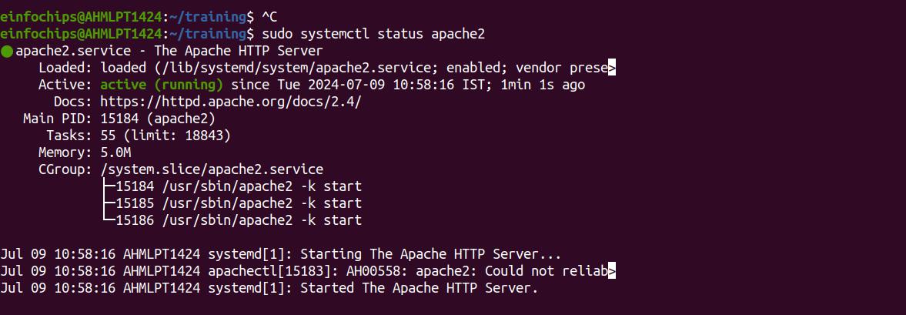
Part 5: Creating the Website

Navigate to the Web Directory
Create a New Directory for the Website
Change ownership of the directory:

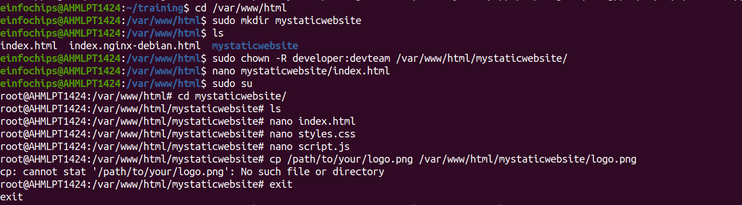

1. Create HTML File
Create and edit the index.html file:

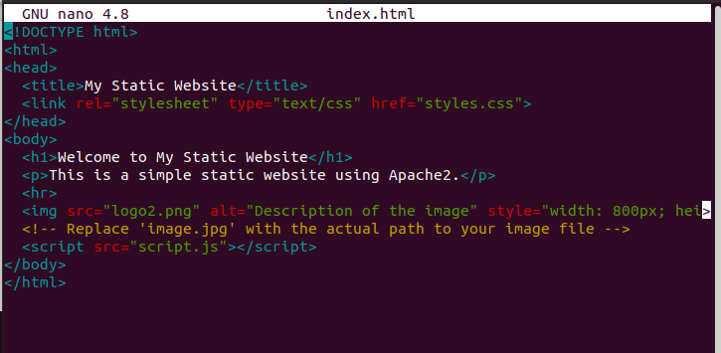

2. Create CSS File
Create and edit the styles.css file:

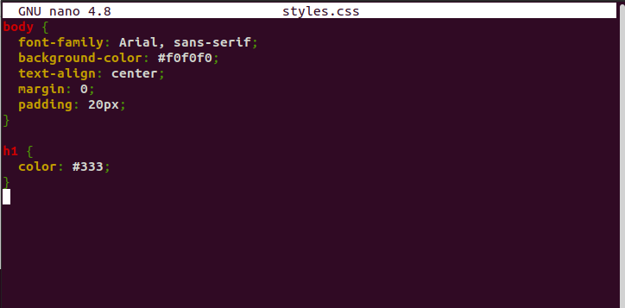
3. Create JavaScript File
Create and edit the script.js file:
Add also add an image to this directory:

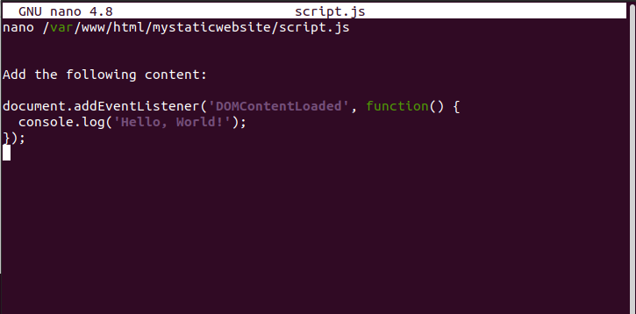

Part 6: Configuring Apache2 to Serve the Website

1. Create a Virtual Host File

Create and edit the virtual host configuration file:

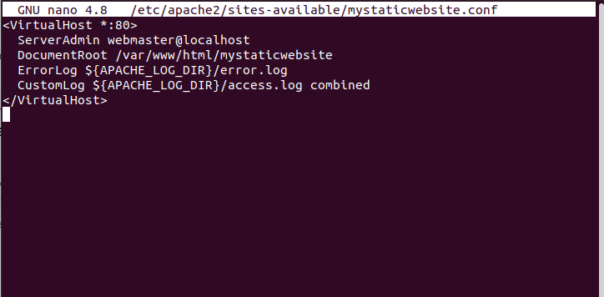

2. Enable the New Virtual Host
Enable the virtual host configuration:

3. Disable the Default Site
Disable the default site configuration:

4. Reload Apache2
Reload the Apache2 service to apply the changes:

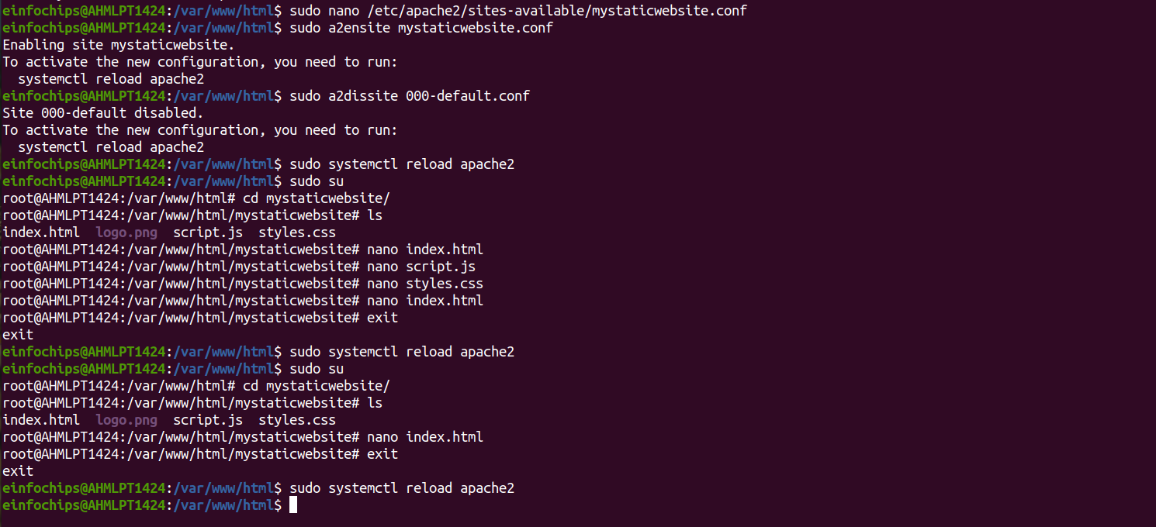
5. Test the Configuration
hit the ip u add your local syster and it shows your website

