Git project
Install Git: Ensure Git is installed on your system. Verify with git --version.
Set Up Git: Configure your Git username and email:
git config --global user.name "Your Name"
git config --global user.email "your.email@example.com"

Create a GitHub Repository:
Go to GitHub and create a new repository named website-project.
Clone the repository to your local machine:
git clone https://github.com/your-username/website-project.git

Initialize the Project:
Navigate to the project directory:
cd website-project

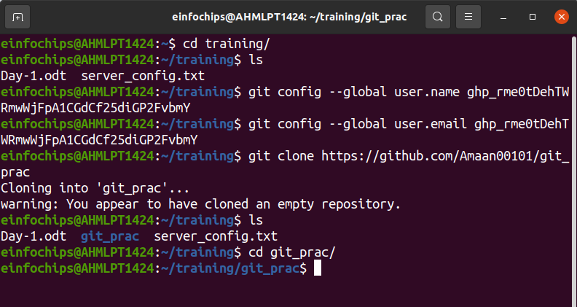
Create initial project structure:

mkdir src
touch src/index.html
echo "<!DOCTYPE html><html><head><title>My Website</title></head><body><h1>Welcome to my website!</h1></body></html>" > src/index.html

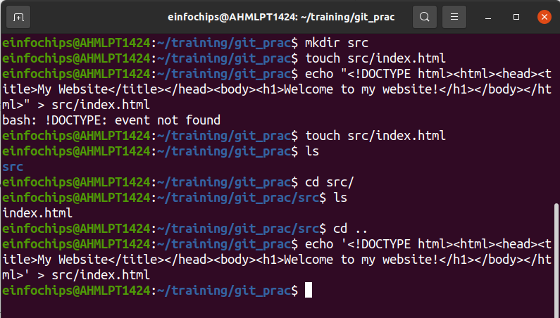

Commit and push the initial project structure:
git add .
git commit -m "Initial commit: Added project structure and index.html"
git push origin main

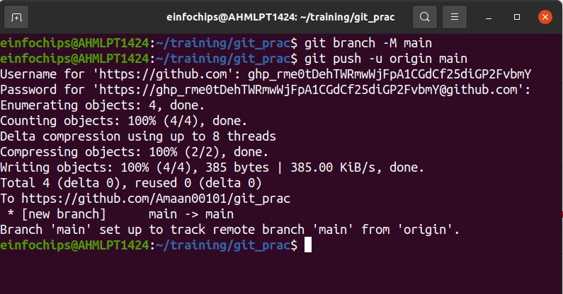
Exercise 1: Branching and Basic Operations (10 minutes)
Create a New Branch:
git checkout -b feature/add-about-page

Add a New Page:
Create about.html:
touch src/about.html
echo "<!DOCTYPE html><html><head><title>About Us</title></head><body><h1>About Us</h1></body></html>" > src/about.html

Commit and push changes:
git add src/about.html
git commit -m "Added about page"
git push origin feature/add-about-page

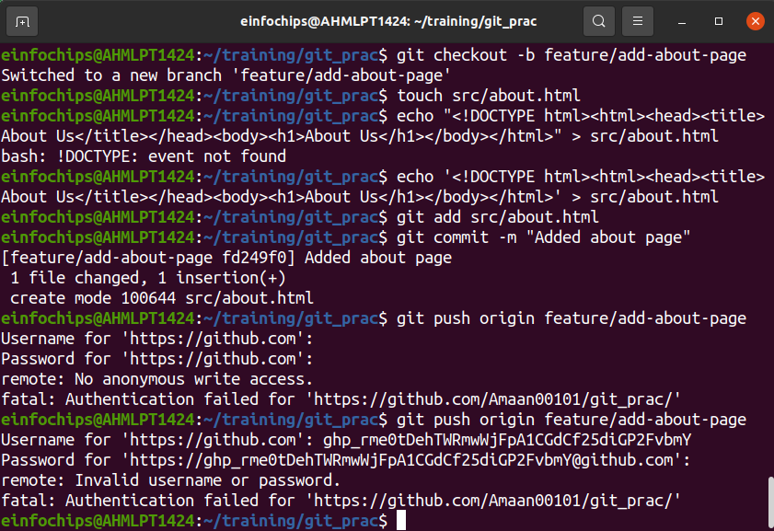
Exercise 2: Merging and Handling Merge Conflicts (15 minutes)
Create Another Branch:
git checkout main
git checkout -b feature/update-homepage

Update the Homepage:
Modify index.html:
echo "<p>Updated homepage content</p>" >> src/index.html

Commit and push changes:
git add src/index.html
git commit -m "Updated homepage content"
git push origin feature/update-homepage
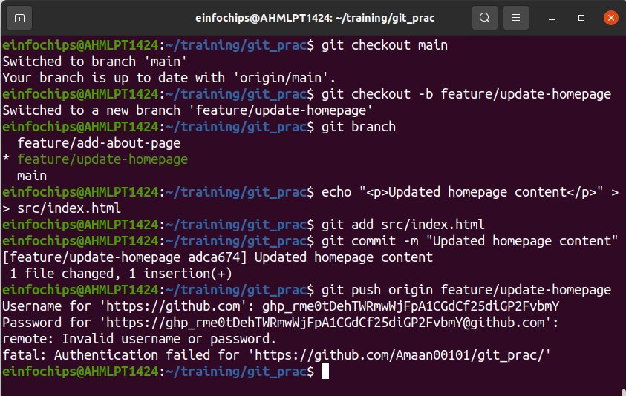

Create a Merge Conflict:
Modify index.html on the feature/add-about-page branch:
git checkout feature/add-about-page
echo "<p>Conflict content</p>" >> src/index.html
git add src/index.html
git commit -m "Added conflicting content to homepage"
git push origin feature/add-about-page

Merge and Resolve Conflict:
Attempt to merge feature/add-about-page into main:
git checkout main
git merge feature/add-about-page

Resolve the conflict in src/index.html, then:
git add src/index.html
git commit -m "Resolved merge conflict in homepage"
git push origin main
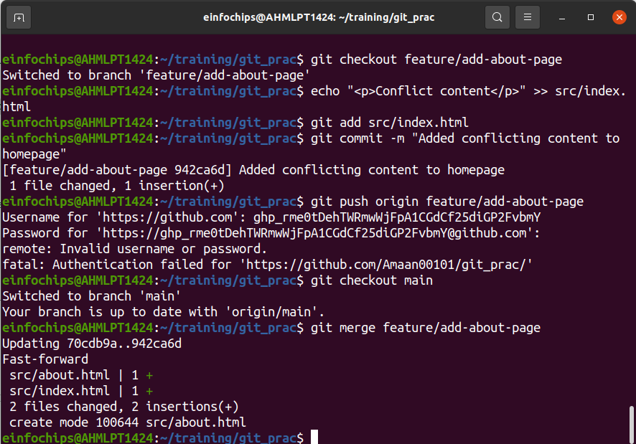
Exercise 3: Rebasing
Rebase a Branch:
Rebase feature/update-homepage onto main:
git checkout feature/update-homepage
git rebase main

Push the Rebased Branch:
git push -f origin feature/update-homepage

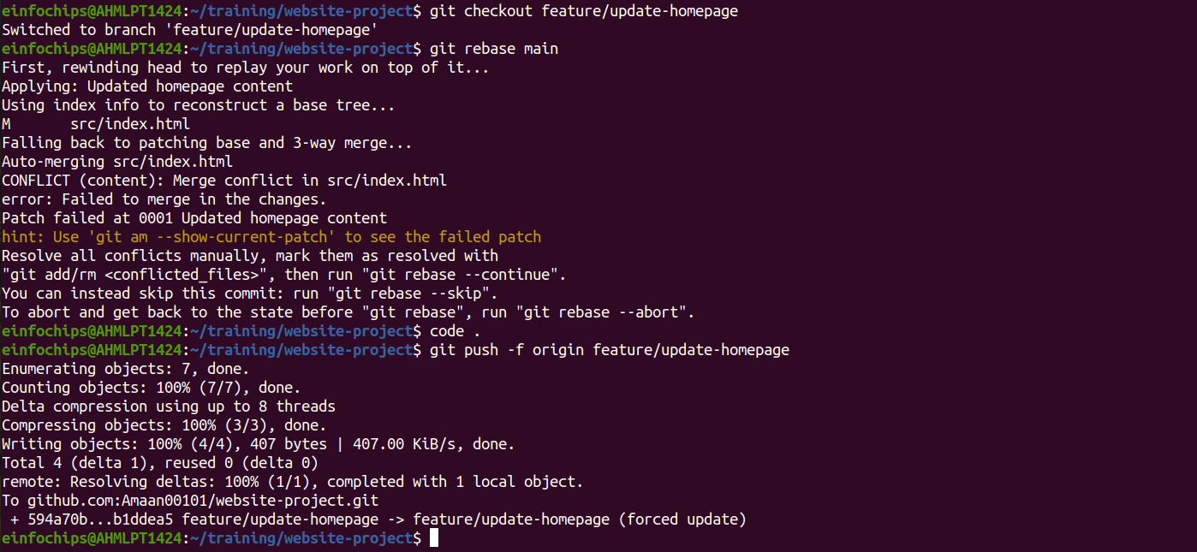
Exercise 4: Pulling and Collaboration
Pull Changes from Remote:
Ensure the main branch is up-to-date:
git checkout main
git pull origin main

Simulate a Collaborator's Change:
Make a change on GitHub directly (e.g., edit index.html).

Pull Collaborator's Changes:
Pull the changes made by the collaborator:
git pull origin main

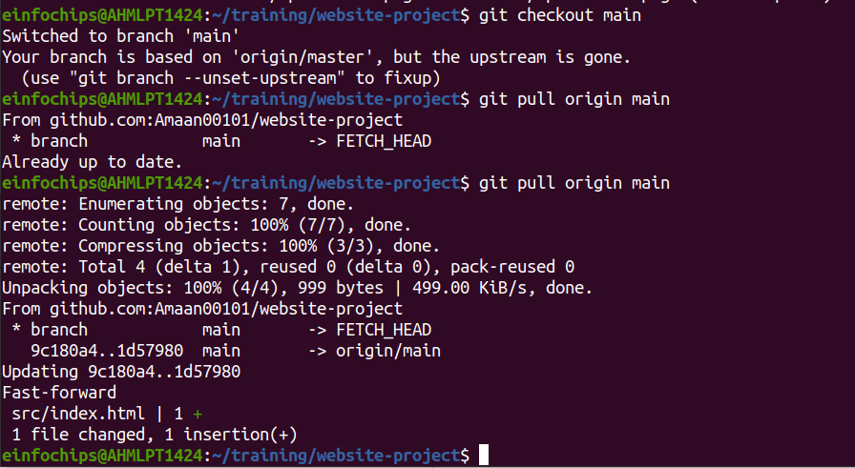
Exercise 5: Versioning and Rollback
Tagging a Version:
Tag the current commit as v1.0:
git tag -a v1.0 -m "Version 1.0: Initial release"
git push origin v1.0
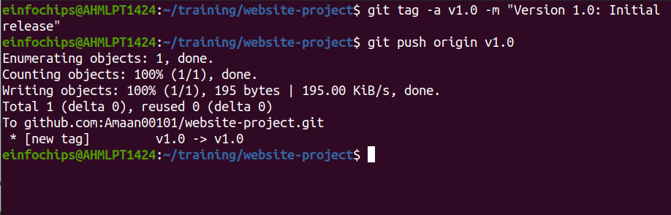
Make a Change that Needs Reversion:
Modify index.html:
echo "<p>Incorrect update</p>" >> src/index.html
git add src/index.html
git commit -m "Incorrect update"
git push origin main

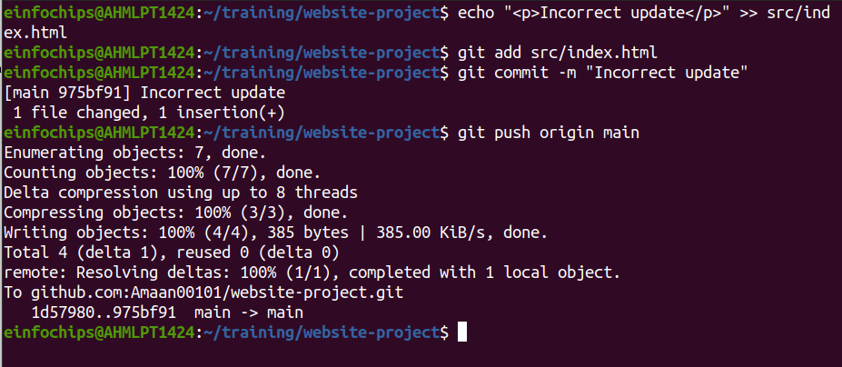
Revert to a Previous Version:
Use git revert to undo the last commit:
git revert HEAD
git push origin main

Alternatively, reset to a specific commit (use with caution): sh Copy code
git reset --hard v1.0
git push -f origin main

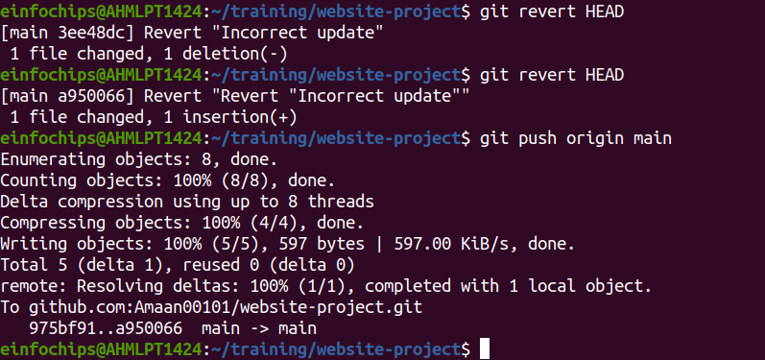

Extra Activities

Stashing Changes:
Make some local changes without committing:
echo "<p>Uncommitted changes</p>" >> src/index.html

Stash the changes:
git stash

Apply the stashed changes:
git stash apply

Viewing Commit History:
Use git log to view commit history:
git log –oneline

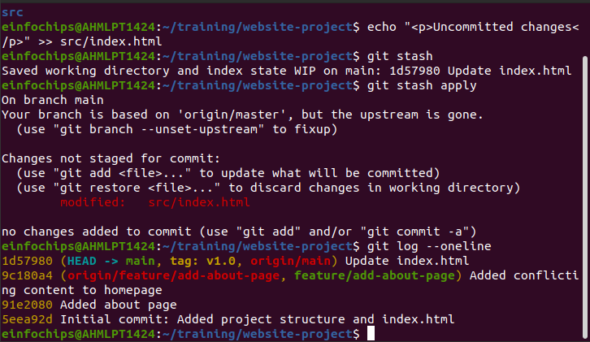

Cherry-Picking Commits:
Create a new branch and cherry-pick a commit from another branch:
git checkout -b feature/cherry-pick
git cherry-pick <commit-hash>
git push origin feature/cherry-pick

Interactive Rebase:
Use interactive rebase to squash commits:
git checkout main
git rebase -i HEAD~3
