Docker Project 01

Part 1: Creating a Container from a Pulled Image
Objective: Pull the official Nginx image from Docker Hub and run it as a container.
Pull the Nginx Image:
docker pull nginx

Run the Nginx Container:
docker run --name my-nginx -d -p 8080:80 nginx

Verify the Container is Running:
docker ps

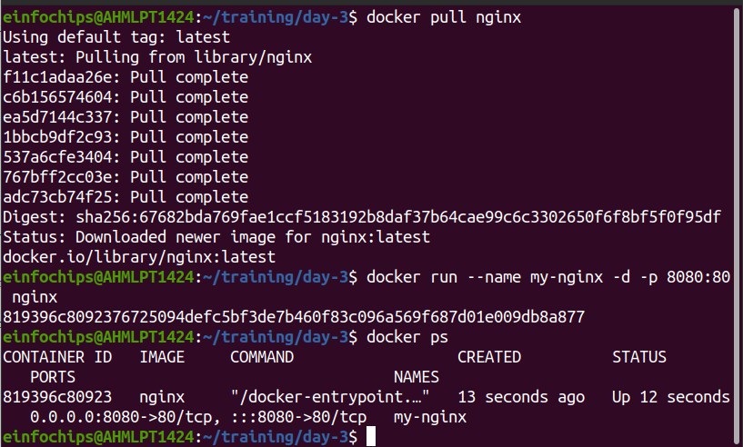
Part 2: Modifying the Container and Creating a New Image

Objective: Modify the running Nginx container to serve a custom HTML page and create a new image from this modified container.

Access the Running Container:
docker exec -it my-nginx /bin/bash

Create a Custom HTML Page:
echo "<html><body><h1>Hello from Docker!</h1></body></html>" > /usr/share/nginx/html/index.html
exit

Commit the Changes to Create a New Image:
docker commit my-nginx custom-nginx

Run a Container from the New Image:
docker run --name my-custom-nginx -d -p 8081:80 custom-nginx

Verify the New Container:
Visit http://localhost:8081 in your browser. You should see your custom HTML page.

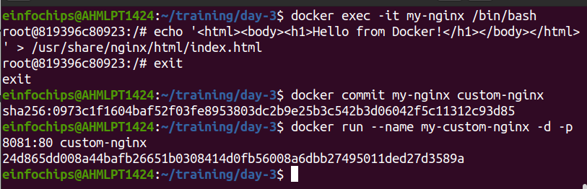
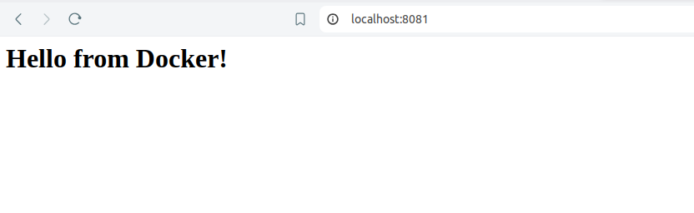
Part 3: Creating a Dockerfile to Build and Deploy a Web Application
Objective: Write a Dockerfile to create an image for a simple web application and run it as a container.
Create a Project Directory:
mkdir my-webapp
cd my-webapp

Create a Simple Web Application:
Create an index.html file:
<!DOCTYPE html>
<html>
<body>
<h1>Hello from My Web App!</h1>
</body>
</html>

write the Dockerfile:
Create a Dockerfile in the my-webapp directory with the following content:
# Use the official Nginx base image
FROM nginx:latest
# Copy the custom HTML file to the appropriate location
COPY index.html /usr/share/nginx/html/
# Expose port 80
EXPOSE 80

Build the Docker Image:
docker build -t my-webapp-image .

Run a Container from the Built Image:
docker run --name my-webapp-container -d -p 8082:80 my-webapp-image

Verify the Web Application:
Visit http://localhost:8082 in your browser. You should see your custom web application.

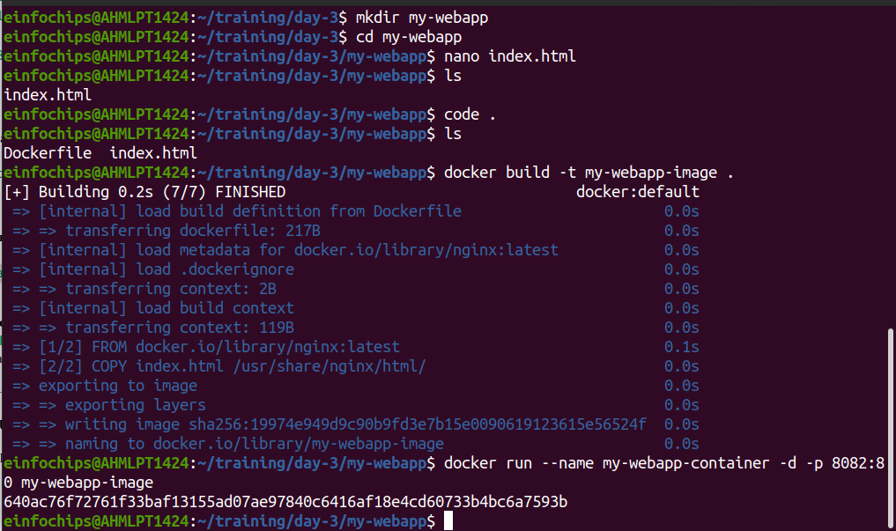
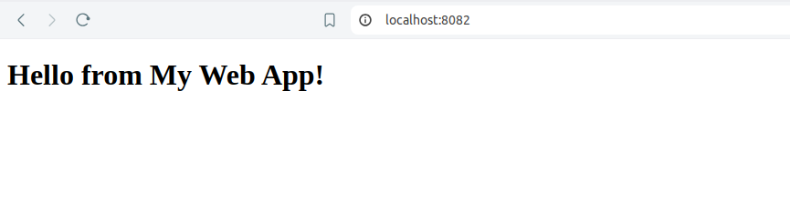

Part 4: Cleaning Up
Objective: Remove all created containers and images to clean up your environment.

Stop and Remove the Containers:
docker stop my-nginx my-custom-nginx my-webapp-container
docker rm my-nginx my-custom-nginx my-webapp-container

Remove the Images:
docker rmi nginx custom-nginx my-webapp-image

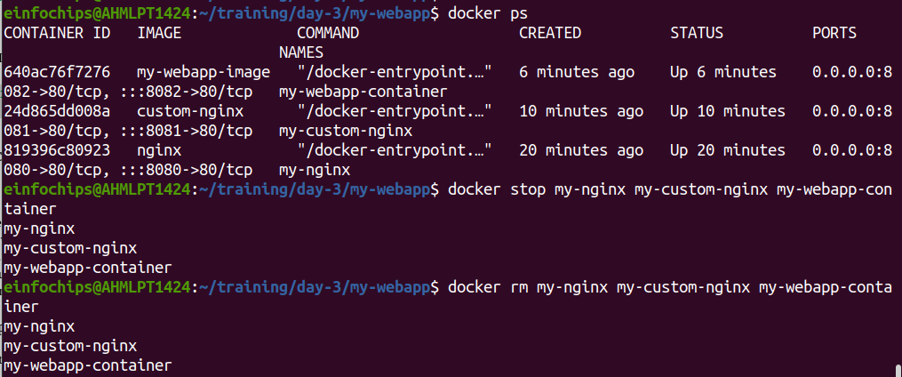

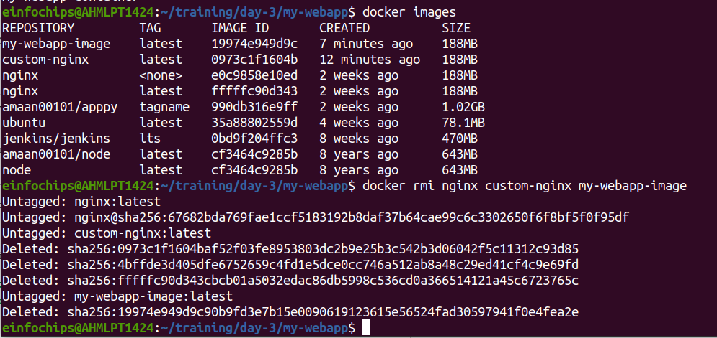

Docker Project 02

Part 1: Setting Up the Project Structure
Objective: Create a structured project directory with necessary configuration files.
Create the Project Directory:
mkdir fullstack-docker-app
cd fullstack-docker-app

Create Subdirectories for Each Service:
mkdir frontend backend database

Create Shared Network and Volume:
Docker allows communication between containers through a shared network.
docker network create fullstack-network

Create a volume for the PostgreSQL database.
docker volume create pgdata

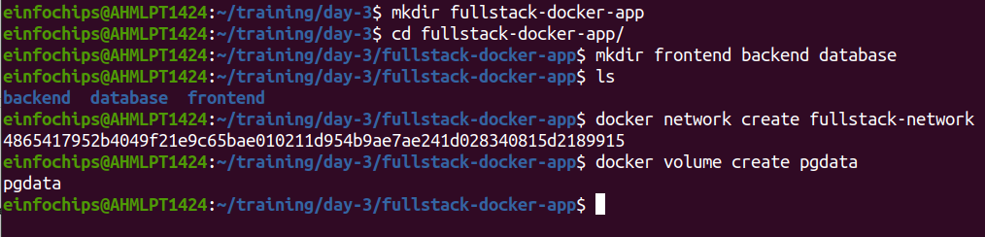

Part 2: Setting Up the Database
Objective: Set up a PostgreSQL database with Docker.
Create a Dockerfile for PostgreSQL:

ENV POSTGRES_USER=user
ENV POSTGRES_PASSWORD=password
ENV POSTGRES_DB=mydatabase

Build the PostgreSQL Image:
cd database
docker build -t my-postgres-db .
cd ..

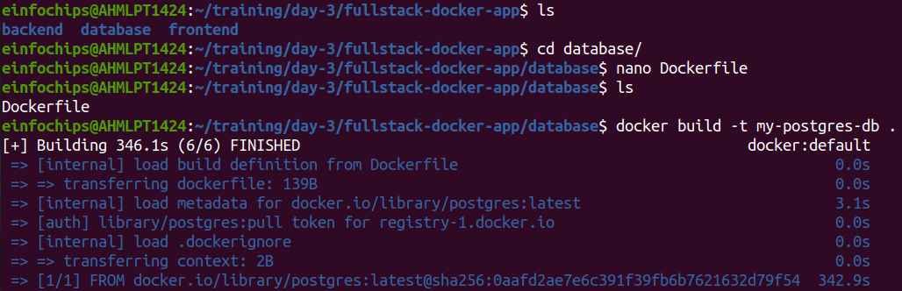
Run the PostgreSQL Container:

docker run --name postgres-container --network fullstack-network -v pgdata:/var/lib/postgresql/data -d my-postgres-db

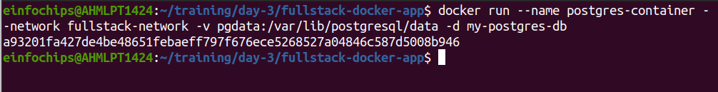

Part 3: Setting Up the Backend (Node.js with Express)
Objective: Create a Node.js application with Express and set it up with Docker.

Initialize the Node.js Application:
cd backend
npm init -y

Install Express and pg (PostgreSQL client for Node.js):
npm install express pg

Create the Application Code:
In the backend directory, create a file named index.js with the following content:

Create a Dockerfile for the Backend:
In the backend directory, create a file named Dockerfile with the following content:
FROM node:latest
WORKDIR /usr/src/app
COPY package*.json ./
RUN npm install
COPY . .
EXPOSE 3000
CMD ["node", "index.js"]

Build the Backend Image:
docker build -t my-node-app .
cd ..

Run the Backend Container:
docker run --name backend-container --network fullstack-network -d my-node-app

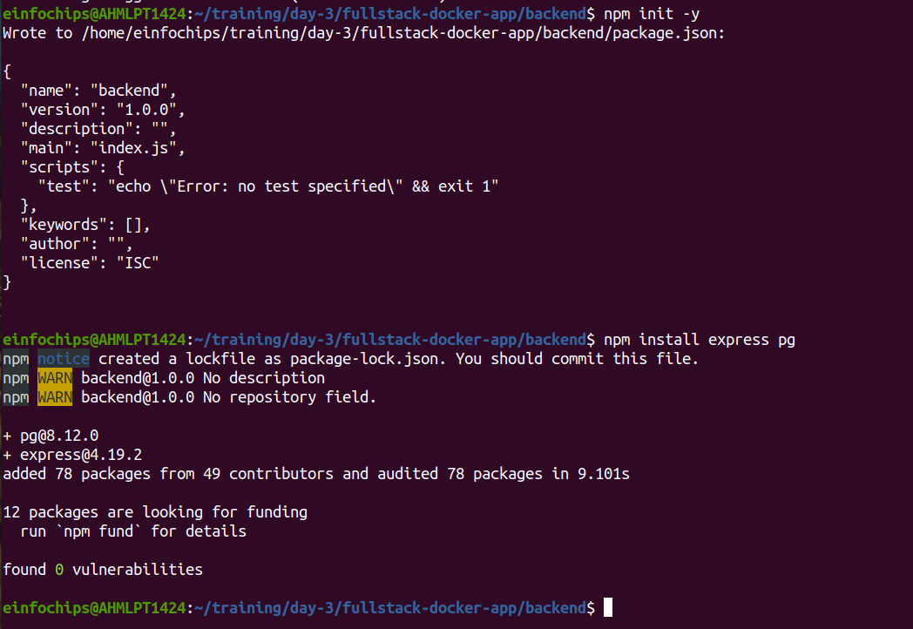
Part 4: Setting Up the Frontend (Nginx)
Objective: Create a simple static front-end and set it up with Docker.
Create a Simple HTML Page:
In the frontend directory, create a file named index.html with the following content:
<!DOCTYPE html>
<html>
<body>
<h1>Hello from Nginx and Docker!</h1>
<p>This is a simple static front-end served by Nginx.</p>
</body>
</html>

Create a Dockerfile for the Frontend:
In the frontend directory, create a file named Dockerfile with the following content:
FROM nginx:latest
COPY index.html /usr/share/nginx/html/index.html

Build the Frontend Image:
cd frontend
docker build -t my-nginx-app .
cd ..

Run the Frontend Container:
docker run --name frontend-container --network fullstack-network -p 8080:80 -d my-nginx-app

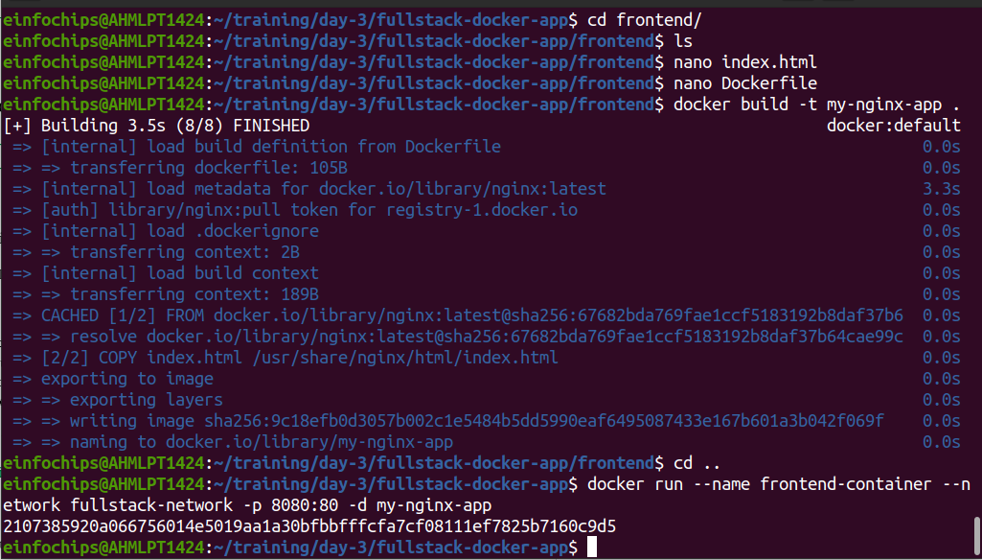

Part 5: Connecting the Backend and Database
Objective: Ensure the backend can communicate with the database and handle data requests.

Update Backend Code to Fetch Data from PostgreSQL:
Ensure that the index.js code in the backend handles /data endpoint correctly as written above.

Verify Backend Communication:
Access the backend container:
docker exec -it backend-container /bin/bash

Test the connection to the database using psql:
apt-get update && apt-get install -y postgresql-client
psql -h postgres-container -U user -d mydatabase -c "SELECT NOW();"

Exit the container:
exit

Test the Backend API:
Visit http://localhost:3000 to see the basic message.
Visit http://localhost:3000/data to see the current date and time fetched from PostgreSQL.

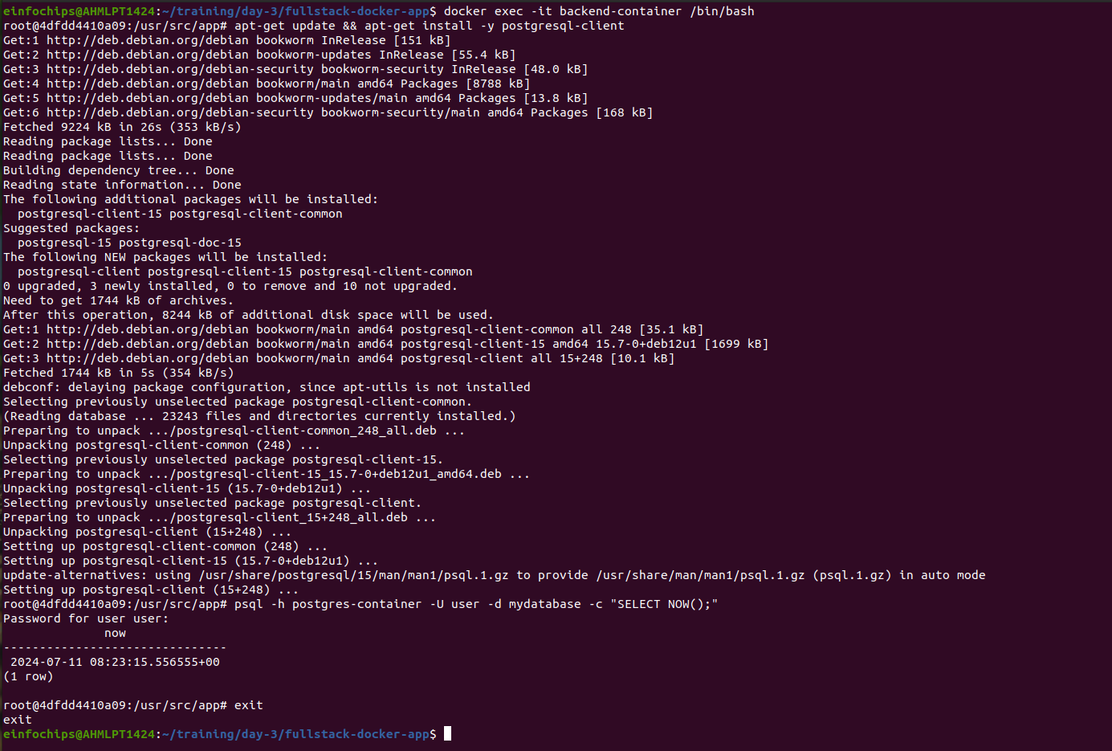
Part 6: Final Integration and Testing
Objective: Ensure all components are working together and verify the full-stack application.
Access the Frontend:
Visit http://localhost:8080 in your browser. You should see the Nginx welcome page with the custom HTML.

Verify Full Integration:
Update the index.html to include a link to the backend:
<!DOCTYPE html>
<html>
<body>
<h1>Hello from Nginx and Docker!</h1>
<p>This is a simple static front-end served by Nginx.</p>
<a href="http://localhost:3000/data">Fetch Data from Backend</a>
</body>
</html>

Rebuild and Run the Updated Frontend Container:
cd frontend
docker build -t my-nginx-app .
docker stop frontend-container
docker rm frontend-container
docker run --name frontend-container --network fullstack-network -p 8080:80 -d my-nginx-app
cd ..

Final Verification:
Visit http://localhost:8080 and click the link to fetch data from the backend.

