Project 01

Deploying a Scalable Web Application with Persistent Storage and Advanced Automation

Step 1: Set up Docker Swarm and Create a Service

Initialize Docker Swarm
# Initialize Docker Swarm
docker swarm init

Create a Docker Swarm Service
# Create a simple Nginx service in Docker Swarm
docker service create --name nginx-service --publish 8080:80 nginx
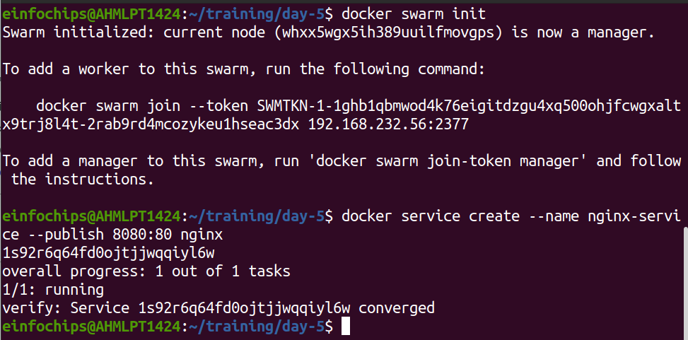
Step 2: Set up Kubernetes Using Minikube

Start Minikube
# Start Minikube
minikube start

Deploy a Web App on Kubernetes
Create a deployment file named webapp-deployment.yaml:

Apply the deployment:
kubectl apply -f webapp-deployment.yaml

Expose the Deployment
kubectl expose deployment webapp --type=NodePort --port=80
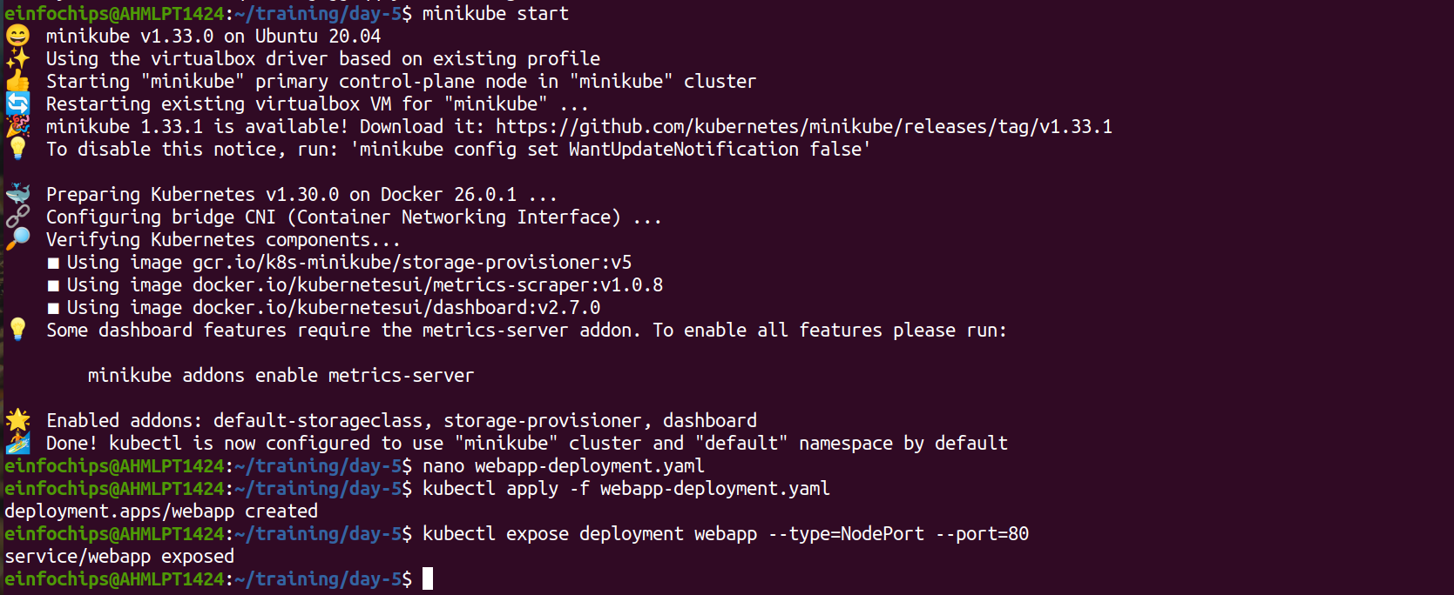
Step 3: Deploy a Web Application Using Docker Compose

Create a docker-compose.yml File
version: '3'
services:
web:
image: nginx
ports:
- "8080:80"
volumes:
- webdata:/usr/share/nginx/html
volumes:
webdata:

Deploy the Web Application

# Deploy using Docker Compose
docker-compose up -d

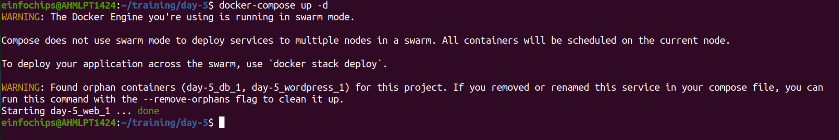

Step 5: Automate the Entire Process Using Advanced Shell Scripting

Create a Shell Script deploy.sh
#!/bin/bash
# Initialize Docker Swarm
docker swarm init
# Create Docker Swarm Service
docker service create --name nginx-service --publish 8080:80 nginx
# Start Minikube
minikube start
# Create Kubernetes Deployment
kubectl apply -f webapp-deployment.yaml
# Expose the Deployment
kubectl expose deployment webapp --type=NodePort --port=80
# Deploy Web App Using Docker Compose
docker-compose -f docker-compose-single-volume.yml up -d
echo "Deployment completed successfully!"

Make the Script Executable

# Make the script executable
chmod +x deploy.sh

Run the Script

# Run the deployment script
./deploy.sh

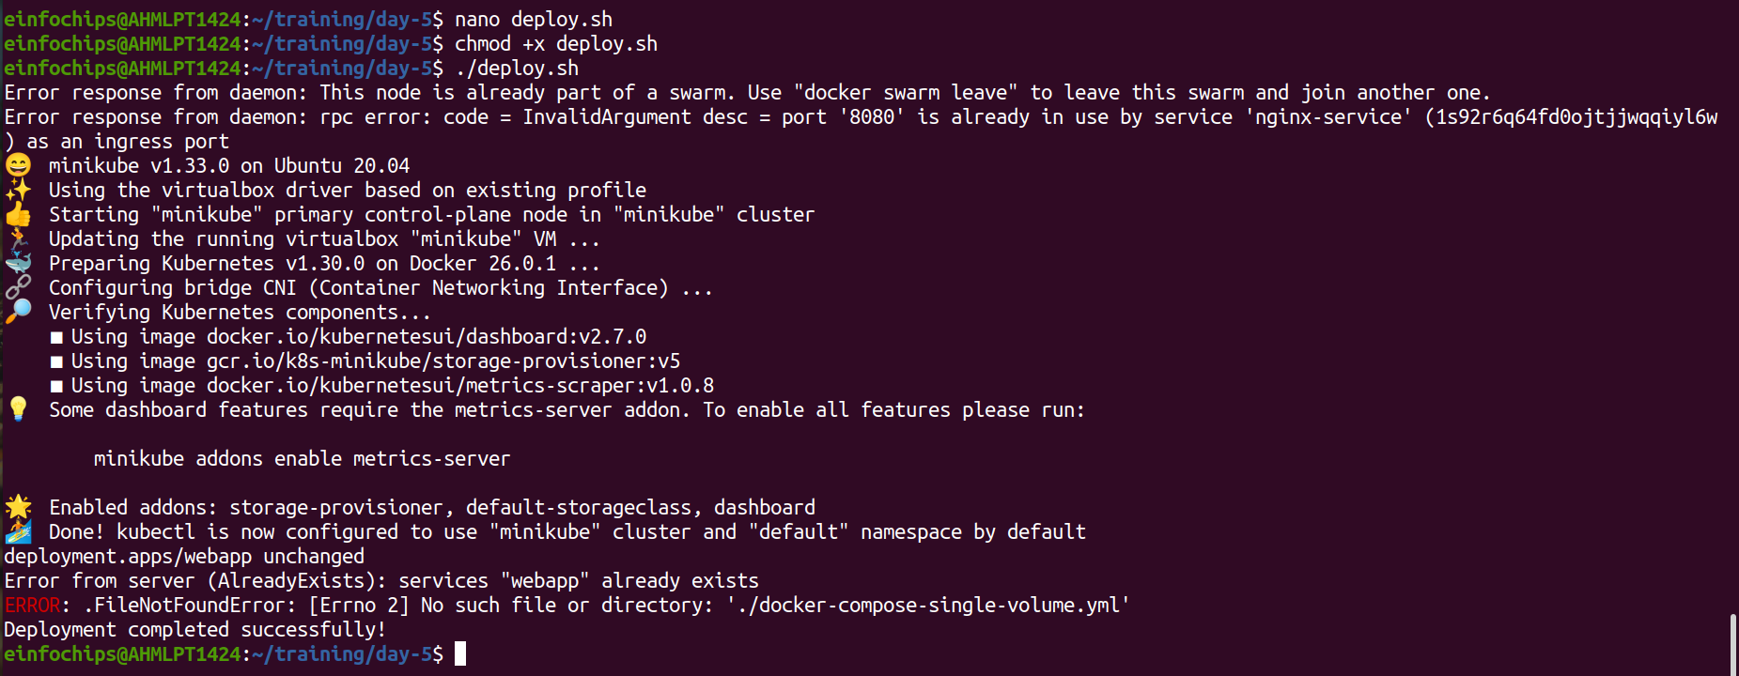
Project 02

Comprehensive Deployment of a Multi-Tier Application with CI/CD Pipeline

Step 1: Set up Docker Swarm and Create a Multi-Tier Service

Initialize Docker Swarm
# Initialize Docker Swarm
docker swarm init

Create a Multi-Tier Docker Swarm Service
Create a docker-compose-swarm.yml file:

Deploy the stack:
docker stack deploy -c docker-compose-swarm.yml myapp
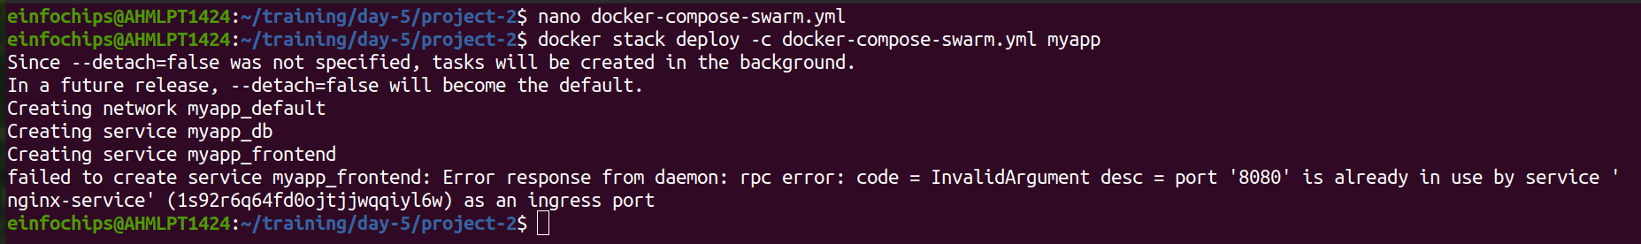
Step 2: Set up Kubernetes Using Minikube

Start Minikube
minikube start

Create Kubernetes Deployment Files

Create frontend-deployment.yaml:
Create backend-deployment.yaml:
Create db-deployment.yaml:
Create shared-pvc.yaml:
Create db-pvc.yaml:

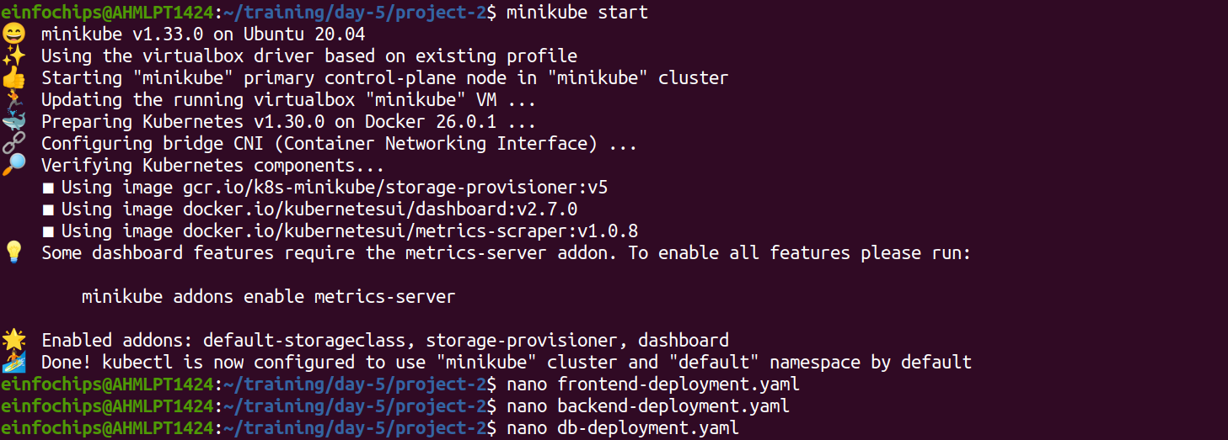

Apply the deployments:
kubectl apply -f shared-pvc.yaml
kubectl apply -f db-pvc.yaml
kubectl apply -f frontend-deployment.yaml
kubectl apply -f backend-deployment.yaml
kubectl apply -f db-deployment.yaml
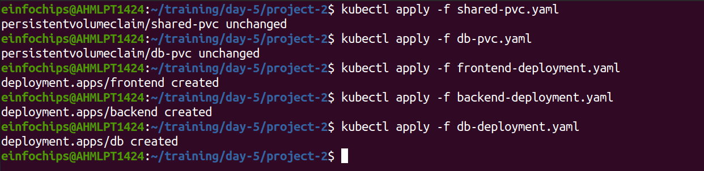

Step 3: Deploy a Multi-Tier Application Using Docker Compose

Create a docker-compose.yml File
# Creat Compose file
nano docker-compose.yml

Deploy the Application
# Deploy using Docker Compose
docker-compose up -d
