A PODCAST STREAMING WESBITE



By

Muhammad Ahmed
21-ARID-736

Amaan Waqar Qureshi
21-ARID-703

Supervisor
Dr. Bushra Hamid

University Institute of Information Technology,
PMAS-Arid Agriculture University, Rawalpindi Pakistan
2025

Bachelors of Software Engineering (2021-2025)

The candidate confirms that the work submitted is their own and appropriate
credit has been given where reference has been made to the work of others.

DECLARATION

We hereby declare that this software, neither whole nor as a part has been copied out from any source. It is further declared that we have developed this software documentation and accompanied report entirely on the basis of our personal efforts. If any part of this project is proved to be copied out from any source or found to be reproduction of some other. We will stand by the consequences. No Portion of the work presented has been submitted of any application for any other degree or qualification of this or any other university or institute of learning.

Muhammad Ahmed Amaan Waqar Qureshi

--------------------------- ---------------------------

CERTIFICATE OF APPROVAL

It is to certify that the final year project of BS (SE) “A Podcast Streaming Website” was developed by “Muhammad Ahmed, 21-Arid-736 “Amaan Waqar Qureshi, 21-Arid-703” under the supervision of “Dr. Bushra Hamid” and that in their opinion; it is fully adequate, in scope and quality for the degree of Bachelors of Software Engineering.

---------------------------------------

(Dr. Bushra Hamid)
Supervisor

---------------------------------------

(Mr. Azhar Manzoor)
Examiner I

---------------------------------------

(Mr. Suleman Khurram)
Examiner II

---------------------------------------
(Prof. Dr. Yaser Hafeez)
Director UIIT

Executive Summary

PodStream is a full-stack podcast streaming web application that allows users to upload, stream, and interact with podcast content through a modern and user-friendly interface. Built using React, Node.js, Express, and MongoDB, the platform supports both manual and Google-authenticated login, enabling users to like podcasts, post and delete comments, and subscribe to other users. The video player is implemented using video.js for seamless HLS streaming, and podcasts are categorized under sections like Business, Entertainment, Lifestyle, and Travel to improve content discovery.

The application features a dashboard with collapsible sections for each category, a detailed video player page with real-time view tracking, like counts, comment count, and a commenting system. Users can also download podcasts for offline access. Admin users are restricted from liking or subscribing to ensure content neutrality. With scalable architecture and a clean UI, PodStream offers a solid foundation for an engaging podcast platform with future-ready extensibility.

Acknowledgement

All praise is to Almighty Allah who bestowed upon us a minute portion of His boundless knowledge by virtue of which we were able to accomplish this challenging task.

We are greatly indebted to our project supervisor “Ms. Bushra Hamid” for personal supervision, advice, valuable guidance and completion of this project. We are deeply indebted to him for encouragement and continual help during this work.

And we are also thankful to our parents and family who have been a constant source of encouragement for us and brought us the values of honesty & hard work.

Muhammad Ahmed Amaan Waqar Qureshi

-------------------------------- -----------------------------

Table of Content
Chapter 1: Introduction 3
1.1 Brief 3
1.2 Relevance to Course Modules 3
1.3 Project Background 4
1.4 Literature Review 4
1.5 Analysis from Literature Review 5
1.6 Methodology and Software Lifecycle for This Project 6
1.6.1 Rationale Behind Selected Methodology 6
1.6.2 Rationale Behind Selected Software Lifecycle 6
1.7 Current System 7
1.7.1 Spotify 7
1.7.2 Apple Podcast 7
1.7.3 Youtube 7
Chapter 2: Problem Definition 8
2.1 Problem Statement 8
2.2 Purpose 8
2.3 Product Function 9
2.4 Proposed Architecture 9
2.4.1 Frontend 9
2.4.2 Backend 9
2.4.3 Database 10
2.5 Deliverables and Development Requirements 10
2.5.1 Deliverables 10
2.5.2 Development Requirements 10
2.6 Operating Environment 11
2.7 Assumptions and Dependencies 11
Chapter 3: Requirement Analysis 12
3.1 Functional Requirements 12
3.1.1 User Sign Up 12
3.1.2 Password Reset 12
3.1.3 Guest Podcast Streaming 12
3.1.4 Search By Genre 12
3.1.5 Like Podcast 13
3.1.6 Podcast Comments 13
3.1.7 Follow Creators 13
3.1.8 Create Playlists 13
3.2 Non-Functional Requirements 13
3.2.1 Encrypted Password Storage 13
3.2.2 JWT Authentication 13
3.2.3 Fast Search Response 13
3.2.4 Caching Mechanism 13
3.3 Traceability 14
3.4 Use cases 16
3.4.1 Diagram 17
3.4.2 Use case description 17
Chapter 4: Design and Architecture 25
4.1 Block Diagram 25
4.2 Component Diagram 26
4.3 Activity Diagram 27
4.5 ER Diagram 37
4.6 Class Diagram 38
4.7 State Transition Diagram 38
4.8 Deployment Diagram 41
Chapter 5: Implementation 42
5.1 Component Diagarm: 42
5.1.1 User component: 43
5.1.2 Admin Components: 43
5.1.3 Backend Components: 44
5.1.4 Database Components: 44
5.2 Network and Protocol Choice 44
5.2.1 Networking Layer 44
5.2.2 Protocols Used 45
5.3. Choice of Object Middleware: 45
5.3.1 Middleware Functions 45
Chapter 6: Testing And Evaluation 46
6.1 Verification 46
6.2 Validation 46
6.3 Usability Testing 46
6.4 Module / Unit Testing 46
6.5 Integration Testing 47
6.6 System Testing 47
6.7 Acceptance Testing 47
6.8 Stress Testing 47
6.9 Hardware Configureuration for Testing 47
6.10 Evaluation 47
6.11 Deployment 47
6.12 Maintenance 47
6.13 Test Cases 48
Chapter 7: Conclusion and Future Work 51
7.1 Conclusion 51
7.2 Future Work 52
References 53

List of Tables

Table 1.1:Bench marking 3
Table 3.1: Traceability Matrix 13
Table 3.2: Authorization 16
Table 3.3: get notifications 17
Table 3.4: Search Podcast 17
Table 3.5: Audio playback 18
Table 3.6: Like podcast 18
Table 3.7: report podcast 18
Table 3.8: Comment podcast 19
Table 3.9: Recommendations 19
Table 3.10: Download podcast 20
Table 3.11: Share Podcast 20
Table 3.13: Add to playlist 20
Table 3.14: View Users 21
Table 3.15: manage podcast 21
Table 3.16: manage users 22
Table 3.17: view reports 22
Table 6.1: Test case matrix 41

List of Figures

Figure 3.1:Use case 17
Figure 4.1: Block diagran 25
Figure 4.2: Component Diagram 26
Figure 4.3: Activity 1 27
Figure 4.4: Activity 2 27
Figure 4.5: Activity 3 27
Figure 4.6: Activity 4 28
Figure 4.7: Activity 5 28
Figure 4.8: Activity 6 29
Figure 4.9: ERD 37
Figure 4.10:Class diagram 38
Figure 4.11: STD 1 38
Figure 4.12: STD 2 39
Figure 4.13: STD 3 39
Figure 4.14: STD 4 40
Figure 4.15: STD 5 40
Figure 4.16: STD 6 41
Figure 4.17: Deployment diagram 41

Chapter 1: Introduction
In the age of digital content, podcasts have emerged as one of the most engaging and accessible forms of media, catering to diverse interests and audiences worldwide. Our Podcast Streaming Platform is designed to revolutionize the way users discover, listen to, and share podcasts, addressing the limitations of existing solutions. Built with a user-centric approach, it delivers seamless streaming, AI-driven personalized recommendations, and robust offline capabilities to ensure an uninterrupted listening experience. The interface is intuitive, visually appealing, and optimized for both desktop and mobile devices, making navigation effortless for users of all technical backgrounds. Social sharing features and community engagement tools encourage interaction and foster a thriving podcast ecosystem. By combining performance, accessibility, and innovation, the platform not only enhances the listening experience but also empowers creators to reach and engage their audiences more effectively.

1.1 Brief
Podstream is an all-in-one podcast streaming platform designed for both creators and listeners. It allows users to watch, listen to, upload, comment on, share, like, download, and follow podcast content with ease. The platform supports both registered users and guests, providing a seamless experience for casual listeners and dedicated subscribers alike.
Podstream features a powerful admin panel for managing users, content, and platform moderation. It integrates an advanced API that fetches and filters relevant podcast content from YouTube, ensuring that only high-quality and appropriate material is showcased on the platform.

1.2 Relevance to Course Modules
This project aligns with several key areas of software engineering, including [1]:
- Web Development: Creating an interactive and user-friendly interface.
- Backend Development: Structuring an efficient system to handle requests and data management.
- Database Management: Organizing and maintaining structured data storage.
- User Authentication: Implementing secure access control mechanisms.
- System Design: Developing a scalable and maintainable architecture.
- UI/UX Design: Ensuring a smooth and intuitive user experience.
- API: Implementing Backend API processing
By working on PodStream, we gain hands-on experience in these areas, making it a comprehensive learning opportunity.

1.3 Project Background
The idea for PodStream emerged from the explosive growth of the podcast industry and the noticeable limitations in existing mainstream platforms. While services like Spotify, Apple Podcasts, and even YouTube offer basic podcast streaming functionality, they often fall short in several key areas—such as advanced offline support, interactive user engagement, content discovery, and creator-focused tools.
PodStream was designed to fill these gaps by offering a centralized, feature-rich environment tailored specifically for podcast consumers and creators. With capabilities like real-time comments, episode-based feedback, customized playlists, robust offline access, and highly personalized recommendations, it delivers a more dynamic and immersive experience.
Moreover, PodStream introduces tools that empower creators—such as in-depth analytics, monetization options, and community-building features, encouraging the growth of independent podcast channels. Its clean interface, AI-driven curation, and multi-device accessibility position it as a strong competitor to current market leaders.
By focusing on what top platforms lack, PodStream doesn't just aim to coexist—it aims to disrupt and redefine the podcast streaming experience, raising the bar for content quality, accessibility, and user satisfaction.

1.4 Literature Review

Table 1.1 Benchmarking

1
Platform | limitations | Features
Spotify | Large podcast library, personalized recommendations, cross-platform support | Limited offline features for free users, lacks dedicated podcast engagement tools
Apple podcast | Seamless Apple ecosystem integration, user-friendly interface | No support for Android, minimal engagement features (no likes, comments, shares)
Youtube | Video-based podcasts, high discoverability, strong engagement (comments, likes, shares) | Not a dedicated podcast platform, no structured episode management, requires video playback
Amazon music | Includes podcasts alongside music, personalized recommendations | Limited engagement features, not widely recognized as a primary podcast platform
CastBox | Advanced offline support, in-app social interaction, customizable playlists | Less popular compared to mainstream platforms, interface can be complex
Pocket cast | Smart playlists, offline downloads, cross-device sync | Subscription required for premium features, limited social engagement tools
Pod bean | Podcast hosting and streaming, built-in monetization options | UI is less intuitive compared to competitors, free version has content limits

1.5 Analysis from Literature Review
The analysis of existing literature and platforms highlights several key gaps that PodStream aims to address. Our analysis is as follows;

Enhancing User Engagement
Unlike video platforms such as YouTube, where users can like, comment, and share, most podcast platforms provide minimal engagement options. PodStream will incorporate robust social interaction features, allowing users to connect with creators and other listeners.

Improving Offline Capabilities
A major drawback of existing services is the restricted offline functionality. Many platforms limit downloads behind a paywall, restricting accessibility. PodStream will prioritize offline support as a key feature, allowing users to manage their downloads more efficiently.

Advanced Personalization and Content Discovery
Current podcast recommendation systems rely mainly on basic listening history, leading to repetitive suggestions. PodStream will implement a more sophisticated personalization system that considers user interactions, preferences, and content engagement patterns.

1.6 Methodology and Software Lifecycle for This Project
The methodology we chose for our project is AGILE and life cycle we chose is Iterative.

1.6.1 Rationale Behind Selected Methodology
The Agile methodology was chosen due to its iterative and user-centric approach, allowing for continuous improvements based on real-time feedback. This methodology provides:
- Flexibility: Adapts to changing requirements and user needs.
- Frequent Iterations: Ensures regular testing and feedback loops.
- Improved User Experience: Continuous refinement enhances functionality and usability.
Given that PodStream is a content-driven platform, Agile ensures that features are developed and refined incrementally, prioritizing user satisfaction and system efficiency.

1.6.2 Rationale Behind Selected Software Lifecycle
The Incremental Model was selected as the software development lifecycle because it enables structured feature-by-feature implementation. This approach provides:
- Early Releases: Users can access core features in initial versions, ensuring functionality is available sooner.
- Systematic Testing: Each increment is tested before integration, reducing the risk of major system failures.
- Better Manageability: Development is broken into smaller, manageable modules, making debugging and optimization easier.

1.7 Current System
Existing podcast platforms provide a variety of features, but each has limitations that impact the overall user experience. The current systems include:

1.7.1 Spotify
  - Features: Offers a large podcast library, personalized recommendations, and multi-device syncing.
  - Limitations: Lacks a dedicated podcast community, offers limited engagement features, and has basic offline support that requires premium membership.

1.7.2 Apple Podcast
  - Features: Seamless integration with Apple devices, easy-to-use interface, and access to a broad range of podcasts.
  - Limitations: No availability on Android, limited engagement options (no likes or shares), and no community-building features.

1.7.3 Youtube
  - Features: Allows video-based podcasts, easy accessibility, and strong community interaction through comments and likes.
  - Limitations: No dedicated podcast experience, no structured episode organization, and lacks offline audio downloads for free users.
- Dedicated podcast community features (likes, comments, follows, and shares).
- Advanced offline capabilities for both video and audio podcasts.
- Personalized recommendations based on user listening history and preferences.
- A seamless and engaging user experience tailored specifically for podcast listeners.

Chapter 2: Problem Definition
Despite the growing popularity of podcasts, many existing platforms lack essential features that address the needs of both listeners and content creators. Listeners often encounter limited offline listening options, poor content discovery mechanisms, and minimal personalization, which reduce engagement and satisfaction. Search functions may be basic or inaccurate, making it difficult to explore niche topics or discover emerging creators. On the other hand, podcast creators face challenges with visibility, limited audience engagement tools, and the absence of intuitive dashboards to upload, organize, and manage their content effectively. Monetization opportunities are often unclear or inaccessible, discouraging creators from investing in high-quality productions. These limitations result in an experience that is less inclusive, less interactive, and less rewarding for both ends of the spectrum, ultimately slowing the growth and innovation of the podcasting community.

2.1 Problem Statement
The podcast industry has grown exponentially, but existing streaming platforms fail to provide a comprehensive user experience that balances accessibility, engagement, and personalization. While platforms like Spotify, Apple Podcasts, and Google Podcasts offer basic streaming capabilities, they lack robust offline features, interactive engagement tools, and advanced content discovery mechanisms. Many users face limitations in exploring new podcasts, interacting with creators, and managing offline content without premium subscriptions.
Additionally, podcast creators struggle with audience engagement, as most platforms do not provide effective tools for interaction beyond passive listening. As a result, there is a need for a dedicated podcast streaming platform that enhances user experience through improved accessibility, engagement, and content discovery while maintaining seamless offline functionality.

2.2 Purpose
The primary objective is to develop PodStream, a podcast streaming platform designed to address the shortcomings of existing services. The platform will focus on:
- Enhancing Offline Access – Providing unrestricted offline downloads without requiring a premium subscription.
- Improving User Engagement – Integrating interactive features like likes, comments, and follows to create a community-driven experience.
- Advanced Personalization – Implementing a recommendation system that considers user behavior and preferences to enhance content discovery.
- Optimizing Content Management – Offering efficient podcast organization and search features to simplify user navigation.
- Bridging Creator-Listener Interaction – Facilitating direct engagement between creators and listeners to improve audience connection.
By addressing these objectives, PodStream aims to create a more interactive and user-friendly podcast streaming experience.

2.3 Product Function
- Audio and Video Streaming: Users can stream podcasts in both formats.
- Offline Downloads: Registered users can download podcasts for offline access.
- User Engagement: Users can like, comment, share, and follow podcast creators.
- Search and Discovery: Users can search for podcasts by title, genre, or creator.
- Personalized Recommendations: AI-driven suggestions based on listening history.
- Playlist Management: Users can create and manage custom playlists.
- Admin Controls: Admins can manage user accounts, content, and reports.

2.4 Proposed Architecture

PodStream is built on the MERN stack, a modern and efficient technology stack that ensures scalability, performance, and ease of development. The architecture is divided into three main layers: [2]

2.4.1 Frontend
  - Built using React.js, a powerful JavaScript library for building dynamic and responsive user interfaces.
  - Ensures a seamless and interactive user experience across devices.

2.4.2 Backend
  - Powered by Node.js and Express.js, a lightweight and efficient framework for building RESTful APIs.
  - Handles business logic, user authentication, and communication between the frontend and database.

2.4.3 Database
  - Uses MongoDB, a NoSQL database, for storing user data, podcast metadata, playlists, and engagement details.
  - Provides flexibility and scalability for handling large volumes of data.
This architecture ensures a robust, modular, and maintainable system, perfectly suited for a feature-rich platform like PodStream.

2.5 Deliverables and Development Requirements

2.5.1 Deliverables

The following key deliverables are expected from the project:
- Fully Functional PodStream Platform
Web-based platform with audio and video streaming capabilities. Secure authentication system for registered users. Admin dashboard for moderation and content management
- Technical Documentation
System architecture and design documentation. API documentation for backend services. User manual for platform navigation.
- Testing and Evaluation Reports
Unit, integration, and system testing reports. User feedback and usability analysis.

2.5.2 Development Requirements

The development of PodStream requires:
- Frontend Development: Implementation of an intuitive UI for seamless navigation.
- Backend Development: Creation of APIs and database management for content handling.
- Security Measures: Implementation of user authentication, encryption, and content protection.
- Database Management: Efficient storage and retrieval of user and podcast data.
- Performance Optimization: Ensuring scalability and fast response times.

2.6 Operating Environment
PodStream will be deployed in the following environments:
- Web Environment: Accessible through modern web browsers (Chrome, Firefox, Edge)
- Server-Side Environment: Dedicated server with high availability.
- Database Environment: NoSQL-based database management system for scalable data handling.

2.7 Assumptions and Dependencies

- Users need an internet connection for streaming (except for downloaded podcasts).
- Licensing agreements are required for hosting podcast content.
- Third-party services may be integrated for recommendations and analytics.
- The platform will be hosted on a reliable server infrastructure.
- Content moderation will be handled by an admin team to ensure compliance.

Chapter 3: Requirement Analysis

To build an efficient and user-friendly podcast streaming platform, a comprehensive requirement analysis was conducted, addressing both functional and non-functional aspects of the system. The primary objective was to identify the core needs of two key user groups—listeners and content creators—and translate those needs into precise technical specifications. This process involved studying market trends, analyzing competitor platforms, and gathering feedback from potential users to ensure that the solution would stand out in terms of usability, performance, and scalability. The analysis also considered factors such as security, accessibility, and integration capabilities to guarantee a robust and future-proof system. The result of this research shaped the development blueprint for the Podcast Streaming Platform, known as PodStream, whose requirements are outlined as follows:

3.1 Functional Requirements
The functional requirements outline the essential features and operations that PodStream must support to fulfill its intended purpose. These requirements focus on the actions the system should perform to meet the needs of both listeners and content creators, ensuring an engaging and reliable podcast streaming experience.

3.1.1 User Sign Up
  - Enables new users to create an account by providing necessary information such as email and password.
  - Essential for granting access to personalized features like saving podcasts and creating playlists.

3.1.2 Password Reset
  - Allows users to securely reset forgotten passwords via email or OTP-based verification.
  - Improves user experience and security by ensuring account access is never permanently lost.

3.1.3 Guest Podcast Streaming
  - Lets unregistered users listen to podcasts without creating an account.
  - Encourages user engagement and increases reach before asking for sign-up.

3.1.4 Search By Genre
  - Users can filter podcasts based on genres like comedy, education, or technology.
  - Helps users quickly discover content that matches their interests.

3.1.5 Like Podcast
- Provides a way to show appreciation for content, boosting visibility of popular episodes.
  - Liked podcasts can be stored in the user’s profile for easy future access.

3.1.6 Podcast Comments
  - Enables engagement and community interaction by allowing users to share feedback.
  - Creates a social environment that fosters user retention and participation.

3.1.7 Follow Creators
  - Users can subscribe to their favorite creators to stay updated on new uploads.
  - Builds a loyal listener base and supports creator-fan connection.

3.1.8 Create Playlists
  - Users can organize episodes into custom playlists for easier access and listening flow.
  - Enhances user control over content consumption

3.2 Non-Functional Requirements
The Podcast Streaming System’s non-functional requirements encompass crucial aspects of user support, password storage, JWT authentication, fast search response, and caching mechanism with regulatory standards. They are outlined as follows [3]

3.2.1 Encrypted Password Storage
- Protects user credentials using strong encryption algorithms like bcrypt or Argon2.
- Reduces the risk of data breaches and ensures compliance with data protection laws.

3.2.2 JWT Authentication
- Allows secure, stateless authentication between frontend and backend.
- Simplifies token management and supports user session validation.

3.2.3 Fast Search Response
- Enhances user experience with quick and responsive search interactions.
- Encourages content discovery by minimizing wait times.

3.2.4 Caching Mechanism
- Reduces redundant data fetching and server load for frequently accessed resources.
- Speeds up page loads and improves user satisfaction

3.3 Traceability

Table 3.1: Traceability Matrix

Requirement ID | Requirement description | Design component | Implementation task | Test case
Fr-1 | User Authentication (Signup/Login) | Authentication Module | Implement JWT-based authentication | Test login, signup, and password reset flows
Fr-2 | Podcast Search and Streaming | Search & Streaming Module | Develop search API and streaming functionality | Test search accuracy and streaming performance
Fr-3 | Offline Downloads | Download Module | Implement download functionality and local storage | Test download and offline playback
 | Like Feature | Engagement Module | Develop API and UI for liking podcasts | Test like functionality and data persistence
Fr-5 | Comment Feature | Engagement Module | Implement API for adding, editing, and deleting comments | Test comment system reliability and moderation
Fr-6 | Share Feature | Engagement Module | Develop share feature to social platforms | Test sharing functionality across devices
Fr-7 | Follow Feature | Engagement Module | Implement user-follow system | Test follow/unfollow actions and notifications
Fr-8 | Playlist Creation and Management | Playlist Module | Implement API for playlist creation and management | Test playlist creation, editing, and deletion
Fr-9 | Personalized Recommendations | Recommendation Engine | Develop recommendation algorithms | Test recommendation accuracy and relevance
Fr-10 | Admin Controls (User, Content, Report Management) | Admin Dashboard | Build admin APIs and dashboard UI | Test admin functionalities and permissions
NFR-1 | Scalability | Backend Architecture | Optimize APIs and database queries | Stress test with multiple concurrent users
NFR-2 | Security | Authentication & Security Module | Implement data encryption and secure APIs | Test for vulnerabilities (e.g., SQL injection)
NFR-3 | High Availability | Server Configureuration | Set up load balancing and failover mechanisms | Test uptime and recovery during failures
NFR-4 | Performance | Performance Optimization | Optimize code and database indexing | Test response times and UI responsiveness
NFR-5 | Database Efficiency | Database Design (MongoDB) | Implement efficient schema design and indexing | Test query performance with large datasets

3.4 Use cases
The following use cases represent the core functionalities and key interactions supported by the PodStream platform. These use cases have been identified to address the diverse needs of both listeners and content creators, while also covering essential administrative and moderation tasks. Together, they define how users will engage with the platform to discover, consume, manage, and share podcast content, as well as how administrators will ensure the system’s smooth operation and security.
- Watch podcast
- Share podcast
- Download podcast
- Share podcast
- Follow channel
- Create playlist
- View user profile
- Authentication
- Recive notifications
- Manage report
- Manage user
- Review rport
- Monitor content
- Comment
- Report
- Like
- Listen to podcast
- Recommendations

Collectively, these use cases form a comprehensive framework that drives the overall user experience and operational efficiency of the platform. They enable seamless podcast consumption through features like streaming, downloading, and personalized recommendations, while fostering community interaction with capabilities such as commenting, liking, and following channels. Administrative functions including user management, content monitoring, and reporting ensure the platform remains safe, compliant, and well-maintained. By supporting these varied interactions, PodStream is positioned to deliver a scalable, engaging, and user-friendly podcast streaming platform. [4]

3.4.1 Diagram
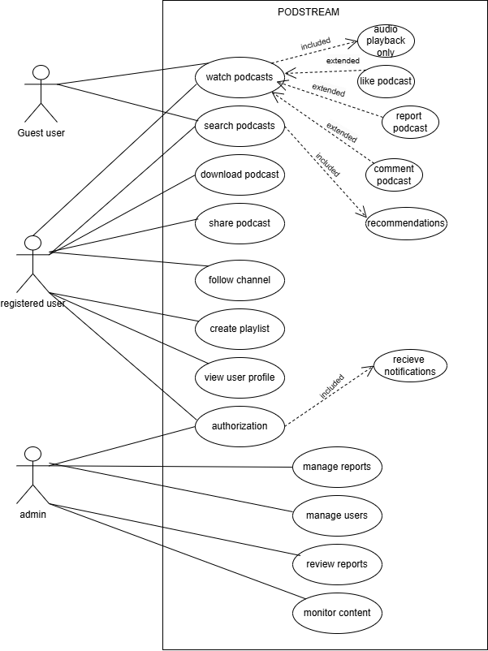
Figure 3.1: Use case Diagram

3.4.2 Use case description
The description of use case:

Table 3.2: Authorization
Attribute | Details
Use Case ID | UC1
Name | Authorization
Actors | User, Admin
Description | Users and admins log into the system to authenticate their accounts.
Preconditions | The user must have a valid account and credentials.
Postconditions | The user or admin is authenticated and granted access rights.
Normal Flow | 1. User/Admin enters credentials.  2. System verifies them.  3. If valid, grants access.
Exceptions | Invalid credentials or account is locked/disabled.

Table 3.3: Receive Notifications
Attribute | Details
Use Case ID | UC1.1
Name | Receive Notifications
Actors | User
Description | Authenticated users receive notifications about updates, new episodes, or interactions.
Preconditions | The user has enabled notifications.
Postconditions | Notifications are delivered successfully.
Normal Flow | 1. System identifies an event requiring a notification.  2. Sends notification to the user.  3. User views the notification.
Exceptions | Notification delivery fails.

Table 3.4: Search Podcast
Attribute | Details
Use Case ID | UC2
Name | Search Podcast
Actors | Registered User, Guest User
Description | Users can search for podcasts using keywords, filters, or categories.
Preconditions | Podcasts must be available in the system.
Postconditions | Relevant podcasts are displayed.
Normal Flow | 1. User enters a search term or selects a filter.  2. System retrieves matching podcasts.  3. Results are displayed.
Exceptions | No matching podcasts found.

Table 3.5: Watch Podcast
Attribute | Details
Use Case ID | UC3
Name | Watch Podcast
Actors | Registered User, Guest User
Description | Users can watch podcasts with both video and audio streams.
Preconditions | Podcast files must exist in the system.
Postconditions | Podcast plays successfully with full playback controls.
Normal Flow | 1. User selects a podcast to watch.  2. System streams the podcast with video and audio.  3. User interacts with controls (pause, play, seek).
Exceptions | Podcast file is unavailable, or streaming is interrupted.

Table 3.6: Audio Playback
Attribute | Details
Use Case ID | UC3.1
Name | Audio Playback
Actors | User
Description | Users can switch to audio-only mode while watching a podcast.
Preconditions | A podcast must already be playing.
Postconditions | Podcast continues playing with only audio output.
Normal Flow | 1. User toggles "Audio-Only" mode.  2. System stops video playback but streams audio.
Exceptions | Audio file is unavailable.

Table 3.7: Like Podcast
Attribute | Details
Use Case ID | UC3.2
Name | Like Podcast
Actors | User
Description | Users can like a podcast to show appreciation.
Preconditions | User must be logged in.
Postconditions | Podcast's like count is updated.
Normal Flow | 1. User clicks the like button on a podcast.  2. System updates the like count for the podcast.
Exceptions | System fails to register the like.

Table 3.8: Report Podcast
Attribute | Details
Use Case ID | UC3.3
Name | Report Podcast
Actors | User
Description | Users can report a podcast for inappropriate content or other issues.
Preconditions | User must be logged in.
Postconditions | Report is submitted to the admin.
Normal Flow | 1. User selects the report option on a podcast.  2. Enters a reason for the report.  3. System submits the report.
Exceptions | Report submission fails due to system error.

Table 3.9: Comment on Podcast
Attribute | Details
Use Case ID | UC3.4
Name | Comment on Podcast
Actors | User
Description | Users can leave comments on a podcast.
Preconditions | User must be logged in.
Postconditions | Comment is added and displayed under the podcast.
Normal Flow | 1. User writes a comment on a podcast.  2. System saves and displays the comment.
Exceptions | Comment fails to save due to a system error.

Table 3.10: Recommendations
Attribute | Details
Use Case ID | UC3.5
Name | Recommendations
Actors | System
Description | System recommends podcasts to users based on their activity and preferences.
Preconditions | User activity history exists.
Postconditions | Recommendations are displayed to the user.
Normal Flow | 1. System analyzes user activity.  2. Generates a list of recommended podcasts.  3. Displays the list.
Exceptions | Recommendations fail to load due to system error.

Table 3.11: Download Podcast
Attribute | Details
Use Case ID | UC4
Name | Download Podcast
Actors | User
Description | Users can download podcasts for offline viewing or listening.
Preconditions | User must be logged in and have enough storage space.
Postconditions | Podcast is downloaded and saved locally.
Normal Flow | 1. User selects the download option on a podcast.  2. System downloads and saves the podcast.
Exceptions | Download fails due to insufficient storage or network error.

Table 3.12: Share Podcast
Attribute | Details
Use Case ID | UC5
Name | Share Podcast
Actors | User
Description | Users can share podcasts via social media, messaging apps, or direct links.
Preconditions | User must have access to sharing features on their device.
Postconditions | Podcast link is successfully shared.
Normal Flow | 1. User clicks the share button on a podcast.  2. Selects a sharing option.  3. System generates and shares the podcast link.
Exceptions | Share fails due to system error or unsupported platform.

Table 3.13: Follow Channel
Attribute | Details
Use Case ID | UC6
Name | Follow Channel
Actors | User
Description | Users can follow channels to get updates on their latest podcasts.
Preconditions | Channel must exist and be active.
Postconditions | Channel is added to the user's follow list.
Normal Flow | 1. User selects the follow option on a channel.  2. System updates the user’s profile to include the channel in their following list.
Exceptions | Follow action fails due to system error or the channel is inactive.

Table 3.14: Create Playlist
Attribute | Details
Use Case ID | UC7
Name | Create Playlist
Actors | User
Description | Users can create personalized playlists of podcasts.
Preconditions | User must be logged in.
Postconditions | Playlist is created and saved under the user’s profile.
Normal Flow | 1. User clicks "Create Playlist" and enters a name.  2. Adds podcasts to the playlist.  3. System saves the playlist under the user’s profile.
Exceptions | Playlist creation fails due to a system error.

Table 3.15: View User Profile
Attribute | Details
Use Case ID | UC8
Name | View User Profile
Actors | User
Description | Users can view profiles to check activity and other details.
Preconditions | Profile must exist.
Postconditions | Profile details are displayed.
Normal Flow | 1. User selects a profile to view.  2. System retrieves and displays profile details.
Exceptions | Profile details fail to load due to system error.

Table 3.15: Manage Reports
Attribute | Details
Use Case ID | UC9
Name | Manage Reports
Actors | Admin
Description | Admin reviews and takes action on user-submitted reports.
Preconditions | Reports must exist in the system.
Postconditions | Report is resolved and logged.
Normal Flow | 1. Admin accesses the reports dashboard.  2. Views a report’s details.  3. Takes action (resolve, reject).
Exceptions | Report management fails due to system error.

Table 3.17: Manage Users
Attribute | Details
Use Case ID | UC10
Name | Manage Users
Actors | Admin
Description | Admin can deactivate or update user accounts as necessary.
Preconditions | User account must exist.
Postconditions | User account is updated or deactivated.
Normal Flow | 1. Admin accesses the user management panel.  2. Selects a user.  3. Updates or deactivates the account.
Exceptions | Account update fails due to a system error.

Table 3.18: Review Reports
Attribute | Details
Use Case ID | UC11
Name | Review Reports
Actors | Admin
Description | Admin can review details of all user-submitted reports.
Preconditions | Reports must be logged in the system.
Postconditions | Reports are reviewed and ready for action.
Normal Flow | 1. Admin views a list of reports.  2. Selects a specific report to review.  3. Reviews details and prepares to take action.
Exceptions | Review fails due to a system error.

Chapter 4: Design and Architecture

The design and architecture of our Podcast Streaming Platform follow a modular and scalable MERN stack approach, integrating MongoDB for database management, Express.js and Node.js for backend logic and secure API handling, and React.js with Tailwind CSS for a responsive and dynamic frontend. Firebase is used for secure Google authentication, with session management handled via HttpOnly cookies. The application is built on a client-server architecture, ensuring clear separation of concerns and maintainability. Components are reusable, and the UI takes inspiration from platforms like Netflix and YouTube to enhance user experience [8].

4.1 Block Diagram
A block diagram for a podcast streaming platform would include the User Interface block (web or mobile app) connected to a Backend API block, which communicates with both a Database (for storing user data, podcast metadata, and analytics) and Cloud Storage (for storing audio files). The backend also connects to an Authentication Service (e.g., Firebase Auth) for secure login and an Audio Streaming Service for delivering content efficiently. Additionally, an Admin Dashboard block may connect to the backend for managing podcasts, users, and platform analytics.

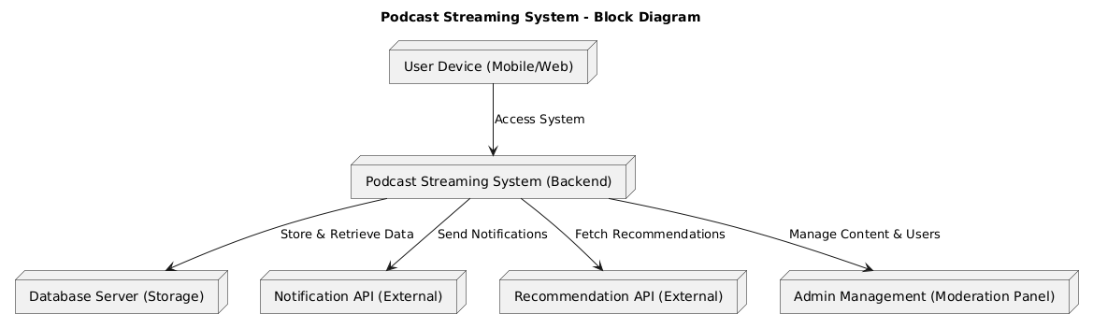
Figure 4.1: Block Diagram

4.2 Component Diagram
A podcast streaming platform consists of a frontend built with React for the user interface, including components for browsing podcasts, searching, managing favorites, playing audio, and uploading new content. The backend, developed with Node.js and Express, handles authentication, podcast management, search, and user interactions like likes and comments. Data is stored in MongoDB collections for users, podcasts, favorites, comments, and likes. External services such as Firebase Authentication enable Google Sign-In, while cloud storage is used to host and deliver podcast audio files efficiently.

\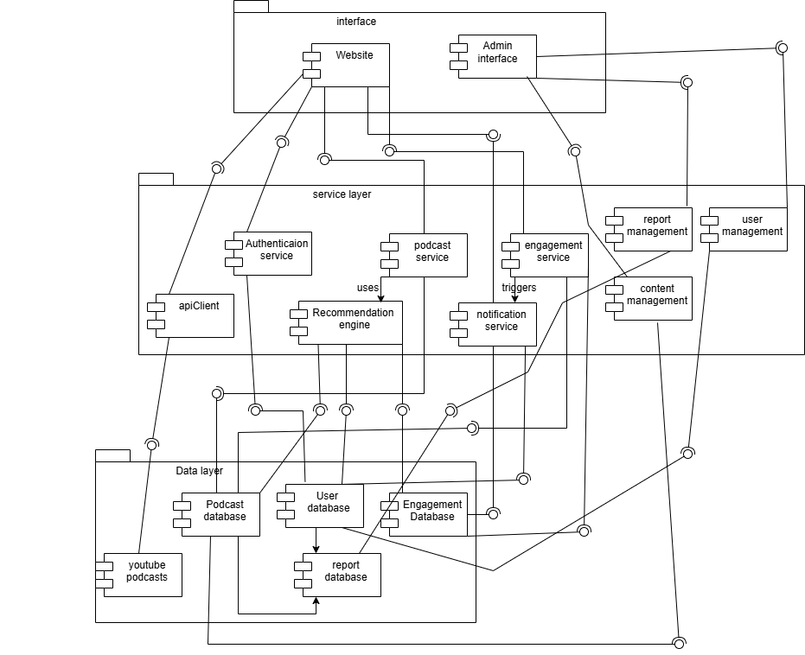
Figure 4.2: Component Diagram

4.3 Activity Diagram

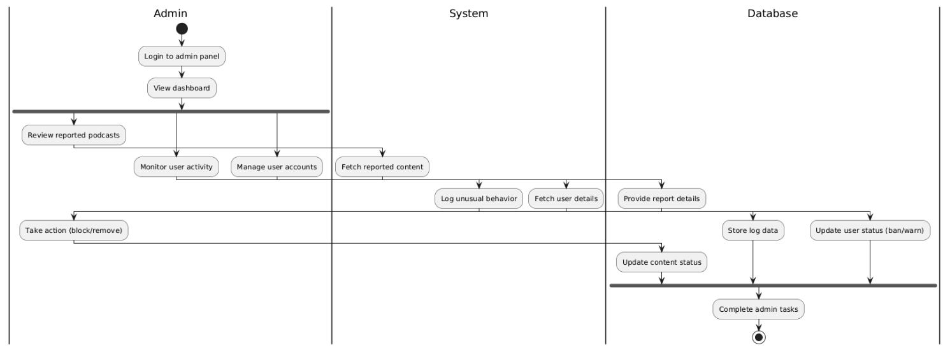
  - Figure 4.3: Activity 1
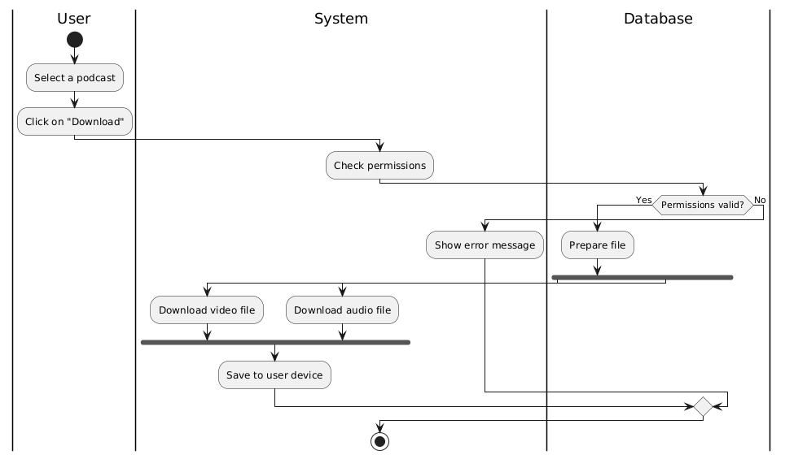

  - Figure 4.4: Activity 2
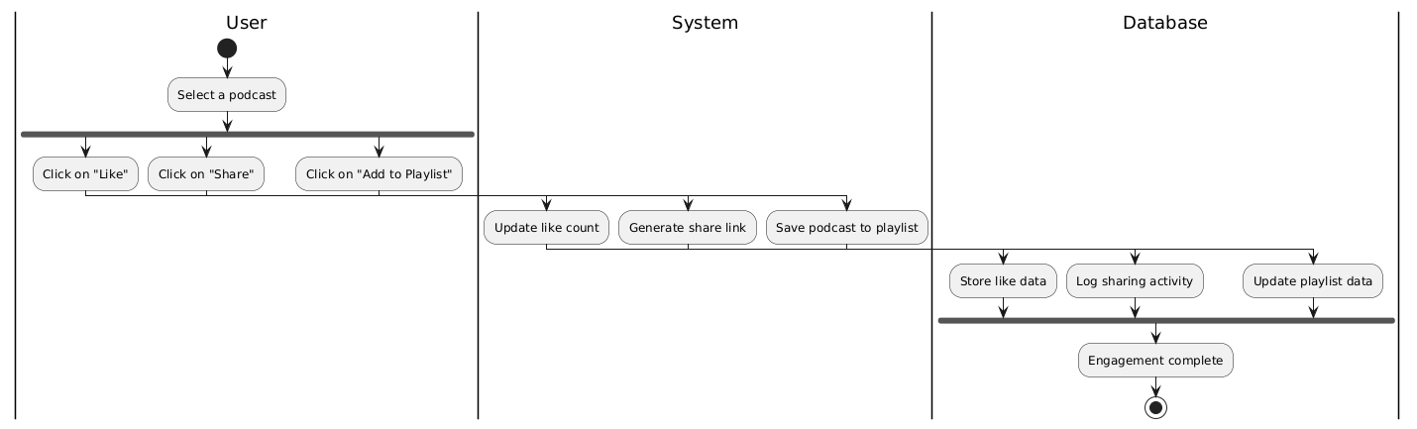

  - Figure 4.5: Activity 3
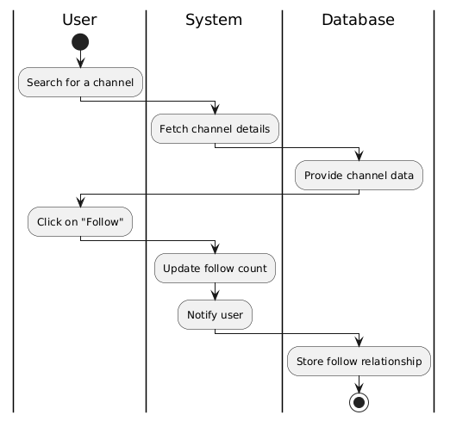
  - Figure 4.6: Activity 4

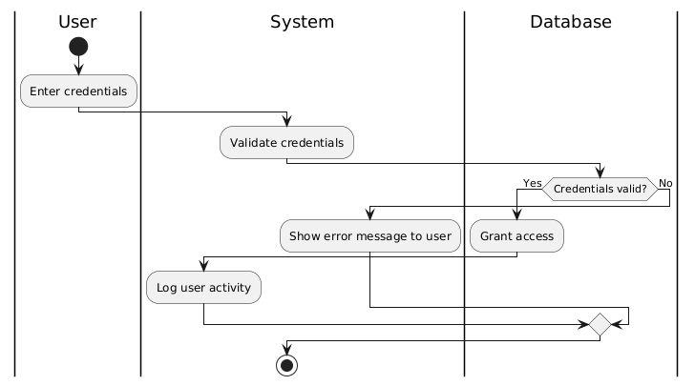
  - Figure 4.7: Activity 5

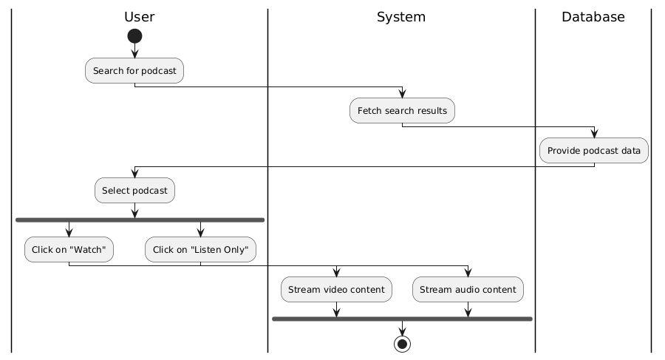
  - Figure 4.8: Activity 6

4.4 Sequence Diagram

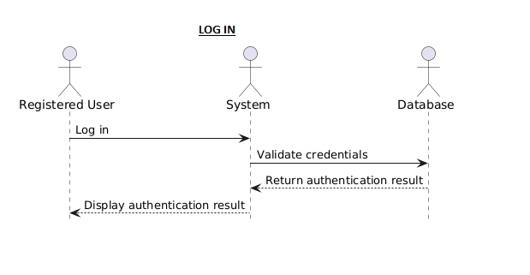

Figure 4.9: Log in
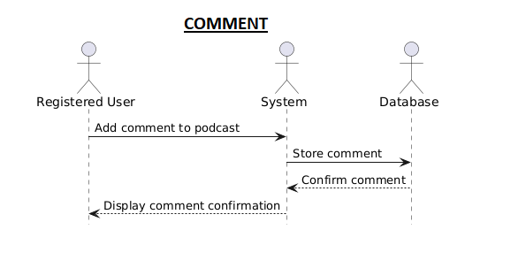
Figure 4.10: Add Comment

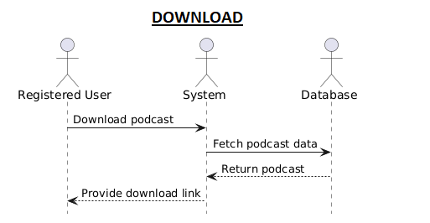

Figure 4.11: Download Podcast
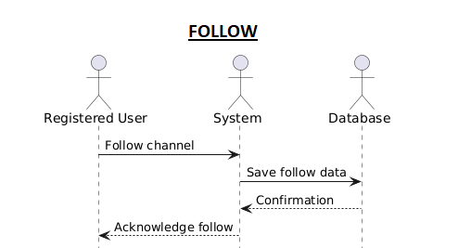

Figure 4.12: Follow creator

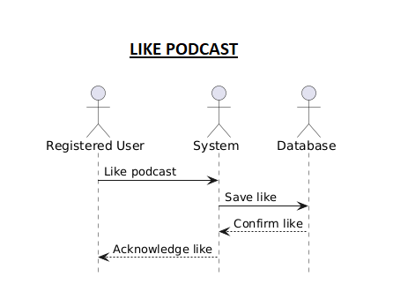
Figure 4.13: Like podcast
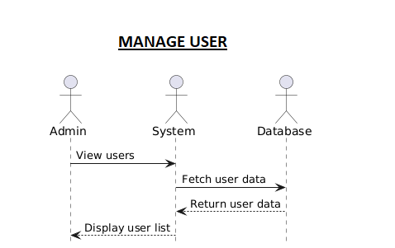
Figure 4.14: Manage Users

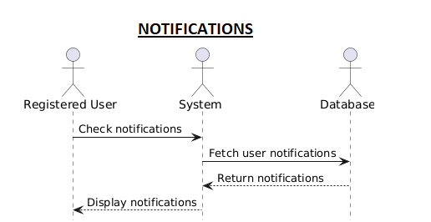

Figure 4.15: Get Notifications
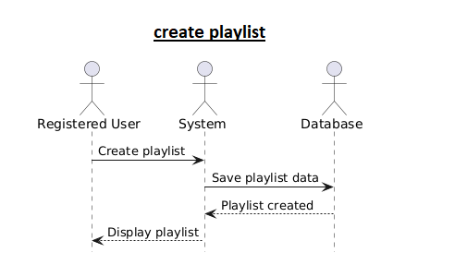
Figure 4.16: Create Playlist

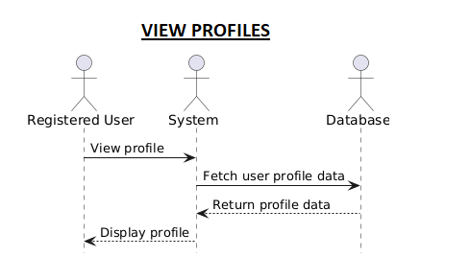

Figure 4.17: View profiles
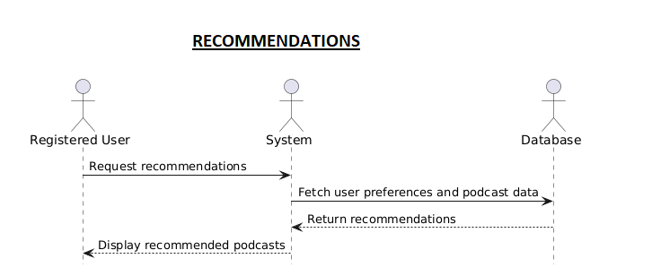
Figure 4.18: Get Recommendations

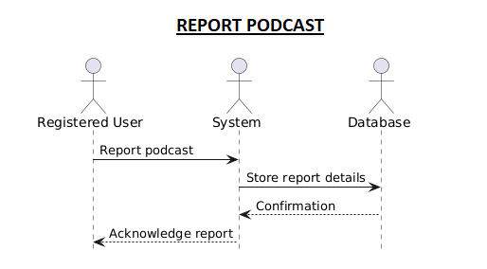
Figure 4.19: Report A Podcast
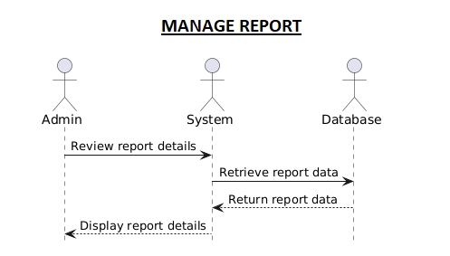

Figure 4.20: Manage Reports

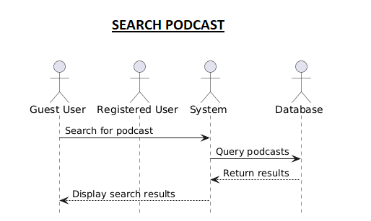
Figure 4.21: Search Podcasts
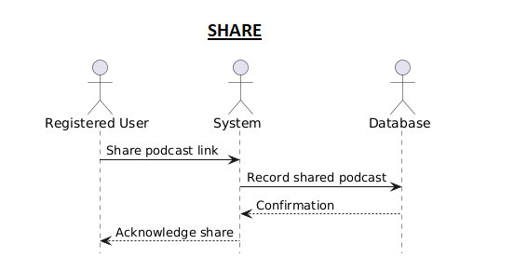

Figure 4.22: Share Podcasts

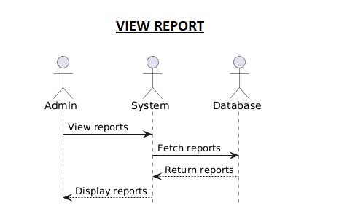
Figure 4.23: View Reports
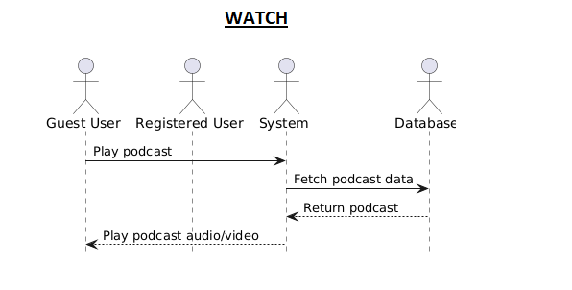
Figure 4.24: Watch Podcasts

4.5 ER Diagram
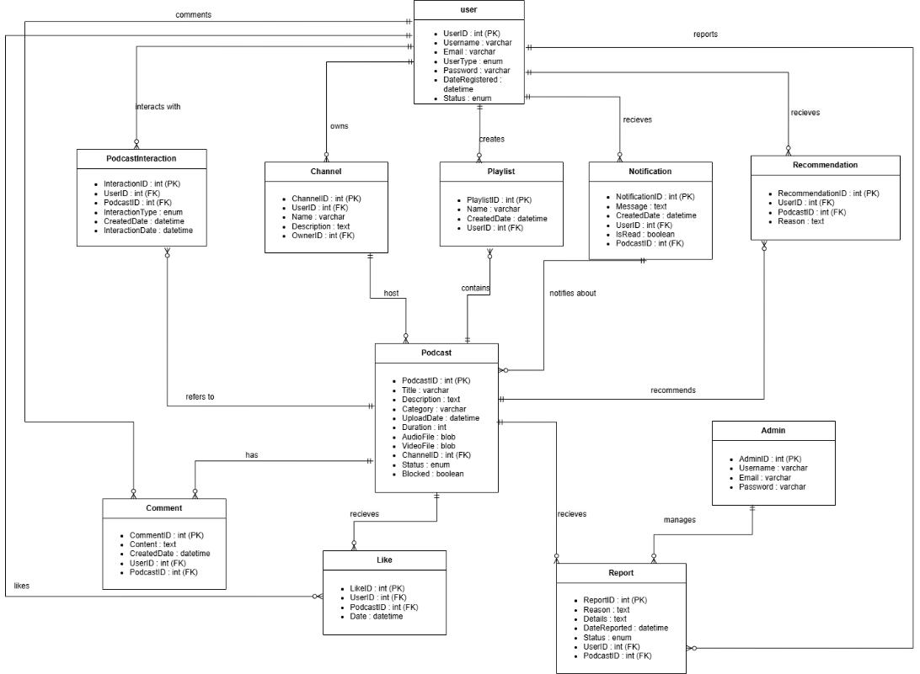
Figure 4.25: ERD
4.6 Class Diagram
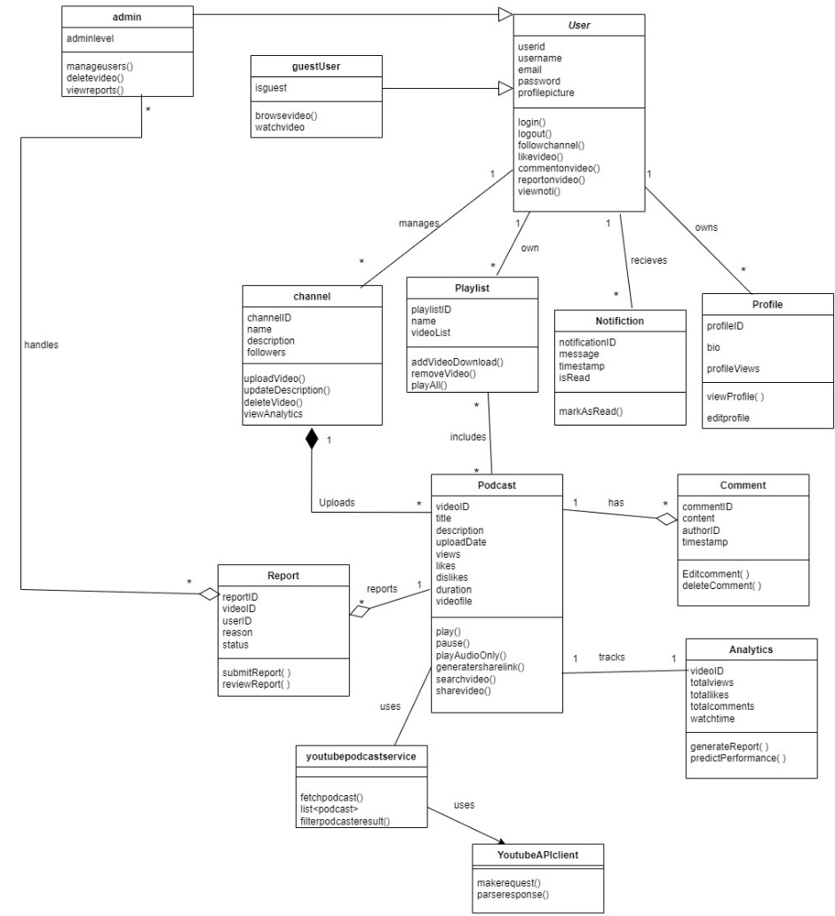
Figure 4.26: Class Diagram

4.7 State Transition Diagram
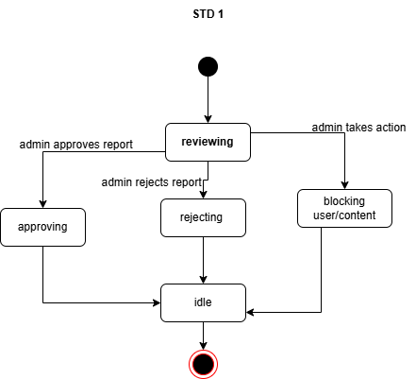
Figure 4.27: STD 1
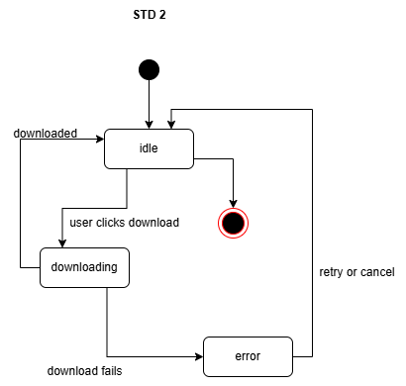
Figure 4.28: STD 2

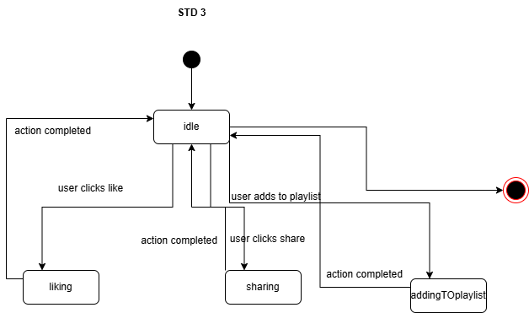
Figure 4.29: STD 3
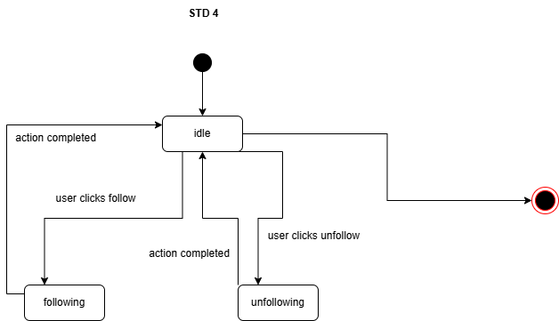
Figure 4.30: STD 4

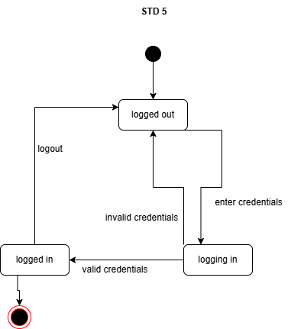
Figure 4.31: STD 5
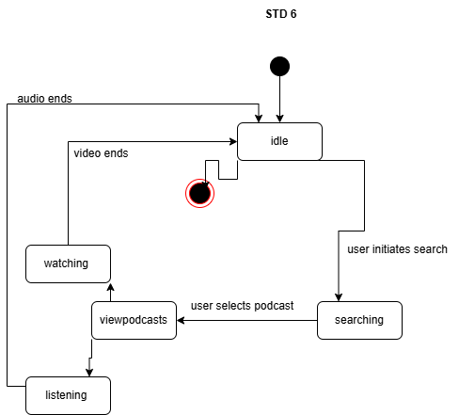
Figure 4.32: STD 6

4.8 Deployment Diagram
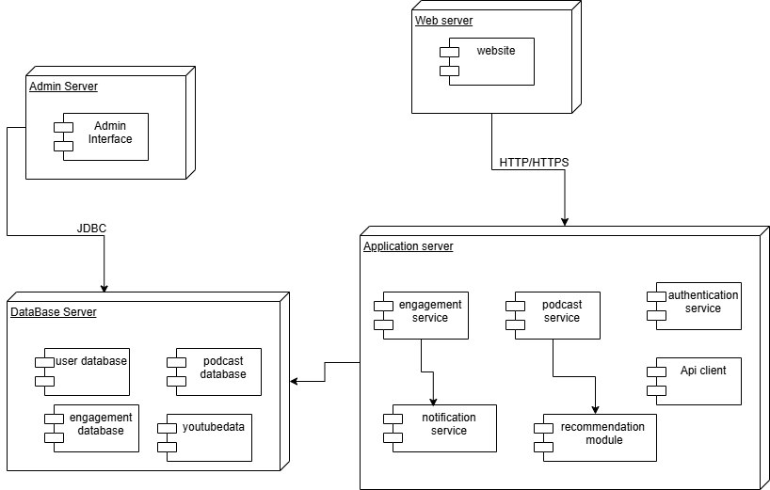

Figure 4.33: Deployment Diagram

Chapter 5: Implementation
The application is built on a client–server architecture, ensuring clear separation of concerns and maintainability. Components are reusable, and the UI takes inspiration from platforms like Netflix and YouTube to enhance user experience. It follows responsive design principles, making it accessible and visually appealing across a variety of devices and screen sizes. Backend APIs are optimized for performance and scalability, ensuring smooth data retrieval and updates even under heavy traffic. Robust error handling and validation mechanisms are implemented to improve reliability and prevent data inconsistencies. The codebase is modular, allowing for easy feature enhancements and reduced development overhead. Security best practices, including authentication and authorization, are integrated to protect sensitive user information. The application is designed with future-proofing in mind, enabling seamless integration of new technologies and third-party services. Comprehensive documentation and testing further ensure that the platform remains maintainable and adaptable to evolving business needs.

5.1 Component Diagarm:

Figure 5.1: Component Diagram

5.1.1 User component:
These are the components directly interacted with by the end-users via the website.
- Signup / Sign in Module: Manages secure user registration and login using email & password.
- Home Module: Displays personalized recommendations, latest and trending podcasts [7].
- Search Module: Allows users to search podcasts by title, category, tags, or keywords.
- Favorites / Playlist Module: Users can like, save, and group podcasts into playlists for later listening.
- Engagement Module: Enables like, share, comment, and follow functionalities to boost interaction.
- Streaming & Download Module: Streams podcasts directly in-browser or lets users download for offline access.
- API Interface Module: Integrates YouTube API to fetch and display only filtered podcast videos.
- Notification Handler: Displays system notifications (e.g., new podcast from followed creator).

5.1.2 Admin Components:
Admin-side tools used for monitoring and controlling platform operations.
- User Management Panel: Allows admin to view, block, or manage users.
- Content Moderation: Used to approve, reject, or flag inappropriate podcasts/comments.
- Dashboard Analytics: Visual data like user counts, upload stats, and trending podcasts.
- Podcast Moderation Panel: Admin can review API-fetched or user-uploaded podcasts.

5.1.3 Backend Components:
Handles core business logic and links UI with the database.
- Authentication Service: Processes login and signup requests with JWT tokens.
- Podcast Management Service: Manages upload, fetch, delete, and view podcast operations.
- Engagement Service: Processes like, share, comment, and follow actions.
- Notification Service: Manages alert creation and delivery to users.
- YouTube API Integration Service: Fetches podcast content from YouTube and filters non-podcasts.
- Search Service: Handles keyword search and content filtering.

5.1.4 Database Components:
- User Table: Stores user profiles, credentials, and block status.
- Podcast Table: Stores metadata for uploaded or API-fetched podcasts.
- Comment Table: Stores comments with timestamps and linked podcast/user.
- Engagement Tables: For likes, follows, shares, and playlists.
- Notification Table: Stores and tracks notifications per user.
- Admin Table: Stores admin credentials and roles.

5.2 Network and Protocol Choice
Following are your network and protocol choices

5.2.1 Networking Layer
- HTTP/HTTPS: All communication is secured via HTTPS to protect data.
- RESTful APIs: Used for interacting with backend services like upload, comment, search, etc.
- WebSockets (optional): For real-time updates like new comments or follows.
- CDN (Content Delivery Network): Used to deliver podcast content efficiently across different regions.

5.2.2 Protocols Used
- OAuth 2.0 / JWT: For authentication and session management.
- HTTPS with TLS Encryption: For end-to-end secure data transmission

5.3. Choice of Object Middleware:
Following is our choice for object middleware

5.3.1 Middleware Functions
Middleware manages the flow of data between requests and responses.
- Authentication Middleware: Verifies user tokens before giving access to protected routes.
- Rate Limiting Middleware: Controls request frequency to avoid abuse.
- Logging Middleware: Tracks actions for debugging and analytics.
- Error Handling Middleware: Catches exceptions and returns meaningful messages.
- CORS Middleware: Allows or blocks cross-origin API requests.
- API Middleware: Interfaces with YouTube API, filters podcast data, and serves clean results.

Chapter 6: Testing And Evaluation
Automated testing tools like Jest and Cypress are employed to streamline quality assurance and detect regressions early. API endpoints undergo schema validation to maintain data integrity between the client and server, while real-time streaming features are stress-tested under heavy load to minimize buffering and downtime. Security protocols are thoroughly reviewed after each deployment cycle, and browser developer tools are used to monitor network activity and address performance bottlenecks. Version control with Git ensures traceability of all code changes, enabling collaborative and efficient testing. Additionally, continuous integration (CI) pipelines automatically execute the complete test suite on every commit, providing rapid detection and resolution of issues before they reach production.

6.1 Verification
The verification process ensures that all features of the platform operate as intended, meet performance benchmarks, and align with project requirements. Automated test suites validate backend logic, database operations, and API responses for accuracy, while manual exploratory testing detects UI inconsistencies and user experience issues that automated checks may overlook. Integration tests confirm seamless interaction between authentication, streaming, search, and playback modules. Cross-platform testing is conducted across desktop, tablet, and mobile devices to verify responsive design and consistent performance. Load and stress testing simulate high-traffic conditions to assess scalability, while security verification focuses on authentication flows, token handling, and safeguarding against vulnerabilities such as SQL injection and XSS attacks [9]. Accessibility audits following WCAG 2.1 guidelines ensure inclusivity, and user acceptance testing (UAT) with a pilot group confirms that the platform meets real-world needs. All identified issues are documented, prioritized, and resolved before deployment to guarantee a stable, user-ready product.
6.2 Validation
The final product was validated against the use case specifications to ensure it meets user expectations and requirements.
6.3 Usability Testing
User testing sessions were conducted to analyze the intuitiveness of the interface, ease of navigation, and overall experience for both registered and guest users.
6.4 Module / Unit Testing
Each module—user authentication, podcast management, YouTube API fetcher, admin panel—was tested in isolation to verify that individual components function as intended.
6.5 Integration Testing
Integration tests ensured proper communication between modules, such as syncing user actions with backend updates and YouTube API responses with the podcast display module.
6.6 System Testing
System-wide tests verified the end-to-end behavior of the platform, ensuring all features operate smoothly in the live environment.
6.7 Acceptance Testing
Final testing was performed with real users and stakeholders to confirm the system fulfills the functional and non-functional requirements.
6.8 Stress Testing
The system was exposed to high traffic, large uploads, and concurrent stream requests to evaluate performance and identify breaking points.
6.9 Hardware Configureuration for Testing
Testing was conducted on standard web server environments with dual-core processors, 8GB RAM, and stable internet connections. Backend was tested on both Windows and Linux environments.
6.10 Evaluation
The system was evaluated based on performance, reliability, user satisfaction, and ability to filter and present relevant podcast content from YouTube.
6.11 Deployment
The website is deployed on local server. CI/CD pipelines were implemented for smooth updates.
6.12 Maintenance
Post deployment, the system will undergo regular updates to address bugs, enhance features, and adapt to YouTube API changes. A versioning strategy is also adopted for stable improvements

6.13 Test Cases
  - Table 6.1: Test case matrix
Test Case ID | Title | Pre-conditions | Test Steps | Expected Result | Actual Result | Status
TC001 | Guest user searches and plays a podcast | User is not logged in | 1. Visit home page  2. Use search bar  3. Click a podcast to play | Podcast should stream without login | Podcast streamed without login | Pass
TC002 | Registered user uploads a podcast | User is logged in | 1. Go to Upload  2. Fill title, description, upload file  3. Click "Upload" | Podcast appears on profile and becomes available | Podcast uploaded and shown on profile and homepage | Pass
TC003 | Like a podcast | User is logged in | 1. Open a podcast  2. Click "Like" | Like count increases and button changes visually | Like count increased and button highlighted | Pass
TC004 | Download podcast for offline use | User is logged in | 1. Open a podcast  2. Click "Download" | File saved locally | File downloaded successfully | Pass
TC005 | Comment on podcast | User is logged in | 1. Open a podcast  2. Type comment  3. Click "Submit" | Comment appears with username | Comment visible with correct username | Pass
TC006 | Follow a podcast creator | User is logged in | 1. Visit creator profile  2. Click "Follow" | Follow status updates and new uploads become visible | Followed successfully | Pass
TC007 | Admin deletes a podcast | Admin is logged in | 1. Go to admin panel  2. Check reports  3. Click "Delete" | Podcast gets deleted | Podcast deleted successfully | Pass
TC008 | Api only fetches youtube podcasts | Backend api is running | 1. Trigger YouTube API  2. Observe podcast list | Only podcast-type videos fetched(no regular content) | Api returned all videos related to keyword | Fail
TC009 | Upload invalid file format | User is logged in | 1. Open Upload  2. Select .txt file  3. Click "Upload" | Upload is rejected with error message | Error message | Pass
TC010 | Playlist creation and add podcast | User is logged in | 1. Go to "Playlists"  2. Create playlist  3. Open podcast  4. Click "Add to Playlist" and select playlist | Playlist created and podcast added successfully | Podcast added to newly created playlist successfully | Pass

Chapter 7: Conclusion and Future Work

In conclusion, the platform delivers a modern, user-friendly podcast streaming experience with real-time features, strong authentication, and scalability, making it suitable for future enhancements and broader user adoption. Its intuitive interface encourages user engagement, while optimized backend processes ensure minimal latency and consistent performance. The architecture supports integration with emerging technologies such as AI-driven recommendations and advanced analytics, paving the way for personalized content delivery. Built with robust security measures, the system safeguards user data and ensures compliance with industry standards. Its modular design and comprehensive API layer enable effortless third-party integrations and rapid feature deployment. By combining performance, security, and adaptability, the platform is well-positioned to meet evolving market demands and deliver long-term value.

7.1 Conclusion
The development of PodStream, a podcast streaming platform built using the MERN stack (MongoDB, Express.js, React.js, and Node.js), has been an insightful journey in both technical and strategic dimensions. The platform is designed to bridge the gap between content creators and listeners by offering an all-in-one, user-friendly experience for streaming, uploading, interacting with, and managing podcast content.
Throughout the course of this project, we addressed various challenges in real-time data fetching, state management, responsive UI design, authentication, content filtering, and storage optimization. By leveraging React for the frontend, we ensured a dynamic and responsive user interface, while Node.js and Express formed the backbone of the backend API infrastructure. MongoDB enabled flexible and scalable data storage, especially well-suited for user-generated content such as podcasts, comments, and likes.
Key features such as user authentication (including Google Sign-In via Firebase), podcast upload and streaming, comments and likes, favorite management, YouTube podcast integration, and a dedicated admin panel were successfully implemented. The system supports both guest and registered users, ensuring accessibility while also providing additional features for registered users such as downloading and saving podcasts.
We also employed Agile methodology and an iterative lifecycle to ensure continuous development, regular feedback incorporation, and flexible upgrades throughout the development cycle. This approach allowed us to gradually enhance and scale PodStream while maintaining quality and alignment with our original goals.
From an engineering perspective, this project has provided hands-on experience with modern full-stack development tools, database modeling, RESTful API design, cloud services, and user-centric design thinking. It has also strengthened team collaboration and agile project management skills.
In summary, PodStream represents a complete, scalable solution for podcast enthusiasts and creators alike. It demonstrates how a modern tech stack can be used to create an impactful, real-world application with real-time interactivity, media handling, and a seamless user experience.

7.2 Future Work
Although PodStream in its current form provides a robust and functional system, there are several enhancements and optimizations we plan to implement in the future to further elevate its performance, usability, and reach:
- We plan to extend the platform to Android and iOS using React Native or Flutter, ensuring users can enjoy podcasts on-the-go with native performance and offline capabilities.
- Integrating a recommendation engine using machine learning (e.g., collaborative filtering or content-based algorithms) would personalize the user experience by suggesting relevant podcasts based on listening history, likes, and behavior.
- Using speech-to-text AI models, we aim to provide real-time transcriptions of podcast episodes. This will improve accessibility for hearing-impaired users and enable features like keyword-based search within podcast audio.
- We plan to implement more advanced search features using Elasticsearch or Algolia for instant, intelligent, and fuzzy searching across podcasts, creators, topics, tags, and transcripts.

References

- A. Williams and R. Patel, Building Full-Stack Web Applications with the MERN Stack: MongoDB, Express, React, and Node. Birmingham, UK: Packt Publishing, 2021.
- M. Bateman, Professional JavaScript: Building Modern Web Applications. Indianapolis, IN: Wrox Press, 2020.
- M. Rouse and M. Purdon, "Real-time data streaming using Node.js and WebSockets for media applications," J. Web Eng., vol. 18, no. 3, pp. 145–158, 2020.
- R. Sharma and A. Malik, "Design and development of a podcast streaming platform using MERN stack," Int. J. Comput. Appl., vol. 184, no. 17, pp. 22–28, 2022.
- S. Kumar and A. Gupta, "Cloud-native approaches in audio streaming applications: A Node.js-based study," in Proc. 6th Int. Conf. Cloud Comput. Appl. (CCA), 2019, pp. 111–119.
- R. Srinivasan and T. Allen, "Web performance optimization techniques for React-based audio streaming platforms," ACM Digit. Libr., vol. 58, no. 4, pp. 79–91, 2020.
- P. Thakkar and A. Iyer, "Authentication and secure session management in Express.js applications," J. Web Secur., vol. 15, no. 2, pp. 63–70, 2021.
- L. Zhang and H. Tan, "Scalable microservices architecture for media platforms using Node.js and Docker," IEEE Access, vol. 9, pp. 72145–72158, 2021.
- J. Kim and S. Choi, "Evaluating performance trade-offs in server-side rendering with React," in Proc. 2020 Int. Conf. Web Eng. (ICWE), 2020, pp. 202–211.
- M. Delgado and N. Singh, "Progressive web apps in media streaming: A MERN stack approach," J. Softw. Eng. Appl., vol. 13, no. 6, pp. 299–310, 2020.

