

**e-Yantra Robotics Competition - 2015**

**Implementation Analysis – Pizza Delivery Service**

**<Team ID>**

|  |  |
| --- | --- |
| **Team leader name** |  |
| **College** |  |
| **Email** |  |
| **Date** |  |

<This report contains three sections:

1. Preparing the Arena

2. Design Analysis

3. Algorithm Analysis

Teams have to answer question/s from these sections according to their understanding of the theme and the given Firebird V robot. >

**Preparing the Arena (5)**

<Prepare the arena according to the steps given in Section 3: Arena, of the rulebook. Take a photo of the completed arena such that the entire arena is clearly visible in the photo. Insert the image here>

**Design Analysis**

**Q-1. What do you understand by “Internal Timer”? and what is the significance of it in this theme. (5)**

<Please explain the answer in your **own words**. The answers copied directly from rulebook will not be considered for evaluation.

Answer format: Text

Word-limit: 150 words

>

**Q-2. Make a video in which time displays from 000 to 030 seconds on the Seven Segment Module. (10)**

<

Refer to the “Time_Overflow_Interrupt” code given in the Experiments folder of the e-Yantra_DVD . Using the concept of “interrupts” and “timer” write a code which will be used to generate an Internal Timer that will be running inside the Robot to measure time

Hint: Increment a variable by one after every one second to make a Stop Watch Timer.

Prepare a video of the same, upload it on Youtube and paste the link of the video on the portal. You also have to submit the code used for implementing the timer.

The video will be acceptable **if and only if** your time (to display 000 to 030 seconds) is equal to 30 seconds as measured by a Stop Watch by e-Yantra Team.

Instructions for uploading the video are given on the portal.

>

**Q-3. Draw a labeled diagram to explain how you have planned to place the sensors on/around the robot? (5)**

<Draw a neat diagram to show the positions of sensors on and around the robot. Show all the sensors you are using in designing the theme. Justify placement of the sensors shown in your diagram>

**Q-4. Teams have to make the robotic arm for picking up/placing the packages in the arena.**

1. **Choose an option you would like to use to position the robotic arm on the robot and why? (2)**

1. **Front 2. Back 3. Right/Left 4. On both sides**

**Answer: ____________________**

< Justify your choice for placement of the robotic arm.

Word-limit: 300 words

>

**b. Draw a diagram to show the robotic arm and how it is mounted on the robot. Also show**

**the mounting of the color sensor. (5)**

<Draw figure(s) to show how you are planning to mount the robotic arm and color sensor on the robot. >

**Q-5. Choose the actuator you will use to design the robotic arm. (3)**

1. **DC-Motor 2. Servo Motor 3. Stepper Motor 4. Others**

**Answer: _________________**

**Justify your answer by stating the advantage of the chosen actuator over others. Also give reasons for not using other actuators.**

**Q-6**

**a. What is the principle of operation of the color sensor? (5)**

< Please explain the answer in your own words. The answers copied directly from tutorials/datasheet will not be considered for evaluation.

Answer format: Text

Word-limit: 150 words

>

**b. Explain frequency scaling. Why is it necessary? (5)**

< Please explain the answer in your own words. The answers copied directly from tutorials/datasheet will not be considered for evaluation.

Answer format: Text

Word-limit: 100 words

>

**c. How will you identify Red, Blue and Green colors from the values you get from the color sensor? Explain your algorithm to identify the three colors (Red, Blue and Green). (5)**

<

Answer format: Bulleted form

Step 1:

Step 2:

Step 3…etc.

>

**Please note: You have to burn the demo code on Firebird V (the robot in your kit) to test the color sensor. If you do not test the color sensor and report any problem in this document, we will assume that your color sensor is working fine. We will not entertain any queries related to faulty color sensor later on; Teams will have to buy the color sensor on their own.**

**Note: The timings mentioned below are purely hypothetical. Your robot timings may be shorter or longer than given below.**

**Consider the following assumptions:**

* **The time taken by the robot to travel between the Nodes of Pizza Shop in arena is 1 second.**
* **The time taken by the robot to travel between the Nodes above Pizza Shop in arena is 5 seconds.**
* **The time taken by the robot to travel from Node before the Front Door to Front Door is 1 second.**

**Refer to Figure 1.**

**Note: Time for picking and placing the Pizza is not considered in the traversal time.**

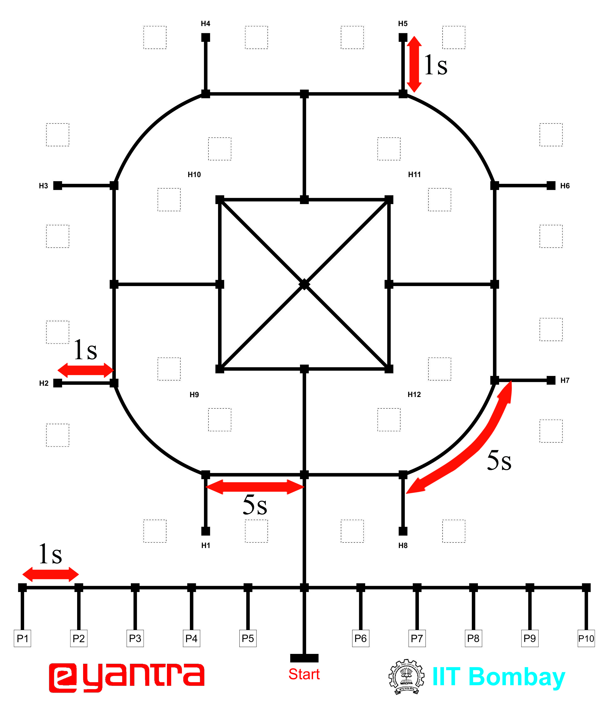

**Figure 1: Time for Traversal between Nodes**

**Q-7 Given an Order Timeline as shown in Figure 2 how you will deliver each and every Pizza such that you score the maximum points as per the Formula in “Scoring System” in the rulebook. (20)**

<

Answer format: Bulleted form

Step 1:

Step 2:

Step 3…etc.

>

Example: If robot delivers a Pizza from P6 to H2

Step1: Robot goes to P6 from Pizza Counter

Time taken: 1 second

Step2: Robot goes to H2 from P6

Time taken: 1 +( 5*3) + 1 = 17 seconds

So on……..

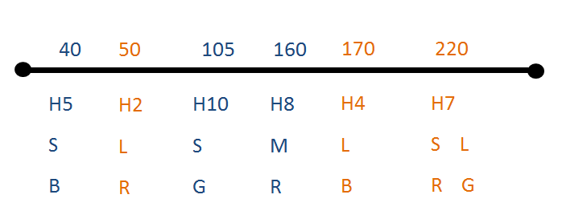

**Figure 2: Order Timeline**

**The placement of Pizzas at Pizza Shop is given below:**

**Small Blue Pizza that is to be delivered at H5 is placed at P8 (S, B is at P8).**

**Similarly: L, R is at P6 S, G is at P5 M, R is at P1 L, B is at P7 S, R is at P2 L, G is at P3**

**Algorithm Analysis**

**Q-1 Draw a flowchart illustrating the major functions that are used. (20)**

<

The flowchart should elaborate on every possible function that you will be using for completing the assigned theme. Example : lineFollowing(), colorDetection() etc.

Follow the standard pictorial representation used to draw the flowchart.

>

**Q-2 Draw a flowchart illustrating main function of your code. (10)**

<

The flowchart should explain how you will be using the functions defined in Q-1 in the main program for completing the theme assigned to you.

Follow the standard pictorial representation used to draw the flowchart.

>