RAILWAY MANAGEMENT SYSTEM

**Submitted by:**

Sheikh Amaan Asghar

BSCS/15/095

**Submitted to:**

Sir Danish Hamid Khattak

Sir Abdul Rehman Ali

**Table of Contents**

1. Table of Contents ……………………………………………………………………………………………………. 2
2. **Entity Relationship Diagram…………………………………………………………………………………….. 3**
3. **Use Case Diagram…………………………………………………………………………………………………….. 4**
4. **Use Case Narratives………………………………………………………………………………………………….. 5**
5. **Forms……………………………………………………………………………………………………………………… 44**

**3. Entity Relationship Diagram:**

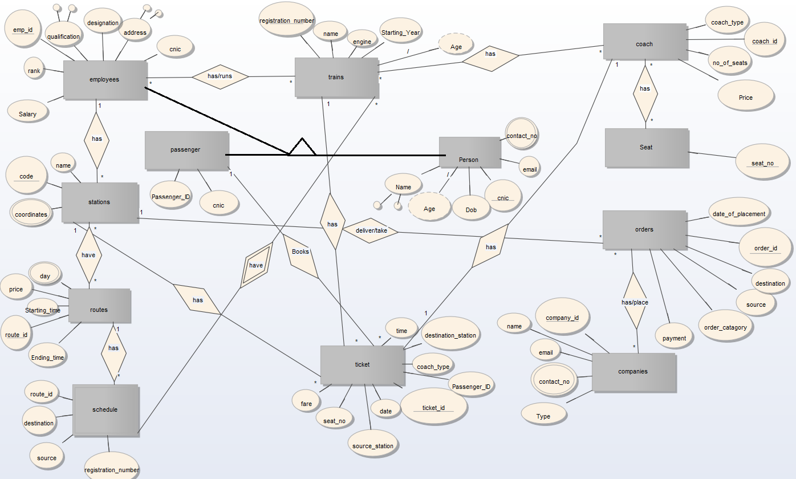

**4. Use Case Diagram:**

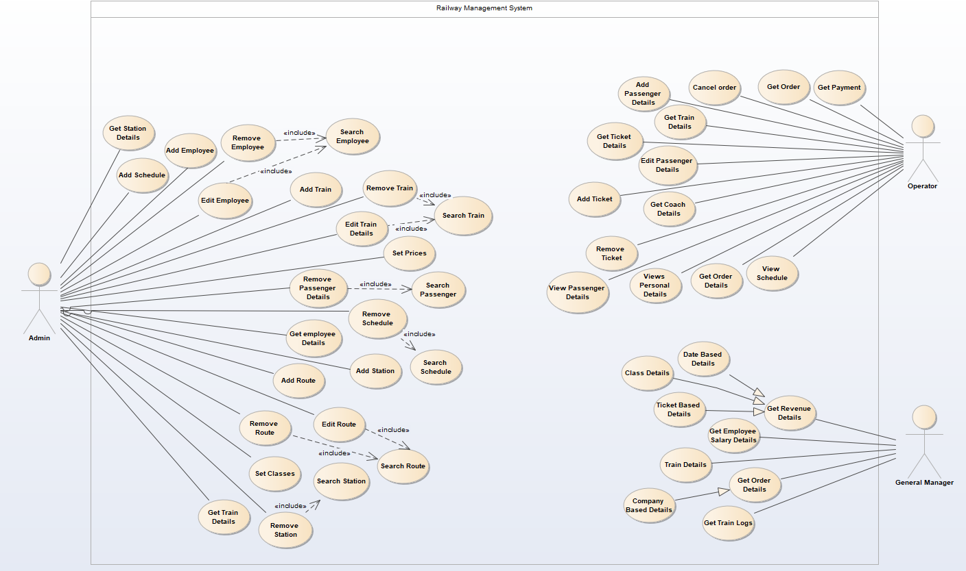

**5. Use Case Narratives:**

1. Remove Passenger

|  |  |  |
| --- | --- | --- |
| 1. | **Use Case Name:** Remove Passenger | |
| 2. | **Implementation Priority:** 5 | |
| 3. | **Actors:** Admin | |
| 4. | **Summary:** Admin first searches the passenger in database. If found he remove the deals from database else admin cancels the task. | |
| 5. | **Pre-condition**: Admin must be logged into the system and has opened administrative panel. | |
| 6. | **Post-condition:** Selected passenger’s record will be removed from database. | |
| 7. | **Extend:** - | |
| 8. | **Include:** - Search Passenger | |
| 9. | **Normal Course of Events:** | |
|  | **System Actor Action** | **System Response** |
|  | 2. Admin requests to remove searched passenger.  4. Admin confirms the deletion. | 1.Include Search Passenger.  3. System prompts for confirmation.  5. System removes the passenger details from database.  6. System informs the admin about successful operation. |
| 10. | **Alternative Path**: 4. If admin denies the removal of passenger. System cancels the operation. | |
| 11. | **Exception:** Database server not available.  Accidental passenger account removal. | |

1. Search Passenger

|  |  |  |
| --- | --- | --- |
| 1. | **Use Case Name:** Search Passenger | |
| 2. | **Implementation Priority:** 4 | |
| 3. | **Actors:** Admin | |
| 4. | **Summary:** Admin requests to find details of particular passenger. System prompts for (Name, CNIC, PassengerID). Admin enters one or multiple options. System searches database and returns the desired passenger details. | |
| 5. | **Pre-condition**: Admin must be logged into the system and has opened administrative panel. | |
| 6. | **Post-condition:** Searched passenger’s details will be available for admins use. | |
| 7. | **Extend:** - | |
| 8. | **Include:** - | |
| 9. | **Normal Course of Events:** | |
|  | **System Actor Action** | **System Response** |
|  | 1. Admin requests to search a passenger.  3. Admin Enters (Passenger Name, CNIC and PassengerID). | 2. System prompts for (Passenger Name, CNIC and PassengerID).  4. System validates the inputs. (type, format).  5. System searches for passenger details in database.  6. System returns the details of passenger to admin in a new panel. |
| 10. | **Alternative Path**: 4. If inputs are invalid system prompts for re-entry of passenger details.  5. If passenger details not found in database system informs admin and request for re-entry or cancelation of operation. | |
| 11. | **Exception:** Database server not available.  Input mismatch. | |

1. Remove Schedule

|  |  |  |
| --- | --- | --- |
| 1. | **Use Case Name:** Remove Schedule | |
| 2. | **Implementation Priority:** 4 | |
| 3. | **Actors:** Admin | |
| 4. | **Summary:** Admin requests for schedule to remove. System searches the schedule in database. System prompts for conformation of removal. Admin confirms the removal. System remove schedule from database. | |
| 5. | **Pre-condition**: Admin must be logged into the system and has opened administrative panel. | |
| 6. | **Post-condition:** Selected schedule will be removed from database. | |
| 7. | **Extend:** - | |
| 8. | **Include:** - Search Schedule | |
| 9. | **Normal Course of Events:** | |
|  | **System Actor Action** | **System Response** |
|  | 1. Admin requests to remove a schedule.  3. Admin selects the schedule to remove.  5. Admin confirms the removal. | 2. Include Search Schedule.  4. System prompts for confirmation.  6. System removes the Schedule from database.  7. System informs the admin about successful removal of Schedule. |
| 10. | **Alternative Path**: 5. Admin denies the removal. System cancel the removal operation. | |
| 11. | **Exception:** Database server not available.  Accidental passenger account removal. | |

1. Search Schedule

|  |  |  |
| --- | --- | --- |
| 1. | **Use Case Name:** Search Schedule | |
| 2. | **Implementation Priority:** 3 | |
| 3. | **Actors:** Admin | |
| 4. | **Summary:** Admin requests to search Schedule. System prompts for (TrainID, Schedule ID). Admin provides the information. System searches in database and returns the information of schedule. | |
| 5. | **Pre-condition**: Admin must be logged into the system and has opened administrative panel. | |
| 6. | **Post-condition:** Searched train schedule will be displayed to the admin. | |
| 7. | **Extend:** - | |
| 8. | **Include:** - | |
| 9. | **Normal Course of Events:** | |
|  | **System Actor Action** | **System Response** |
|  | 1. Admin requests to search schedule.  3. Admin enters (ScheduleID, TrainID) | 2. System prompts for (ScheduleID, TrainID).  4. System validates inputs.  5. System searches in database for required information.  6. System returns the information of schedule in a new panel. |
| 10. | **Alternative Path**: 4. If inputs are invalid system prompts for re-entry of schedule details.  5. If Schedule details not found in database system informs admin and request for re-entry or cancelation of operation. | |
| 11. | **Exception:** Database server not available. | |

1. Get Employee Details

|  |  |  |
| --- | --- | --- |
| 1. | **Use Case Name:** Get Employee Details | |
| 2. | **Implementation Priority:** 2 | |
| 3. | **Actors:** Admin | |
| 4. | **Summary:** Admin requests for employee details. System prompts for employee information (Name, CNIC, EmpID). Admin enters the required information; system searches for employee in database and returns all of his details. | |
| 5. | **Pre-condition**: Admin must be logged into the system and has opened administrative panel. | |
| 6. | **Post-condition:** Requested employee’s details panel will be available to admin. | |
| 7. | **Extend:** - | |
| 8. | **Include:** - | |
| 9. | **Normal Course of Events:** | |
|  | **System Actor Action** | **System Response** |
|  | 1. Admin requests to view employee details.  3. Admin enters employee details (Name, CNIC, EmpID). | 2. System prompts for employee information (Name, CNIC, EmpID).  4. System validates the inputs.  5. System searches database for employee.  6. System returns employee Details in a panel.  7. System informs administrator about successful operation. |
| 10. | **Alternative Path**: 4. If inputs are invalid system prompts for re-entry of schedule details.  5. If Schedule details not found in database system informs admin and request for re-entry or cancelation of operation. | |
| 11. | **Exception:** Database server not available.  Database connection error. | |

1. Add Station

|  |  |  |
| --- | --- | --- |
| 1. | **Use Case Name:** Add Station | |
| 2. | **Implementation Priority:** 2 | |
| 3. | **Actors:** Admin | |
| 4. | **Summary:** Admin requests to add station in database. System prompts for information (Name, Coordinates and Description). Admin enters the required information. Admin submits the information. System verifies the submission and adds the station in database. | |
| 5. | **Pre-condition**: Admin must be logged into the system and has opened administrative panel. | |
| 6. | **Post-condition:** Station’s information will be added in database. | |
| 7. | **Extend:** - | |
| 8. | **Include:** - | |
| 9. | **Normal Course of Events:** | |
|  | **System Actor Action** | **System Response** |
|  | 1. Admin requests to add station.  3. Admin enters the stations details (Name, Description and coordinates).  4. Admin submits the information.  7. Admin confirms the submission. | 2. System prompts for station information (Name, Description and coordinates).  5. System validates the inputs.  6. System requests for confirmation of submission.  8. System adds the information in database.  9. System informs the admin about successful operation. |
| 10. | **Alternative Path**: 5. System fails to validate inputs; System requests for re-entry of information.  7. Admin rejects submission; System cancels the operation and takes admin to previous panel. | |
| 11. | **Exception:** Database Server error.  Database connection error. | |

1. Add Route

|  |  |  |
| --- | --- | --- |
| 1. | **Use Case Name:** Add Route | |
| 2. | **Implementation Priority:** 1 | |
| 3. | **Actors:** Admin | |
| 4. | **Summary:** Admin requests to add route for a schedule of a train. System prompts for (Departure time, Starting Time and stations in route from available stations list and prices). Admin enters details and submits. System adds the route in database. | |
| 5. | **Pre-condition**: Admin must be logged into the system and has opened the train. | |
| 6. | **Post-condition:** Route of train will be added in database. | |
| 7. | **Extend:** - | |
| 8. | **Include:** - | |
| 9. | **Normal Course of Events:** | |
|  | **System Actor Action** | **System Response** |
|  | 1. Admin requests to add route of a train schedule.  3. Admin enters the details (Departure time, Starting time and stations in route and price). | 2. System prompts for (Departure time, Starting time and stations in route from available stations list and price).  4. System validates inputs.  5. System adds route in database.  6. System informs admin about successful addition of route and returns routeID. |
| 10. | **Alternative Path**: 5. System fails to validate inputs; System requests for re-entry of information. | |
| 11. | **Exception:** Database Server error.  Database connection error. | |

1. Search Route

|  |  |  |
| --- | --- | --- |
| 1. | **Use Case Name:** Search Route | |
| 2. | **Implementation Priority:** 2 | |
| 3. | **Actors:** Admin | |
| 4. | **Summary:** Admin requests to search route. System prompts for routeID, TrainID. | |
| 5. | **Pre-condition**: Admin must be logged into the system and has opened the administrative panel. | |
| 6. | **Post-condition:** Requested route will be displayed in a panel to admin. | |
| 7. | **Extend:** - | |
| 8. | **Include:** - | |
| 9. | **Normal Course of Events:** | |
|  | **System Actor Action** | **System Response** |
|  | 1. Admin requests to search route.  3. Admin enters (TrainID or RouteID).  4. Admin submits the details. | 2. System prompts for (TrainID, RouteID).  5. System validates the inputs.  6. System searches database for route information.  7. System displays route information to admin in a new panel. |
| 10. | **Alternative Path**: 5. System fails to validate the inputs and requests for resubmission of information. | |
| 11. | **Exception:** Database server error.  Database Connection error. | |

1. Edit Route

|  |  |  |
| --- | --- | --- |
| 1. | **Use Case Name:** Edit Route | |
| 2. | **Implementation Priority:** 3 | |
| 3. | **Actors:** Admin | |
| 4. | **Summary:** Admin requests to edit route. System searches route in database. System provides options to edit route details (Departure time, Starting time and stations). | |
| 5. | **Pre-condition**: Admin must be logged into the system and has opened the administrative panel. | |
| 6. | **Post-condition:** Route information will be updated in database. | |
| 7. | **Extend:** - | |
| 8. | **Include:** - Search Route | |
| 9. | **Normal Course of Events:** | |
|  | **System Actor Action** | **System Response** |
|  | 1. Admin requests to edit route.  4. Admin updates the information.  5. Admin submits the information. | 2. Include Search Route  3. System prompts for new information in a panel (Departure time, Starting time and stations).  6. System validates the inputs.  7. System adds the updated information in database.  8. System informs admin about successful operation. |
| 10. | **Alternative Path**: 6. System fails to validate inputs; System requests for re-entry of information. | |
| 11. | **Exception:** Database Server error.  Database connection error. | |

1. Remove Route

|  |  |  |
| --- | --- | --- |
| 1. | **Use Case Name:** Remove Route | |
| 2. | **Implementation Priority:** 3 | |
| 3. | **Actors:** Admin | |
| 4. | **Summary:** Admin requests to remove selected route. System asks for confirmation. Admin confirms and system removes route from database. | |
| 5. | **Pre-condition**: Admin must be logged into the system and have opened the administrative panel. | |
| 6. | **Post-condition:** Route will be removed from the database. | |
| 7. | **Extend:** - | |
| 8. | **Include:** - Search Route | |
| 9. | **Normal Course of Events:** | |
|  | **System Actor Action** | **System Response** |
|  | 2. Admin selects route to remove.  4. Admin confirms the removal. | 1. Include Search Route  3. System asks for confirmation.  5. System removes the route from the database.  6. System informs the admin about the successful removal. |
| 10. | **Alternative Path**: 4. Admin denies the removal of route; system cancels the operation and takes the admin back to previous panel. | |
| 11. | **Exception:** Database server error.  Database connection error. | |

1. Set Classes

|  |  |  |
| --- | --- | --- |
| 1. | **Use Case Name:** Set Classes | |
| 2. | **Implementation Priority:** 2 | |
| 3. | **Actors:** Admin | |
| 4. | **Summary:** Admin requests to set classes. System prompts for Class name. Admin enters the name. System prompts for upgradation of class (Class type, name, no of seats, price). Admin enters the details. System asks for confirmation. Admin confirms and system saves the details in database. | |
| 5. | **Pre-condition**: Admin must be logged into the system and has opened administrative panel. | |
| 6. | **Post-condition:** Class will be upgraded with latest information. | |
| 7. | **Extend:** - | |
| 8. | **Include:** - | |
| 9. | **Normal Course of Events:** | |
|  | **System Actor Action** | **System Response** |
|  | 1. Admin requests to set classes.  3. Admin enters the class name.  6. Admin enters the class details (Type, no of seats, Price, Name)  7. Admin submits the information.  10. Admin confirms changes. | 2. System requests for Class Name.  4. System searches for class in database and displays its information.  5. System shows upgradation menu (Type, No. of Seats, Price, Name)  8. System validates the input.  9. System asks for confirmation.  11. System updates the changes in database.  12. System informs admin about successful operation. |
| 10. | **Alternative Path**: 8. System fails to validate inputs; System asks for re-entry of information.  10. Admin denies changes; System cancels the changes and returns the administrator to previous panel. | |
| 11. | **Exception:** Database server error.  Database connection error. | |

1. Search Station

|  |  |  |
| --- | --- | --- |
| 1. | **Use Case Name:** Search Station | |
| 2. | **Implementation Priority:** 4 | |
| 3. | **Actors:** Admin | |
| 4. | **Summary:** Admin requests for station. System asks for (StationCode, StationName). Admin enters information. System searches database and displays the results. | |
| 5. | **Pre-condition**: Admin must be logged into the system and has opened administrative panel. | |
| 6. | **Post-condition:** Stations result will be displayed to the admin. | |
| 7. | **Extend:** - | |
| 8. | **Include:** - | |
| 9. | **Normal Course of Events:** | |
|  | **System Actor Action** | **System Response** |
|  | 1. Admin requests for station.  3. Admin enters (StationCode or StationName) | 2. System requests for (StationCode, StationName)  3. System validates inputs.  4. System searches database for station.  5. System displays the results to the admin. |
| 10. | **Alternative Path**: 3. System fails to validate inputs; system asks for resubmission. | |
| 11. | **Exception:** Database server error.  Database connection error. | |

1. Remove Station

|  |  |  |
| --- | --- | --- |
| 1. | **Use Case Name:** Remove Station | |
| 2. | **Implementation Priority:** 5 | |
| 3. | **Actors:** Admin | |
| 4. | **Summary:** Admin selects the station to remove. System asks for confirmation. Admin confirms and system removes the station from the database. | |
| 5. | **Pre-condition**: Admin must be logged into the system and has opened administrative panel. | |
| 6. | **Post-condition:** Station will be removed from the database. | |
| 7. | **Extend:** - | |
| 8. | **Include:** - Search Station | |
| 9. | **Normal Course of Events:** | |
|  | **System Actor Action** | **System Response** |
|  | 2. Admin selects station to remove.  4. Admin confirms. | 1. Include Search Station  3. System asks for confirmation.  5. System removes the selected station from the database.  6. System informs admin about successful removal. |
| 10. | **Alternative Path**: 4. Admin denies removal; System cancels the operation and takes the admin to previous panel. | |
| 11. | **Exception:** Database server error.  Database connection error. | |

1. Remove Ticket

|  |  |  |
| --- | --- | --- |
| 1. | **Use Case Name:** Remove Ticket | |
| 2. | **Implementation Priority:** 2 | |
| 3. | **Actors:** Operator | |
| 4. | **Summary:** Operator removes the ticket from the database. | |
| 5. | **Pre-condition** The system is working | |
| 6. | **Post-condition:** Ticket and its information is deleted from the database. | |
| 7. | **Extend:** - | |
| 8. | **Include:** - | |
| 9. | **Normal Course of Events:** | |
|  | **System Actor Action** | **System Response** |
|  | 1. Operator will request the system to remove a ticket.  3- Operator enters required information (Ticket ID). | 2. System prompts for the required information (Ticket ID).  4. System validates the entered information by match it with the entries in database.  5. System removes the details against the entered information. |
| 10. | **Alternative Path**:  4. If provided information does not match with the database system will show no results. | |
| 11. | **Exception:** Database server not available.  Server timeout. | |

1. View Passenger Details

|  |  |  |
| --- | --- | --- |
| 1. | **Use Case Name:** View Passenger Details | |
| 2. | **Implementation Priority:** 3 | |
| 3. | **Actors:** Operator | |
| 4. | **Summary:** Operator gets information about a passenger. | |
| 5. | **Pre-condition** The system is working | |
| 6. | **Post-condition:** Operator will be show passenger details. | |
| 7. | **Extend:** - | |
| 8. | **Include:** - | |
| 9. | **Normal Course of Events:** | |
|  | **System Actor Action** | **System Response** |
|  | 1. Operator will request the system to view the passenger details.  3- Operator enters required information (CNIC). | 2. System prompts for the required information (CNIC).  4. System validates the entered information by match it with the entries in database.  5. System shows the details of the passenger against the entered information. |
| 10. | **Alternative Path**:  4. If provided information does not match with the database system will show no results. | |
| 11. | **Exception:** Database server not available.  Server timeout. | |

1. Get Train Details

|  |  |  |
| --- | --- | --- |
| 1. | **Use Case Name:** Get Train Details | |
| 2. | **Implementation Priority:** 3 | |
| 3. | **Actors:** Operator | |
| 4. | **Summary:** Operator get information about a train. | |
| 5. | **Pre-condition** The system is working | |
| 6. | **Post-condition:** Operator will get the train details. | |
| 7. | **Extend:** - | |
| 8. | **Include:** - | |
| 9. | **Normal Course of Events:** | |
|  | **System Actor Action** | **System Response** |
|  | 1. Operator will request the system to view the train details  3- Operator enters required information (Registration Number). | 2. System prompts for the required information (Registration Number).  4. System validates the entered information by match it with the entries in database.  5. System shows the details of the train against the entered information. |
| 10. | **Alternative Path**:  4. If provided information does not match with the database system will show no results. | |
| 11. | **Exception:** Database server not available.  Server timeout. | |

1. Get Coach Details

|  |  |  |
| --- | --- | --- |
| 1. | **Use Case Name:** Get Coach Details | |
| 2. | **Implementation Priority:** 3 | |
| 3. | **Actors:** Operator | |
| 4. | **Summary:** Operator gets information about a coach | |
| 5. | **Pre-condition** The system is working | |
| 6. | **Post-condition:** Operator will be shown details of a coach. | |
| 7. | **Extend:** - | |
| 8. | **Include:** - | |
| 9. | **Normal Course of Events:** | |
|  | **System Actor Action** | **System Response** |
|  | 1. Operator will request the system to view the details of a coach.  3- Operator enters required information (Coach ID). | 2. System prompts for the required information (Coach ID).  4. System validates the entered information by match it with the entries in database.  5. System shows the details of the coach against the entered information. |
| 10. | **Alternative Path**:  4. If provided information does not match with the database system will show no results. | |
| 11. | **Exception:** Database server not available.  Server timeout. | |

1. Add Ticket

|  |  |  |
| --- | --- | --- |
| 1. | **Use Case Name:** Add Ticket | |
| 2. | **Implementation Priority:** 1 | |
| 3. | **Actors:** Operator | |
| 4. | **Summary:** Operator adds a ticket and information related to it in the database. | |
| 5. | **Pre-condition** The system is working | |
| 6. | **Post-condition:** Operator will add ticket and its details to the system. | |
| 7. | **Extend:** - | |
| 8. | **Include:** - | |
| 9. | **Normal Course of Events:** | |
|  | **System Actor Action** | **System Response** |
|  | 1. Operator will request the system to add a ticket to the database.  3- Operator enters required information (CNIC). | 2. System prompts for the required information (Ticket ID, Fare, Source Station, Destination Station, Date, Time, Coach Type, Seat Number and Passenger CNIC).  4. System validates the entered information and saves it to database. |
| 10. | **Alternative Path**:  4. If any field is not filled, operator is given an error and system requires to fill all the fields. | |
| 11. | **Exception:** Database server not available. | |

1. Edit Passenger Details

|  |  |  |
| --- | --- | --- |
| 1. | **Use Case Name:** Edit Passenger Details | |
| 2. | **Implementation Priority:** 3 | |
| 3. | **Actors:** Operator | |
| 4. | **Summary:** Operator is promoted to edit the details of a passenger. | |
| 5. | **Pre-condition** The system is working | |
| 6. | **Post-condition:** Operator will edit the details of the passenger. | |
| 7. | **Extend:** - | |
| 8. | **Include:** - | |
| 9. | **Normal Course of Events:** | |
|  | **System Actor Action** | **System Response** |
|  | 1. Operator will request the system to edit the passenger details.  3- Operator enters required information (CNIC).  6- Operator enters required information  (Name, Contact Number, Email, Ticket IDs) | 2. System prompts for the required information (CNIC).  4. System validates the entered information by match it with the entries in database.  5. System shows the details of the passenger against the entered information and requires the operator to enter new information (Name, Contact Number, Email, Ticket IDs)  System updates the information in the database. |
| 10. | **Alternative Path**:  4. If provided information does not match with the database system will show no results.  6. If old information is valid and only new Ticket ID is added, system continues to save the data and gives no error.  6. If operator changes its mind, edition of information is canceled. | |
| 11. | **Exception:** Database server not available.  Server timeout. | |

1. Get Ticket Details

|  |  |  |
| --- | --- | --- |
| 1. | **Use Case Name:** Get Ticket Details | |
| 2. | **Implementation Priority:** 2 | |
| 3. | **Actors:** Operator | |
| 4. | **Summary:** Operator gets information about a ticket. | |
| 5. | **Pre-condition** The system is working | |
| 6. | **Post-condition:** Operator will be shown details of a ticket. | |
| 7. | **Extend:** - | |
| 8. | **Include:** - | |
| 9. | **Normal Course of Events:** | |
|  | **System Actor Action** | **System Response** |
|  | 1. Operator will request the system to view the details of a ticket.  3- Operator enters required information (Ticket ID). | 2. System prompts for the required information (Ticket ID).  4. System validates the entered information by match it with the entries in database.  5. System shows the details of the ticket against the entered information. |
| 10. | **Alternative Path**:  4. If provided information does not match with the database system will show no results. | |
| 11. | **Exception:** Database server not available.  Server timeout. | |

1. Add Passenger Details

|  |  |  |
| --- | --- | --- |
| 1. | **Use Case Name:** Add Passenger Details | |
| 2. | **Implementation Priority:** 3 | |
| 3. | **Actors:** Operator | |
| 4. | **Summary:** Operator is promoted to add the details of a passenger. | |
| 5. | **Pre-condition** The system is working | |
| 6. | **Post-condition:** Operator will add the details of the passenger. | |
| 7. | **Extend:** - | |
| 8. | **Include:** - | |
| 9. | **Normal Course of Events:** | |
|  | **System Actor Action** | **System Response** |
|  | 1. Operator will request the system to add the passenger details.  3- Operator enters required information (CNIC, Name, Contact Number(s), Email). | 2. System prompts for the required information (CNIC, Name, Contact Number(s), Email).  4. System validates the entered information and check if all fields are entered correctly.  5. System saves the information into the database. |
| 10. | **Alternative Path**:  4. If provided information is not complete, operator is required to fill the information again and fill all the fields. | |
| 11. | **Exception:** Database server not available.  Server timeout. | |

1. Cancel Order

|  |  |  |
| --- | --- | --- |
| 1. | **Use Case Name:** Cancel Order | |
| 2. | **Implementation Priority:** 3 | |
| 3. | **Actors:** Operator | |
| 4. | **Summary:** Operator cancels an order already registered by a company. | |
| 5. | **Pre-condition** The system is working | |
| 6. | **Post-condition:** Operator cancels the order. | |
| 7. | **Extend:** - | |
| 8. | **Include:** - | |
| 9. | **Normal Course of Events:** | |
|  | **System Actor Action** | **System Response** |
|  | 1. Operator will request the system to cancel an order.  3- Operator enters required information (Order ID). | 2. System prompts for the required information (Order ID).  4. System validates the entered information by matching it with records in the database.  5. System delete the details against the information entered. |
| 10. | **Alternative Path**:  4. If no match is found, zero record is displayed. | |
| 11. | **Exception:** Database server not available.  Server timeout. | |

1. Get Order

|  |  |  |
| --- | --- | --- |
| 1. | **Use Case Name:** Get Order | |
| 2. | **Implementation Priority:** 3 | |
| 3. | **Actors:** Operator | |
| 4. | **Summary:** Operator gets the order details and save them into the database. | |
| 5. | **Pre-condition** The system is working | |
| 6. | **Post-condition:** Operator will add the details of order into the database. | |
| 7. | **Extend:** - | |
| 8. | **Include:** - | |
| 9. | **Normal Course of Events:** | |
|  | **System Actor Action** | **System Response** |
|  | 1. Operator will request the system to add order details.  3- Operator enters required information (Order ID, Source, Destination, Date of Placement, Order Category, Payment). | 2. System prompts for the required information (Order ID, Source, Destination, Date of Placement, Order Category, Payment).  4. System validates the entered information and check if all fields are entered correctly.  5. System saves the information into the database. |
| 10. | **Alternative Path**:  4. If provided information is not complete, operator is required to fill the information again and fill all the fields. | |
| 11. | **Exception:** Database server not available.  Server timeout. | |

1. Get Payment

|  |  |  |
| --- | --- | --- |
| 1. | **Use Case Name:** Get Payment | |
| 2. | **Implementation Priority:** 3 | |
| 3. | **Actors:** Operator | |
| 4. | **Summary:** Operator gets the payment and logs it into the database against a ticket or an order. | |
| 5. | **Pre-condition** The system is working | |
| 6. | **Post-condition:** Operator will add payment against a ticket or an order. | |
| 7. | **Extend:** - | |
| 8. | **Include:** - | |
| 9. | **Normal Course of Events:** | |
|  | **System Actor Action** | **System Response** |
|  | 1. Operator will request the system to add payment.  3- Operator enters required information (Order ID/Ticket ID).  6- Operator enters the required information (Payment). | 2. System prompts for the required information (Order ID/Ticket ID).  4. System validates the entered information and check in the database.  5. System promotes the operator to enter the information (Payment).  7- System verifies the entered information and saved it to the database. |
| 10. | **Alternative Path**:  4. If no information is found, zero record is shown.  7. If provided information is not complete, operator is required to fill the information again and fill all the fields.  7. If entered information is not valid, operator is required to enter the information again. | |
| 11. | **Exception:** Database server not available.  Server timeout. | |

1. Get Train Details

|  |  |  |
| --- | --- | --- |
| 1. | **Use Case Name:** Get Train Details | |
| 2. | **Implementation Priority:** 3 | |
| 3. | **Actors:** Admin | |
| 4. | **Summary:** Admin get comprehensive information about a train. | |
| 5. | **Pre-condition** The system is working | |
| 6. | **Post-condition:** Admin will get the train details. | |
| 7. | **Extend:** - | |
| 8. | **Include:** - | |
| 9. | **Normal Course of Events:** | |
|  | **System Actor Action** | **System Response** |
|  | 1. Admin will request the system to view the train details  3- Admin enters required information (Registration Number). | 2. System prompts for the required information (Registration Number).  4. System validates the entered information by match it with the entries in database.  5. System shows the details of the train against the entered information. |
| 10. | **Alternative Path**:  4. If provided information does not match with the database system will show no results. | |
| 11. | **Exception:** Database server not available.  Server timeout. | |

1. View Personal Details

|  |  |  |
| --- | --- | --- |
| 1. | **Use Case Name:** View Personal Details | |
| 2. | **Implementation Priority:** 4 | |
| 3. | **Actors:** Operator | |
| 4. | **Summary:** Operator first searches the Details in database. System searches database and returns the desired details. | |
| 5. | **Pre-condition**: Operator must be logged into the system and has opened Operation panel. | |
| 6. | **Post-condition:** Searched details will be available for Operator use. | |
| 7. | **Extend:** - | |
| 8. | **Include:** - | |
| 9. | **Normal Course of Events:** | |
|  | **System Actor Action** | **System Response** |
|  | 1. Operator requests to search the details  3. Operator enter the details. | 2. System prompts for Details.  4. System validates the inputs.  5. System searches for details in database.  6. System returns the details to Operator in a panel. |
| 10. | **Alternative Path**: 4. If inputs are invalid system prompts for re-entry of details.  5. If details not found in database system informs Operator and request for re-entry or cancelation of operation. | |
| 11. | **Exception:** Database server not available.  Details not found. | |

1. Get Order Details:

|  |  |  |
| --- | --- | --- |
| 1. | **Use Case Name:** Get order details | |
| 2. | **Implementation Priority:** 4 | |
| 3. | **Actors:** Operator | |
| 4. | **Summary:** Operator requests for Order details. System prompts for Order information (Name, ID). Operator enters the required information; system searches for Order in database and returns all of his details. | |
| 5. | **Pre-condition**: Operator must be logged into the system and has opened Operation panel. | |
| 6. | **Post-condition:** Requested order details panel will be available to operator. | |
| 7. | **Extend:** - | |
| 8. | **Include:** - | |
| 9. | **Normal Course of Events:** | |
|  | **System Actor Action** | **System Response** |
|  | 1. Operator requests to view order details.  3. Operator enters order details (Name, ID). | 2. System prompts for order information (Name, ID).  4. System validates the inputs.  5. System searches database for order.  6. System returns order Details in a panel. |
| 10. | **Alternative Path**: 4. If inputs are invalid system prompts for re-entry of order details.  5. If order details not found in database system informs operator and request for re-entry or cancelation of operation. | |
| 11. | **Exception:** Database server not available.  Order Details not found. | |

1. View Schedule

|  |  |  |
| --- | --- | --- |
| 1. | **Use Case Name:** View Schedule | |
| 2. | **Implementation Priority:** 4 | |
| 3. | **Actors:** Operator | |
| 4. | **Summary:** Operator requests for Schedule. system searches for Schedule in database and returns all of his details. | |
| 5. | **Pre-condition**: Operator must be logged into the system and has opened Operation panel. | |
| 6. | **Post-condition:** Requested View Schedule panel will be available to operator. | |
| 7. | **Extend:** - | |
| 8. | **Include:** - | |
| 9. | **Normal Course of Events:** | |
|  | **System Actor Action** | **System Response** |
|  | 1. Operator requests to view Schedule.  3. Operator enters Schedule details (time, date). | 2. System prompts for order information (Time and Date).  4. System validates the inputs.  5. System searches database for schedule.  6. System returns schedule Details in a panel. |
| 10. | **Alternative Path**: 4. If inputs are invalid system prompts for re-entry of Schedule details.  5. If schedule details not found in database system informs operator and request for re-entry or cancelation of operation. | |
| 11. | **Exception:** Database server not available.  Schedule Details not found. | |

1. Date Based Details

|  |  |  |
| --- | --- | --- |
| 1. | **Use Case Name:** Date based details | |
| 2. | **Implementation Priority:** 3 | |
| 3. | **Actors:** General Manager | |
| 4. | **Summary:** General Manager requests for Date Based Details. system searches for Details in database and returns all of his details. | |
| 5. | **Pre-condition**: General Manager must be logged into the system and has opened the General panel. | |
| 6. | **Post-condition:** Requested View Date details panel will be available to General Manager. | |
| 7. | **Extend:** - Get Revenue Details | |
| 8. | **Include:** - | |
| 9. | **Normal Course of Events:** | |
|  | **System Actor Action** | **System Response** |
|  | 1. General Manager requests to view date.  3. General Manager enters Schedule details (time, day). | 2. System prompts for date information (Time and Day).  4. System validates the inputs.  5. System searches database for date details.  6. System returns date Details in a panel. |
| 10. | **Alternative Path**: 4. If inputs are invalid system prompts for re-entry of date details.  5. If date details not found in database. System informs General Manager and request for re-entry or cancelation of operation. | |
| 11. | **Exception:** Database server not available.  Date Details not found. | |

1. Class Details

|  |  |  |
| --- | --- | --- |
| 1. | **Use Case Name:** Class Details | |
| 2. | **Implementation Priority:** 3 | |
| 3. | **Actors:** General Manager | |
| 4. | **Summary:** General Manager requests for Class Details. system searches for Details in database and returns all of his details. | |
| 5. | **Pre-condition**: General Manager must be logged into the system and has opened the General panel. | |
| 6. | **Post-condition:** Requested View Class Details panel will be available to General Manager. | |
| 7. | **Extend:** - Get Revenue Details | |
| 8. | **Include:** - | |
| 9. | **Normal Course of Events:** | |
|  | **System Actor Action** | **System Response** |
|  | 1. General Manager requests to view Class Details.  3. General Manager enters Class Details (Name, type). | 2. System prompts for Class information (Name, Type).  4. System validates the inputs.  5. System searches database for Class Details.  6. System returns Class Details in a panel. |
| 10. | **Alternative Path**: 4. If inputs are invalid system prompts for re-entry of Class Details.  5. If Class Details not found in database. System informs General Manager and request for re-entry or cancelation of operation. | |
| 11. | **Exception:** Database server not available.  Class Details not found. | |

1. Ticket Based Details:

|  |  |  |
| --- | --- | --- |
| 1. | **Use Case Name:** Ticket Based Details | |
| 2. | **Implementation Priority:** 3 | |
| 3. | **Actors:** General Manager | |
| 4. | **Summary:** General Manager requests for Ticket Details. system searches for Details in database and returns all of his details. | |
| 5. | **Pre-condition**: General Manager must be logged into the system and has opened the General panel. | |
| 6. | **Post-condition:** Requested View Ticket Details panel will be available to General Manager. | |
| 7. | **Extend:** - Get Revenue Details | |
| 8. | **Include:** - | |
| 9. | **Normal Course of Events:** | |
|  | **System Actor Action** | **System Response** |
|  | 1. General Manager requests to view Ticket Details.  3. General Manager enters Ticket Details (ID). | 2. System prompts for Ticket information (ID).  4. System validates the inputs.  5. System searches database for Ticket Details.  6. System returns Ticket Details in a panel. |
| 10. | **Alternative Path**: 4. If inputs are invalid system prompts for re-entry of Ticket Details.  5. If Ticket Details not found in database. System informs General Manager and request for re-entry or cancelation of operation. | |
| 11. | **Exception:** Database server not available.  Ticket Details not found. | |

1. Get Revenue Details

|  |  |  |
| --- | --- | --- |
| 1. | **Use Case Name:** Get Revenue Details | |
| 2. | **Implementation Priority:** 3 | |
| 3. | **Actors:** General Manager | |
| 4. | **Summary:** General Manager requests for Revenue Details. system searches for Details in database and returns all of his details. | |
| 5. | **Pre-condition**: General Manager must be logged into the system and has opened the General panel. | |
| 6. | **Post-condition:** Requested View Revenue Details panel will be available to General Manager. | |
| 7. | **Extend:** - | |
| 8. | **Include:** - | |
| 9. | **Normal Course of Events:** | |
|  | **System Actor Action** | **System Response** |
|  | 1. General Manager requests to view Revenue Details.  3. General Manager enters Revenue Details (Name, ID). | 2. System prompts for Revenue information (Name, ID).  4. System validates the inputs.  5. System searches database for Revenue Details.  6. System returns Revenue Details in a panel. |
| 10. | **Alternative Path**: 4. If inputs are invalid system prompts for re-entry of Revenue Details.  5. If Revenue Details not found in database. System informs General Manager and request for re-entry or cancelation of operation. | |
| 11. | **Exception:** Database server not available.  Revenue Details not found. | |

1. Get Employee Salary Details

|  |  |  |
| --- | --- | --- |
| 1. | **Use Case Name:** Get Employee Salary Details. | |
| 2. | **Implementation Priority:** 3 | |
| 3. | **Actors:** General Manager | |
| 4. | **Summary:** General Manager requests for Employee Salary Details. system searches for Details in database and returns all of his details. | |
| 5. | **Pre-condition**: General Manager must be logged into the system and has opened the General panel. | |
| 6. | **Post-condition:** Requested View Employee Salary Details panel will be available to General Manager. | |
| 7. | **Extend:** - | |
| 8. | **Include:** - | |
| 9. | **Normal Course of Events:** | |
|  | **System Actor Action** | **System Response** |
|  | 1. General Manager requests to view Employee Salary Details.  3. General Manager enters Employee Salary Details (Name, ID, CNIC). | 2. System prompts for Employee Salary information (Name, ID, CNIC).  4. System validates the inputs.  5. System searches database for Employee Salary Details.  6. System returns Employee Salary Details in a panel. |
| 10. | **Alternative Path**: 4. If inputs are invalid system prompts for re-entry of Employee Salary Details.  5. If Employee Salary Details not found in database. System informs General Manager and request for re-entry or cancelation of operation. | |
| 11. | **Exception:** Database server not available.  Employee Salary Details not found. | |

1. Train Details

|  |  |  |
| --- | --- | --- |
| 1. | **Use Case Name:** Train Details. | |
| 2. | **Implementation Priority:** 3 | |
| 3. | **Actors:** General Manager | |
| 4. | **Summary:** General Manager requests for Train Details. system searches for Details in database and returns all of his details. | |
| 5. | **Pre-condition**: General Manager must be logged into the system and has opened the General panel. | |
| 6. | **Post-condition:** Requested View Train Details panel will be available to General Manager. | |
| 7. | **Extend:** - | |
| 8. | **Include:** - | |
| 9. | **Normal Course of Events:** | |
|  | **System Actor Action** | **System Response** |
|  | 1. General Manager requests to view Train Details.  3. General Manager enters Train Details (Name, ID, Type, Engine). | 2. System prompts for Train Details information (Name, ID, Type, Engine).  4. System validates the inputs.  5. System searches database for Train Details.  6. System returns Train Details in a panel. |
| 10. | **Alternative Path**: 4. If inputs are invalid system prompts for re-entry of Train Details.  5. If Train Details not found in database. System informs General Manager and request for re-entry or cancelation of operation. | |
| 11. | **Exception:** Database server not available.  Train Details not found. | |

1. Get Order Details

|  |  |  |
| --- | --- | --- |
| 1. | **Use Case Name:** Get Order Details. | |
| 2. | **Implementation Priority:** 3 | |
| 3. | **Actors:** General Manager | |
| 4. | **Summary:** General Manager requests for Order Details. system searches for Details in database and returns all of his details. | |
| 5. | **Pre-condition**: General Manager must be logged into the system and has opened the General panel. | |
| 6. | **Post-condition:** Requested View Order Details panel will be available to General Manager. | |
| 7. | **Extend:** - | |
| 8. | **Include:** - | |
| 9. | **Normal Course of Events:** | |
|  | **System Actor Action** | **System Response** |
|  | 1. General Manager requests to view Order Details.  3. General Manager enters Order Details (Name, ID). | 2. System prompts for Order Details information (Name, ID).  4. System validates the inputs.  5. System searches database for Order Details.  6. System returns Order Details in a panel. |
| 10. | **Alternative Path**: 4. If inputs are invalid system prompts for re-entry of Order Details.  5. If Order Details not found in database. System informs General Manager and request for re-entry or cancelation of operation. | |
| 11. | **Exception:** Database server not available.  Order Details not found. | |

1. Company Based Details

|  |  |  |
| --- | --- | --- |
| 1. | **Use Case Name:** Company Based Details. | |
| 2. | **Implementation Priority:** 3 | |
| 3. | **Actors:** General Manager | |
| 4. | **Summary:** General Manager requests for Company Details. system searches for Details in database and returns all of his details. | |
| 5. | **Pre-condition**: General Manager must be logged into the system and has opened the General panel. | |
| 6. | **Post-condition:** Requested View Company Details panel will be available to General Manager. | |
| 7. | **Extend:** - Get Order Details | |
| 8. | **Include:** - | |
| 9. | **Normal Course of Events:** | |
|  | **System Actor Action** | **System Response** |
|  | 1. General Manager requests to view Company Details.  3. General Manager enters Company Details (Name). | 2. System prompts for Company Details information (Name).  4. System validates the inputs.  5. System searches database for Company Details.  6. System returns Company Details in a panel. |
| 10. | **Alternative Path**: 4. If inputs are invalid system prompts for re-entry of Company Details.  5. If Company Details not found in database. System informs General Manager and request for re-entry or cancelation of operation. | |
| 11. | **Exception:** Database server not available.  Company Details not found. | |

1. Get Train Logs

|  |  |  |
| --- | --- | --- |
| 1. | **Use Case Name:** Get Train Logs. | |
| 2. | **Implementation Priority:** 3 | |
| 3. | **Actors:** General Manager | |
| 4. | **Summary:** General Manager requests for Train Logs. system searches for Details in database and returns all of his details. | |
| 5. | **Pre-condition**: General Manager must be logged into the system and has opened the General panel. | |
| 6. | **Post-condition:** Requested View Train Logs panel will be available to General Manager. | |
| 7. | **Extend:** - Get Order Details | |
| 8. | **Include:** - | |
| 9. | **Normal Course of Events:** | |
|  | **System Actor Action** | **System Response** |
|  | 1. General Manager requests to view Train Logs.  3. General Manager enters Train Logs Details (Name, Size, Shape). | 2. System prompts for Train Logs Details information (Name, Size, Shape).  4. System validates the inputs.  5. System searches database for Train Logs Details.  6. System returns Train Logs Details in a panel. |
| 10. | **Alternative Path**: 4. If inputs are invalid system prompts for re-entry of Train Logs Details.  5. If Train Logs Details not found in database. System informs General Manager and request for re-entry or cancelation of operation. | |
| 11. | **Exception:** Database server not available.  Train Logs Details not found. | |

1. Get station details

|  |  |  |
| --- | --- | --- |
| 1. | **Use Case Name:** Get Station Details | |
| 2. | **Implementation Priority:** 1 | |
| 3. | **Actors:** Admin | |
| 4. | **Summary:** Admin gets the station details which lie between the source and destination of train. | |
| 5. | **Pre-condition**: Admin must be logged into the system . | |
| 6. | **Post-condition:** Details will be available for admin use. | |
| 7. | **Extend:** - | |
| 8. | **Include:** - | |
| 9. | **Normal Course of Events:** | |
|  | **System Actor Action** | **System Response** |
|  | 1. Admin requests for the details  3. Admin validates the details. | 2. System gives the details. |
| 10. | **Alternative Path**: 4. If details are not available system should give an error. | |
| 11. | **Exception:** Database server not available.  Details not found. | |

1. Add Schedule

|  |  |  |
| --- | --- | --- |
| 1. | **Use Case Name:** Add Schedule | |
| 2. | **Implementation Priority:** 2 | |
| 3. | **Actors:** Admin | |
| 4. | **Summary:** Admin first get the Details in database. Then add the schedule | |
| 5. | **Pre-condition**: Admin must be logged into the system . | |
| 6. | **Post-condition:** Searched details will be available for Admin use. | |
| 7. | **Extend:** - | |
| 8. | **Include:** - | |
| 9. | **Normal Course of Events:** | |
|  | **System Actor Action** | **System Response** |
|  | 1. Admin adds the schedule of trains   3. Admin enter the details | 2. System asks for the destination and source, fares and amount of seats .  4. System validates the details.  5. Show the message of success. |
| 10. | **Alternative Path**: 4. If clashes are in schedule, show the error schedule not possible . | |
| 11. | **Exception:** Database server not available. | |

1. Add Employee

|  |  |  |
| --- | --- | --- |
| 1. | **Use Case Name:** Add Employee | |
| 2. | **Implementation Priority:** 3 | |
| 3. | **Actors:** Admin | |
| 4. | **Summary:** Admin adds the new employee. System asks for its details and save them | |
| 5. | **Pre-condition**: Admin must be logged into the system. | |
| 6. | **Post-condition:** New Employee will be added. | |
| 7. | **Extend:** - | |
| 8. | **Include:** - | |
| 9. | **Normal Course of Events:** | |
|  | **System Actor Action** | **System Response** |
|  | 1. Admin requests to add the employee  3. Admin enters the details. | 2. System prompts for Details.  4. System validates the details.  5. System saves the details in database.  6. System returns the admin in details panel. |
| 10. | **Alternative Path**: 4. If details are invalid system prompts for re-entry of details. | |
| 11. | **Exception:** Database server not available. | |

1. Edit Employee

|  |  |  |
| --- | --- | --- |
| 1. | **Use Case Name:** Edit Employee | |
| 2. | **Implementation Priority:** 4 | |
| 3. | **Actors:** Admin | |
| 4. | **Summary:** Admin edits the employee. System saves edited details and save them | |
| 5. | **Pre-condition**: Admin must be logged into the system. | |
| 6. | **Post-condition:** New Employee will be added . | |
| 7. | **Extend:** - | |
| 8. | **Include:** - | |
| 9. | **Normal Course of Events:** | |
|  | **System Actor Action** | **System Response** |
|  | 1. Admin requests to edit details of the employee  3. Admin edits the details. | 2. System shows the details panel.  4. System validates the details.  5. System saves the details in database.  6. System returns the admin in details panel. |
| 10. | **Alternative Path**: 4. If details are invalid system prompts for re-entry of details. | |
| 11. | **Exception:** Database server not available. | |

1. Remove Employee

|  |  |  |
| --- | --- | --- |
| 1. | **Use Case Name:** Remove Employee | |
| 2. | **Implementation Priority:** 5 | |
| 3. | **Actors:** Admin | |
| 4. | **Summary:** Admin remove the employee. System deletes the details related to them. | |
| 5. | **Pre-condition**: Admin must be logged into the system. | |
| 6. | **Post-condition:** Employee will be removed . | |
| 7. | **Extend:** - | |
| 8. | **Include:** - | |
| 9. | **Normal Course of Events:** | |
|  | **System Actor Action** | **System Response** |
|  | 1. Admin requests to remove the employee  3. Admin confirms the system. | 2. System prompts for confirmation.  4. System validates the details.  5. System removes the employee and its details in database.  6. System returns the admin in details panel. |
| 10. | **Alternative Path**: 4. If employee is invalid system prompts for re-entry of details. | |
| 11. | **Exception:** Database server not available. | |

1. Search Employee

|  |  |  |
| --- | --- | --- |
| 1. | **Use Case Name:** Search Employee | |
| 2. | **Implementation Priority:** 6 | |
| 3. | **Actors:** Admin | |
| 4. | **Summary:** Admin searches the employee. System ask for its details and search them in database. | |
| 5. | **Pre-condition**: Admin must be logged into the system. | |
| 6. | **Post-condition:** System searches the employee and show the result . | |
| 7. | **Extend:** - | |
| 8. | **Include:** Edit Employee , Remove Employee | |
| 9. | **Normal Course of Events:** | |
|  | **System Actor Action** | **System Response** |
|  | 1. Admin requests to search the employee  3. Admin enter the details. | 2. System prompts for details.  4. System validates the details.  5. System searches the details in database.  6. System shows the admin the details of employee. |
| 10. | **Alternative Path**: 4. If details are invalid system prompts for re-entry of details.  5. Employee not found in database. | |
| 11. | **Exception:** Database server not available. | |

1. Add Train

|  |  |  |
| --- | --- | --- |
| 1. | **Use Case Name:** Add Train | |
| 2. | **Implementation Priority:** 6 | |
| 3. | **Actors:** Admin | |
| 4. | **Summary:** Admin adds the new train. System asks for its details and save them | |
| 5. | **Pre-condition**: Admin must be logged into the system. | |
| 6. | **Post-condition:** New train will be added . | |
| 7. | **Extend:** - | |
| 8. | **Include:** - | |
| 9. | **Normal Course of Events:** | |
|  | **System Actor Action** | **System Response** |
|  | 1. Admin requests to add the new train.  3. Admin enter the details. e.g. no. of seats , fare etc. | 2. System prompts for details.  4. System validates the details.  5. System saves the details in database.  6. System returns the admin in details panel. |
| 10. | **Alternative Path**: 4. If details are invalid system prompts for re-entry of details. | |
| 11. | **Exception:** Database server not available. | |

1. Remove Train

|  |  |  |
| --- | --- | --- |
| 1. | **Use Case Name:** Remove Train | |
| 2. | **Implementation Priority:** 7 | |
| 3. | **Actors:** Admin | |
| 4. | **Summary:** Admin remove the train. System asks for its details and remove them | |
| 5. | **Pre-condition**: Admin must be logged into the system. | |
| 6. | **Post-condition:**  Train will be removed . | |
| 7. | **Extend:** - | |
| 8. | **Include:** - | |
| 9. | **Normal Course of Events:** | |
|  | **System Actor Action** | **System Response** |
|  | 1. Admin requests to remove the train.  3. Admin enter the details. e.g. no. of seats , fare , train no. etc. | 2. System prompts for details.  4. System validates the details.  5. System removes the details and train from database.  6. System returns the admin in details panel. |
| 10. | **Alternative Path**: 4. If details are invalid system prompts for re-entry of details. | |
| 11. | **Exception:** Database server not available. | |

1. Edit Train

|  |  |  |
| --- | --- | --- |
| 1. | **Use Case Name:** Edit Train | |
| 2. | **Implementation Priority:** 7 | |
| 3. | **Actors:** Admin | |
| 4. | **Summary:** Admin edit the train. System asks for its details and save them | |
| 5. | **Pre-condition**: Admin must be logged into the system. | |
| 6. | **Post-condition:** Editing in train details will be saved . | |
| 7. | **Extend:** - | |
| 8. | **Include:** - | |
| 9. | **Normal Course of Events:** | |
|  | **System Actor Action** | **System Response** |
|  | 1. Admin requests to edit the train.  3. Admin enter the details. e.g. no. of seats , fare etc. | 2. System prompts for details.  4. System shows the details panel.  5. System saves the details in database.  6. System returns the admin in details panel. |
| 10. | **Alternative Path**: 4. If details are invalid system prompts for re-entry of details. | |
| 11. | **Exception:** Database server not available. | |

1. Search Train

|  |  |  |
| --- | --- | --- |
| 1. | **Use Case Name:** Search Train | |
| 2. | **Implementation Priority:** 8 | |
| 3. | **Actors:** Admin | |
| 4. | **Summary:** Admin searches the train. System ask for its details and search them in database. | |
| 5. | **Pre-condition**: Admin must be logged into the system. | |
| 6. | **Post-condition:** System searches the train and show the result . | |
| 7. | **Extend:** - | |
| 8. | **Include:** Edit train , Remove train | |
| 9. | **Normal Course of Events:** | |
|  | **System Actor Action** | **System Response** |
|  | 1. Admin requests to search the employee  3. Admin enter the details. | 2. System prompts for details.  4. System validates the details.  5. System searches the details in database.  6. System shows the admin the details of train. |
| 10. | **Alternative Path**: 4. If details are invalid system prompts for re-entry of details.  5. Train not found in database. | |
| 11. | **Exception:** Database server not available. | |

1. Set Prices

|  |  |  |
| --- | --- | --- |
| 1. | **Use Case Name:** Set Prices | |
| 2. | **Implementation Priority:** 9 | |
| 3. | **Actors:** Admin | |
| 4. | **Summary:** Admin sets the prices for trains. System saves the rates. | |
| 5. | **Pre-condition**: Admin must be logged into the system. | |
| 6. | **Post-condition:** System shows the set prices of train | |
| 7. | **Extend:** - | |
| 8. | **Include:** - | |
| 9. | **Normal Course of Events:** | |
|  | **System Actor Action** | **System Response** |
|  | 1. Admin requests to set the prices  3. Admin enter the prices of trains. | 2. System shows the menu.  4. System validates the prices.  5. System saves the prices in database.  6. System shows the admin the details of prices. |
| 10. | **Alternative Path**: 4. If prices are invalid system prompts for re-entry of details. | |
| 11. | **Exception:** Database server not available. | |

**Forms:**

1. **Main Panel**

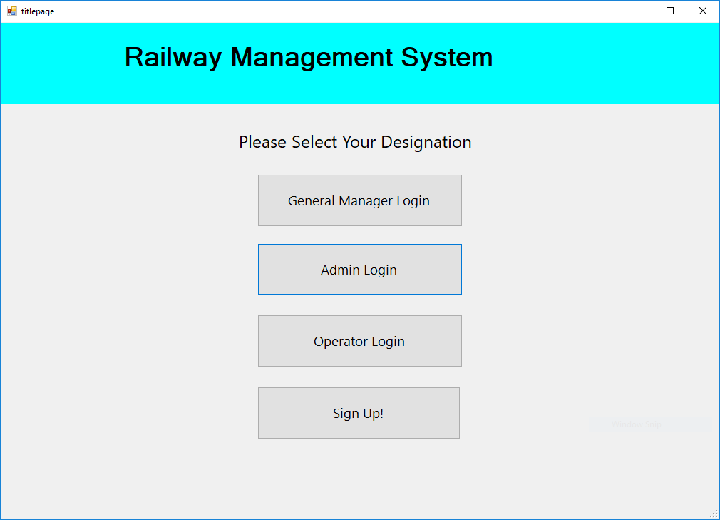

1. **Sign up**

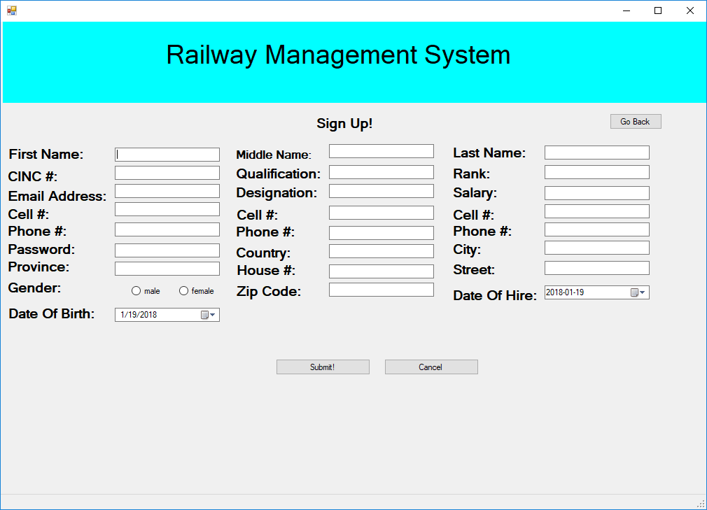

1. **GM login**

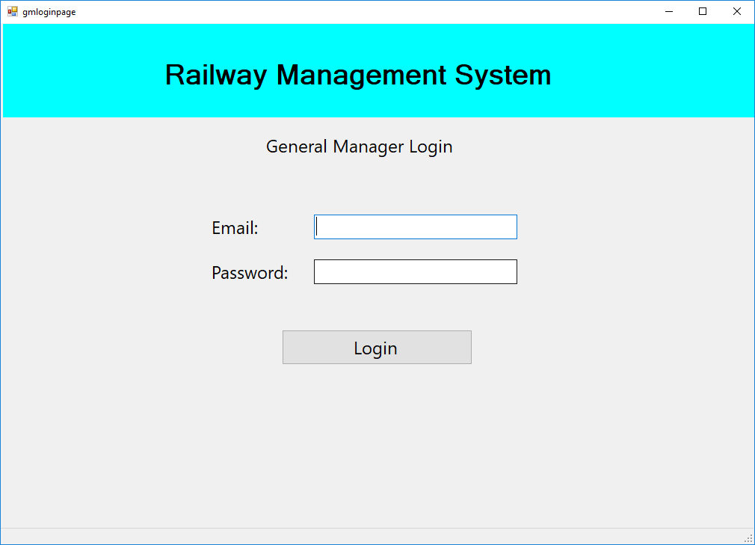

1. **Admin Login**

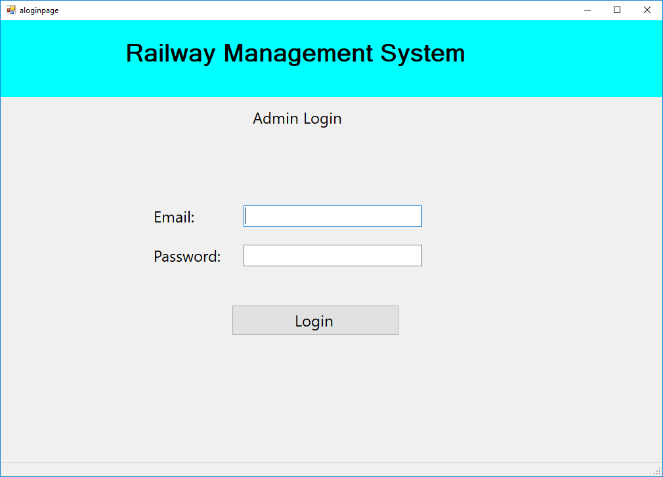

1. **Operator Login**

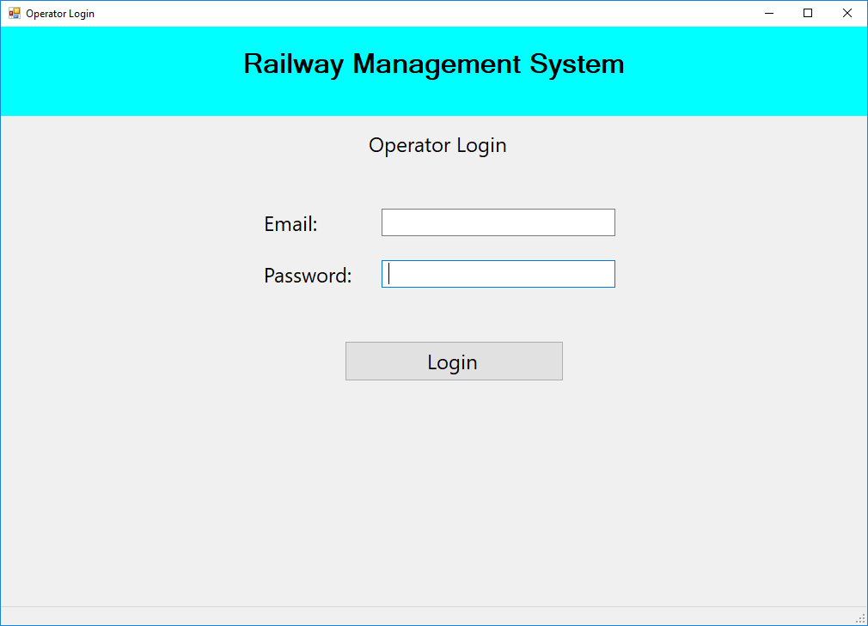

1. **GM Panel**

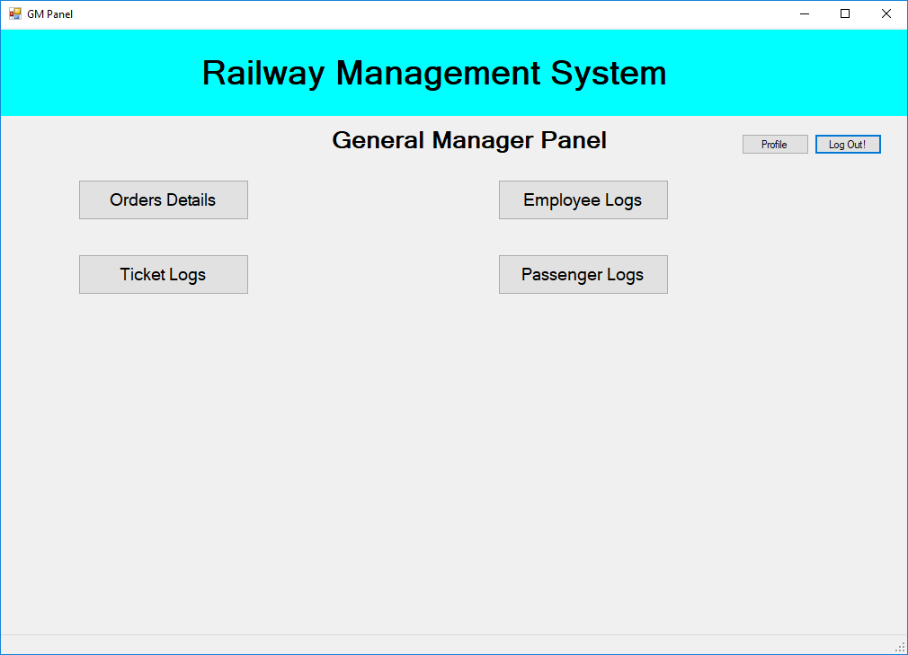

1. **View Profile**

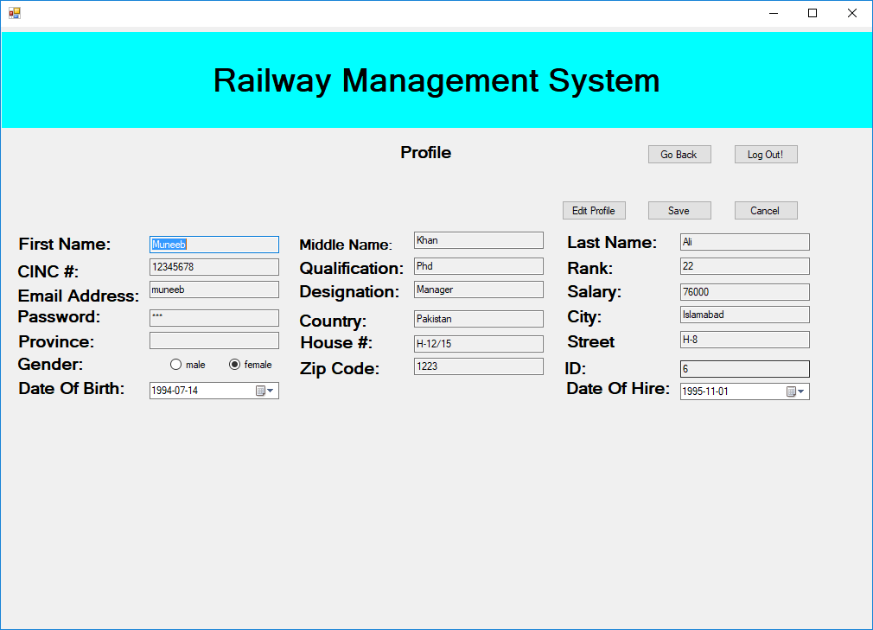

1. **Orders Details**

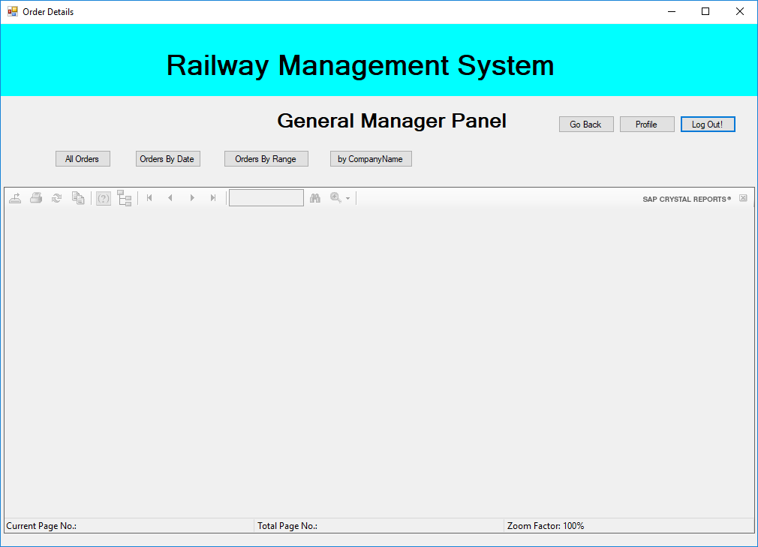

1. **Employee Logs**

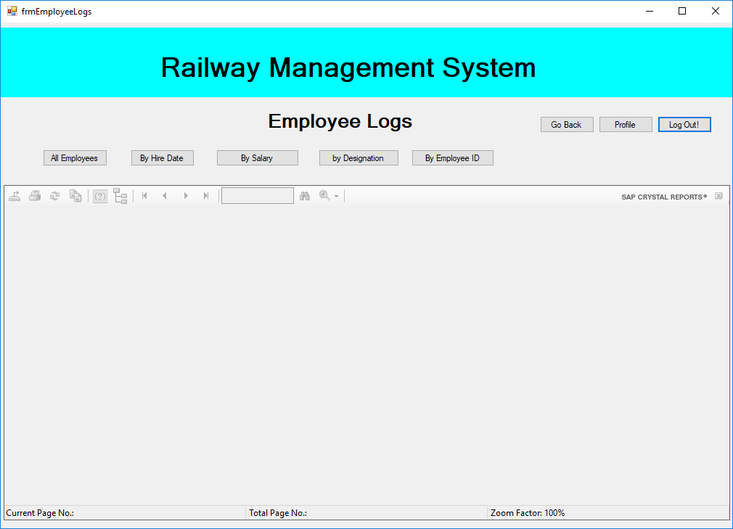

1. **Ticket Logs**

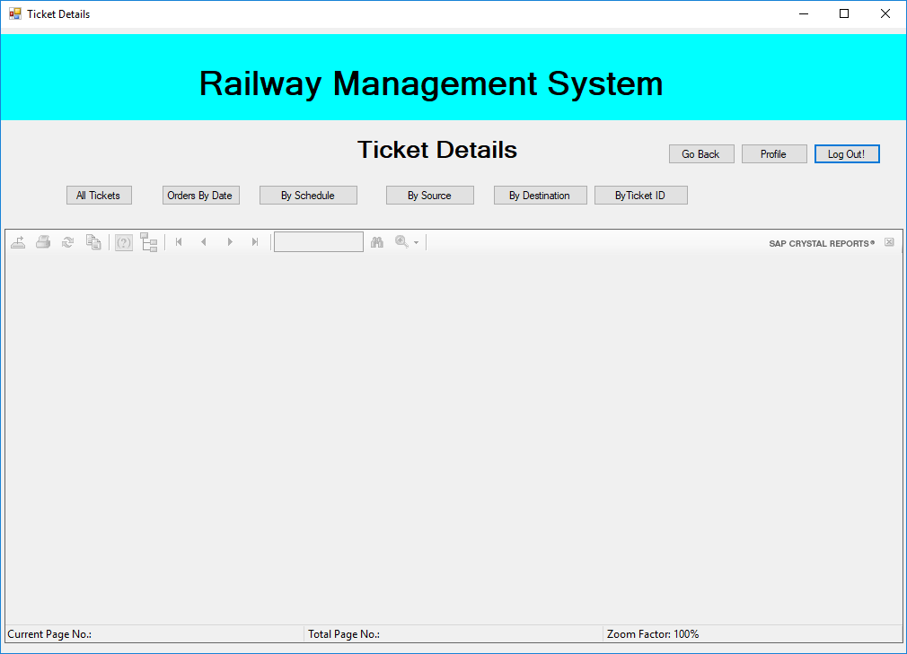

1. **Passenger Logs**

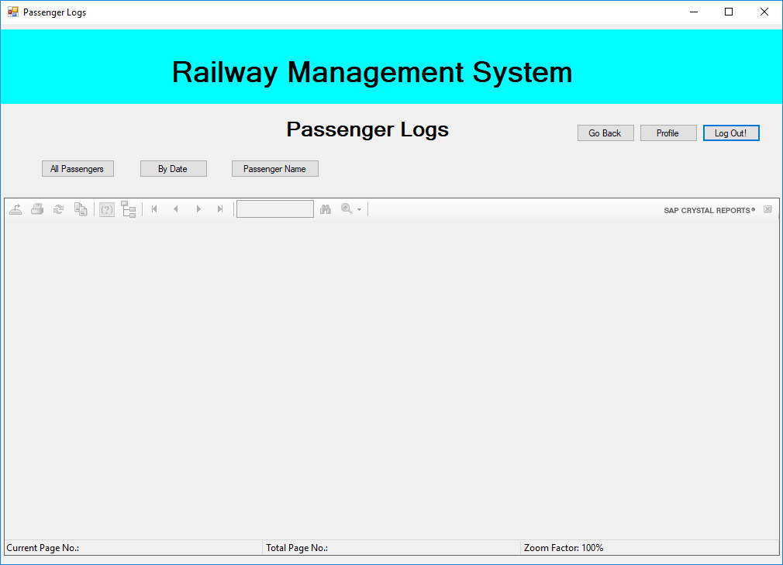

1. **Operator Panel**

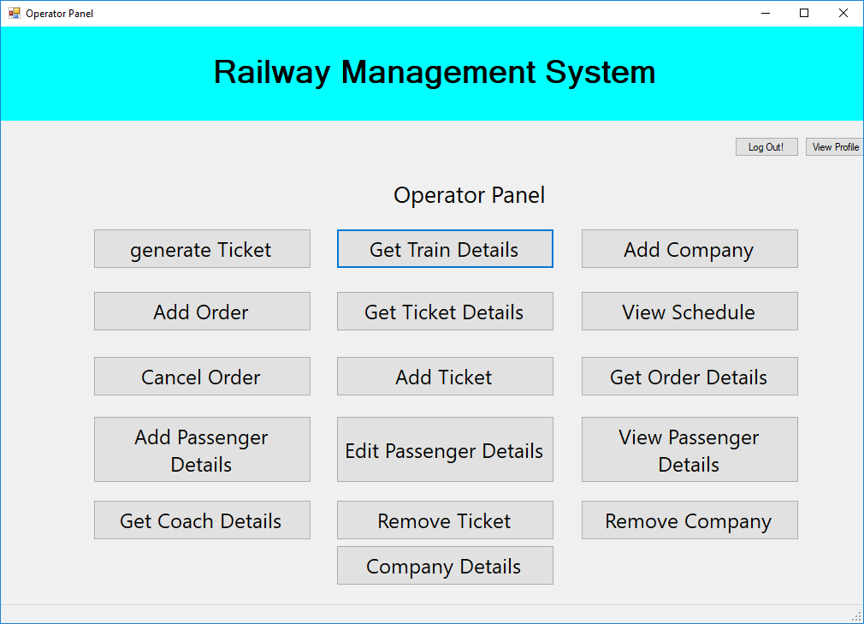

1. **Generate Ticket**

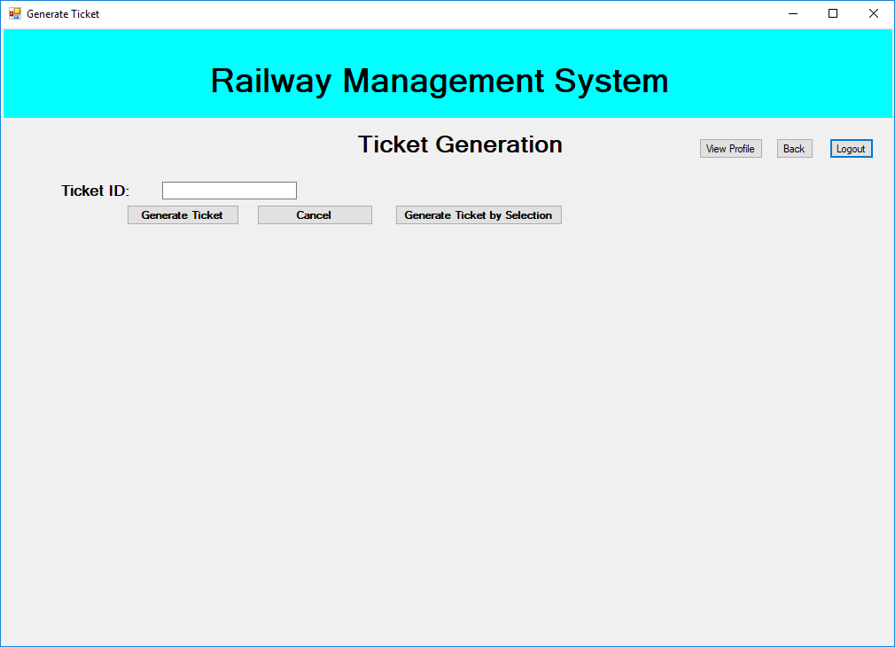

1. **Train Details**

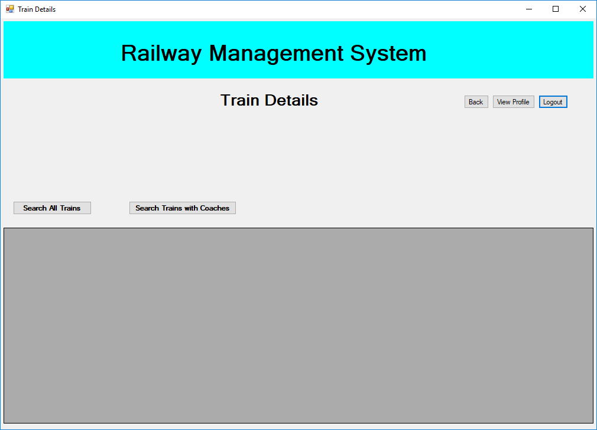

1. **Add Company**

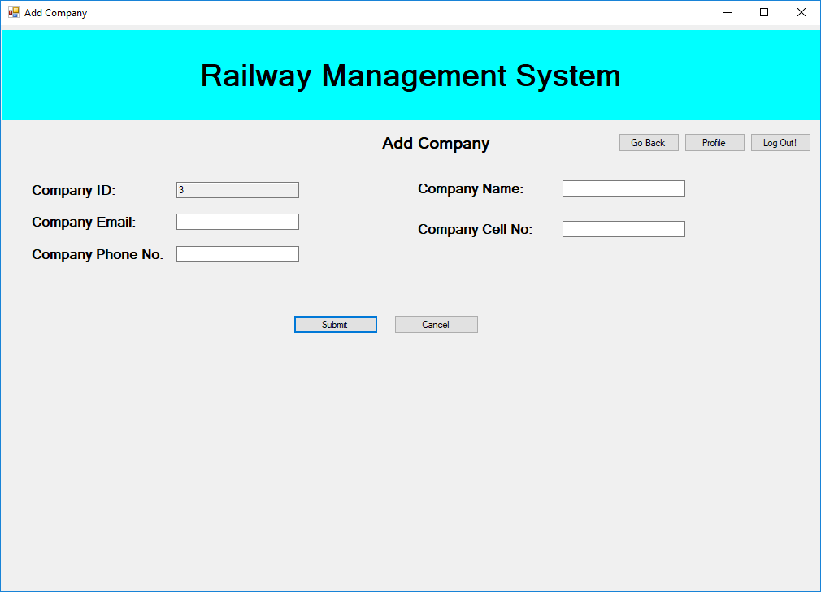

1. **Add Order**

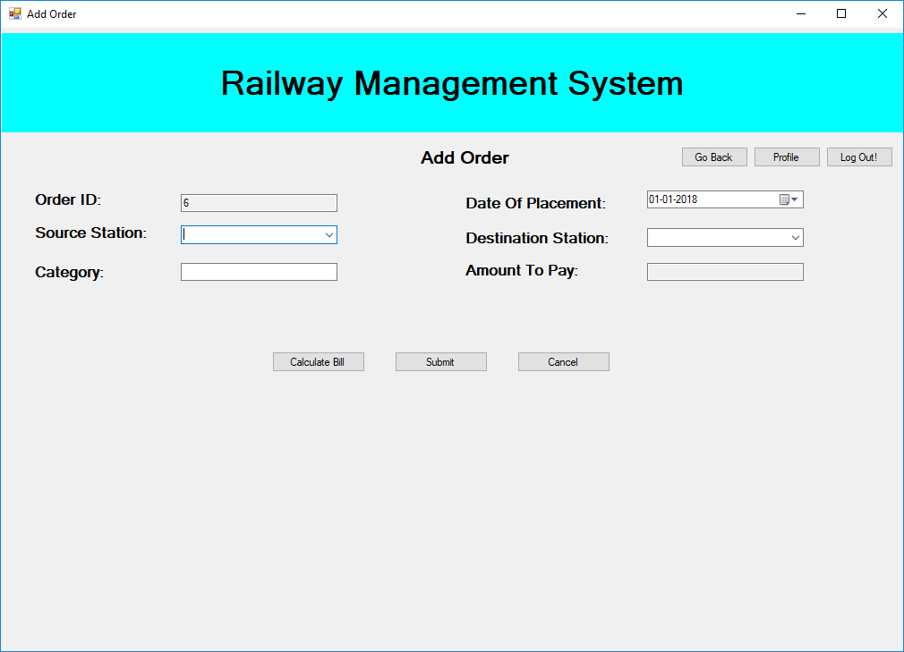

1. **Ticket Details**

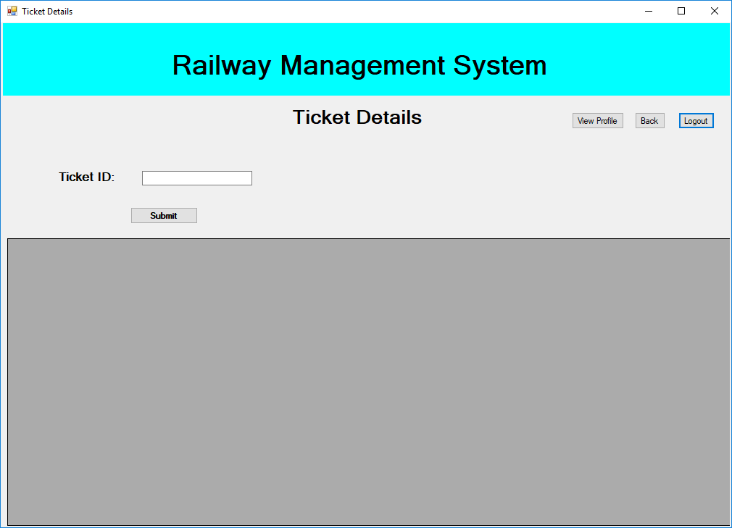

1. **View Schedule**

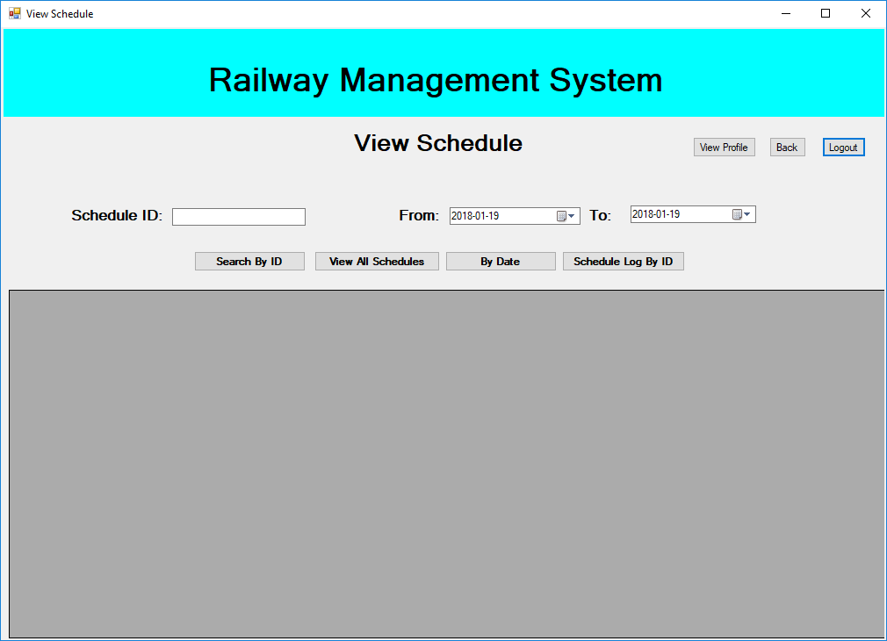

1. **Cancel Order**

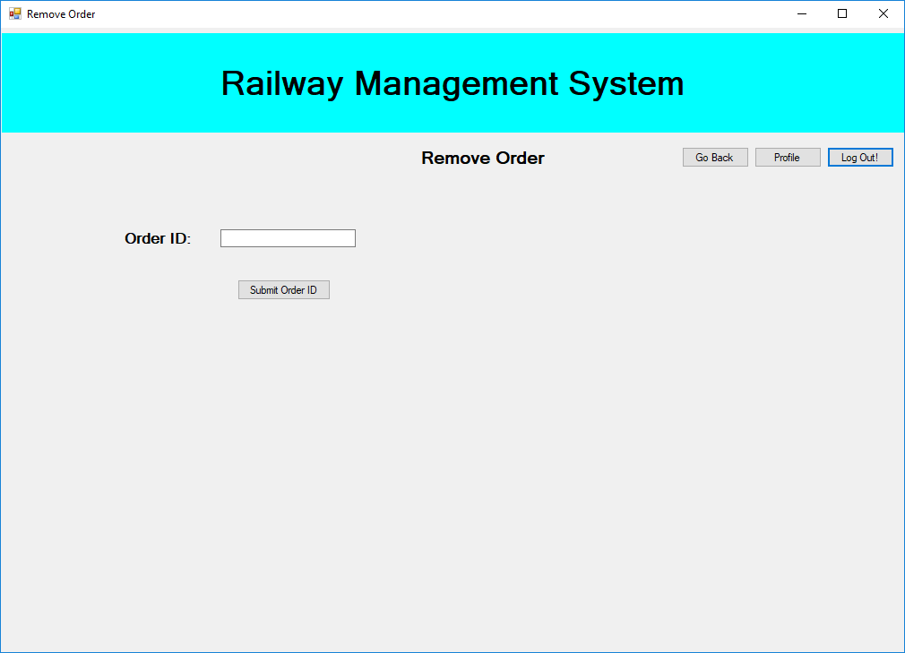

1. **Add ticket**

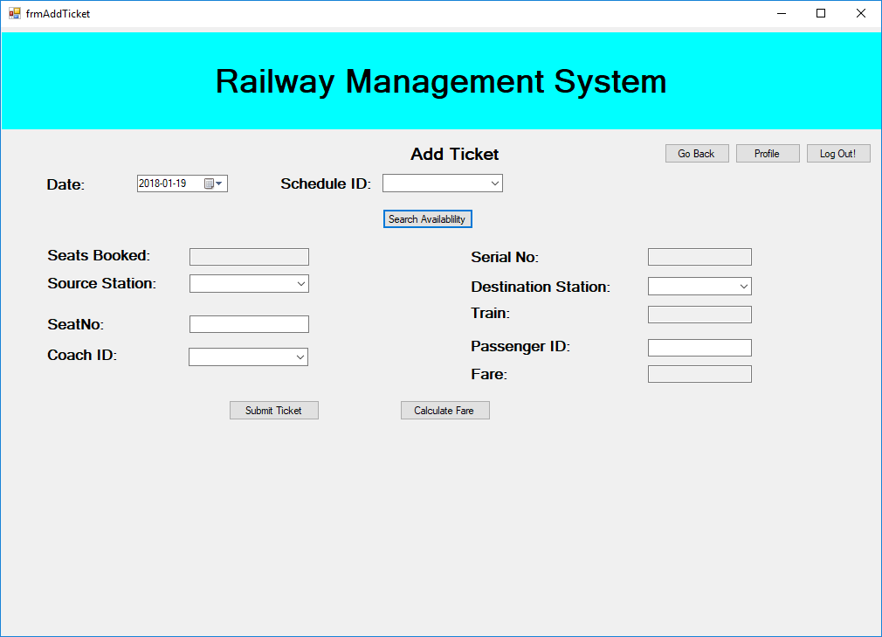

1. **Get Orders Details**

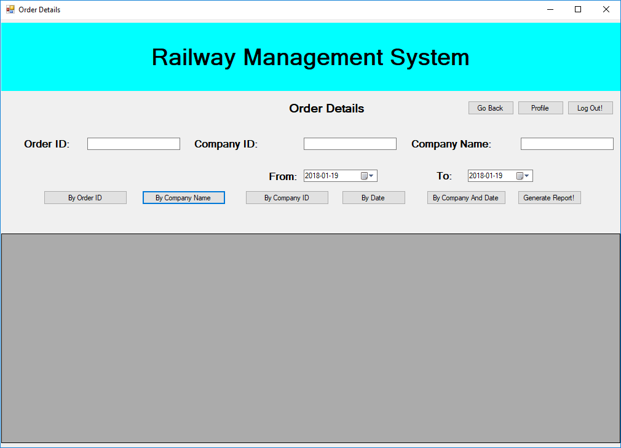

1. **Add Passenger**

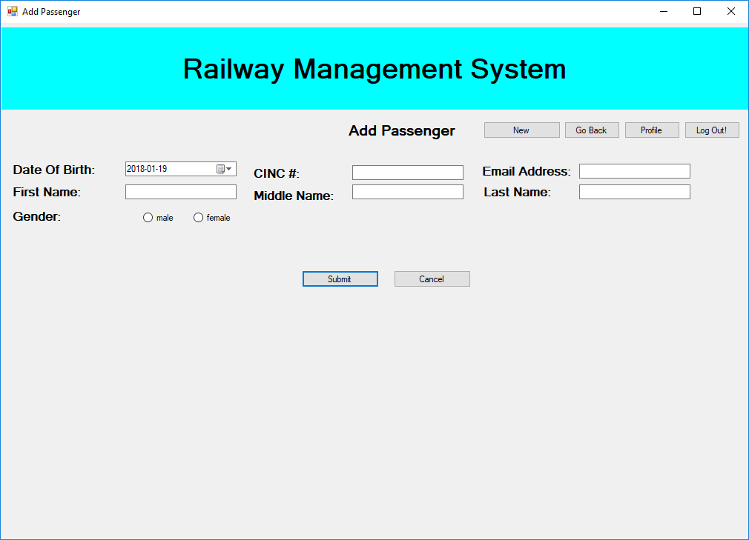

1. **Edit Passenger**

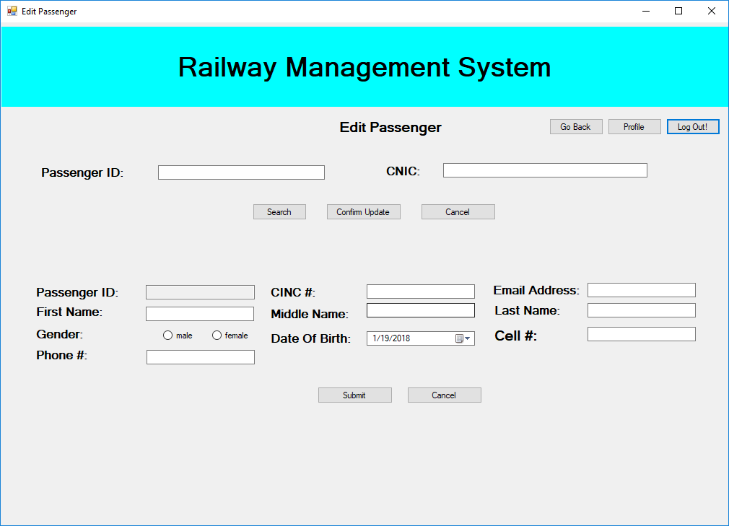

1. **Search Passenger**

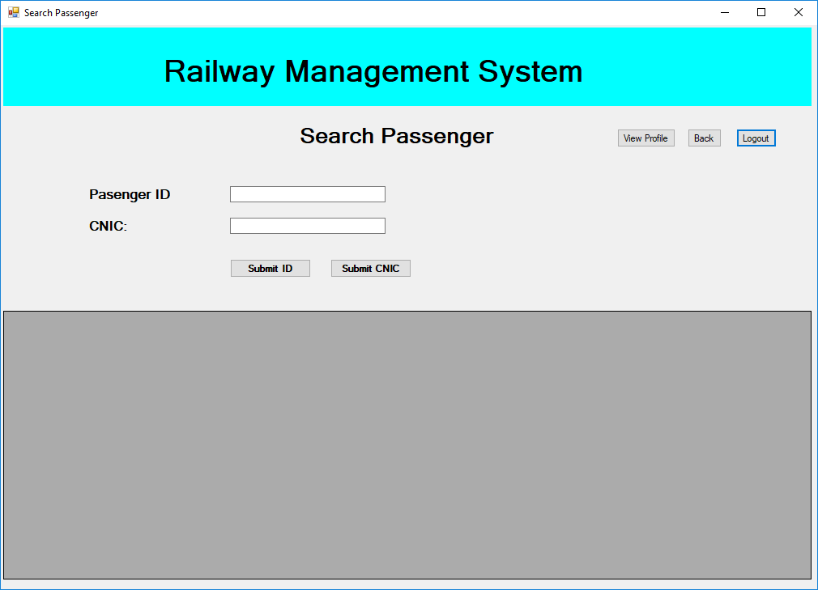

1. **Remove Ticket**

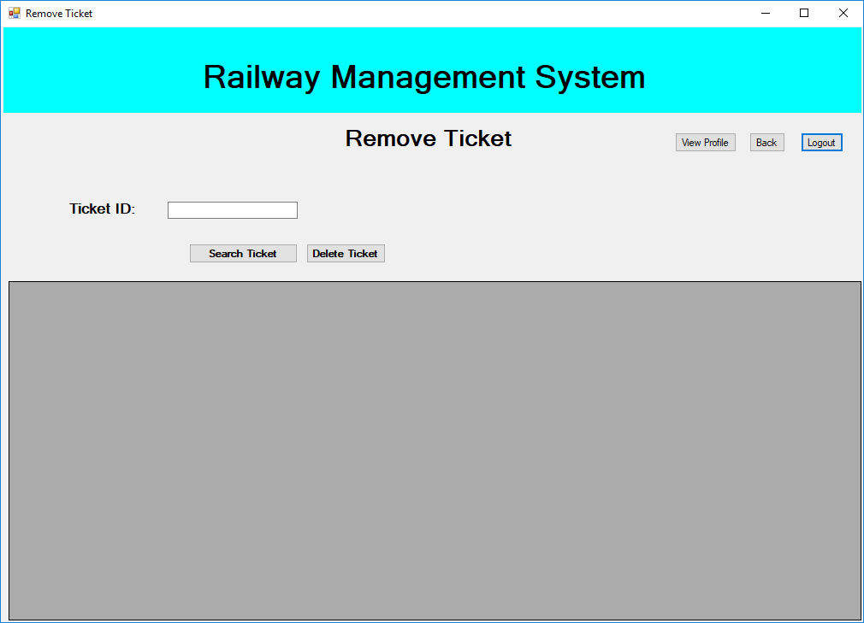

1. **Remove Company**

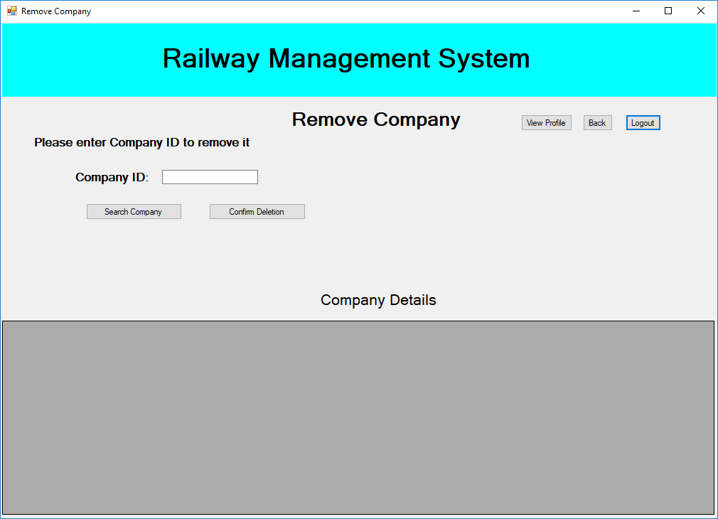

1. **Company Details**

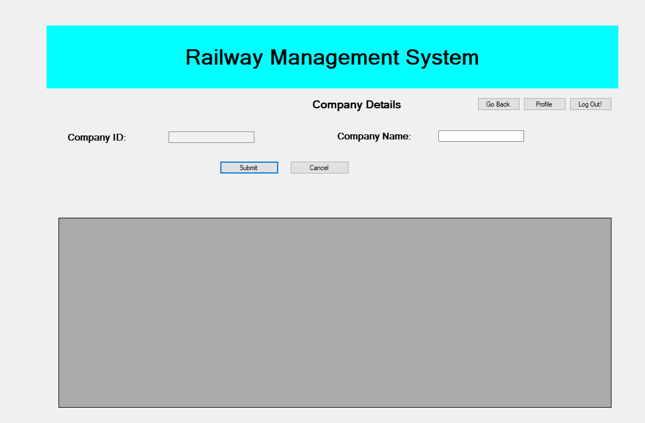

1. **Admin Panel**

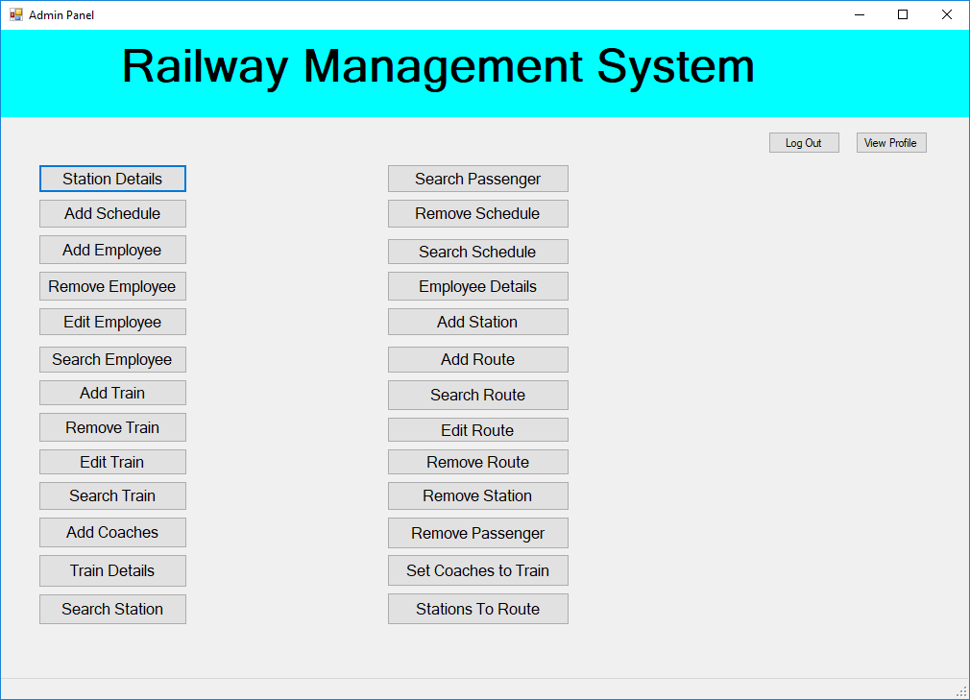

1. **Station Details**

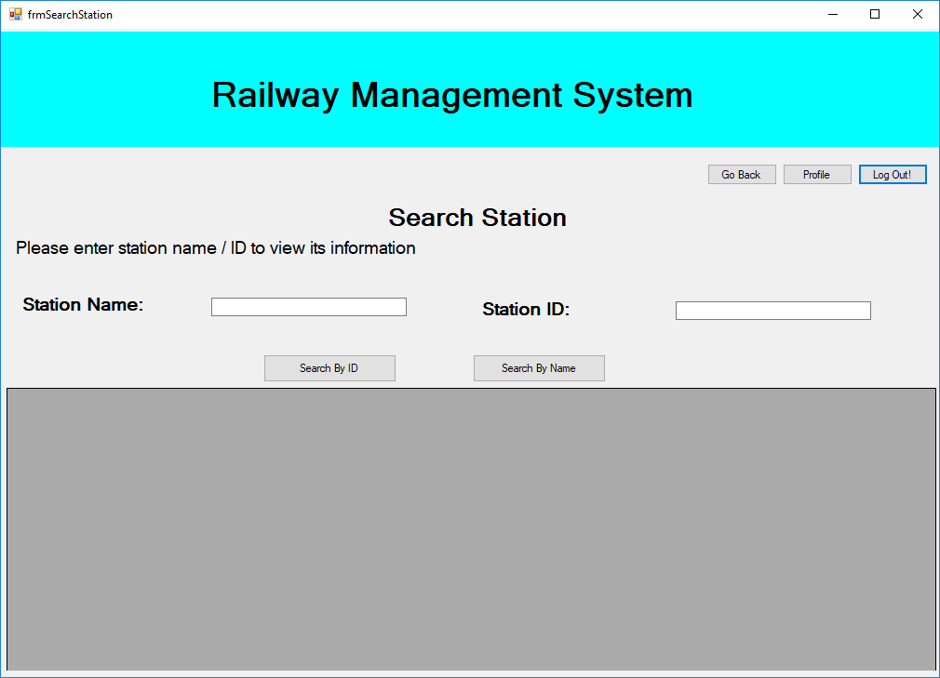

1. **Add Schedule**

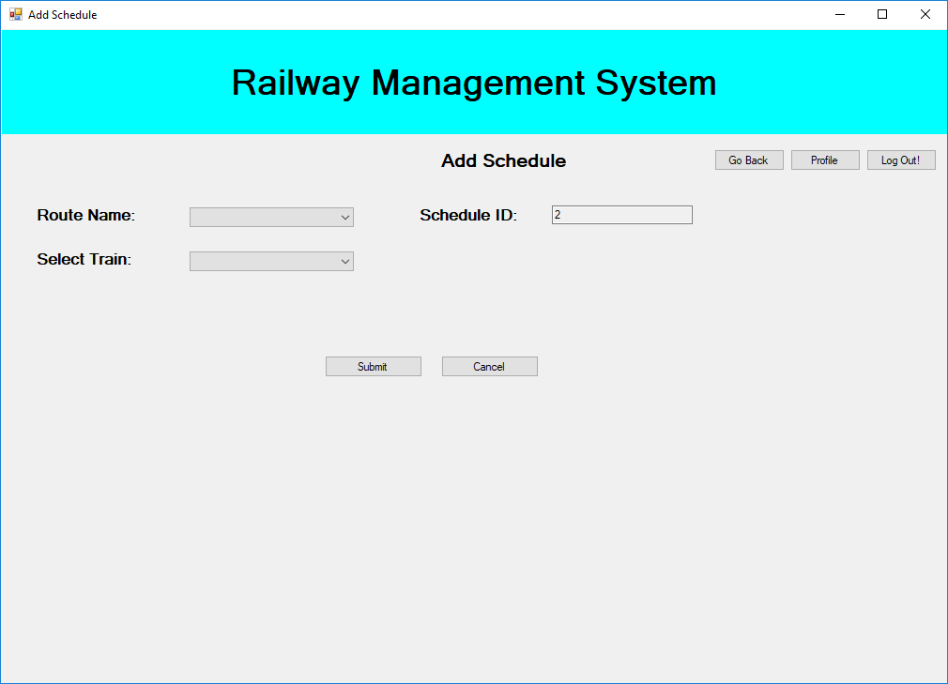

1. **Add Employee**

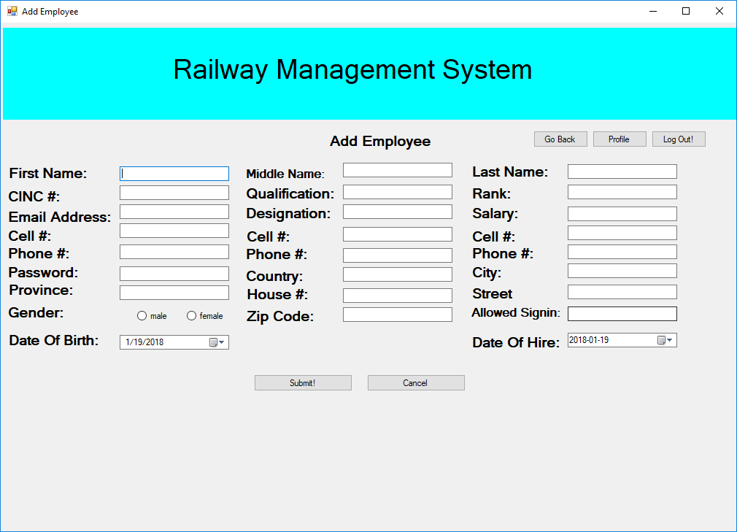

1. **Remove Employee**

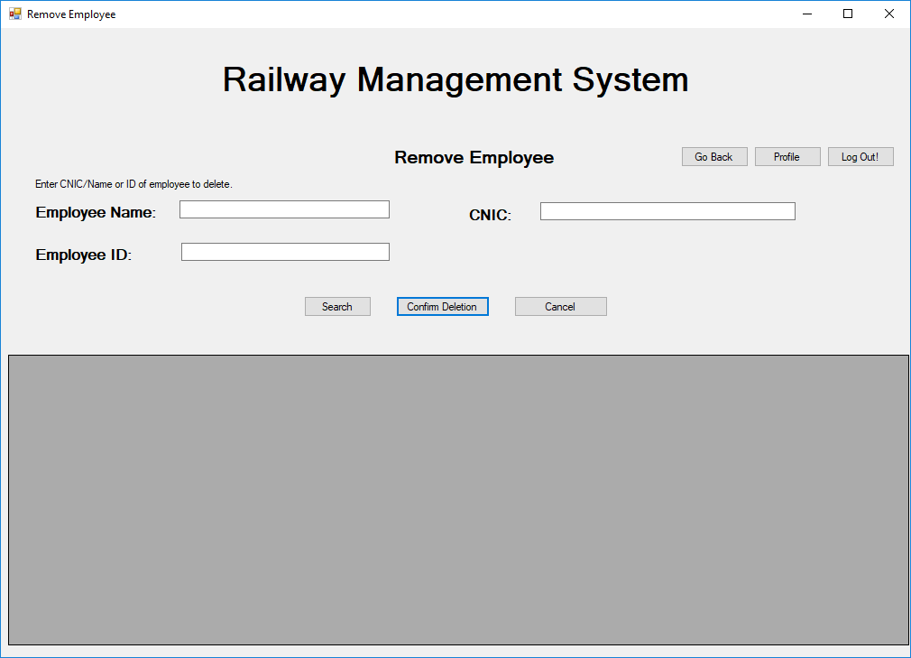

1. **Edit Employee**

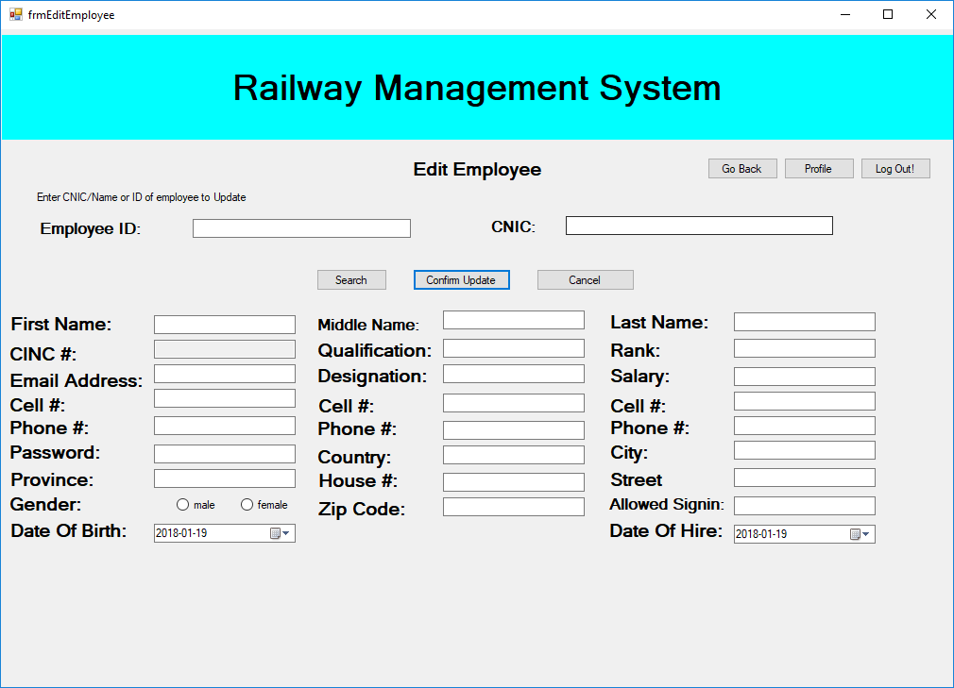

1. **Search Employee**

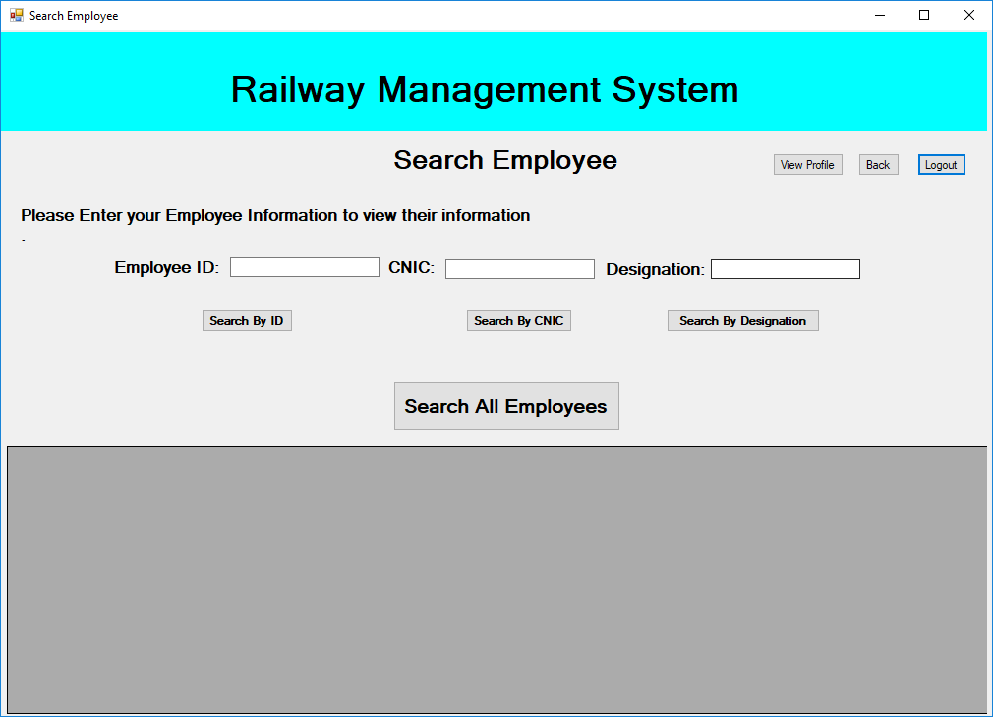

1. **Add Train**

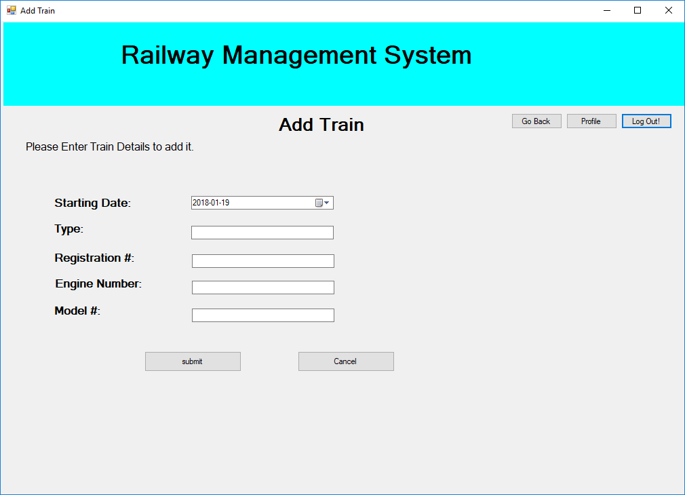

1. **Remove Train**

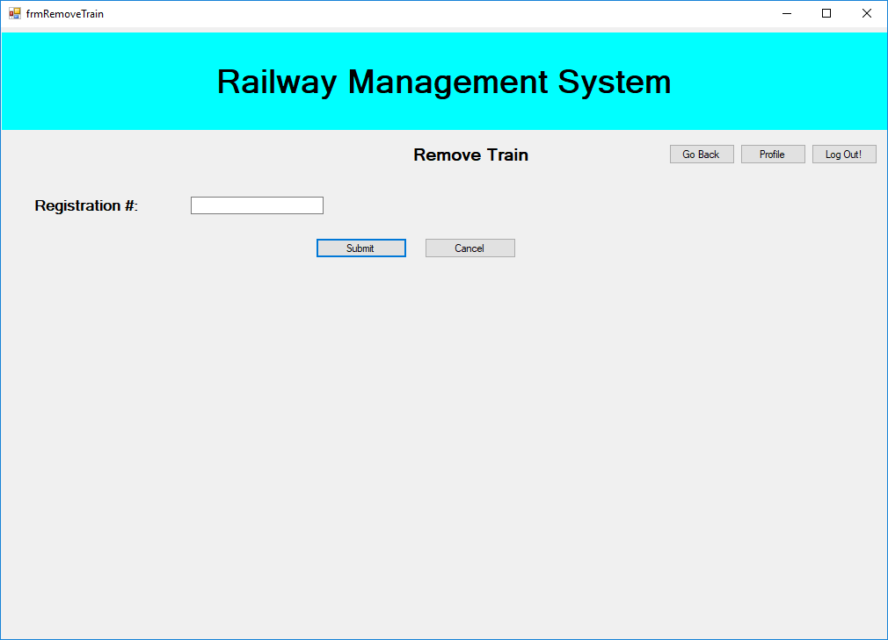

1. **Edit Train**

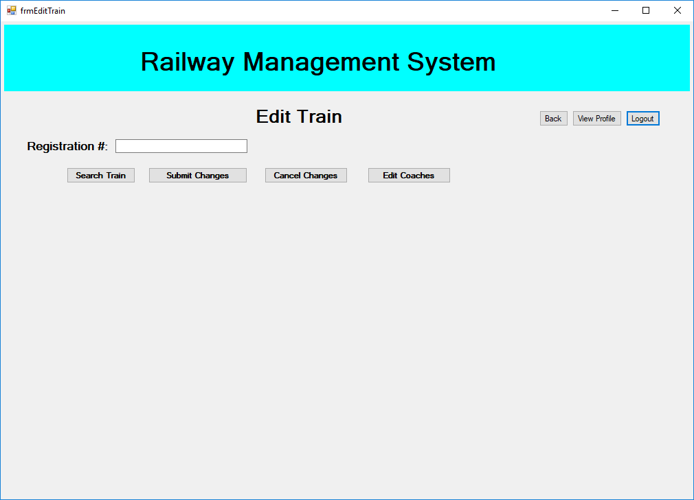

1. **Search Train**

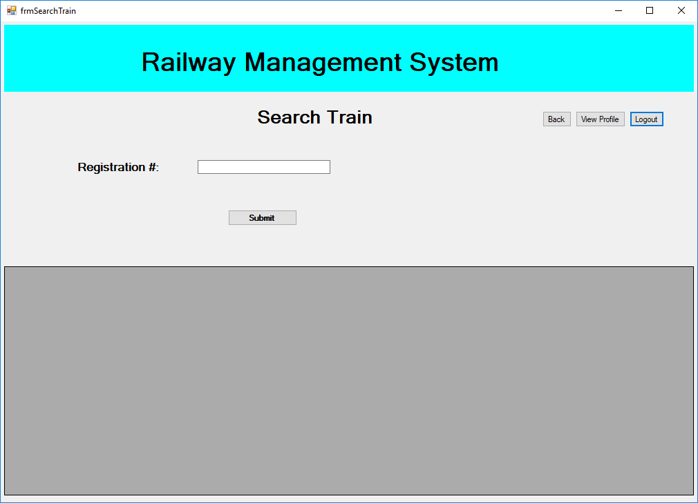

1. **Add Coach**

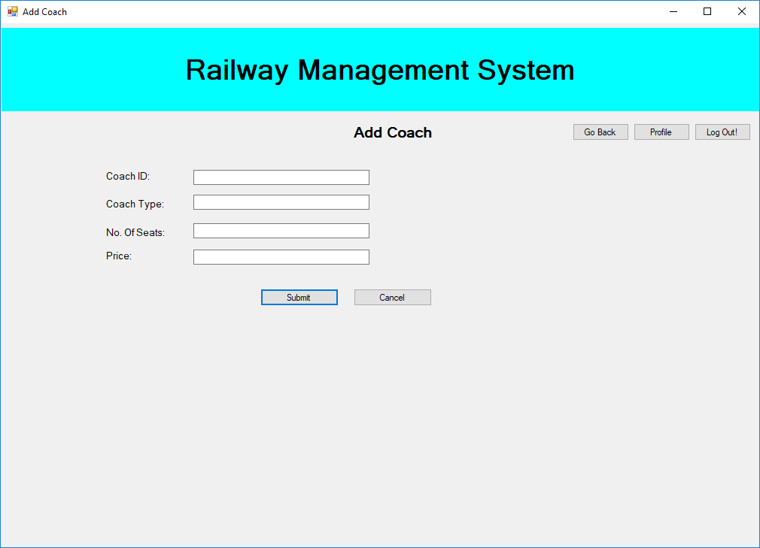

1. **Train Details**



1. **Search Station**



1. **Search Passenger**



1. **Remove Schedule**

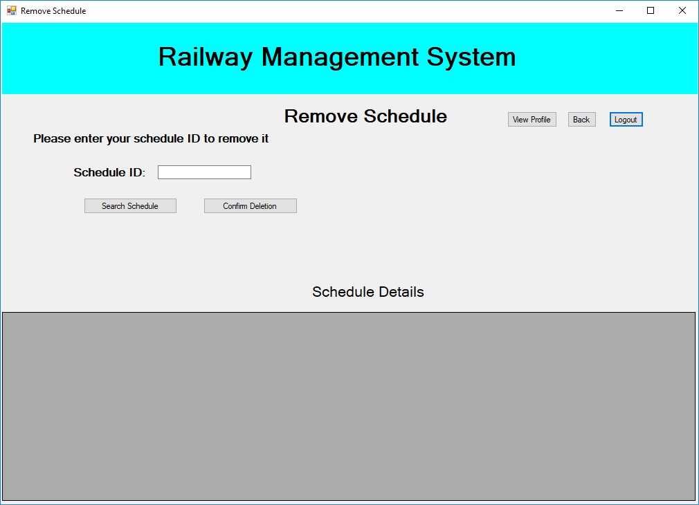

1. **Search Schedule**

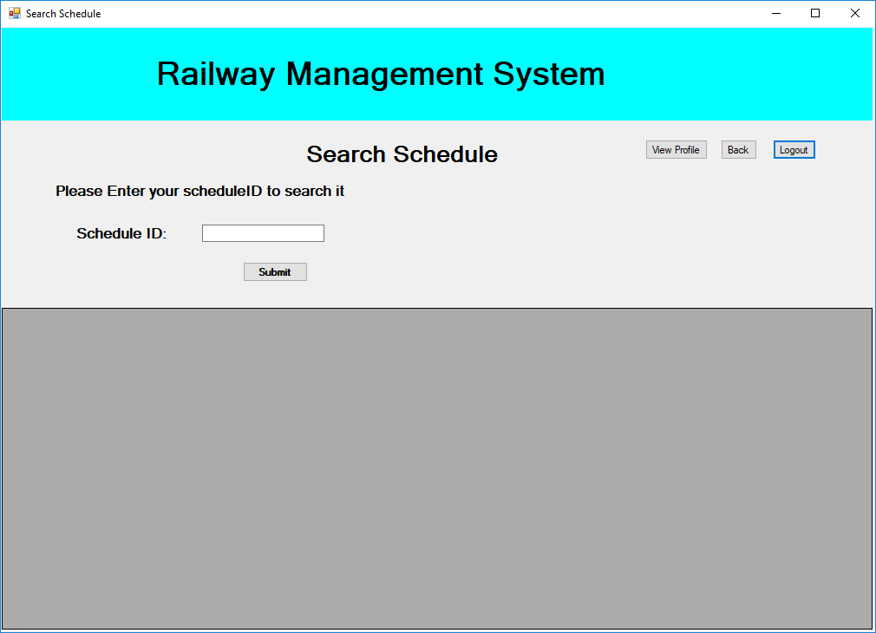

1. **Employee Details**

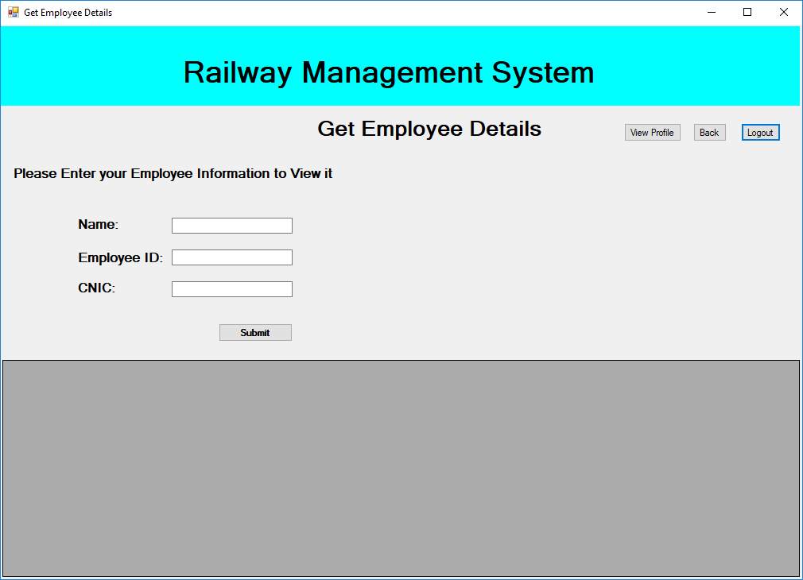

1. **Add Station**

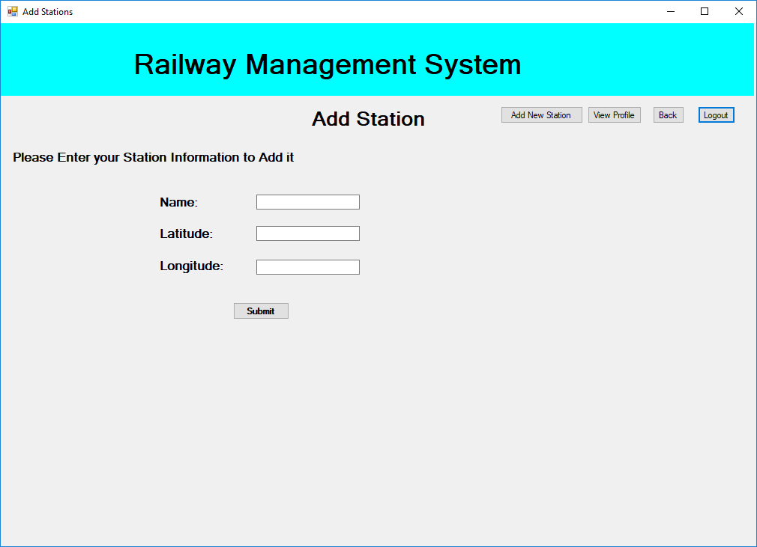

1. **Add Route**

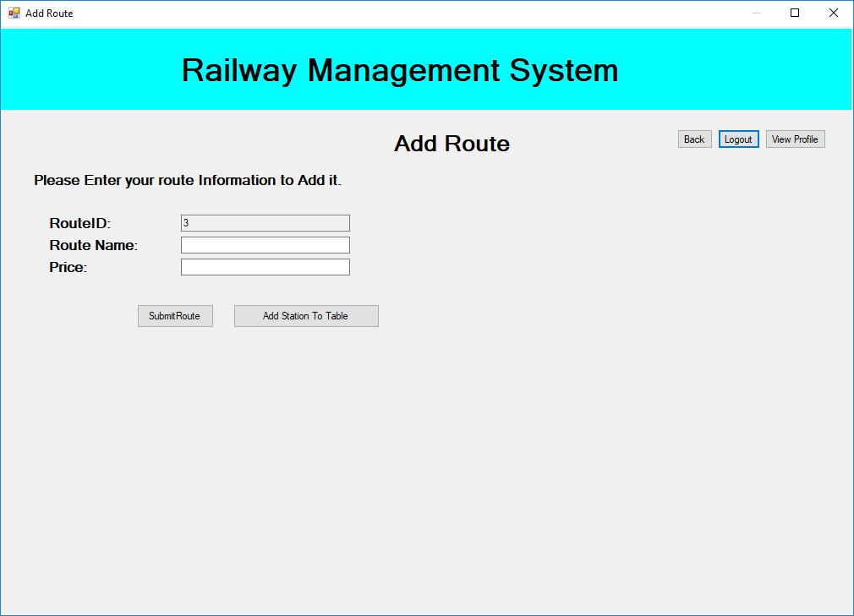

1. **Search Route**

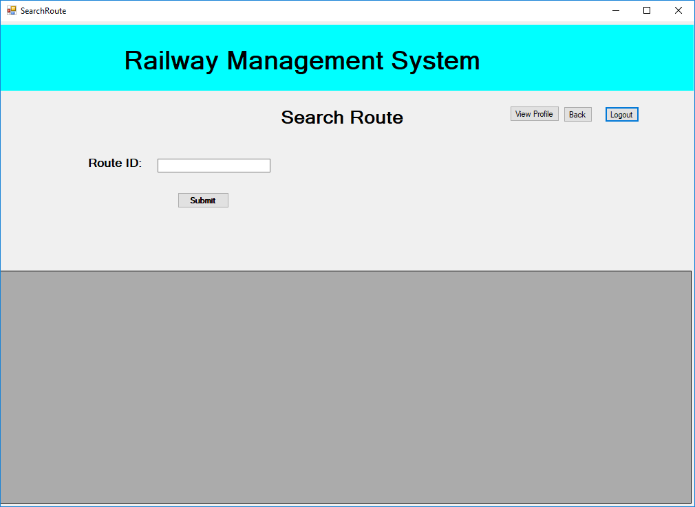

1. **Edit Route**

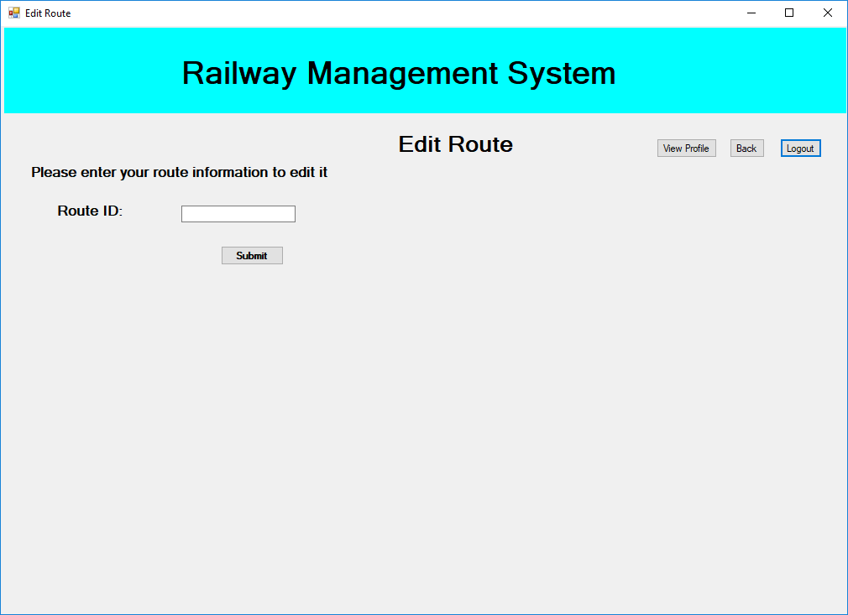

1. **Remove Route**

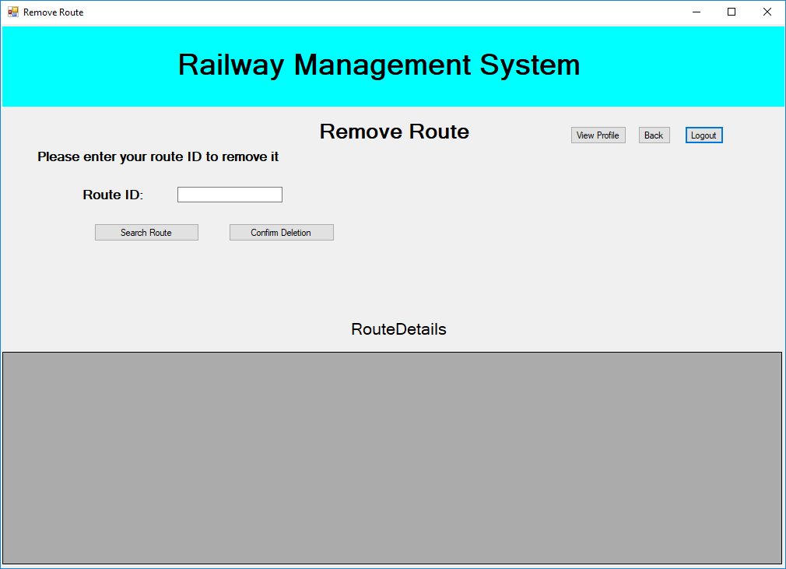

1. **Remove Station**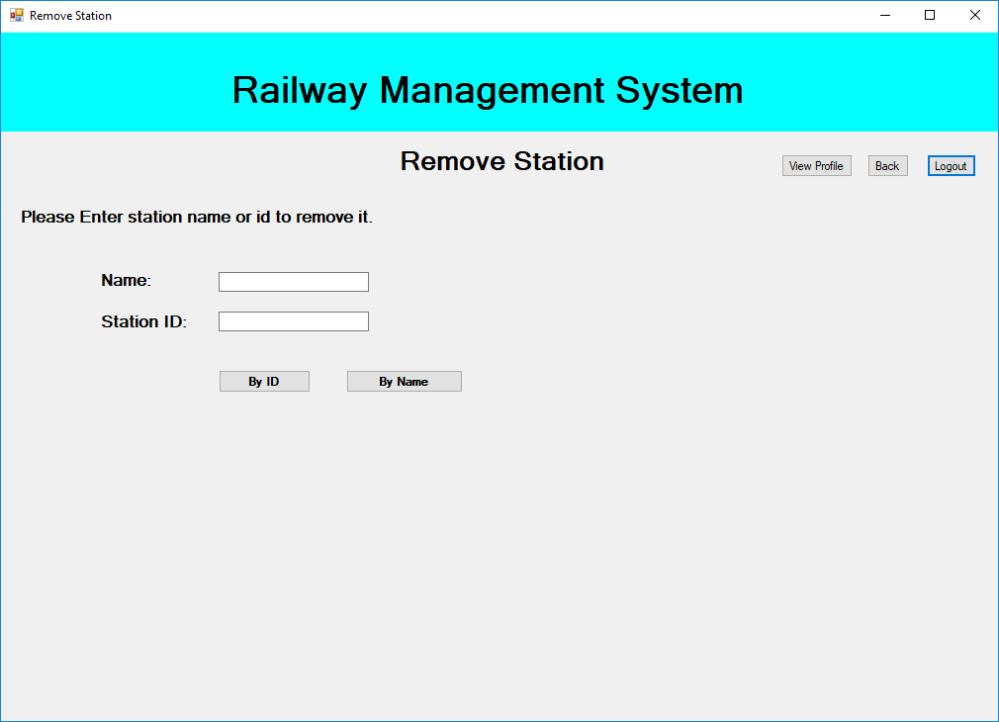
2. **Remove Passenger**

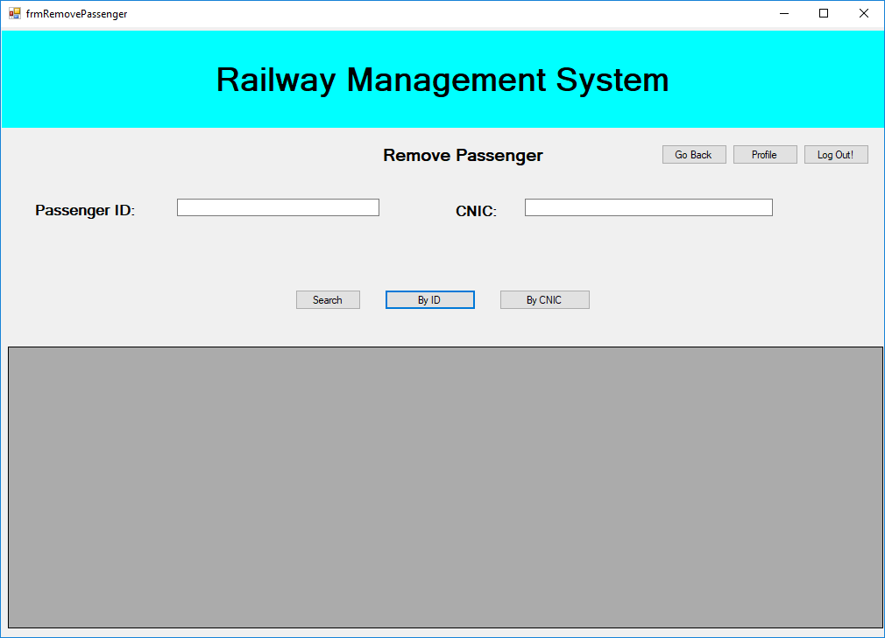

1. **Set Coaches to Trains**

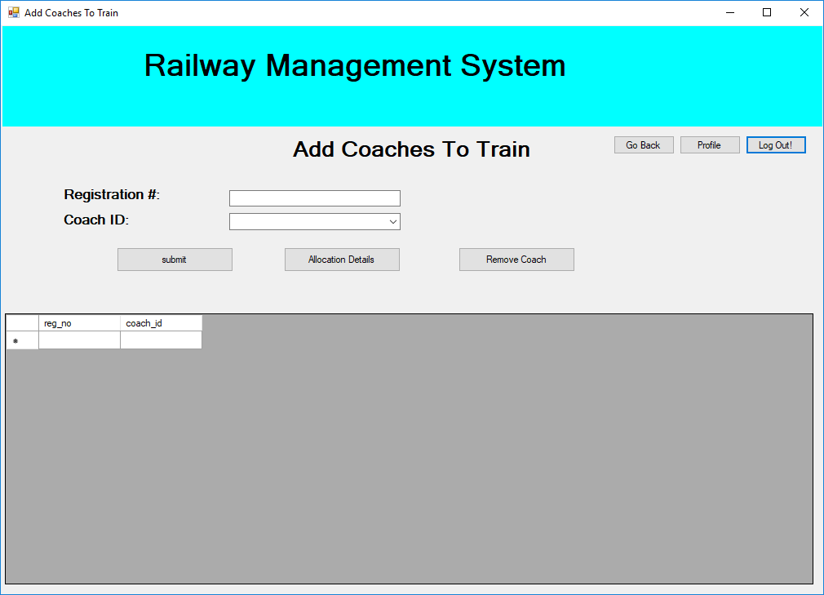

1. **Add Stations to route**

