|  |  |
| --- | --- |
| D:\Personal\RA\Functions\Marketing\Brand Management\Logo\RisingArjun\FinalLogo.png  Rising Arjun DEsign doc  Design Document | Abstract  This document contains the design of Rising Arjun.  Rising Arjun  Design doc |

**All Rights Reserved.** No part of this document may be copied, altered, or used in any form, or by any means, electronic or otherwise, without the express prior written permission of The Rising Arjun. The document however can be shared with others AS-IS in totality without any changes in it.

**Printed in ________**

The Rising Arjun Logo & other contents are intellectual property of Rising Arjun in India.  The use of these without Rising Arjun’s prior written consent is strictly prohibited. Other third party trademarks referenced shall be the property of their respective owners.  Please note that the above list is not all-inclusive, & the absence of any mark from this list does not mean that it is not a Rising Arjun property.

**DISCLAIMER** The information in this book is provided “AS - IS”, without warranty of any kind, express or implied, including but not limited to a warranty of merchantability, fitness for any particular purpose, title or non-infringement of third party rights, & Rising Arjun specifically disclaims all other warranties, conditions or representations. Information in this document is subject to change without notice.

**REQUESTS** for information requests or for obtaining permission for the use of this work, please submit a written request to:

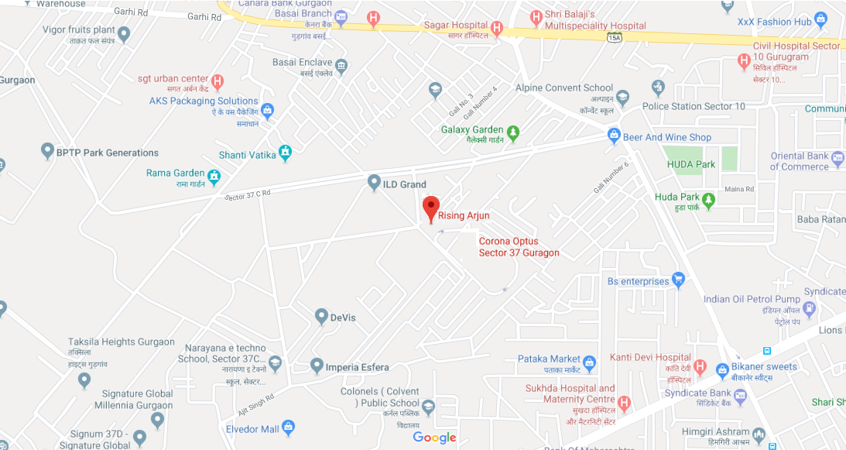Rising Arjun,

Kataria Market,

Near ILD/Corona/Taksila,

Sector 37C, Gurugram

Haryana, India. 122001

e-id: [therisingarjun@gmail.com](mailto:therisingarjun@gmail.com)

(m)-+91-9319412223

+91-7838362175

Contents

1. Introduction 5

Overview 5

Purpose of Handbook 5

Scope 5

Who should read this manual 5

1. Architecture 6

Functional Architecture 6

Deployment Architecture 6

1. Sequence Diagrams 7

Enterprise Onboarding 7

Teacher Registration 7

Student Registration 7

1. API Details 8

Salarypayments 8

Salarypayments 8

1. Annexure 10

Contact Details – Horizontals 10

Contact Details – Verticals 10

Revision History 10

Tables

Table 1 – Document Coverage 5

Table 23 – Contact Details - Horizontals 10

Table 24 – Contact Details - Verticals 10

Table 25 – Document Revision History 10

Chapter 1

# Introduction

## Overview

This document contains the design details of Rising Arjun as below:

|  |  |  |
| --- | --- | --- |
| # | Content | Detail |
| 1 | Architecture | Architecture & modular details |
| 2 | Sequence Diagrams | Client server sequence diagram |
| 3 | API details | Details of APIs exposed by server |

Table 1 – Document Coverage

## Purpose of Handbook

This handbook is meant for all developers, designers & testers of Rising Arjun.

This document will remain valid until a new version of this document is released. With the release of new version, this version will become invalid.

## Scope

All information given in this document is “Strictly Confidential” and cannot be shared outside.

## Who should read this manual

Designers: responsible for UX design.

Developers: responsible for developing features of Rising Arjun.

Testers: responsible for testing software.

Chapter 2

# Architecture

This chapter captures the Architectural details of Rising Arjun platform.

## Functional Architecture

This section captures the Architectural details of Rising Arjun platform.

## Deployment Architecture

This section captures the deployment details of Rising Arjun platform.

Chapter 6

# Sequence Diagrams

This chapter captures the sequence diagrams for the functionalities that are most commonly used.

## Enterprise Onboarding

Below sequence diagram captures the details of enterprise onboarding

## Teacher Registration

Below sequence diagram captures the details of teacher registration

## Student Registration

Below sequence diagram captures the details of student registration

Chapter 7

# API Details

This section captures the schedule as per which syllabus shall be covered for class X students.

## Salarypayments

**Request:**

GET /api/salarypayments

**Response:**

[

{

"date": "2020-09-22",

"employeeIdEmployeeId": "string",

"employeeIdId": 0,

"id": 0,

"month": "JAN",

"paid": 0,

"paymentMode": "NEFT",

"remarks": "string",

"salary": 0,

"sessionAcadSessionId": "string",

"sessionId": 0,

"transactionId": "string",

"unpaid": 0

}

]

RESPONSE MESSAGES

HTTP Status Code Reason Response Model Headers

401 Unauthorized

403 Forbidden

404 Not Found

## Salarypayments

**Request:**

GET /api/salarypayments

**Response:**

[

{

"date": "2020-09-22",

"employeeIdEmployeeId": "string",

"employeeIdId": 0,

"id": 0,

Chapter 17

# Annexure

## Contact Details – Horizontals

|  |  |  |  |
| --- | --- | --- | --- |
| Horizontal Name | Description | HOD/SPOC | E-mail-Id/Contact Details |
|
|
| Admin | Institute’s administration | Gulshan Kumar | [therisingarjun@gmail.com](mailto:therisingarjun@gmail.com) |
| HR | HR functions | Sarita Raturi | [therisingarjun@gmail.com](mailto:therisingarjun@gmail.com) |
| Teaching | Teaching methodologies & content creation | Aniket Khanchi | [therisingarjun@gmail.com](mailto:therisingarjun@gmail.com) |
| Marketing | Sales & marketing | Position Vacant | [therisingarjun@gmail.com](mailto:therisingarjun@gmail.com) |
| Finance | Accounting & finance | Position Vacant | [therisingarjun@gmail.com](mailto:therisingarjun@gmail.com) |
| Legal | Handling legal matters | Position Vacant | [therisingarjun@gmail.com](mailto:therisingarjun@gmail.com) |
| Software | Software development Team | Sarita Raturi | aasoftwaredivision@gmail.com |

Table 23 – Contact Details - Horizontals

## Contact Details – Verticals

|  |  |  |
| --- | --- | --- |
| Vertical Name | Description | E-mail-Id/Contact Details |
|
|
| Online Coaching | Online Coaching | [therisingarjun@gmail.com](mailto:therisingarjun@gmail.com) |
| Home Coaching | home tuitions | [therisingarjun@gmail.com](mailto:therisingarjun@gmail.com) |
| CLAT | CLAT entrance | [therisingarjun@gmail.com](mailto:therisingarjun@gmail.com) |
| IIT | IIT entrance | [therisingarjun@gmail.com](mailto:therisingarjun@gmail.com) |
| NEET | NEET entrance | [therisingarjun@gmail.com](mailto:therisingarjun@gmail.com) |
| BOARDS | All boards classes | [therisingarjun@gmail.com](mailto:therisingarjun@gmail.com) |

Table 24 – Contact Details - Verticals

## Revision History

|  |  |  |  |  |
| --- | --- | --- | --- | --- |
| Rev | Date of Issue | Author | Approver | Scope |
| 1.0 | 25/09/2020 | Rising Arjun | Rising Arjun | Draft template for architecture document |

Table 25 – Document Revision History