AI-BASED USER AND ENTITY BEHAVIOUR ANALYTICS SYSTEM

AN IN-HOUSE PROJECT REPORT

Submitted by

AMAAN SAIFY (2023BCSE07AED025)

In partial fulfilment for the award of the degree of

BACHELOR OF TECHNOLOGY
In
COMPUTER SCIENCE AND ENGINEERING (CYBER SECURITY)

Under the Supervision of
Dr. Rathnakar Achary

ALLIANCE SCHOOL OF ADVANCED COMPUTING
ALLIANCE UNIVERSITY, BENGALURU
OCTOBER - 2026

ALLIANCE SCHOOL OF ADVANCED COMPUTING
ALLIANCE UNIVERSITY, BENGALURU
DEPARTMENT OF COMPUTER SCIENCE AND ENGINEERING (CYBER SECURITY)

----------------------------------------------------------------------------------------------------------

CERTIFICATE

This is to certify that the In-house Project work entitled “AI-BASED USER AND ENTITY BEHAVIOUR ANALYTICS SYSTEM” is the bonafide work done by AMAAN SAIFY (2023BCSE07AED025) submitted in partial fulfilment of the requirements for the award of the degree Bachelor of Technology in Computer Science and Engineering (Cyber Security) during the year 2026-27.

Dr. Rathnakar Achary
Associate Professor
Dept. of Computer Science and Engineering



DECLARATION

This is to declare that the report titled “AI-Based User and Entity Behaviour Analytics System” has been made for the partial fulfilment of the Programme - Bachelor of Technology in Computer Science and Engineering (Cyber Security), under the guidance of Dr. Rathnakar Achary. I confirm that this report truly represents my work undertaken as a part of my In-house Project work. This work is not a replication of work done previously by any other person. I also confirm that the contents of the report and the views contained therein have been discussed and deliberated with the Mentor.

NAME | REGESTRATION NO. | SIGNATURE
AMAAN SAIFY | 2023BCSE07AED025

ACKNOWLEDGEMENT

The satisfaction that accompanies the successful completion of the task would be put incomplete without the mention of the people that made it possible, whose constant guidance and encouragement crown all the efforts successfully.
I am very thankful to my supervisor Dr. Rathnakar Achary for his sustained inspiring guidance and cooperation throughout the process of this project. His wise counsel and valuable suggestions are invaluable.
I would like to thank Dr. K. Ramalakshmi, Head of the Department, Computer Science and Engineering (Cyber Security), and Dr. Vullikanti Vivek, Deputy Director / ASAC, for their encouragement and cooperation at various levels of the project.
I avail this chance to express my deep sense of gratitude and hearty thanks to the Management of Alliance University, for providing world class infrastructure, congenial atmosphere, and encouragement.
I express my deep sense of gratitude to the teaching and non-teaching staff of our department who stood with me during the project and helped me to make it a successful venture.
I place highest regards to my parents, my friends and well-wishers who helped plenty in making the report of this project.

Amaan Saify (2023BCSE07AED025)

ABSTRACT
Most data breaches today do not begin with a software exploit. They begin with a stolen password or with an employee who already has access. Signature-based tools such as antivirus software and intrusion detection systems look for known bad patterns, so a login with valid credentials or a slow insider copying files looks normal to them. User and Entity Behaviour Analytics (UEBA) addresses this by learning how each user and device normally behaves and flagging changes from that behaviour.
This project develops a Python-based UEBA system. It captures four kinds of logs (authentication, system access, network and resource usage), turns each user's and device's day into 44 and 19 behavioural features respectively, and learns a personal baseline and a department peer baseline for every entity. Deviations are scored by three independent layers: robust statistics, an unsupervised machine-learning ensemble (Isolation Forest, Local Outlier Factor and an autoencoder) and 21 threat rules mapped to MITRE ATT&CK. The scores are fused into a 0-100 risk score weighted by asset criticality, and every alert carries plain-English reasons. Baselines adapt over time, but suspicious days are quarantined so that an attacker cannot teach the system to accept an attack. Analysts can mark alerts as benign or confirmed through a Streamlit dashboard, and this feedback updates the profiles.
The system was evaluated on 60 days of simulated logs from a 48-person organisation (about 205,000 events, 108 monitored entities) containing 11 planted attacks and 4 harmless but unusual events. All 11 attacks were detected on the day they started, with precision, recall and F1-score of 0.964 and one false alert in 30 days. Across five differently generated organisations the mean F1-score was 0.951, and with all rules switched off the behavioural layers alone still reached an F1-score of 0.857.
The system was then made to operate as a product rather than a one-off script. Logs arrive by upload with automatic column mapping, a drop folder, a token-authenticated ingest API or an endpoint agent; a collector service scores new data incrementally with saved models, which gives exactly the same result as a full re-run, and notifies analysts by webhook or e-mail. The console is protected by accounts with roles, salted password hashes, lock-out, scoped API tokens and an audit trail. Replaying the simulated organisation through the API as a live feed reproduced the batch result exactly (11/11 attacks, F1-score 0.964). On the public CMU CERT r4.2 insider-threat benchmark (1,000 users, 70 insiders), on which the system was not designed, the out-of-the-box detector found only 3 of 36 held-out insiders, showing that its behavioural layers ignore the small deviations of quiet insiders. Adding one generic indicator, removable-media use by an account with no such history, raised this to 22 of 36 at under one alert per day, including every insider of the first scenario, while gradual data theft by job-seeking insiders remained largely undetected.
Keywords: UEBA, insider threat, anomaly detection, Isolation Forest, autoencoder, risk scoring, explainable alerts, SOC.

LIST OF SYMBOLS & ABBREVIATIONS
Abbreviation | Meaning
AE | Autoencoder
API | Application Programming Interface
AUC | Area Under the Curve
CERT | Computer Emergency Response Team (CMU insider-threat dataset)
CISO | Chief Information Security Officer
CSV | Comma-Separated Values
DFD | Data Flow Diagram
EDR | Endpoint Detection and Response
FN / FP | False Negative / False Positive
FPR | False Positive Rate
GCN / GNN | Graph Convolutional Network / Graph Neural Network
IF | Isolation Forest
LOF | Local Outlier Factor
LSTM | Long Short-Term Memory
MAD | Median Absolute Deviation
MITRE ATT&CK | MITRE Adversarial Tactics, Techniques and Common Knowledge
ML | Machine Learning
P95 | 95th percentile
PBKDF2 | Password-Based Key Derivation Function 2
PR-AUC | Area under the Precision-Recall curve
ROC | Receiver Operating Characteristic
SHA-256 | Secure Hash Algorithm, 256-bit
SIEM | Security Information and Event Management
SMTP | Simple Mail Transfer Protocol
SOAR | Security Orchestration, Automation and Response
SOC | Security Operations Centre
TLS | Transport Layer Security
TN / TP | True Negative / True Positive
UEBA | User and Entity Behaviour Analytics
VPN | Virtual Private Network
z | Robust z-score (deviation measured in units of typical spread)

CONTENTS
Page No
Title Page i
Certificate ii
Declaration iii
Acknowledgement iv
Abstract v
List of Symbols & Abbreviations vi
1. Introduction 1
2. Literature Review 2
3. Identification of the Problem / Scope of the Project 10
4. Proposed Idea / Solution 12
5. Objectives 13
6. Process / Methodology 14
6.1 Identify the needs of customer and users through Design Thinking Methods
6.2 Translate the needs of customer into Project / Product
6.3 Specification of the Project / Product
6.4 Designing the solution for the customer needs
6.5 Process / Flow / Design Diagram
7. Requirements 24
7.1 Hardware Requirements
7.2 Software Requirements
7.3 Datasets
7.4 Technologies and Tools
8. Novelty of the Proposed Idea / Project 26
9. Experimentation 28
10. Results and Discussion 30
11. Conclusion and Future Directions 37
References 39
Source Code 41
Submission Page of the Paper 44
Plagiarism Report 45

1. INTRODUCTION
Organisations depend on user accounts to control who can do what. That same dependence makes accounts the easiest way in for an attacker. The 2025 Verizon Data Breach Investigations Report found that credential abuse was the most common initial access vector, involved in 22% of breaches, and that the human element played a part in about 60% of breaches [1]. Insiders are an equally serious problem: the 2025 Cost of Insider Risks report puts the average annual cost of insider incidents at US$17.4 million per organisation, with 81 days needed on average to contain an incident [2].
Traditional security tools are good at recognising known bad things: a malware signature, a blacklisted IP address, a known exploit. They struggle when the attacker uses a real username and password, or when the person causing harm is an employee who already has access. In these cases every log line can look legitimate. What gives the attack away is behaviour: a salesperson logging in at 3 a.m. from another country, an engineer reading ninety files instead of the usual fifteen, a laptop uploading gigabytes to a file-sharing site it has never used before.
User and Entity Behaviour Analytics (UEBA) is the class of security analytics built for this situation. A UEBA system learns a profile of normal behaviour for every user and every entity (devices, servers, applications) and raises an alert when current behaviour deviates from that profile [3]. Because it does not need a signature, it can catch stolen-credential attacks, insider activity and previously unseen techniques. The practical difficulty is false alarms. Human behaviour is irregular, and security analysts already report being flooded with alerts that turn out to be harmless [4]. A useful UEBA system therefore has to be accurate, quiet and able to explain itself.
This project builds such a system in Python. It captures authentication, system-access, network and resource-usage logs, builds behavioural profiles for users and devices, identifies deviations with three complementary detection layers, and produces prioritised, explained, risk-based alerts in an analyst dashboard. Each alert is tagged with techniques from the MITRE ATT&CK framework [5] so that analysts can relate it to known attacker behaviour.

1.1 Organisation of the Report
Chapter 2 reviews recent research on UEBA and insider-threat detection. Chapter 3 defines the problem and the scope. Chapters 4 and 5 present the proposed solution and its objectives. Chapter 6 describes the methodology, starting from user needs identified through design thinking and ending with the system design and diagrams. Chapter 7 lists the requirements and Chapter 8 explains what is new about the project. Chapters 9 and 10 describe the experiments and discuss the results, and Chapter 11 concludes with future directions.

2. LITERATURE REVIEW
This chapter reviews nine primary research papers published from 2022 onwards on UEBA, insider-threat detection, lateral-movement detection and alert triage. Each paper is summarised with its abstract, accomplishments and limitations, and its relevance (scope) to this project. Section 2.10 compares the papers and identifies the research gap.

2.1 Paper 1: A User and Entity Behavior Analytics Log Data Set for Anomaly Detection in Cloud Computing [3]
Published in: IEEE BigData 2022.
Abstract:
The authors note that compromised accounts let attackers act through legitimate operations, which signature-based tools cannot recognise, and that very few real log data sets exist for testing UEBA methods. They publish CLUE-LDS, a real log data set from a cloud file-sharing platform covering more than 5,000 users over more than five years. Because real data has no labelled attacks, they propose injecting account-hijacking anomalies by swapping the identities of two users with similar behaviour. They also present an adaptive anomaly detector that compares each user-day's event counts with a queue of earlier days and retrains whenever behaviour changes.
Accomplishments and Limitations:
The paper provides a rare public, real-world UEBA data set and a reproducible attack-injection method. With a model size of 30 days and a threshold of 0.6, the adaptive detector reached a true positive rate of 65% at a false positive rate of 4.6% (fewer than two false alarms per day), spending 6.8% of days in retraining. The authors also show that real user behaviour changes abruptly and often, and they warn that false alarm rates measured on synthetic data may be unrealistically low. The limitations are that detection uses only event-type frequencies from a single log source, the attacks are simulated, and there is no explanation or risk prioritisation of alerts.
Scope:
This work supports two design decisions of the project: an adaptive baseline that keeps learning, and an honest statement that results on synthetic data are likely optimistic. It also shows that a detection rate near 65% at a 4.6% false positive rate is a realistic level on real data, which frames how our synthetic results should be read.

2.2 Paper 2: Multi-homed Abnormal Behavior Detection Algorithm Based on Fuzzy Particle Swarm Cluster in User and Entity Behavior Analytics [6]
Published in: Scientific Reports 2022.
Abstract:
The paper treats UEBA as anomaly detection for both internal threat analysis and external intrusion detection, and models the behaviour of entities as well as users. It proposes MAD-FPC, which groups entity behaviour with fuzzy clustering whose cluster centres are searched with particle swarm optimisation. A behaviour frequency-inverse entities frequency (BF-IEF) measure, similar to TF-IDF in text mining, gives more weight to rare behaviour when comparing entities. A point is judged abnormal by looking at its membership in several clusters at once (multi-homed attribution) instead of a single cluster.
Accomplishments and Limitations:
On simulated entity and user connection behaviour built from the NSL-KDD data set, the method reported an accuracy of 0.92, precision of 0.96, recall of 0.90 and F1-score of 0.93, better than the traditional detectors it was compared with. Its strength is entity-aware, unsupervised detection with a sensible rarity weighting. Its limitations are the evaluation data (NSL-KDD is an old network intrusion data set, not a behaviour log), a static model that does not adapt over time, and no explanation or risk scoring of the anomalies it finds.
Scope:
The paper supports profiling devices and other entities, not only users, which this project does with 19 device features. The idea of weighting rare behaviour more heavily is reflected in our novelty features (new hosts, new domains, new countries).

2.3 Paper 3: Cybersecurity Threat Detection Based on a UEBA Framework Using Deep Autoencoders [7]
Published in: AIMS Mathematics 2025.
Abstract:
The authors build a UEBA anomaly-detection framework for a financial institution using deep autoencoders, with Doc2Vec embeddings so that both numeric and text log fields can be used. The autoencoder is trained on data assumed to be mostly normal, and a record is flagged when it cannot be reconstructed well. Feature-level reconstruction residuals are used to explain which fields made a record anomalous. The paper also contributes a proof that two common definitions of fully connected neural networks are equivalent.
Accomplishments and Limitations:
The framework handles mixed numeric and textual logs and gives feature-level explanations, which the authors argue makes it practical for security teams. The real data set had no anomaly labels, so precision, recall and F1-score could not be computed; the few real attack events available were detected almost trivially, so the authors evaluated sensitivity with synthetic anomalies of increasing intensity. Limitations are reliance on a single model type, the absence of standard detection metrics, and no fused or prioritised risk score.
Scope:
This paper is the closest published example of an explainable UEBA system and supports the autoencoder used in our ML ensemble. Our project extends the idea by combining the autoencoder with two other unsupervised models, statistics and rules, and by turning deviations into plain-English reasons inside a single risk score.

2.4 Paper 4: Hunting for Insider Threats Using LSTM-Based Anomaly Detection [8]
Published in: IEEE Transactions on Dependable and Secure Computing 2023.
Abstract:
Insiders mix the steps of an attack with their normal work, which makes the attack hard to see in logs. The authors propose LADOHD, an anomaly-detection framework based on Long Short-Term Memory (LSTM) networks that learns the expected order of events on endpoints and flags event sequences that do not fit, even when an attack spreads over several days.
Accomplishments and Limitations:
On 38.9 million endpoint events collected from a commercial network of 30 computers over twenty days, containing a four-day insider attack, LADOHD achieved a true positive rate of 97.29% with a false positive rate of 0.38%, outperforming the anomaly-detection system already protecting that network. The authors also show that LSTMs predict variable-length event sequences more precisely than Hidden Markov Models. Limitations: it uses a single source of endpoint events, its alerts are not explained to analysts, it was tested on one organisation, and it needs a clean training period.
Scope:
The paper is the main example of deep sequence modelling for insider threats. It shows what order-aware models can achieve and is listed as future work for this project, which uses daily feature vectors because they are lighter and easier to explain.

2.5 Paper 5: A High Accuracy and Adaptive Anomaly Detection Model With Dual-Domain Graph Convolutional Network for Insider Threat Detection [9]
Published in: IEEE Transactions on Information Forensics and Security 2023.
Abstract:
The authors argue that most insider-threat methods treat each user's behaviour as an isolated sequence and ignore relationships between users, which leads to false positives. DD-GCN converts user features and relationships into heterogeneous graphs, balances feature similarity against existing links with a weighted similarity mechanism, and applies graph convolution in two domains (feature and topology) with constraints that keep the learned representations consistent but distinct.
Accomplishments and Limitations:
On the CERT r4.2 and r6.2 insider-threat data sets the model reached accuracies of 98.21% and 98.65% respectively, a clear margin over earlier methods. Its limitations are that it is semi-supervised and relies on a portion of labelled users (the experiments vary the proportion of labels), it profiles users only, it is evaluated only on the synthetic CERT data, and it gives no explanation or prioritised risk score.
Scope:
The paper shows the value of comparing a user with related users. This project captures a simpler, explainable version of the same idea through department peer-group baselines, and it needs no labels.

2.6 Paper 6: LAN: Learning Adaptive Neighbors for Real-Time Insider Threat Detection [10]
Published in: IEEE Transactions on Information Forensics and Security 2024.
Abstract:
Earlier insider-threat work usually flags a suspicious user or a suspicious day after the fact. LAN instead detects malicious activity in real time at the level of individual activities. It learns temporal dependencies within each user's activity sequence and relationships between activities across sequences using graph structure learning, and it uses a hybrid prediction loss that combines self-supervision from normal activities with supervision from the few abnormal ones to cope with extreme class imbalance.
Accomplishments and Limitations:
On CERT r4.2 and r5.2, LAN outperformed nine state-of-the-art baselines by at least 9.92% and 6.35% in AUC for real-time detection, and it also outperformed eight baselines in post-hoc detection. Limitations: its loss uses labels from abnormal activities, it profiles users only, it was evaluated only on CERT data, and its deep model does not explain its decisions.
Scope:
LAN shows where the field is heading (real-time, activity-level detection). This project works at the day level, which is simpler and easier to explain, and lists streaming detection as future work.

2.7 Paper 7: AUTH: An Adversarial Autoencoder Based Unsupervised Insider Threat Detection Scheme for Multisource Logs [11]
Published in: IEEE Transactions on Industrial Informatics 2024.
Abstract:
AUTH targets the stealth of insider behaviour and the heavy imbalance between normal and malicious data. It is fully unsupervised and uses both time features and event features from multiple log sources. Its core model, TL-AAE, is an autoencoder whose encoder combines a temporal convolutional network and an LSTM, trained adversarially in the style of a generative adversarial network to make the latent space more regular.
Accomplishments and Limitations:
On a widely used public insider-threat data set, AUTH achieved an AUC of 0.932, 4.95% higher than the best baseline, and an equal error rate of 0.146, 12.57% lower than the best baseline. The ablation study shows that time features improve detection. Limitations: it profiles users only, its anomaly scores are not explained, it produces no risk ranking, and it assumes the training data is mostly benign without any protection against slow baseline poisoning.
Scope:
The paper supports two choices in this project: unsupervised learning, so that no attack labels are needed, and time-of-day features such as logins at unusual hours.

2.8 Paper 8: Euler: Detecting Network Lateral Movement via Scalable Temporal Link Prediction [12]
Published in: ACM Transactions on Privacy and Security 2023.
Abstract:
Lateral movement, where an attacker moves from one machine to another, is a key stage of advanced attacks. Euler represents network and authentication logs as a series of graph snapshots and treats lateral movement as the appearance of unlikely edges. It stacks a graph neural network on a recurrent sequence model and distributes the graph computation across machines so that it scales to very large logs.
Accomplishments and Limitations:
On the Los Alamos National Laboratory 2015 data set (58 days of real network activity, about 1.6 billion events, with red-team activity), a GCN-GRU Euler model reached an AUC of about 0.99 with a true positive rate of 89.65% and a false positive rate of 0.57%, and trained much faster than earlier models. However, its precision was only about 0.006, meaning almost every alert was a false alarm, because real attacks are extremely rare among benign connections. It models host-to-host links only and does not explain its alerts.
Scope:
Euler supports the lateral-movement scenario and the device profiling in this project. Its very low precision despite a high AUC is strong evidence for the project's focus on reducing false positives through corroboration between layers.

2.9 Paper 9: DEEPCASE: Semi-Supervised Contextual Analysis of Security Events [13]
Published in: IEEE Symposium on Security and Privacy 2022.
Abstract:
Security operators often need several related events to decide whether something is a real threat, and the volume of events forces them to ignore many. DeepCASE uses an attention-based neural network to learn the context (the events that came before) of each security event, clusters similar event sequences, and lets an operator label a few sequences per cluster so that the label is applied to the rest. The attention weights show which earlier events drove the decision.
Accomplishments and Limitations:
On a real data set of 10.5 million security events from 20 international organisations over five months, DeepCASE automatically filtered 86.72% of events and reduced the operators' manual workload by 90.53%, while underestimating the risk of a potential threat in less than 0.001% of cases. Limitations: it works on alerts that other detectors have already raised rather than on raw user behaviour, and it needs operator labelling.
Scope:
DeepCASE is strong evidence that context and explanation reduce analyst workload. It supports the project's explained alerts, its analyst feedback loop and its decision to rank alerts by risk instead of presenting them as a flat list.

2.10 Comparison and Research Gap
Table 2.1: Comparison of the reviewed papers
Paper | Data | Technique | Profiles | Explained | Risk score | Key result
[3] Landauer 2022 | Real cloud logs | Adaptive similarity | Users | No | No | TPR 65%, FPR 4.6%
[6] Cui 2022 | NSL-KDD | Fuzzy PSO clustering | Users + entities | No | No | F1 0.93
[7] Fuentes 2025 | Real bank logs | Autoencoder + Doc2Vec | Users + entities | Yes | No | No labels for metrics
[8] LADOHD 2023 | Real EDR, 30 PCs | LSTM | Endpoints | No | No | TPR 97.29%, FPR 0.38%
[9] DD-GCN 2023 | CERT r4.2, r6.2 | Graph conv. net | Users | No | No | Acc. 98.21%, 98.65%
[10] LAN 2024 | CERT r4.2, r5.2 | Graph + sequence | Users | No | No | +9.92% AUC
[11] AUTH 2024 | Public insider data | Adversarial AE | Users | No | No | AUC 0.932
[12] Euler 2023 | LANL, 1.6B events | Temporal GNN | Hosts | No | No | AUC 0.99, precision 0.006
[13] DeepCASE 2022 | 20 orgs, 10.5M events | Attention + clustering | Alerts | Yes | Partly | Workload -90.53%
This project | Simulated org + CERT adapter | Stats + IF/LOF/AE + rules | Users + devices | Yes | Yes | F1 0.964 (Ch. 10)

Recent work has pushed detection accuracy on public insider-threat benchmarks very high [9]-[11], but these systems profile users only, depend on deep models that analysts cannot question, and stop at an anomaly score without ranking or explaining it. Work that profiles entities either models hosts on their own [12] or uses data that is not behaviour logs [6]. Explanation has begun to appear [7], [13], and adaptive baselines are clearly needed for real, changing behaviour [3], but these ideas have not been combined in one pipeline. None of the reviewed systems protects its baseline against an attacker who slowly makes malicious behaviour look normal, and none corroborates machine-learning anomalies with ATT&CK-mapped rules to cut false positives, even though [12] shows how badly precision suffers without such filtering.
The gap this project addresses is therefore one of integration and usability rather than a single new algorithm: a system that profiles users and devices together against personal and peer baselines, keeps those baselines adaptive but poisoning-resistant, requires agreement between statistical, machine-learning and rule-based evidence before alerting, and presents a single explained risk score to the analyst. Its main weakness relative to [9]-[11] is that it is evaluated on simulated logs rather than a large labelled benchmark, which is discussed in Chapter 10.

2.11 Any Other Sources
- MITRE ATT&CK knowledge base [5]: used to map every threat rule to a technique ID such as T1110 (Brute Force) or T1567 (Exfiltration Over Web Service).
- Verizon Data Breach Investigations Report 2025 [1]: source of breach statistics on credential abuse and the human element.
- Ponemon / DTEX Cost of Insider Risks 2025 [2]: source of insider-incident cost and containment-time figures.
- CMU CERT Insider Threat Test Dataset [14]: the standard public benchmark for insider-threat research; the project includes an adapter for it.
- Studies of SOC analysts [4], [15], [16], [17]: used in Chapter 6 to build user personas through design thinking.
- scikit-learn documentation and the original Isolation Forest, LOF and autoencoder papers [18], [19], [20], [21]: reference for the machine-learning models used.

3. IDENTIFICATION OF THE PROBLEM / SCOPE OF THE PROJECT

3.1 Problem Identification
Attacks that use valid accounts, such as stolen credentials, account takeover and malicious insiders, produce log entries that look legitimate one at a time. Signature-based tools therefore miss them, and the damage is often discovered weeks later [2]. Behaviour-based detection can find them, but existing approaches have practical problems:
- Too many false alarms. Real behaviour is irregular, and analysts already report that most alerts are false or benign [4]. A detector with a high AUC can still have a precision below 1% [12].
- Alerts that do not explain themselves. Analysts distrust scores they cannot understand [17] and need context to decide quickly [16].
- Users only. Most research models user accounts and ignores devices, although some attacks (cryptomining, a compromised laptop used as a pivot) show up on machines.
- Static or unprotected baselines. A baseline learned once becomes stale as people change jobs and habits; a baseline that learns everything can be slowly poisoned by an attacker.
- No prioritisation. An analyst needs to know which alert to open first, not just which events are anomalous.

Problem statement: to develop a Python-based UEBA system that captures authentication, system-access, network and resource-usage logs, builds behavioural profiles for users and devices, identifies deviations from normal behaviour, and generates risk-based security alerts that are accurate, explained and prioritised.

3.2 Scope of the Project
In scope:
- Collection and normalisation of four log streams, including live capture of resource and connection data from the host machine.
- A simulated 48-person organisation (60 days, about 205,000 events) with labelled attacks for objective evaluation, and an adapter for the CERT data set.
- Daily behavioural profiles for 48 users and 60 devices, with personal and peer-group baselines.
- Three detection layers (statistical, unsupervised ML ensemble, MITRE-mapped rules), risk fusion, explained alerts and an analyst feedback loop.
- A Streamlit dashboard for security analysts and a full evaluation with robustness and ablation experiments.

Out of scope: real-time event streaming, automated response actions (for example disabling an account), deployment on a production network, and inspection of file or e-mail content (only metadata is analysed, for privacy).

4. PROPOSED IDEA / SOLUTION
The proposed solution is a layered UEBA pipeline that turns raw logs into a short list of explained, risk-ranked alerts. It works in five stages (Figure 6.1 shows the architecture):
- Capture. Authentication, system-access, network and resource-usage logs are loaded, validated and merged into one event timeline.
- Behavioural features. Each user's day is summarised into 44 numbers (for example failed logins, logins at unusual hours, MB uploaded to new domains) and each device's day into 19 numbers. Features such as "new host" and "unusual hour" are computed only from earlier days, as a live system would.
- Profiles. Every entity gets a personal baseline (its own normal) and a peer baseline (its department's normal), using robust statistics. The personal baseline adapts over a rolling 45-day window, but days that look like attacks are quarantined.
- Detection. Three independent layers score each day: robust z-score statistics, an unsupervised ML ensemble (Isolation Forest, Local Outlier Factor and an autoencoder) trained only on normal days, and 21 threat rules mapped to MITRE ATT&CK.
- Risk and response. The layer scores are fused into a 0-100 daily risk, weighted by how critical the account or device is, and accumulated with decay over days to catch slow attacks. An alert is raised at a risk of 45 or more, with severity, plain-English reasons and ATT&CK techniques, and shown in a dashboard where analysts can mark it benign or confirmed.

Three ideas make the solution practical. First, corroboration: the threshold is set so that statistical deviation alone can never raise an alert; the ML ensemble or a rule must agree, which removes most false alarms caused by one unusual number. Second, explainability: every alert lists what was unusual and by how much compared with the entity's own history. Third, learning with protection: profiles keep adapting to legitimate change, while high-risk days, rule matches and analyst-confirmed threats are never learned.
The solution also runs as a continuous system rather than a one-off script (Figure 6.6). Logs reach a workspace by upload, a drop folder, an authenticated HTTP API or an endpoint agent; a collector service imports them every few seconds, scores only what changed using the saved models, and notifies analysts of new or escalated alerts. The console requires sign-in, enforces viewer, analyst and administrator roles, and records every security-relevant action in an audit trail.

5. OBJECTIVES
The objectives of the project are:
- To capture and normalise authentication, system-access, network and resource-usage logs into a single, consistent event schema.
- To build daily behavioural profiles for both users and devices, with personal and department peer-group baselines that adapt over time and resist poisoning.
- To detect deviations from normal behaviour using complementary statistical, unsupervised machine-learning and rule-based methods, without requiring labelled attack data.
- To combine all evidence into a single 0-100 risk score that accounts for asset criticality and slow, multi-day behaviour, and to generate alerts with plain-English reasons and MITRE ATT&CK mapping.
- To provide an analyst dashboard for triage, investigation and feedback.
- To evaluate the system objectively, aiming to detect every planted attack while keeping precision above 0.9 and false alerts to about one per day or fewer, and to check robustness across different simulated organisations.
- To operate continuously and securely: collect logs automatically from several sources, score new data incrementally with the same result as a full re-analysis, notify analysts, and protect the console with accounts, roles, API tokens and an audit trail.
- To validate the system on an independent public benchmark (CMU CERT r4.2) in addition to the simulated organisation.

6. PROCESS / METHODOLOGY
The project followed the design-thinking cycle (empathise, define, ideate, prototype, test) before and during implementation. This chapter moves from the users' needs (6.1) to product features (6.2), the specification (6.3), the detailed design (6.4) and the diagrams (6.5).

6.1 Identify the Needs of Customer and Users through Design Thinking Methods

Empathise
The primary users of a UEBA system are security operations centre (SOC) analysts; secondary stakeholders are the security manager who runs the SOC and the employees whose behaviour is monitored. It was not possible to interview working SOC analysts for this project, so the personas below are composites built from four published studies of SOC analysts, and are stated as such:
- A survey (n = 20) and interviews (n = 21) of SOC practitioners found that tools produce many false alarms needing manual validation, that most are benign triggers caused by legitimate behaviour, and that alarm validation causes burnout. Analysts asked for alarms that are Reliable, Explainable, Analytical, Contextual and Transferable (REACT) [4].
- Interviews with 17 professionals from 9 organisations showed that detection rules are judged mostly by how many alerts and false positives they generate, and that no interviewee saw replacing rules with AI-based anomaly detection as the answer [15].
- An experiment with 10 tier-1 analysts on 200 alerts found that analysts who followed a structured analysis process were 2.5 times more likely to reach an accurate assessment than those who did not [16].
- A study of six US Navy SOC analysts using ML-based tools found that they lacked a mental model of how scores were produced, which led to mistrust or misuse of the tools [17].

Table 6.1: User personas (composites built from published research)
Persona | Goals | Pain points | Needs from the system
Priya, tier-1 SOC analyst | Triage the queue quickly; never miss a real attack | Flood of false and benign alerts; scores with no reason; relies on experience rather than a structured process | Few, ranked alerts; a reason for every alert; context (usual vs today) in one place
Rahul, SOC manager / CISO | Balance analyst workload against detection coverage; report risk to management | Rules tuned only to reduce noise; sceptical of black-box AI; no overview of what is covered | Risk ranking, severity, MITRE ATT&CK coverage, measurable performance
Ananya, monitored employee | Do her job without being wrongly accused | Fear of intrusive monitoring; unusual but legitimate work (a new project) being flagged | Metadata-only monitoring, fair comparison with her own history and peers, quick clearing of false alerts

Table 6.2: Empathy map for the SOC analyst persona
Says | Thinks
"Most of these alarms are false." "Why did the tool flag this?" | "If I ignore alerts, I might miss the real one." "I cannot trust a score I don't understand."

Does | Feels
Opens each alert, searches logs manually, compares with what the user normally does, escalates or closes | Overloaded, desensitised to alarms, uncertain when closing an alert

Define
How might we help a SOC analyst spot account misuse and insider activity early, without adding to the flood of false alarms, and show clearly why each alert was raised?

Ideate
Three directions were considered. Signature rules alone would be precise and explainable but blind to anything without a rule. A single deep-learning model could find novel patterns but would be a black box, which the studies above show analysts distrust. The chosen direction was a hybrid: statistics and rules for explanation and precision, an unsupervised ML ensemble for unknown patterns, and a fused risk score that requires agreement between them.

Prototype and Test
A first working prototype detected every planted attack but raised 67 alerts in 30 days with a precision of only 0.31, mostly because legitimate monthly uploads were flagged. Testing against the users' needs led to three design changes: a baseline spread that respects each person's own occasional peaks, an adaptive baseline with quarantine, and a threshold that requires corroboration between layers. A later fix to the accumulated-risk calculation removed alerts that lingered after incidents. Together these raised precision to 0.964 (Chapter 10). Design thinking also added a feature: an analyst feedback button, so that a false alert can be closed and learned from.

6.2 Translate the Needs of Customer into Product
Table 6.3: User needs translated into product features
User need | Product feature | Where implemented
Fewer false alarms (Priya, Rahul) | Corroboration threshold of 45; P95-aware spread; adaptive baselines | risk.py, profiles.py, pipeline.py
Know why an alert was raised (Priya) | Plain-English reasons, per-layer score chart, MITRE technique IDs | detectors.py, dashboard
Context in one place (Priya) | Alert card with usual vs today values, risk timeline, login-hour chart, event timeline | dashboard (Alerts, Investigate)
Know what to open first (Priya, Rahul) | 0-100 risk score, asset criticality, severity levels | risk.py
Catch slow insiders (Rahul) | Accumulated risk with a 3-day half-life | risk.py
Trust in automation (Rahul) | ML used as one corroborating layer alongside rules, never alone | pipeline.py
Close and learn from false alerts (Priya, Ananya) | "Mark benign" / "Confirm threat" buttons feeding back into baselines | feedback.py, dashboard
Privacy and fairness (Ananya) | Metadata-only daily counts; comparison with own history and own department | features.py, profiles.py
Coverage reporting (Rahul) | Overview page with alerts by ATT&CK technique; model performance page | dashboard

6.3 Specification of the Product

Functional requirements
Table 6.4: Functional requirements
ID | Requirement
FR1 | Accept authentication, access, network and resource logs as CSV, JSON or JSON-lines files (or ZIP archives), detect the log type, map and validate the columns, and normalise the values.
FR2 | Compute 44 daily features per user and 19 per device.
FR3 | Learn personal and department peer baselines and update personal baselines over a rolling 45-day window.
FR4 | Score every entity-day with the statistical layer, the ML ensemble and 21 threat rules.
FR5 | Produce a 0-100 daily risk and a decaying accumulated risk per entity.
FR6 | Raise alerts with severity, reasons and MITRE ATT&CK techniques when risk reaches the threshold.
FR7 | Let an analyst mark an alert benign or confirmed and use this at the next analysis run.
FR8 | Show overview, alerts, entity investigation, model performance, data sources, live host monitor, log explorer and administration pages, refreshed automatically when new results arrive.
FR9 | Measure precision, recall, F1-score, false positive rate, ROC-AUC and PR-AUC against ground truth.
FR10 | Collect logs automatically from a drop folder, a token-authenticated HTTP ingest API and an endpoint agent, in addition to uploads.
FR11 | Keep independent workspaces, each moving from learning to monitoring once its learning period is covered.
FR12 | Score new data incrementally with the saved models, with exactly the same result as a full re-run.
FR13 | Notify analysts of new or escalated alerts by webhook or e-mail, without duplicates.
FR14 | Require sign-in with viewer, analyst and administrator roles; scope API tokens to a workspace; audit every security-relevant action.

Non-functional requirements and key parameters
- Performance: analyse about 205,000 events for 108 entities in about 5 seconds on a laptop; an incremental update takes about 3 seconds, and new data is analysed within one collector-service pass (10 seconds by default).
- Explainability: every alert must state its reasons; no black-box-only decisions.
- Configurability: all thresholds and weights kept in one configuration file.
- Privacy: only metadata (counts, hosts, domains, volumes) is processed, never file or message content.
- Reliability: behaviour verified by 24 automated tests; one malformed file or workspace never stops the collector service.
- Security: PBKDF2-hashed passwords with lock-out, workspace-scoped API tokens stored only as hashes, role-based permissions, an audit trail, and services bound to the local machine by default.

Table 6.5: Key system parameters
Parameter | Value | Purpose
Baseline period | Days 6-30 (days 1-5 warm-up) | Learn normal behaviour
Adaptive window | Last 45 accepted days | Keep profiles current
Deviation threshold | z ≥ 3 | A feature counts as unusual
Layer weights | statistics 0.28, peer 0.10, ML 0.30 | Fusion into daily risk
Alert threshold | Daily risk ≥ 45 | Statistics alone cannot alert
Quarantine | Risk ≥ 60 or any rule hit | Protect baselines from poisoning
Criticality | Admin/server 1.3, Finance/Management 1.2, HR 1.1, others 1.0 | Reflect impact of compromise
Risk half-life | 3 days | Accumulate slow behaviour
Impossible travel | > 500 km at > 900 km/h | Faster than a commercial flight

6.4 Designing the Solution for the Customer Needs

6.4.1 Log capture
Four log streams are used. Authentication logs record the time, user, source device and IP, destination host, method (interactive, VPN, SSH, RDP, Kerberos), result and location. Access logs record the resource, action (read, write, delete, execute, privilege escalation) and sensitivity label. Network logs record the destination domain, port and bytes in and out. Resource logs record hourly CPU, memory, disk and process counts. For evaluation a simulated organisation produces these logs (Chapter 9); the collector module captures real resource and connection data from the host using psutil, and an adapter converts the CERT data set [14] into the same format.

6.4.2 Behavioural features
Table 6.6: Behavioural features per user-day
Group | Examples | Detects
Authentication (14) | failed logins, failures in 10 min, success after failures, new hosts, logins at unusual hours, new countries, impossible travel, unregistered devices | brute force, stolen credentials, lateral movement
System access (12) | sensitive and restricted accesses, privilege escalations, new resources, account creation, log clearing, USB events | data theft, privilege abuse, covering tracks
Network (12) | MB uploaded, largest upload, new domains, MB to new external domains, cloud-storage uploads, mining-pool connections, job-site visits | exfiltration, cryptomining, insider risk
Resource (6) | average and peak CPU, hours above 85% CPU, memory, disk I/O, active hours | cryptomining, malware

A login hour is "unusual" when the user logged in at that hour on fewer than 2% of earlier days. Impossible travel uses the great-circle (haversine) distance between consecutive login locations divided by the time between them. Device features mirror these from the machine's side (logins into the device, new users on it, uploads, CPU).

6.4.3 Profiles
For each entity and feature the baseline stores a centre and a spread. Robust statistics are used because behaviour data is spiky:
centre = median(history) spread = max(1.4826 × MAD, (P95 − median) / 1.645, floor)
z = (today − centre) / spread, clipped to [−10, 10]
The 95th-percentile term stops a person's normal occasional peaks (for example a monthly 60 MB presentation upload) from being flagged. The floor prevents division by zero for features that are always zero. A peer baseline is computed the same way over the department. During detection the personal baseline is recomputed each day from the last 45 accepted days; a day is not accepted if its risk is 60 or more, if it matched any threat rule, or if an analyst confirmed it as a threat. Days an analyst marks benign are always accepted.

6.4.4 Detection layers
- Statistical layer: the three largest positive deviations above z = 3 are combined into a score between 0 and 1, for both the personal and the peer baseline.
- ML ensemble: Isolation Forest [19] (300 trees), Local Outlier Factor [20] (25 neighbours, novelty mode) and an autoencoder [21] (44-16-6-16-44 neurons), implemented with scikit-learn [18], are trained on the z-score vectors of normal days only. Each score is calibrated against its training distribution and the three are averaged.
- Threat rules: 21 rules, for example brute force (10 or more failures in 10 minutes followed by success, T1110), impossible travel (T1078), privilege escalation by a non-admin (T1068), large upload to a new external domain (T1048), cloud-storage upload (T1567.002), mining-pool traffic (T1496) and log clearing (T1070). Each rule has a weight between 0.10 and 0.80. Rule R16 (removable-media use by an account that never used removable media in its learning period, T1052.001) was added after the CERT evaluation (Section 10.5).

6.4.5 Risk scoring and alerts
A = 1 − (1 − 0.28·stat)(1 − 0.10·peer)(1 − 0.30·ml)(1 − rules)
daily risk = 100 × min(1, A × criticality)
entity risk(t) = min(100, entity risk(t−1) × 0.5^(days/3) + max(0, daily risk − 15))
The fusion behaves like a probabilistic OR: one strong signal raises risk, agreeing signals raise it further, and it never exceeds 100. The statistical layers alone can reach at most 43.8 (both at their maximum of 0.953, with criticality 1.3), so the alert threshold of 45 always requires the ML ensemble or a rule to agree. Alerts are critical at 80 or more, high at 60-79 and medium at 45-59. If accumulated risk reaches 60 without a recent alert, a "sustained risk" alert is raised to catch slow insiders.

6.4.6 Dashboard and feedback
The Streamlit console has eight pages behind a sign-in screen: an overview of alerts and risk, an alert queue with an explained detail view and verdict buttons, an entity investigation page (profile, risk timeline, biggest deviations, login hours and event timeline), a model performance page with a threshold slider, a data sources page (uploads with column mapping, automatic collection, notification settings), a live host monitor, a log explorer and an administration page (users, API tokens, audit log, service health). Pages refresh by themselves when new results arrive. Each workspace keeps its results in its own SQLite database.

6.4.7 Continuous operation
Each monitored environment is a workspace with its own logs, models, alerts and analyst verdicts. A workspace is learning until its logs cover the learning period (30 days by default) and monitoring afterwards. Logs reach it by four routes that all end in the same import step (log-type detection, column mapping, value normalisation and de-duplicated append):
- Upload. CSV, JSON or ZIP exports in the dashboard, with automatic column mapping (for example TimeCreated to timestamp, TargetUserName to user) and a preview before import; the mapping is remembered for later files with the same columns.
- Drop folder. Files copied into the workspace's inbox folder are imported automatically; rejected files are moved aside with a file explaining why.
- Ingest API. Agents and log shippers send batches over HTTP with a workspace-scoped token; the API only authenticates and queues the batch, so all data follows one code path.
- Endpoint agent. Streams a machine's CPU, memory, disk, process and connection data every 15 seconds and keeps data while the server is unreachable.
The analysis is incremental. The first analysis after the learning period trains the baselines and the ML ensemble and saves them with a fingerprint of the settings. Later analyses reuse them: days already scored keep their scores and their accept or quarantine decisions, and only days from the earliest changed day onwards are scored (the last day always, because it may have been partial). Because every feature is computed only from earlier days, this gives exactly the same scores and alerts as a full re-run, which an automated test checks at a day boundary and in the middle of a day. A full re-training happens automatically when the settings, the learning period, the user directory or the asset inventory change. An analyst verdict on a day marks the following days for re-scoring, so a day cleared as benign is learned into the baseline for the days after it.
A collector service runs this loop every 10 seconds: import the inbox, analyse incrementally if anything changed, and send notifications. Notifications go to a webhook (Slack, Microsoft Teams, Discord or any JSON endpoint) or by e-mail; each alert is sent once and again only if its severity increases, and imported history older than seven days stays quiet. Workspace changes run under a file lock so the service and the dashboard cannot corrupt each other, and the service writes a heartbeat that the dashboard shows.

6.4.8 Security of the console
A tool that holds an organisation's security logs must itself be secure:
- Accounts and roles. Viewers can only read, analysts can also record alert verdicts, and administrators can also manage data, analyses, settings, users and tokens. The first start creates the administrator account.
- Passwords. Stored as PBKDF2-HMAC-SHA256 hashes (310,000 iterations, a random salt per user) and compared in constant time; five failed logins lock the account for 15 minutes; sessions expire after eight hours.
- API tokens. 256-bit random tokens shown once, stored only as SHA-256 hashes, limited to one workspace and revocable.
- Audit trail. Logins and failed logins, verdicts, uploads, analyses, setting changes, users and tokens are recorded and can be exported.
- Exposure. The console and the API listen only on the local machine by default; serving a team requires a reverse proxy with TLS.

6.5 Process / Flow / Design Diagram
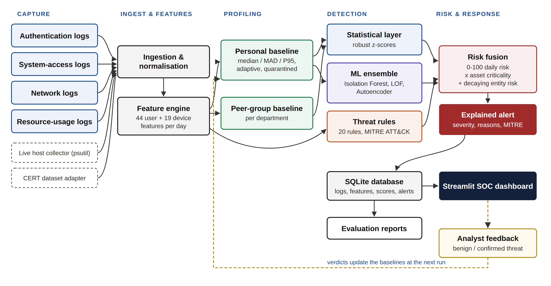
Figure 6.1: System architecture
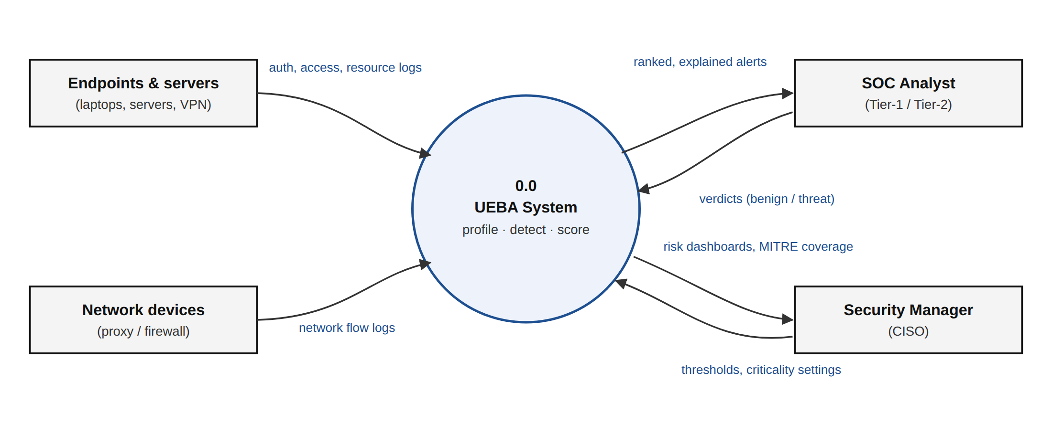
Figure 6.2: Data flow diagram, level 0 (context)
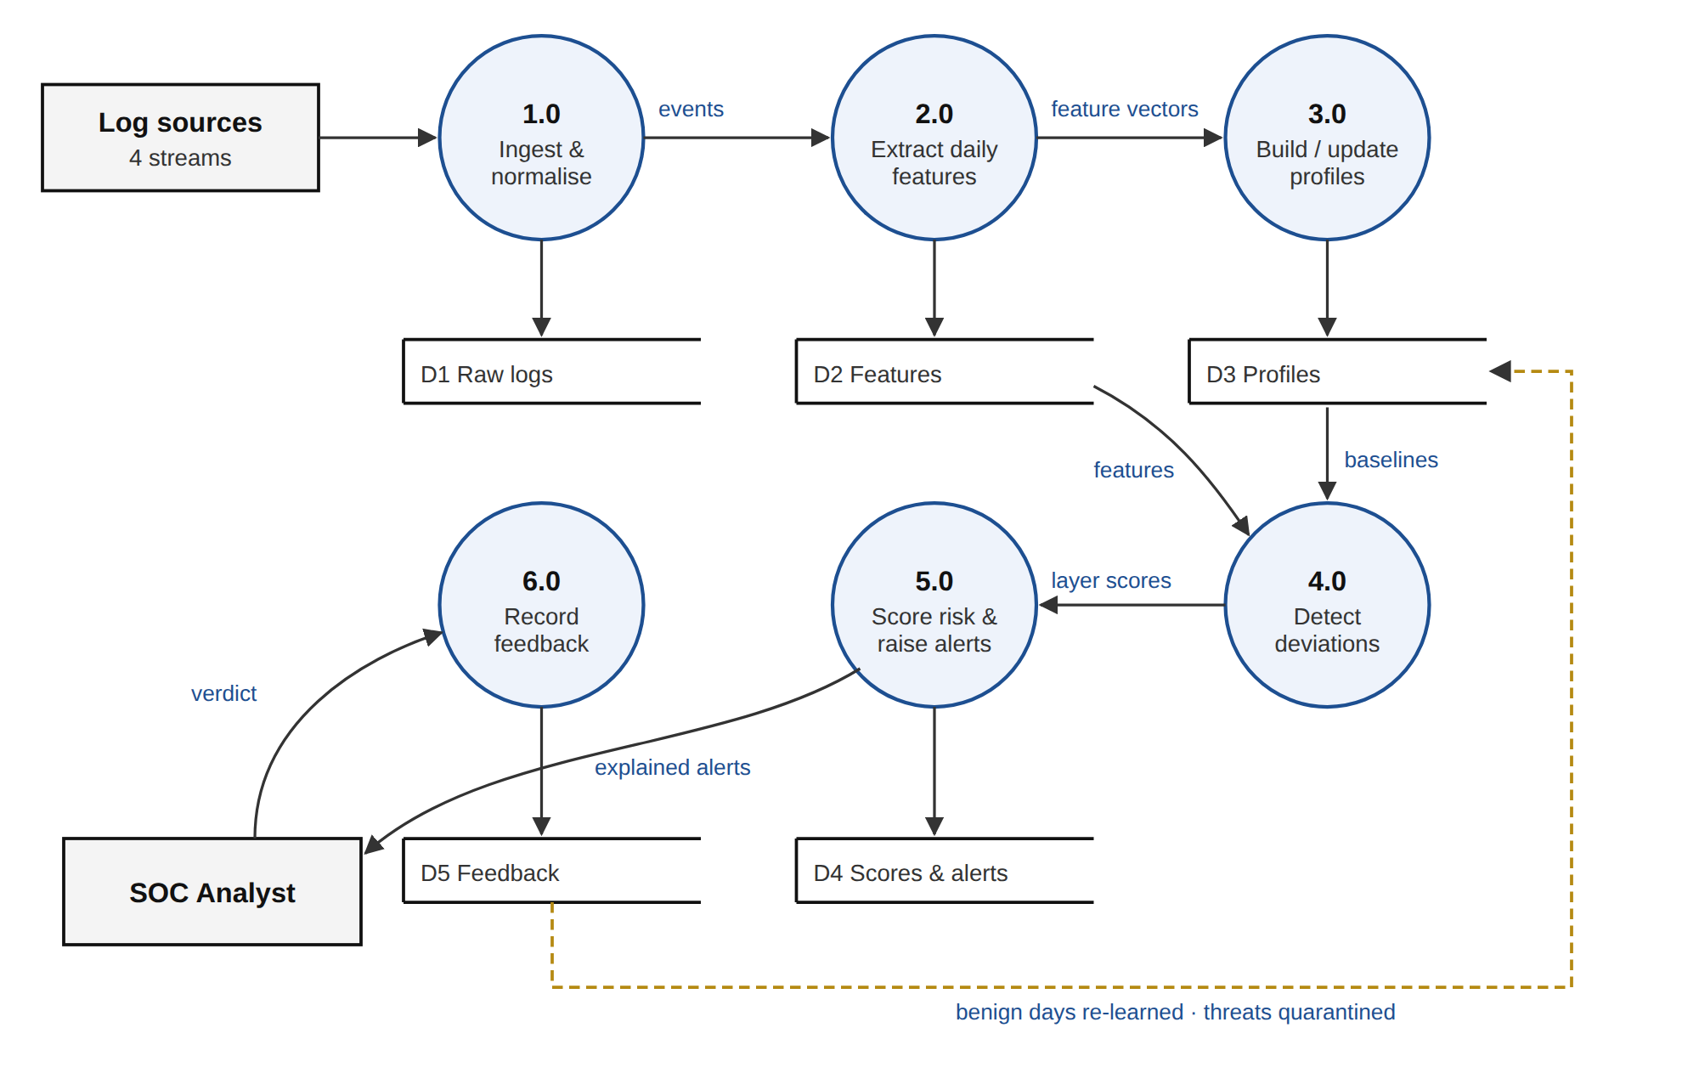
Figure 6.3: Data flow diagram, level 1
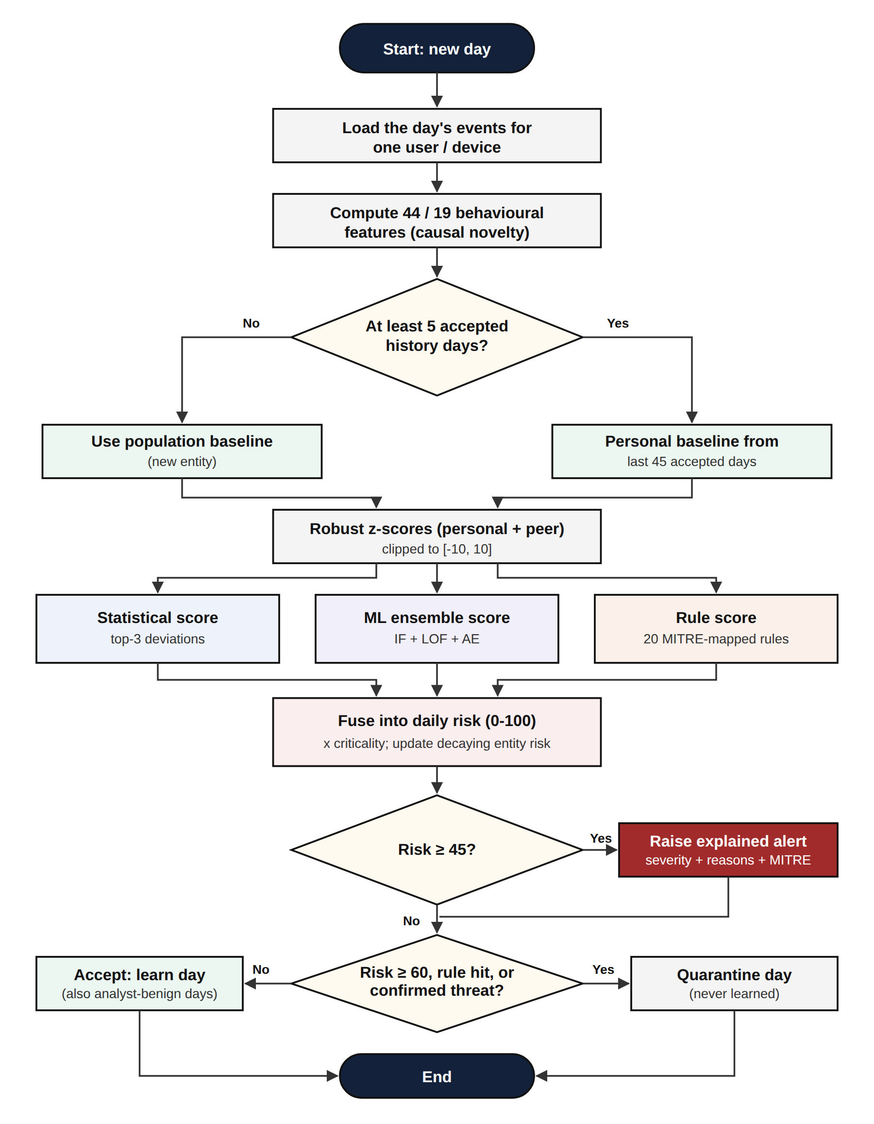
Figure 6.4: Flowchart of daily scoring for one entity
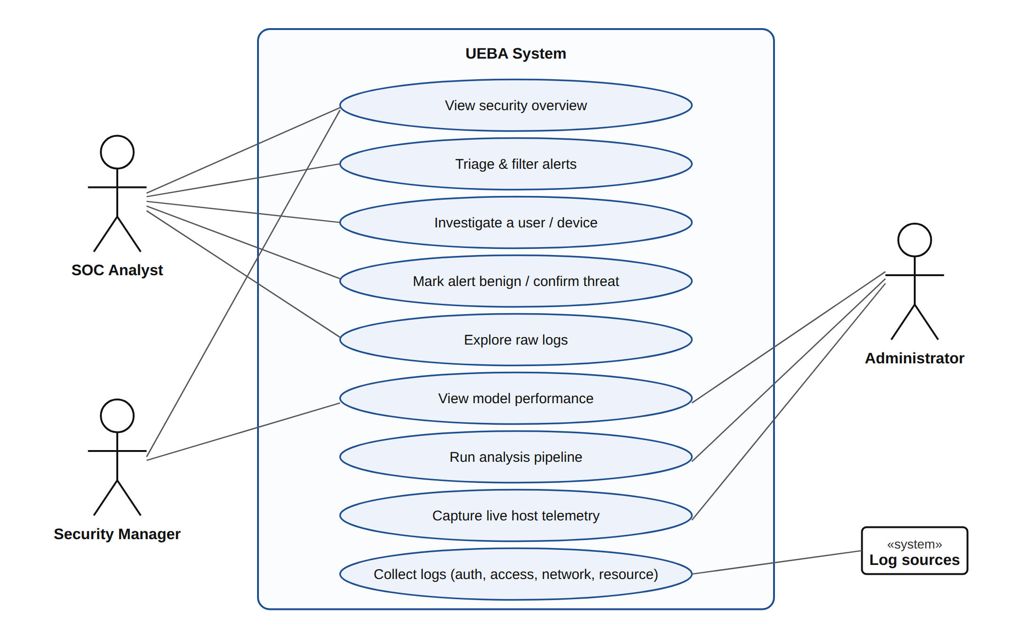
Figure 6.5: Use case diagram
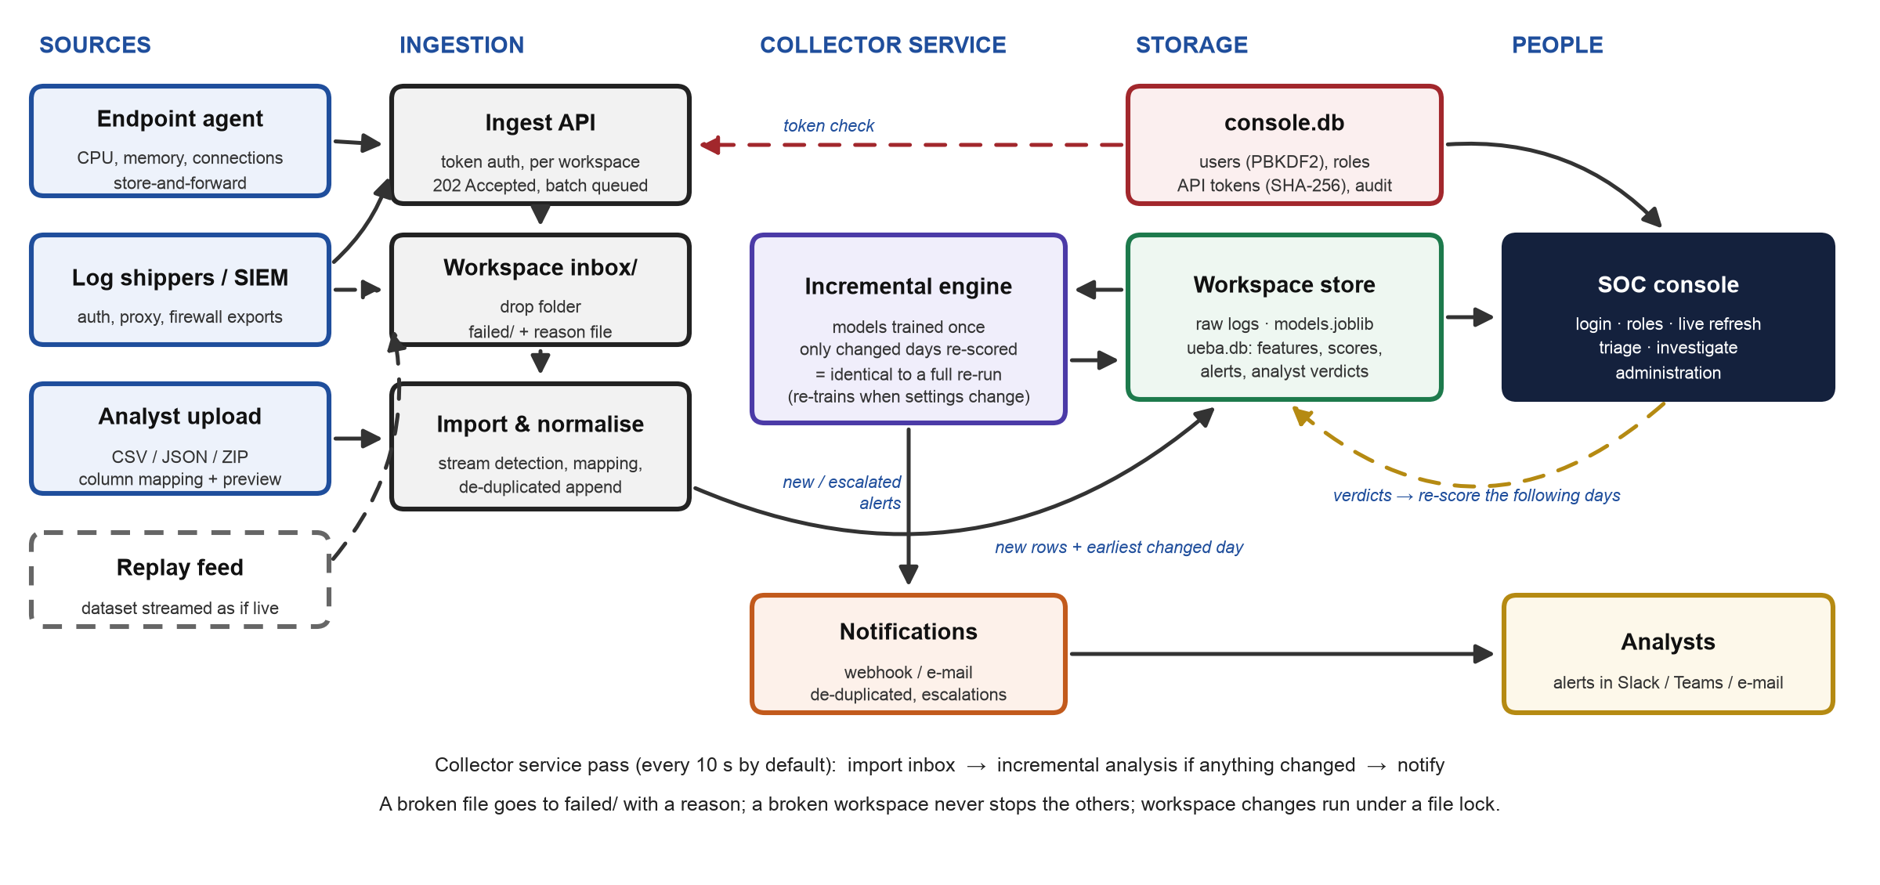
Figure 6.6: Operational architecture - how logs arrive, are scored continuously and reach analysts

7. REQUIREMENTS

7.1 Hardware Requirements
Table 7.1: Hardware requirements
Component | Minimum | Used for development
Processor | Dual-core, 64-bit | Apple M-series / x86-64 laptop
Memory (RAM) | 4 GB | 8 GB or more
Storage | 1 GB free (15 GB if the CERT data set is used) | SSD
GPU | Not required | Not used

7.2 Software Requirements
Table 7.2: Software requirements
Software | Version | Purpose
Operating system | macOS, Linux or Windows | Development and execution
Python | 3.10 or later | Programming language
pandas, NumPy | pandas 2.0+, NumPy 1.24+ | Log processing and features
scikit-learn | 1.3+ | Isolation Forest, LOF, autoencoder (MLP)
Streamlit, Plotly | Streamlit 1.50+, Plotly 5.18+ | Dashboard and interactive charts
Matplotlib | 3.7+ | Evaluation figures
SQLite | Bundled with Python | Storage of logs, scores and alerts
psutil | 5.9+ | Live host capture
Python standard library | Bundled with Python | Ingest API (http.server), password hashing (hashlib), notifications (smtplib, urllib), file locking
pytest | 7.4+ | Automated tests
Web browser | Any modern browser | Viewing the dashboard

7.3 Datasets
- Simulated enterprise logs (primary): generated by the project for a 48-person organisation over 60 days: 9,347 authentication, 75,295 access, 85,432 network and 35,409 resource events (205,483 in total), with 11 labelled attacks (28 attack entity-days) and 4 unlabelled benign anomalies. Real organisational logs are confidential and never labelled, so simulation with planted attacks is what makes objective measurement possible.
- CMU CERT Insider Threat Test Dataset r4.2 [14]: the standard public benchmark: 1,000 simulated employees over 17 months (January 2010 to May 2011) with 70 malicious insiders in three scenarios. The full data set (about 16 GB) was converted with the project's adapter into 12.8 million events and analysed in full (Section 10.5).
- Live host data: CPU, memory, process and connection samples captured from the machine running the dashboard and streamed by the endpoint agent.

7.4 Technologies and Tools
Table 7.3: Technologies and tools
Category | Technology / tool
Language | Python 3
Data processing | pandas, NumPy
Machine learning | scikit-learn (IsolationForest, LocalOutlierFactor, MLPRegressor autoencoder, StandardScaler)
Storage | SQLite
Dashboard | Streamlit, Plotly
Visualisation | Matplotlib
System telemetry | psutil
Service, API and security | Python standard library: http.server, hashlib (PBKDF2, SHA-256), secrets, smtplib, urllib, fcntl
Testing | pytest
Threat framework | MITRE ATT&CK
Editor and tools | Visual Studio Code, Git, terminal

8. NOVELTY OF THE PROPOSED IDEA / PROJECT
The individual techniques used in the project are established. What is new is how they are combined to address the practical problems identified in Chapter 2. Table 8.1 compares the project with the reviewed work.
Table 8.1: Feature comparison with reviewed work
Capability | Reviewed work | This project
Users and devices profiled together | Users only in [9], [10], [11]; hosts only in [12] | Yes: 44 user and 19 device features
Personal and peer baselines | Relationships via graphs in [9] | Yes, with robust statistics
Adaptive baseline | Retraining in [3] | Yes, rolling 45 days
Protection against baseline poisoning | Not addressed | Yes: quarantine of risky days, rule hits and confirmed threats
No attack labels needed | Labels used in [9], [10] | Yes: fully unsupervised plus rules
Statistics, ML and rules corroborated | Single model in most work | Yes: threshold requires agreement
Explained alerts | Feature attribution in [7]; attention in [13] | Plain-English reasons, layer scores, MITRE IDs
Prioritised 0-100 risk with criticality and decay | Not provided | Yes
Analyst feedback updates profiles | Labels per cluster in [13] | Yes: benign / threat verdicts
Continuous operation with exact incremental scoring | Offline batch evaluation in most work | Yes: saved models, only changed days re-scored, identical to a full re-run
Secured console and ingestion | Not addressed | Roles, hashed passwords, lock-out, scoped API tokens, audit trail

The main points of novelty are:
- Poisoning-resistant adaptive baselines. Profiles keep learning legitimate change, but days with high risk, rule matches or analyst-confirmed threats are never learned, while analyst-cleared days are.
- Corroboration by design. The alert threshold is derived from the score formula so that a single statistical deviation can never alert on its own. This is the main reason precision rose from 0.31 in the first prototype to 0.96.
- Spread that respects personal peaks. Using the 95th percentile alongside the MAD stops a person's normal occasional spikes from being treated as anomalies.
- One explained risk score for users and devices. Statistical, ML and rule evidence, asset criticality and slow multi-day behaviour are combined into a single number, with the reasons attached in plain English.
- Designed from analyst needs. Features were derived from published SOC studies through design thinking (Table 6.3), not added for their own sake.
- Exact incremental scoring. Saved models are reused and only the days touched by new data are scored, and because all features are causal the result is provably identical to re-analysing everything - a property checked by an automated test rather than assumed.
- Operable as a product. Collection, scoring, notification and a secured console are delivered in one small Python codebase using only the standard library beyond the analytics stack.

9. EXPERIMENTATION

9.1 Experimental Setup
The experiments use a simulated organisation of 48 employees in six departments (Engineering 14, Sales 10, Finance 8, HR 6, IT-Admin 5, Management 5), each with a laptop, plus 12 servers, giving 108 monitored entities. Every person has individual habits: working hours, office or remote location, servers, files and websites used, upload volumes and CPU load. Weekends, leave days, mistyped passwords and occasional legitimate large uploads are included. The logs cover 60 days: days 1-5 are warm-up, days 6-30 form the attack-free baseline, and days 31-60 form the detection window.
Table 9.1: Attacks planted in the detection window
ID | Scenario | What appears in the logs | ATT&CK
INC-01 | Brute force + takeover | 45 failed VPN logins from a Tor exit node at 03:10, then success, file reads, 400 MB upload | T1110
INC-02 | Impossible travel | Login in Bengaluru, then from Amsterdam 70 minutes later | T1078
INC-03 | Off-hours access | Login at 02:20, 60 confidential files including payroll read, upload to WeTransfer | T1078
INC-04 | Data exfiltration | 90 files and production API keys read, 3.3 GB uploaded to mega.nz | T1567
INC-05 | Slow insider | Five days of growing Dropbox uploads (120 MB to 1.3 GB) and job-site visits | T1567.002
INC-06 | Privilege escalation | Sales user runs administrator commands on the domain controller | T1068
INC-07 | Lateral movement | SSH/RDP into 12 never-seen hosts within 50 minutes | T1021
INC-08 | Cryptomining | Laptop CPU at about 96% for three days; traffic to a mining pool on port 3333 | T1496
INC-09 | Password spray | 30 failed logins on an administrator account, no success | T1110
INC-10 | Travel + exfiltration | Login from Lagos 70 minutes after Bengaluru, then 1.2 GB upload | T1078, T1567
INC-11 | Admin account abuse | Login from Frankfurt at 03:05, four accounts created, security log cleared | T1136, T1070

These produce 28 labelled attack entity-days (17 user-days and 11 device-days, because an attack run from a person's own laptop also labels that laptop). Four harmless but unusual events are also planted and not labelled, to test whether the system can tell "unusual" from "dangerous": an engineer working until 1 a.m., a salesperson logging in from Singapore for three days, an IT administrator sending 20 GB to the internal backup server, and an HR employee opening 11 files from another department for a new project.

9.2 Evaluation Protocol and Metrics
Each entity-day in the detection window (2,363 days with activity) is a test case: positive if it is a labelled attack day, and predicted positive if the system raised an alert for it. No labels are used for training; they are used only for scoring. The metrics are precision TP/(TP+FP), recall TP/(TP+FN), F1-score, false positive rate FP/(FP+TN), ROC-AUC and PR-AUC of each layer's score, and incident-level detection (whether and when each attack was alerted). PR-AUC matters because attacks are only about 1% of entity-days, so accuracy would be misleading.

9.3 Experiments Conducted
- Main run: the full system on the default organisation (random seed 42).
- Robustness: the whole organisation regenerated with five random seeds (42, 7, 123, 2024, 99), each giving different people, habits, victims and timing.
- Ablation: layers switched off in turn (no rules, no ML, each layer alone) and re-measured on the five seeds.
- Threshold sweep: precision and recall measured for alert thresholds from 20 to 80.
- CERT r4.2 benchmark: the full data set (1,000 users, 70 insiders) analysed with January to May 2010, before any malicious activity, as the learning period. The system was run exactly as designed on the simulated organisation (out-of-the-box) and again with one generic insider indicator added afterwards (rule R16). To keep that addition honest, the users were split at random into a development half and a held-out test half, each with half of the insiders; R16 was chosen on the development half only, and the test half is what is reported.
- Incremental equivalence: the logs were cut at a day boundary and in the middle of a day, analysed, then completed and updated incrementally; scores, explanations and alerts were compared with a full re-run.
- Live operation: the simulated organisation was streamed through the ingest API (30 days of history, then one day every few seconds in slices) while the collector service imported, scored and notified, and the result was compared with the batch run.
- Functional tests: 24 automated tests covering distance calculation, unusual-hour logic, rules, risk-score bounds and corroboration, the full pipeline, the analyst feedback loop, the CERT adapter, log-format mapping, partial log streams, incremental equivalence, the inbox, the ingest API, passwords, roles, lock-out and tokens, notification de-duplication, and a collector-service pass that learns, detects and notifies.

All experiments were run in Python 3.14 on a laptop (16 GB RAM). One full analysis of the simulated organisation (about 205,000 events) takes about 5 seconds and an incremental update about 3 seconds; the CERT analysis (12.8 million events, about 2,000 users and computers over 17 months) takes about 8 minutes with a peak memory use of 6.4 GB.

10. RESULTS AND DISCUSSION

10.1 Main Results
Table 10.1: Detection results on the main run (detection window)
Metric | Value
Entity-days scored / attack entity-days | 2,363 / 28
Alerts raised | 28 (26 critical, 1 high, 1 medium), about 0.9 per day
TP / FP / FN / TN | 27 / 1 / 1 / 2,334
Precision / Recall / F1-score | 0.964 / 0.964 / 0.964
False positive rate | 0.04%
Incidents detected | 11 of 11, all on the day they started
Fused risk ROC-AUC / PR-AUC | 1.000 / 0.999

Table 10.2: Ranking quality of each layer (main run)
Detector | ROC-AUC | PR-AUC
Fused risk score | 1.000 | 0.999
Personal baseline (z-score) | 0.997 | 0.926
Peer-group baseline | 0.982 | 0.956
ML ensemble | 0.998 | 0.855
Isolation Forest | 0.869 | 0.455
Local Outlier Factor | 0.909 | 0.734
Autoencoder | 0.996 | 0.633
Threat rules | 0.982 | 0.965

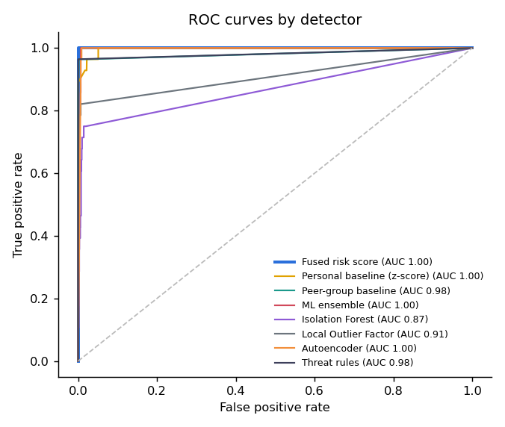
Figure 10.1: ROC curves of each detection layer
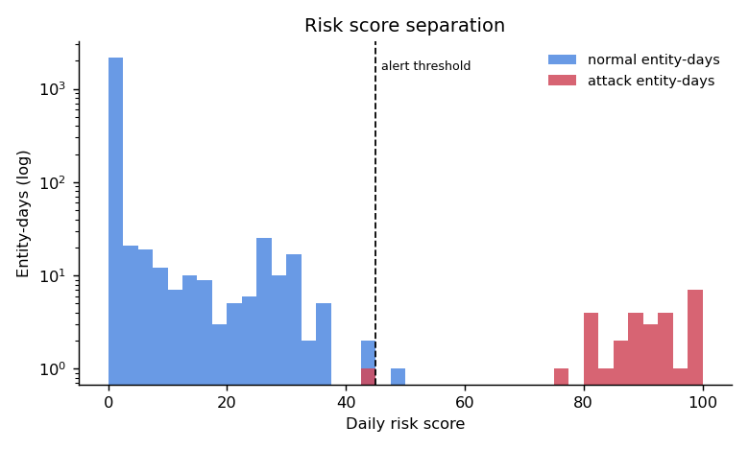
Figure 10.2: Daily risk of normal and attack entity-days (dashed line: alert threshold 45)
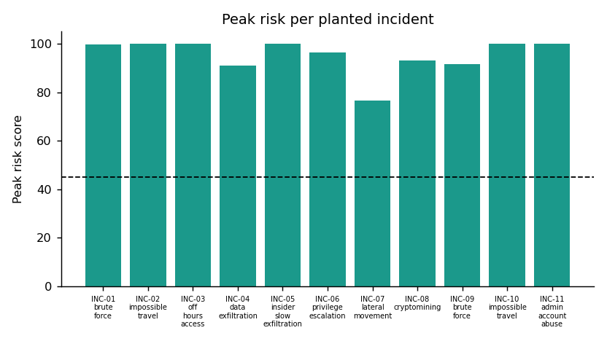
Figure 10.3: Peak risk of each planted incident
Every incident reached a peak risk above the threshold; ten were critical and the lateral-movement attack was high (76.6). The single false positive was the planted "new project" case: an HR employee opened 11 files from another department (risk 49.4). It is genuinely unusual behaviour, and the alert's reasons make it quick for an analyst to close with the feedback button. The single false negative was the laptop used as the pivot for lateral movement, which scored 43.6, just below the threshold; the user account carrying out the lateral movement was alerted on the same day, so the incident itself was caught. The other three harmless anomalies (late-night work, the business trip and the large internal backup) did not raise alerts.

10.2 Robustness Across Organisations
Table 10.3: Results for five differently generated organisations
Seed | Incidents | Precision | Recall | F1-score | FPR | Alerts/day
42 | 11/11 | 0.964 | 0.964 | 0.964 | 0.04% | 0.93
7 | 11/11 | 0.931 | 0.964 | 0.947 | 0.09% | 0.97
123 | 11/11 | 0.964 | 0.964 | 0.964 | 0.04% | 0.93
2024 | 11/11 | 0.931 | 0.964 | 0.947 | 0.08% | 0.97
99 | 11/11 | 0.900 | 0.964 | 0.931 | 0.13% | 1.00
Mean | 55/55 | 0.938 | 0.964 | 0.951 | 0.08% | 0.96

All 55 planted incidents were detected across the five organisations, with a mean F1-score of 0.951 and about one alert per day for 108 entities. The results are therefore not specific to one random organisation.

10.3 Ablation Study
Table 10.4: Contribution of each layer (mean ± standard deviation over five seeds)
Variant | PR-AUC | Precision | Recall | F1-score
Full system | 0.996 ± 0.002 | 0.938 ± 0.027 | 0.964 ± 0.000 | 0.951 ± 0.014
Without threat rules | 0.951 ± 0.007 | 0.774 ± 0.124 | 0.971 ± 0.016 | 0.857 ± 0.086
Without ML ensemble | 0.984 ± 0.001 | 0.979 ± 0.020 | 0.964 ± 0.000 | 0.971 ± 0.010
ML ensemble only | 0.856 ± 0.074 | 0.763 ± 0.080 | 0.821 ± 0.036 | 0.789 ± 0.048
Personal baseline only | 0.457 ± 0.047 | 0.295 ± 0.027 | 0.971 ± 0.016 | 0.451 ± 0.031
Threat rules only | 0.965 ± 0.000 | 1.000 ± 0.000 | 0.964 ± 0.000 | 0.982 ± 0.000

The ablation needs careful reading. The rules alone look almost perfect only because they were written with these attack types in mind; against an attack with no matching rule they score nothing. With all rules switched off, the behavioural layers still reached an F1-score of 0.857 with no prior knowledge of the attacks, which is the real value of the UEBA approach. Statistics alone flag almost everything unusual (recall 0.971) but with poor precision (0.295), which justifies the corroboration threshold. On this data, removing the ML ensemble slightly raises F1 because the rules already cover every planted attack; the ensemble improves ranking (PR-AUC) and matters for attacks that no rule describes.

10.4 Choice of Threshold
Table 10.5: Effect of the alert threshold (main run, daily-risk alerts)
Threshold | Precision | Recall | F1-score | Alerts
30 | 0.509 | 1.000 | 0.675 | 55
35 | 0.778 | 1.000 | 0.875 | 36
40 | 0.903 | 1.000 | 0.949 | 31
45 (chosen) | 0.964 | 0.964 | 0.964 | 28
50 | 1.000 | 0.964 | 0.982 | 27
80 | 1.000 | 0.929 | 0.963 | 26

A threshold of 50 would have removed the one false positive on this data. The threshold was nevertheless kept at 45 because it follows from the design rule that statistics alone must not alert, rather than being tuned to the test results, which would overfit the evaluation. The dashboard lets an analyst explore this trade-off live.

10.5 Results on the CERT r4.2 Benchmark
Table 10.6 reports the results on the held-out half of the CERT r4.2 users (113,374 user-days in the detection window, June 2010 to May 2011, of which 475 are malicious). The answer key labels 72 accounts: the 70 insiders and two supervisors whose accounts were misused by scenario-3 insiders. An insider counts as detected if an alert was raised on at least one of their malicious days.
Table 10.6: Results on CERT r4.2 (detection window, user-days)
Measure | Out-of-the-box | With R16
Insiders alerted on a malicious day | 3 / 36 | 22 / 36
Scenario 1: new USB user leaks data | 1 / 18 | 18 / 18
Scenario 2: job seeker steals data | 1 / 14 | 1 / 14
Scenario 3: administrator, keylogger | 1 / 4 | 3 / 4
Alerts per day (about 500 users) | 0.66 | 0.84
Day-level precision / recall | 0.017 / 0.008 | 0.146 / 0.091
False positive rate | 0.20 % | 0.22 %
Fused ROC-AUC / PR-AUC | 0.699 / 0.010 | 0.733 / 0.021
Insiders among the 3 riskiest users per day | 12 / 36 | 28 / 36

Table 10.7 and Figure 10.4 show why the out-of-the-box result is weak: on CERT the statistical and machine-learning layers rank user-days barely better than chance, and almost all of the ranking comes from the rules.
Table 10.7: Ranking quality of each layer on CERT r4.2
Layer | Out-of-the-box | With R16
Personal baseline (statistics) | 0.540 | 0.540
Peer-group baseline | 0.499 | 0.499
ML ensemble | 0.547 | 0.547
Isolation Forest / LOF / autoencoder | 0.521 / 0.504 / 0.543 | 0.521 / 0.504 / 0.543
Threat rules | 0.673 | 0.711
Fused risk score | 0.701 | 0.732

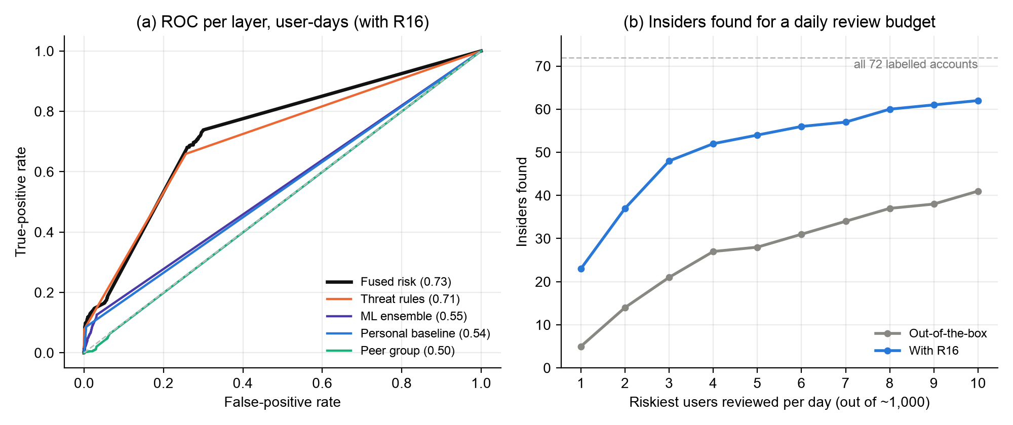
Figure 10.4: CERT r4.2 - (a) ROC curve of each layer, (b) insiders found for a daily review budget (all 72 labelled accounts)
The cause is calibration. The behavioural layers were designed on the simulated organisation, whose attacks are loud (gigabytes uploaded, dozens of failed logins), and they deliberately ignore deviations below three robust standard deviations and machine-learning scores below the 99th percentile of normal days; this is what keeps false alarms to about one a day. CERT insiders are quiet: a first USB connection, a few visits to job sites, a handful of after-hours logons. These fall inside the band the system was built to ignore, so on most malicious days the behavioural layers contribute nothing and the fused score rests on the rules; the weak job-site rule alone gives most scenario-2 days a risk of only 10.
The out-of-the-box result was frozen and is reported as the generalisation result. One generic insider-threat indicator was then added: removable-media use by an account that never used removable media in its learning period (rule R16, MITRE ATT&CK T1052.001, weight 0.45 like the comparable exfiltration rules). It is not specific to CERT, where 77% of users never use removable media, as in many organisations that restrict USB storage; it never fires on the simulated organisation, whose results are unchanged; and it was chosen on the development half, where it raised the insiders detected from 4 to 17 of 36. On the untouched test half it raised them from 3 to 22 of 36, while alerts rose only from 0.66 to 0.84 a day for about 500 users. It catches every scenario-1 insider and three of the four scenario-3 insiders, but not the job seekers of scenario 2, who already used USB drives and simply used them more; catching them needs behavioural layers that respond to smaller deviations.
For an analyst who reviews the three riskiest users each day (0.3% of users), 28 of the 36 held-out insiders appear on the list on at least one malicious day (Figure 10.4b). Day-level precision stays low (0.15) because the long scenario-2 windows contribute most malicious days. The results are not directly comparable with the models in Chapter 2, which use labelled training data or per-session sequences; this system uses no labels and daily aggregates.

10.6 Continuous Operation
Two experiments checked that the operational system gives the same answers as the batch analysis. In the first, the logs were cut at a day boundary and in the middle of a day, analysed, then completed and updated incrementally: every score, explanation and alert was identical to a full re-run. In the second, the simulated organisation was streamed through the ingest API as a live feed while the collector service ran (Table 10.8).
Table 10.8: Live replay of the simulated organisation through the ingest API
Measure | Value
Data sent | 30 days of history, then 30 live days in slices of 8 hours
Analyses run by the service | 2 full trainings (learning, first detection day) + 29 incremental updates
Time per incremental update | 1.6 - 3.2 seconds
Rejected files / service errors | 0 / 0
Incidents detected | 11 / 11, each in the service pass after its data arrived
Precision / Recall / F1-score | 0.964 / 0.964 / 0.964 (identical to the batch run)

The live result equals the batch result because features are causal and the incremental engine re-scores exactly the days whose data changed. In a real deployment a day lasts a day, so the service, which needs about three seconds per update, is never the bottleneck; detection delay is bounded by how often logs are shipped, not by the analysis.

10.7 Dashboard
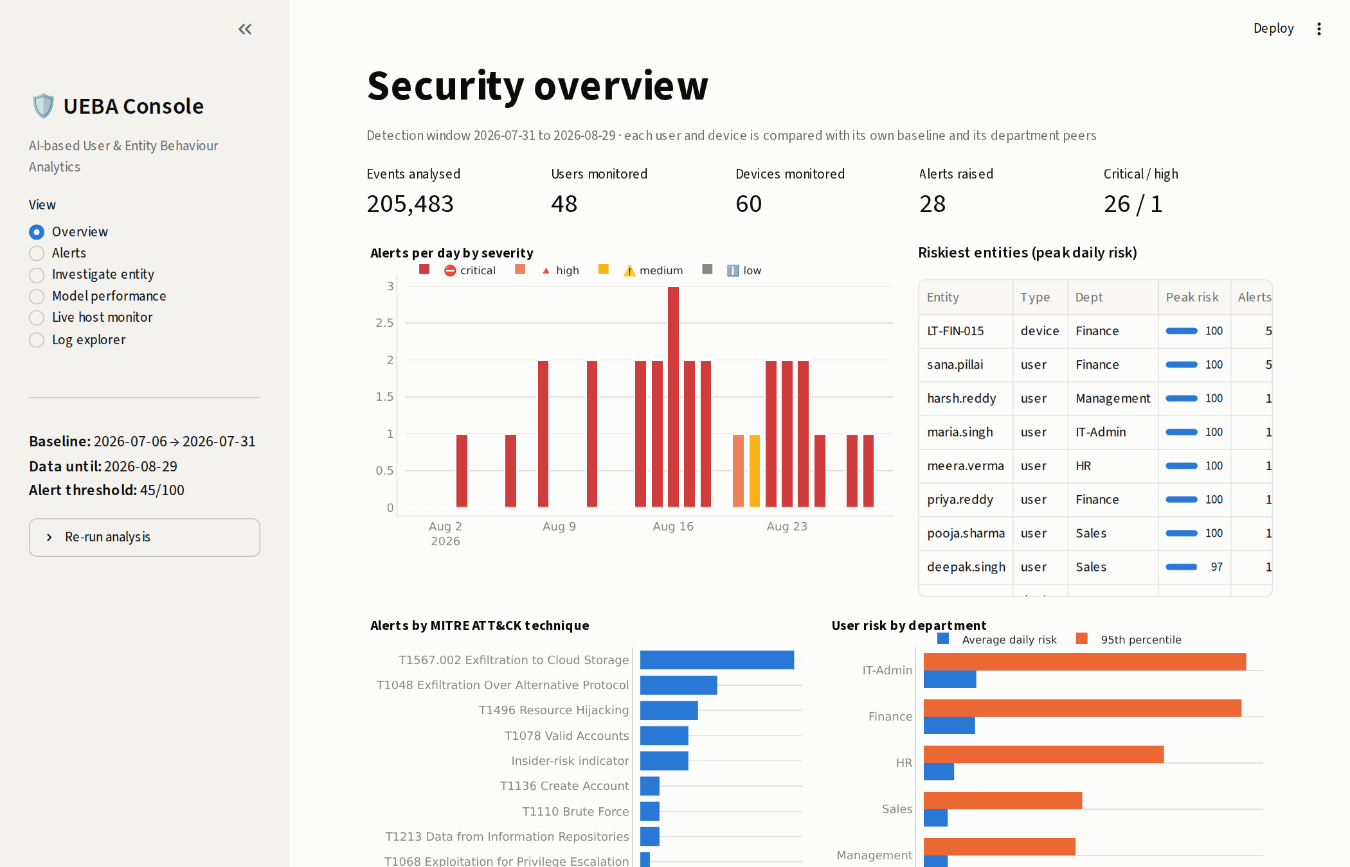
Figure 10.5: Dashboard overview page
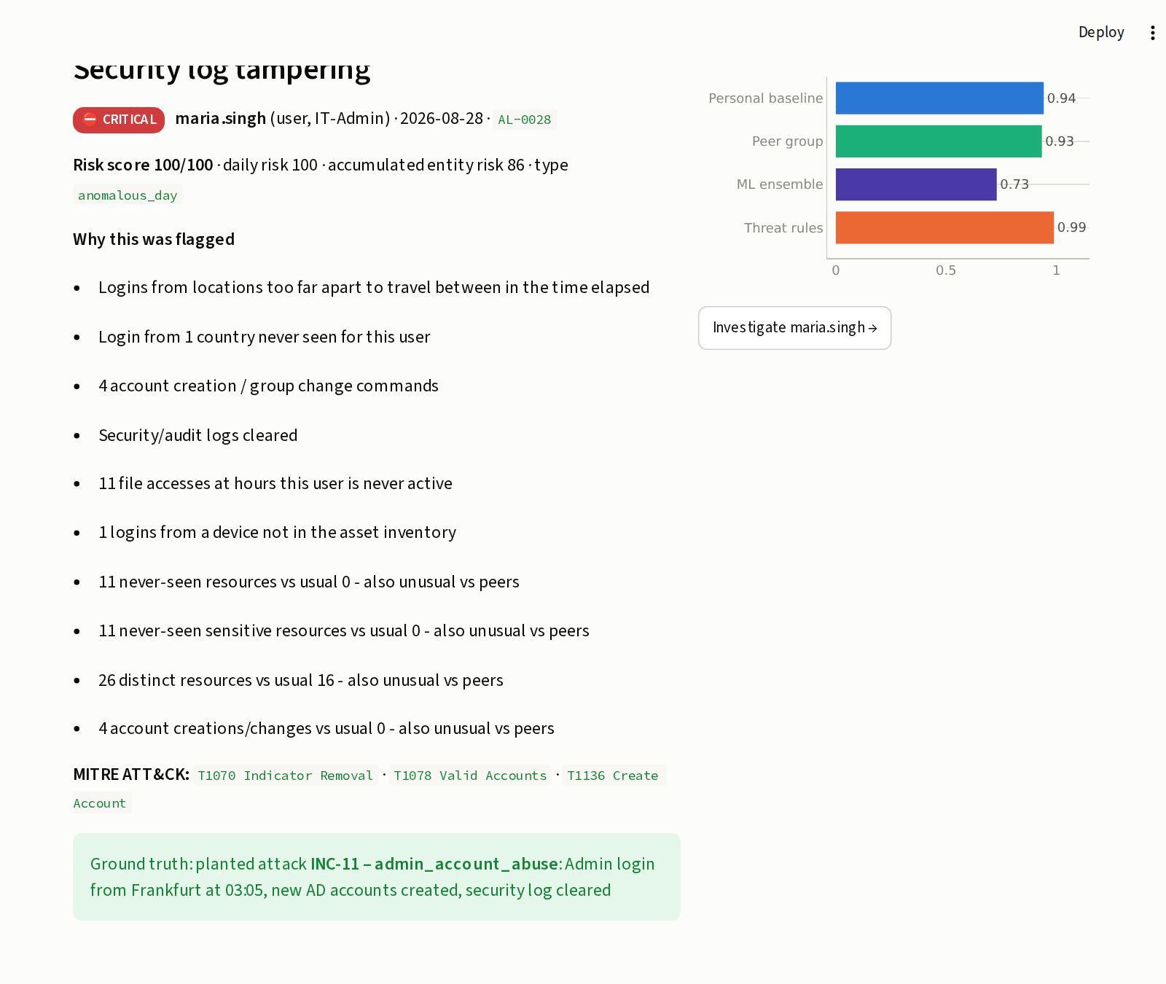
Figure 10.6: Alert detail with reasons, ATT&CK techniques and layer scores

10.8 Discussion
The results show that the system meets its objectives on the simulated organisation: all attacks were detected on the first day, with about one alert per day and clear reasons for each. They should not be compared directly with the CERT results in Chapter 2, because the data sets differ. The simulated attacks were also designed by the same person who built the detector, and Landauer et al. note that synthetic data tends to give lower false alarm rates than real behaviour [3]; on real logs, precision would be expected to fall. Euler's precision of about 0.006 on real data [12] shows how hard this is, and why the corroboration and feedback features matter. The main limitations are the simulated evaluation data, daily rather than real-time scoring, and rules that cover only known techniques.
The CERT benchmark makes the main limitation concrete. On data it was not designed on, the system's behavioural layers were too conservative: out of the box only 3 of 36 held-out insiders were detected. One generic indicator raised this to 22 of 36 at under one alert a day, but insiders whose behaviour changes only by degree (scenario 2) remain hard. Precision on the simulated organisation (0.964) should therefore be read as an upper bound, and the threshold, weights and calibration as settings to tune per organisation.

11. CONCLUSION AND FUTURE DIRECTIONS

11.1 Conclusion
This project developed a Python-based User and Entity Behaviour Analytics system that meets the problem statement. It captures authentication, system-access, network and resource-usage logs; builds daily behavioural profiles for 48 users and 60 devices with personal and peer baselines that adapt over time but resist poisoning; detects deviations with three complementary layers (robust statistics, an unsupervised Isolation Forest, LOF and autoencoder ensemble, and 21 MITRE ATT&CK rules); and turns the evidence into a single 0-100 risk score with explained, prioritised alerts in an analyst dashboard with a feedback loop.
On 60 days of simulated logs with 11 planted attacks, the system detected every attack on the day it began, with precision, recall and F1-score of 0.964 and one false alert in 30 days. Across five differently generated organisations the mean F1-score was 0.951, and without any rules the behavioural layers alone reached 0.857. The design-thinking process, grounded in published studies of SOC analysts, shaped the most important features: corroboration between layers, plain-English reasons and analyst feedback. These raised precision from 0.31 in the first prototype to 0.96.
Beyond the analytics, the project delivers an operable system: logs arrive by upload, drop folder, authenticated API or endpoint agent; a collector service scores new data incrementally with exactly the same result as a full re-run and notifies analysts; and the console is protected by roles, hashed passwords, lock-out, scoped tokens and an audit trail. On the independent CERT r4.2 benchmark the out-of-the-box system detected only 3 of 36 held-out insiders, because its behavioural layers were calibrated to ignore small deviations; with one generic insider indicator it detected 22 of 36, including every scenario-1 insider, at under one alert a day, while gradual data theft by job-seeking insiders remained largely undetected.

11.2 Future Directions
- Quiet insiders and more data: make the behavioural layers respond to many small deviations (continuous scores calibrated per organisation) so that gradual insiders such as CERT scenario 2 are caught, and evaluate on CERT r5.2 / r6.2 and the real CLUE-LDS logs [3].
- Event-level streaming: the collector service already analyses new data within seconds of its arrival; per-event streaming (for example with Apache Kafka) would add intra-day sequence detection.
- Sequence and graph models: add an LSTM over event order [8] and user-host graph features for lateral movement [12] as further corroborating layers.
- Automated response: integrate with a SOAR platform to disable an account or isolate a host when a critical alert is confirmed.
- Real deployment: parse native Windows Event (EVTX), Sysmon and syslog formats directly, serve the console and API through TLS, move storage to PostgreSQL for larger organisations, and adopt a monitoring policy compliant with data-protection law.

REFERENCES
[1] Verizon Business, "2025 Data Breach Investigations Report," Verizon, 2025. [Online]. Available: https://www.verizon.com/business/resources/reports/2025-dbir-data-breach-investigations-report.pdf
[2] Ponemon Institute and DTEX Systems, "2025 Cost of Insider Risks Global Report," Feb. 2025. [Online]. Available: https://www.globenewswire.com/news-release/2025/02/25/3032261/0/en/Ponemon-Cybersecurity-Report-Insider-Risk-Management-Enabling-Early-Breach-Detection-and-Mitigation.html
[3] M. Landauer, F. Skopik, G. Höld, and M. Wurzenberger, "A user and entity behavior analytics log data set for anomaly detection in cloud computing," in Proc. IEEE Int. Conf. Big Data (Big Data), Osaka, Japan, Dec. 2022, pp. 4285-4294, doi: 10.1109/BigData55660.2022.10020672.
[4] B. A. Alahmadi, L. Axon, and I. Martinovic, "99% false positives: A qualitative study of SOC analysts' perspectives on security alarms," in Proc. 31st USENIX Security Symp., Boston, MA, USA, Aug. 2022, pp. 2783-2800.
[5] The MITRE Corporation, "MITRE ATT&CK," 2026. [Online]. Available: https://attack.mitre.org/
[6] J. Cui, G. Zhang, Z. Chen, and N. Yu, "Multi-homed abnormal behavior detection algorithm based on fuzzy particle swarm cluster in user and entity behavior analytics," Sci. Rep., vol. 12, Art. no. 22349, Dec. 2022, doi: 10.1038/s41598-022-26142-w.
[7] J. Fuentes, I. Ortega-Fernández, N. M. Villanueva, and M. Sestelo, "Cybersecurity threat detection based on a UEBA framework using deep autoencoders," AIMS Math., vol. 10, no. 10, pp. 23496-23517, 2025, doi: 10.3934/math.20251043.
[8] M. Villarreal-Vasquez, G. Modelo-Howard, S. Dube, and B. Bhargava, "Hunting for insider threats using LSTM-based anomaly detection," IEEE Trans. Dependable Secure Comput., vol. 20, no. 1, pp. 451-462, 2023, doi: 10.1109/TDSC.2021.3135639.
[9] X. Li, X. Li, J. Jia, L. Li, J. Yuan, Y. Gao, and S. Yu, "A high accuracy and adaptive anomaly detection model with dual-domain graph convolutional network for insider threat detection," IEEE Trans. Inf. Forensics Security, vol. 18, pp. 1638-1652, 2023, doi: 10.1109/TIFS.2023.3245413.
[10] X. Cai, Y. Wang, S. Xu, H. Li, Y. Zhang, Z. Liu, and X. Yuan, "LAN: Learning adaptive neighbors for real-time insider threat detection," IEEE Trans. Inf. Forensics Security, vol. 19, pp. 10157-10172, 2024, doi: 10.1109/TIFS.2024.3488527.
[11] X. Zhu, J. Dong, J. Qi, Z. Zhou, Z. Dong, Y. Sun, and M. Wang, "AUTH: An adversarial autoencoder based unsupervised insider threat detection scheme for multisource logs," IEEE Trans. Ind. Informat., vol. 20, no. 9, pp. 10954-10965, Sep. 2024, doi: 10.1109/TII.2024.3393491.
[12] I. J. King and H. H. Huang, "Euler: Detecting network lateral movement via scalable temporal link prediction," ACM Trans. Privacy Security, vol. 26, no. 3, pp. 1-36, 2023, doi: 10.1145/3588771.
[13] T. van Ede et al., "DEEPCASE: Semi-supervised contextual analysis of security events," in Proc. IEEE Symp. Security Privacy (SP), San Francisco, CA, USA, May 2022, pp. 522-539, doi: 10.1109/SP46214.2022.9833671.
[14] B. Lindauer, "Insider Threat Test Dataset," Carnegie Mellon Univ., Software Engineering Institute, 2020, doi: 10.1184/R1/12841247.v1.
[15] M. Vermeer, N. Kadenko, M. van Eeten, C. Gañán, and S. Parkin, "Alert alchemy: SOC workflows and decisions in the management of NIDS rules," in Proc. ACM SIGSAC Conf. Comput. Commun. Secur. (CCS), Copenhagen, Denmark, Nov. 2023, pp. 2770-2784, doi: 10.1145/3576915.3616581.
[16] L. Kersten, T. Mulders, E. Zambon, C. Snijders, and L. Allodi, "'Give me structure': Synthesis and evaluation of a (network) threat analysis process supporting tier 1 investigations in a security operation center," in Proc. 19th Symp. Usable Privacy Security (SOUPS), Anaheim, CA, USA, Aug. 2023, pp. 97-111.
[17] S. Oesch et al., "An assessment of the usability of machine learning based tools for the security operations center," in Proc. IEEE Int. Conf. iThings/GreenCom/CPSCom/SmartData/Cybermatics, Rhodes, Greece, Nov. 2020, pp. 634-641, doi: 10.1109/iThings-GreenCom-CPSCom-SmartData-Cybermatics50389.2020.00111.
[18] F. Pedregosa et al., "Scikit-learn: Machine learning in Python," J. Mach. Learn. Res., vol. 12, pp. 2825-2830, 2011.
[19] F. T. Liu, K. M. Ting, and Z.-H. Zhou, "Isolation forest," in Proc. 8th IEEE Int. Conf. Data Mining (ICDM), Pisa, Italy, 2008, pp. 413-422.
[20] M. M. Breunig, H.-P. Kriegel, R. T. Ng, and J. Sander, "LOF: Identifying density-based local outliers," in Proc. ACM SIGMOD Int. Conf. Management of Data, Dallas, TX, USA, 2000, pp. 93-104.
[21] G. E. Hinton and R. R. Salakhutdinov, "Reducing the dimensionality of data with neural networks," Science, vol. 313, no. 5786, pp. 504-507, 2006.

SOURCE CODE
The complete source code (about 5,600 lines of Python in 21 analysis and service modules and a 13-file Streamlit console, with 24 automated tests) is in the project folder and kept in a Git repository. The key parts of the detection logic are reproduced below.

Risk fusion and accumulated risk (ueba/risk.py)
def daily_risk(df: pd.DataFrame, cfg: Config = CONFIG) -> np.ndarray:
a = 1 - ((1 - cfg.w_stat * df["stat"]) * (1 - cfg.w_peer * df["peer"]) *
(1 - cfg.w_ml * df["ml"]) * (1 - df["rule"]))
crit = df["department"].map(cfg.criticality).fillna(1.0)
crit = np.where(df["is_admin"].astype(bool), np.maximum(crit, cfg.criticality.get("IT-Admin", 1.3)), crit)
return np.round(100 * np.clip(a * crit, 0, 1), 1)

def entity_risk(df: pd.DataFrame, cfg: Config = CONFIG) -> np.ndarray:
"""Decayed accumulation of daily risk above the noise floor (per entity, chronological)."""
out = np.zeros(len(df))
decay_per_day = 0.5 ** (1 / cfg.risk_half_life_days)
order = df.sort_values(["entity", "date"]).index
prev_ent, prev_date, r = None, None, 0.0
dates = pd.to_datetime(df["date"])
for idx in order:
ent, d = df.at[idx, "entity"], dates.at[idx]
if ent != prev_ent:
r = 0.0
else:
r *= decay_per_day ** max(1, (d - prev_date).days)
r = min(100.0, r + max(0.0, df.at[idx, "daily_risk"] - NOISE_FLOOR))
out[df.index.get_loc(idx)] = r
prev_ent, prev_date = ent, d
return np.round(out, 1)

Robust baseline spread (ueba/pipeline.py)
def _robust(hist: np.ndarray, floor: np.ndarray) -> tuple[np.ndarray, np.ndarray]:
"""Median and robust scale of an entity's history (same formula as profiles._scales)."""
med = np.median(hist, axis=0)
mad = np.median(np.abs(hist - med), axis=0) * 1.4826
tail = (np.quantile(hist, 0.95, axis=0) - med) / 1.645
return med, np.maximum(np.maximum(mad, tail), floor)

Adaptive baseline with quarantine and analyst feedback (excerpt of score_entities) (ueba/pipeline.py)
accepted = train_mask.copy()
rows_by_entity = {e: np.array(ix) for e, ix in F.groupby("entity").indices.items()}
dates = F["date"].to_numpy()
for day in sorted(F.loc[~train_mask, "date"].unique()):
idx = np.flatnonzero((dates == day))
for i in idx:
ix = rows_by_entity[F.at[i, "entity"]]
hist = ix[(dates[ix] < day) & accepted[ix]][-cfg.history_days:]
if len(hist) >= 5:
med[i], scale[i] = _robust(X[hist], floor)
score_rows(idx)
# quarantine high-risk days and anything matching a threat signature; medium,
# purely behavioural deviations are absorbed so the profile adapts to new habits
accepted[idx] = ((S.loc[idx, "daily_risk"].to_numpy() < cfg.quarantine_risk)
& (S.loc[idx, "rule"].to_numpy() < 0.2))
for i in idx:
key = (F.at[i, "entity"], day)
if benign and key in benign:
accepted[i] = True
elif threat and key in threat:
accepted[i] = False

Statistical score and ML ensemble (ueba/detectors.py)
def deviation_score(z: pd.DataFrame, z_alert: float) -> np.ndarray:
"""Combine the three largest positive deviations into one 0-1 score."""
excess = np.clip(np.asarray(z, dtype=float) - z_alert, 0, None)
if excess.shape[1] < 3:
excess = np.pad(excess, ((0, 0), (0, 3 - excess.shape[1])))
top = -np.sort(-excess, axis=1)[:, :3]
raw = top[:, 0] + 0.5 * top[:, 1] + 0.25 * top[:, 2]
return 1 - np.exp(-raw / 4.0)

class MLEnsemble:
def __init__(self, cfg: Config = CONFIG):
self.cfg = cfg
self.scaler = StandardScaler()
self.iforest = IsolationForest(n_estimators=cfg.iforest_trees, random_state=cfg.seed)
self.lof = LocalOutlierFactor(n_neighbors=cfg.lof_neighbors, novelty=True)
self.ae = MLPRegressor(hidden_layer_sizes=cfg.autoencoder_layers, activation="tanh",
max_iter=800, random_state=cfg.seed, early_stopping=True,
validation_fraction=0.15, alpha=1e-3)
self.calib: dict[str, tuple[float, float]] = {}

def _raw(self, X: np.ndarray) -> dict:
Xs = self.scaler.transform(X)
rec = self.ae.predict(Xs)
return {"iforest": -self.iforest.score_samples(Xs),
"lof": -self.lof.score_samples(Xs),
"autoencoder": np.mean((Xs - rec) ** 2, axis=1)}

def fit(self, X: np.ndarray) -> "MLEnsemble":
Xs = self.scaler.fit_transform(X)
self.iforest.fit(Xs)
self.lof.fit(Xs)
self.ae.fit(Xs, Xs)
for k, s in self._raw(X).items():
med, q99 = np.median(s), np.quantile(s, 0.99)
self.calib[k] = (med, max(q99 - med, 1e-9))
return self

def score(self, X: np.ndarray) -> pd.DataFrame:
out = {}
for k, s in self._raw(X).items():
med, spread = self.calib[k]
norm = (s - med) / spread # 1.0 == 99th percentile of normal behaviour
out[f"ml_{k}"] = np.clip((norm - 1.0) / 3.0, 0, 1)
out[f"raw_{k}"] = s
df = pd.DataFrame(out)
df["ml"] = df[["ml_iforest", "ml_lof", "ml_autoencoder"]].mean(axis=1)
return df

Threat rules (first three of twenty-one) (ueba/detectors.py)
RULES = [
Rule("R01", "Brute-force success", 0.80, "T1110 Brute Force", "user",
lambda d: (d["max_fail_10min"] >= 10) & (d["fail_then_success"] > 0),
lambda r: f"{r.max_fail_10min:.0f} failed logins within 10 min followed by a successful login"),
Rule("R02", "Brute-force / password spray attempt", 0.45, "T1110 Brute Force", "user",
lambda d: (d["max_fail_10min"] >= 10) & (d["fail_then_success"] == 0),
lambda r: f"{r.max_fail_10min:.0f} failed logins within 10 minutes"),
Rule("R03", "Impossible travel", 0.70, "T1078 Valid Accounts", "user",
lambda d: d["impossible_travel"] > 0,
lambda r: "Logins from locations too far apart to travel between in the time elapsed"),
# ... 17 further rules (R04-R15, D01-D05)
]

Impossible-travel detection (ueba/features.py)
def haversine_km(lat1, lon1, lat2, lon2):
lat1, lon1, lat2, lon2 = map(np.radians, (lat1, lon1, lat2, lon2))
a = np.sin((lat2 - lat1) / 2) ** 2 + np.cos(lat1) * np.cos(lat2) * np.sin((lon2 - lon1) / 2) ** 2
return 6371.0 * 2 * np.arcsin(np.sqrt(a))

def impossible_travel_events(auth: pd.DataFrame, max_kmh: float) -> pd.DataFrame:
"""Consecutive successful logins whose implied speed exceeds ``max_kmh``."""
ok = auth[(auth["result"] == "success") & auth["lat"].notna()].sort_values(["user", "timestamp"]).copy()
ok["prev_lat"] = ok.groupby("user")["lat"].shift()
ok["prev_lon"] = ok.groupby("user")["lon"].shift()
ok["prev_ts"] = ok.groupby("user")["timestamp"].shift()
ok["prev_city"] = ok.groupby("user")["city"].shift()
ok = ok.dropna(subset=["prev_lat"])
ok["km"] = haversine_km(ok["prev_lat"], ok["prev_lon"], ok["lat"], ok["lon"])
hrs = (ok["timestamp"] - ok["prev_ts"]).dt.total_seconds() / 3600
ok["kmh"] = ok["km"] / hrs.clip(lower=1 / 60)
return ok[(ok["km"] > 500) & (ok["kmh"] > max_kmh)]

Analyst feedback (ueba/feedback.py)
def record(db_path: Path, entity: str, date: str, verdict: str, note: str = "", analyst: str = "analyst",
alert_id: str = "") -> None:
if verdict not in VERDICTS:
raise ValueError(f"verdict must be one of {VERDICTS}")
with sqlite3.connect(db_path) as con:
_ensure(con)
con.execute("INSERT OR REPLACE INTO feedback VALUES (?,?,?,?,?,?,?)",
(entity, str(date), verdict, note, analyst, alert_id,
datetime.now().isoformat(timespec="seconds")))

def as_sets(fb: pd.DataFrame) -> tuple[set, set]:
"""(benign keys, confirmed-threat keys) as sets of (entity, date)."""
benign = set(zip(fb.loc[fb["verdict"] == "benign", "entity"], fb.loc[fb["verdict"] == "benign", "date"]))
threat = set(zip(fb.loc[fb["verdict"] == "threat", "entity"], fb.loc[fb["verdict"] == "threat", "date"]))
return benign, threat

SUBMISSION PAGE OF THE PAPER

PLAGIARISM REPORT

