Nama : Muhammad Syafei  
NIM : 20210140032  
Link : <https://github.com/Amadd11/UCP1_20210140032_A.git>

HTML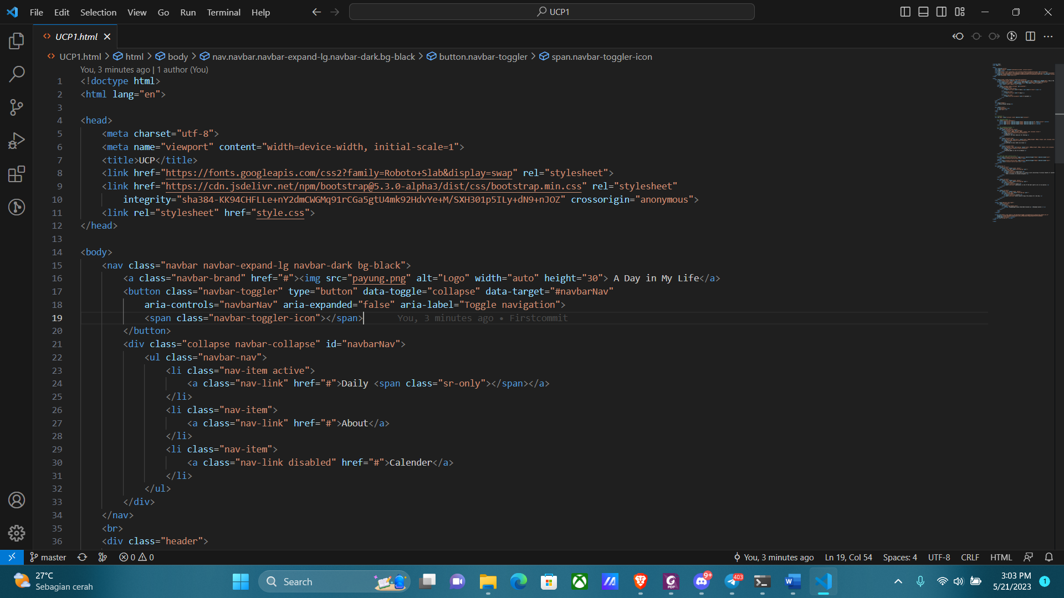

CSS

JS

Hasil

