Evidence of AI Use: Tableau Pulse
Dataset coverage: January 2023 – December 2025

The screenshots

Figure 1 - Month to Date
Pulse defaulted to the current month, September 2026, against a dataset ending December 2025. The caption states plainly that there is no data, while the chart beneath draws a line at zero from Sep 1 to Sep 5.
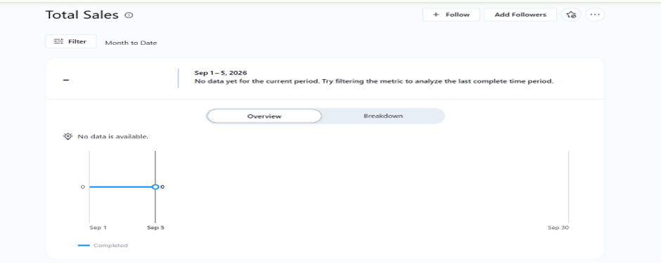
Figure 1: Month to Date view. "No data yet for the current period", with a zero-valued line rendered alongside.

Figure 2 - Last 90 days
Widening the window to 90 days did not resolve the problem, since the whole window still falls after the end of the data. The flat zero line now spans the full width of the chart.
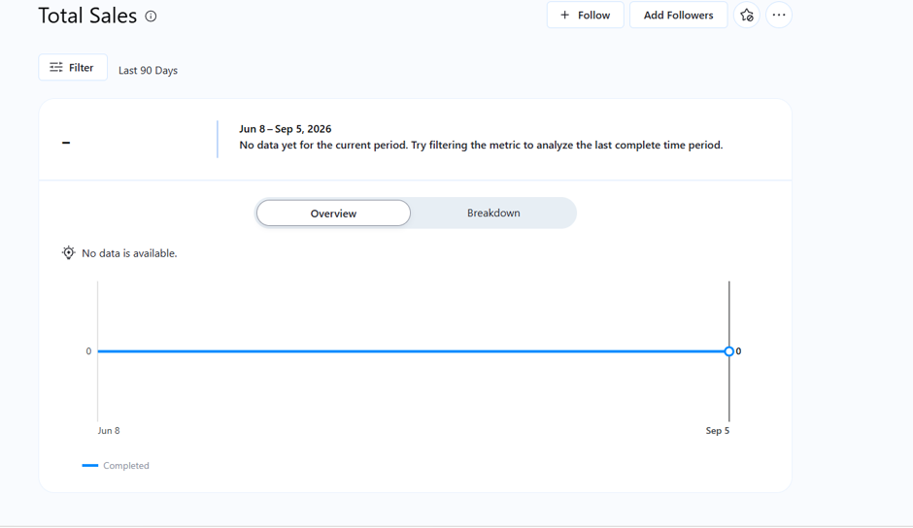
Figure 2: Last 90 days. "No data is available", with a zero line drawn across the entire period.

Figure 3- One year, overlapping the end of the data
The first window to return a value. It spans Sep 2025 – Aug 2026, of which only four months contain data. Pulse reported a decline of 65.6% twice, in identical styling, with no indication that the two periods being compared were of different effective lengths.
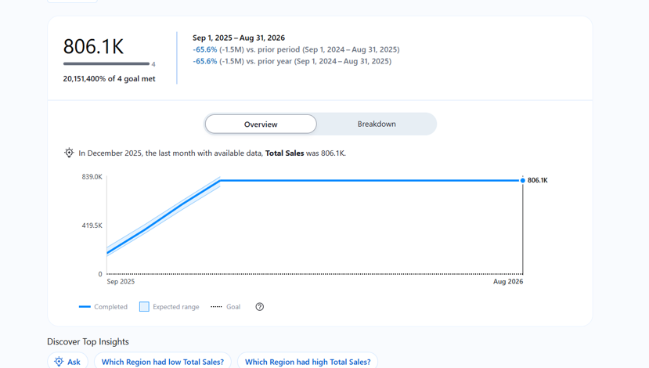
Figure 3: One-year window. −65.6% reported against an incomplete period; note also the implausible "20,151,400% of 4 goal met".

Figure 4 Corrected window
Filtering to Dec 2024 – Nov 30, 2025, places the whole window inside the data. The headline figure of −5.9% is consistent with the annual totals in the source.
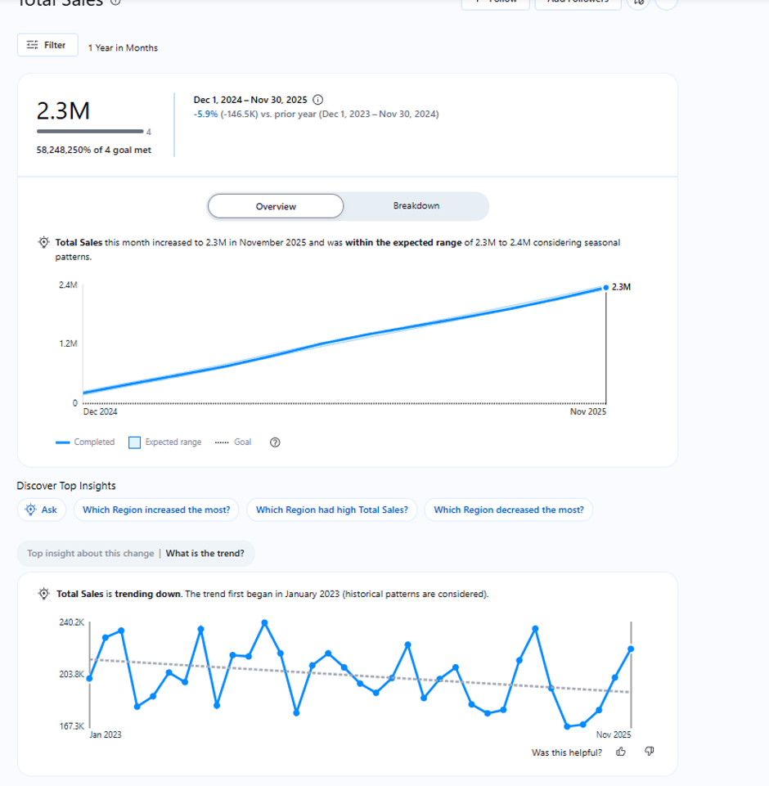
Figure 5: Corrected window. −5.9% year on year, plus a trend insight dating the decline to January 2023.

Observations - what Pulse did well
- The corrected headline figure is accurate. −5.9% (−146.5K) for Dec 2024 – Nov 2025 is consistent with the annual totals visible in the underlying data.
- The trend detection is correct and was not requested. Pulse identified a downward trend and dated its start to January 2023. Reaching the same conclusion manually required building a line chart and adding a linear trend line.

Limitations identified
- Pulse assumes live, continuously updated data. Applied to a historical extract it produced three unusable states before a manual filter corrected it.
- It compared periods of unequal effective length without flagging the fact.
- The headline metric is aggregate only, masking that the decline is uniform across every region and category a materially different situation from a decline concentrated in one area, requiring a different response.
- The source data is pre-aggregated to monthly totals with no transaction-level detail, so neither Pulse nor the analyst can distinguish fewer customers from smaller baskets.
- Configuration shaped the output: the measure, time dimension, monthly granularity, comparison period and enabled insight types were all chosen before any analysis took place.
- No confidence or uncertainty is reported. −5.9% and −65.6% were presented with identical visual authority.

