Observe, Reason, Act: Spatial Mapping
  - COMPENG 2DX3: Microprocessor Systems Project: Final Project

April 9, 2025
Amaiam Ul Haque – haquea24 – 400520641

As a future member of the engineering profession, the student is responsible for performing the required work in an honest manner, without plagiarism and cheating. Submitting this work with my name and student number is a statement and understanding that this work is our own and adheres to the Academic Integrity Policy of McMaster University and the Code of Conduct of the Professional Engineers of Ontario.

Device Overview

Intro
The device is an embedded spatial mapping system that uses a Time-of-Flight (ToF) sensor (VL53L1X) mounted on a stepper motor to perform 360° scans of its surroundings. It measures distances in the y-z plane at fixed angular intervals and combines these with manual displacements along the x-axis to generate 3D spatial data. The data is transmitted to a PC via UART and visualized using MATLAB.

Features
- Bus Speed: 16MHz
- Operating voltage: overall system needs 2.97V - 3.63V
  - MCU: 2.97V - 3.63V (regulated from 5V PC’s USB supply)
  - ToF Sensor: 2.8V (regulated from 3.3V MCU supply)
  - Stepper Motor: 5V (from MCU supply)
- Cost: $94.26 CAD total
  - MCU: $55.47
  - ToF Sensor: $31.84
  - Stepper Motor + Driver: $6.95
- Serial communication:
  - I²C:
    - ToF to MCU
    - Address: 0x29
    - Speed: 100 kbps
    - Standard mode
  - UART:
    - MCU to PC
    - Baud: 115200 bps
    - Data format: CSV style (RangeStatus, Distance, SignalRate, AmbientRate, SpadNum)
- Programming:
  - C:
    - Embedded Firmware
    - Texas Instruments Code Composer Keil Studio
  - MATLAB:
    - PC Visualization
    - Converts polar ToF data to Cartesian x,y,z coordinates
- Memory:
  - Onboard RAM:
    - 256KB
    - Stores temporary measurement buffers (128 samples/revolution).
  - Data Handling:
    - MATLAB saves scans as .xyz files for 3D plotting.
    - Streaming to PC: raw data sent via UART in real-time, avoiding any possible MCU memory limitations

General Description
- Signal Acquisition:
  - ToF Principle: VL53L1X emits 940 nm laser pulses and measures time for reflected photons to return (SPAD array).
  - The distance is automatically calculated via: $d = \frac{1}{2}△t×c$
    - $△t$is the time it takes for the reflected photons to return.
    - $c$is the speed of light constant.
  - I²C Protocol:
    - Addressing: 0x29
    - Data Flow: MCU initiates ranging via VL53L1X_StartRanging(), polls dataReady flag, and reads distance (mm) via VL53L1X_GetDistance().
- Data Processing:
  - Coordinate Conversion:
    - Polar to Cartesian:
    - $y=d⋅\sin\left(θ\right)$,$z=d⋅\cos\left(θ\right)$, $x=n⋅△x$, $△x = 300mm$
    - Example: At step 512 out of 2048 (θ = 90°), distance measured = 270mm, displacement = 1500 mm → (x, y, z) = (1500, 270, 0).
  - Trigonometric Optimization: Precomputed sin/cos lookup tables (LUTs) mitigate FPU limitations.
- Visualization:
  - MATLAB:
    - UART Read: serial port object with timeout handling.
    - 3D Plotting: plot3 with dynamic updates and plots data in real-time; data saved as .xyz file

Block Diagram (Data flow graph)
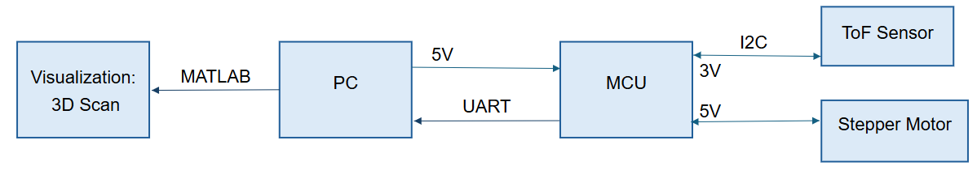

Device Characteristics Table
Parameter | Note
Microcontroller MSP-EXP432E401Y | ARM Cortex-M4  Bus speed: 16MHz  Communication: I²C (ToF) & UART (PC)  --------------------------------------------------------------  Pins:  Micro USB  PF4: UART Tx status (LED2)  PN1: measurement status (LED1)  PN0: additional status --> scanning status (LED0)  PJ0: on-board push button  PB2-3: ToF sensor  PH0-3: stepper motor  POWER: 3V3, 5V  x2 GND
VL53L1X ToF Sensor | Distance Mode: long mode (3.6 m)  Communication: I²C (MCU)  --------------------------------------------------------------  Pins:  GND  VIN  SDA  SCL
Stepper Motor  28BYJ-48 + ULN2003 | 2048 steps/revolution  0.175°/step  1ms/step  --------------------------------------------------------------  Pins:  +  -  IN1  IN2  IN3  IN4
PC | Port: COM4  Communication: UART (MCU)  --------------------------------------------------------------  Pins:  USB-A
I²C Configuration | I²C address: 0x29  Speed: 100 kbps  ToF sensor MCU
UART Configuration | Port: COM4  Baud: 115200 bps  MCU PC

Detailed Description

Distance Measurement

Data Processing
The system converts raw ToF distance measurements (d) and stepper motor angles (θ) into Cartesian coordinates (x,y,z) through the following steps:
- Once the pushbutton is pressed, the motor rotates and pauses briefly for a moment so the ToF sensor can do a measurement and sends the data via I²C to the MCU and the MCU sends it to the PC via UART.
- The actively running MATLAB code parses the incoming data via UART and checks if the data is valid.
- If the data is invalid, it gets skipped. Otherwise, the ToF sensor’s distance measurement is stored as the variable ‘distance’ measured in mm.
- The angle is calculated based on the number of measurements the ToF sensor has done in a revolution so far and the motor’s step angle and stored as ‘angle’ in degrees.
- The y and z coordinates are calculated based on the distance and angle determined in steps 2 and 3.
- The x coordinate is calculated based on the number of revolutions measured so far and predefined increment between each displacement.
- Each coordinate is plotted in real time
- Once a full revolution is made, the device is manually moved physically forward by the user and then steps 1-7 are repeated until 10 revolutions have been measured.
- The MATLAB code finishes execution and the final plot with all the data is displayed as a ‘MATLAB Figure’ (.fig) file.

Formula
The conversion calculations are shown below:
$$θ=θ_{step}⋅\left(i-1\right)$$
$$y = d⋅\sin\left(θ\right)$$
$z=d⋅\cos\left(θ\right)$
$$x = j⋅△x$$
Where:
- $d$is the distance measured by the ToF sensor, in mm.
- $θ$is the angle of the stepper motor, in degrees.
- $θ_{step}$ is the stepper motor’s angle per step, $θ_{step}=2.8125°$.
- $i$is the current measurement index. The –1 ensures that the first angle is 0°, facing forward.
- $j$is the current revolution index.
- $△x$is the default displacement increment of $△x = 300$, in mm.

For example, if the device is currently on its 55th measurement of its 3rd revolution and the ToF measures 172mm:
$d=172mm$, $i=55$, $j=3$,$θ_{step}=2.8125°$,$△x=300mm$
$$θ=2.8125\left(55-1\right)=151.875°$$
$$y=172⋅\sin\left(151.875\right)=151.58mm$$
$$z=172⋅\cos\left(151.875\right)=81.28mm$$
$$x=3⋅300=900mm$$
$$∴\left(x,y,z\right)=\left(900mm,151.58mm,81.28mm\right)$$

Displacement
Displacement was implemented during the process using two means. The first means is by moving the physical system forward by the displacement increment of 300mm after each revolution scanned. The second means to accommodate the physical adjustment is via the MATLAB code on line 96, x_coord = j * 300, the displacement is 300. So, when the coordinates are plotted in real time, after each revolution, represented by j, the x coordinate increments by 300mm, the 3D plot also adjusts for the physical displacement made.

Visualization

Software Overview
- Tool: MATLAB R2023a+ (with Instrument Control Toolbox for serial communication).
- Key Functions/Libraries:
  - serialport: Configures UART communication (115200 bps).
  - plot3: Real-time 3D point cloud rendering.
  - sind/cosd: Efficient polar-to-Cartesian conversion.
  - drawnow: Updates plot dynamically during data acquisition.
Data Flow Pipeline
MCU → UART → PC (COM4)→ Serial Port → MATLAB → Polar-to-Cartesian → 3D Plot → .xyz File

Step-by-Step Procedure
- Initialization:
s = serialport('COM4', 115200, 'Timeout', 30); % UART setup
configureTerminator(s, "CR/LF"); % CR/LF line endings
figure; hold on; view(3); %3D plot initialization

- Real-Time Plotting:
For each measurement (128/revolution × 10 scans):
  - Read & Parse UART Data:
data = sscanf(x, '%u, %u, %u, %u, %u'); % Extract ToF metrics
distance = data(2); % Distance (mm)
  - Coordinate Conversion:
angle = 2.8125 * (i-1); % i = measurement index (1-128)
y_coord = distance * sind(angle); % Horizontal (y-axis)
z_coord = distance * cosd(angle); % Vertical (z-axis)
x_coord = j * 300; % Scan plane displacement (x-axis)
  - Plot Update:
plot3([x_prev, x_coord], [y_prev, y_coord], [z_prev, z_coord], '-b');
plot3(x_coord, y_coord, z_coord, 'ro', 'MarkerSize', 6);
drawnow; % Force immediate render
- Blue lines: Connect consecutive points.
- Red circles: Highlight individual measurements.

- Final Output:
Results in a MATLAB Figure (.m) file that allows for interactive 3D rotation/zoom.
  - .xyz File
Stores raw coordinates for external use:
fprintf(f, "%.4f\t%.4f\t%.4f\n", x_coord, y_coord, z_coord);
  - Summary Plot
Post-processing with enhanced styling:
plot3(x_coords, y_coords, z_coords,'-o','MarkerFaceColor','r');

Application Note, Instructions, and Expected Output
- Gather all necessary components and download all necessary files.
- Setup hardware
  - Setup ToF
    - Gently remove cover from over the sensor
    - Attach ToF sensor to stepper motor’s rotary part ensuring nothing blocks/covers the sensor or its path
  - Wire stepper motor to driver board
    - Plug stepper motor’s 1x4 pin wires into 1x4 pin port of driver board.
  - Wire the driver board to the MCU (driver board to MCU respectively)
    - + to 5V
    - - to GND
    - IN1 to PH0
    - IN2 to PH1
    - IN3 to PH2
    - IN4 to PH3
  - Wire the ToF sensor to the MCU (ToF senor to MCU respectively)
    - VIN to 3V3
    - GND to GND
    - SDA to PB3
    - SCL to PB2
  - Wire PC to MCU respectively
    - USB-A to micro-USB
- Setup software
  - Setup MCU’s code
    - Open the Keil project file
    - In Keil, ensure to select MCU target and verify target and debugger settings
    - In Keil, translate and build target
    - In Keil, flash to the board
    - On MCU, press the ‘restart’ push button
    - Open the MATLAB file
    - Run the MATLAB file
- Prepare for scan
  - Go to scan location
  - Find a suitable elevated object for device placement ensuring steady scans
  - Securely place device onto object ensuring consistent position and direction throughout scans
  - Ensure nothing is obscuring the ToF sensor itself or its path
  - Ensure MATLAB file is still running.
  - In MATLAB’s command section, ensure that you see the following text: "Press Enter to start communication..."
  - Click anywhere on MATLAB’s command section window
- Start scan
  - Press enter on the PC, then immediately move onto the next step.
  - Press pushbutton PJ0 on MCU
  - On MCU, check if LED D2 is on, ensuring scan is in process.
    - Note that LED D1 and D3 will be flashing throughout each individual scan
  - Wait for stepper motor to stop rotating and/or wait for LED D2 to turn off.
  - Steadily move object forward by 300mm without changing its orientation
    - Note that this ensures the physical increment of the displacement, the x coordinate, which automatically increments after each revolution. The X coordinate, orthogonal to the YZ plane, is updated after each revolution. The YZ plane is actively measured during the entire revolution.
  - Repeat steps 5b-5e for a maximum total of 10 times.
- View final results
  - On PC, view the MATLAB window with the 3D scan called 'Final 3D Visualization of ToF Sensor Data'
  - To do another scan, repeat steps 4a-6a.

Limitations
1. Floating-Point and Trigonometric Limitations
- FPU Capability: The MSP432E401Y lacks a hardware Floating-Point Unit (FPU), forcing software emulation for float/double operations. This introduces:
  - ~10–100x slower trig calculations vs. FPU-equipped MCUs.
  - Error Accumulation: Repeated software-based sin/cos calls compound rounding errors (e.g., ±0.0005 rad error per call).
- Workaround: Offloaded trig to MATLAB (sind/cosd), which uses hardware-accelerated functions.

2. ToF Sensor Quantization Error
- Resolution: The VL53L1X has a 1 mm resolution (per datasheet, Section 2.4).
- Max Quantization Error: $error = \frac{resolution}{2}= ±0.5mm$

3. Maximum UART Communication Rate
The maximum reliable UART baud rate achievable is 115,200 bps, verified through oscilloscope measurements. This aligns with the TIA-232E standard's 20 kbps limit (lecture week 7, slide 19) for signal integrity over 15 meters and avoids MATLAB's serialport buffer issues. While the MSP432E401Y supports up to 12.5 Mbps (datasheet §15.3.6), practical constraints from clock synchronization requirements (lecture, week 7, slide 28: "sender/receiver must use same clock speed").

4. Microcontroller-to-ToF Communication
- Method: I²C (Standard Mode, 100 kbps).

5. System Speed Bottlenecks & Testing
Primary Limitations
- ToF Sensor Ranging Time:
  - Typical Timing: ~33 ms/measurement in Long Mode (per VL53L1X datasheet section 2.5.2).
  - Confirmed via SysTick profiling:
uint32_t start = SysTick_Value();
VL53L1X_GetDistance(&Distance); // Actual measurement: 32-35 ms
uint32_t duration = start - SysTick_Value();
- Stepper Motor Step Delay:
  - 1.5 ms/step (empirically optimized via trial-and-error), any smaller than 1.5ms led to the motor not spinning
void SysTick_WaitMinimum(uint32_t delay){
uint32_t i;
for(i=0; i<delay; i++){
SysTick_Wait(24000); // wait 1.5ms (assumes 16MHz clock)
}
return;
}
  - Hardware Limit: 28BYJ-48's 64:1 gear ratio prevents faster stepping without stalling.
  - To prevent the mounted ToF’s wires from getting tangled, at the end of each revolution, the motor makes a complete rotation counterclockwise.
Total Scan Time:
$$=t_{ToF}+2⋅t_{motor}$$
$$=128⋅33ms+2⋅2048⋅1.5ms$$
$$=4224ms+2⋅3072ms$$
$$=10368ms$$
$$=10.368s$$
Testing:
This timing was verified by measuring the time in between scans. This was done so by using PF1 outputting a logic high once the scanning process began and then outputting a logic low once the scan was over while using an AD3 to measure the resulting period. The following lines of code were added to the MCU’s main function code.
if (state0 == 1){
GPIO_PORTF_DATA_R |= 0b00000010;

getData();
GPIO_PORTF_DATA_R &= 0b11111101;
state0 = 0;
}

Circuit Schematic
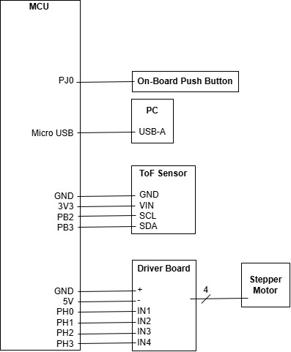

Programming Logic Flowchart(s)

MCU Code (C)
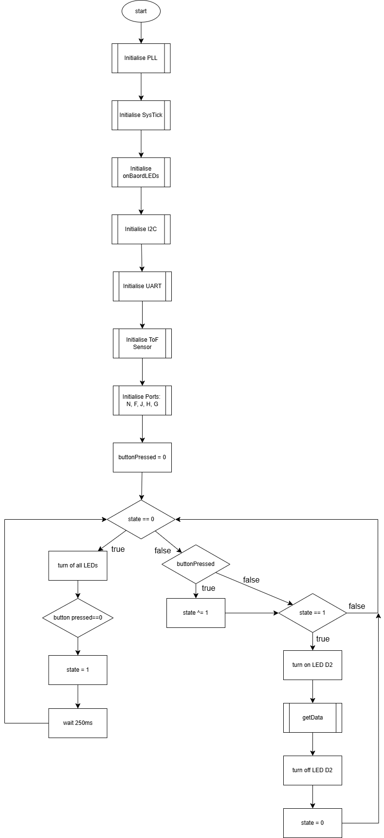

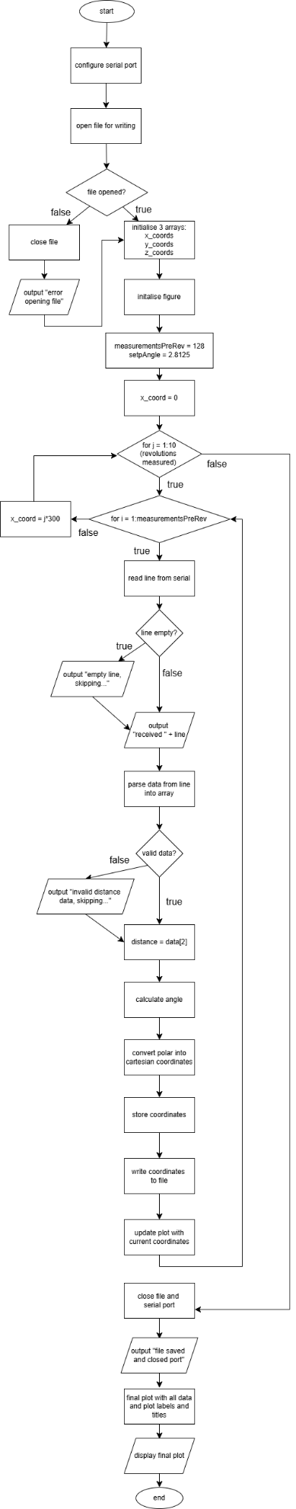
PC Code (MATLAB)

