SOC AUTOMATION WITH SHUFFLE SOAR AND WAZUH SIEM:
Severity-Based Alert Triage and Automated Incident Response
Submitted by: Amaima
Module: Security Operations Center (SOC) Automation Laboratory
Date: 13 July 2026

Workflow Design
Wazuh Alert (Webhook Trigger)
|
v
Extract Rule ID
|
v
Extract Alert Level
|
v
IF Alert Level >= 10
/ \
YES NO
| \
v v
[Branch] Ignore Alert
/ \ (workflow terminates,
v v no action taken)
Send Log Result
Email (HTTP POST)
\ /
v v
END
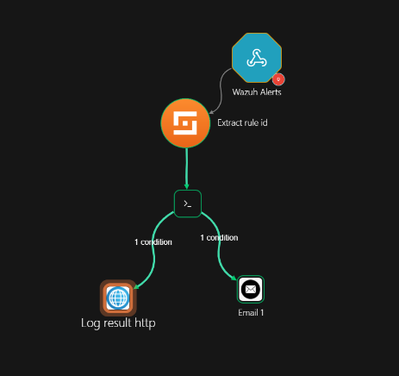
Figure 2. Shuffle Workflow

Alert 1 - SSH Brute Force
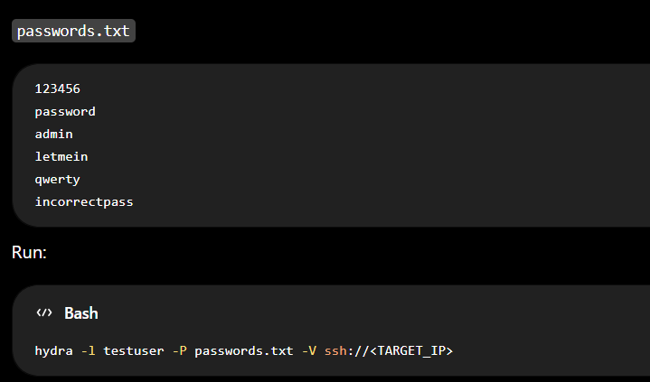Hydra Attack Execution
Field | Value
Alert Name | sshd: brute force trying to get access to the system. Non existent user.
Rule ID | 5712
Alert Level | 10
Alert Description | sshd: brute force trying to get access to the system. Non existent user.
MITRE ATT&CK Technique | T1110 - Brute Force
Source Agent | kali (192.168.0.121)
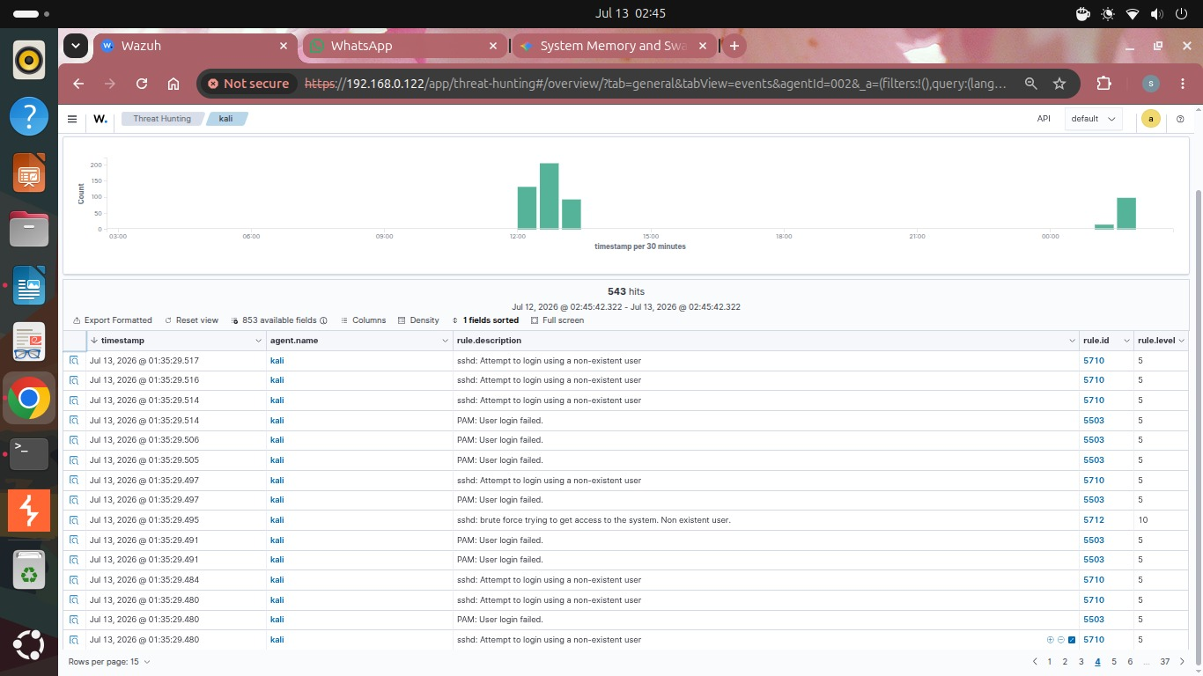Wazuh Alert - Rule 5712]

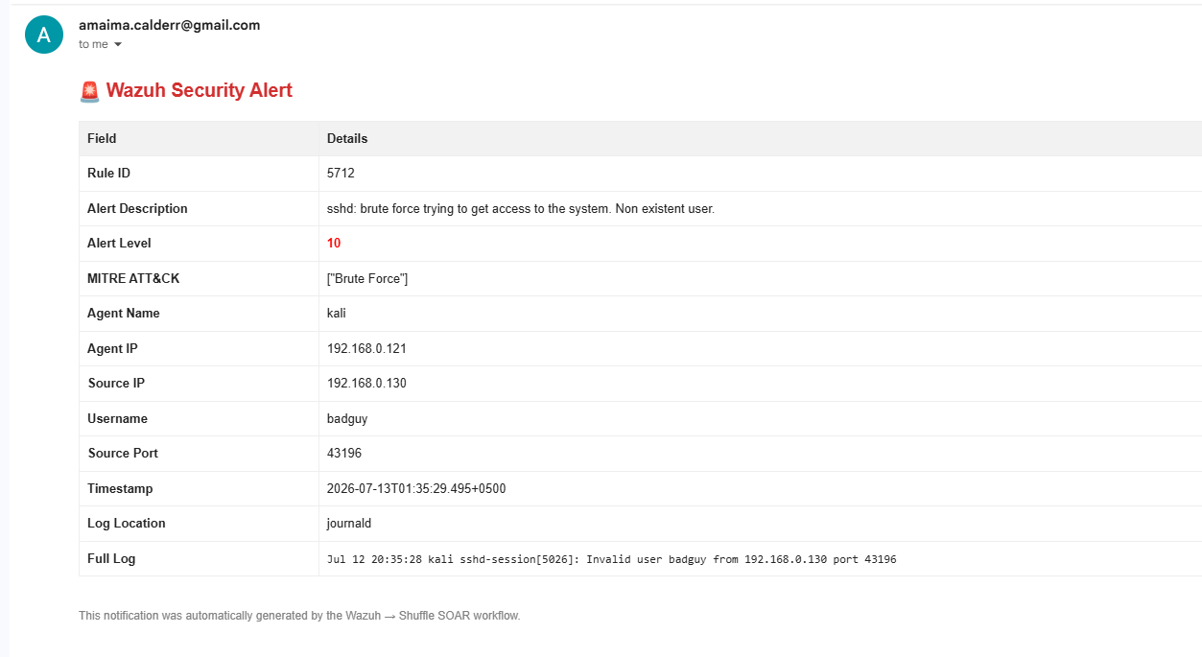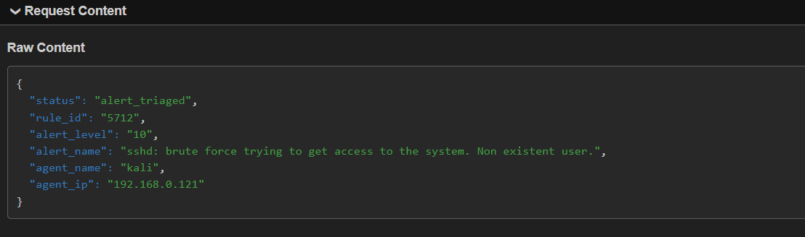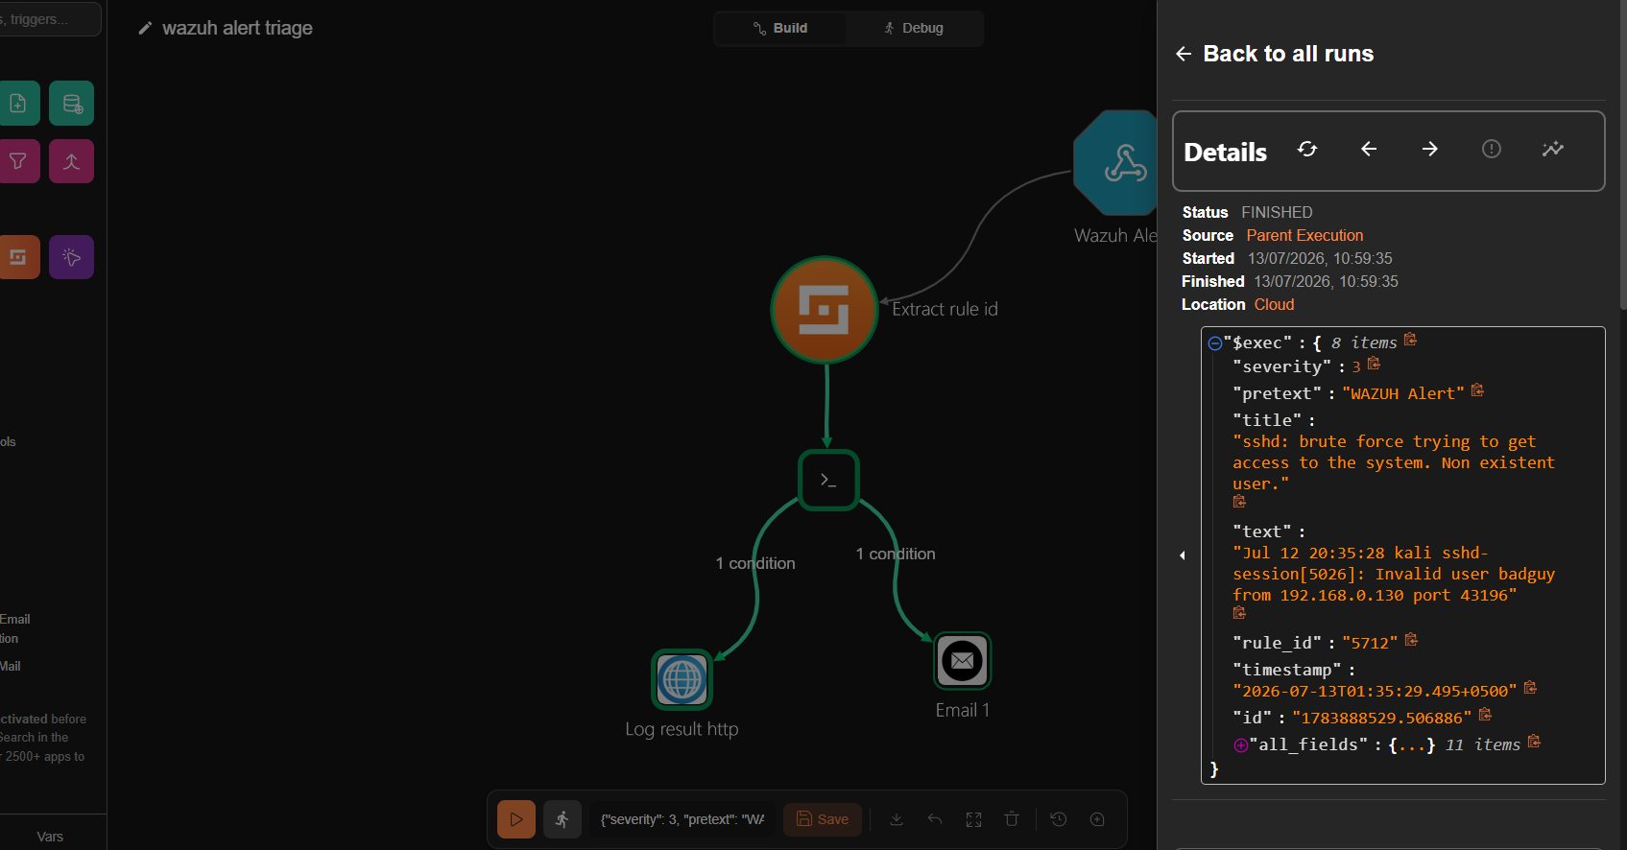

Alert 2 - File Integrity Monitoring (FIM)

Custom Wazuh Rule - Critical File Modification
<group name="custom_fim,syscheck,">
<rule id="100100" level="10">
<if_sid>550</if_sid>
<field name="file">/etc/passwd</field>
<description>Critical system file /etc/passwd was modified - possible unauthorized account or privilege change.</description>
<mitre>
<id>T1565.001</id>
</mitre>
<group>syscheck,critical_file_change,</group>
</rule>
<rule id="100101" level="10">
<if_sid>550</if_sid>
<field name="file">/etc/shadow</field>
<description>Critical system file /etc/shadow was modified - possible unauthorized credential tampering.</description>
<mitre>
<id>T1565.001</id>
</mitre>
<group>syscheck,critical_file_change,</group>
</rule>
</group>
Field | Value
Alert Name | Critical file /etc/passwd modified
Rule ID | 100100 (custom, parent rule 550)
Alert Level | 10 (elevated from default level 7)
Alert Description | Critical system file /etc/passwd was modified - possible unauthorized account or privilege change.
MITRE ATT&CK Technique | T1565.001 - Stored Data Manipulation
Rule Type | Custom (locally defined, extends built-in rule 550)
File Modification Command Executed on Monitored Host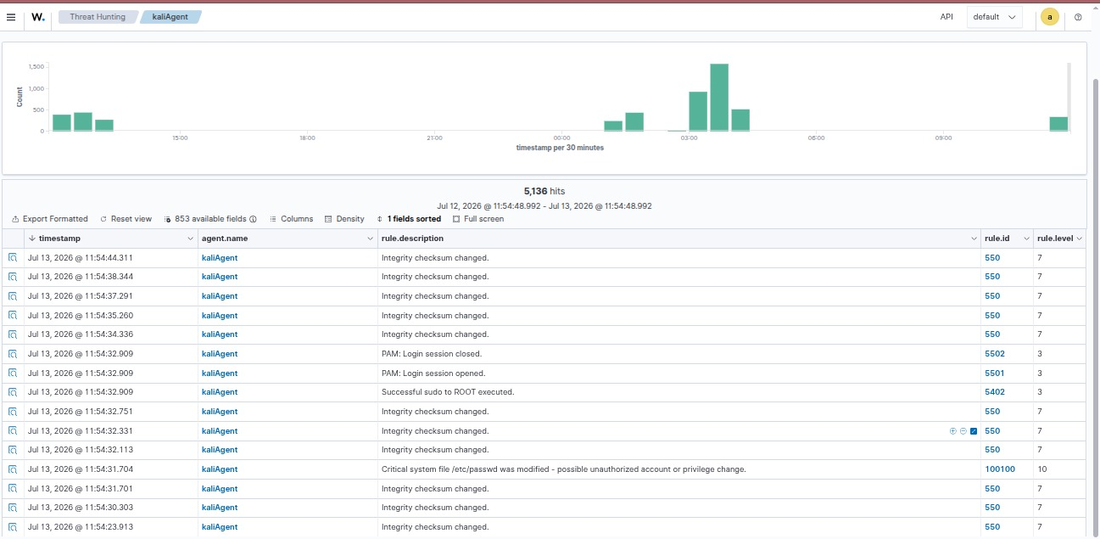
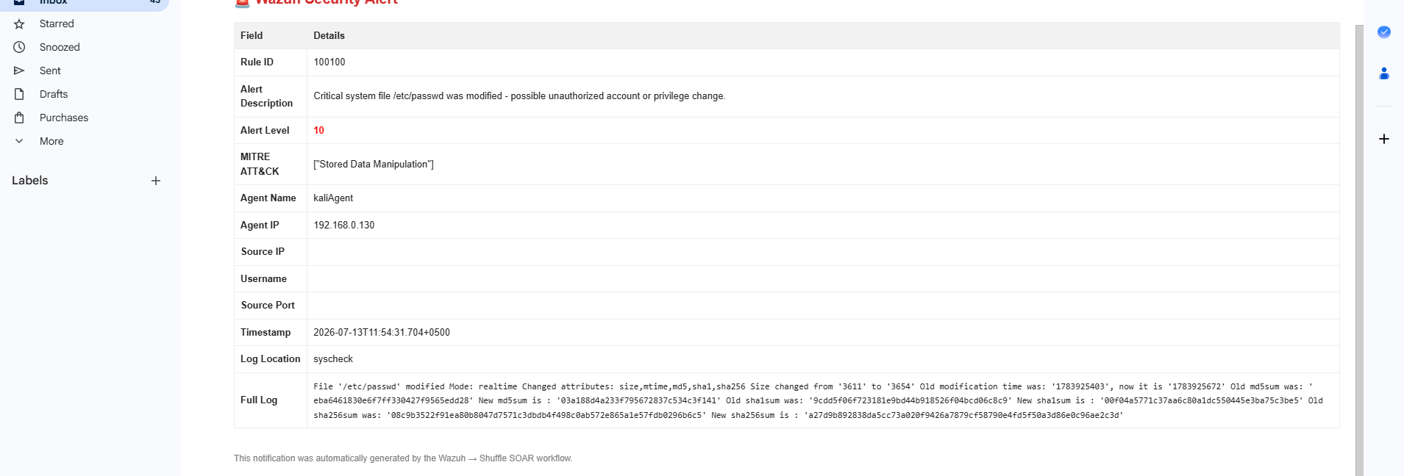 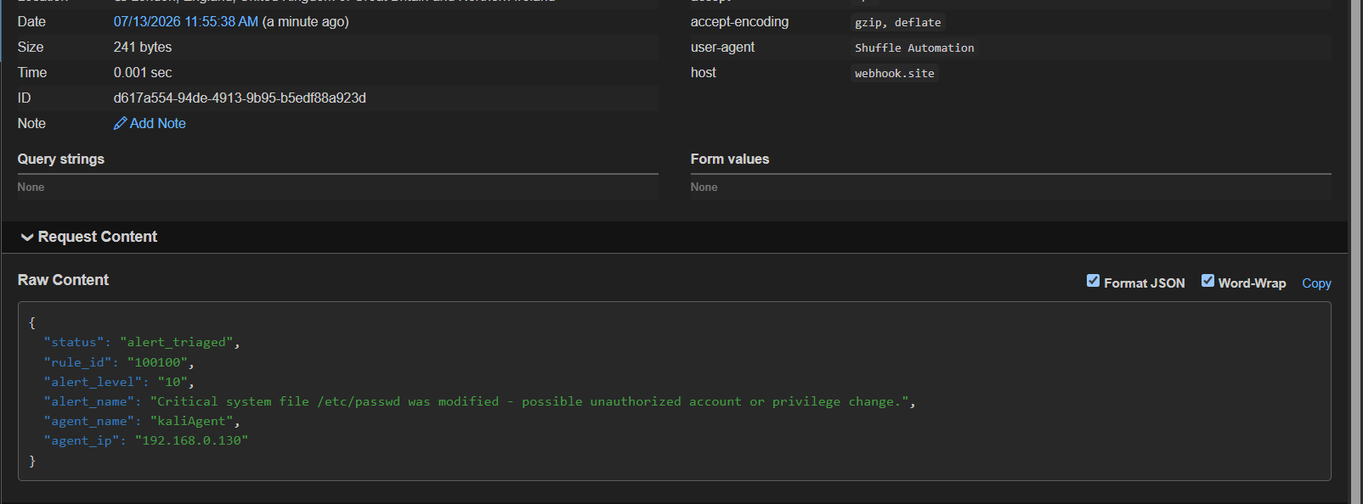 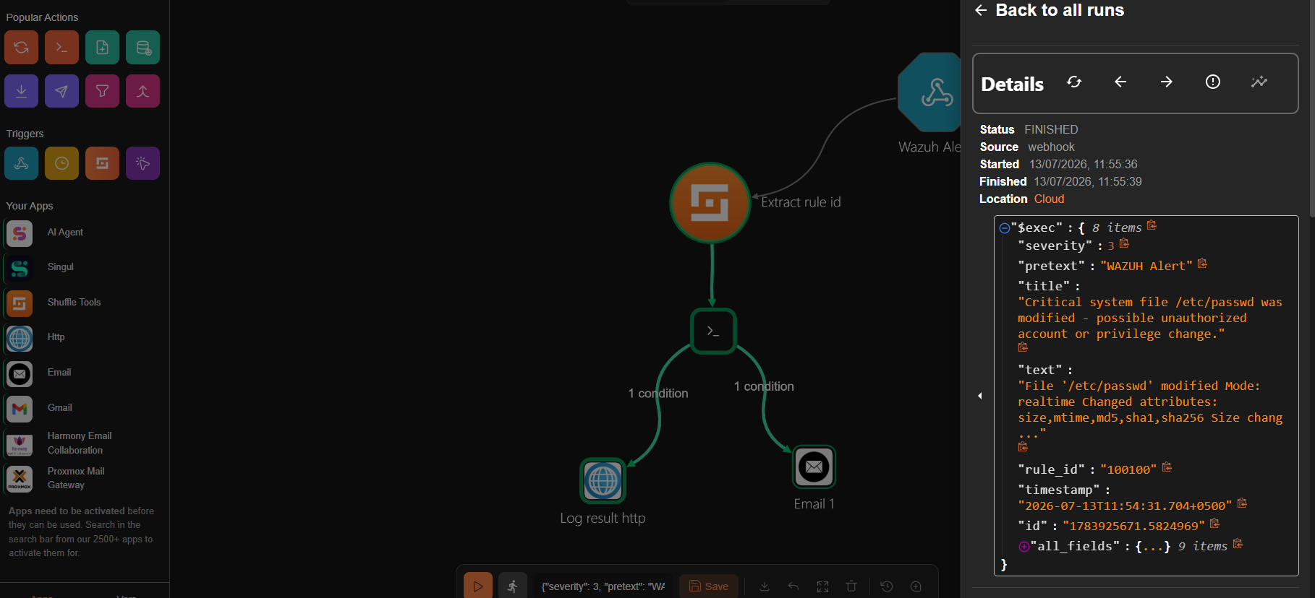 Shuffle Execution - Alert 2

Alert 3 - Nmap Port Scan Detection

Custom Wazuh Rule - Nmap Scan Escalation
<group name="custom_suricata,">
<rule id="100102" level="12" ignore="60">
<if_sid>86601</if_sid>
<field name="alert.severity" type="pcre2">^[12]$</field>
<field name="alert.signature" type="pcre2">(?i)scan</field>
<description>High-confidence Suricata scan/recon signature detected - $(alert.signature)</description>
<mitre>
<id>T1046</id>
</mitre>
<group>suricata,nmap_scan,recon,</group>
</rule>
</group>
Field | Value
Alert Name | High-confidence Suricata scan/recon signature detected
Rule ID | 100102 (custom, extends Suricata group)
Alert Level | 12
Detection Source | Suricata IDS, correlated by Wazuh
MITRE ATT&CK Technique | T1046 - Network Service Discovery
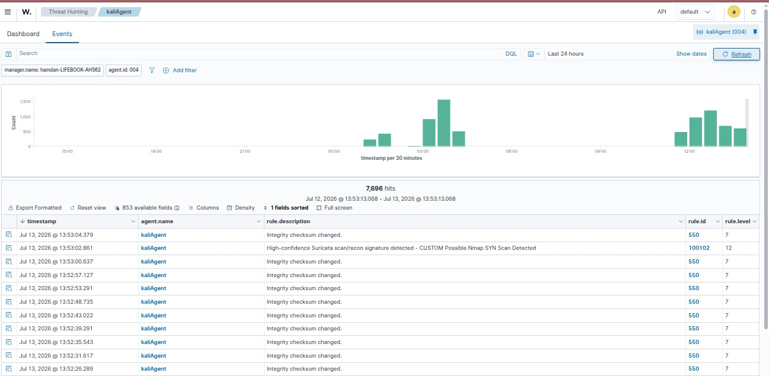Wazuh Alert - Rule 100103
