

A Project Report On

# BLAUCTIONS

“Yatra Pratibha Avasara Prapnotihi“

**Submitted By:**

**NAME ENROLLMENT NO.**

VAISHNAWI RANJAN A45304821028

TANYA KUMARI A45304821027

PRINCE KUMAR A45304821023

AONE A45304821026

**Third Year Bachelor’s in Computer Application**

**(V–Semester)**

**Amity Institute of Information Technology**

To the Amity University in Partial Fulfilment Of Bachelor of Computer application

## Academic Year: 2021-2024

**Under Supervision of: -**

**Prof. Dheeraj Kumar**

## DECLARATION

We hereby declare that major project work for NTCC BCA-5th Semester entitled “BLAUCTION” is an authentic record of our own work carried out in partial fulfilment of the requirement for the award of Bachelor’s of Computer Application (BCA) from Amity University, Patna under the guidance of Prof. Dheeraj Kumar (Amity University Patna), during May to June (2023). All the information furnished in this project is based on our own intensive work and is genuine.

**Name Enrollment No. Signature**

Vaishnawi Ranjan A45304821028

Tanya Kumari A45304821027

Prince Kumar A45304821023

Aone A45304821026

## CERTIFICATE

This is to certify that this project entitled “BLAUCTION” submitted in partial fulfilment of the degree of BACHELOR OF COMPUTER APPLICATION (BCA) to Amity Institute of Information Technology, Amity University Patna done by Vaishnawi Ranjan(A45304821028), Tanya Kumari(A45304821027), Prince Kumar (A45304821023), Aone (A45304821026), is an authentic work carried out by him/her under my guidance. The matter embodied in this project work has not been submitted earlier for award of any degree or diploma to the best of my knowledge and belief.

**Signature of the student:**

**Name Enrollment No. Signature**

Vaishnawi Ranjan A45304821028

Tanya Kumari A45304821027

Prince Kumar A45304821023

Aone A45304821026

**Signature of the Guide: - _______________________ Date: ____________________**

Name: Prof. Dheeraj Kumar

Prof. Amity University Patna

Vaishnawi Ranjan Aone

Tanya Kumari Prince Kumar

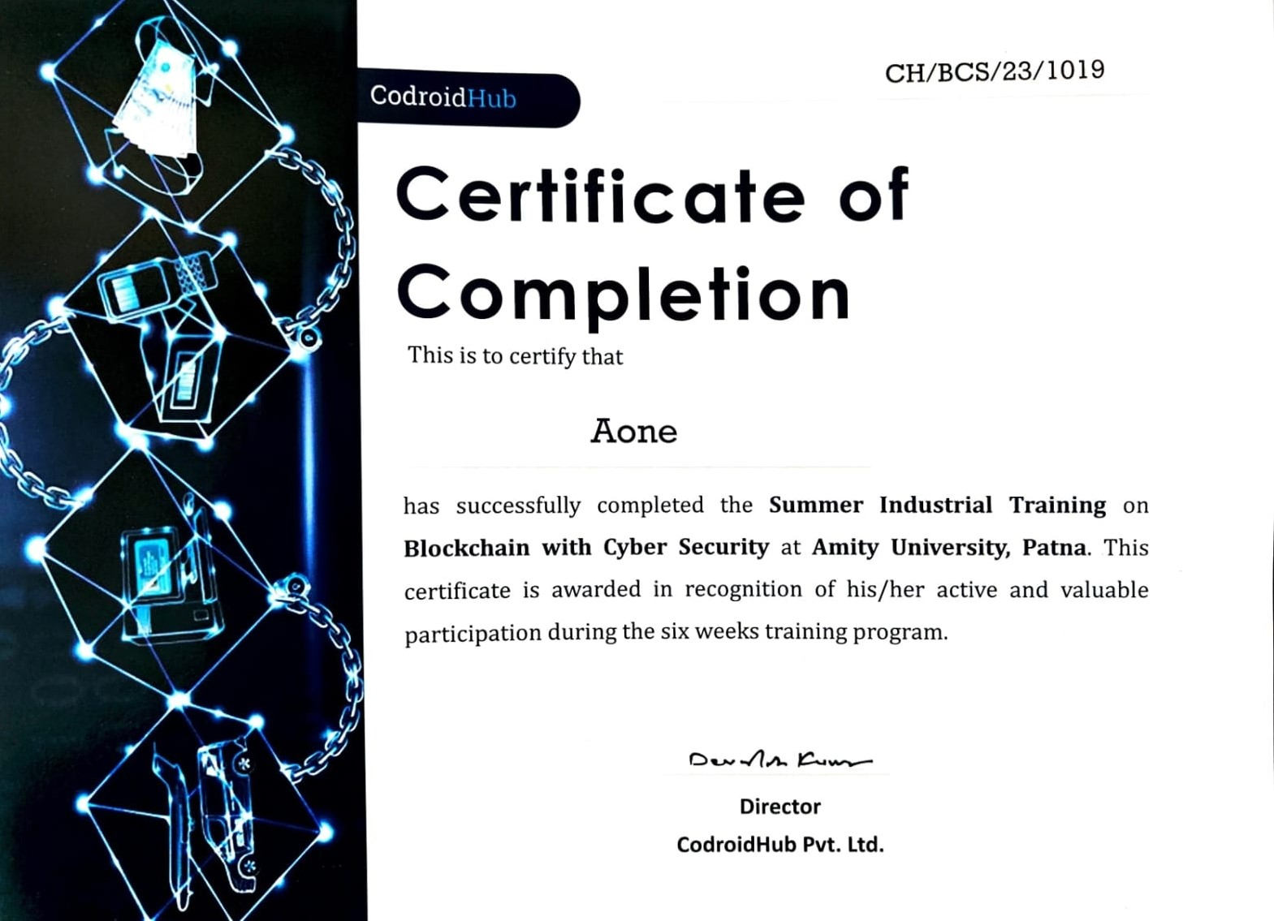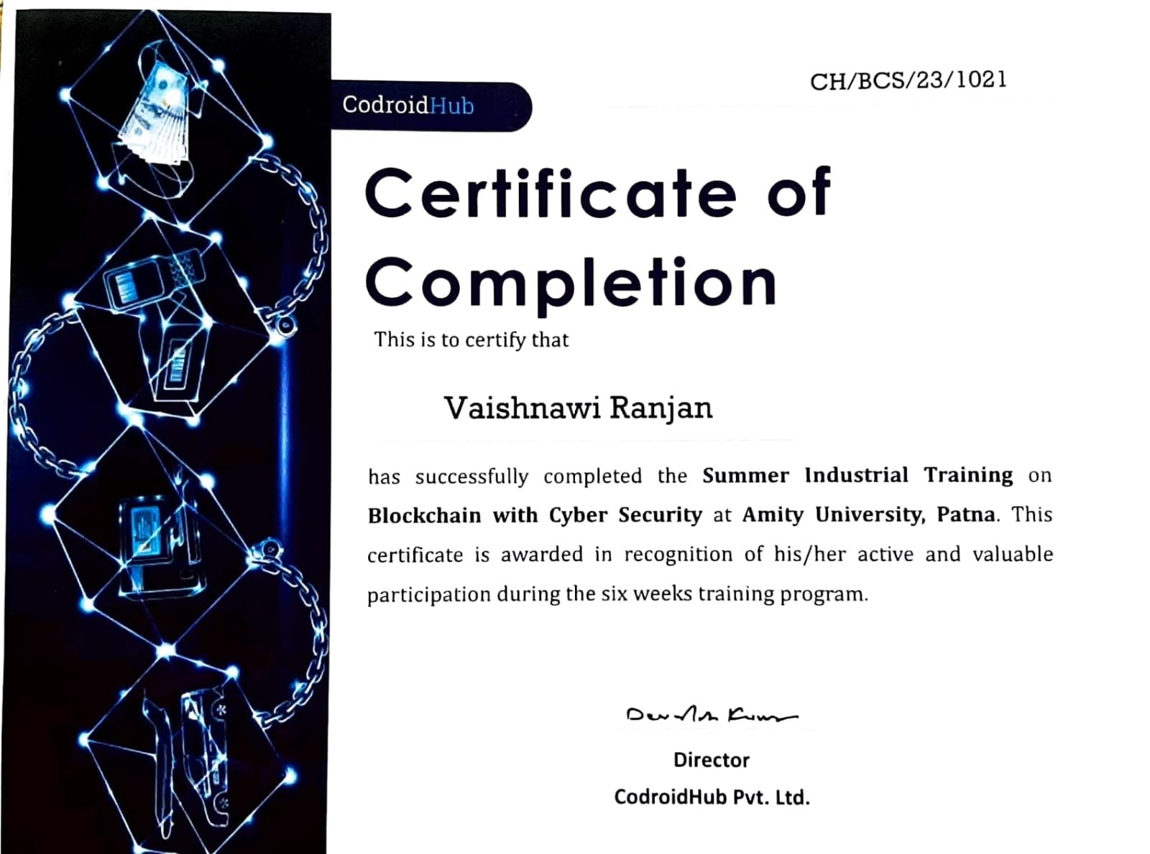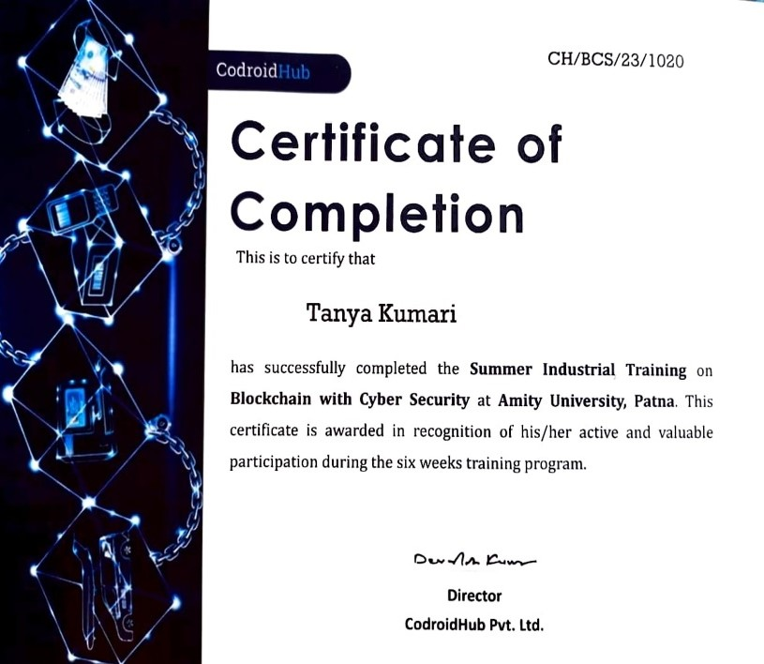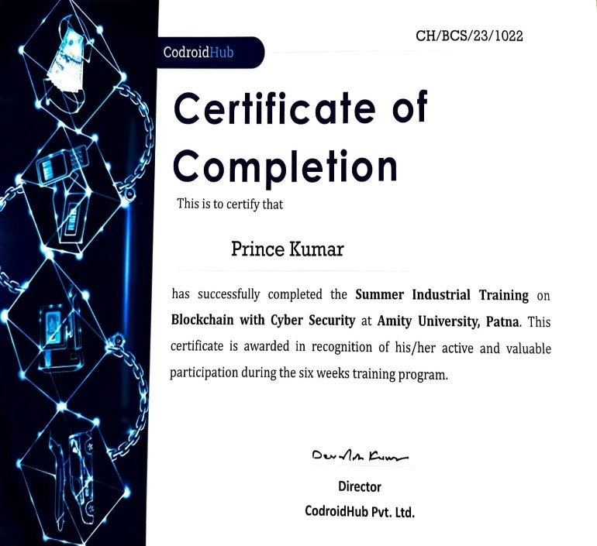

## ROLES AND RESPONSIBILITIES FORM

Name of the project: **BLAUCTIONS**

|  |  |
| --- | --- |
| **Name of Team**  **Member and Enrollment No.** | **Roles** |
| Vaishnawi Ranjan  (A45304821028) | Programmer |
| Tanya Kumari  (A45304821027) | Programmer |
| Prince Kumar  (A45304821023) | Tester |
| Aone  (A45304821026) | Tester |

Signature of the team member:

1.____________________________

2.____________________________

3.____________________________

4.____________________________

Signature of the Guide: _________________________

Date: ________________________

## ABSTRACT

BLAUCTION service is the backbone of every IPL match. IPL matches are one of the most watched genres of the Indian TV. Though being such an interesting game to watch, there is a whole of hectic procedure of organizing IPL matches. Putting forward the proposal for conducting the match, dividing the teams. The most important aspect of the game is the selection of players for respective teams which are carried out through auction. IPL auctions decide the fate of the teams as auctions are the events which decide which player are going to play for which team. With this project the procedure of IPL auction becomes more secure and reliable due to the implementation of blockchain technology.

This project is developed using Blockchain Technology.

## ACKNOWLEDGEMENT

This project being an enormous piece of work happens to be the outcome of time, hard work and patience of a multitude and was unfeasible to accomplish single handed It. We feel and express our gratitude for AMITY UNIVERSITY, PATNA for giving us a strong foundation and infinite opportunities to harness our skills. This esteemed institute, under the proficient administration of Respected VC sir Dr. Vivekanand Pandey Sir has been providing a nurturing environment to all its disciples for growing.

We took on this task with assurance coming from our Dr. Rashmi Shekhar and an unremitting guidance and support of our mentor Prof. Dheeraj Kumar. Their direction and tutorial skills were the stimuli behind the completion of this project. We thank all the faculty members of BCA for entrusting our potential.

Our thanks and appreciations also go to our group members in developing the project.

Thank you to all the people who have willingly helped us out with their abilities.

## INDEX

1. **Introduction**
   1. Overview …………………………………………………………………………………… 10
   2. Scenario ……………………………………………………………………………………. 11
   3. Objective and Scope
      1. Objective ……………………………………………………………………………… 14
      2. Scope ………………………………………………………………………………….. 14

**2.Literature Review …………………………………………………………………………… 16**

**3.Methodology ………………………………………………………………………………… 17**

**4.Why particular topic chosen ………………………………………………………………. 18**

**5.System Requirements**

* 1. Hardware used ……………………………………………………………………………… 19
  2. Software used ………………………………………………………………………………. 20

1. **Design** 
   1. Design principle …………………………………………………………………………….. 21
   2. Use case Diagram …………………………………………………………………………… 22

**7.UML Diagram ……………………………………………………………………………….. 23**

**8. Implementation ……………………………………………………………………………... 24**

**9.Testing**

9.1 Testing Technique …………………………………………………………………………. 29

9.2 Testing case and report …………………………………………………………………….. 30

**10.Resources and Limitation**

10.1 Resources …………………………………………………………………………………. 31

10.2 Limitation ………………………………………………………………………………… 32

**11.Annexure ……………………………………………………………………………………. 33**

1. **Conclusion …………………………………………………………………………………. 36**
2. **Future Scope ………………………………………………………………………………. 37**
3. **References ………………………………………………………………………………….. 38**

## 1.INTRODUCTION

**1.1 OVERVIEW:**

In this section, we provide a overview of the IPL Auction project, explaining its objectives and benefits. The decentralization of the auction process ensures:

1. Transparency: All auction-related data and transactions are recorded on the Ethereum blockchain, visible to all participants in real-time.
2. Immutability: Once the auction process is initiated, the smart contracts ensure that the rules and conditions cannot be altered, preserving the integrity of the auction.
3. Security: Blockchain technology ensures that all transactions and bids.

In recent years, blockchain technology has emerged as a promising solution to address these issues and revolutionize the way IPL auctions are conducted.

Blockchain, the underlying technology behind cryptocurrencies like Bitcoin, is a decentralized and immutable digital ledger that records transactions and data in a secure and tamper-resistant manner. When applied to IPL auctions, blockchain introduces a new paradigm, offering several transformative benefits.

The purpose of this documentation is to provide a clear and concise understanding of the IPL Auction project and its underlying mechanisms. It caters to developers, auditors, and stakeholders interested in exploring and contributing to the blockchain-based IPL auction system. The documentation outlines the architectural design, smart contract functionalities, and interactions to enable a seamless understanding of the entire process.

**1.2 SCENARIO:**

First there will be selling and buying of players among different teams that will be participating in the tournament which will be organized by BCCI.

➢ Team having the highest bid value will get selected in the team for throughout the season.

Q1. What is the specific business problem or challenges that the scenario will address?

* Gradual selection process of the current scenario would be resolved.
* There would be no hitches in the transactions related with money.
* The process of selection of players would become more convenient and reliable.

Q2. What is the current way of solving this business problem?

* By using traditional way to bid price tag with the help of hording which is now comparatively gradual and less trustworthy.

Q3. What are the business network participants involved and what are their role?

* BCCI
* Indian Premier League
* Cricket Players

Q4. Who are the specific peoples involved from organization and what are their roles?

* Chief selector of BCCI: Responsible for selecting members of cricket teams to represent India at various levels.
* IPL Auctioneer: Responsible for hosting IPL Auctions.
* Cricket Players: Players are selected based on their performance and their bidding amount.

Q5. What assets are involved and what is the key information associated with the assets?

* Cricket Players are the key assets involved in the whole procedure and very basic information associated with those assets are their performance throughout their cricket career.

Q6. What are the transactions involved between whom and what assets are associated with transaction?

* The main transaction involved in the procedure is the bidding amount which takes place between the cricket players and the auctioneer for the IPL teams.
* The cricket players being selected in the team are the assets themselves as they are deciding factors for the future of the team

Q7. What are the main steps in the current workflow and how are these executed by the business network participants?

* Players are put up for an auction.
* The IPL teams that are interested in a particular player will bid for it.
* If the player has a good track record and more teams want to include the player in their team, more teams bid for it.
* The team giving the highest bid gets the player.

Q8. What are the expected benefits of applying blockchain technology to the business problem for each of the network participants.

* BCCI: BCCI could be assured of procedure transparency, and it need not monitor each stage of selection.
* IPL: The selection board does not have to go through a series of hectic selection procedures as the whole procedure would be carried out securely through blockchain.
* Cricket Players: The players need not to worry about the transaction of bidding amount

being diverted or meddled with as the blockchain network would provide them enough transparency and security.

Q9. What Legacy system are involved?

* The Revenue and Expenses Department
* The Central Sponsors
* IPL Governing Council
* Regulatory Aspects Monitoring

**1.3 OBJECTIVE AND SCOPE:**

**1.3.1 Objective:**

The objective of this project is to explore the application of blockchain technology in IPL Auctions with the aim of enhancing transparency, security, and efficiency in the real estate industry. The project seeks to understand how blockchain can revolutionize the auction process, create a more trustworthy marketplace, and identify the potential benefits it can offer to all stakeholders involved.

**1.3.2 Scope:**

The scope of this project encompasses the following areas:

**1.Enhanced Transparency:** Building the IPL auction platform on a blockchain would provide complete transparency in the bidding process. All bids, offers, and transactions would be recorded on the blockchain, enabling anyone to verify the authenticity and accuracy of the data.

**2.Trust and Integrity:** Blockchain's decentralized and immutable nature ensures that the auction data cannot be altered or manipulated by any single party. This instils trust among stakeholders, including team owners, players, and fans.

**3.Smart Contract Automation:** Smart contracts can automate the bidding process, ensuring that bids are accepted and rejected automatically based on predefined rules and conditions. This reduces the need for intermediaries and minimizes the chances of errors.

**4.Global Participation:** With blockchain, interested parties from anywhere in the world can participate in the IPL auction. This expanded reach can attract more bidders and potentially increase revenue for teams and the IPL organizers.

**5.Real-Time Updates:** A blockchain-based IPL auction platform could offer real-time updates on bids, player acquisitions, and auction progress. This feature can keep fans and stakeholders engaged and informed throughout the event.

**6.Secure Payments and Transactions:** Blockchain provides secure payment options, allowing teams to make payments for successful bids using cryptocurrencies or other digital payment methods. This can streamline the payment process and reduce transaction costs.

**7.Data Privacy:** Blockchain can ensure data privacy by allowing selective access to sensitive information using cryptographic keys. Players' personal information, medical records, and other confidential data can be securely stored and shared only with authorized parties.

### 2. LITERATURE REVIEW

The project "Transforming IPL Auctions through Blockchain" would make several valuable contributions to the real estate industry and the broader adoption of blockchain technology:

**Smart Contracts for Auction Rules:** Smart contracts can be utilized to encode the rules and conditions of the auction. These self-executing contracts automatically enforce the auction rules, ensuring that bids and transactions follow the predetermined criteria. This would eliminate the need for intermediaries and streamline the auction process.

**Enhanced Data Privacy:** Blockchain can enable selective data sharing, where only relevant parties have access to specific information, ensuring players' privacy during the auction process.

**Proof of Concept:** The project's successful execution of the proof-of-concept testing demonstrates the feasibility and practicality of implementing blockchain in IPL auctions. This serves as tangible evidence that blockchain can effectively address challenges in the auction process, paving the way for further exploration and implementation.

**Security and Anti-Fraud Measures:** Blockchain's cryptographic features ensure that data and transactions are secure and cannot be altered or manipulated. This would reduce the likelihood of fraud or unauthorized access to sensitive auction information.

**Transparency and Immutability:** This project ensures transparency in recording and maintaining auction-related data. All transactions, bids, and other auction-related activities would be recorded on the blockchain, making them immutable and tamper-proof. This transparency would instill trust among stakeholders, such as team owners, players, and fans, as they can verify auction results and activities independently.

**Efficiency and Speed:** By leveraging blockchain's decentralized nature, the IPL auction could reduce processing delays and enhance the overall efficiency of the auction. Real-time updates and confirmation of bids can be achieved, accelerating the auction process.

**Global Accessibility:** Blockchain technology is not limited by geographical boundaries, allowing potential team owners from anywhere in the world to participate in the auction process, expanding the pool of bidders.

## 3. METHODOLOGY

**Methodology:**

The project's methodology is described, including the research and analysis phase, design and development of the blockchain-based system, testing procedures, and data collection. It outlines the steps taken to ensure the project's accuracy and effectiveness in achieving its objectives.

**SCENARIO:**

In this project first there will be selling and buying of players among different teams that will be participating in the tournament which will be organised by BCCI.

Team having the highest bid value will get selected in the team for throughout the season.

Gradual selection process of the current scenario would be resolved.

There would be no hitches in the transactions related with money.

The process of selection of players would become more convenient and reliable. For an auctioning and bidding purposes we are using blockchain technology**.**

**4.WHY PARTICULAR TOPIC CHOSEN?**

Choosing the topic of IPL (Indian Premier League) auction in the context of blockchain can be a fascinating and innovative choice.

**Transparency and Security:** Blockchain technology is known for its transparency and security. Applying blockchain to the IPL auction process can make it more transparent, reducing the chances of tampering with bids, player contracts, and other crucial aspects of the auction.

**Smart Contracts:** Blockchain allows for the creation of smart contracts. In the context of the IPL auction, smart contracts can be used to automate the execution of agreements between teams, players, and the league, ensuring that the terms and conditions are met.

**Immutable Records:** Blockchain records are immutable, meaning once data is added to the blockchain, it cannot be altered. This feature can be essential in maintaining the integrity of player transactions and financial dealings in the IPL auction.

**Decentralization:** Blockchain operates on a decentralized network, reducing the control of a single entity over the auction process. This can reduce the influence of a central authority and make the process fairer.

**Data Privacy:** Protecting sensitive player and team data is crucial. Blockchain can provide a secure and private way to handle this information, with control in the hands of the players and teams

## 5.SYSTEM REQUIREMENTS

## 5.1 Hardware Used:

**Personal Computers:** Standard personal computers were used for research, data analysis, and programming tasks. These computers typically include a central processing unit (CPU), memory (RAM), storage (hard drive or solid-state drive), and input/output peripherals.

**Server:** A dedicated server might have been used to host the blockchain network during the proof of-concept testing. The server would provide the necessary computational power and storage to maintain the blockchain network's integrity and ensure smooth transaction processing.

**Mobile Devices:** Mobile devices, such as smartphones or tablets, may have been used to access and interact with the blockchain-based system during testing. These devices would represent the interface through which bidders and auction participants can engage in the auction process.

**5.2 Software Used:**

**1.Blockchain Platforms and Frameworks:**

**Ethereum:** Ethereum is one of the most popular blockchain platforms for developing decentralized applications (dApps) and smart contracts. It provides a robust infrastructure for creating custom tokens and executing smart contracts using Solidity or other programming languages.

**Hyperledger Fabric:** Hyperledger Fabric is an open-source enterprise blockchain framework developed by the Linux Foundation. It is designed for permissioned blockchains and supports modular architecture, enabling private and confidential transactions.

**Corda:** Corda is a blockchain platform tailored for financial institutions, enabling secure and private sharing of data and transactions between parties.

**2.Smart Contract Development Tools:**

**Remix:** Remix is a web-based integrated development environment (IDE) for writing, testing, and deploying smart contracts on the Ethereum blockchain.[4]

**Truffle Suite:** Truffle Suite is a development framework for Ethereum that includes tools like Truffle, Ganache, and Drizzle, making smart contract development, testing, and deployment easier.

**3.Integrated Development Environments (IDEs):**

**Visual Studio Code:** A popular code editor with extensions available for various blockchain development frameworks and languages.

**JetBrains IDEs:** IntelliJ IDEA, WebStorm, and other JetBrains IDEs can be used with plugins for blockchain development on different platforms.

**4.Front-end Development Tools:**

HTML, CSS, JavaScript: Standard web development languages for creating user interfaces for decentralized applications. React, Angular, or Vue.js: Front-end frameworks to build interactive and user-friendly dApps.

**5.Version Control Systems:**

**Git:** Essential for tracking changes in code, collaborating with teams, and managing different versions of the project.

**6.Deployment and Hosting:**

**Ethereum Nodes:** To deploy smart contracts and interact with the Ethereum network, you can run your Ethereum node or use a third-party node service like Infura.

## 6. DESIGN

## 6.1 Design Principle

* **Player’s Data**:
  + Player’s Name
  + Player's Value •
* **Proposal**:
  + Bidding Amount
  + Minimum Bid
  + Highest Bid ▪ Bidder Name •
* **Function**:
  + Deploy (To deploy the contract while taking the player list as input)
  + Player_Details (To enter player details for bidding)
  + Bidder_Details (To enter the bidder details for bidding for his desired player)
  + Time_Left (To show the time left before closing the nominations)
  + Winner_Name (To declare the winner of the auction)
* **Rules**:
  + Auction order: Players would be selected in an order and the order would be determined by the blockchain.
  + Bid increments: Bidding continues until no other team is willing to raise the bid further.
  + Time Limit: There is a time limit for each player's auction. If a team doesn't make a bid within the allocated time, they may lose the opportunity to acquire that player.
  + Unsold Players: If a player goes unsold in the initial round of the auction, they may be available for a second round at a reduced base price.

**:**

**Use Case Diagram**

**6.2**

IPL

decrement

Accumulation

of players

Highest

bid

increment

Teams

Formed

Lowest bid

initialize

Selection of

players

result

output

get

## 7. UML Diagram

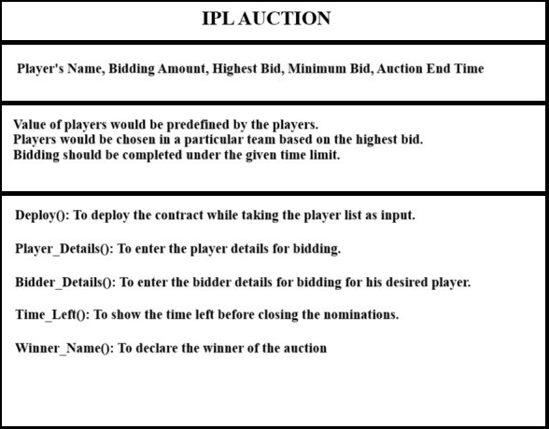

## 8. IMPLEMENTATION

Step 1: Deploy the Contract

You need to deploy this contract to the Ethereum blockchain using a development environment or a tool like Remix. You can specify the constructor parameters (player's address, bidding time, player name, and minimum bid) when deploying the contract.

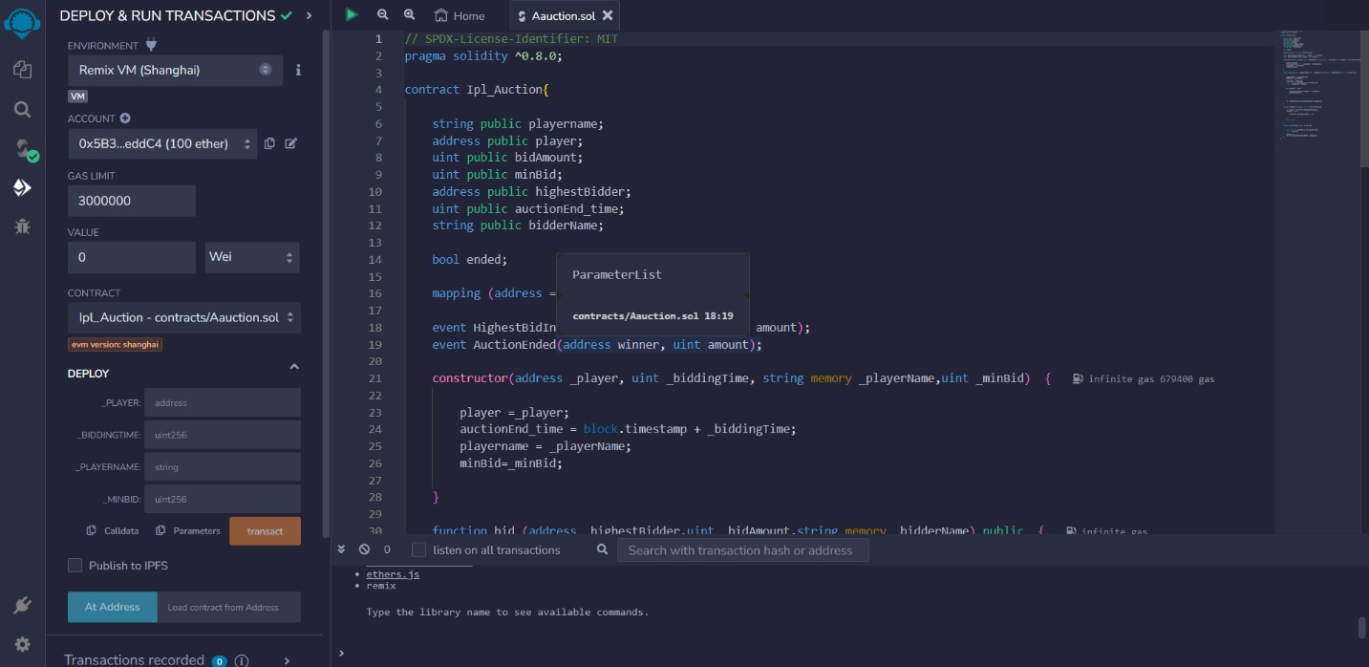

Step 2: Bidding

Once the contract is deployed, anyone can bid for the player by calling the bid function. They need to provide the highest bidder's address, the bid amount, and the bidder's name as parameters. Ensure that the bid amount is higher than the current minimum bid, and the auction has not ended.

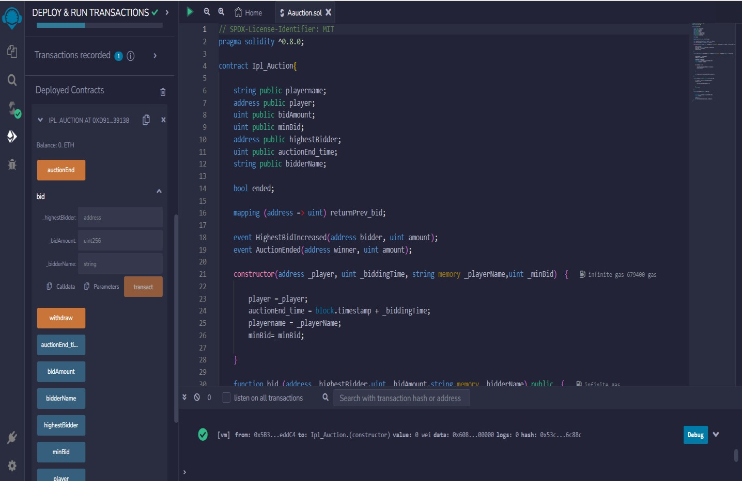

Step 3: Withdraw Funds

If you are the highest bidder and want to withdraw your bid, you can call the withdraw function. It will return the previously deposited amount to you. Make sure to call this function if you're not the winning bid.

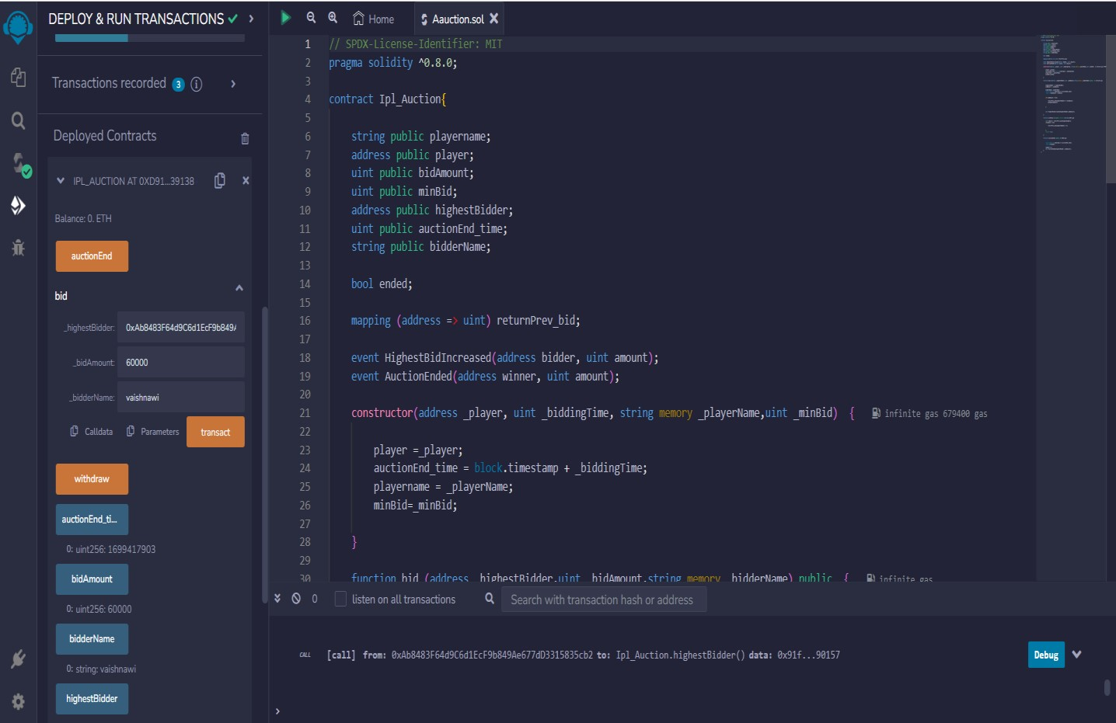

Step 4: Ending the Auction

The auction can be ended by calling the auctionEnd function. This can only be done once the bidding time has expired (block.timestamp >= auctionEnd_time) and the auction hasn't already ended. When the auction ends, the highest bidder is declared the winner, and the contract emits the AuctionEnded event.

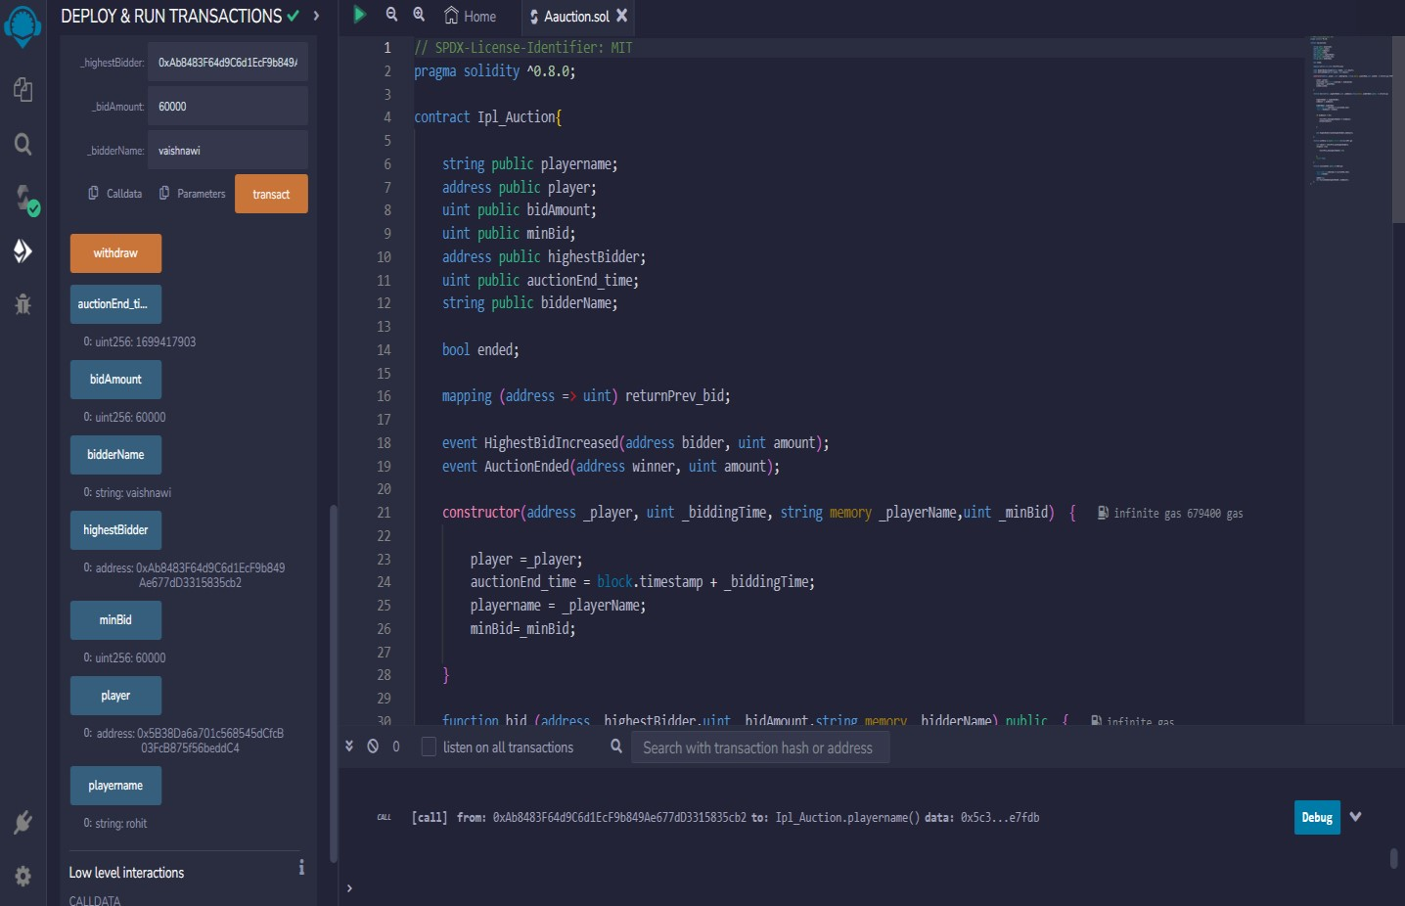

## 9. TESTING

## 9.1 Testing Technique

Testing is a part of Project design. Without testing a project is not called as

Comple

ted because testing provides us the real functioning picture of our development. The design of tester for Project can be as challenging as the initial design of the product itself.

But we perform testing by using the various method of the testing for the completeness of the system. We performed the following testing methods in our project

* Unit testing
* Integration testing

**Unit testing:**

Unit testing is a software development process in which the smallest testable parts of an application, called units, are individually and independently scrutinized for proper operation.

How unit tests work

A unit test typically comprises of three stages: plan, cases and scripting and the unit test itself. In the first step, the unit test is prepared and reviewed. The next step is for the test cases and scripts to be made, then the code is tested.

**Integration testing:**

Integration testing (sometimes called integration and testing, abbreviated I&T) is the phase in software testing in which individual software modules are combined and tested as a group.

Integration testing is conducted to evaluate the compliance of a system or component with specified functional requirements. It occurs after unit testing and before system testing.

Integration testing takes as its input modules that have been unit tested, groups them in larger aggregates, applies tests defined in an integration test plan to those aggregates, and delivers as its output the integrated system ready for system testing.

**9.2 Test case Design & Report**

Test Case Design

Test cases are the specified area where we check that our system is working with perfection or not. For our project following are the test area on which we made test during the project.[3]

|  |  |  |  |  |  |  |
| --- | --- | --- | --- | --- | --- | --- |
| Functions | Purpose of the  Function | No. of  Cases | Test | No. of  Cases  Successful | Test | No. of Test  Cases Failed |
| Deploy | To deploy the contract while taking the player list as input. | 5 |  | 4 |  | 1 |
| Player_Details | To Enter the player details for bidding. | 5 |  | 3 |  | 2 |
| Bidder_details | To Enter the bidder details for bidding for his desired player | 5 |  | 3 |  | 2 |
| Time_Left | To Show the time left before closing the nominations. | 5 |  | 2 |  | 3 |
| Winner_Name | To Declare the winner of the auction. | 5 |  | 4 |  | 1 |

## 10.RESOURCES & LIMITATION

**10.1 Resources:**

**Research Literature:** The project relied on academic papers, articles, and industry publications related to blockchain technology and IPL auctions. These resources provided foundational knowledge and insights into the potential applications of blockchain.

**Blockchain Platforms and Tools**: The project utilized various blockchain platforms and development tools to design and implement the blockchain-based system for IPL auctions. These included Ethereum, Hyperledger Fabric, Remix, Truffle, and other relevant frameworks.

**Development Team:** A team of skilled developers, researchers, and domain experts collaborated on the project. Their expertise in blockchain development, smart contract programming, and real estate industry knowledge contributed to the successful execution of the proof-of-concept and system design.

**Testing Environment:** To test the functionality and performance of the blockchain-based system, a testing environment was created using local blockchain networks or virtual machines. Tools like Ganache and Remix simulator facilitated the testing process.

**Documentation Tools:** Software tools like Microsoft Word, LaTeX, or Google Docs were used to create the project report, providing a structured and well documented account of the research, development, and testing phases.

**10.2 Limitations:**

**Privacy Concerns:** While blockchain provides transparency and immutability, it also raises concerns about privacy. Since all transactions are recorded on the public ledger, it becomes challenging to keep sensitive information confidential.

**Time Constraint**: Implementing blockchain in a real-world project like the IPL auction can be time-consuming, especially for college students who have academic commitments and other responsibilities.

**Limited Real-world Testing:** While the IPL auction project could provide valuable learning experiences for college students in blockchain development, its real-world impact might be limited due to the specific context of the project.

**Budget Constraints:** Implementing blockchain technology might require financial resources for development, testing, and maintenance, which could be a limitation for college students working on a limited budget.

**Resource Constraints:** College projects often have limited resources, which could affect the sophistication of the system or the scale of testing. Resource constraints may also limit the number of developers, participants, or computing power available for testing.

**Regulatory Compliance:** The project might have explored the challenges related to regulatory compliance, but actual adherence to all real-world regulations might not have been fully addressed due to the complexity and dynamic nature of real estate regulations.

**Scalability:** One of the most significant challenges for blockchain is scalability. As the number of transactions and users on the network grows, the size of the blockchain and the time required to process transactions also increase. This can lead to slower transaction times and higher fees, limiting the overall throughput of the system.

**Regulatory Compliance:** The use of blockchain in a real-world project could raise legal and regulatory concerns, especially in the context of IPL auctions, which involve significant financial transactions and player contracts.

|  |  |
| --- | --- |
| **11. ANNEXURE**  // SPDX-License-Identifier: MIT  pragma solidity ^0.8.0;  contract Ipl_Auction{    string public playername;  address public player;  uint public bidAmount;  uint public minBid;  address public highestBidder;  uint public auctionEnd_time;  string public bidderName;  bool ended;  mapping (address => uint) returnPrev_bid;  event HighestBidIncreased(address bidder, uint amount);  event AuctionEnded(address winner, uint amount);  constructor(address _player, uint _biddingTime, string  _playerName,uint _minBid) { | memory  33 |

player =_player;

auctionEnd_time = block.timestamp + _biddingTime;

playername = _playerName;

minBid=_minBid;

}

function bid (address _highestBidder,uint _bidAmount,string memory

_bidderName) public {

highestBidder = _highestBidder;

bidAmount = _bidAmount;

bidderName= _bidderName;

require (block.timestamp <= auctionEnd_time);

require (bidAmount > minBid);

if (bidAmount != 0) {

returnPrev_bid[highestBidder] += bidAmount;

minBid=bidAmount;

}

emit HighestBidIncreased(highestBidder,bidAmount);

}

function withdraw () public returns (bool){

uint amount = returnPrev_bid[highestBidder];

if(amount >0){

returnPrev_bid[highestBidder] = 0;

}

return true;

}

function auctionEnd() public {

require (block.timestamp >= auctionEnd_time);

require(!ended);

ended=true;

emit AuctionEnded(highestBidder, bidAmount);

}

}

## 12. CONCLUSION

In this project we are providing an auction which could enhance transparency and trust among all stakeholder, including teams, players, fans, and sponsors. The decentralized nature of blockchain ensures that all the transactions and bids are recorded immutably, reducing the possibility of fraud or manipulation. It can also facilitate faster and secure transaction during auction process. It can also help in the global participation in the IPL auction, which allow interested parties from around the world to participate seamlessly without any geographical restrictions.

## 13. FUTURE SCOPE

Currently we are providing an IPL auction which is conducted on the blockchain platform in a decentralized manner. All the team owner, player and representatives have access to the auction, making it transparent and accessible process.

In this each owner has a digital wallet connected to the platform which allow them to bid for his favourite player.

Further we are planning to add token system, in which these tokens may give a chance to a fan to vote or to make a decision on matter related to their teams. Fan ownership model can lead to increased fan engagement and loyalty, as supporter will have financial stake in the success of their chosen player.

## 14.REFERENCES

* [**https://www.ibm.com/topics/blockchain[**](https://www.ibm.com/topics/blockchain)**1]**
* [**https://remix.ethereum.org/#lang=en&optimize=false&runs=200&evmVersion=null**](https://remix.ethereum.org/#lang=en&optimize=false&runs=200&evmVersion=null)

**[2]**

* [**https://github.com/topics/blockchain**](https://github.com/topics/blockchain)**[3]**
* **https://remix.ethereum.org/#lang=en&optimize=false&runs=200&evmVersion=nul**

**[4]**

* **www.w3school.com[5]**