МИНОБРНАУКИ РОССИИ  
Федеральное государственное бюджетное образовательное учреждение  
высшего образования  
«Ижевский государственный технический университет имени М.Т. Калашникова»  
Кафедра «Программное обеспечение»

Отчет  
по лабораторной работе №2  
по дисциплине «Управление Программными Проектами»  
на тему «Разработка базового Расписания»

Выполнил:  
студент группы Б17-191-1 Кинг Э.  
  
Принял: Еланцев М.О.

Ижевск 2020

1. **AfriLearning Web Application prototype**

1, **Sign Up**

A standard page that enables teachers, administrators, and students to sign up using a unique school ID couple with their username, email and a password.

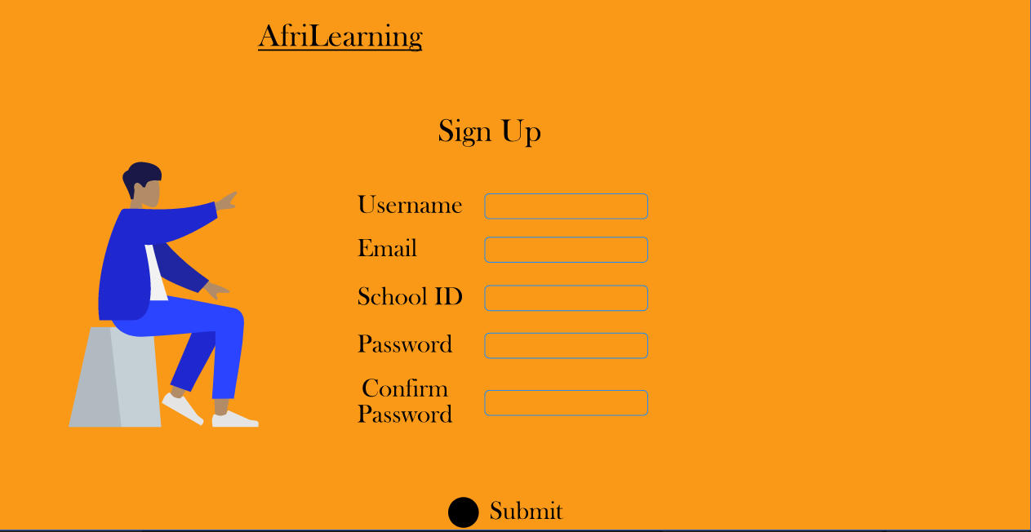

B.**Sign In**

With the previous information which the user used to register on the platform, they can use the username school Id and password optionally they can also sign in with their existing Facebook account.

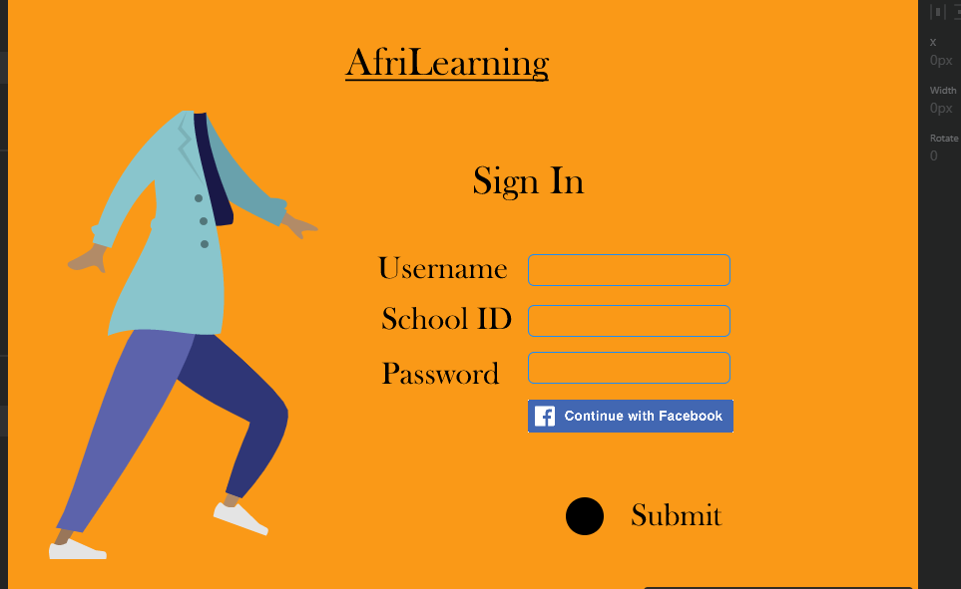

C. **Course Selection**

After the student **Sign In** they can be able to choose their interested course and can also search for a course using the search bar if the course is not available in the display table.

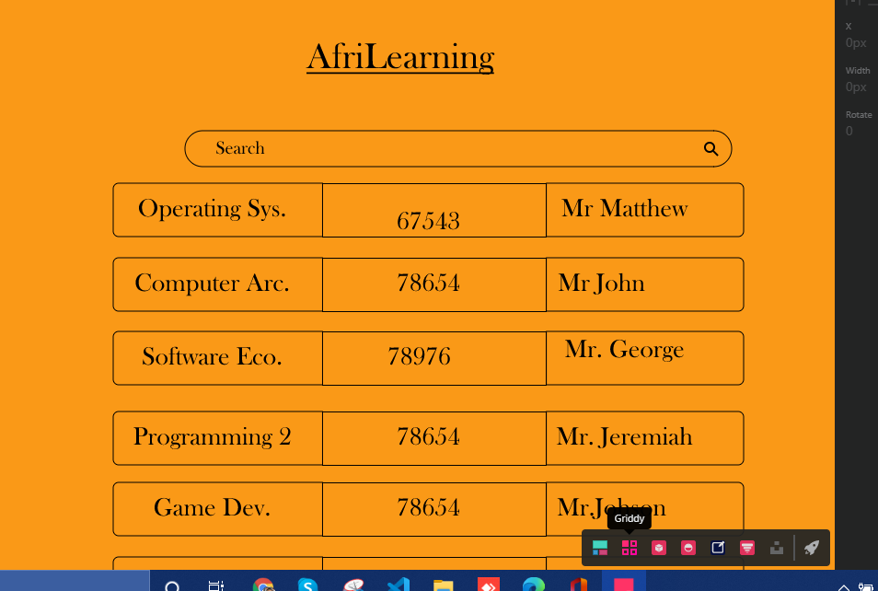

D. **Students Board**

After the selection process students can choose a specific function based on a grid of functions, either by taking the course exam, viewing materials, or submitting a project.

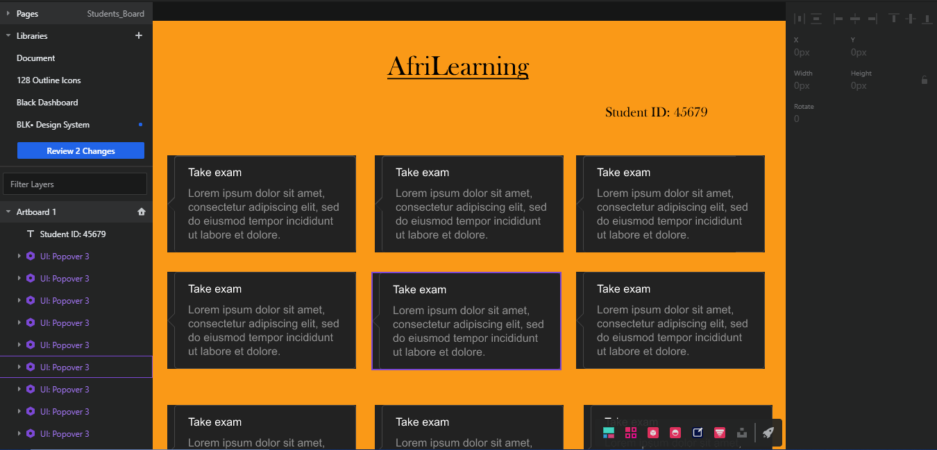

E. **Teacher Board**

A unique dashboard is provided for the teacher to visualize the student results, view student statistics and generate students records.

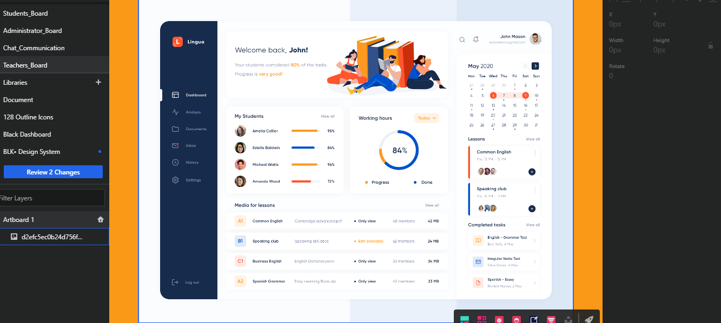

F. **Administrator Board**

The administrator have access to several function including analysing student result, generating reports based on data on the dashboard etc.

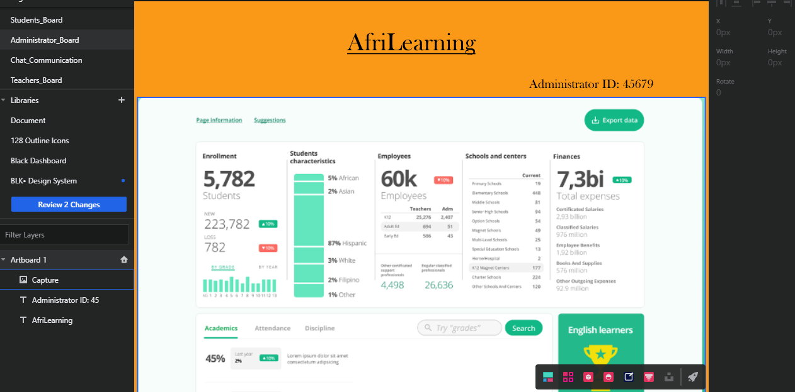

G. **Chat and Communication**

The chat and communication panel feature a general and one to one group chat where students, teachers and administrators can communicate and solve tangible problems.

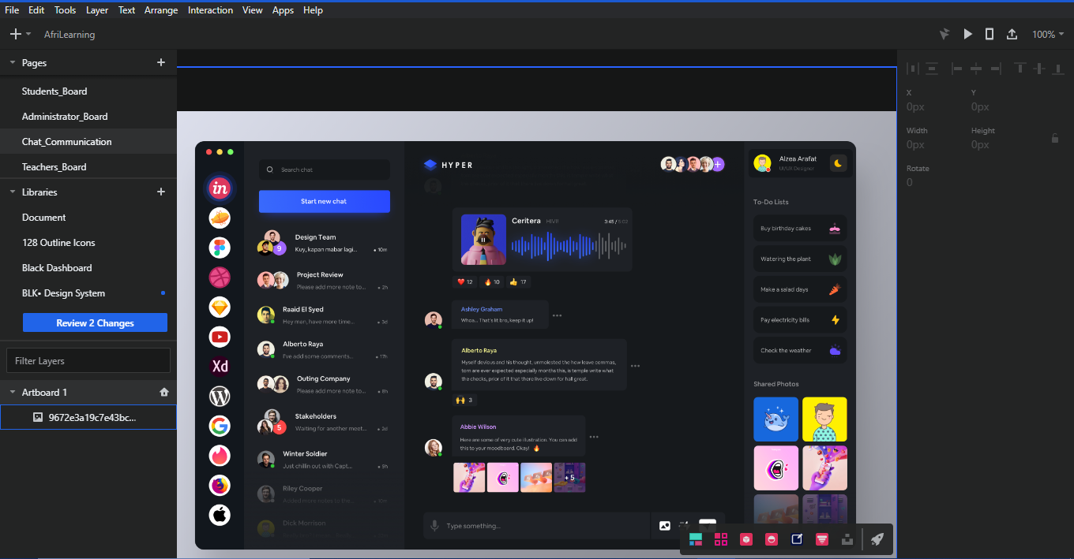

1. Диаграмма сущностей (ER) (не менее 7 сущностей)

**Entity Relationship Diagram**

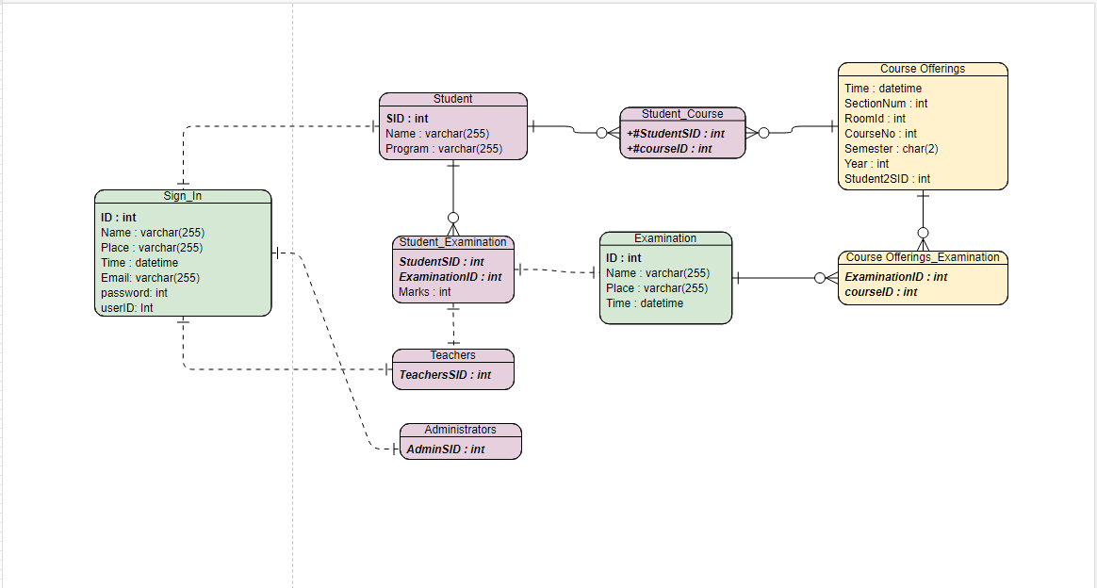

3.Разработка api системы (не менее 10 функций)

**API system development**

|  |  |  |  |  |
| --- | --- | --- | --- | --- |
| No. | Name of function | Function Description | Input Description | Output Information |
| 1 | Sign Up | Register the user in the system i.e teacher, students and administrators | Sign up button | Output the signup page |
| 2 | Submit | Submit the user information in the database | Submit button | A confirmation mail is sent to the user email registered with |
| 3 | Sign In | The user is allowed to sign in with the existent data registered with. | Sign In button | The user is automatically signed in to the system |
| 4 | Course selection | The student can choose the course of preference from the table | Course selection button | A table showing the course name, course Number, and teachers name |
| 5 | Student board | A board that displays exam, quiz, and materials needed by the students | Student board button | Display a board where students can choose from. |
| 6 | Teachers board | A multi-feature display of several components needed by the teacher | Entity Relational | Display dashboard for teachers |
| 7 | Chat button | Enables a group chat, for teachers students and admins | Directional | Output the chat feature |
| 8 | Videl call | A real-time video call, that features peer-to-peer communication. | Entity Relational | Output the video widget |
| 9 | Student rank | A simple algorithm to rank the most active student | - | Output list of student by ranks |
| 10 | Comments portal | A feature that enables students teachers and admins | Entity relational | Output a comment portal |

4. Иерархическая структура работ (СПР) (минимум 3 уровня). В нем должно быть указано развитие всех элементов из пункта выше + сопутствующие работы

<https://mm.tt/1649930033?t=Yl1ixZIUI0>

5. Разбить работы на 2 этапа: [MVP](https://ru.wikipedia.org/wiki/%D0%9C%D0%B8%D0%BD%D0%B8%D0%BC%D0%B0%D0%BB%D1%8C%D0%BD%D0%BE_%D0%B6%D0%B8%D0%B7%D0%BD%D0%B5%D1%81%D0%BF%D0%BE%D1%81%D0%BE%D0%B1%D0%BD%D1%8B%D0%B9_%D0%BF%D1%80%D0%BE%D0%B4%D1%83%D0%BA%D1%82) и финальная-версия

|  |  |  |
| --- | --- | --- |
| **S/n** | **MVP Features** | **Final Version Features** |
| 1 | Comments and feedbacks portal | Interactive dashboard for both Administrators, teachers, and students |
| 2 | Multiple language support | AI Power exam and quiz assessment function. |
| 3 | Automatic results generation based on students reports | Chat and communication feature |
| 4 | Bots support feature | Videos and audio plugin |
| 5 | Product demo feature | End-to-end authentication systems using unique school ID |

6. Оценить время выполнения проекта по методу PERT

пожалуйста, проверьте прикрепленные отдельные файлы.

1. AfriLearning PERT chart
2. AfrLearning.png

7. Базовое расписание в виде диаграммы Ганта. В базовом расписании должно быть отражены оба этапа и все элементы ИСР

Пожалуйста, просмотрите прикрепленный проект названия project1.pdf