1. SWOT Analysis for AfriLearning

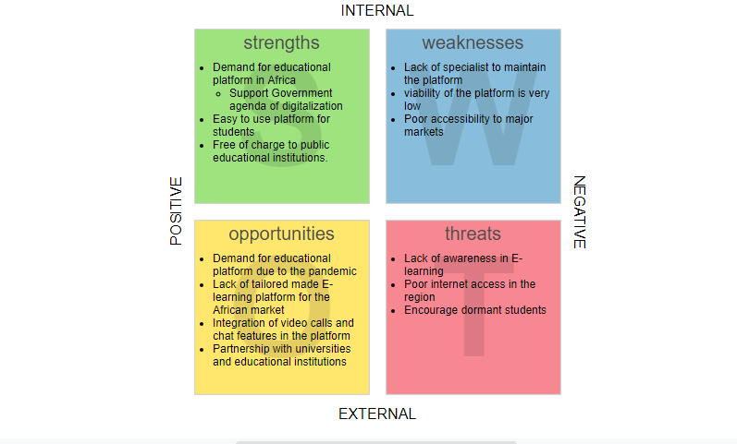

2. Product MVP

<https://afrilearning.bubbleapps.io/version-test/?debug_mode=true>

3.AfriLearning product demonstrations

<https://www.loom.com/share/7057169661a64da1949181500a3f8673>

4. Landing page for AfriLearning

Project name

Brief description of the problem being solved

Three benefits of your product

Product screenshots

Product video

Feedback form (for users who are interested in the product)

<http://afrilearning.tilda.ws/>

