# CST PTM Data

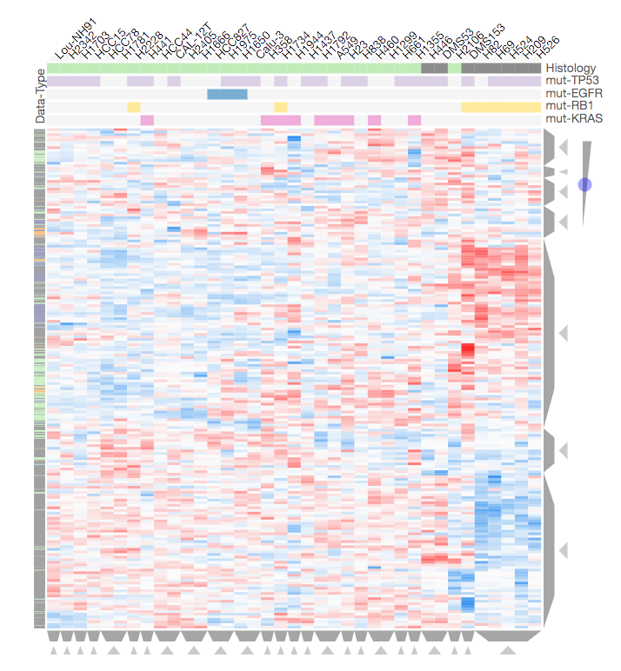

This is a combination of all types of PTM data. I excluded PTMs that had too many missing values (details in processing notebook). I will focus on the two large clusters with high and low PTM values in SCLE and vice versa in NSCLC.

## GO Bio Process

### Up-regulated SCLC PTMs:

mRNA processing, gene expression, splicing, …

### Down-regulated SCLC PTMs:

neurotrophin TRK receptor signaling, mRNA processing response to peptide, … (PTMs were mostly phosphorylation)

## KEGG 2016

### Up-regulated SCLC PTMs:

Spliceosome, mRNA surbeilance, …

### Down-regulated SCLC PTMS:

Neurotrophin signaling pathway

### MGI Mammalian Phenotype Level 4:

Abnormal embryo for both clusters.

# Gene Expression Data CCLE

# ../../../Desktop/Screen%20Shot%202017-04-10%20at%202.54.47%20PM.png

This includes the top ~1000 variably expressed genes across the lung cancer cell lines. I’ll focus on the three largest clusters.

## GO Biological Process

### Up-regulated SCLC Genes:

neuronal differentiation

Refs: Neuronal Characteristics of small-cell lung cancer [link](https://www.ncbi.nlm.nih.gov/pmc/articles/PMC2361510/). Markers of small cell lung cancer [link](https://www.ncbi.nlm.nih.gov/pmc/articles/PMC441408/).

### Down-regulated SCLC Genes:

Wounding, cell migration, cell component movement, cell motility, adhesion, ECM, …

Ref: An adherent subline of a unique small-cell lung cancer cell line downregulates antigens of the neural cell adhesion molecule [link](https://www.ncbi.nlm.nih.gov/pmc/articles/PMC329817/): “Small-cell lung cancer (SCLC) lines are distinguished from non-small-cell lung cancer (NSCLC) lines by their growth in gloating aggregates, in contrast to the adherent monolayers formed by NSCLC cells in culture,”.

### Mixed-regulated Genes (bottom cluster):

No strong enrichments, endopepsidase, single cell adhesion

## ChEA

### Up-regulated SCLC Genes:

SUZ12, BMI1

Refs: SUZ12 is involved in progression on NSCLC by promoting cell proliferation and metastasis [link](https://www.ncbi.nlm.nih.gov/pubmed/24633887). BMI1 expression modulates non-small cell lung cancer progression [link](https://www.ncbi.nlm.nih.gov/pubmed/25880371).

### Down-regulated SCLC Genes:

SOX2, CJUN, ERLA, SMAD2/3

Refs: The role of SOX2 in small cell lung cancer [link](https://www.ncbi.nlm.nih.gov/pmc/articles/PMC4367598/).

### Mixed-regulated Genes (bottom cluster):

SOX2 enrichment

### Down-regulated SCLC:

Focal adhesion, proteoglycans in cancer, influenza A, TNF signaling

## Disesase Perturbatiosn from GEO Up (expression sig comparisons)

### Up-regulated SCLC Genes:

**Multiple sclerosis**, spinal muscular atrophy, **large cell neuroendocrine carcinoma,** multiple scletosis, **oligodendroglioma**, anterior horn cell disease, squamous cell carcinoma of the mouth, astrocytoma,

Summary: there is similarity between the up-regulated genes in SCLC cell lines and the up-regulated genes in several neuronal-related diseases and cancers.

Refs:

Multiple associations between a broad spectrum of autoimmune diseases, chronic inflammatory diseases and cancer [link](https://www.ncbi.nlm.nih.gov/pmc/articles/PMC3349285/).

Large cell neuroendocrine carcinoma: an aggressive form of non-small cell lung cancer [link](https://www.ncbi.nlm.nih.gov/pubmed/15999058). Large-cell neuroendocrine carcinoma (LCNEC) of the lung displays morphologic and immunohistochemical characteristics common to neuronendocrine tumors and morphogenic features of large cell carcinomas [link](http://www.medscape.com/viewarticle/550291_1).

Oligodendrogliomas come from oligodendrocytes, one of the types of cells that make up the supportive, or glial, tissue of the brain,

### Down-regulated SCLC Genes:

**Pancreatic ductal adenocarcinoma**, papillary carcinoma, ulcerative colitis, pancreatic …

Summary: pancreatic cancer is also caused by smoking. Pancreatic cancer can metastasize to the lung and cause confusion in diagnosis.

### Mixed-regulated Genes (bottom cluster):

**Pancreatic ductal adenocarcinoma**, prostate cancer …

## MGI Mammalian Phenotype Level 4

### Up-regulated SCLC Genes:

Abrormal neuronal morphology, abnormal neuronal physiology, brain nervous system, etc…

### Down-regulated SCLC Genes:

Abnormal innate immunity, blood vessel, inflammatory reponse, abnormal response to injury

### Mixed-regulated Genes (bottom cluster):

Abnormal extraembryonic tissue, impared skin barrier, abnormal skin appearance, abnormal epidermal layer, abnormal skin physiology,

# Merge PTM and Gene Expression Data (~2500 rows)

# ../../../Desktop/Screen%20Shot%202017-04-10%20at%203.17.37%20PM.png

## GO Biological Processes

### Up-regulated SCLC:

mRNA processing, mRNA splicing, gene expression,

Ref: Aberrant RNA splicing and its functional consequences in cancer cells [link](https://www.ncbi.nlm.nih.gov/pmc/articles/PMC2561970/).

### Down-regulated SCLC:

Cellular component movement, cell motility, cell migration, locomotion, response to wounding, response to virus/organism, cell adhesion, cell junction, coagulation

Ref: See above: An adherent subline…

## ChEA (may not make sense since this is mix of data types)

### Up-regulated SCLC:

KDM5B, FOXM1, E2F1

### Down-regulated SCLC:

SOX2, SMAD3, SMAD3, RELA, …

Ref:

Comprehensive genomic analysis identifies SOX2 as a frequently amplified gene in small-cell lung cancer [link](http://www.nature.com/ng/journal/v44/n10/full/ng.2405.html).

The role of SOX2 in small cell lung cancer, lung adenocarcinoma and sqyamous cell carcinoma of the lung [link](https://www.ncbi.nlm.nih.gov/pmc/articles/PMC4367598/).

## KEGG 2016

### Up-regulated SCLC:

RNA transport, spliceosome, mRNA surveillance, mTOR signaling

### Down-regulated SCLC:

Focal adhesion, proteoglycans in cancer, influenza A, TNF signaling

## MGI Mammalian Phenotype Level 4

### Up-regulated SCLC:

Prenatal lethality, abnormal neuron morphology

### Down-regulated SCLC:

Abnormal immunity, abnormal epidermal layer, embryogenesis, cardiovascular

### Is there a relationship between GO enrichment cell motility and ChEA enrichment SOX2/SMAD2/etc.. ?

This reference seems to imply that loss of SOX2 leads to cell motility [link](https://www.ncbi.nlm.nih.gov/pubmed/26040981)

# Merge PTM and Gene Expression Data Filtered (~700 rows, two large clusters)

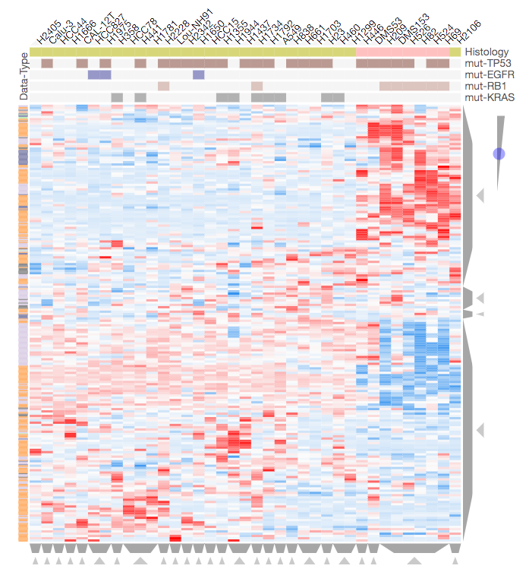

## GO Biological Processes

### Up-regulated SCLC:

mRNA splicing, mRNA processing, lung epithelian cell differentiation, lung cell differentiation, epithelial cell differentiation, neuron fate specification,

### Down-regulated SCLC:

Single organism cell adhesion, response to inorganic substances, cell-substrate adhesion, cell-cell adhesion, nitrogen compound, substrate adhesion dependent cell spreading

## ChEA

### Up-regulated SCLC:

BMI1, RNF2, SUZ12

### Down-regulated SCLC:

CJUN, KLF4, RARG, ..

## KEGG

### Up-regulated SCLC:

Low enrichment: Thyroid hormone signaling, viral carcinogenesis

### Down-regulated SCLC:

Proteoglycans in cancer, viral myocarditis, focal adhesion, leishmaniasis, complement and coagulation cascades, platelet activation,

## MGI Mammalian Phenotype level 4

### Up-regulated SCLC:

Abnormal pancreas morphology, abnormal neuron physiology, abnormal neuron morphology, abnormal nervous system, brain morphology, prenatal lethality, maternal imprinting

### Down-regulated SCLC:

Abnormal dermal layer, abnormal response to injury, abnormal innate immunity, abnormal cell adhesion, pre/post weaning lethality

# Specific Genes in Clusters

**NKX2-1**: Initially identified as thyroid specific transcription factor. The encoded protein binds to the thyroglobulin promotor and regulateds expression … [refseq]. From the heatmap, it is highly correlated with SFTA3 gene expression.

**ref: NKX2-1** a novel tumor biomarker of lung cancer. NKX2-1, also known as TTF-1 is a tissue specific transcription factor of the thyroid, lung and ventral forebrain. While it has been shown to play a critical role in lung development and lung cancer differentiation and mrphogenesis, molecular mechanisms mediating NKX2-1 cell- and tissue-specific expression in normal nad cancerous lungs have yet to be fully elucidated. [link](https://www.ncbi.nlm.nih.gov/pmc/articles/PMC3494024/)

## NSCLC Up Merged Cluster

**SFTPA2**: surfactant protein known to be highly expressed in lung.

**STFA2**: surfactant associated 2

**MUC1**: mucin 1, cell surface associated. This gene encodes a membrane-bound protein that is a member of the mucin family. Mucins are O-glycosylated proteins that play an essential role in forming protective mucous barrier on epithelial surfaces… expressed on the apical surface of epithial surfaces of many different tissues including lung, breast. … This protein is proteolytically cleved into alpha and beta subunits that form a heterodimeric complex. The N-terminal alpha subunit functions in cell-adhesion and the C-erimninal beta subunit is involved in cell signaling. Overexpression, abbrent intracellular localization, and changes in glycosylation have been associated with carcinomas. This gene is known to contain a highly polymorphic variable of …

Ref: **MUC1 tyrosine phosphorylation activates the extracellular signal-reglulated kinase** [link](https://www.ncbi.nlm.nih.gov/pubmed/15358196)**.** MUC1 is a transmembrane glycoprotein expressed on the apical surface of epithelial cells and exhibiting structural features characteristic of receptors for cytokines and growth factors. Its intracellular cytoplasmic tail contains multiple amino acid sequences motifs that, once phosphorylated, serve as docking sites for SH2 domain-containing proteins mediating signal transduction. Most studies examining MUC1 signaling have focused on cancer cells where MUC1 is overexpressed, aberrantly glycosylated, and constitutively phosphorylated. No …