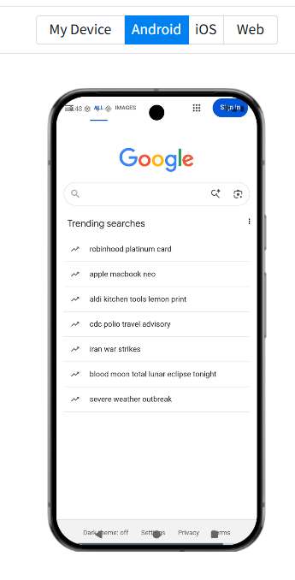
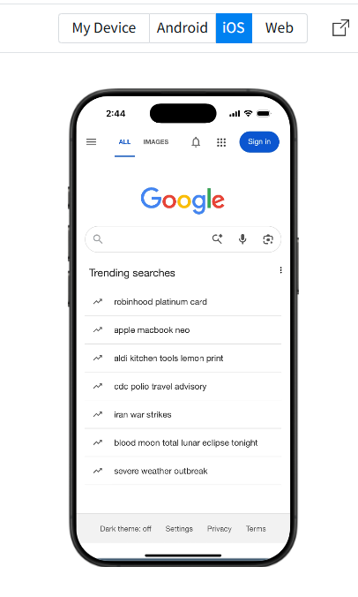

This implementation is considered a Hybrid/Shell architecture because the React Native app only works as a container that displays a web page using WebView. The interface is rendered by the Google website through the device’s browser engine, not by native React Native UI components.

