CREATE TABLE employee(
emp_id VARCHAR(10) PRIMARY KEY,
emp_name VARCHAR(10),
dept VARCHAR(10),
salary number
);
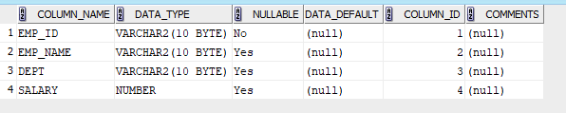

INSERT INTO employee(emp_id,emp_name,dept,salary) VALUES (1,'DavidSmith','HR',3000);
INSERT INTO employee(emp_id,emp_name,dept,salary) VALUES (2,'Ouseph','Marketing',5000);
INSERT INTO employee(emp_id,emp_name,dept,salary) VALUES (3,'Clerin','Production',7000);
INSERT INTO employee(emp_id,emp_name,dept,salary) VALUES (4,'Aby','Sales',8000);
INSERT INTO employee(emp_id,emp_name,dept,salary) VALUES (5,'Ken','Security',9000);
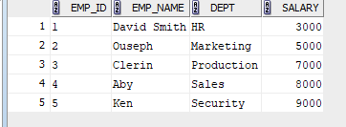

3).SELECT * FROM employee WHERE salary >7000;

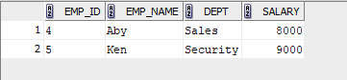

UPDATE employee set salary=8200 WHERE emp_name='DavidSmith';

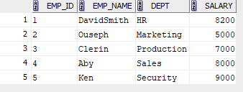

INSERT INTO employee1(emp_id,emp_name,dept,salary) VALUES (6,'Daniel Harris','Production',6700);
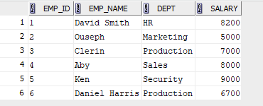

DELETE FROM employee1 WHERE emp_id=3;
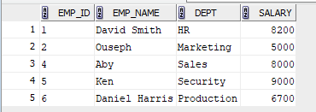

SELECT * FROM employee1 WHERE emp_name not like 'D%' and emp_name not like 'O%';
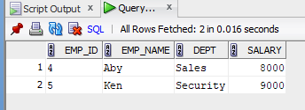

SELECT dept,SUM(salary) FROM employee1 GROUP BY dept;
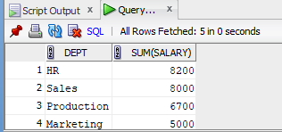

UPDATE employee1 SET salary=salary*1.05 WHERE dept='Production';
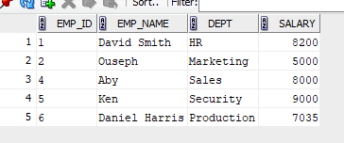

DELETE FROM employee1 WHERE salary<7000;
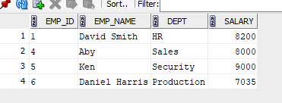

SELECT emp_name,salary FROM employee1 WHERE salary=(SELECT MIN(salary) FROM employee1);
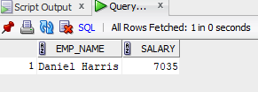

insert into employee1 values (7,'amal','Marketing',5000);
update employee1 set salary=8200 where dept= 'Marketing';
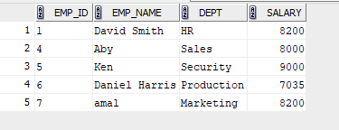

SELECT * FROM employee1 where emp_name like 'a%';
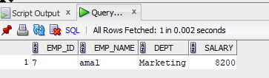

SELECT * FROM employee1 where emp_name like '%it%';
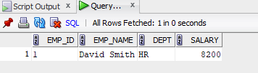

select distinct upper(dept) from employee1;
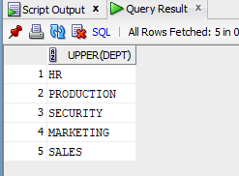

select * from employee1 where lower(dept) like 'm_r%ket%';
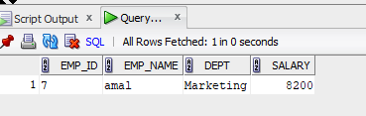

select distinct dept, reverse(upper(dept)) as reversed from employee1;
