GH-200

GitHub Actions Practice Questions
  - Questions 5, 6, 7, 8 and 10 | Answers, Hinglish Explanations and Exam Tips

Prepared for | Amaljeet Puthiya
Coverage | 5 original screenshot questions
Purpose | GH-200 certification revision

Important correction: Question 7 final answer is B. The earlier .github interpretation was incorrect and is not used in this document.

Contents
- Question 5: Default environment variables
- Question 6: Persisting an environment variable between steps
- Question 7: Artifact and package storage limits
- Question 8: npm publishing and job dependencies
- Question 10: Shared secure token across repositories
- Quick Revision Sheet

Question 5: Default Environment Variables
Which statement is true about using default environment variables?
Option | Statement
A | Environment variables can be read using the ENV: variable_name syntax.
B | Created environment variables should be prefixed with GITHUB_.
C | Environment variables can be set in the defaults: section.
D | GITHUB_WORKSPACE should be used to access files from within the runner.

Correct Answer: D

Question kya kehna chahta hai?
Question pooch raha hai ki GitHub ke automatically provided default variables ko workflow mein sahi tarah kaise use kiya jata hai.

Why this answer is correct
- GITHUB_WORKSPACE runner par repository working directory ka path deta hai.
- Hard-coded filesystem path ke bajaye workspace variable use karna portable approach hai.

Why the other options are wrong
- A: ENV: variable_name GitHub Actions syntax nahi hai.
- B: GITHUB_ prefix GitHub-provided variables ke liye reserved hai.
- C: defaults: run shell aur working-directory jaise defaults ke liye hota hai, variables define karne ke liye env: use hota hai.

Example
steps:
- uses: actions/checkout@v4
- run: echo "$GITHUB_WORKSPACE"

GH-200 Exam Tip: GITHUB_WORKSPACE = repository path on the runner. GITHUB_SHA = triggering commit. GITHUB_REF = branch or tag ref. RUNNER_OS = runner operating system.

Question 6: Persist Environment Variable Between Steps
Which command sets FOO within a script so that it can be used in subsequent steps of the same job?
Option | Statement
A | echo "::set-env name=FOO::bar"
B | echo "FOO=bar" >> $GITHUB_ENV
C | echo ${{ $FOO=bar }}
D | export FOO=bar

Correct Answer: B

Question kya kehna chahta hai?
Question current shell ke variable aur same job ke future steps ke variable mein difference test karta hai.

Why this answer is correct
- GITHUB_ENV environment file mein NAME=value append karne par value current job ke later steps mein available hoti hai.
- Har run step normally naya process/shell use karta hai, isliye persistence ke liye environment file chahiye.

Why the other options are wrong
- A: set-env workflow command deprecated approach hai.
- C: Expression syntax invalid hai.
- D: export sirf current shell/step tak effective hota hai.

Example
steps:
- name: Set variable
run: echo "FOO=bar" >> "$GITHUB_ENV"
- name: Read variable
run: echo "$FOO"

GH-200 Exam Tip: Current step only = export. Subsequent steps in same job = write NAME=value to $GITHUB_ENV.

Question 7: Artifact and Package Storage Limits
You are reaching your organization's storage limit for GitHub artifacts and packages. What should you do to prevent the storage limit from being reached?
Option | Statement
A | Manage it via the .github repository owned by the organization.
B | Manage and clean up artifacts and packages via repositories owned by the organization.
C | Manage it via GitHub Marketplace.
D | Manage it via a repository owned by a third party.

Correct Answer: B

Question kya kehna chahta hai?
Question storage quota consume karne wale artifacts and packages ko identify karke unka cleanup kahan manage hoga, ye check karta hai.

Why this answer is correct
- Organization-owned repositories ke workflow artifacts aur packages quota mein contribute karte hain.
- Unnecessary artifacts/packages delete karna aur retention/lifecycle manage karna storage growth ko control karta hai.

Why the other options are wrong
- A: .github repository mainly shared community files and templates ke context mein aata hai; yahan storage cleanup target nahi hai.
- C: Marketplace actions/apps discover karne ke liye hai.
- D: Third-party repository cleanup tumhari organization-owned storage ka direct answer nahi hai.

Example
steps:
- uses: actions/upload-artifact@v4
with:
name: test-results
path: reports/
retention-days: 7

GH-200 Exam Tip: Keywords storage limit + artifacts + packages dikhen, to repository cleanup, retention, and package lifecycle socho. Final answer B.

Question 8: npm Publishing and Job Dependency
Based on the YAML, which two statements are correct? The workflow has a build job, and publish-npm declares needs: build and uses JS-DevTools/npm-publish with NPM_TOKEN.
Option | Statement
A | The workflow will publish a package to an npm registry.
B | The workflow will publish a package to GitHub Packages.
C | The workflow uses a matrix strategy.
D | The publish-npm job will run only after the build job succeeds.

Correct Answer: A, D

Question kya kehna chahta hai?
YAML mein publishing destination ke clues aur jobs ke dependency keyword ko read karna hai.

Why this answer is correct
- npm-publish action plus NPM_TOKEN npm registry publishing ko indicate karta hai.
- needs: build publish-npm ko build job par dependent banata hai. Default success behavior mein dependent job build success ke baad run karta hai.

Why the other options are wrong
- B: GitHub Packages ke liye explicit npm.pkg.github.com/GITHUB_TOKEN configuration visible nahi hai.
- C: strategy: matrix: block present nahi hai.

Example
jobs:
build:
runs-on: ubuntu-latest
steps:
- run: npm test
publish-npm:
needs: build
runs-on: ubuntu-latest
steps:
- uses: JS-DevTools/npm-publish@v1
with:
token: ${{ secrets.NPM_TOKEN }}

GH-200 Exam Tip: needs creates job dependency. strategy.matrix creates a matrix. npm-publish + NPM_TOKEN points to npm registry.

Question 10: Secure Shared Token Across Repositories
A microservice needs runtime access to a secure token. The same token is used by microservices managed by different teams in different repositories. To minimize management overhead and keep it secure, which two mechanisms should be used?
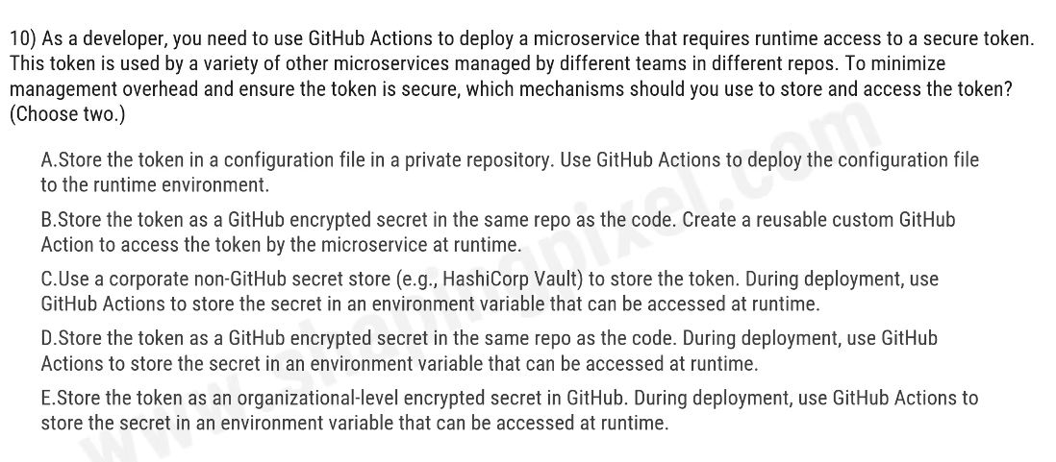
Original question screenshot provided by the learner
Option | Statement
A | Store the token in a configuration file in a private repository and deploy the file.
B | Store the token as a repository secret and create a reusable custom action.
C | Use a corporate non-GitHub secret store, such as HashiCorp Vault, and inject the secret during deployment.
D | Store the token as a repository secret and inject it into the runtime environment.
E | Store the token as an organization-level encrypted secret and inject it during deployment.

Correct Answer: C, E

Question kya kehna chahta hai?
Question ka biggest clue hai same token, different teams, different repositories. Objective secure central management aur low duplication hai.

Why this answer is correct
- C central external vault pattern deta hai, jahan rotation and access management ek location se ho sakta hai.
- E organization-level encrypted secret ko selected/all repositories ke saath share kiya ja sakta hai, duplicate repository secrets ki zarurat kam hoti hai.

Why the other options are wrong
- A: Secret ko configuration file mein store/commit karna secure pattern nahi hai.
- B and D: Repository-level secret secure ho sakta hai, lekin same value ko multiple repositories mein duplicate karna management overhead badhata hai.
GH-200 Exam Tip: One repository = repository secret. Many repositories in one organization = organization secret. Central enterprise secret lifecycle = external vault. Runtime variable is delivery mechanism, long-term secret store nahi.

Quick Revision Sheet
Keyword | Remember
GITHUB_WORKSPACE | Repository working directory on runner
$GITHUB_ENV | Persist environment variables to later steps in same job
export VAR=value | Current shell/step only
Artifacts and packages | Review repository storage, cleanup, retention and lifecycle
needs: build | Current job depends on build
strategy.matrix | Creates job combinations
Organization secret | Share one encrypted secret across permitted repositories
External vault | Central secret storage and lifecycle management

