Screen-1 : Accept Author or title to display list of books

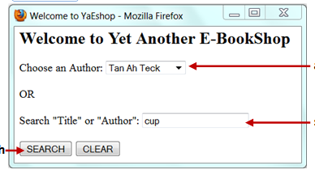

Screen:2 – select book and enter quantity, after order, quantity should be reduced from DB and order confirmation message

