

ANNEXURE-1

S Y M B I O S I S
INTERNATIONAL (DEEMED UNIVERSITY)
(ESTABLISHED UNDER SECTION 3 OF THE UGC ACT 1956, BY NOTIFICATION NO.F.9-12/2001-U3 GOVERNMENT OF INDIA)
ACCREDITED BY NAAC WITH "A" GRADE
Service Learning Centre

Application Form for Service Learning Project

Name of the Student Amal Sunil Pillai Institute SICSR Programme BCA _
PRN 19030121009
Gender Male Date of Birth (DD/MM/YYYY) 02/08/2001 Contact Number 7620035183_
Email Id amp1921009@sicsr.ac.in Correspondence Address:Niks boys hostel, Deep Banglow Chowk, Pune 411016

Personal Statement:
I'll use my social skills and knowledge in technology to provide support to the NGO which will aim to improve the circumstances and the prospects of people and to act on concerns and issues detrimental to the well-being, circumstances, or prospects of people or society as a whole.

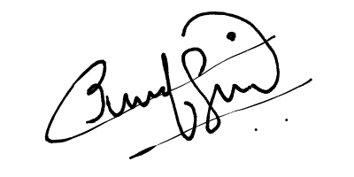

Signature of the Student: Date:15/05/21

Page 24 of 34

ANNAXURE-2

Service Learning Undertaking
Service learning is a form of experiential learning that links class room learning with community experiences and critical, reflective practices. Students in service learning will be engaged in projects and activities in the community.
Learning will occur through individual and collective critical reflection during working on project that will help students to integrate concrete experiences of real world with course/discipline concepts.

You must have received information that describes the project that you will be engaged in as well as the NGO/Organization's requirements and the learning outcomes of your service experience. As a participant in the Service Learning Programme you are required to read and sign the following student undertaking.

Signature
(Service learning In-charge of the Institute)
While participating in service learning I agree to abide by the following:
  - I understand the requirements and goals of service learning project in which I will participate. I know that the academic credit I receive is based on the participation and learning demonstrated through my project work, project report and presentation.
  - I will fulfill the minimum number of hours for service learning project.
  - I will attend orientation/training session organized by NGO/Organization for my project.
  - I will behave professionally while providing my service, including observance of established dress code.
  - While working on the project I will keep all sensitive information concerning people and organization confidential. I will not use or publish any information based on the data outside my project report.
  - I understand that failure to fulfill the expectations of the service learning project may result in a disciplinary action.
I, the undersigned have read and agree to the above.

Name Amal Sunil Pillai Signature Date 15/05/21
Institute SICSR Programme BCA PRN 19030121009
Page 25 of 34

ANNAXURE-3

Student Time Log

Name of the Student Amal Sunil Pillai

Institute SICSR

PRN 19030121009 Semester IV

Programme BCA Academic Year 2nd

Name of the Faculty Coordinator Priti Kulkarni, Kumari Deepika

Address of the NGO/Organization Aadhaar Samajik Sanstha, Pune

Project Supervisor’s Name& Designation Priti Kulkarni, Kumari Deepika

Contact Number 7620035183

E- Mail amp1921009@sicsr.ac.in

To be completed by the service learning student and handed over to the Faculty/ Coordinator
Please use this form to record the number of hours per day you served at your Service Learning Organization or worked independently on your service project. When you have completed your service learning hours, please return this report to your Faculty/ Coordinator.

Date | Time In | Time Out | Total Hours | Work Description | Student Signature | Project Supervisor Signature
12/03/2021 | 17:00 | 17:40 | 0:40:00 | Teams Meeting
12/03/2021 | 19:00 | 20:30 | 1:30:00 | Analyzing different payment gateways(stripe,instamojo,razorpay,cashfree etc) for donation portal
12/03/2021 | 21:00 | 23:00 | 2:00:00 | Research on additional features that could be included in the project.
23/03/2021 | 15:30 | 18:00 | 0:45:00 | Teams Meeting with client(NGO)
23/03/2021 | 18:00 | 18:30 | 0:45:00 | Teams Meeting with development team w.r.t android app development.
23/03/2021 | 19:00 | 23:00 | 4:00:00 | Setting up Android Studio ,AVD and starting with Kotlin basics
24/03/2021 | 18:00 | 20:00 | 2:00:00 | Learning kotlin for android
25/03/2021 | 18:00 | 20:00 | 2:00:00 | Learning kotlin for android
26/03/2021 | 18:00 | 20:00 | 5:00:00 | Learning kotlin for android and creating sample apps, discussing ideas regarding donation portal implementation
27/03/2021 | 15:30 | 17:00 | 1:30:00 | Teams meeting regarding client requirements implementation ideas
28/03/2021 | 10:00 | 13:00 | 3:00:00 | Learning kotlin for android
29/03/2021 | 10:00 | 13:00 | 4:00:00 | Learning android programming and creating sample apps
30/03/2021 | 15:00 | 18:00 | 4:00:00 | Learning android programming and creating sample apps
31 March 2021 | 11:40 | 21:20 | 9:40:00 | Graphic Designing for featured card UI. Added all the fragments with bottom navigation bar on the main activity. Animated the "More" fragment components and Finished "Midday meal" and "Education centres" cards.
01/04/2021 | 11:40 | 00:00 | 12:20:00 | Connected Firebase. Redisgned UI for a modern gradient look with tranitions. Connected Database. Finished Add Education Centres and Viewing features. Edited the whole code to support MVVM with LiveData for reactive experience
02/04/2021 | 00:00 | 02:15 | 2:15:00 | Fixed Some bugs and optimized code
02/04/2021 | 14:00 | 18:00 | 4:00:00 | Restructured project and fixed a bug with recycler view. Optimized Observer code and seperated all constants into different file stucture. Did some research on GCP pricing and CND services
7 April 2021 | 15:30 | 16:00 | 0:30:00 | Team meeting
27 April 2021 | 18:30 | 21:30 | 3:00:00 | Working on the Meal Menu Part and created necessary data models
03/05/2021 | 16:30 | 19:30 | 3:00:00 | Team Meeting
04/05/2021 | 16:00 | 22:00 | 6:00:00 | Working on Meal Menu Activity
05/05/2021 | 13:30 | 16:30 | 3:00:00 | Teams meeting for data modelling and coding approach
05/05/2021 | 17:00 | 22:00 | 5:00:00 | Designing and implementing logic w.r.t dynamic views for "add meal menu" activity
06/05/2021 | 15:30 | 16:05 | 0:35:00 | Teams meeting with mentor on work update
06/05/2021 | 18:30 | 23:00 | 4:30:00 | Reading docs for firebase querying, creating custom dialog UI(Redesigned) and implementing logic to add meal menu data w.r.t day and centre name and update the same on firestore database
07/05/2021 | 17:00 | 21:00 | 4:00:00 | R & D for online research for qr code scanners and generators
08/05/2021 | 07:00 | 14:00 | 7:00:00 | Reading docs about Recycler views and implementing the same in Meal menu. Implement nested collection query logic to fetch dishes w.r.t centre and day chosed by the user.
08/05/2021 | 18:00 | 20:00 | 2:00:00 | Team Meeting
09/05/2021 | 07:00 | 12:00 | 5:00:00 | Add feature to delete a recycler view item selected by the user from the database and list of item in recycler view. Design dialog box to confirm deletion of items
09/05/2021 | 16:00 | 19:00 | 3:00:00 | Update the UI designs(layout,styles and images) of all dialog boxes related to Meal Menu
10/05/2021 | 18:00 | 22:00 | 4:00:00 | Update the UI of recycler view items and activity related components(add images, change theme etc) of Meal Menu
11/05/2021 | 19:00 | 21:00 | 2:00:00 | Teams meeting for data modelling and coding approach w.r.t "Students" activity
11/05/2021 | 21:00 | 00:00 | 03:00:00 | Working on Client Application. Listing Centres on Client Application. Adding About Us section. Few Bug fixing
12/05/2021 | 00:00 | 02:00 | 02:00:00 | Add recycler view to show centres list in students fragment
12/05/2021 | 07:00 | 13:00 | 06:00:00 | Create activity and recycler view for students list with simple UI and defining entity/object structure for students
12/05/2021 | 13:30 | 19:30 | 06:00:00 | Working on Client application. Added About US details, Added Students counter. Added Centres Counter
12/05/2021 | 21:00 | 23:00 | 02:00:00 | Fixed ViewModel buf with centres counter and made we UI updartes. Pushed changes to VCS and resolved few merge conflicts
13/05/2021 | 06:30 | 13:30 | 7:00:00 | Add ViewModel and livedata features for real time db update of Students data. Implement logic to bind the queried students data w.r.t centre name and batch number with recycler view.
13 May 2021 | 15:30 | 16:35 | 01:05 | Teams Meeting
13/05/2021 | 18:30 | 22:30 | 4:00:00 | Design UI, decide activities and data flow to add student and show student details
14/05/2021 | 10:00 | 14:00 | 4:00:00 | Create activity to add show student details when user clicks on the recycler view list item and design UI for the same.Design UI for activity to add a new student to database
14/05/2021 | 16:30 | 22:00 | 5:30:00 | Create activity to add a new student to database and implement field validations for all the required fields

Student Signature Total Hours 153.35 Project Supervisor’s Name Signature Faculty Coordinator’s Signature [This Time Log is to be handed over to your Faculty/ Coordinator]

Screen Shots :

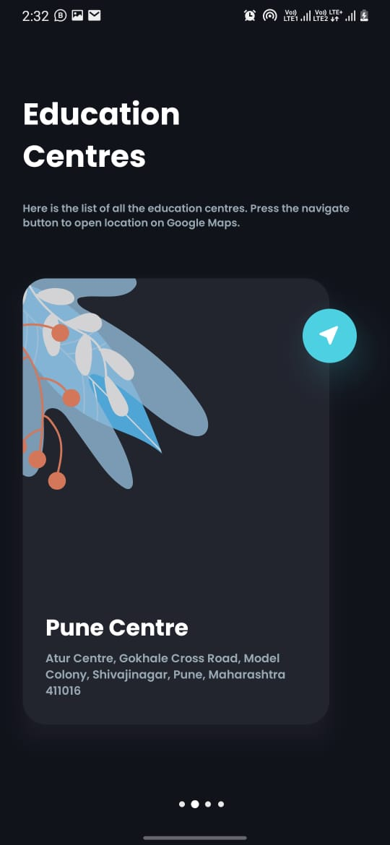
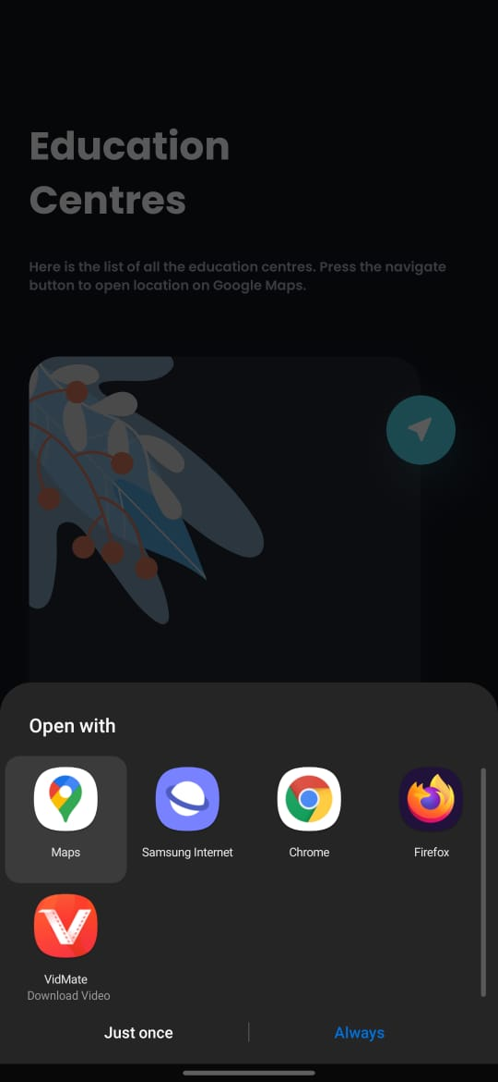

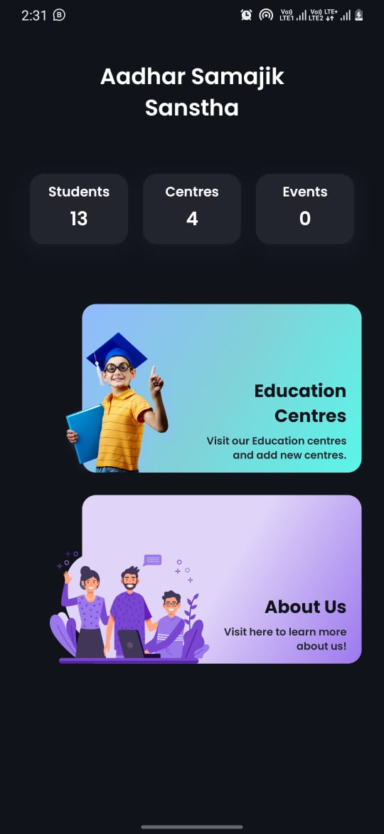
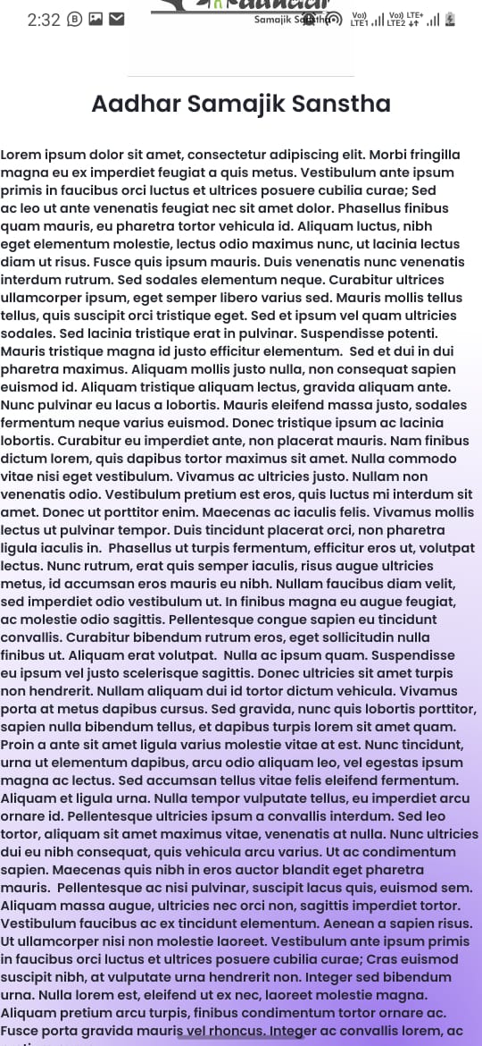
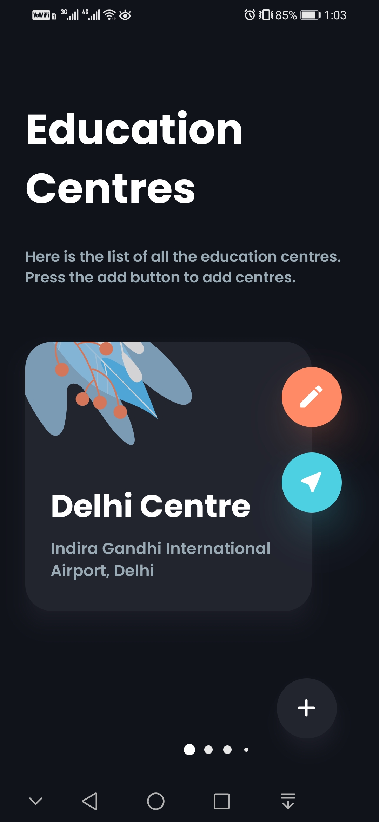
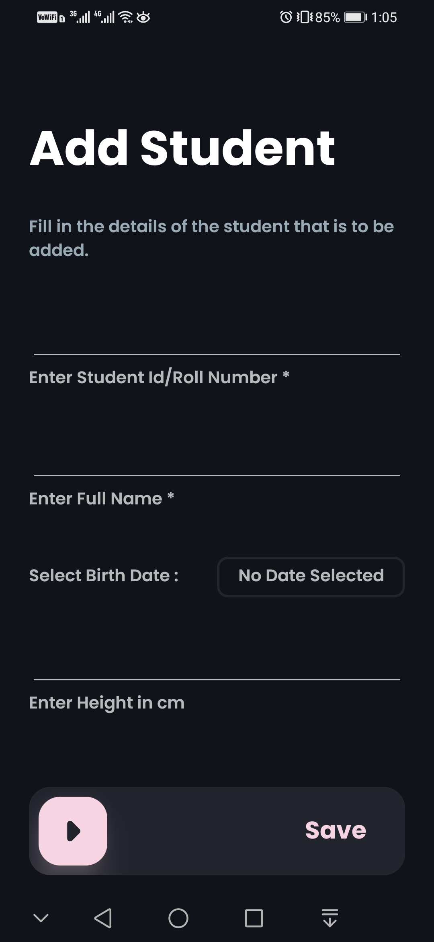
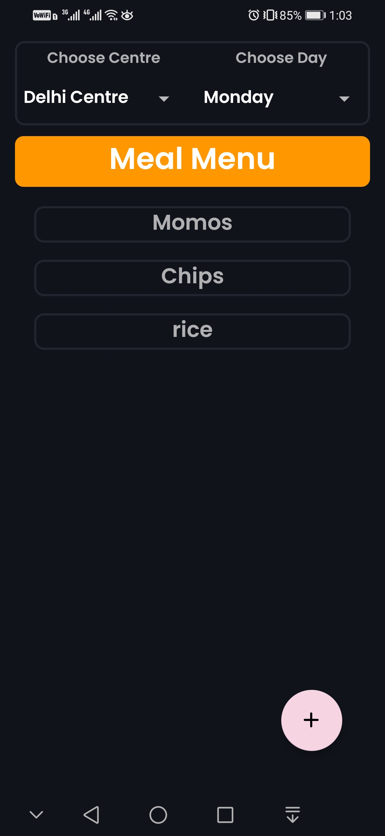
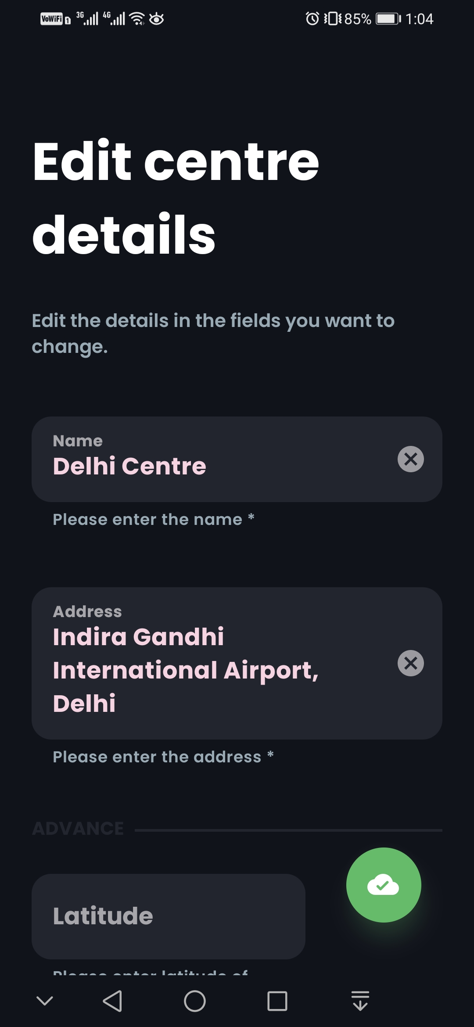
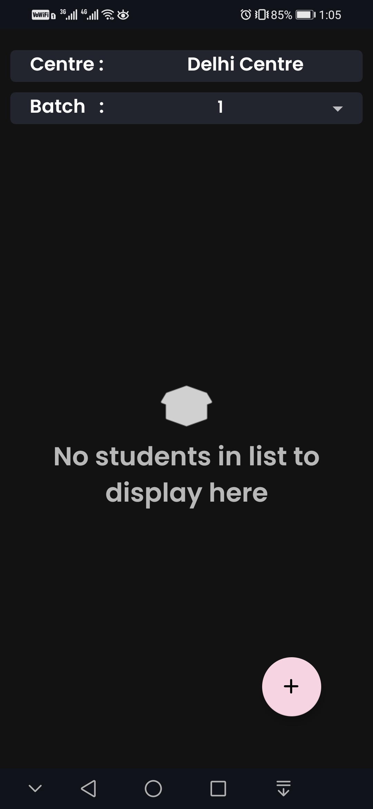
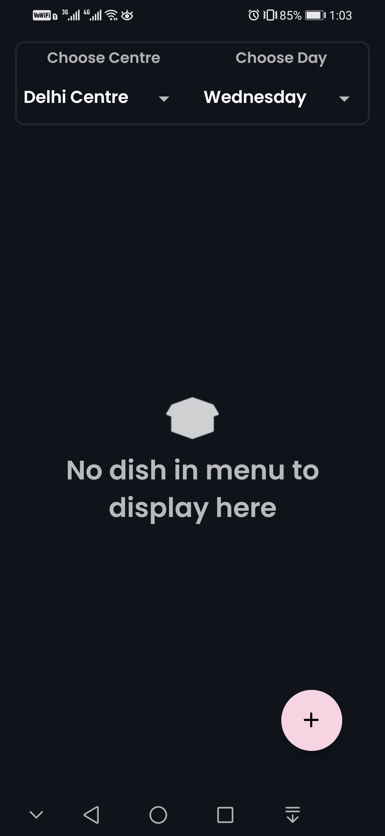
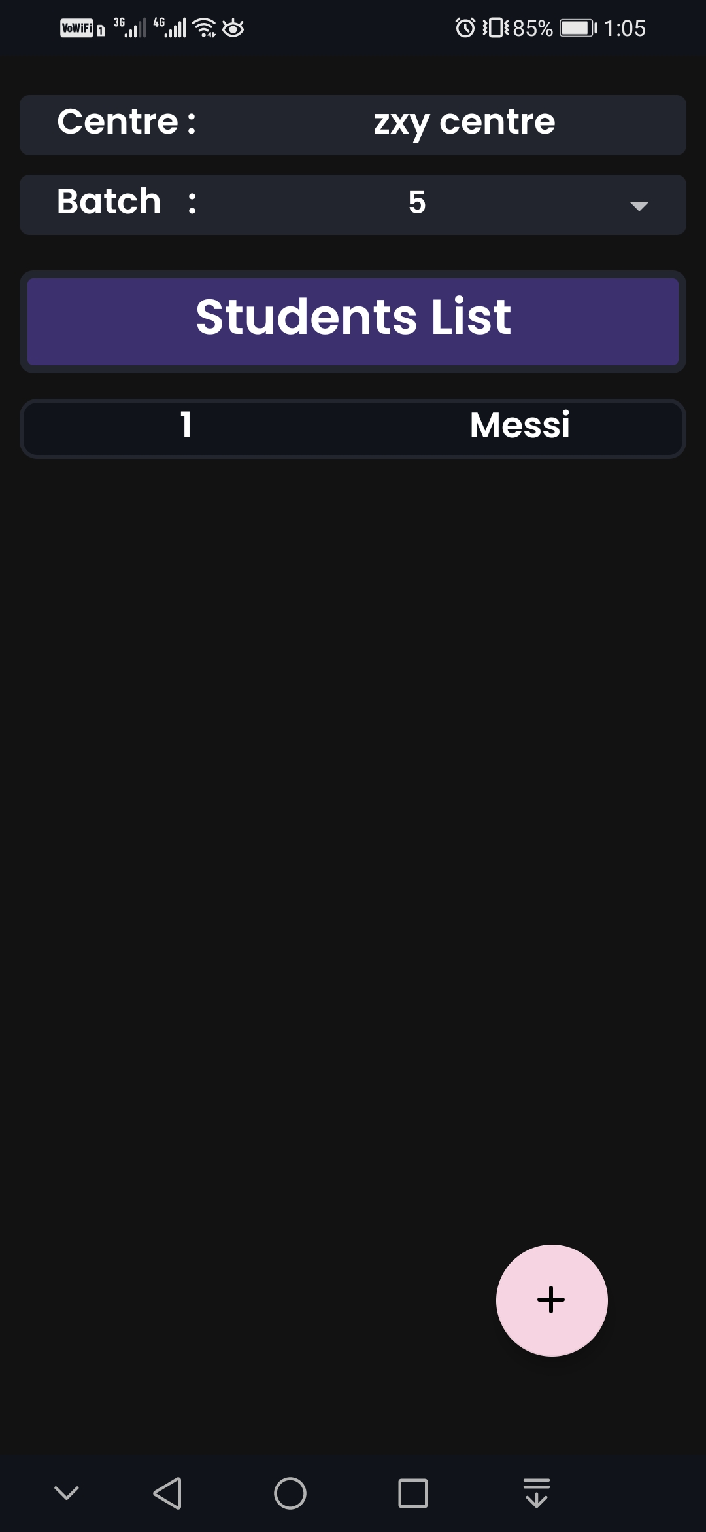

ANNAXURE-4

NGO/Organization/SCOPE Feedback Form for the Student

(To be filled by the student and sent to Service Learning Centre by the Institute)

Name of the Student Amal Sunil Pillai Institute SICSR PRN 19030121009 Programme BCA NGO/Organization Aadhaar Samajik Sanstha Date(s) of Service 76
Total Hours of Service Provided 153.35
Please circle one response for each item. (5=Excellent/4=Very Good/3=Good/2=Moderate/1=Not Good)

Sr. No | Item | Circle choice of number
1 | The NGO/Organization contact person was helpful. | 5 | 4 | 3 | 2
2 | I received adequate support and encouragement from the NGO/Organization staff member(s). | 5 | 4 | 3 | 2
3 | I received adequate orientation and training for the  service I provided. | 5 | 4 | 3 | 2
4 | I received adequate on- site supervision for the service I provided. | 5 | 4 | 3 | 2
5 | I personally benefitted from this service experience. | 5 | 4 | 3 | 2
6 | I would recommend service in this NGO/Organization. | 5 | 4 | 3 | 2
Additional comments/suggestions:

Name of the Student Amal Sunil Pillai Date 15/05/21 Signature of Student

Page 28 of 34

ANNAXURE-5

Feedback Form for the Student on Personal Experience

To be filled by the student and sent to Service Learning Centre by the Institute
Please circle one response for each item. (5=Excellent/4=Very Good/3=Good/2=Moderate/1=Not Good)

Sr.  No. | Questions | Circle choice of number
1 | How much did you learn from working at your project | 5 | 4 | 3 | 2
2 | Do you think you made a significant  Contribution to the community? | 5 | 4 | 3 | 2
3 | Did your experience increase in  your level of commitment to “get involved” in your community? | 5 | 4 | 3 | 2
4 | How well did service learning  activity enable you to utilize your classroom learning? | 5 | 4 | 3 | 2
5 | To what extend did assigned tasks  facilitate your service learning project plan objectives? | 5 | 4 | 3 | 2
6 | Did your service learning  experience have any effect on the following?
 | a. Improved relationships with faculty | 5 | 4 | 3 | 2
 | b. Increased desire to take more interest in Institute | 5 | 4 | 3 | 2
 | c. Heightened self confidence | 5 | 4 | 3 | 2
 | d. Developed insight into personal strengths and weaknesses | 5 | 4 | 3 | 2
 | e. Enhanced ability to work and learn Independently | 5 | 4 | 3 | 2
 | f. In what way your service learning experience has changed your career or educational plans? Please select only one option. | - Confirmed your plans  - Made you question your previous choice  - Decided to change career.  - Had no effect

Page 29 of 34
Any other Comment

Name of the Student Amal Sunil Pillai Programme BCA

Institute BCA PRN 19030121009 _

Signature of Student

Page 30 of 34

ANNAXURE-6

Guidelines for students on Project Report of Service Learning

Title of the Service Learning Project: Aadhaar Samajik Sanstha, software(App and website)

Name of the
NGO/Organization:Aadhaar Samajik Sanstha
Name of the Student Amal Sunil Pillai

Name of Institute: SICSR

PRN 19030121009
Programme BCA Semester IV
Academic Year 2nd

Introduction of the Service Learning Project
Though this course I expect to work on some interesting projects and learn more about team work and meeting client requirements in limited amount of time. I expect to build something that I can add to my profile and also that helps the client to solve his business challenges in the most cost effective way.

Description of the Service Learning Project:

Our team were responsible for creating an Android app and a website to support the services and manage the organization 's daily activities.

Objectives of the Service Learning Project:

- Improve the website interface
- Add Donation options in the Website
- Create two Android Application (customer and administrator)
- Add Centers details for the customer with navigation option and option to edit, add or delete data from Admin application
- Add options to add, edit and delete students records.
- Maintain teachers record
- Add, Delete or Edit Daily events and take user feedback
- Show users all the details in an aesthetic way
- Have a trending, unique and ergonomic user interface

Page 31 of 34

Methodology of the Service Learning Project:

Website:
To add donations options in the website we first decided to include a Payment Gateway (Razor Pay) but then as the gateway would charge a service amount of 2% on the principle transaction amount and the client didn’t approve of that we went for a work around and integrated a UPI Donation QR code which could be scanned or downloaded by the customer to make a donation to the organization without any extra charges.
Android Application:
For the android application we used the Android SDK with Kotlin for developing the edge application and for the backend we used GCP and Firebase. We opted for Firebase and GCP because it provides free Authentication services, real-time No-SQL database, free crash logging system, play service verification, app indexing, controlled distribution, in-app messaging, analytics and is horizontally scalable in case the userbase and workload on the application increases. We used ViewModel for making reactive user interface and worked a lot in R&D of User Interface.

Learning Outcomes of the Service Learning Project:
- Learned android programming
- Learned Kotlin
- Learned to deliver results under-pressure

Implications of the Service Learning Project:
The services and applications we created will be helping the organization in proper and effective management of the centers and also reach the public with the client application and convey their brand message/value and services and get financial support from the people for sustainable execution of the center’s activities.

Obstacles/Impediment while working on the Service Learning Project:

- I was not an android developer or hadn't taken any android courses before this project, therefore I had to learn new a technology/programming language and then work on the project.
- Therefore these challenges taught me to learn and deliver quality work under a short span of time.
- The client’s limited budget was also pushing us to move a bit away from recommended solutions and find more cost-effective solutions.
- The client had a busy schedule which made less frequent communication another issue.

Signature of Student

