Name: Amal Sunil Pillai
PRN: 19030121009
Div: A (BCA Sem-4)
Topic: IOT lab assignment

Experiment 1:
Q. Design an arudino based call bell system. Use push button and buzzer. Buzzer must beep with a 1.5KHz Note when the push button is pressed.

Diagram:
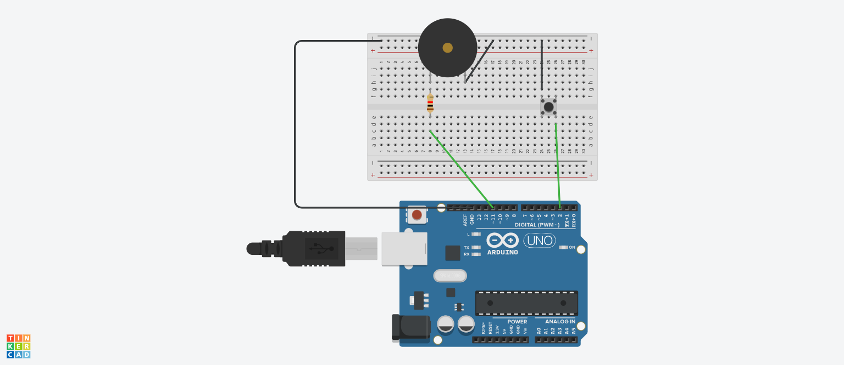

Sketch:

int val=0;
const int buzzer=11; //pwd pin
const int switchIP=2; //input pin to read the state of the switch.

void setup()
{
pinMode(buzzer, OUTPUT);

//pin 2 will have 5v to it i.e by default value 1/HIGH.
pinMode(switchIP, INPUT_PULLUP); //adding a pull up resistor

Serial.begin(9600);

}

void loop()
{
//When we press the button the current is drawn to the ground
//as setting the pin to pull up resistor the impedance will be high.
if(digitalRead(switchIP)==0)
{
tone(buzzer,1500);
}
else
{
noTone(buzzer);
}
val=digitalRead(switchIP);
Serial.println(val);
}

Description of the experiment:
It's an arduino based call bell system. The push button is attached to pull-up resistor which pulls up it's state(when open) to HIGH , when the push-button is pressed(closed circuit) the current will flow through the path of least resistance(GND) thus input read of pin 2 will be 0/LOW.

Therefore when the push-button state is 0/LOW the buzzer is activated with a 1.5kHz note otherwise
the buzzer is deactivated.

Experiment 2:
Q. Dubstep is a genre of Electronic dance Music that originated in South London in the late 1990s. It is generally characterised by sparse, syncopated rhythmic patterns with prominent sub-bass frequencies. (Source :wiki). A tempo of 140 Beats Per Minute is a common note here. Design an LED blink program with 140 BPM to support the musicians of this genre.

Diagram:
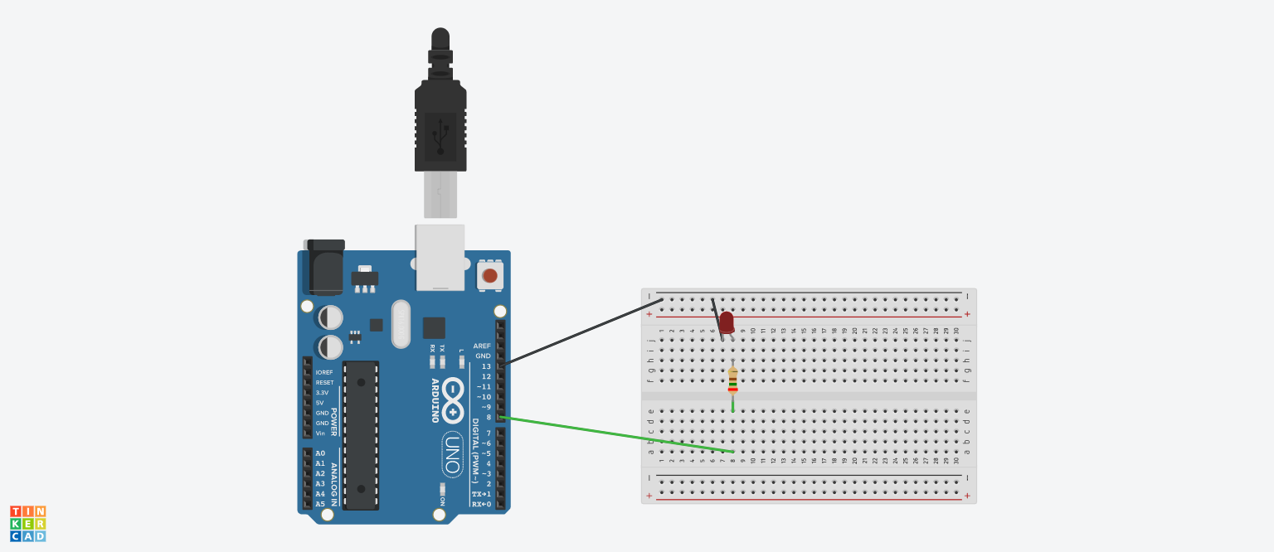
Sketch:
const int led=8; //pin to control the led

void setup()
{
pinMode(led,OUTPUT); //setting led pin as output
Serial.begin(9600); //for debugging purpose.
}

void loop()
{
//we want 140BPM i.e 60000ms/140 = 1 beat in every 428.57ms.
double val=(double)60000/140;

//debug purpose
//Serial.println(val);
//Serial.println((double)val/2);

//Since a blink consist of "on" and "off" state of the led
//we “on” it for 214.29ms and the “off” it for 214.29ms
digitalWrite(led,1);
delay((double)val/2);
digitalWrite(led,0);
delay((double)val/2);
}

Description of the experiment:

A simple led blinking program to make the led have 140 blinks per minute. The led is connected to pin number 8 on the arduino board and has a resistor in series with it, when the program is activated the led blinks 140 times per minute.

Calculation of delay:
Since we want 140 blinks per minute(60,000ms) I.e we want 60000/140 = 1 blink in every 428.57ms,
since a blink consist of a “on” and “off” state of the led, we “on” the led for 214.29ms and the “off” it for 214.29ms.

