Name : Amal Sunil Pillai
Prn : 19030121009
BCA Div-A (Sem IV)

J2EE Servlet Assignment

Code Snippets:
1)(index.html)html page to let user enter login details:

<html>
<head>
<title>TODO supply a title</title>
<meta charset="UTF-8">
<meta name="viewport" content="width=device-width, initial-scale=1.0">
</head>
<body>
<h2 style='color:red'>User Login for Patient record management</h2>
<form method="post" action="LoginUser">
<center>
Username : <input type="text" name="username" ><br><br>
Password : <input type="password" name="password" ><br><br>
<input type="submit" value="Login">
</center>
</form>
</body>
</html>

2)Servlet 1 (LoginUser.java) :
To verify user login details, create a session object w.r.t the logged in user and show the form to enter patient details.

protected void doPost(HttpServletRequest request, HttpServletResponse response)
throws ServletException, IOException {
processRequest(request, response);
PrintWriter out = response.getWriter();
try{
String username=request.getParameter("username");
String pwd=request.getParameter("password");
if(username.equals("admin_medical123") && pwd.equals("123")){

HttpSession session=request.getSession(); //creates a new session and returns it.
session.setAttribute("user",username); //setting attribute of "user" to the session object.

out.println("<h2 style='color:green'> Welcome "+username+" to Patient record management</h2>");
//out.println("<a href='SessionLogout'> Logout </a>");

out.println("<html><body><center><form method='post' action='InsertRecord'>");
out.println("<h3>Enter the info about the patient to be entered : </h3> Name of Patient <input type='text' name='pname'><br> ");
out.println("<br>Patient Id : <input type='text' name='pid'><br> ");
out.println("<br>Age : <input type='text' name='age'><br> ");
out.println("<br>Sex : <input type='radio' name='sex' value='male'>Male &nbsp;&nbsp;");
out.println("<input type='radio' name='sex' value='female'>Female &nbsp;&nbsp;<br><br>");

out.println("<input type='submit' value='Insert Record'>&nbsp;&nbsp;");
out.println("<input type='reset' value='Clear'></form></center></html></body>");
}
else{
out.println("<html><body><div style='margin-top:30;color:red'>Invalid Username/password Please try again...</div></body></html>");
RequestDispatcher r=request.getRequestDispatcher("index.html");
r.include(request,response);
}

}
catch(Exception e){
System.out.println(e);
}

}

3) Servlet 2 (InsertRecord.java):
To insert the record of patient along with the logged in user's username(who entered this data) to the database, the username is extracted from the session object created in Servlet 1(LoginUser).

protected void processRequest(HttpServletRequest request, HttpServletResponse response)
throws ServletException, IOException {
response.setContentType("text/html;charset=UTF-8");
Connection conn=null;
Statement stmt=null;
ResultSet rs=null;
PrintWriter out = response.getWriter();
try{
/* TODO output your page here. You may use following sample code. */

String pname=request.getParameter("pname");
String pid=request.getParameter("pid");
String age=request.getParameter("age");
String sex=request.getParameter("sex");

HttpSession session=request.getSession(false); //doesn't create a new session but returns if any if already exists.
String user_in_charge=(String)session.getAttribute("user"); //getting the value from the session.

out.println("<!DOCTYPE html>");
out.println("<html>");
out.println("<body>");
out.println("<h1>Patient details : </h1>");
out.println("<table border=1><th>Patient id</th><th>Patient name</th>");
out.println("<th>Patient age</th><th>Patient gender/sex</th><th>User in charge(Who entered the data)</th>");
out.println("<tr><td>"+pid+"</td><td>"+pname+"</td><td>"+age+"</td><td>"+sex+"</td><td>"+user_in_charge+"</td></tr></table>");

Class.forName("com.mysql.jdbc.Driver");
conn=DriverManager.getConnection("jdbc:mysql://localhost/test","root","");
stmt=conn.createStatement();

String sql="insert into Patient_details values (?,?,?,?,?)";

PreparedStatement s=conn.prepareStatement(sql);

s.setInt(1,Integer.parseInt(pid));
s.setString(2,pname);
s.setInt(3,Integer.parseInt(age));
s.setString(4,sex);
s.setString(5,user_in_charge);

int r=s.executeUpdate();
if(r>0){
out.println("<h3 style='color:green'>Data Added Successfully</h3>");
}

out.println("<p><a href='LogoutUser'>Logout</a></p>");

out.println("</body>");
out.println("</html>");
}
catch(Exception e){
out.println(e);
}
}

4) Servlet 3 (LogoutUser.java):
To logout the user (Invalidates the current session then unbinds any objects bound to it.)

protected void doGet(HttpServletRequest request, HttpServletResponse response)
throws ServletException, IOException {
processRequest(request, response);
PrintWriter out = response.getWriter();

request.getRequestDispatcher("index.html").include(request,response); //doesn't create a new session but returns if any if already exists.
HttpSession session=request.getSession(false); //Returns the current session associated with this request, or if the request does not have a session, creates one.

String present_user=(String)session.getAttribute("user");

session.invalidate(); //Invalidates this session then unbinds any objects bound to it.
out.print(present_user+" you are successfully logged out! ");
}

ScreenShots of the assignment:
1) Form 1(index.html)
-Takes user login details
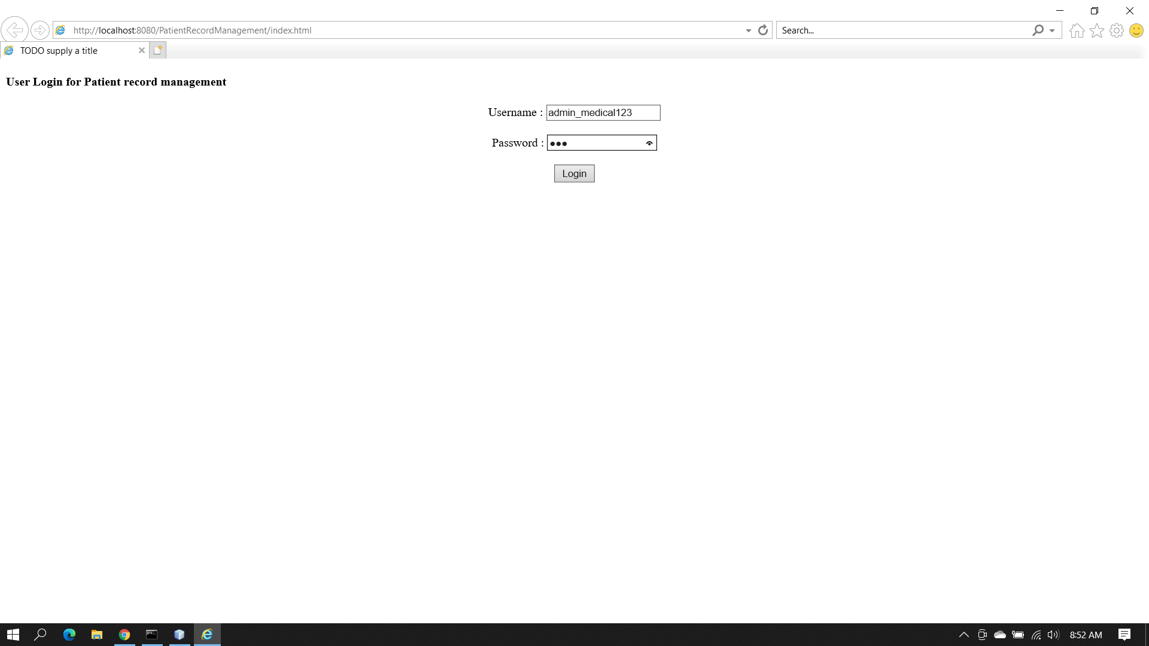
2)Servlet 1(LoginUser.java)
-User details are verified, if it's a valid user then the form to enter patient details is shown.
-Session object w.r.t the user is created in this servlet.
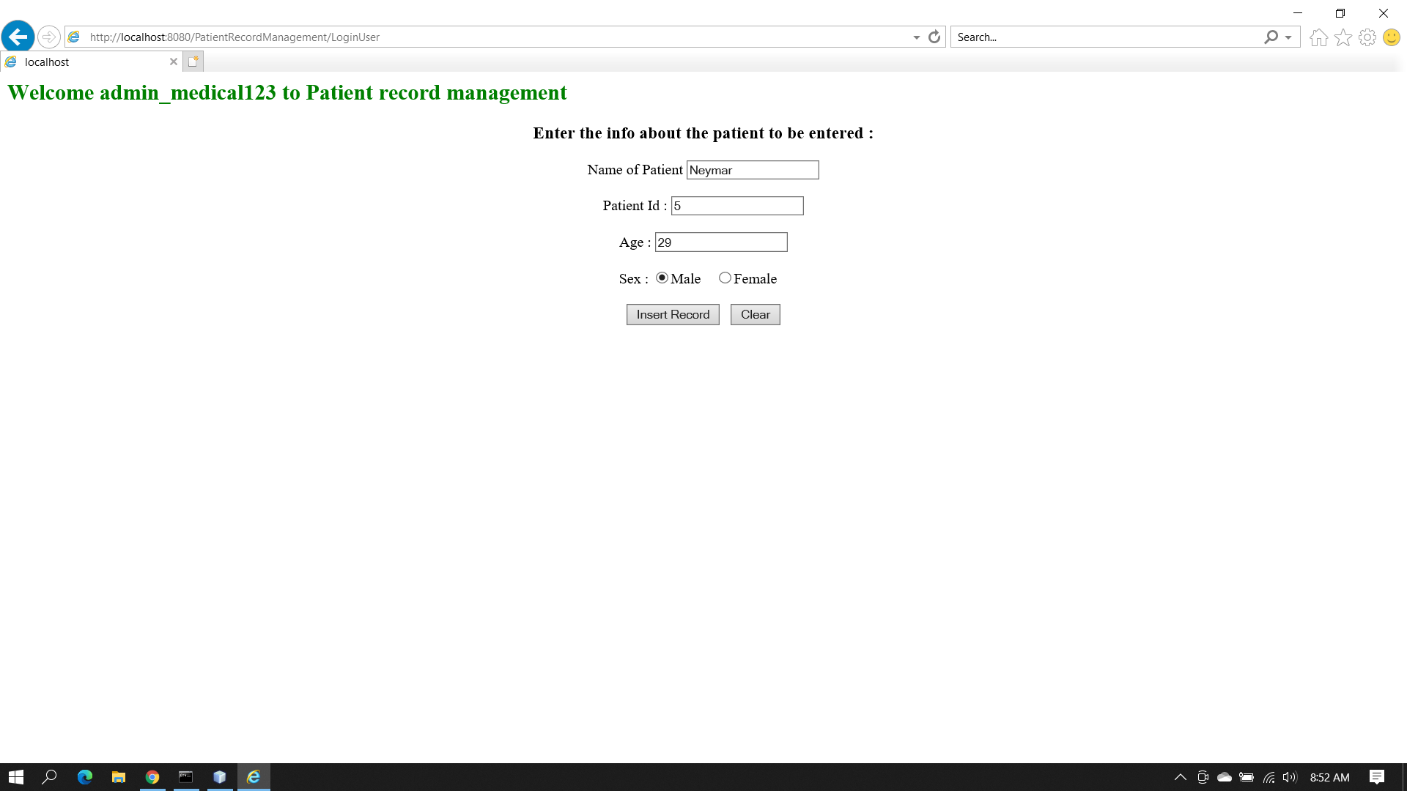

3)Servlet 2(InsertRecord.java):
-Displays the patient details entered in the last form, the user_in_charge value is the username extracted from the Session object created in the last Servlet(LoginUser.java).
-Upon successful insertion of record in the database the message “Data added successfully” is shown
-A hyper link to “Logout” is also shown
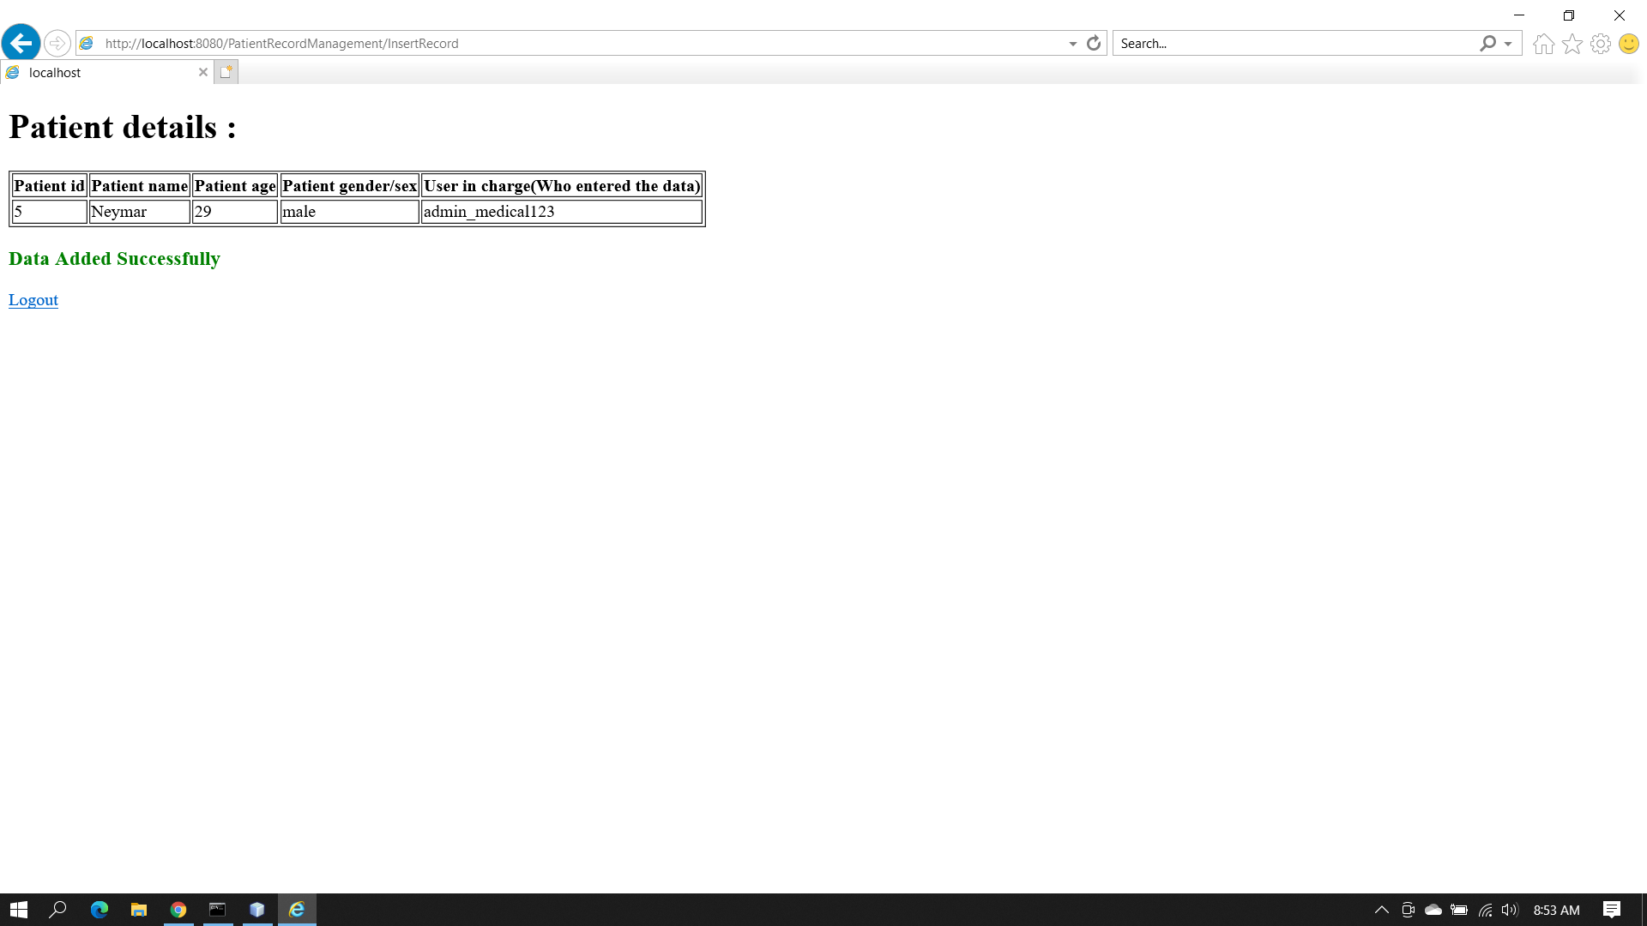

4) Servlet3(LogoutUser.java)
-Logouts the user(Invalidates the session) and shows in the page to login(index.html)
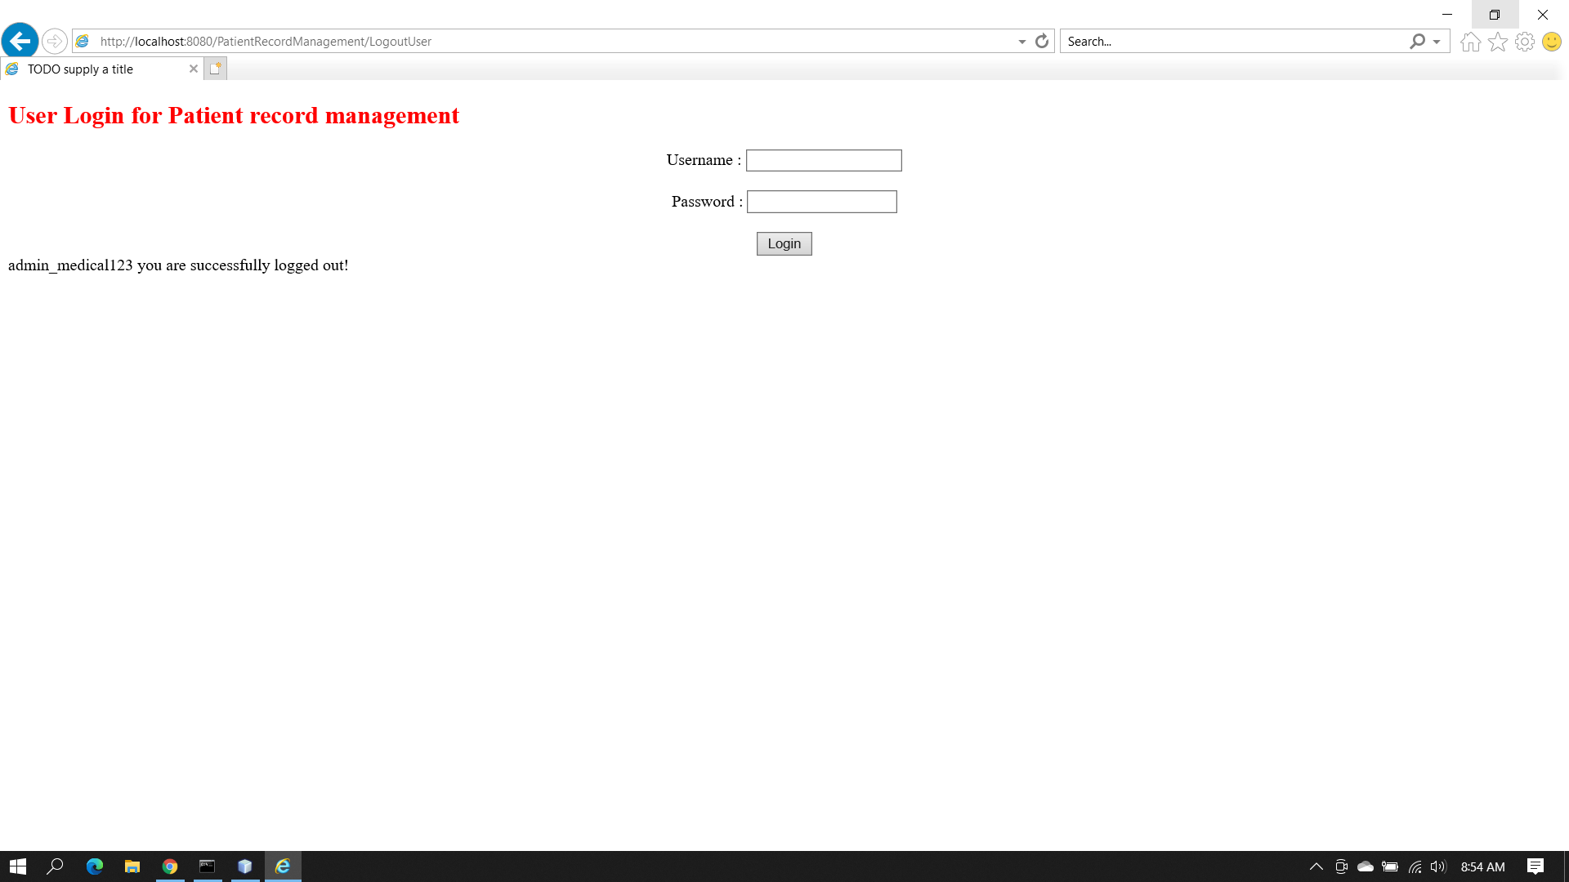

5)Database output
