Prn : 19030121009
Name : Amal Sunil

Code snippets :

1: Imported libs and constructor:

import java.sql.Connection;
import java.sql.DriverManager;
import java.sql.ResultSet;
import java.sql.Statement;
import javax.swing.JFrame;
import javax.swing.JOptionPane;

/*
* To change this license header, choose License Headers in Project Properties.
* To change this template file, choose Tools | Templates
* and open the template in the editor.
*/

/**
*
* @author Amal Sunil
*/
public class BookForm extends javax.swing.JFrame {

/**
* Creates new form BookForm
*/
static final String JDBC_DRIVER = "com.mysql.jdbc.Driver"; //specifying the driver name
static final String DB_URL = "jdbc:mysql://localhost/book_db"; //specifying database url

//Database credentials
static final String USER = "root";
static final String PASSWORD = "";

static Connection conn=null;
static Statement st=null;
static ResultSet rs=null;
static int id=0;
public BookForm() {
initComponents();
try{
System.out.println("Connecting to database");
conn=DriverManager.getConnection(DB_URL,USER,PASSWORD);

//Execute a query(statement object carries the sql query and the database engine queries/processes it and sends the response as a resultset object)
System.out.println("Creating statement");
st=conn.createStatement();

jButton2.setEnabled(false); //disable the delete button by default

}
catch(Exception e)
{
System.out.println(e);
}

}

2. Search button:

private void jButton1ActionPerformed(java.awt.event.ActionEvent evt) {
// TODO add your handling code here:
try{
String xx = JOptionPane.showInputDialog(null, "Enter the ID of the book to be searched : ");//prompt window to enter the id being searched(default value, i.e if no input is given it takes null as the value)
int id_input = Integer.valueOf(xx);

rs=st.executeQuery("select * from book where id="+id_input);
rs.next();
id=rs.getInt(1);
// String name=rs.getString(2);
// float loc=rs.getFloat(3);

jTextField1.setText(String.valueOf(id));
jTextField2.setText(rs.getString(2));
jTextField3.setText(rs.getString(3));

if(!rs.next())
{
jButton2.setEnabled(true); //activating the delete button only when a valid record searched and found.
}

}
catch(Exception e)
{

}

}

3. Delete button:

private void jButton2ActionPerformed(java.awt.event.ActionEvent evt) {

//Activated only when a valid record is found using search button
JFrame frame=new JFrame();
try{
String sql="delete from book where id="+id;
// System.out.println(sql);
st.executeUpdate(sql);

JOptionPane.showMessageDialog(frame, "Deletion successful");
jTextField1.setText("");
jTextField2.setText("");
jTextField3.setText("");
id=0;
jButton2.setEnabled(false); //Disable the button once the Deletion is done

}
catch(Exception e)
{
System.out.println(e);
}
}

Output Screenshots:

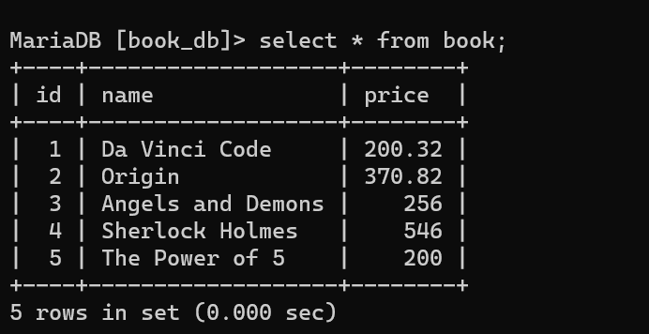
1)Table :

2) Output window, delete button is disables by default.
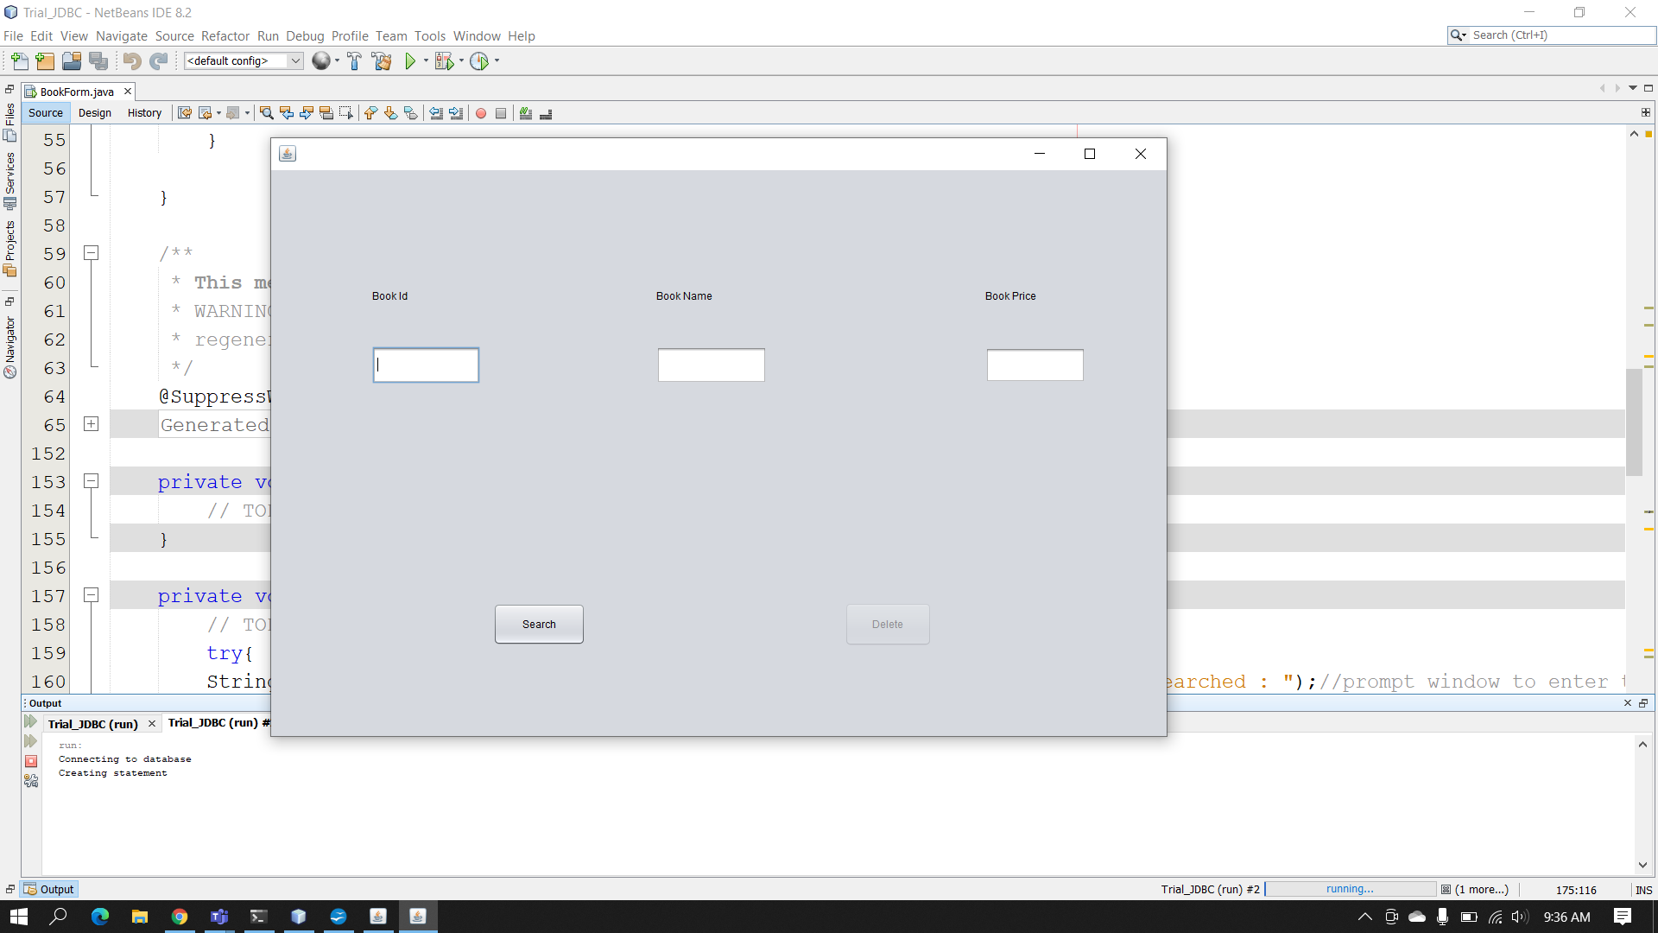

3)Delete button activated when a valid record is found:
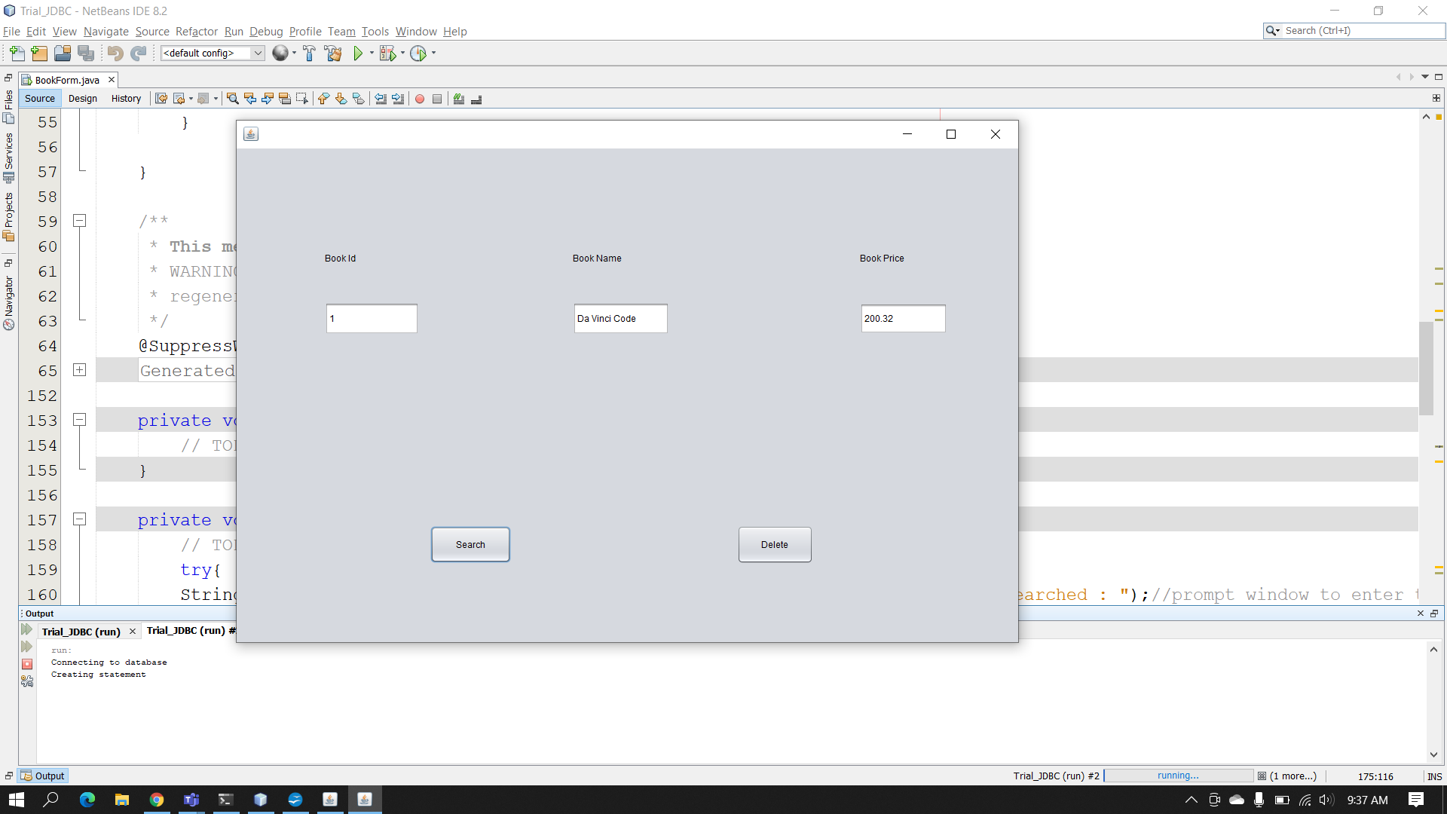
4)Successful deletion of valid record
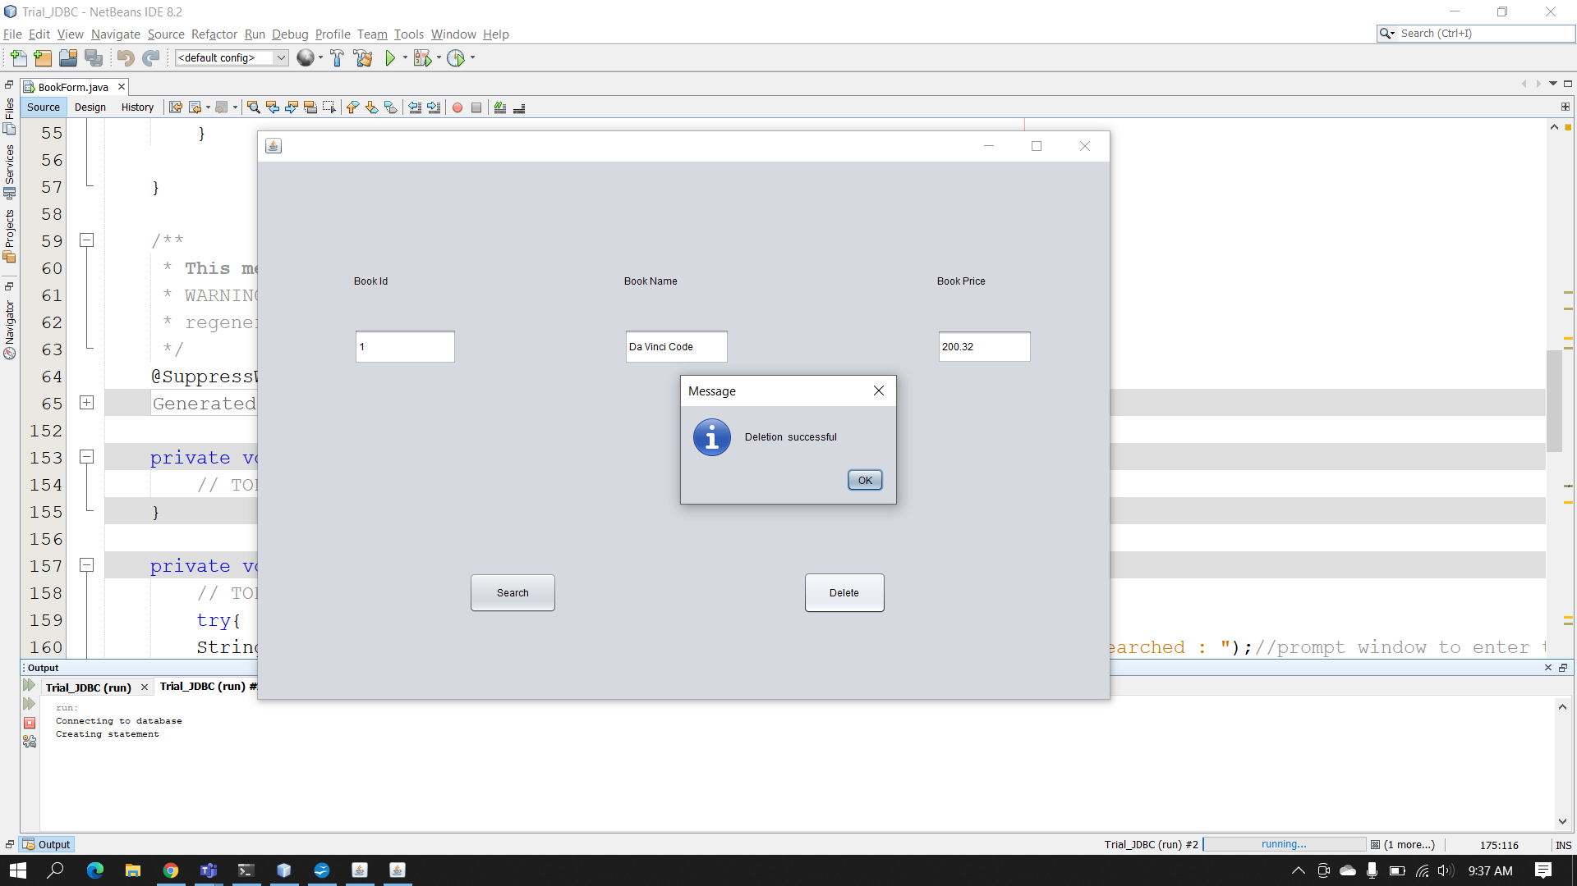

5)When invalid id is entered, the delete button stays disabled.
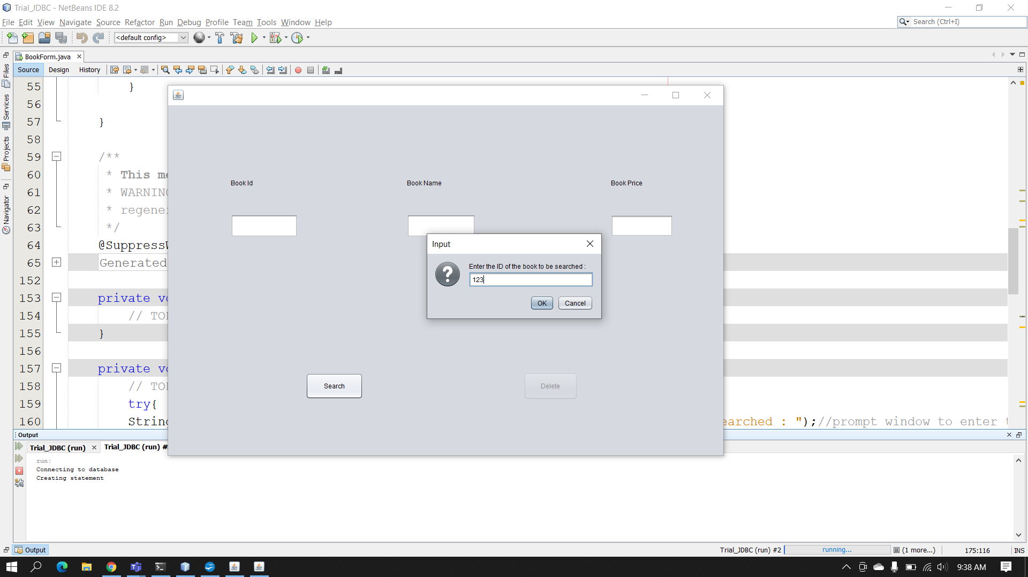
6) Ouput of the table after deletion
