**Linux**

Introduction to Linux

Linux is a powerful and widely-used open-source operating system known for its stability, security, and flexibility. It is commonly employed in various fields, including software development, robotics, and data science. One of the key features of Linux is its robust permission system, which ensures proper access control for files and directories. Understanding file permissions is crucial for effectively managing resources and maintaining system integrity.

File Permissions

File permissions in Linux play a critical role in managing the security and functionality of files and directories. Permissions define who can read, modify, or execute files, ensuring system stability and data integrity.

Understanding File Permissions

Linux file permissions consist of three components:

1. Owner: The user who owns the file or directory.

2. Group: A set of users who share similar access rights.

3. Others: All other users on the system.

Each file or directory has a set of permissions divided into three categories:

- Read (r): Allows viewing the contents of a file or listing a directory.

- Write (w): Permits modifying the file or adding/removing files in a directory.

- Execute (x): Enables running a file as a program or accessing a directory.

Permissions are represented in symbolic format (e.g., `-rw-rw-r--`) or octal format (e.g., `664`).

Permission Examples

Example 1: `drwxrwxr-x`

- d: Indicates a directory.

- rwx: The owner has read, write, and execute permissions.

- rwx: The group also has the same permissions.

- r-x: Others can read and execute but cannot write.

Use Case:

This setup is ideal for shared directories where the owner and team members need full access, but others are restricted from making modifications.

Example 2: `-rw-rw-r--`

- : Indicates a regular file.

rw- : The owner can read and write but cannot execute.

rw- : The group has similar permissions.

r--: Others can only read the file.

Use Case:

This configuration is suitable for configuration files or logs that require modifications only by the owner and group, while others can view the contents without altering them.

Octal Representation of Permissions

Linux permissions can also be represented numerically using a three-digit format:

1. First digit : Owner's permissions.

2. Second digit: Group's permissions.

3. Third digit: Others' permissions.

Each permission is assigned a value:

- Read (r): 4

- Write (w):2

- Execute (x): 1

The sum of these values determines the permission level.

rwx = 4 + 2 + 1 = 7

rw- = 4 + 2 + 0 = 6

r-- = 4 + 0 + 0 = 4

Examples:

775 :

- Owner: `rwx` (7)

- Group: `rwx` (7)

- Others: `r-x` (5)

Suitable for shared directories requiring full access for the owner and group, with read and execute access for others.

- 664:

- Owner: `rw-` (6)

- Group: `rw-` (6)

- Others: `r--` (4)

Commonly used for shared files where the owner and group can edit, and others can only read.

Commands for Managing Permissions

1. Viewing Permissions :

bash

ls -l filename

Displays detailed file permissions.

2. Setting Permissions:

To apply permissions:

- For -rw-rw-r--:

```bash

chmod 664 filename

- For drwxrwxr-x:

bash

chmod 775 directoryname

flowchart

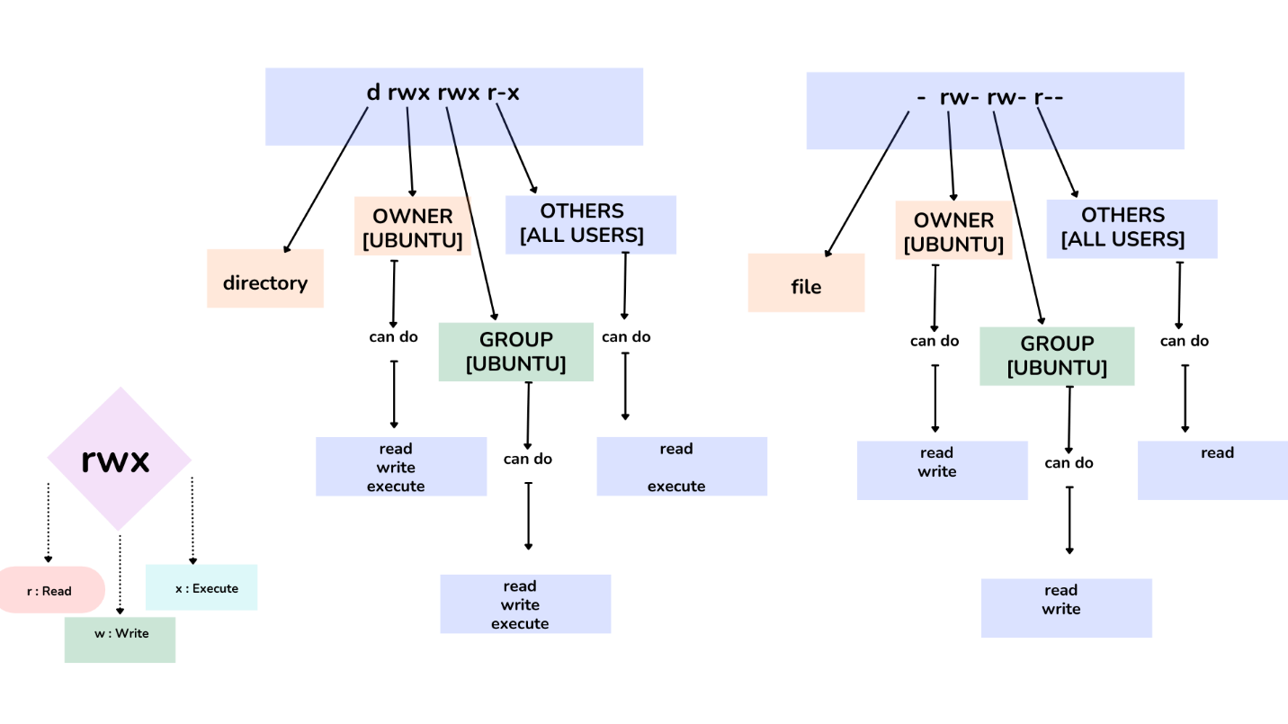

Conclusion

Mastering file permissions in Linux is an essential skill for developers. Properly configuring permissions ensures a balance between security and collaboration, protecting sensitive data while maintaining system efficiency. By understanding symbolic and octal formats, developers can manage permissions effectively to support robust systems.

