Design Description and Tools Used
1. Coffee Mug Design:
In this project, a coffee mug was designed using Onshape, focusing on its dimensions and practical features. The design includes a cylindrical base and a comfortable handle.
2. Tools Utilized:
- Sketch Tool (Sketch 1):
The base of the mug was created using the Sketch Tool on the horizontal Top Plane by defining a circular profile.
- Extrude Tool (Cylinder Ext):
The circular sketch was extruded into a 3D cylindrical shape to form the body of the mug.
- Shell Tool (Shell 1):
The cylinder was hollowed out using the Shell Tool, defining the wall thickness to create an inner cavity for the mug.
- Handle Profile and Path:
  - A cross-sectional profile of the handle was created using the Sketch Tool.
  - A path representing the handle’s curvature was drawn.
- Sweep Tool (Sweep 1):
The Sweep Tool was used to generate the handle by sweeping the cross-sectional profile along the defined path.
- Fillet Tool (Fillet 1):
The Fillet Tool was applied to smooth the edges, ensuring a professional and polished look for the mug.

Dimensional Measurements:
The mug’s dimensions were measured precisely using the Measure Tool in Onshape. This tool guarantees accurate measurements of the diameter, height, and handle size, ensuring consistency in the design.
Key Dimensions:
- Mug Diameter: 1.763 inches
- Mug Height: 3.018 inches
- Handle Dimensions: 9.910 inches

Sharing the Design:
[https://cad.onshape.com/documents/17e0bf26d20dca3be3a5b592/w/ff31b558d9a16d2fd7590f50/e/e3448382738474c679a37f7e?renderMode=0&uiState=6783858e5ca3832df4595b71]
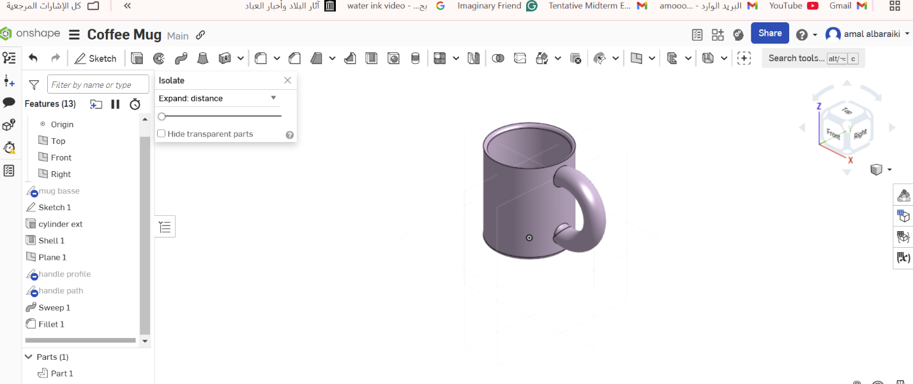

3D Design Report Using Onshape

Design Name:
Donut

Description of the Design:
This design is a 3D model of a delicious donut with a glossy pink frosting layer. The design showcases simple yet appealing details, closely resembling a real donut. It can be used for educational purposes or as a decorative piece when 3D printed.

Tools Used in the Design:
- Revolve:
  - The Revolve tool was used to create the basic shape of the donut by drawing a half-circle cross-section and rotating it around a central axis.
- Extrude Add:
  - The Extrude Add tool was used to add the frosting layer by sketching the frosting design and slightly raising it above the donut's surface.
- Fillet:
  - The Fillet tool was applied to smooth the upper and lower edges of the donut, giving it a more natural and rounded appearance.

Benefits of the Design:
- Educational:
The design demonstrates how to use 3D modeling tools like Revolve, Extrude, and Fillet in a cohesive way.
- Decorative:
The model can be 3D printed and used as an appealing decorative piece.
- Learning Digital Design:
This project enhances 3D modeling skills by following professional design steps.

Onshape Design Link:
View the Donut Design on Onshape
