The prediction of our model is to determine if the customer will subscribe ('yes') or not ('no') in the marketing campaign.

The goal of this project is to find category of individuals who are expected to join the marketing campaign in the bank, the bank aims to ensure the people will have long term deposit.

.

. 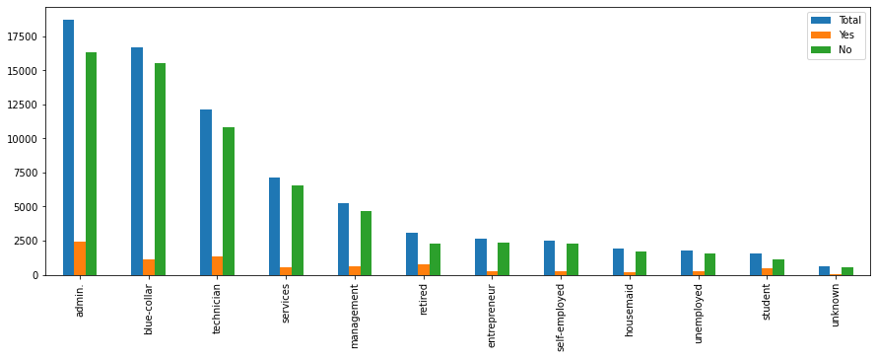

To start exploring this goal, we have noticed based on positions, individuals work admin, and blue-collar are affordable to pay loans and who are the most. So, we will concentrate on those people to archive out target. Hence, predictive model will be classified into people who subscribed or not to marketing campaign

the model will show the accuracy of classification model with a help of various algorithms such as (KNN), decision tree, naive bays). In addition , we dealt with imbalanced data