**Software Requirements Specification**

**(SRS)**

**For NOGOUMI website**

**Prepared by :**

**Amal asaad ibrahim**

**Shrouk ali mahmoud**

**Menna allah hisham**

**Group number : 21**

**Table of Contents**

1. Preface …………………………………………………………………………………………….…...

1.1. Document Purpose …………………………………………….…………………….….…….

1.2. Target Users …………………………………………………….………………….….………

1.3. Revision History ………………………………………………….……………………...….....

2. Introduction .......………………………………………………………………….…………….………

2.1. Purpose ………………………………………………………….………………………...…...

2.3. Scope …………………………………………………………….……………….………….…

3. System users ……………………………………………………………………………………………

3.1. System stakeholders …………………………………………….………………………...…

3.2. Users objectives ………………………………………………….……………….………..…

4. User requirements definitions …………………………………………………………...

4.1. System functions .……………………………………………….…………………………..

4.2. Constraints ……………………………………………………….………………………..…

5. System architecture ……………………………………………………………………….…

6. System functional Requirements ...……………………...………………………….

7. Non-Functional requirements ……………………………… ……………………...…

7.1. Performance Requirements …………………………………….……………….……

7.2. Security Requirements …………………………………………….………..……...…

7.3. Software Quality Attributes ………………………………………….…..……………

8. System interfaces ………………………………………………………………………….…

8.1. User interfaces ……………………………………………………….……...………...…

8.2. Hardware interfaces ………………………………………………….…………......…

8.3. Communication interfaces …………………………………………………..………..

9. System (Use cases – Sequence diagrams – Scenarios) ………………………

10. System Modeling ……………………………………….………………………………….

10.2. Class diagram ……………...……………………………………….……………….…

1) Preface

***1.1 Document Purpose :***

The purpose of the document is to provide a detailed and complete specifications of NOGOUMI to make it easy to understand.

The document will provide an overview of the system in explained

details including diagrams.

***1.2 Target Users :***

This document is composed by system engineers based on the requirements

gathered from website owner. This document is intended to be approved by the

website owner and the staff working on developing the system such as

developers, testers, project manager.

2) Introduction

***2.1 Purpose :***

NOGOUMI is a software that link between actors

and all users, and make connection between them easy.

(People who are want to know about actors and their movies, and connect with their online without watching tv or go to cinema)

1. Collect information and data of users.

2. Facilitate user to add reviews and send message to satisfy his needs.

3. Facilitate admin to add new actors for user .

4. Save time and effort and money of user.

5. Guarantee the safety of all users during the process by secure his personal data and information

6. Maintain the quality of service by using rating form.

***2.3 Scope :***

NOGOUNI is a website used to link between actors and people in physical interaction or online interaction .

Services added on this website can be:

● Online services such as: Photoshop design or coding.

● Physical services such as: Baby sitting or pets care.

3)System users

***3.1 System stakeholders***

● System Analyst

o Responsible for requirements gathering.

o Responsible for deployment and support.

o Create SRS.

● System designer

o Receive SRS.

o Create SDD.

● System testers

o Test the functionalities of the code.

● System developers

o Implement and maintain Software based on SDD.

● Software Owner

o Add features.

o Edit features.

o Approve edits.

● Users

o admin : Add actors and their description and complete information, view data of Job

Seekers.

o user: view actors names and profile and search for a specific actor.

O authenticated user : add review about actors and send for them email messages.

● Administrator

o Add advertisement to website.

o follow up with hosts.

o Receive and respond to website feedback.

***4.2 Users objectives:***

● System Engineers

(System analyst, System testers, System designer, System developers)

o Gain experience in Software Engineering according to their roles.

● Users

o admin: Save time and satisfy user need ,manage website.

o a user: Gain experience and information about actors by view their profiles .

o an authenticated user :connect with actors .

● Administrator

o Ensure availability of the website

o Ensure security of users’ data.

o Ensure users’ satisfaction.

4)User requirements definitions

***4.1 System functions***

1. Add new account.

2. log in (register).

3. Edit account.

4. Delete account.

5. Add actor.

6. update actor.

7.Search actor.

9. Apply reviews .

10. Respond process .

11. Feedback form.

12. Data privacy.

13. Access Information.

14.send messages.

***4.2 Constraints***

• Server breakdown

1. Data overflow.

2. User traffic.

3. Maintenance breakdown.

• Culture Constraints

1. Trust issues.

• Failure of marketing

5)System architecture

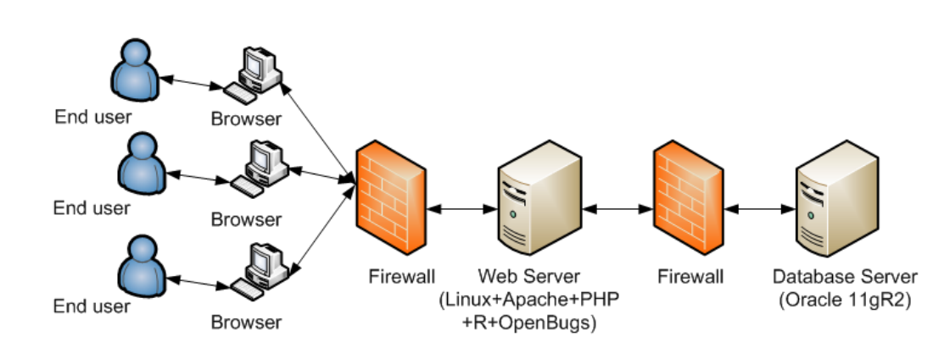

6)System functional Requirements

***6.1 Add new account(register)***

• The user "Person" can add a new account by adding the following information:

o First name and last name.

o Phone number.

o Mail.

o Date of birth.

o ID number.

o Address information. (Country "default Egypt”, City, Region, Address)

o Upload profile picture. // data-type unknown.

o Press verify.

o Verification process.

o Enter verification code.

o Press submit.

***6.2 Edit account:***

The user have to write the right password to edit his account.

The User can edit the following information:

o Change Phone number.

o Change password.

o Change Mail.

o Change Profile picture.

o Update address.

o Submit.

***6.3 Sign in***

User to sign in to his Account needs to enter:

• Email.

• Password.

• System verifies Email and password.

***6.4 Delete Account***

The user has to write the password to delete account.

• Delete the account.

• Confirm.

***6.5 Add new actor :***

Admin can add new actor by adding the following information:

• upload images .

•add movies.

• set awards.

• Set social media links.

• Write an information about actor.

• Confirm and share.

***6.6 Edit and update actors:***

The admin can update actor's profile he can edit following:

● add movies.

● add awards

●write news about actors.

●edit social media links.

***6.7 Delete actors:***

The admin can delete actor.

● Delete the actor.

● Confirm.

***6.8 Search for actor:***

user can search for actor by selecting the following information:

●select name of actor.

● Search.

***6.9 Feedback form***

The user has to fill this form to rate website :

● Rate his experience on website. (optional)

● Rate his satisfaction over his performance.

● Submit.

***6.10 Access data:***

● System can view user data but can’t edit it. (For security concerns)

***6.11 Verification process:***

In add new account after user enter his information, system verifies his data such as:

● ID number.

● E-mail.

●password.

To make sure that there is no two users have same Id or E-mail

After system verify this data, System will send code to the user on his phone number or email

● User will enter verification code and submit.

● When user log in to NOgOUMI website, System verifies:

● Email.

● Password.

***6.12 message:***

● authenticated user can send message to actors to connect to them.

***6.13 review :***

●authenticated user can comment to review actors on his profile actors.

7)Non-Functional requirements

***7.1 Performance Requirements***

7.1.1 Availability:

The system should be available 24 hours.

7.1.2 Response time:

*● Wait time:*

User wait seconds till system response .

● *Transmission time:*

request take maximum 1 minute due to transferring to the system.

7.1.3 Hardware specifications: (Beta version)

Cloud computing will be used:

● 1 CPU Core and upto.

● 2 GB RAM

● 50GB SSD Storage

● 5TB Data Transfer

7.1.4 Throughput:

The system can process 600 request per hour. (Can be increased due to usage measurements)

7.1.5 Benchmarks:

Track system usage of the cloud specifications to indicate expansion needed.

7.1.6 Environmental impact:

Environment Friendly because the system use

cloud computing and this reduces energy consumption by up to 95 percent and also cuts the company’s utility costs by up to 90 percent.

***7.2 Safety Requirements***

Information transmission should be securely transmitted to server without any

changes in information through Web site encryption by using secure socket

layers. (SSL)

Secure socket layers: is the standard security technology for establishing an

encrypted link between a web server and a browser. This link ensures that all

data passed between the web server and browsers remain private and integral.

This allows the transmission and collection of private data over a Web site,

without worrying about a hacker accessing it.

***7.3 Security Requirements***

● User will be authorized to view only the public information of other.

***7.4 Software Quality Attributes***

7.4.1 Design Qualities:

● *Conceptual Integrity:*

System is committed to conceptual integrity

defines the consistency and coherence of the overall design. This

includes the way that components or modules are designed, as well as

factors such as coding style and variable naming.

● *Maintainability:*

System is able to undergo changes with a degree of

ease. These changes could impact components, services, features, and

interfaces when adding or changing the functionality, fixing errors, and

meeting new business requirements.

● *Reusability:*

System components and subsystems is suitable for use in

other applications and in other scenarios. That minimizes the duplication

of components and also the implementation time.

7.4.2 Run-time Qualities:

● *Manageability:* System administrator is able to monitor and debug the

system easily.

● *Reliability:* System guarantee the operation over time to the users

according to terms and conditions.

● *Scalability:* System handle increases in load without impact on the

performance of the system through benchmarks.

7.4.3 System Qualities:

● *Supportability:* system provides information helpful for identifying and

resolving issues when it fails to work correctly.

● *Testability:* System measures how easy it is to create test cases for the

system and its components, and to execute these tests in order to

determine if the specifications are met.

7.4.4 User Qualities:

● *Usability:* System meets the requirements of the user by being easily used, useful to use, and resulting in a good overall user experience.

8) System interfaces

***8.1 User interfaces***

The user interface for the software shall be compatible to any browser such as Internet Explorer,

Mozilla or Netscape Navigator by which user can access to the system

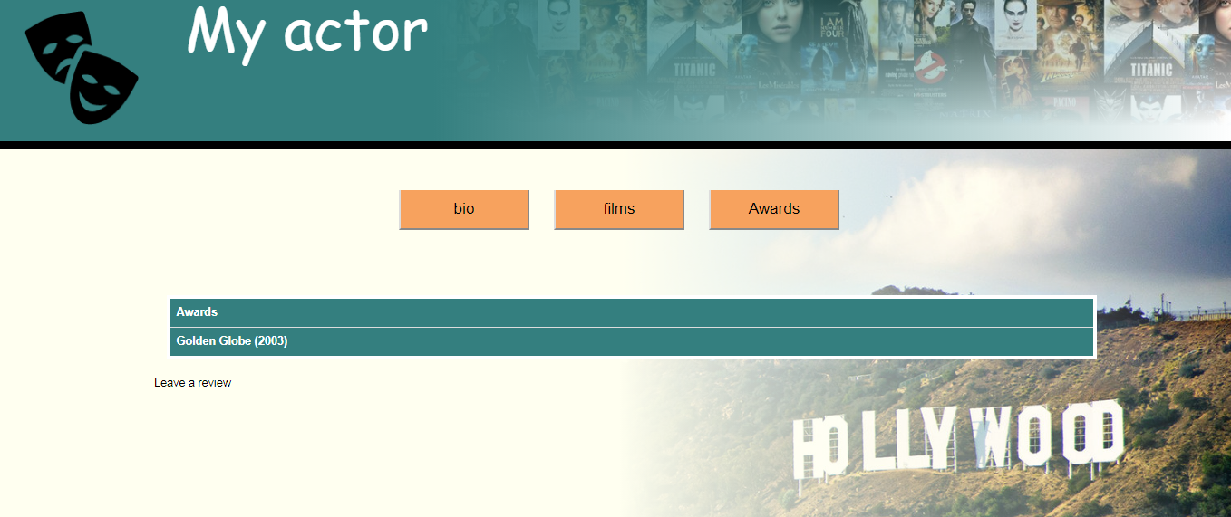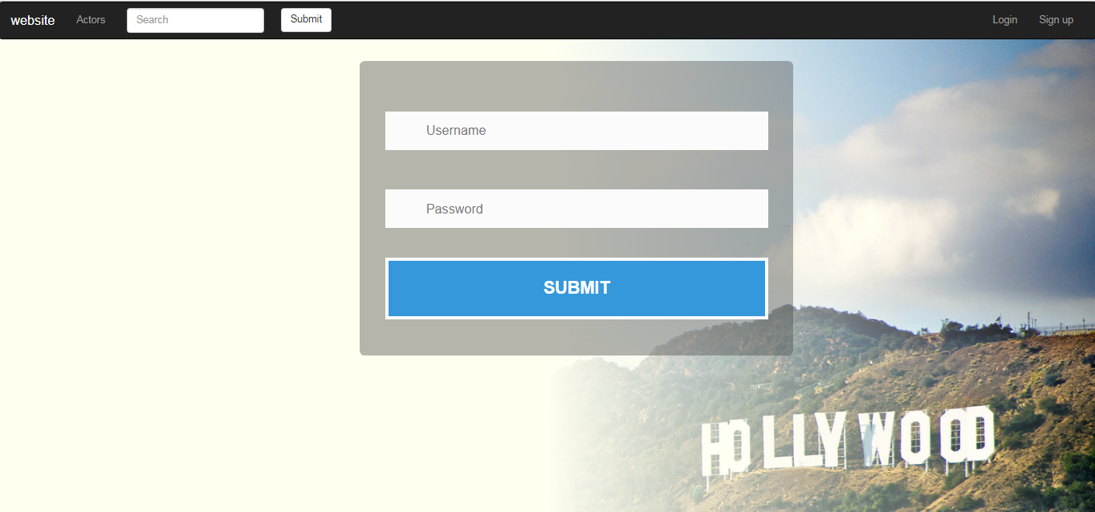

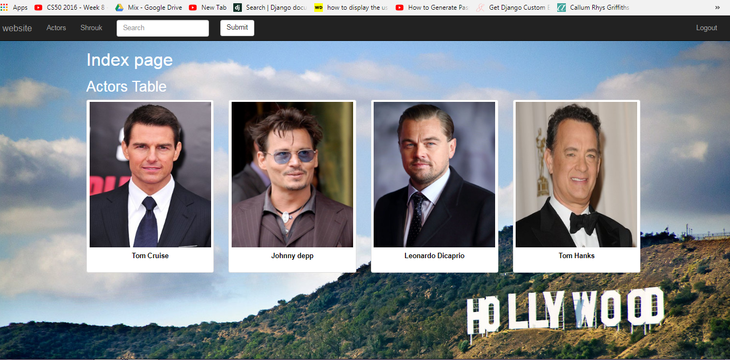

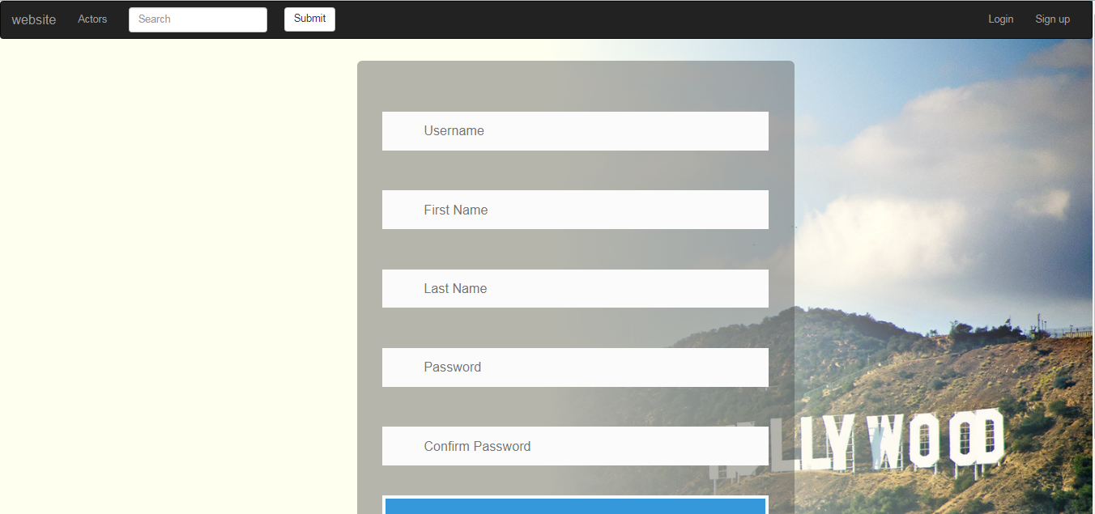

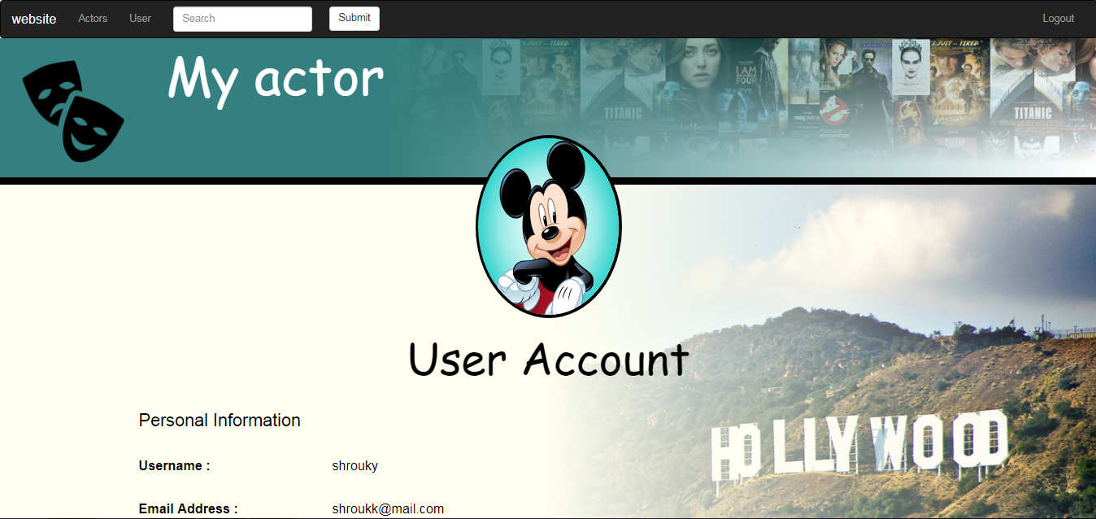

***8.2 Hardware interfaces***

Since the application must run over the internet, all the hardware shall require to connect internet

will be hardware interface for the system. As for e.g. Modem, WAN – LAN, Ethernet Cross-Cable.

***8.4 Communication interfaces***

● NOGOUMI shall use the HTTP protocol for communication over the Internet and for the

intranet communication will be through TCP/IP protocol.

● Information transmission should be securely transmitted to server without any changes in

information through Web site encryption by using SSL.

9) System (Use cases – Sequence diagrams – Scenarios):

**\*Use case for NOGOUMI website :**

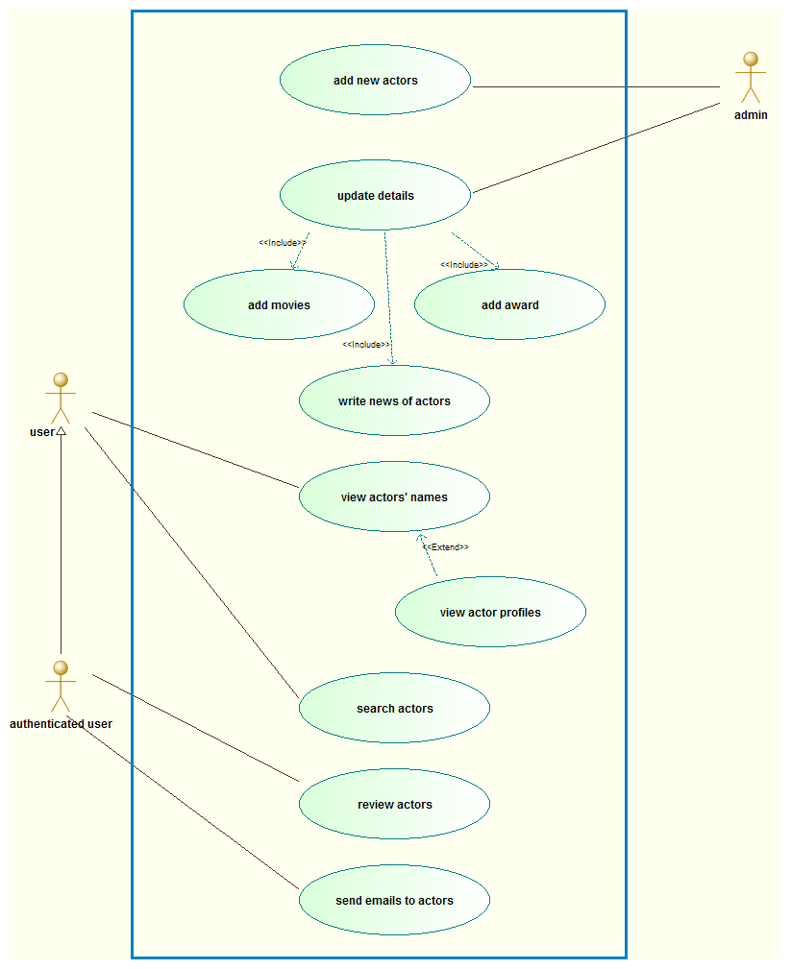

**Create Account Scenario**

*Participating Actors:* User & System.

*Entry Condition:* A (user) visit the website and would like to use it for review and send message to actors .

*Exit Condition:* The system Realize that user already blocked. Or he select

Cancel or back.

*Quality Requirements:* Performance system can send verification code and

verify account and created during seconds.

*Related Requirements:* Edit and Delete Account.

*Typical Flow of Events*: User select create account so system invokes create

account use case which let the user fill the following information:

● First and last name.

● Phone number.

● E-mail.

● Birthdate.

● Gender.

● Upload picture.

● Address.

● ID number.

● Password.

Then user select verify so that invoke the system to check those data and

verified it.

***log in Scenario:***

*Participating Actors:* User & System.

*Entry Condition: a*(user) visit the website to login for reaching to his own profile .

*Exit Condition:* The system Realize that user already log in correctly. Or he select Cancel or back.

*Quality Requirements:* Performance system can verification entered data to

verify account and log in to user profile.

*Related Requirements:*  Edit and Delete Account.

*Typical Flow of Events*: User select create account so system invokes create

account use case which let the user fill the following information:

● E-mail.

● Password.

***\*creat account and login sequence diagram :***

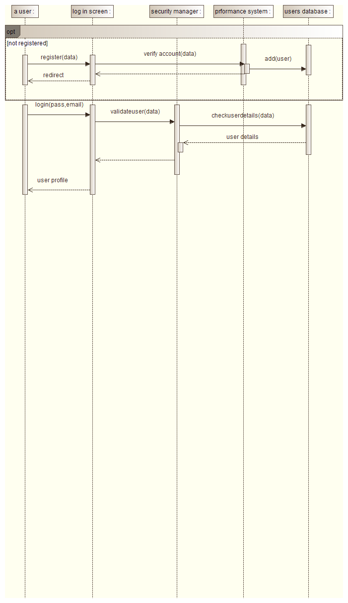

**Review Scenario:**

*Participating Actors:* authenticated user.

*Entry Condition:* (user) sign in then go to actor profile then add comment.

*Exit Condition:* he select Cancel or back or submit his comment and system share his review on profile actor .

*Quality Requirements:* Performance system can share the task on the website after approve it in less than 1 minute.

*Related Requirements:* non .

*Typical Flow of Events*:

the user select profile actor he wanted to review him and system invokes add review use case which let the authenticated person add his comment .

Then the user submit and system share the comment on the actor profile.

**\*Review and message sequence diagram :**

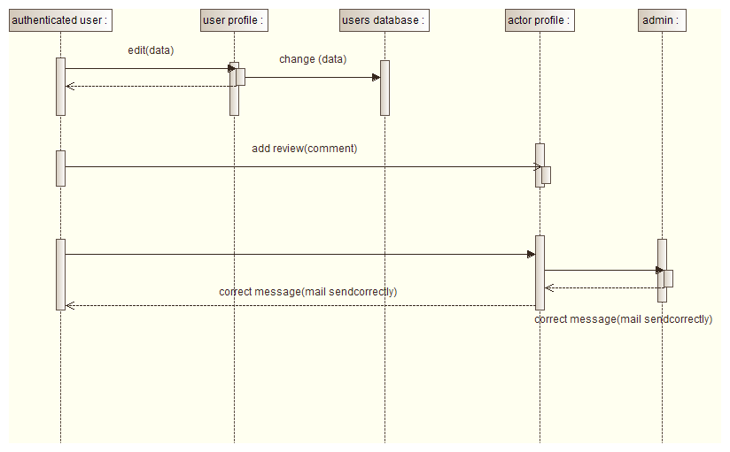

**Feedback Scenario :**

*Participating Actors:* authenticated user.

*Entry Condition:* (user) sign in then go to feedback form in home page to add rate about websit .

*Exit Condition:* he select Cancel or back or submit his feedback .

*Quality Requirements:* Performance system can send the feedback form to admin in seconds .

*Related Requirements:* non .

*Typical Flow of Events*: user should fill the following information:

● Rate the experience.

● Rate the behavior.

● Rate the level satisfaction.

● write any comments or suggestion in paragraph box.

*Alternative:* None.

**Search for actor Scenario:**

*Participating Actors:* user.

*Entry Condition:* A (user) visit the website and would like to about specific actor .

*Exit Condition:* The system response to user and back to him the result page with actor names

. Or he search for no exist actor so system warned it for no exicting .

Cancel or .

*Quality Requirements:* Performance system can send verification message for exciting or not .

verify message can create and send during seconds.

*Related Requirements:* search by name of actor , any user non authenticated can search also.

*Typical Flow of Events*: User go to search box and select actor he wanted system invokes search for an actor use case which make the user fill name of actors.

**\*Search for actor sequence diagram :**

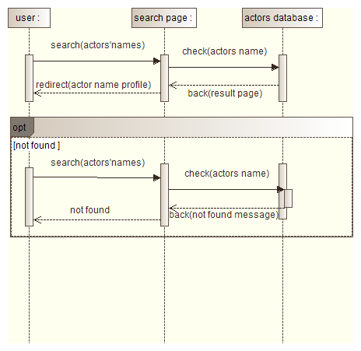

***Class diagram:***

