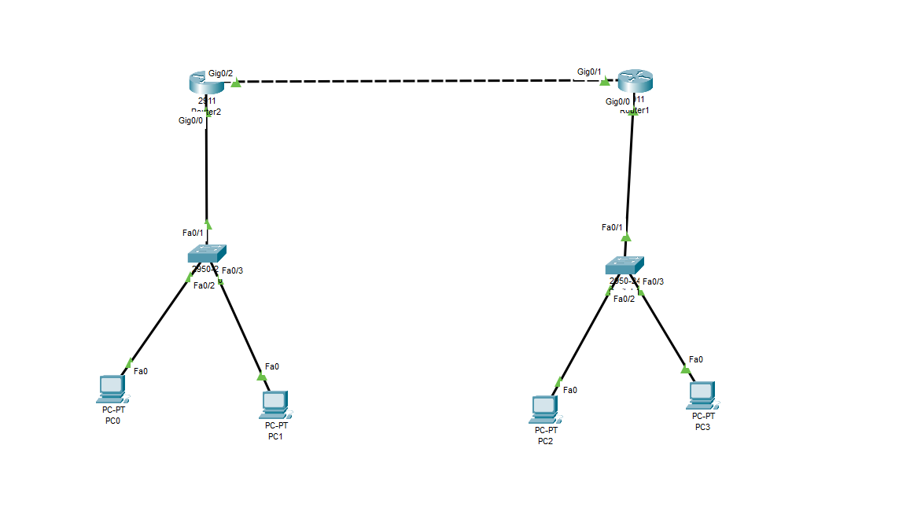

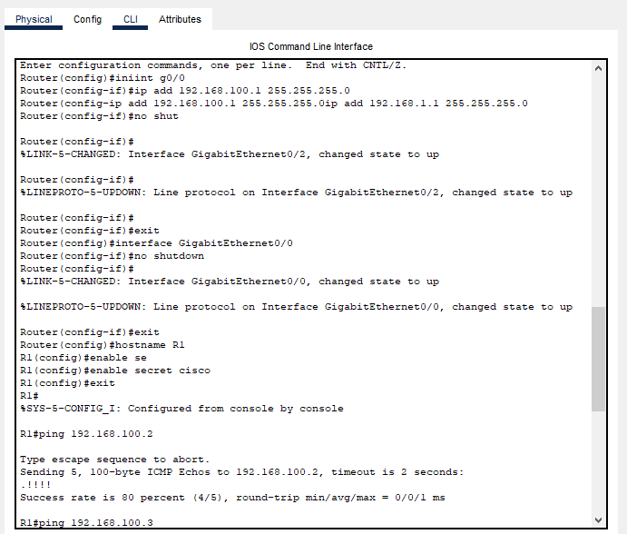

1. Assign the IP address to the interfaces that are connected to the router 1
2. Change the router name
3. Create a secret password for router 1

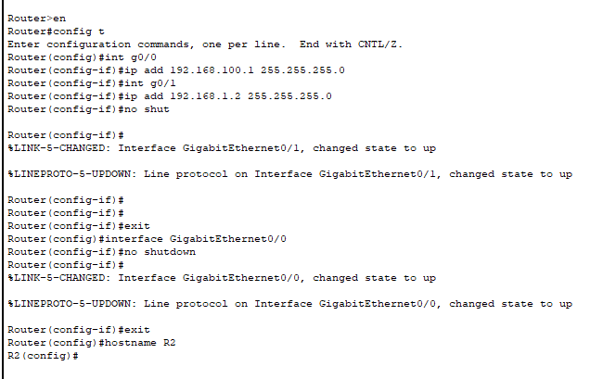

1. Assign the IP address to the interfaces that are connected to the router 2
2. Change the router name
3. Create a secret password for router 2

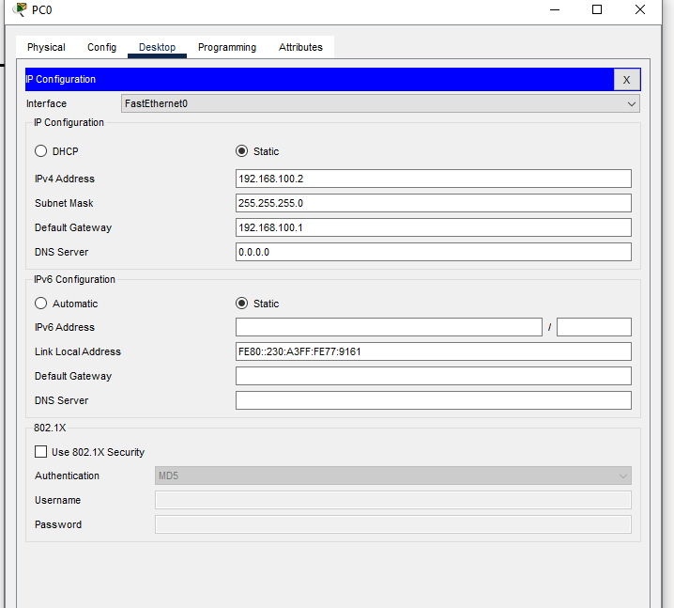

Assign IP address for pc 0

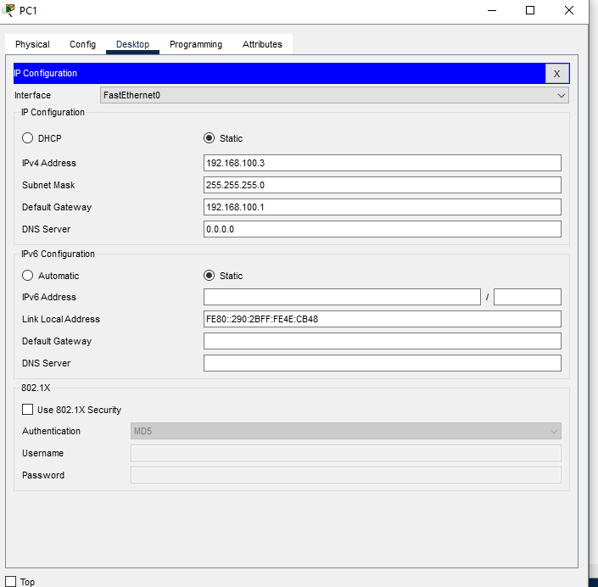

Assign IP address for pc 1

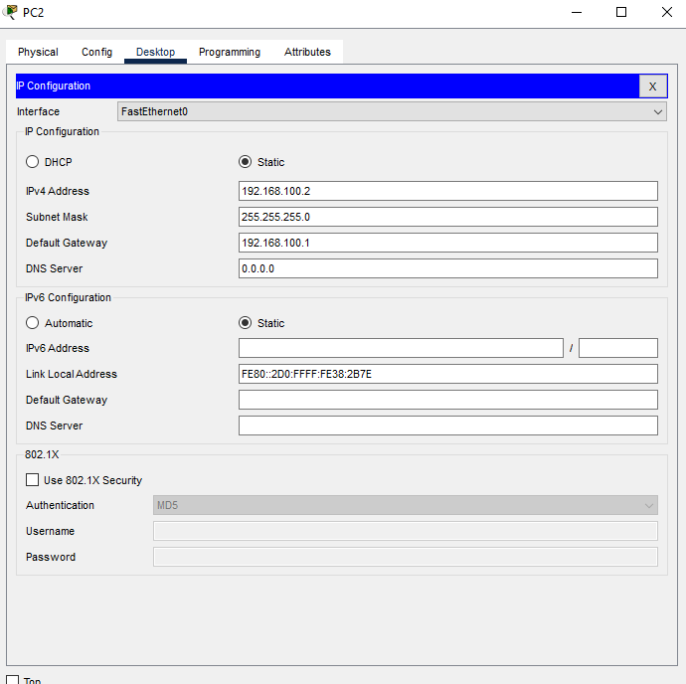

Assign IP address for pc 2

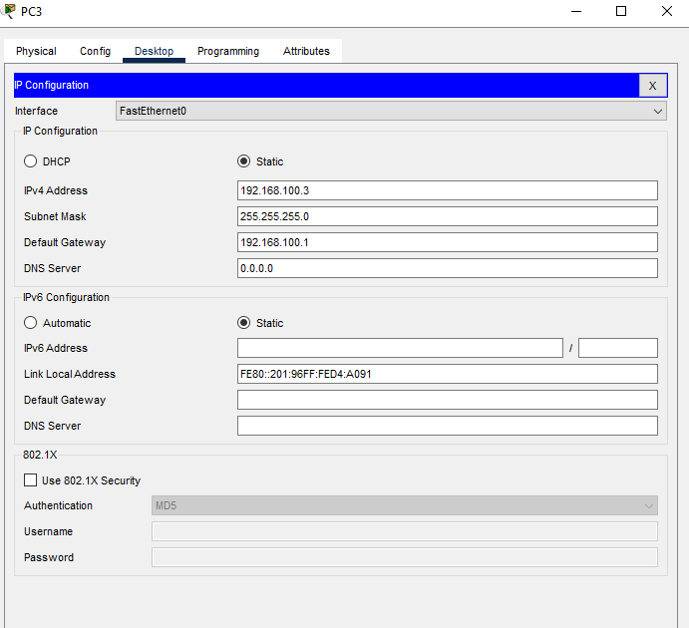

Assign IP address for pc 3

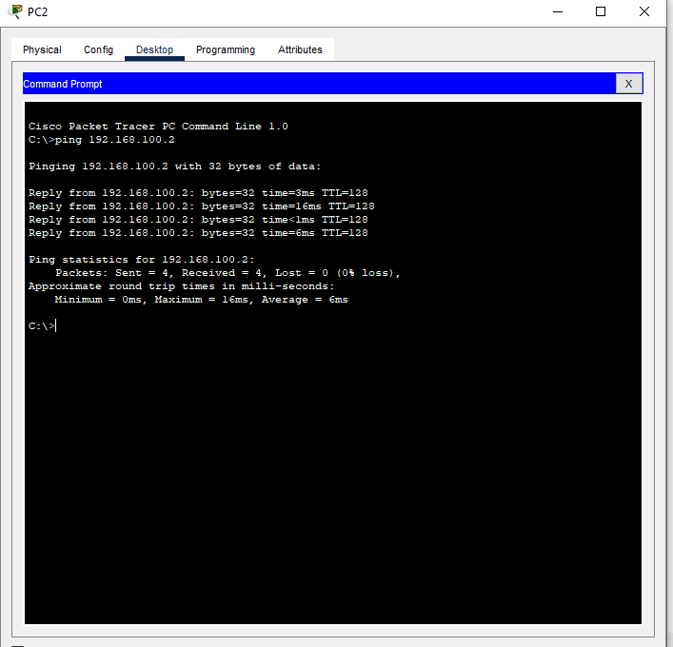

Test:

