20 May **Python Basic - 1**

Q.1. What are keywords in python? Using the keyword library, print all the python keywords.

Ans: Keywords are predefined, reserved words used in Python programming that have special meanings to the compiler. We cannot use a keyword as a variable name, function name, or any other identifier. They are used to define the syntax and structure of the Python language.

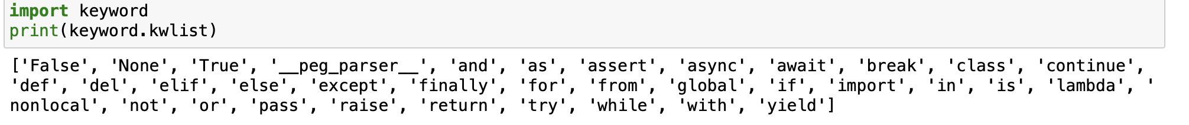

Q.2. What are the rules to create variables in python?

* A variable name must start with a letter or the underscore character.
* A variable name cannot start with a number.
* A variable name can only contain alpha-numeric characters and underscores (A-z, 0-9, and _ )
* Variable names are case-sensitive (age, Age and AGE are three different variables)

Q.3. What are the standards and conventions followed for the nomenclature of variables in python to improve code readability and maintainability?

Ans: Instance variable names should follow the lowercase convention. Have the underscore as a separator while naming a multi-word instance variable. Begin a non-public instance variable name with a single underscore. Use two consecutive underscores at the beginning of an instance variable.

Q.4. What will happen if a keyword is used as a variable name?

Ans: we cannot use them as variable names.We'll get a SyntaxError if we try to do that.

Q.5. For what purpose def keyword is used?

Ans: Python def keyword is used to define a function, it is placed before a function name that is provided by the user to create a user-defined function.

Q.6. What is the operation of this special character ‘\’?

Ans: In Python strings, the backslash "\" is a special character, also called the "escape" character. It is used in representing certain whitespace characters: "\t" is a tab, "\n" is a newline, and "\r" is a carriage return. Conversely, prefixing a special character with "\" turns it into an ordinary character.

Q.7. Give an example of the following conditions:

1. Homogeneous list – [1,2,3,4,5]
2. Heterogeneous set- {“amal”,2,”ajay”,8}
3. Homogeneous tuple-(“hai”,”hello”,”bye”)
   1. Explain the mutable and immutable data types with proper explanation & examples.

Ans: Mutable: A mutable object can be changed after it is created. – list, set, dictionary.

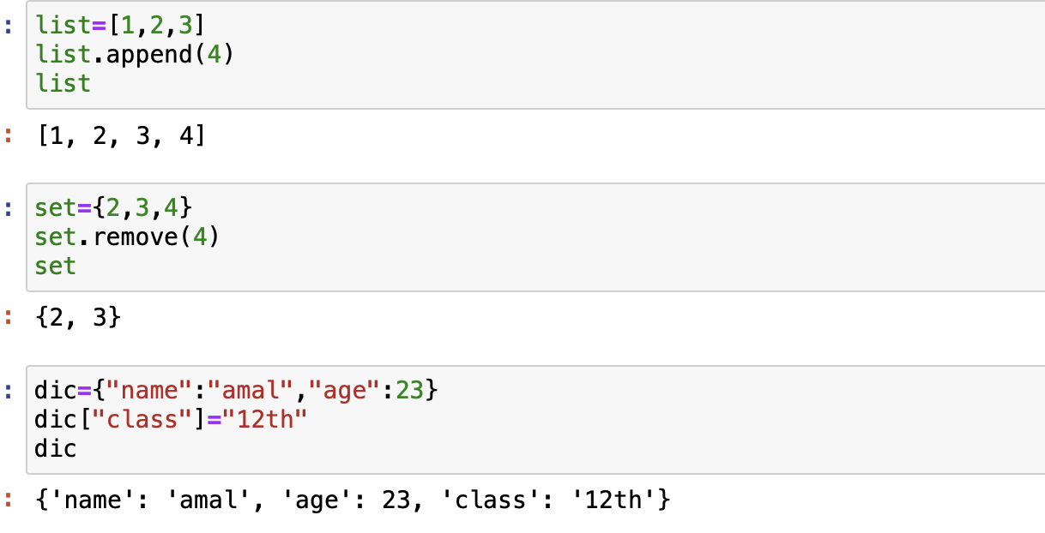

Immutable- An immutable object cannot be changed after it is created.- tuple

* 1. Write a code to create the given structure using only for loop.

*

***

*****

*******

*********

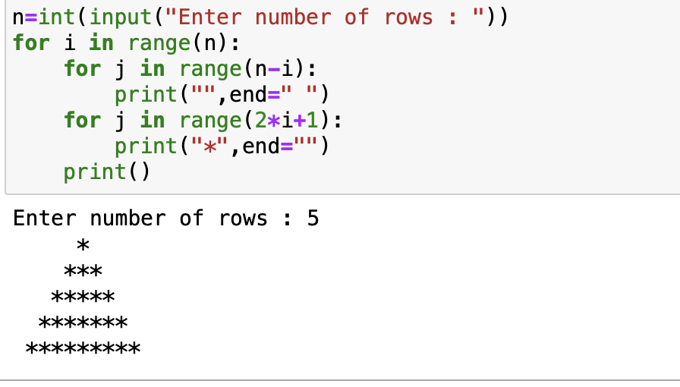Ans:

* 1. Write a code to create the given structure using while loop.

|||||||||

|||||||

|||||

|||

|

Ans: 