**ASSIGNMENT-4**

1. What exactly is []?

Ans: The empty list value, which is a list value that contains no items.

1. In a list of values stored in a variable called spam, how would you assign the value 'hello' as the third value? (Assume [2, 4, 6, 8, 10] are in spam.)

Ans: spam.insert(2,”hello”)

Eg:

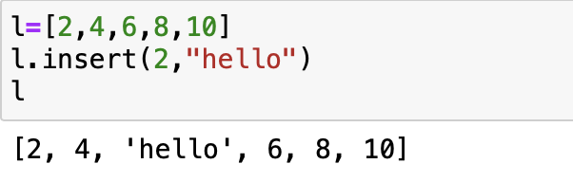

Let's pretend the spam includes the list ['a', 'b', 'c', 'd'] for the next three queries.

1. What is the value of spam[int(int('3' * 2) / 11)]?

Ans: 'd' ('3' * 2 is the string '33', which is passed to int() before being divided by 11. This eventually evaluates to 3, spam[3] is equal to d.)

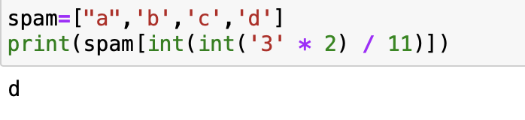

1. What is the value of spam[-1]?

Ans: d

1. What is the value of spam[:2]?

Ans:[‘a’,’b’]

Let's pretend bacon has the list [3.14, 'cat,' 11, 'cat,' True] for the next three questions.

1. What is the value of bacon.index('cat')?

Ans: 1

1. How does bacon.append(99) change the look of the list value in bacon?

Ans: [3.14, 'cat,' 11, 'cat,' True,99]

1. How does bacon.remove('cat') change the look of the list in bacon?

Ans: list [3.14,11, 'cat,' True]

1. What are the list concatenation and list replication operators?

Ans: The operator for list concatenation is +, while the operator for replication is *. (This is the same as for strings.)

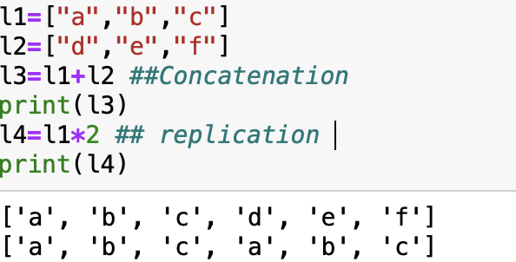

1. What is difference between the list methods append() and insert()?

Ans: While append() will add values only to the end of a list, insert() can add them anywhere in the list(we can give the index).

1. What are the two methods for removing items from a list?

Ans: The del statement and the remove() method are two ways to remove values from a list.

1. Describe how list values and string values are identical.

Ans: Below are some reasons how list values and string values are identical:

* Both lists and strings can be passed to len() function
* Have indexes and slices, be used in for loops,
* Can be concatenated or replicated

- Can be used with the in and not in operators.

13. What's the difference between tuples and lists?

Ans: List – ordered collection of items, mutable, values enclosed in [ ].

Tuple- Ordered collection of items, immutable, values enclosed in ( ).

1. How do you type a tuple value that only contains the integer 42?

Ans: (42,) (The trailing comma is mandatory. otherwise its considered as a int by python Interpreter)

1. How do you get a list value's tuple form? How do you get a tuple value's list form?

Ans: The tuple() and list() functions are used to convert a list to tuple and tuple to list.

1. Variables that "contain" list values are not necessarily lists themselves. Instead, what do they contain?

Ans: Variables will contain references to list values rather than list values themselves.

1. How do you distinguish between copy.copy() and copy.deepcopy()?

Ans: The copy() returns a shallow copy of the list, and deepcopy() returns a deep copy of the list. As you can see, both have the same value but different IDs.