EnergyTrade
A Peer-to-Peer Renewable Energy Trading Platform
PROJECT REPORT

Abstract
EnergyTrade is a prototype peer-to-peer (P2P) renewable-energy marketplace designed to demonstrate how households can publish surplus renewable energy as offers and allow other registered households to purchase available quantities. The system combines a browser-based interface, Web3.js, a Solidity smart contract, a local Ethereum-compatible blockchain provided by Ganache, and a Python API. It also provides demonstration views for microgrid conditions, solar forecasting, participant matching, community registration, and a blockchain ledger.
The smart contract is responsible for enforcing important transaction rules, including participant eligibility, offer validity, available quantity, payment, and the recording of completed trades. Transactions can be inspected in Ganache, and the website can display updated offer and trade information. The project demonstrates the potential of blockchain-based auditability and automated rule enforcement for local energy markets. The current implementation is a prototype: smart-meter and microgrid values and forecasting/dashboard content include simulated demonstration data, and the application does not itself establish that physical electricity has been transferred.
Keywords: peer-to-peer energy trading, renewable energy, Solidity, smart contracts, blockchain, Ganache, Web3.js, Python API, microgrid simulation.

Table of Contents
- 1. Introduction
- 2. Problem Statement
- 3. Aim and Objectives
- 4. Scope and Limitations
- 5. Background and Key Concepts
- 6. System Requirements
- 7. System Architecture
- 8. Technology Stack
- 9. System Design and Workflow
- 10. Smart Contract Design
- 11. Application Modules
- 12. Implementation Overview
- 13. Testing and Demonstration Results
- 14. Security and Reliability Considerations
- 15. Limitations
- 16. Future Enhancements
- 17. Conclusion
- References
- Appendix A: Demonstration Runbook

1. Introduction
Renewable-energy technologies such as rooftop solar panels allow homes and small communities to generate electricity. At certain times, a household may produce more energy than it immediately consumes, while another household may have a higher demand. A peer-to-peer energy marketplace is a model in which participants can publish offers and other participants can purchase available energy under defined rules.
EnergyTrade explores this model through a web application backed by a Solidity smart contract. The frontend provides the marketplace and dashboard views. Web3.js connects the browser to a local Ganache blockchain, where contract transactions are executed and recorded. A Python API serves the website and exposes blockchain information for dashboard updates. Additional views demonstrate microgrid data, solar forecasting, and offer matching.
The purpose of the project is to demonstrate a software architecture for transparent, rule-based energy trading. It is not a production electricity-market platform, and the current local test network does not represent the public Ethereum mainnet.

2. Problem Statement
Households can have different patterns of renewable-energy generation and consumption. A household may have surplus energy when another participant would benefit from access to an offer. A trading system needs a way to publish the quantity and price of an offer, define how long it remains valid, restrict purchases to eligible participants, verify payment, update remaining inventory, and preserve a record of trades.
EnergyTrade addresses this software-level problem by using a smart contract to maintain offers and trades in an auditable ledger. It also provides interface views intended to help users explore simulated microgrid conditions and possible matches between offers and buyers.

3. Aim and Objectives
Aim: To develop a prototype peer-to-peer renewable-energy trading marketplace that demonstrates blockchain-based offer management, purchase validation, settlement, and ledger reporting.
- Allow a seller to create an energy offer with a quantity, price, validity duration, and proof/attestation value.
- Allow registered and active buyers to purchase part or all of an available offer.
- Apply contract-level checks for participant eligibility, self-purchase, offer status, deadlines, quantity, and payment.
- Update remaining offer quantity and record completed trades on-chain.
- Provide a web interface for the marketplace, participant registry, blockchain ledger, microgrid simulation, forecasting, and matching views.
- Expose current on-chain information through a Python API so the dashboard can refresh after transactions.

4. Scope and Limitations
The project scope covers a local prototype and a demonstration of the software transaction flow. The blockchain records offers and trades; dashboard and meter-related views include simulated/demo data. The system should not be described as controlling a real electricity grid or transferring physical electricity unless a separate, verified integration has been implemented.
Included in the prototype | Not established by the current guide
Create and display energy offers | Physical delivery of electricity between households
Validate purchases through a Solidity contract | Live, verified smart-meter readings
Record trades and update offer inventory on-chain | Production-grade payment settlement or real currency transfer
Local blockchain testing with Ganache test accounts | Deployment and operation on public Ethereum mainnet
Demonstration views for microgrid, forecast and matching | A particular ML model, dataset, or measured prediction accuracy

5. Background and Key Concepts

5.1 Peer-to-peer energy trading
P2P energy trading is a marketplace model in which participants can offer energy and other participants can buy it. In a real electricity system, physical delivery, grid balancing, metering, market regulation, and settlement require additional infrastructure. EnergyTrade models the offer-and-purchase process in software.

5.2 Blockchain
A blockchain is a sequence of linked blocks that stores transactions. In this prototype, Ganache provides a local Ethereum-compatible blockchain for development and testing. The local chain allows contract transactions, account balances, blocks, and transaction hashes to be inspected without making public-mainnet transactions.

5.3 Smart contracts
A smart contract is program code deployed to a blockchain. It can enforce transaction rules and update stored state when a valid transaction is submitted. In EnergyTrade, the Solidity contract validates energy purchases, changes offer availability, records trade details, updates aggregate statistics, transfers the specified test ETH payment to the seller, refunds excess payment where applicable, and emits a trade event.

5.4 Energy units and payment
The contract stores quantities in watt-hours (Wh), while the interface may display kilowatt-hours (kWh). One kilowatt-hour equals 1,000 watt-hours. The demonstration contract uses an ETH-denominated value for payment on the local test chain; this is not a claim that real-world electricity billing or fiat settlement is implemented.

6. System Requirements

6.1 Functional requirements
- Connect the frontend to the local Ganache RPC endpoint.
- Allow users to select an account and interact with the deployed contract.
- Create energy offers with quantity, price, validity duration, and an attestation value.
- Allow eligible buyers to purchase an available quantity from an offer.
- Reject invalid purchases, including self-purchases, inactive/unregistered buyers, expired or unavailable offers, excessive quantities, and insufficient payment.
- Record successful trades and refresh the ledger and aggregate summaries.
- Display participant, marketplace, microgrid, forecast, matching, and ledger information where available.

6.2 Non-functional requirements
- Usability: the main transaction workflow should be accessible through a browser interface.
- Auditability: completed transactions should be inspectable by transaction hash and block in Ganache.
- Consistency: a reverted transaction should not commit its intended state changes, although gas may still be consumed.
- Maintainability: the frontend, contract, and Python API are separated into distinct project components.
- Transparency: dashboard values should be identified as simulated where they are not based on real sensors.

7. System Architecture
Component | Technology / location | Responsibility
Web frontend | HTML, CSS, JavaScript; frontend/index.html and frontend/app.js | User interface, forms, account selector, transaction calls, dashboard rendering.
Blockchain connection | Web3.js | Connects browser JavaScript to Ganache RPC and calls contract methods.
Local blockchain | Ganache Desktop; http://127.0.0.1:7545 | Provides local test accounts, balances, blocks, and transaction execution.
Smart contract | Solidity; contracts/EnergyTradingPlatform.sol | Enforces offer, buyer, quantity, deadline, and payment rules; records trades.
Python API | ml_engine/api_server.py | Serves the website and exposes /api/blockchain for current on-chain data.
Forecasting / microgrid views | ML and demonstration components | Displays generation, demand, forecasting, and matching information; exact implementation must be verified in source code.

7.1 Architecture flow
- A participant opens the EnergyTrade website and selects a Ganache account.
- The frontend uses Web3.js to submit a contract call or transaction.
- Ganache executes the contract transaction and mines it into a local block.
- The frontend refreshes blockchain information through the Python API endpoint /api/blockchain.
- The Blockchain Ledger view displays the updated offers, trades, and summary information.
Suggested architecture figure for the final submission: draw five connected boxes—Web Frontend → Web3.js → Solidity Smart Contract on Ganache, with the Python API reading current blockchain data for the dashboard. Place the simulated microgrid/forecast views alongside the dashboard and label their data as demonstration data.

8. Technology Stack
Technology | Purpose in EnergyTrade
HTML / CSS / JavaScript | Builds the browser interface and dashboard.
Web3.js | Allows frontend JavaScript to communicate with the Ethereum-compatible RPC endpoint and contract.
Solidity | Implements offer creation, purchase validation, payment handling, and trade recording.
Ganache | Runs a local blockchain and supplies development accounts and test ETH.
Python | Runs the API server and supports the demonstration backend/pipeline.
HTTP API | The /api/blockchain endpoint supplies current blockchain information to the interface.
Forecasting / microgrid components | Support demonstration views; the exact model, dataset, and evaluation metrics should only be stated after checking the implementation.

9. System Design and Workflow

9.1 Creating an offer
A seller enters an energy quantity, price per kWh, validity duration, and an attestation/proof value through the P2P Marketplace form. The frontend submits createEnergyOffer(energyWh, pricePerKwhWei, durationSeconds, attestationHash). The contract stores the seller, quantity, price, validity, status, and attestation hash. The offer can then be displayed in the marketplace and ledger.

9.2 Purchasing an offer
A registered and active buyer selects an available offer and specifies a positive quantity that does not exceed the remaining amount. The frontend calls buyEnergy(offerId, requestedEnergyWh) and includes the required ETH payment. The contract validates the buyer and offer, checks the requested quantity and deadline, and verifies payment.

9.3 Settlement and ledger update
After a valid purchase, the contract calculates the required cost, decreases the offer's available quantity, updates its status when appropriate, records the trade, updates aggregate statistics, transfers the payment to the seller, refunds excess payment if applicable, and emits a trade event. The ledger can then show the trade and updated totals.

9.4 Payment calculation
The guide specifies the settlement formula:
totalCostWei = requestedEnergyWh × pricePerKwhWei ÷ 1,000
Example from the demonstration guide: 0.1 kWh is 100 Wh. At 0.001 ETH per kWh, the total cost is 0.0001 ETH. The local Ganache ETH is test currency used for the demonstration.

10. Smart Contract Design

10.1 Contract purpose
The contract file is contracts/EnergyTradingPlatform.sol. It serves as the transaction rule-enforcement layer, rather than relying solely on validation in the web form. The frontend uses the compiled contract ABI to call the deployed contract instance.

10.2 Main operations
Operation | Description
createEnergyOffer(...) | Creates an offer and stores seller, quantity, price, validity, status, and attestation hash.
buyEnergy(offerId, requestedEnergyWh) | Validates a purchase and performs settlement for the requested quantity.
Participant eligibility checks | Checks registration and active status for the buyer.
Offer validation | Checks that the offer exists, is available, and has not passed its deadline.
Quantity and payment checks | Requires a positive quantity within available inventory and sufficient payment.
Trade recording | Updates offer inventory and aggregate statistics, records the trade, and emits an event.

10.3 Why contract-level validation matters
Frontend checks help users avoid mistakes, but a user interface alone cannot guarantee that a transaction follows the rules. Contract-level checks provide an additional enforcement layer at transaction execution. A rejected transaction should not commit its intended state changes, though the sender may still pay gas for the failed attempt.

10.4 Attestation value
The offer includes a proof/attestation hash field. A hash can act as a reference or integrity-related identifier for associated data, but the presence of a hash alone does not prove that energy was generated or delivered. The report should not claim that an external meter or certificate is cryptographically verified unless that validation is present in the actual implementation.

11. Application Modules

11.1 P2P Marketplace
This is the primary transaction interface. It lists offers and allows sellers to create offers and registered buyers to initiate purchases. It is the main screen for demonstrating on-chain transactions.

11.2 Microgrid & Smart Meters
This view shows simulated household solar generation, home load, grid balance, and renewable self-sufficiency. A time scrubber changes the displayed time. These values should be described as simulated unless live sensor integration is separately verified.

11.3 ML Solar Forecast
This view is intended to display expected solar generation. The supplied guide does not establish the exact model, dataset, training procedure, or prediction accuracy. Those details must be taken from the actual source code or experiment results before being included as factual claims.

11.4 AI Matchmaker
This interface is intended to help identify suitable buyer/offer matches. The exact matching criteria should be explained from the implementation; do not assume it uses a particular optimization algorithm or machine-learning model without verifying the code.

11.5 Blockchain Ledger
The ledger displays on-chain summary values and recorded trades. After a purchase, it can be used to demonstrate the trade record, energy traded, settlement volume, offer availability, latest block, and other details exposed by the interface.

11.6 Community Registry
This view displays registered participants and their roles/status where those values are exposed by the contract or API.

12. Implementation Overview
The project is organized into separate frontend, contract, and Python API components. The guide identifies the following key paths and endpoints:
Item | Location / value
Project directory | W:\Sem5\Blockchain\Energy_trade
Frontend | frontend/index.html and frontend/app.js
Smart contract | contracts/EnergyTradingPlatform.sol
Python API server | ml_engine/api_server.py
Local Ganache RPC | http://127.0.0.1:7545
Website | http://127.0.0.1:8080/
Blockchain data endpoint | /api/blockchain

The contract address recorded in the demonstration guide is 0x7b6f61AbD1B669D7eB2A19C52E19813a26Befb66. This address is specific to the current local deployment and may change if Ganache is reset or the contract is redeployed. It should be included in a formal report only if useful, and should be rechecked at submission time.

13. Testing and Demonstration Results
The supplied guide reports the following successful demonstrations. These results describe the state captured in the guide; ledger totals may change as additional test transactions are made.
Test | Observed result reported in guide
Ganache connection | Website connected to local RPC and loaded contract data.
Offer creation | An offer was created through the website and appeared in on-chain data.
Successful purchase | A registered buyer purchased 0.1 kWh from offer #4 for 0.0001 ETH.
Ledger refresh | The trade appeared, aggregate values changed, and available quantity decreased by 100 Wh.
Oversized purchase | Website rejected an attempt to buy more energy than was available before submitting a transaction.
Insufficient payment | A test helper submitted one Wei less than required; the attempt was rejected and the ledger remained unchanged.

The guide records the transaction hash for the sample purchase as:
0x20e3039af9cb3319a8e2ea9ab4a86e5c4a2ee070e3d54db6b085ab43edad2711
Figures 1 and 2 show the Ganache Desktop view of the local test blockchain used for the demonstration (Quickstart workspace, network ID 5777, RPC server http://127.0.0.1:7545, automining enabled). Each transaction listed is a contract creation or a contract call, and each was mined into its own block.
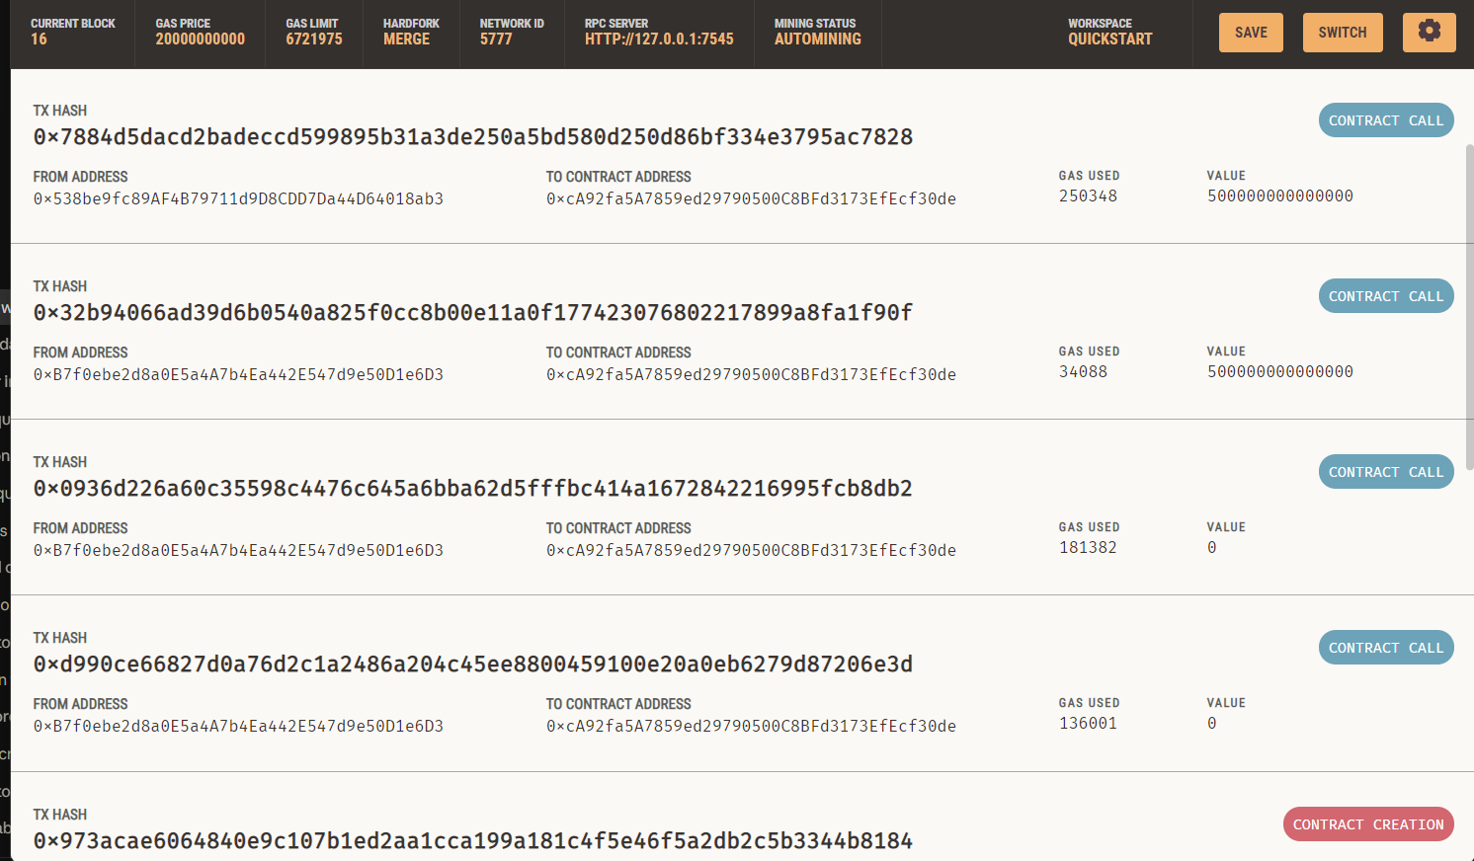
Figure 1: Ganache Transactions tab showing the contract-creation transaction and the contract calls made to the deployed EnergyTrade contract, with the sender address, gas used and ETH value (in wei) for each transaction.
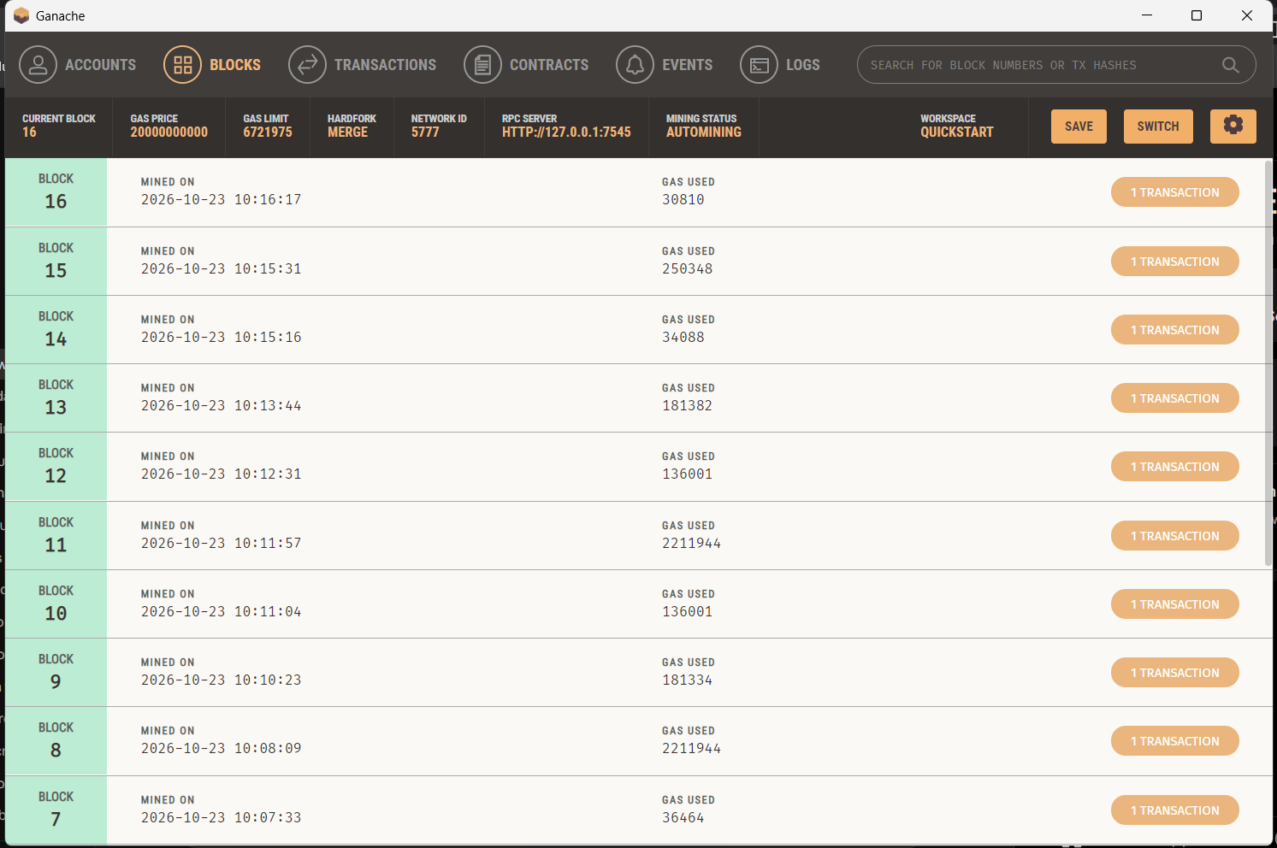
Figure 2: Ganache Blocks tab showing blocks 7 to 16 of the local chain (current block 16). Each block contains a single transaction, mined on 23 October 2026 under automining, with the gas used per block.
For a formal submission, screenshots should be captured from the current running application: the connected frontend, a created offer, the successful purchase confirmation, and the updated Blockchain Ledger. Do not use the guide's sample values as current live totals if the local chain has changed.

14. Security and Reliability Considerations
- Contract validation should remain the source of truth for transaction rules; frontend validation is only a usability aid.
- Participant registration and active status must be checked before a buyer can purchase.
- Self-purchase should be rejected when the buyer and seller are the same account.
- Offer deadline, status, remaining quantity, and payment must be validated for every purchase.
- Contract address and ABI configuration must match the currently running Ganache deployment.
- A local Ganache network is suitable for development and demonstration, not for proving production security or public-network availability.
- Real deployment would require contract review, security testing, access-control analysis, and a plan for key management.
- Meter readings, forecasts, and attestation claims should be clearly labelled and validated against their actual sources.

15. Limitations
- The current environment is a local Ganache blockchain, not public Ethereum mainnet.
- The application models trading records; it does not by itself route or physically deliver electricity.
- Meter and microgrid dashboard values include simulated demonstration data.
- The supplied guide does not specify the exact ML forecasting model, dataset, accuracy, or the AI Matchmaker's precise algorithm.
- The attestation hash field alone does not establish that a real-world energy measurement is genuine.
- A real-world deployment would need integration with validated meters, grid/operator systems, applicable regulations, and a secure settlement mechanism.

16. Future Enhancements
- Integrate certified smart meters or trusted meter gateways and clearly distinguish measured data from simulated values.
- Document and evaluate the solar forecasting model using a named dataset, train/test separation, suitable error metrics, and reproducible experiments.
- Define and evaluate the matching algorithm using explicit criteria such as quantity, price, time window, and participant constraints.
- Add comprehensive automated tests for contract success cases, boundary values, expiry, invalid accounts, insufficient payment, and partial purchases.
- Conduct independent smart-contract security review and consider deployment to a suitable testnet before any production use.
- Improve transaction status feedback, error messages, and event-based ledger refresh.
- Explore integration with grid operators and regulatory-compliant settlement processes before making claims about real electricity delivery.

17. Conclusion
EnergyTrade demonstrates a software prototype for peer-to-peer renewable-energy trading. Its central contribution is the use of a Solidity smart contract to create offers, validate purchases, enforce quantity and payment rules, update available energy, and record trades on a local blockchain. The web frontend provides access to the marketplace and ledger, while a Python API supplies current blockchain information to the dashboard. Microgrid, smart-meter, forecasting, and matching views broaden the demonstration, but their exact data sources and algorithms must be verified in the implementation.
The prototype illustrates how blockchain can support transparent and auditable transaction records. To move beyond a demonstration, the project would need verified meter data, documented and evaluated forecasting/matching logic, security testing, and integration with real-world energy delivery and regulatory processes.

References
1. EnergyTrade – Faculty Explanation & Live Demonstration Guide, supplied project document, 6 pages.
2. EnergyTrade source files referenced by the project guide: contracts/EnergyTradingPlatform.sol, frontend/index.html, frontend/app.js, and ml_engine/api_server.py. Consult the actual repository for implementation-specific details.
3. Solidity documentation: https://docs.soliditylang.org/
4. Web3.js documentation: https://web3js.readthedocs.io/
5. Ganache documentation: https://archive.trufflesuite.com/ganache/
Note: The external documentation links are suggested technical references. The implementation-specific descriptions and demonstration results in this report are based on the supplied EnergyTrade guide.

Appendix A: Demonstration Runbook
The following sequence is adapted from the supplied faculty demonstration guide. Use the existing workspace and deployment; do not reset Ganache or redeploy during a presentation unless intentionally creating a fresh deployment.
- Open Ganache Desktop and open the existing EnergyTrade workspace. Confirm that the RPC endpoint is http://127.0.0.1:7545.
- Open PowerShell and navigate to the project folder: cd W:\Sem5\Blockchain\Energy_trade
- Start the Python API and website using: python ml_engine/api_server.py. Keep this terminal running.
- Open http://127.0.0.1:8080/ in a browser. Use Ctrl+F5 after code changes if the page appears stale.
- Connect the website to Ganache and verify the contract address matches the active deployment.
- Select a registered seller account and create a positive-quantity offer with a price and validity duration.
- Select a different registered buyer account. Choose an active offer and purchase a positive quantity no greater than the available amount.
- Open Blockchain Ledger and confirm that the trade is visible, the available offer quantity has decreased, and the summary values have updated.
- If the website does not open, check that the Python server is running. If Ganache connection fails, confirm the local RPC endpoint. If the contract is not found, verify the deployment address and workspace.

