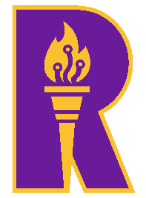 | Rajalakshmi Engineering College  (An Autonomous Institution)  Rajalakshmi Nagar, Thandalam-602105

DEPARTMENT OF
ARTIFICIAL INTELLIGENCE AND DATA SCIENCE

PRECISION FARMING USING SENSOR STREAMS
AI23532 – BIG DATA ARCHITECTURE
Project Report submitted by

Name | : | Akshayaa /Amala Encilin / Hannah
University Registration No | : | 2116231801007/009/047
College Registration No | : | 231801007/009/047
Semester | : | V
Academic Year | : | 2025 – 2026

CHAPTER NO. | TITLE | PG NO.
ABSTRACT |  | 1
1 | INTRODUCTION | 2
1.1 | Problem Definition & Explanation | 3
1.2 | Literature Survey | 4
1.3 | Existing System | 6
1.4 | Proposed System | 8
2 | DATA COLLECTION AND PREPROCESSING
2.1 | Data Collection | 10
2.2 | Architecture Diagram & Pseudocode | 16
2.3 | Preprocessing Steps | 17
3 | RESULTS AND DISCUSSION
3.1 | Overview | 19
3.2 | Exploratory Analysis | 20
3.3 | Python Implementation Code | 21
3.4 | Outputs | 23
4 | CONCLUSION AND FUTURE WORK
4.1 | Conclusion | 24
4.2 | References | 25

1. Introduction
Agriculture forms the foundation of the Indian economy, contributing significantly to the livelihood of millions. However, the industry faces persistent challenges such as erratic weather conditions, depletion of water resources, soil degradation, and inefficient resource utilization. Farmers often depend on intuition, manual observations, and experience-based decisions for irrigation, fertilization, and crop management, which leads to inconsistent outcomes and wastage of critical resources.
In recent years, technological advancements in IoT (Internet of Things) and Big Data Analytics have opened new possibilities in the field of precision agriculture — an innovative approach that uses digital technologies to make farming more data-driven, efficient, and sustainable.
Precision farming aims to apply the right inputs (water, fertilizer, pesticide) in the right amount, at the right time, and in the right place. IoT sensors installed in agricultural fields continuously monitor essential environmental and soil parameters such as soil moisture, humidity, temperature, pH level, and rainfall. These readings generate massive volumes of streaming data that, when properly analyzed, can provide insights into soil health, irrigation needs, and optimal crop growth conditions.
However, the real challenge lies in managing and analyzing this high-volume, high-velocity data efficiently. Traditional relational databases are not designed to handle such unstructured, time-sensitive data. To overcome these limitations, Big Data technologies like Hadoop (for distributed storage), Apache Spark (for in-memory data processing), and Apache Hive (for analytical querying) are employed to build a scalable data pipeline.
This project, “Precision Farming with IoT Sensor Streams,” integrates IoT sensors with Big Data tools to collect, store, and process continuous agricultural data streams. By analyzing this data, the system delivers actionable recommendations — such as when to irrigate or how to optimize water usage — enabling farmers to make timely and informed decisions. Ultimately, this approach supports sustainable agriculture, resource conservation, and increased crop productivity, bridging the gap between traditional and digital farming.
2. Abstract
The project titled “Precision Farming with IoT Sensor Streams” aims to revolutionize conventional agricultural practices by harnessing the combined potential of Internet of Things (IoT) technologies and Big Data Analytics. Agriculture, being one of the most crucial sectors for human sustenance, faces major challenges such as erratic weather patterns, improper irrigation management, and inefficient utilization of resources. These challenges call for a data-driven, automated, and intelligent approach to farming. The proposed system addresses this need by continuously collecting, processing, and analyzing large volumes of real-time agricultural data obtained from IoT sensors deployed across the farmland.
IoT sensors are strategically placed in the agricultural field to capture critical environmental and soil parameters such as soil moisture, temperature, humidity, pH level, and rainfall intensity. These sensors transmit continuous data streams that reflect the dynamic conditions of the soil and the surrounding atmosphere. However, handling and analyzing such a vast amount of sensor data in real-time requires a robust and scalable Big Data infrastructure. To meet this requirement, the proposed system employs a multi-layered Big Data architecture, integrating Hadoop Distributed File System (HDFS) for distributed data storage, Apache Spark for fast and efficient data processing, and Apache Hive for high-level data querying and analytics.
The HDFS serves as the backbone of the system by ensuring fault-tolerant, scalable, and reliable storage for large datasets collected from multiple IoT nodes. The Spark framework is used to perform real-time data cleaning, transformation, and aggregation, enabling high-speed computation on streaming data. Meanwhile, Hive facilitates structured analysis through SQL-like queries, making it possible to extract meaningful patterns and actionable insights from complex datasets. This end-to-end pipeline transforms raw, heterogeneous sensor data into valuable information that can be directly utilized for agricultural decision-making.
Through these analytical insights, the system is capable of generating real-time irrigation recommendations, monitoring soil fertility and health, predicting weather-based crop conditions, and assisting farmers in making evidence-based decisions. The implementation of such a system minimizes human dependency, reduces resource wastage, and improves overall productivity by delivering timely and precise suggestions. Furthermore, the project promotes sustainability by ensuring the optimal use of natural resources such as water and fertilizer, which are often overused in traditional farming practices.
By offering farmers a data-driven decision support system, this project bridges the gap between raw environmental data and actionable intelligence. It demonstrates how the integration of IoT sensors with Big Data technologies can create a smart agricultural ecosystem that is efficient, scalable, and environmentally conscious.
In conclusion, “Precision Farming with IoT Sensor Streams” stands as a practical blueprint for next-generation digital agriculture, where every agricultural decision — from irrigation to harvest — is guided by real-time data analytics. This project highlights the transformative potential of IoT and Big Data in creating a smarter, sustainable, and high-yield farming environment, aligning with the global vision of Agriculture 4.0.
3.Literature Survey (Existing System)
Agriculture has traditionally been one of the most vital yet least digitized sectors of the economy. Most farming practices are still manual, experience-based, and weather-dependent, leaving farmers vulnerable to environmental changes and inefficiencies in irrigation, fertilization, and pest control. Decisions such as when to irrigate, how much fertilizer to apply, or which crop to cultivate are often made based on intuition or fixed schedules, rather than real-time field data.
While this traditional approach may work under predictable conditions, it fails in the face of climate variability, soil degradation, and population-driven food demand. As a result, the sector urgently needs data-driven, adaptive, and scalable technologies that can automate monitoring and provide actionable insights.
Over the past decade, researchers and engineers have developed several systems using IoT, cloud computing, and machine learning to address these issues. However, each existing approach has certain limitations that prevent it from achieving a truly integrated, large-scale, real-time agricultural management system.
The following subsections summarize the key categories of existing systems, their contributions, and their limitations:
3.1. IoT-Based Smart Irrigation Systems
IoT-based systems have been widely adopted for basic automation in irrigation management. Typically, these systems involve soil moisture sensors, temperature sensors, and microcontrollers such as Arduino, ESP8266, or Raspberry Pi. The sensors collect soil and weather data, which are used to automatically trigger irrigation pumps when the soil moisture level drops below a threshold.
Researchers such as Mekala and Viswanathan (2017) implemented a smart irrigation framework that utilized Arduino, GSM modules, and soil moisture sensors to automate water usage based on soil conditions. Similarly, Patil et al. (2018) developed a system that sends SMS alerts to farmers whenever crops require irrigation, enabling basic automation and awareness in water management. These IoT-based irrigation systems have shown the potential to reduce manual intervention, minimize water wastage, and provide a cost-effective solution for small-scale farms. However, despite these advantages, most of these systems operate in isolation and lack advanced analytical capabilities.
The collected data is usually stored locally without integration into a scalable or centralized data management platform, which limits their ability to analyze historical trends or provide predictive insights. Furthermore, these systems struggle to maintain real-time analytics and scalability when deployed across large farmlands with multiple sensors. As a result, while such IoT-based frameworks improve the efficiency of irrigation, they remain largely reactive, small-scale, and incapable of performing data-driven decision-making essential for large-scale precision agriculture.
3.2. Cloud-Based Agricultural Monitoring Systems
With advancements in cloud computing, several projects have shifted their data processing and storage to cloud platforms such as AWS, Azure, or Google Cloud. These solutions collect sensor data from IoT devices and store it in cloud databases, allowing users to visualize conditions remotely through dashboards or mobile applications.

Example Studies
Suma et al. (2019) proposed a cloud-based crop monitoring system that utilizes IoT sensors to measure soil and weather parameters, transmitting the collected data to a cloud platform for centralized monitoring and analysis. Farmers receive updates and insights through IoT–cloud integration, allowing them to remotely track field conditions. Similarly, Nagesh et al. (2020) introduced a cloud-based precision agriculture framework that integrates mobile applications for real-time field monitoring, enabling farmers to visualize environmental data and make timely decisions. These studies demonstrate how cloud computing can significantly improve agricultural data accessibility and enhance situational awareness for farmers.
Advantages
Cloud-based agricultural monitoring systems offer several key benefits. They provide remote access to real-time data, allowing farmers and agronomists to monitor soil and environmental conditions from anywhere. This capability eliminates the need for manual field visits and supports data-driven decision-making even in geographically dispersed locations. Additionally, these systems enable centralized data visualization and management, which simplifies deployment across multiple farms or regions. As a result, farmers gain an integrated view of their agricultural operations, improving responsiveness and overall efficiency.
Limitations
Despite their advantages, cloud-based agricultural systems face notable limitations. The transmission of continuous sensor data streams to cloud servers introduces latency issues, which can delay real-time analysis and affect timely decision-making. There are also significant data privacy and cost concerns, particularly for small and medium-scale farmers who may find cloud
3.3. Machine Learning and AI-Based Agricultural Models
Recent research has explored machine learning (ML) and artificial intelligence (AI) techniques for yield prediction, disease detection, and soil classification. These models use historical data and environmental parameters to forecast outcomes and assist farmers in decision-making.
Example Studies:
Researchers such as Kamble et al. (2021) utilized random forest algorithms to predict crop yield by analyzing soil and climate data, demonstrating the potential of machine learning for agricultural forecasting. Similarly, Li et al. (2022) applied convolutional neural networks (CNNs) to detect crop diseases using image data, highlighting how AI can assist in early disease identification and management.
Advantages:
Machine learning–based agricultural models provide several benefits. They enable predictive analysis for yield estimation and crop health monitoring, allowing farmers to make informed decisions ahead of time. By automating data analysis, these models enhance accuracy and significantly reduce reliance on manual field inspections, saving time and labor.
Limitations:
Despite their strengths, these ML models face significant challenges. They require large, clean, and well-labeled datasets, which are often unavailable in real-world farming environments. Sensor and field data are typically noisy, inconsistent, and incomplete, reducing the accuracy of predictions. Furthermore, most existing models focus on a single parameter, such as yield or disease detection, rather than providing an integrated view of multiple agricultural factors. Additionally, many systems operate offline, lacking the ability to analyze continuous sensor streams in real-time, which limits their effectiveness for dynamic, real-world farming conditions.
Hence, while ML offers predictive power, its implementation is hindered by data quality issues and infrastructure limitations.
3.4. Big Data and IoT Integration Attempts
A few studies have attempted to integrate Big Data frameworks with IoT for scalable agricultural data management. These systems store and analyze large datasets using platforms like Hadoop, Spark, and Kafka.
Example Studies:
Chen et al. (2020) developed a Big Data-based agricultural monitoring platform using Hadoop and Spark for real-time environmental analytics.
Zhang et al. (2021) implemented a data pipeline combining IoT sensors and Hive queries to analyze soil fertility patterns.
Advantages:
These systems offer high scalability and distributed computation for handling large-scale data. They also provide real-time processing and analytics capabilities.
Limitations:
These systems are often research prototypes and lack practical field deployment. Many lack integration with visualization layers or farmer-friendly interfaces. Some implementations handle data storage and processing, but do not provide recommendation generation or decision support for farmers.
Thus, while Big Data technologies provide the ideal foundation, the challenge remains in integrating real-time IoT data streams, processing frameworks, and actionable visualization dashboards in one unified system.

Research Gap and Need for the Proposed System
From the survey of existing literature and systems, several key gaps have been identified:
Lack of scalability:
Most systems fail when scaled beyond small farms due to limited storage or processing capabilities.
Absence of real-time data analytics:
Many models rely on static or batch data processing rather than continuous streaming data, limiting timely insights.
Data heterogeneity and quality issues:
Sensor data from various sources is often unstructured and inconsistent, which affects the accuracy and reliability of analytics.
Limited integration:
Existing systems typically handle only one part of the workflow, such as data collection or prediction, rather than providing a complete end-to-end solution.
No actionable decision support:
Few systems convert data analytics into practical recommendations that farmers can directly use for decision-making.
Summary and Novelty of the Proposed System
To address the above limitations, the proposed project “Precision Farming with IoT Sensor Streams” introduces a comprehensive, real-time, and scalable precision agriculture framework.

It integrates:
- IoT sensors for continuous data collection,
- Hadoop (HDFS) for distributed storage,
- Apache Spark for real-time data transformation, and
- Apache Hive for analytical querying and reporting.
The system bridges the gap between raw IoT data and decision-making intelligence, enabling farmers to receive real-time irrigation recommendations, soil health insights, and environmental predictions.
Unlike previous systems, it provides a complete data pipeline — from sensor acquisition to visual analytics — making it suitable for real-world deployment and sustainable agricultural innovation.
4. Architecture of the Precision Farming System
The architecture of the Precision Farming System is designed as a layered data pipeline that enables continuous collection of field data, fault-tolerant storage, high-speed processing, and real-time analytics. It ensures that the system can handle massive volumes of sensor data from agricultural fields and transform it into actionable insights for farmers.
4.1. IoT Data Collection Layer
The IoT Data Collection Layer forms the foundation of the Precision Farming System, as it is responsible for capturing real-time field data essential for smart agricultural decisions. In this layer, a variety of IoT sensors are deployed across farms to continuously monitor environmental and soil conditions, ensuring that accurate and up-to-date data is available at all times.
Soil moisture sensors measure the water content in the soil, helping farmers optimize irrigation schedules and avoid issues like overwatering or underwatering that can reduce crop yield. The DHT11 sensor records air temperature and humidity, providing insights into weather conditions that influence crop growth, pest infestations, and the spread of plant diseases. pH sensors track soil acidity or alkalinity, which is crucial for understanding nutrient availability and determining the suitability of crops for specific soil types. Meanwhile, rain gauge sensors monitor rainfall, allowing farmers to correlate natural precipitation with irrigation needs and plan water usage efficiently.
All these sensors are connected to microcontrollers such as NodeMCU or Raspberry Pi, which act as communication bridges between the field and the backend system. These devices transmit sensor readings wirelessly using protocols like Wi-Fi, LoRa, or MQTT, ensuring that data reaches cloud systems or farmer dashboards in near real-time. This continuous flow of information provides a comprehensive and accurate view of farm conditions, enabling precision decision-making, better resource management, and improved crop productivity.
2. Data Storage Layer (HDFS)
Once the IoT sensors capture data from the field, it must be stored in a manner that is both efficient and reliable. This is achieved using the Hadoop Distributed File System (HDFS), a big data storage solution designed to handle massive volumes of data. HDFS is fault-tolerant, meaning data is automatically replicated across multiple nodes so that even if one node fails, no information is lost. Additionally, it is scalable, allowing the system to expand easily as the number of sensors or farm size increases, making it suitable for farms of any scale.
To manage and organize the data effectively, HDFS uses a layered storage approach. The Bronze Layer stores raw, unprocessed data directly from the sensors, preserving the original information for auditing or future reference. The Silver Layer contains cleaned and transformed data, where inconsistencies, null readings, and errors are removed to ensure high-quality datasets for analysis. The Gold Layer holds aggregated and analytics-ready data, formatted specifically for dashboards, queries, and decision-making processes.
This multi-layered approach ensures a structured data flow, simplifying downstream processing and enabling faster, more accurate analysis. By separating raw, cleaned, and processed data into distinct layers, the system supports better data management, improves reliability, and ensures that subsequent modules like data processing, querying, and visualization can operate efficiently. This organization is critical for delivering real-time insights and actionable recommendations to farmers.
3. Data Processing Layer (Apache Spark)
While HDFS efficiently stores the data, the raw sensor readings are not immediately meaningful or actionable. Apache Spark is used to process and transform this massive volume of data in real-time, turning it into structured and analyzable information. The first step is data cleaning, where faulty or missing sensor readings are detected and removed to maintain accuracy and reliability. Next, data transformation converts the raw sensor data into structured formats, such as time-series tables or normalized datasets, making it ready for analysis. Finally, data aggregation summarizes the data by computing averages, trends, and other key metrics—for example, average soil moisture per day, weekly rainfall patterns, or temperature trends over time. Spark’s distributed processing engine allows it to handle gigabytes of streaming data from multiple sensors simultaneously, making it highly suitable for large-scale precision farming applications. This ensures that the analytics are fast, reliable, and scalable, providing timely insights that can directly support decision-making for farm management.
4. Query and Analysis Layer (Apache Hive)
After the data is processed by Apache Spark, it is queried and analyzed using Apache Hive, which provides a SQL-like interface (HiveQL) for big data analytics. Hive allows users to perform complex analytical queries, such as examining soil moisture trends over the past month across multiple fields, helping farmers and analysts identify patterns in crop and soil conditions.
Hive also supports statistical summaries, enabling the calculation of minimum, maximum, and average values for key environmental parameters like soil moisture, temperature, and humidity. These summaries help in monitoring field conditions, detecting unusual readings, and providing baseline insights for decision-making.
Additionally, Hive facilitates historical comparisons, allowing current field data to be compared with historical datasets to detect anomalies or predict crop performance. By providing easy access to large-scale processed data without requiring deep programming skills, Hive simplifies the analytical process for agricultural analysts, data scientists, and farmers, making the system more user-friendly and practical for real-world applications.
5. Visualization Layer
The final layer of the Precision Farming System is the Visualization Layer, which transforms all processed and analyzed data into interactive dashboards using tools like Tableau or Power BI. These dashboards present complex agricultural data in a visual format that is easy to understand and interpret.
Key features of this layer include real-time monitoring of soil moisture levels, allowing farmers to track the current condition of their fields and make timely irrigation decisions. The system can also provide irrigation suggestions based on both current measurements and predicted rainfall, helping optimize water usage and prevent over- or under-watering.
Additionally, the dashboards display temperature and humidity trends, which are essential for monitoring crop health, and generate alerts for anomalies, such as low soil fertility or potential disease conditions. By presenting data visually and intuitively, this layer ensures that information is actionable and accessible, even for farmers who may not have technical expertise, enabling them to make informed decisions for better crop management.
5. Modules of the System
The Sensor Data Collection Module continuously captures soil and environmental data using IoT sensors deployed across the farm. This module ensures that accurate, real-time data is available for all subsequent stages of the system.The Data Transmission and Ingestion Module is responsible for sending the collected data from microcontrollers to the big data storage system. It uses wireless communication protocols such as Wi-Fi, LoRa, or MQTT to ensure reliable and timely data transfer.
The Data Storage Module uses HDFS to store massive amounts of raw and processed data in a structured and organized manner. This enables easy retrieval for analysis and ensures fault-tolerant and scalable storage across multiple nodes.The Data Processing Module utilizes Apache Spark to clean, transform, and aggregate the data. It removes errors and inconsistencies while calculating key metrics, making the data suitable for analytical queries.The Analytical Query Module employs Apache Hive to run queries on the processed data. This module extracts meaningful insights and statistics, such as trends in soil moisture, temperature, or rainfall patterns.
Finally, the Visualization and Recommendation Module displays analyzed insights on interactive dashboards using tools like Tableau or Power BI. It also generates intelligent recommendations for farmers, such as optimal times for irrigation, fertilization, or pesticide application, turning raw data into actionable decisions.
6.Implementation:
6.1.Hardware Implementation
The hardware component forms the backbone of the Precision Farming System, enabling real-time monitoring of agricultural fields. Various IoT sensors are deployed across the farm to capture critical environmental and soil parameters that directly affect crop growth and yield. Soil moisture sensors measure water content in the soil, helping farmers optimize irrigation schedules and prevent overwatering or underwatering, which can reduce productivity. pH sensors track soil acidity or alkalinity, which is essential for nutrient availability and determining suitable crops. Humidity and temperature sensors, such as DHT11, monitor air conditions, which influence pest activity and disease prevalence. Additionally, rainfall sensors or rain gauges measure rainfall levels, enabling farmers to adjust irrigation based on natural precipitation. All sensors are connected to microcontrollers, such as NodeMCU or Raspberry Pi, which act as the central hub for data collection. These devices process the sensor readings and transmit them to the backend system via wireless protocols like Wi-Fi, ZigBee, or LoRa. To ensure uninterrupted operation, the sensors and microcontrollers can be powered by batteries or solar modules, making the system suitable for remote farms with limited electricity.
6.2.Data Acquisition and Storage
Once the hardware collects the data, it must be transmitted and stored efficiently for further processing. The data acquisition process involves Python scripts or the MQTT protocol to capture readings from the sensors and send them to the backend system in near real-time. The Hadoop Distributed File System (HDFS) is used for storing this massive volume of data in a fault-tolerant and scalable manner. HDFS ensures that data is replicated across multiple nodes, preventing data loss in case of hardware failures. To maintain structured and organized storage, the data is divided into three layers: the Bronze Layer for raw sensor data, the Silver Layer for cleaned and transformed data, and the Gold Layer for aggregated, analytics-ready datasets. This layered approach simplifies data management, allows easy retrieval, and prepares the data for high-speed processing and analysis. By combining efficient acquisition with structured storage, the system ensures reliability, scalability, and smooth downstream operations.
6.3.Data Processing
After storage, the raw sensor data is processed using Apache Spark, which performs real-time data cleaning, transformation, and aggregation. Data cleaning removes faulty, null, or inconsistent readings to ensure accurate analytics. Data transformation converts raw sensor data into structured formats, such as time-series tables or normalized datasets, suitable for analysis. Data aggregation calculates averages, trends, and other key metrics, such as weekly rainfall, daily soil moisture levels, or temperature patterns. Spark’s distributed processing engine can handle gigabytes of streaming data from multiple sensors simultaneously, making it ideal for large-scale precision farming applications. This ensures that data analytics are fast, reliable, and scalable, enabling timely insights that support decision-making. By structuring and summarizing the data, Spark allows subsequent modules to extract meaningful trends and patterns efficiently.

6.4.Querying and Analysis
Processed data is then made accessible through Apache Hive, which provides a SQL-like interface (HiveQL) for querying large datasets. Hive allows agricultural analysts, data scientists, and farmers to perform complex analytical queries, such as examining soil moisture trends across multiple fields over the past month. It also supports statistical summaries, calculating minimum, maximum, and average values for environmental parameters like temperature, humidity, or rainfall. Additionally, Hive enables historical comparisons, allowing current field conditions to be compared with previous data to detect anomalies or predict crop performance. By providing easy access to large-scale processed data without deep programming knowledge, Hive simplifies the analytics process and ensures that insights are actionable. This layer bridges the gap between raw data and practical recommendations for farm management.
6.5.Visualization and Decision Support
The final step in the workflow is the Visualization and Recommendation Layer, which converts all analyzed data into interactive dashboards using tools like Tableau or Power BI. These dashboards provide real-time insights into soil moisture, temperature, humidity, and rainfall trends, allowing farmers to monitor field conditions at a glance. The system can generate irrigation recommendations based on current and predicted weather, helping optimize water usage and reduce wastage. Dashboards also provide alerts for anomalies, such as low soil fertility, nutrient deficiencies, or potential disease conditions. By presenting complex data visually and intuitively, this layer ensures that information is understandable and actionable, even for farmers who are not tech-savvy. It completes the loop of precision agriculture by transforming sensor data into practical guidance that supports timely and informed decision-making, improving productivity and sustainability.
Result:
The Precision Farming System effectively demonstrates how IoT and Big Data technologies can be integrated to transform traditional agriculture into smart, data-driven farming. By deploying IoT sensors across the farm, the system captures real-time data on soil conditions, temperature, humidity, and rainfall. This continuous monitoring provides a comprehensive view of the environmental and soil parameters, enabling farmers to understand the field conditions at any moment. The ability to access up-to-date information helps in identifying potential issues early, such as water stress, nutrient deficiencies, or environmental anomalies, which can otherwise go unnoticed in conventional farming practices.
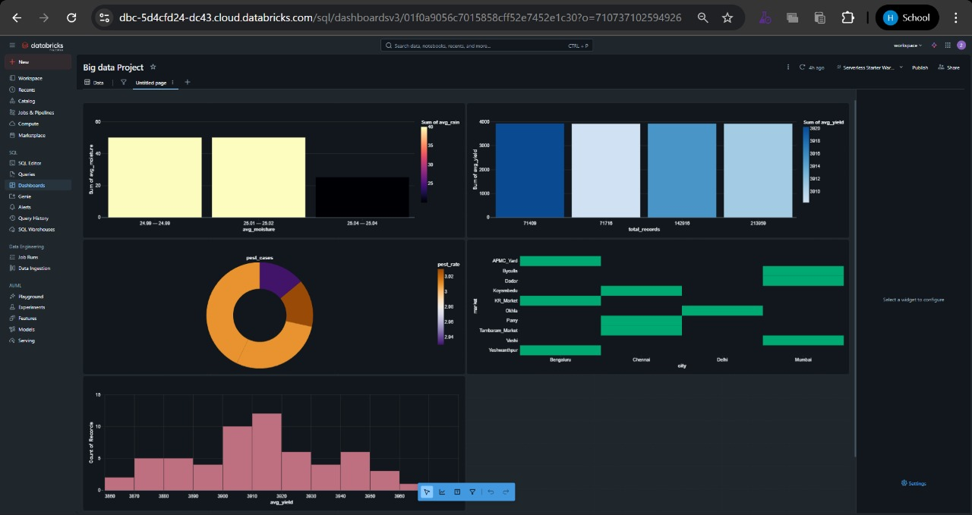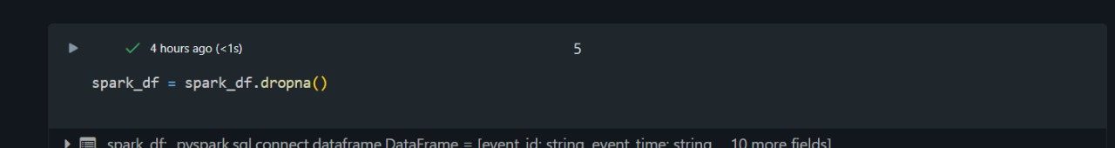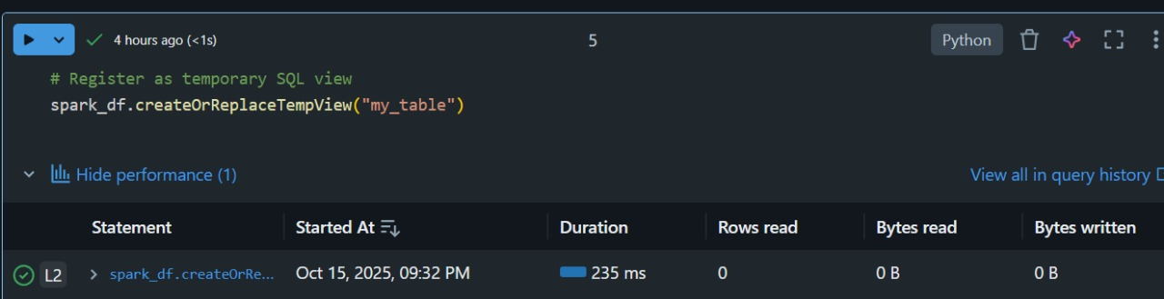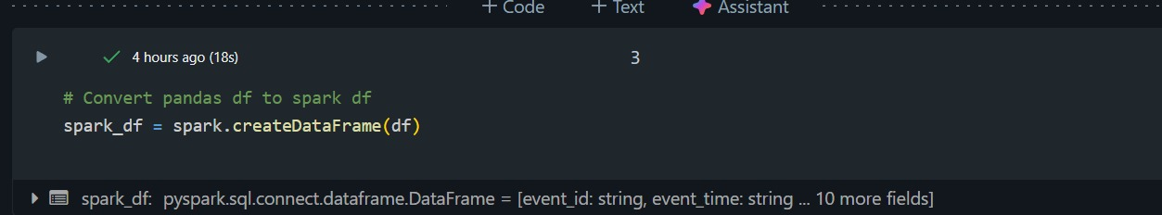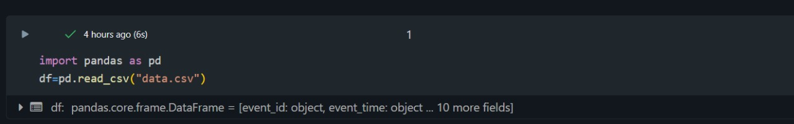
One of the key results of the system is the automated analysis of irrigation requirements. By processing the collected sensor data through Spark and querying it with Hive, the system determines when and how much water is needed for different sections of the farm. This automation reduces human error, prevents over-irrigation or under-irrigation, and ensures optimal water usage. Farmers can make informed irrigation decisions without relying solely on manual observation, saving both time and resources while maintaining crop health.
The system also provides interactive visualization dashboards that display key metrics such as soil moisture, temperature, and rainfall patterns over time. These dashboards allow farmers to easily interpret complex data through visual trends, graphs, and alerts. By converting raw sensor data into actionable insights, the system enables improved resource utilization, such as optimized water and fertilizer application, and supports timely decision-making. Overall, the integration of IoT, Big Data processing, and visualization leads to enhanced crop yield, reduced wastage, and more sustainable farming practices, demonstrating the practical benefits of precision agriculture.
8.Conclusion:
The Precision Farming with IoT Sensor Streams project successfully demonstrates how modern technology can bridge the gap between traditional farming practices and data-driven agriculture. By deploying IoT sensors across agricultural fields, the system captures real-time data on crucial parameters such as soil moisture, temperature, humidity, pH levels, and rainfall. This continuous monitoring provides farmers with an accurate understanding of their field conditions, allowing them to make timely and informed decisions. Unlike conventional farming, which often relies on manual observation and guesswork, this system ensures that farming practices are guided by quantitative data, reducing uncertainty and improving overall efficiency.
The integration of Big Data tools like Hadoop, Spark, and Hive allows the system to handle large volumes of heterogeneous sensor data efficiently. Hadoop provides scalable and fault-tolerant storage, Spark enables fast processing and real-time analytics, and Hive allows structured querying and statistical analysis of processed datasets. This combination ensures that data collected from multiple sensors can be transformed into meaningful insights and actionable recommendations. Farmers can use these insights to determine optimal irrigation schedules, monitor environmental trends, and plan crop management strategies, all of which contribute to enhanced productivity.
Moreover, the system promotes sustainability and resource optimization. By automatically analyzing irrigation needs and providing visual dashboards with real-time metrics, it minimizes water wastage, prevents over-fertilization, and reduces unnecessary use of pesticides. The ability to detect anomalies such as low soil fertility or disease-prone conditions further supports proactive farm management. Overall, the project proves that integrating IoT and Big Data technologies in agriculture not only improves efficiency and productivity but also ensures more sustainable and environmentally conscious farming practices. It highlights the transformative potential of smart farming, showing that advanced analytics and real-time monitoring can revolutionize the way farmers make decisions and optimize agricultural outcomes.
9.Future Enhancement:
AI-Based Prediction Models:One of the most impactful future enhancements is the integration of machine learning and AI algorithms into the precision farming system. These models can be trained on historical sensor data, weather patterns, and crop performance records to predict crop yield, helping farmers plan harvests, storage, and market strategies more efficiently. Additionally, AI can be used to detect early signs of plant diseases or pest infestations by identifying anomalies in soil, temperature, or humidity patterns. For example, a sudden change in soil moisture combined with rising temperature may indicate conditions favorable for fungal growth. Predictive models like Random Forests, LSTM networks, or CNNs (for image data) can provide actionable insights, enabling farmers to implement preventive measures and reduce crop losses.
Mobile and Web Applications:To make the system more accessible, mobile and web applications can be developed as user-friendly interfaces for farmers. These applications would allow farmers to view live analytics, monitor sensor readings, and receive real-time irrigation alerts directly on their smartphones or computers. Interactive dashboards could visualize trends in soil moisture, temperature, rainfall, and crop health, making complex data easy to understand. Push notifications or SMS alerts could inform farmers of critical conditions, such as water deficiency or sudden temperature drops, ensuring timely action even when they are away from the field. By providing a convenient digital interface, these apps empower farmers to manage their farms proactively without needing technical expertise in data analytics.
Cloud and Edge Computing Integration:Currently, the system relies on local processing and storage, but migrating data pipelines to cloud or edge computing platforms could significantly improve scalability and processing speed. Cloud platforms, such as AWS, Azure, or Google Cloud, provide virtually unlimited storage and computing power, enabling the system to handle data from larger farms or multiple locations simultaneously. Edge computing, on the other hand, allows real-time data processing closer to the sensors, reducing latency and enabling instant responses for critical actions, such as triggering irrigation. Combining cloud and edge solutions ensures highly scalable, fault-tolerant, and low-latency operations, making the system suitable for deployment at national or regional agricultural scales.
Integration with Satellite and Drone Data:For a more comprehensive understanding of farm conditions, IoT sensor data can be integrated with aerial imagery from drones and satellites. Drones can capture high-resolution images of crop health, detecting stress, nutrient deficiencies, or pest infestations that sensors alone may not reveal. Satellite data provides large-scale monitoring of weather, soil moisture, and vegetation indices over time. Combining these aerial and IoT datasets using data fusion techniques allows for more accurate crop analysis, early disease detection, and precise irrigation planning, creating a holistic precision farming approach.
Automated Irrigation Systems:A highly practical enhancement is connecting the system directly to automated irrigation controllers, enabling real-time adjustment of water supply based on sensor data. For example, if soil moisture falls below a predefined threshold, the system can automatically open irrigation valves to deliver the right amount of water. This not only reduces manual labor and human error but also optimizes water usage, minimizing wastage and ensuring crops receive adequate hydration at the right time. Coupled with predictive AI models and weather forecasts, such automated irrigation can significantly increase crop yield and resource efficiency, making farming smarter, more sustainable, and less labor-intensive.

